Camunda Community edition BPM primer

Prasad Narwadkar

Table of Contents

1. Overview 3

2. Installation 3

2.1 Prerequisites 3

2.2 Installation Steps 3

2.2.1 Download and unzip 3

2.2.2 Start up Camunda 3

2.2.3 Check it out 3

2.2.4 Run your own Workflow 4

2.2.5 REST API 4

3. References 5

# Overview

Camunda is an open-source BPM tool. It allows developers to use a RESTful API that enables users to do the same things (complete their tasks in the process) from within a Web App UI which they can do from the Camunda modeler/cockpit. It is extremely easy to install and run as you can see from the steps mentioned below. Although we have mentioned Alfresco Activiti for our proposed BPM solution, I have found Camunda to surpass all the open-source headless-enabled BPM solutions based on parameters like ease of use, ease of installation and quick churn of REST API.

# Installation

Time to complete this: 5 minutes

## 2.1 Prerequisites

[**Java development Kit (JDK) 15**](https://www.oracle.com/java/technologies/javase/jdk15-archive-downloads.html)  
[**Camunda Modeler**](https://camunda.com/download/modeler/)

**License:**

Camunda Platform Community Edition is licensed under the Apache License. Third-party libraries or application servers included are distributed under their respective licenses [**(view third-party notices)**](https://docs.camunda.org/manual/7.15/introduction/third-party-libraries/).

Recommended distribution: Camunda Platform Run

[**Download RUN ZIP (30mb) RUN ZIP (30mb)**](https://downloads.camunda.cloud/release/camunda-bpm/run/7.16/camunda-bpm-run-7.16.0.zip) 

## 2.2 Installation Steps

### 2.2.1 Download and unzip

The Camunda Platform Run distribution will start up right out of the box.  
If you want to add additional configuration check out [**the user guide.**](https://docs.camunda.org/manual/latest/user-guide/camunda-bpm-run/)

### 2.2.2 Start up Camunda

Run start.bat (Windows) or start.sh (Linux)

### Check it out

Open [**http://localhost:8080/camunda-welcome/index.html**](http://localhost:8080/camunda-welcome/index.html) and play with the Camunda webapps Cockpit and Task list. User name/password is demo/demo.

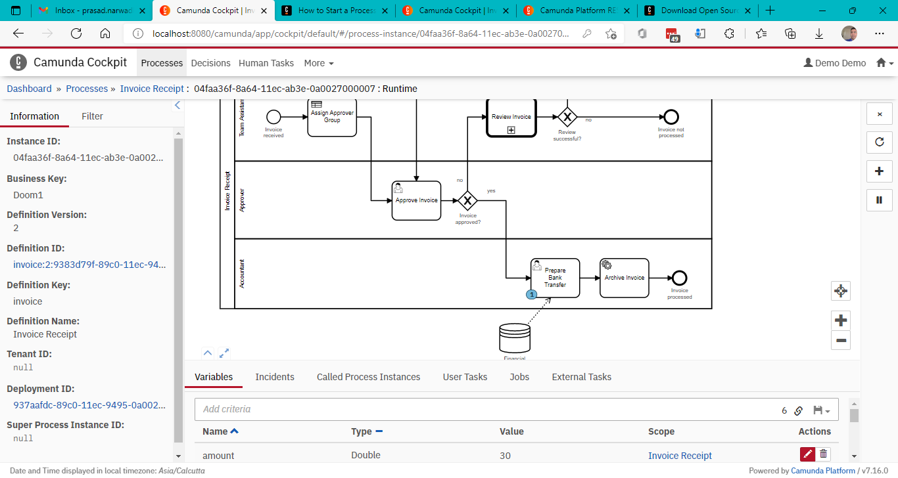

*Figure 1 Camunda BPM community edition platform running on my machine*

### Run your own Workflow

Check out the [**getting started page**](https://docs.camunda.org/get-started/quick-start/) or watch [**Niall and his hawk**](https://www.youtube.com/watch?v=TlFojzQNopA&list=PLJG25HlmvsOX8TiIGUZcVW-ez053YsOX0) to learn how to build and run your own workflow in no time.

### REST API

It is available at <http://localhost:8080/swaggerui>.

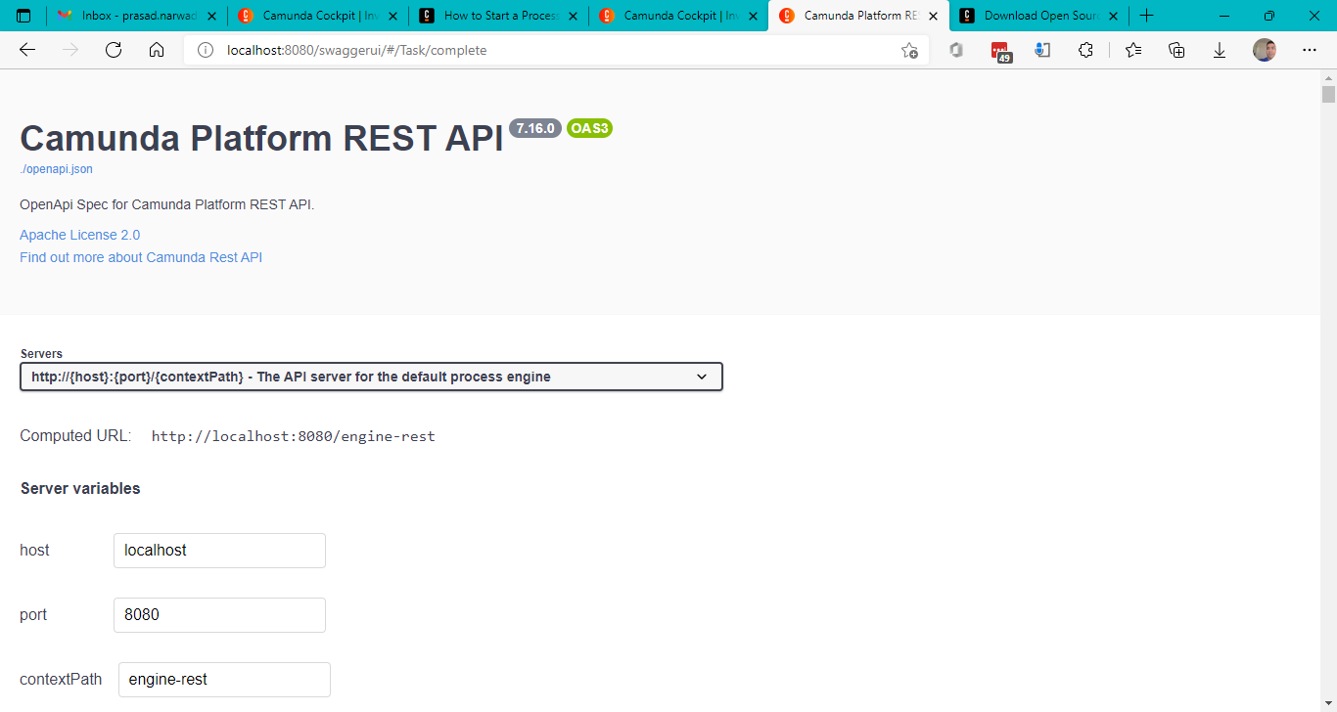

*Figure 2 Camunda Platform REST API*

# References

1. [Download Open Source Workflow Software | Camunda](https://camunda.com/download/)
2. [How to Start a Process with Camunda’s REST API - Camunda](https://camunda.com/blog/2021/10/start-and-step-through-a-process-with-rest-feat-swaggerui/)