# Top 10 Best-Selling Product Categories

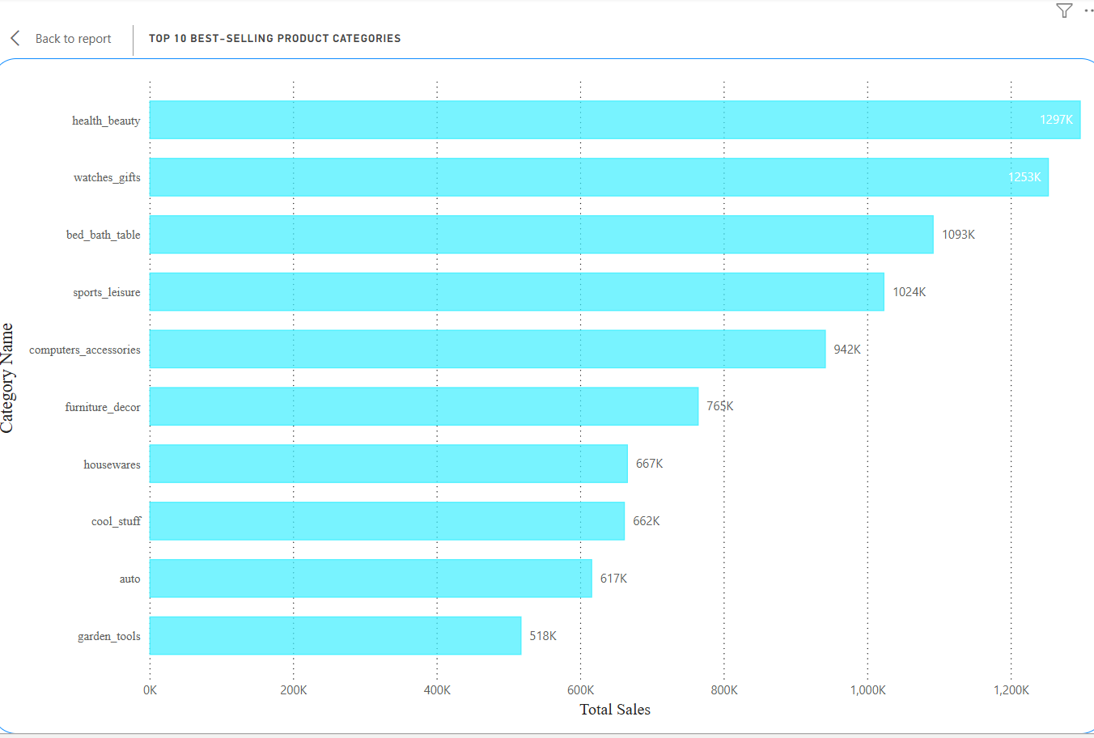

This chart represents the top 10 best-selling product categories based on total sales volume. Each bar in the horizontal bar graph indicates the total sales in thousands (K) for each product category. The data helps in understanding which categories are performing well in terms of sales and can guide business strategies such as inventory management, marketing focus, and sales promotions.

## Top 3 Performing Categories

1. Health & Beauty: Leading the sales chart with 1,297K in total sales.  
2. Watches & Gifts: Close second with 1,253K in total sales.  
3. Bed, Bath & Table: Holds third place with 1,093K in total sales.

## Insights and Usage

This visual and tabular representation can be used by sales and marketing teams to:  
- Identify high-performing product categories.  
- Allocate resources effectively.  
- Design category-specific marketing campaigns.  
- Make data-driven decisions for inventory and promotions.

# Delayed Orders by Product Category

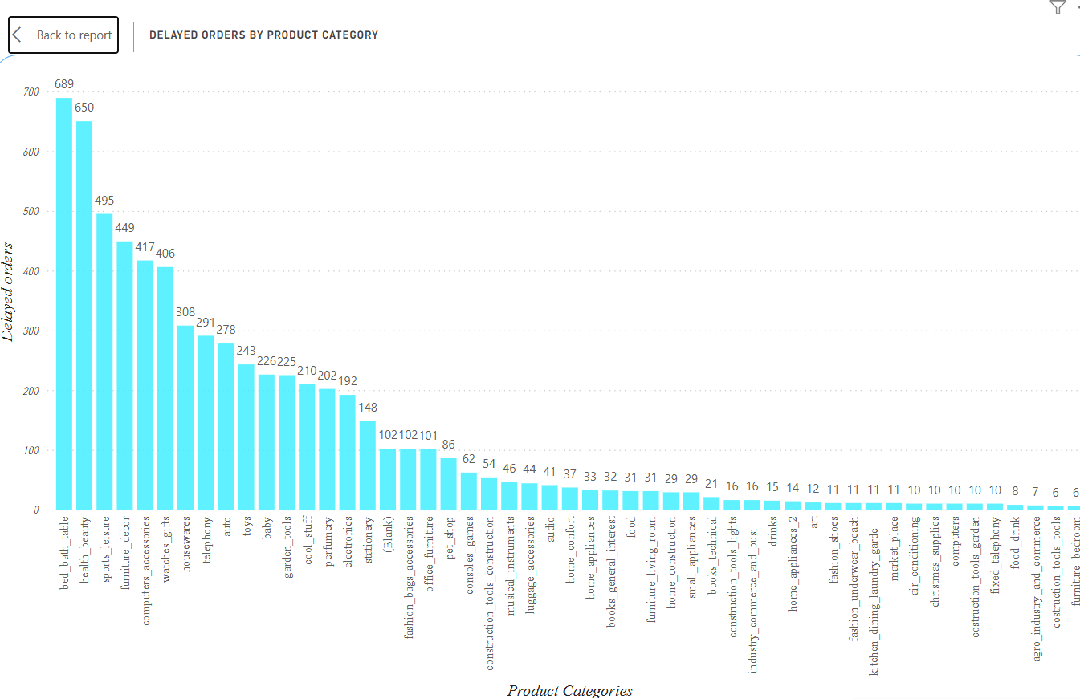

This chart provides a visual representation of the number of delayed orders categorized by product type. It highlights which product categories experience the highest and lowest delays, offering insight into potential supply chain or logistics issues.

## Key Observations

1. Bed, Bath & Table has the highest number of delayed orders at 689, followed closely by Health & Beauty with 650.  
2. Watches & Gifts, Sports & Leisure, and Furniture & Decor also show significantly high delays, indicating possible inventory, supplier, or transportation issues.  
3. Several categories such as Construction Tools & Lights, Agriculture Industry & Consumers, and Construction Tools & Tools show very few delays, with only 6–8 delayed orders each.

## Implications and Recommendations

Understanding the distribution of delayed orders helps organizations prioritize operational improvements. Recommendations include:  
- Investigating supply chain bottlenecks in high-delay categories.  
- Enhancing vendor coordination and demand forecasting.  
- Streamlining logistics and warehousing for frequently delayed product types.  
- Monitoring performance of low-delay categories for best practices.

## ****Early and Delayed Orders by Month****

### ****Overview****

This chart presents a visual comparison of early and delayed orders on a monthly basis. It uses pink bars to represent early orders and purple bars for delayed ones. This layout allows for a quick and clear understanding of order delivery performance throughout the year.

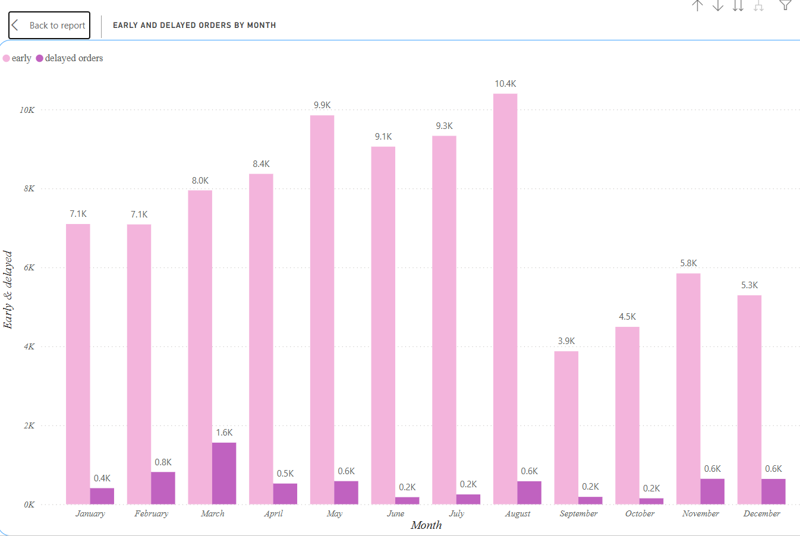

### ****Key Observations****

1. **Highest Early Orders:**
   * **August** had the highest number of early orders at **10.4K**, followed closely by **May (9.9K)** and **July (9.3K)**.
2. **Highest Delayed Orders:**
   * **March** recorded the highest number of delayed orders at **1.6K**, suggesting delivery inefficiencies or bottlenecks in that month.
3. **Consistently Low Delays:**
   * **June, July, September, October, and November** saw only **0.2K delayed orders** each, indicating efficient logistics performance.
4. **End of Year Stability:**
   * **November (5.8K)** and **December (5.3K)** maintained a relatively stable early delivery rate with only **0.6K delayed orders** in each.
5. **Overall Trend:**
   * Early orders consistently outperformed delayed orders, showing a positive trend in order fulfilment across the year.

### ****Insights and Recommendations****

* **March delays** may signal issues such as inventory shortages, staffing gaps, or logistics disruptions and should be investigated further.
* **Best-performing months** (like July and August) can serve as benchmarks to replicate success across other months.
* **Maintaining consistency** in warehouse operations, shipping processes, and supplier coordination is essential for reducing delays.
* **Seasonal planning** and historical data should be used to pre-emptively manage order spikes and avoid future delays.

## ****Payment Method Breakdown****

### ****Overview****

The chart provides a clear breakdown of the different payment methods used by customers. Represented as a donut chart, it visually indicates the percentage and volume of transactions completed using various payment types.

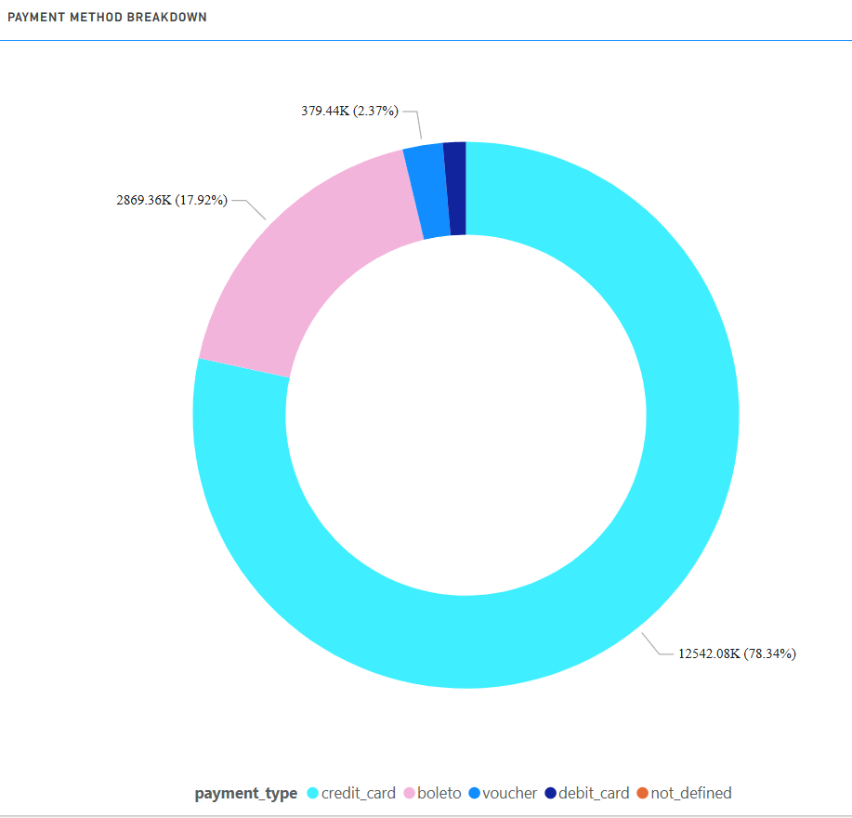

### ****Key Insights****

1. **Credit Card (78.34%)**
   * The majority of transactions were completed using credit cards, totaling approximately **12,542.08K**.
   * This indicates a strong preference for credit-based purchasing among customers, possibly due to credit offers, reward points, or ease of use.
2. **Boleto (17.92%)**
   * The second most-used method was **boleto**, with **2,869.36K** transactions.
   * This method is popular in certain markets (like Brazil), where printed or digital payment slips are commonly used for offline payments.
3. **Voucher (2.37%)**
   * Vouchers accounted for **379.44K** transactions.
   * Often used during promotions, discounts, or loyalty programs, this figure reflects a relatively smaller yet important customer segment.
4. **Debit Card**
   * The use of **debit cards** is shown as a thin dark blue segment, indicating very limited use compared to other methods.
   * This could reflect customer hesitation to link bank accounts directly or a preference for credit features.
5. **Not Defined**
   * A minimal portion of transactions falls under the “not_defined” category, suggesting minor data inconsistencies or unclassified payment types.

### ****Business Implications****

* **Optimize Credit Card Promotions:** Given its dominance, partnerships with credit card providers and targeted offers could further boost conversions.
* **Support Regional Methods:** The high usage of boleto suggests the need to maintain and optimize this option in regions where it’s culturally relevant.
* **Explore Voucher Strategy:** Vouchers, though limited, can be leveraged more aggressively for customer acquisition and retention.
* **Investigate Debit Card Use:** Explore why debit cards are underutilized—possibly through user surveys or testing more seamless integrations.

## ****Top 10 Low Rated Products****

### ****Overview****

This bar chart illustrates the product categories that received the lowest customer ratings. Each bar represents the total count of low-rated products within a given category, highlighting key areas where product satisfaction is lacking.

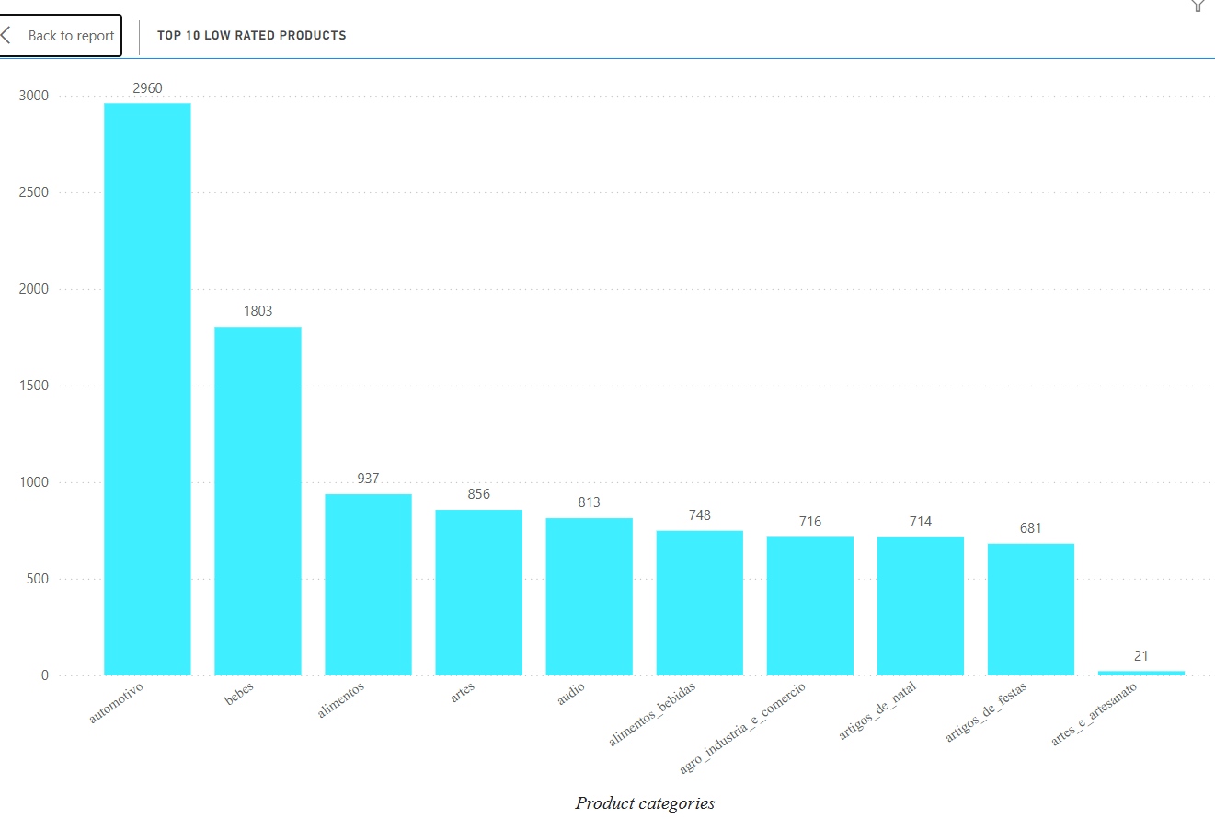

### ****Key Insights****

1. **Automotivo (2960 low ratings):**
   * This category stands out with the highest number of low-rated products, indicating significant customer dissatisfaction—possibly due to quality, compatibility issues, or misleading descriptions.
2. **Bebes (1803 low ratings):**
   * The second highest in poor ratings. Since this category likely includes baby care products, safety, reliability, and effectiveness might be concerns for users.
3. **Alimentos (937) & Alimentos_Bebidas (748):**
   * Both food-related categories are present in the top 10, suggesting issues with product freshness, packaging, or mismatched expectations.
4. **Artes (856) & Audio (813):**
   * Creative and electronics categories also show a considerable number of low ratings, which may be tied to user experience, durability, or technical performance.
5. **Agro_Industria_E_Comercio (716):**
   * A broad industrial category appearing on the list may indicate inconsistent quality across various sub-products.
6. **Artigos_De_Natal (714) & Artigos_De_Festas (681):**
   * These seasonal or decorative items being low rated could point to perceived low value, quality issues, or unmet aesthetic expectations.
7. **Artes_E_Artesanato (21):**
   * Although it appears on the list, the number of low-rated products is significantly lower, suggesting it may have had fewer total reviews or lower sales volume.

### ****Business Implications & Recommendations****

* **Automotive and Baby Product Review:** Immediate quality audits and customer feedback loops should be implemented to resolve recurring issues in these high-volume low-rated categories.
* **Product Detail Optimization:** Categories like audio and artes (arts) may benefit from clearer product specifications and visual demonstrations to align expectations.
* **Vendor and Supplier Monitoring:** For food and drink categories, tighter control over shelf-life, packaging, and delivery conditions is recommended.
* **Holiday Product Improvements:** Seasonal products can be enhanced by improving design variety, material quality, and durability.
* **Prioritize Customer Feedback:** Implementing more robust review and response systems could help identify root causes early and boost customer trust.

## ****State Wise Analysis****

### ****Overview****

This bar chart presents a detailed breakdown of total purchase amounts by customer state. Each bar represents the **sum of prices** of purchases made from each state, helping identify key markets and regional demand distribution.

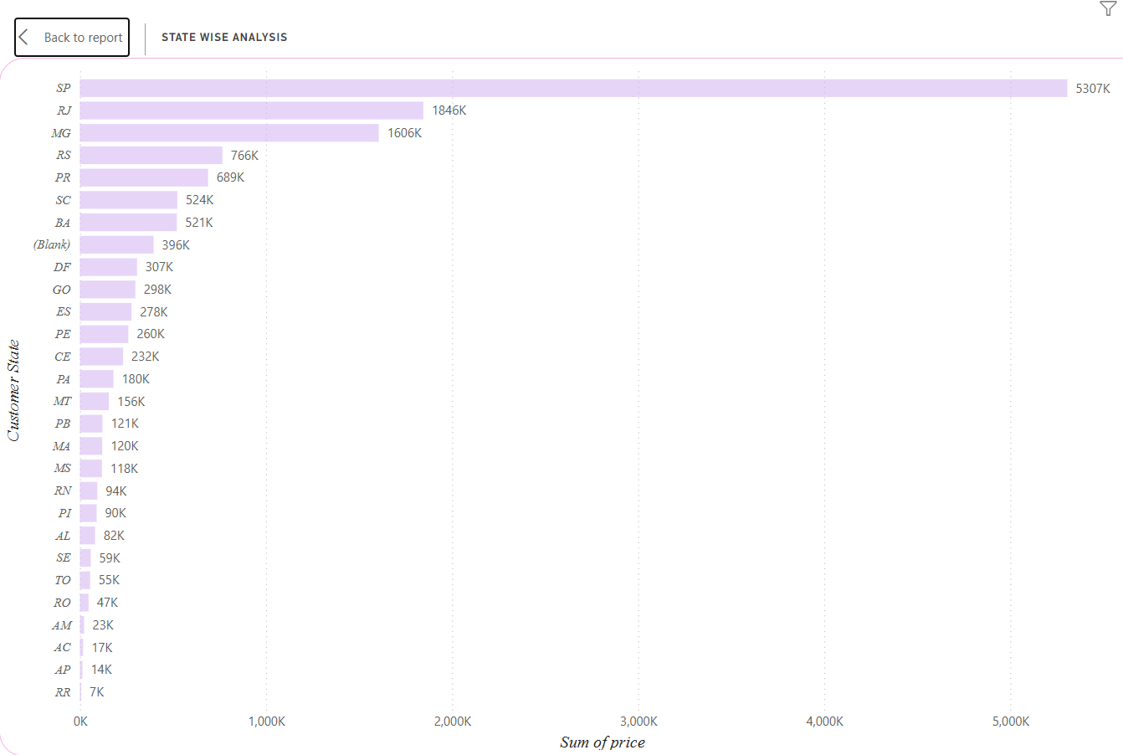

### ****Key Insights****

1. **Top Performing States:**
   * **São Paulo (SP)** dominates with a massive **5307K** in total purchases, indicating a highly active and potentially profitable customer base.
   * **Rio de Janeiro (RJ)** follows with **1846K**, and **Minas Gerais (MG)** with **1606K**, marking them as major commercial hubs.
2. **Mid-Tier States:**
   * States like **Rio Grande do Sul (RS)** – **766K**, **Paraná (PR)** – **689K**, and **Santa Catarina (SC)** – **524K** show strong but slightly lower market activity.
   * The presence of a significant value for **(Blank)** – **396K** indicates data with missing state entries, which could affect the accuracy of analysis.
3. **Low Activity States:**
   * States such as **Roraima (RR)** – **7K**, **Amapá (AP)** – **14K**, and **Acre (AC)** – **17K** have the lowest purchasing values, possibly due to lower population density, limited digital access, or logistical challenges.

### ****Business Implications & Recommendations****

* **Focus on High-Value States:**
  + Invest more in marketing, fulfillment centers, and customer engagement in SP, RJ, and MG to maximize ROI from high-demand regions.
* **Data Quality Improvement:**
  + Resolve the **(Blank)** entries to ensure complete and accurate regional analytics.
* **Growth Opportunities:**
  + Mid-tier states like RS, PR, and SC could be targeted with localized campaigns to boost engagement and move them to higher tiers.
* **Addressing Low Activity:**
  + Analyze constraints in low-performing states (e.g., delivery delays, payment options) and explore partnerships or promotions to tap into underserved markets.

## ****Seasonal Sale Analysis****

### ****Overview****

The chart above showcases the **total sales performance segmented by financial quarters (Q1 to Q4)**. This analysis helps identify seasonal sales trends and determine peak and low-performing periods within the business cycle.

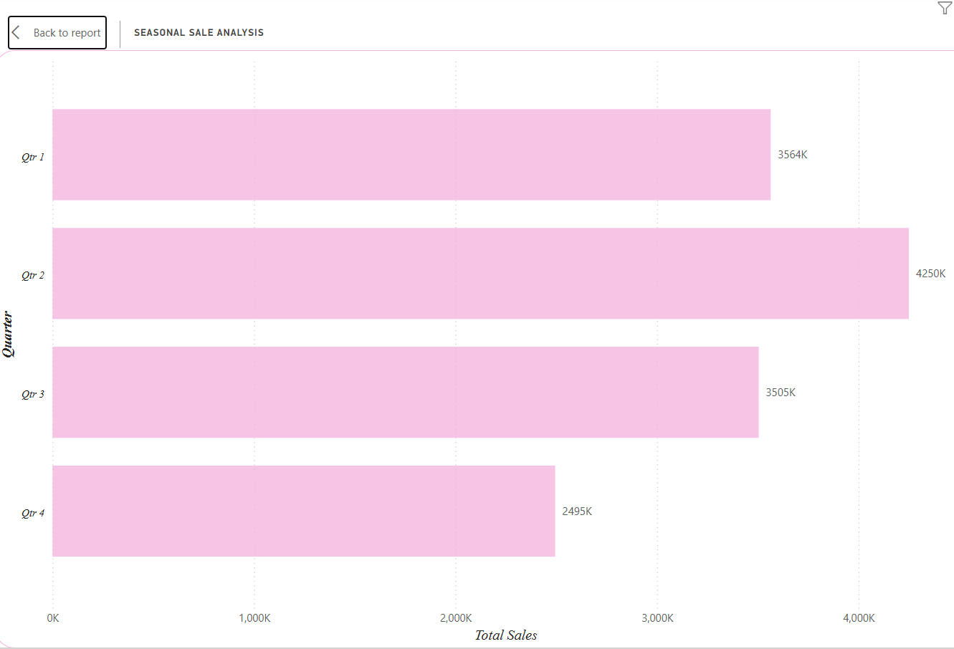

### ****Quarter-wise Sales Breakdown****

* **Quarter 2 (Q2):**
  + **Total Sales: 4250K**
  + This is the **best-performing quarter**, indicating a seasonal sales peak likely influenced by mid-year promotions, festivals, or product launches. This period shows the highest customer activity and purchase volume.
* **Quarter 1 (Q1):**
  + **Total Sales: 3564K**
  + A strong start to the year, possibly driven by New Year campaigns, clearance sales, or post-holiday shopping behavior.
* **Quarter 3 (Q3):**
  + **Total Sales: 3505K**
  + Close in performance to Q1, indicating a steady demand through mid-to-late year. It suggests consistent customer engagement without extreme fluctuations.
* **Quarter 4 (Q4):**
  + **Total Sales: 2495K**
  + This quarter recorded the **lowest total sales** despite usually hosting major shopping events like Black Friday, Cyber Monday, and holiday sales. This could point to missed marketing opportunities or supply chain issues during this period.

### ****Insights & Recommendations****

* **Focus on Q2 Campaigns:**  
  Leverage Q2’s proven success by increasing marketing spend and optimizing product availability during this peak season.
* **Q4 Sales Recovery Strategy:**  
  Investigate why Q4 underperformed. Potential improvements could include early promotions, more competitive pricing, or improved delivery timelines before holidays.
* **Maintain Momentum in Q1 & Q3:**  
  Since these quarters show balanced sales performance, focus on customer retention, loyalty programs, and timely stock replenishment to maintain growth.
* **Seasonal Inventory Planning:**  
  Use this data to forecast demand and plan inventory levels more accurately for each quarter.

## ****Revenue Analysis (2016–2018)****

### ****Overview****

The chart presents the total sales revenue across three consecutive years — 2016, 2017, and 2018 — offering a clear view of the company's annual growth trajectory.

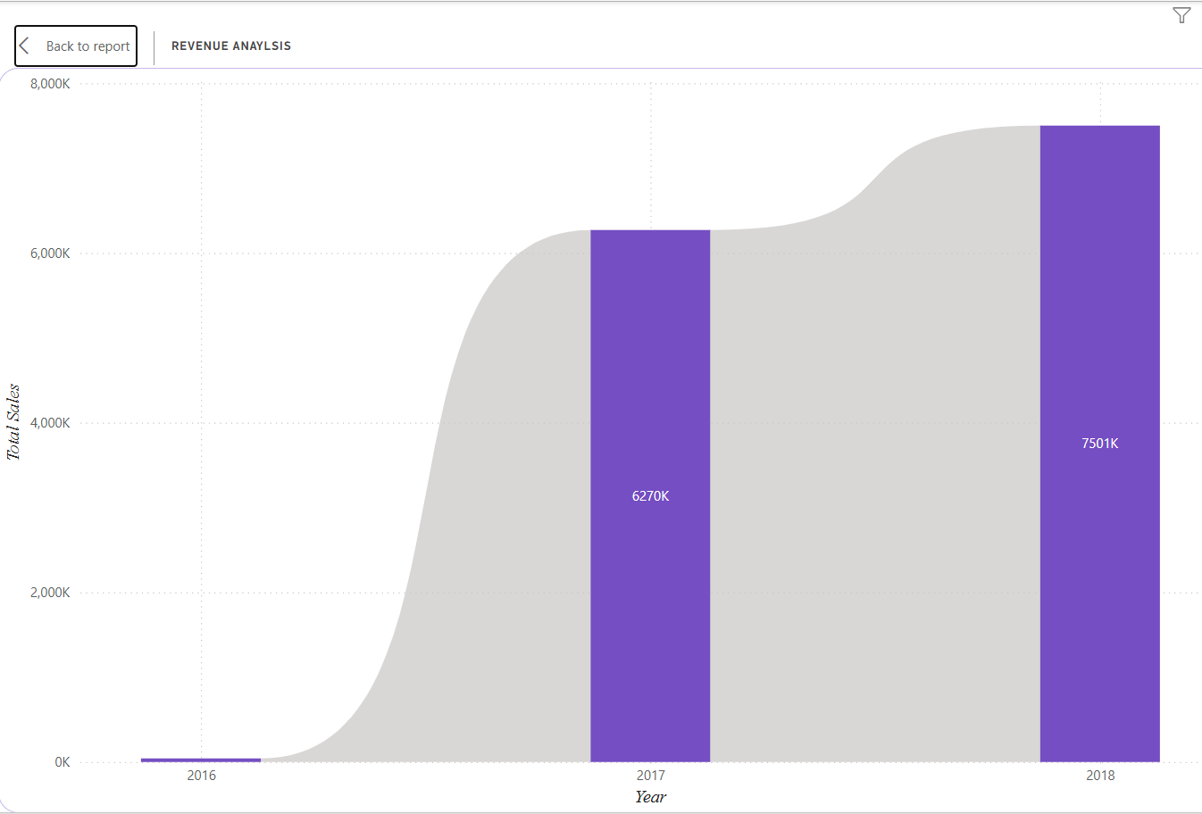

### ****Year-wise Revenue Breakdown****

* **2016:**
  + Revenue is negligible, indicating either the initial phase of operations or minimal market presence. This year likely involved foundational activities such as platform setup, vendor onboarding, or soft launch efforts.
* **2017:**
  + **Total Sales: 6,270K**
  + A significant surge in revenue occurred in 2017, marking a successful scale-up phase. This leap suggests increased customer acquisition, expanded product offerings, improved logistics, and possibly aggressive marketing campaigns.
* **2018:**
  + **Total Sales: 7,501K**
  + The upward trend continued in 2018 with a **19.6% increase** in total sales compared to the previous year. The business seems to have sustained its momentum through strategic growth initiatives and customer retention.

### ****Insights & Recommendations****

* **Positive Growth Trend:**  
  The consistent year-over-year revenue growth confirms the effectiveness of the business strategy and market demand.
* **Scalability Proof:**  
  The jump from near-zero in 2016 to over 7.5 million in 2018 demonstrates strong scalability. The company should continue to invest in operational efficiency, customer experience, and data-driven marketing.
* **Future Planning:**  
  Forecasting for subsequent years should factor in a 15–20% YoY growth projection while also planning for market saturation or external challenges.