**ENTERPRISE WEB SOFTWARE DEVELOPMENT**

**Course Title: COMP1640: Enterprise Web Software Development**

**Due Date: 11/11/2016**

**Student ID : 000947746**

Contents

**Evolution of the project process** 3

**Screenshots** 4

**Group Members and Their contribution** 9

**Our Team members:** 9

**Duties of members** 9

Git repo : <https://github.com/prasadsampath/marketingmag>

Site link : <http://gw-mag.tk/>

Admin login:

Username: admin

Password: admin

Student login:

Username: john

Password: abc123

Coordinator login: smith

Password: abc123

Manager login:

Username: manager

Password: abc123

# **Evolution of the project process**

Introduction

This is a web based secure role-based system for a large university to upload the students’ contributions for an annual university magazine. Each marketing coordinator manage the process of uploading the documents and images from each faculty. The head of this process is the Marketing Manager.

User are granted roles (levels) based on their responsibilities on the collecting contributions. Each user will have to register in the system and then they can log In with the user name and password.

# **Screenshots**

1. Login

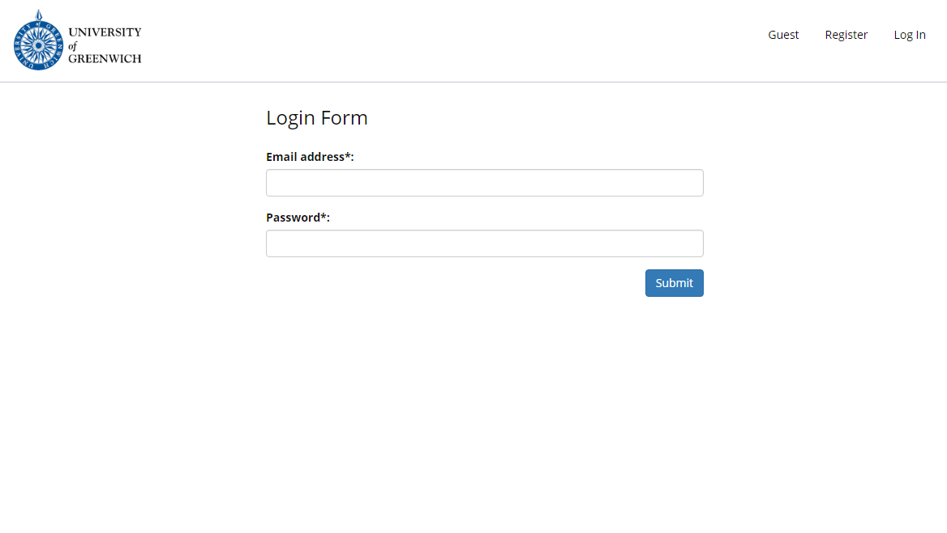

1. Register

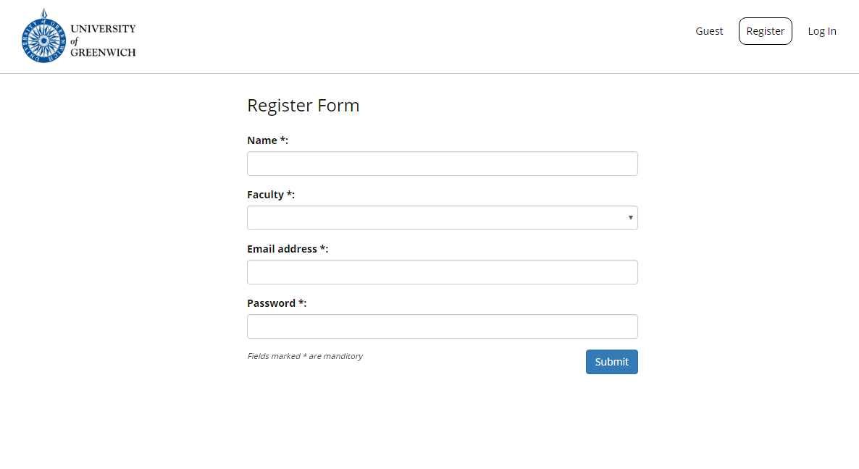

1. Admin Dashboard

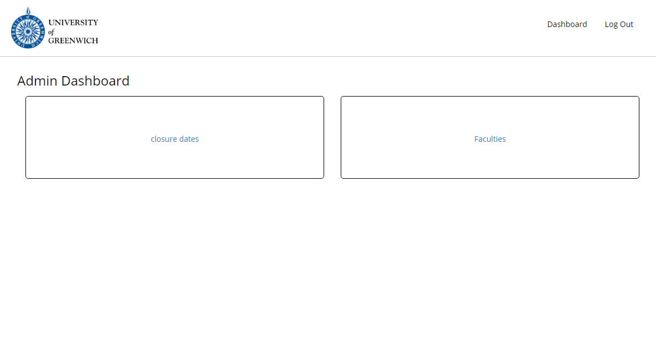

1. Faculty details

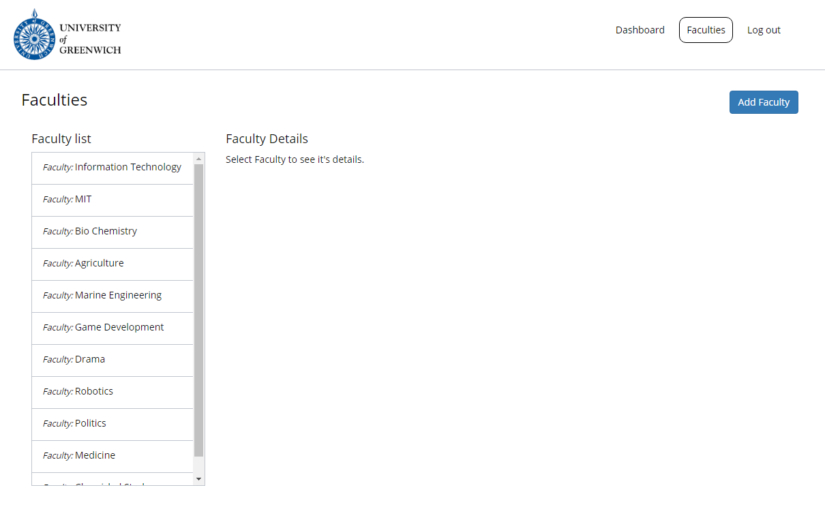

1. Admin Closure dates

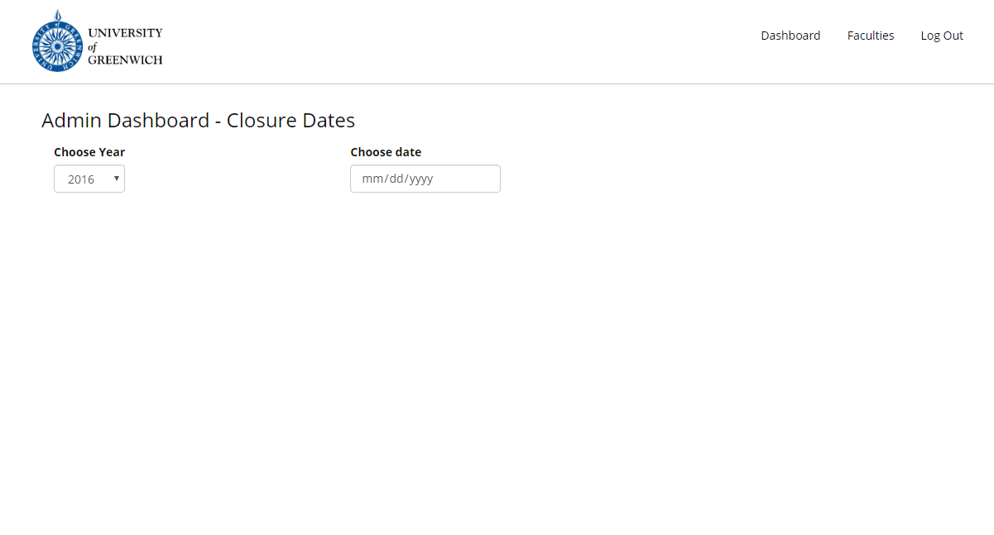

1. Student Upload

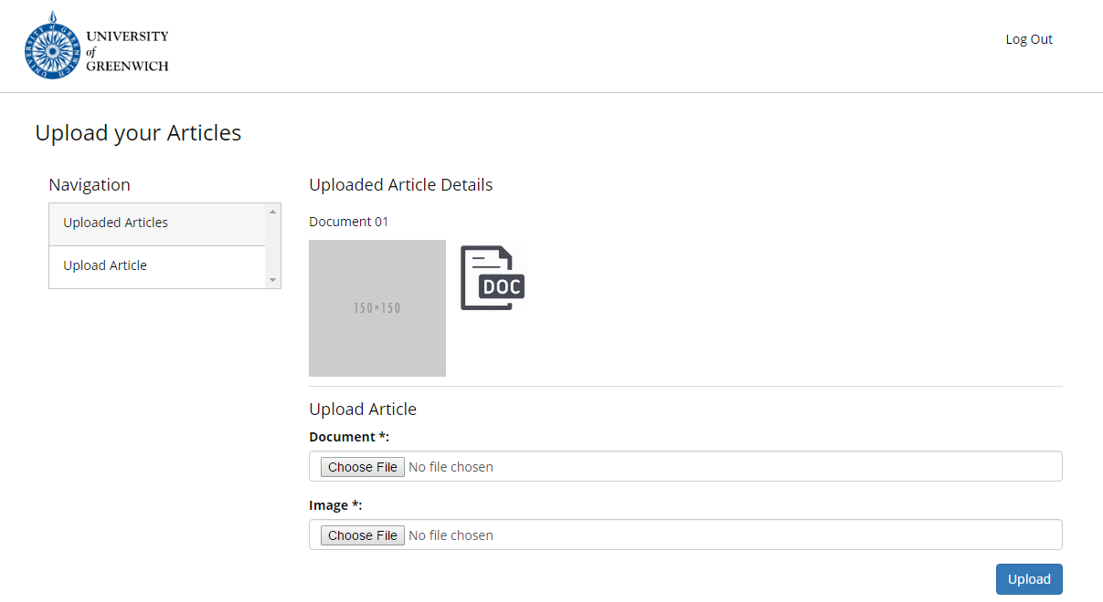

1. Marketing Coordinator Dashboard

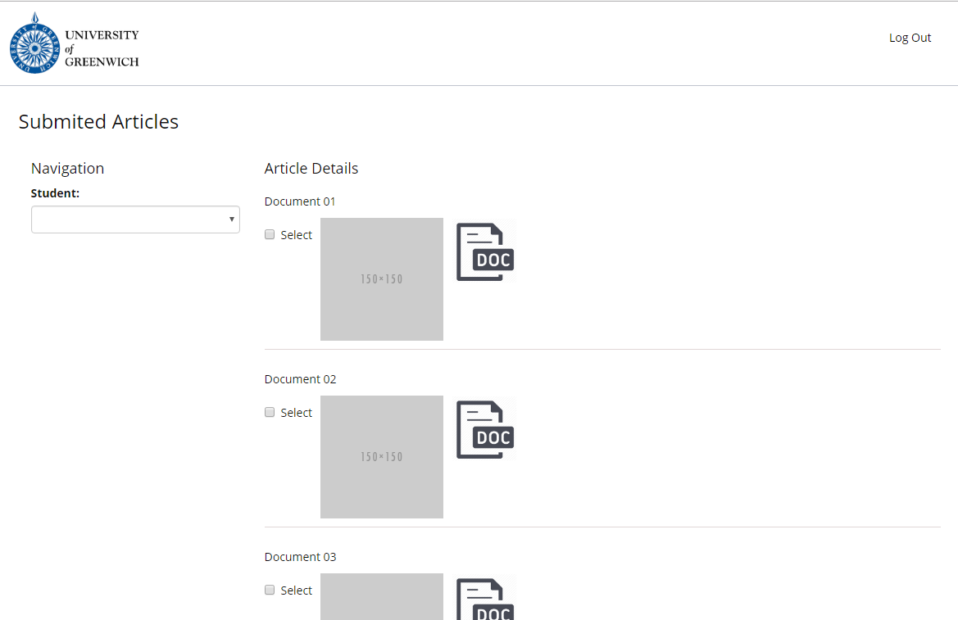

1. Guest dashboard

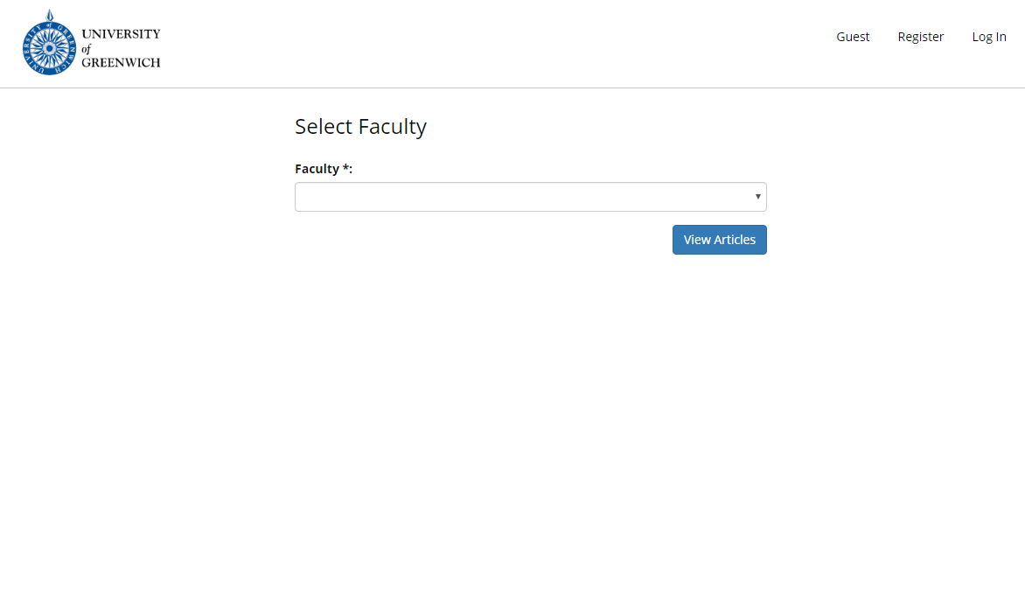

09. Marketing Manager dashboard

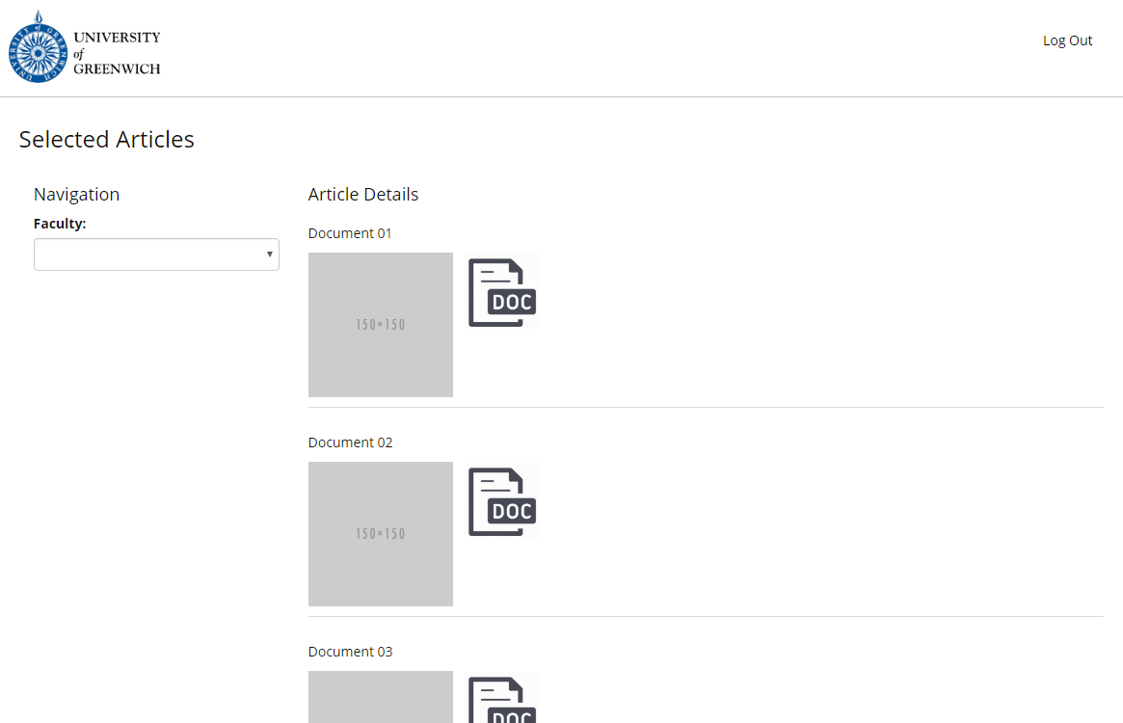

# 

# **Group Members and Their contribution**

## **Our Team members:**

* Dimuthu lakmal
* Sampath Hewage
* Charith

## **Duties of members**

**Dimuthu Lakmal**

1. Web design

2. Testing

Dimuthu design the web pages and the testing part. He design web pages using html and the

Css and he used bootstrap tool. He use this tool to responsive purposes.

In the testing part he has done the verification via unit testing

*login page

*Registration page

*student portal page

*coordinator page

*faculty marketing Marketing head page

*Admin page

*Guest page

**Charitha Madushan**

1. Use case diagram

2. Information architecture

3. Scrum master

Charitha created the use case diagram Information architecture, Scrum master.

**Sampath Hewage**

1. Coding

2. Development

3. Database design

|  |  |  |
| --- | --- | --- |
| **Name of Member** | **Commitment** | **Weight** |
| Dimuthu Lakmal | Fully committed | 8 |
| Charitha Madushan | Fully committed | 9 |
| Sampath Hewage | Fully committed | 9 |

In this group project my responsibility was to do the coding, development and the database designing.

Database Design

Development of the Application

Languages used to develop the Application

* PHP
* MySQL
* HTML
* CSS

Compatibility

System need PHP 5.2.4 or above, and will work with shared or dedicated hosting

Platforms. This web application uses MySQL as its database.

MySql

A database is a structure of rows and columns filled with a collection of data. MySQL database is used to do CRUD operations.

Bootstrap

Bootstrap is the most popular HTML, CSS, and JavaScript framework for developing

responsive, mobile-first web sites.

some example codes

Database connection

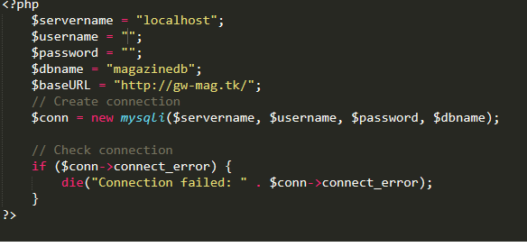

Header

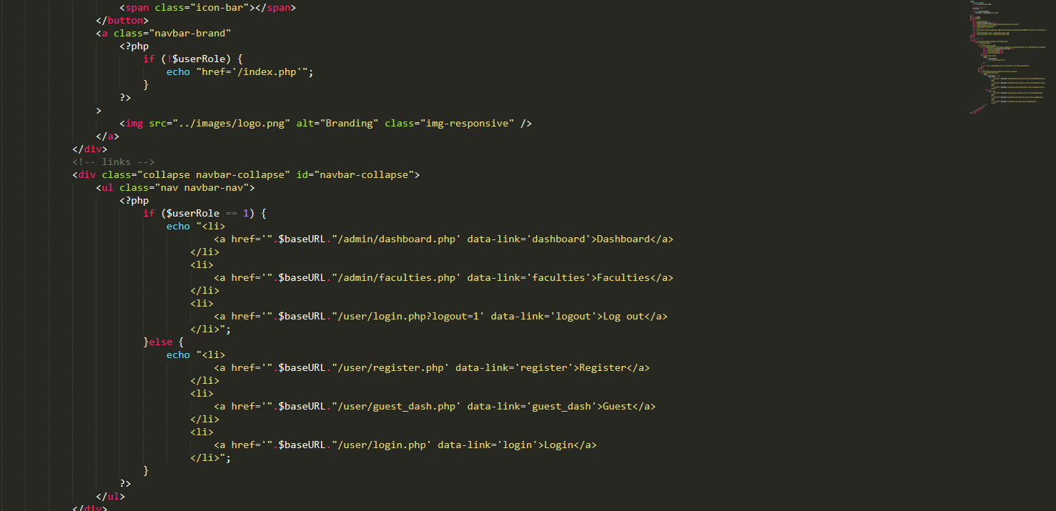

Login code

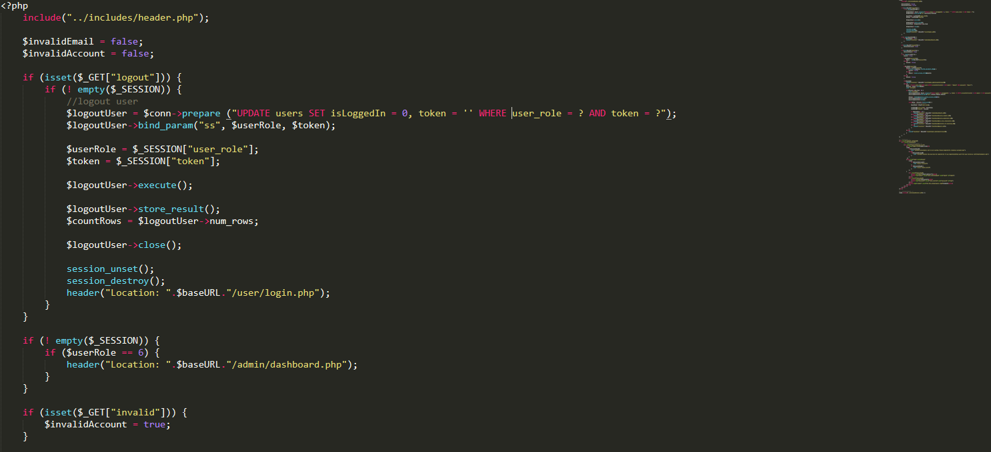

Register code

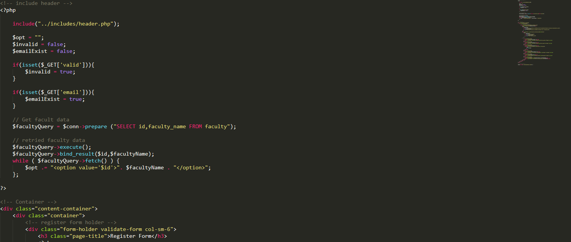

User role code

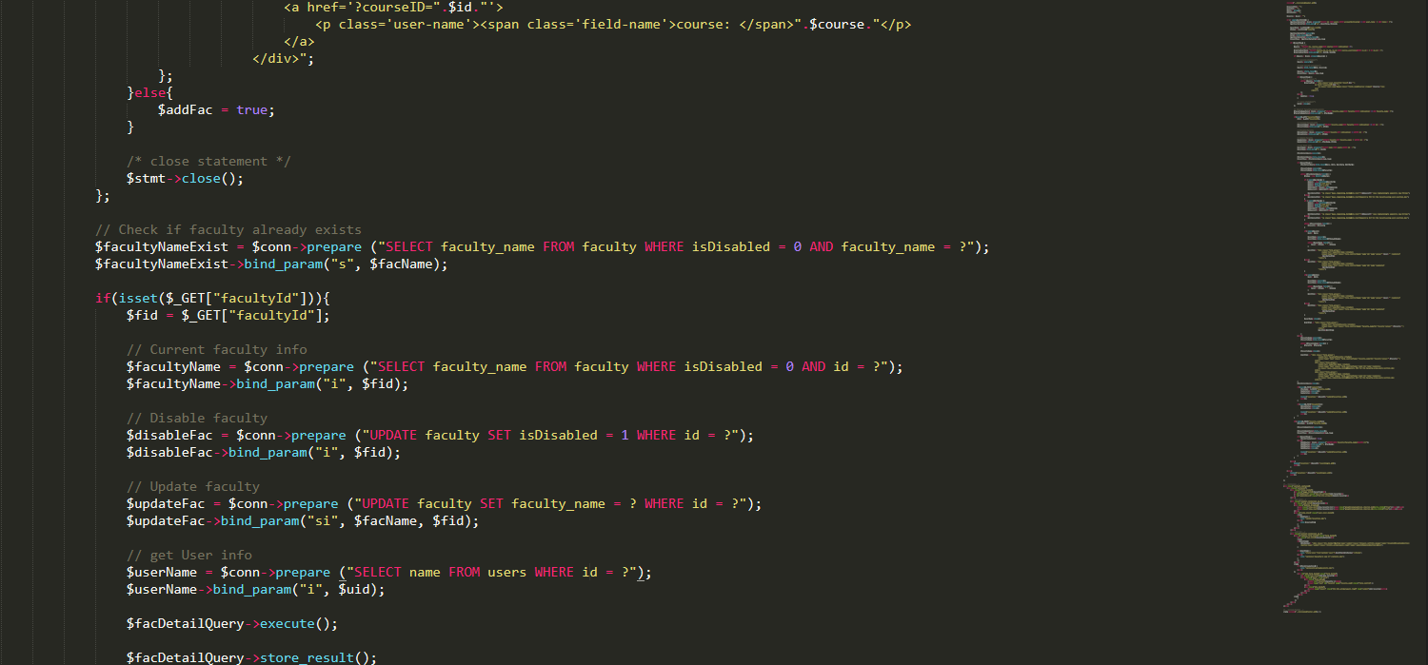

In the development phase, as the developer I was not able to complete the time period evaluation part. If I was given to do the assignment again I would have done a more thorough research before starting the project.

**Entity Relationship Diagram**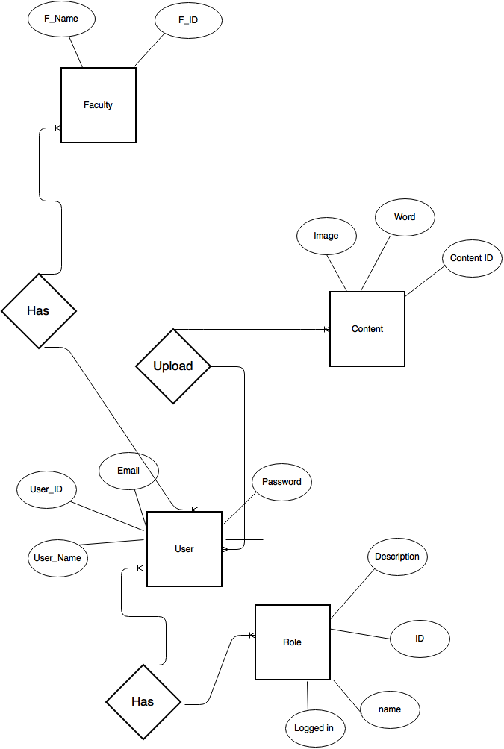

## **Tables**

1. Faculty table

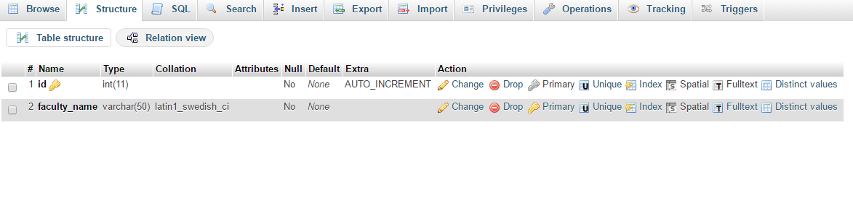

Through the faculty table admin can add faculties through the auto incrementing primary key

Faculty name: varchar(50)

id : int

1. Files table

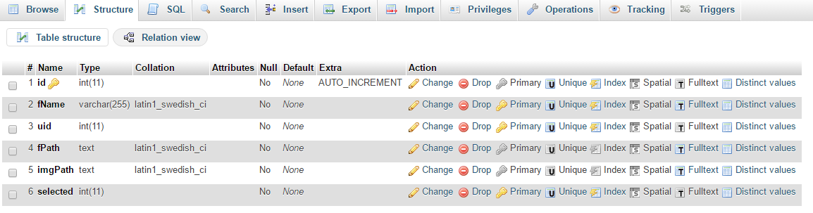

This table holds all the images and documents uploading by the student.

Id int

fName varchar(255)

uid int

fPath text

imgPath text

selected int

1. Uploads Table

Keep all the records of the students and their faculties who do uploading. Sole purpose is for report functions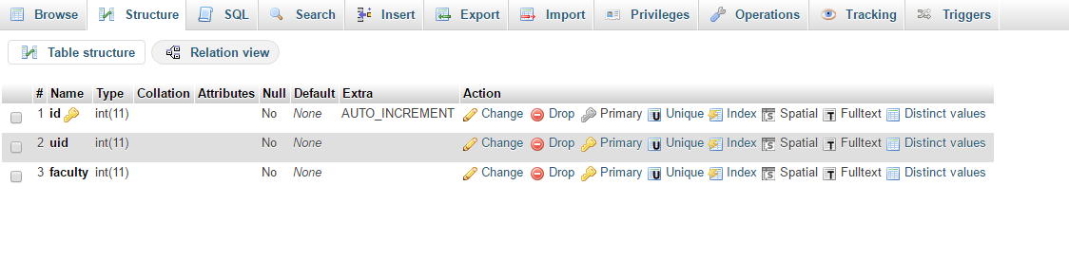

Id int

Uid int

Faculty int

1. User role table

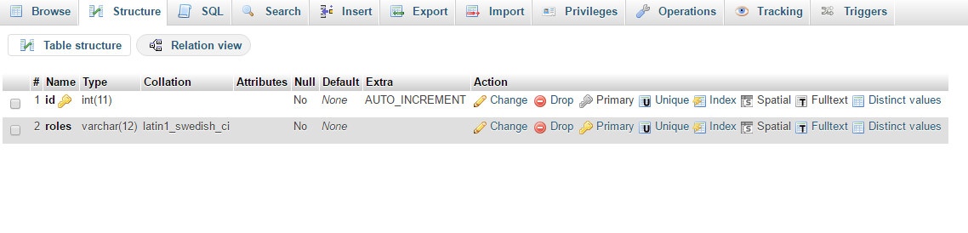

There are several user roles such as student, admin, manager, coordinator defined in the table. This determine the roles performed by the static table

Id int

Roles varchar(12)

1. User table

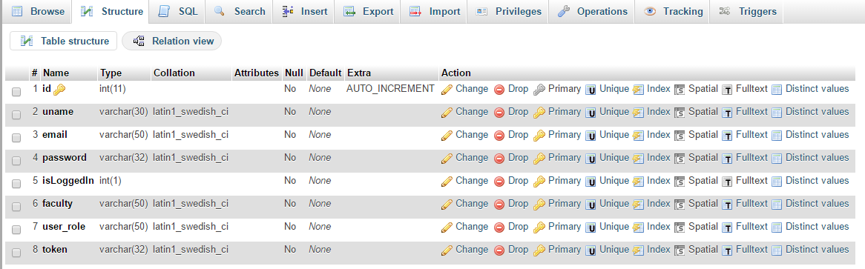

User table stores all the record of the registering users. Token will issue for the log in users and do the session will be maintained.

Id int

Uname varchar (30)

Email varchar (50)

Password varchar (32)

isLogged int

Faculty varchar (50)

User_role varchar (50)

Token varchar (32)

