Vending Machine Disgn Document – Prasadu Munagala

==================================================================

**1. System Overview:**

System is implemented as Microservice using Java/J2EE with Spring Boot and AngularJS. **Soda Vending machine** application provides the facility to display the available products (Coke, Pepsi, Soda) to the customer. If customer wants to purchase any product (Coke, Pepsi, Soda), system will provide the faculty to display the selected product details (productPrice, productName, availableStock).

Customer wants to purchase selected product, system will check whether the customer has provide the sufficient amount in the form of coin(CENT,QUARTER, DOLLAR) for this system is provided insertCoin action to add amount to account balance. If customer has sufficient amount to purchase the product, then system will dispense the selected product from ProductRepository and update the availableStock post transaction.

Post transaction system will re-check account balance and verify if there is any extra amount in account then system calculate accordingly and update the account balance accordingly. System will also notify to customer when insufficient amount or no stock in products. System will also provide the facility to track the product sales and persist the same when customer purchases a product. i.e for reporting purpose.

**2. Implemented System How to Use Case:**

System provides the facility to user with various user interface screens to interact with the system in convenience way. System is Scalability & Flexibility and can change items, price and quantity being dispensed, promotion without any code changes.

* System provides the facility of SSO to maintained user session across multiple actions performed by logged user.
* System provides the facility to user to create and maintain the account by Authenticating user credentials.
* Login screen : <http://localhost:8070/hcaservices/login>

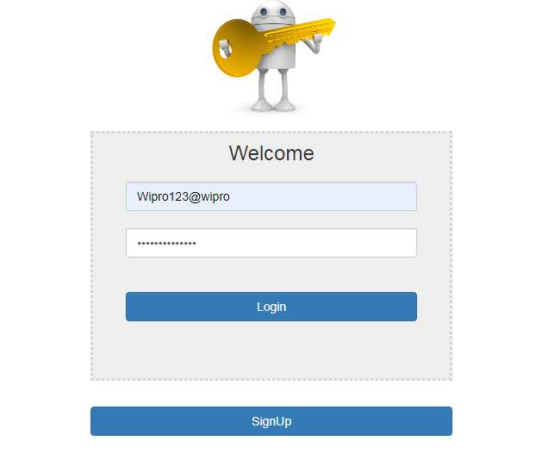

* Registration screen: <http://localhost:8070/hcaservices/registration>

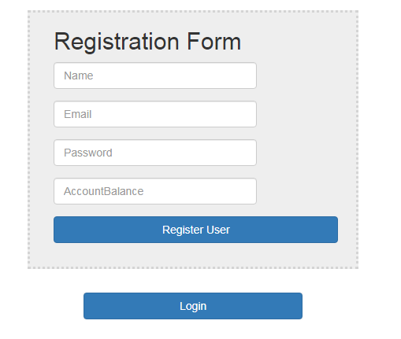

* Vending machine screen with logged user details along with available products to purchase.

<http://localhost:8070/hcaservices/vendingmachine>

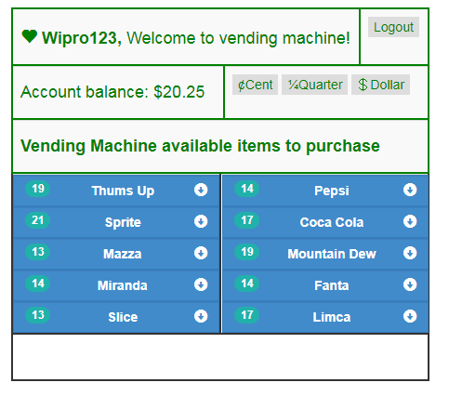

* **Operating Steps:**
  + Select product it will display the product details
  + Push on wished to product it will dispense from the application
  + Alert will be shown for dispensed product
  + On after purchase account balance will be updated
  + Push Cent, Quarter and Dollar buttons when user wish to add balance to account.
* System also provide the facility to screens to monitor and maintain the application with dashboards.
* GetUsers: <http://localhost:8070/hcaservices/vendingmachine/getUsers>

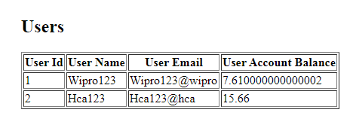

* GetProductSales : <http://localhost:8070/hcaservices/vendingmachine/getProductSales>

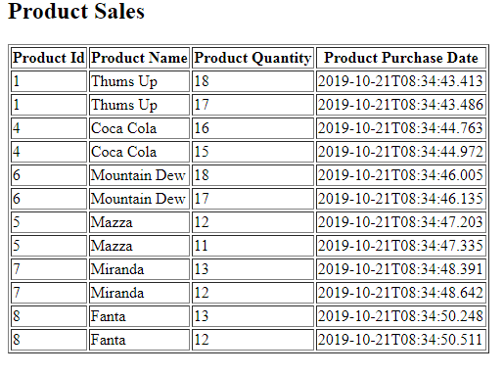

**3. Technical Consideration:**

* System provides the facility of SSO to maintained user session across multiple actions performed by logged user.
* System is Scalability & Flexibility and can change items, price and quantity being dispensed, promotion without any code changes by considering various design approaches.
* System is developed as a Microservice, that can be deployable or executable anywhere without bothering about infrastructure and not required additional software’s to install.
* Database can change from one to other by making changes in configuration file

**4. Architectural and Technical Overview:**

* System is developed as a Microservice, that can be deployable or executable anywhere without bothering about infrastructure and not required additional software’s to install.
* Microservice implementation contains with multiple layers and components as a re-usable patterns to interact with each other.
  + **UI Components** are being used to provide and interact with Users. It is developed using HTML, CSS and AngualrJS.
  + **Micro Controllers** are being used to provide communication between client and business services. It is developed using Java/J2EE with Spring Boot.
  + **Service Layer** implemented the business logic to process and validates the system requirement. It is developed using Java/J2EE with Spring Boot.
  + **Persistent Layer** implemented used to persists application data. It is developed using Java/J2EE, Spring Boot data JPA with H2 database.

**5. System Class diagram:**

