Vending Machine Disgn Document – Prasadu Munagala

==================================================================

**1. System Overview:**

System is implemented as Micro-Service using Java/J2EE with Spring Boot and AngularJS.

**Soda Vending machine** application provides the facility to display the available products (Coke, Pepsi, Soda) to the customer. If customer wants to purchase any product (Coke, Pepsi, Soda), system will display the selected product details (productPrice, productName, availableStock).

If customer wants to purchase any selected product which is displayed in the Vending machine, then the machine will prompt to insert currency (Cent/quarter/dollar), once the system validates the correct match of currency the vending machine will dispense the product.

Post the successful transaction System will dispense the extra amount to customer and update the account balance and the inventory accordingly.

System is also capable of generating sales report.

**2. How to use Implemented System:**

System provides the facility to user with various user interface screens to interact with the system in convenience way. System is Scalable & Flexible and can change items, price and quantity being dispensed and promotion without any code changes.

* System provides the facility of SSO to maintain user session across multiple actions performed by logged user.
* System provides the user the facility to create and maintain the account by authenticating user credentials.
* Login screen : <http://localhost:8070/hcaservices/login>

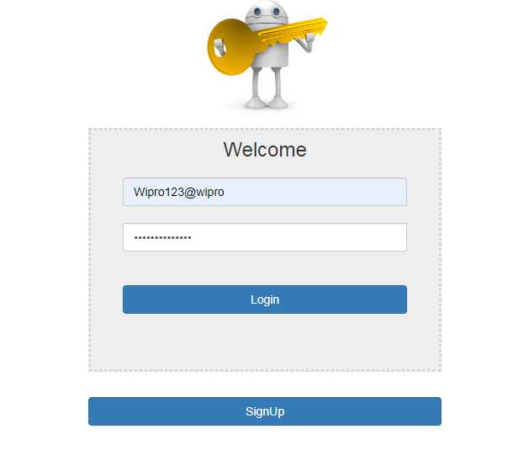

* Registration screen: <http://localhost:8070/hcaservices/registration>

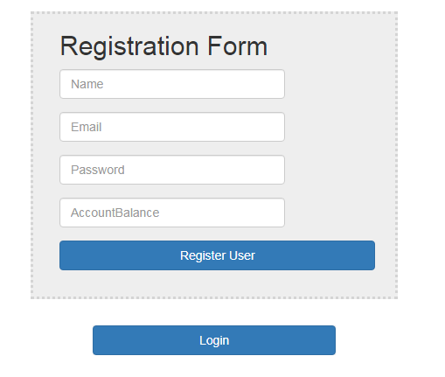

* Vending machine screen with logged user details along with available products to purchase.

<http://localhost:8070/hcaservices/vendingmachine>

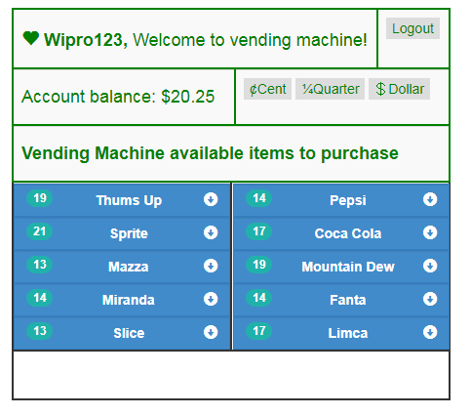

* **Operating Steps:**
  + “Select product”: The user should select his choice from the displayed products.
  + Press the product choice which customer wants to purchase
  + Message will be displayed to insert the Amount (Cent/Quarter/Dollar) if account balance is less than the product price.
  + Post account balance validation System validate the exact amount and dispense the product.
  + Once the product is dispensed, system returns the extra amount if any to customer and updates the inventory and account balance.
* System also provide the facility to monitor and maintain the application with dashboards in the form of following REST Full Web services.

* Get Users Service url: <http://localhost:8070/hcaservices/vendingmachine/getUsers>

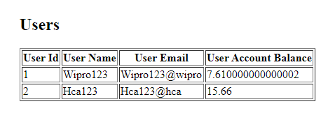

* GetProductSales:<http://localhost:8070/hcaservices/vendingmachine/getProductSales>

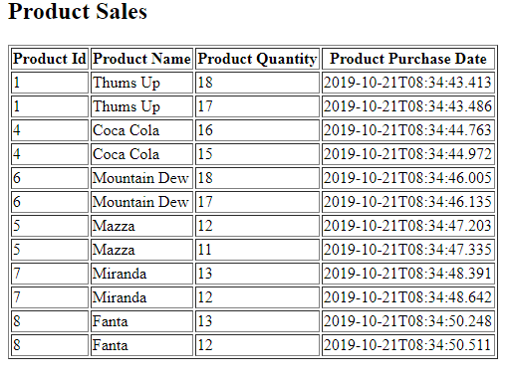

**3. Technical Consideration:**

* System provides the facility for users to login with SSO and perform desired actions in the vending machine.
* System is Scalable & Flexible to change items, price and quantity being dispensed & performs promotional activities without any code changes by respective products available in the system.
* System is developed as a Micro-service that can be deployable or executable anywhere without any dependency of infrastructure and any software’s.
* Database is user friendly and can be adoptable to any environment.

**4. Architectural and Technical Overview:**

* Micro-Service implementation contains multiple layers and components as a re-usable patterns to interact with each other.
  + **UI Components** are being used to provide and interact with Users. It is developed using HTML, CSS and AngualrJS.
  + **Micro Controllers** are being used to provide communication between client and business services. It is developed using Java/J2EE with Spring Boot.
  + **Service Layer** implemented the business logic to process and validates the system requirement. It is developed using Java/J2EE with Spring Boot.
  + **Persistent Layer** implemented used to persist application data. It is developed using Java/J2EE, Spring Boot data JPA with H2 database.

**5. System Class diagram:**

