GRL · PROJECT PLAN · IN PROGRESS
GRAIL — Standards-Grounded Audit of Foundation Models
Owner | Reporting | Status | Next checkpoint
Prasad Devendra Watane | Monday standup, weekly | GREEN on build / AMBER on evidence | Mon 10 Aug 2026
SRH Heidelberg · Prof. Dr. Swati Chandna | github.com/prasadwatane/CASE-STUDY | 148 tests passing | Pilot report + re-signed checklist
Scope: EU AI Act conformance auditing for high-risk consumer credit (Annex III 5(b)), with insurance (5(c)) as a generalisation demonstration.

1. Summary
Two numbers, because one would mislead. Roughly 55% of the software is built and tested; roughly 15% of the empirical evidence exists. Four of ten stages are complete. No model has yet answered a single probe, so the repository holds a validated measuring instrument and zero measurements.
The binding constraint is not engineering. The annotation study requires ethics approval and two recruited annotators; success criterion S2 depends entirely on it, and that is calendar time no amount of coding recovers. It has not started.
Ask of this plan: agreement that development pauses after W2 and the remaining effort goes to producing results.

2. Architecture
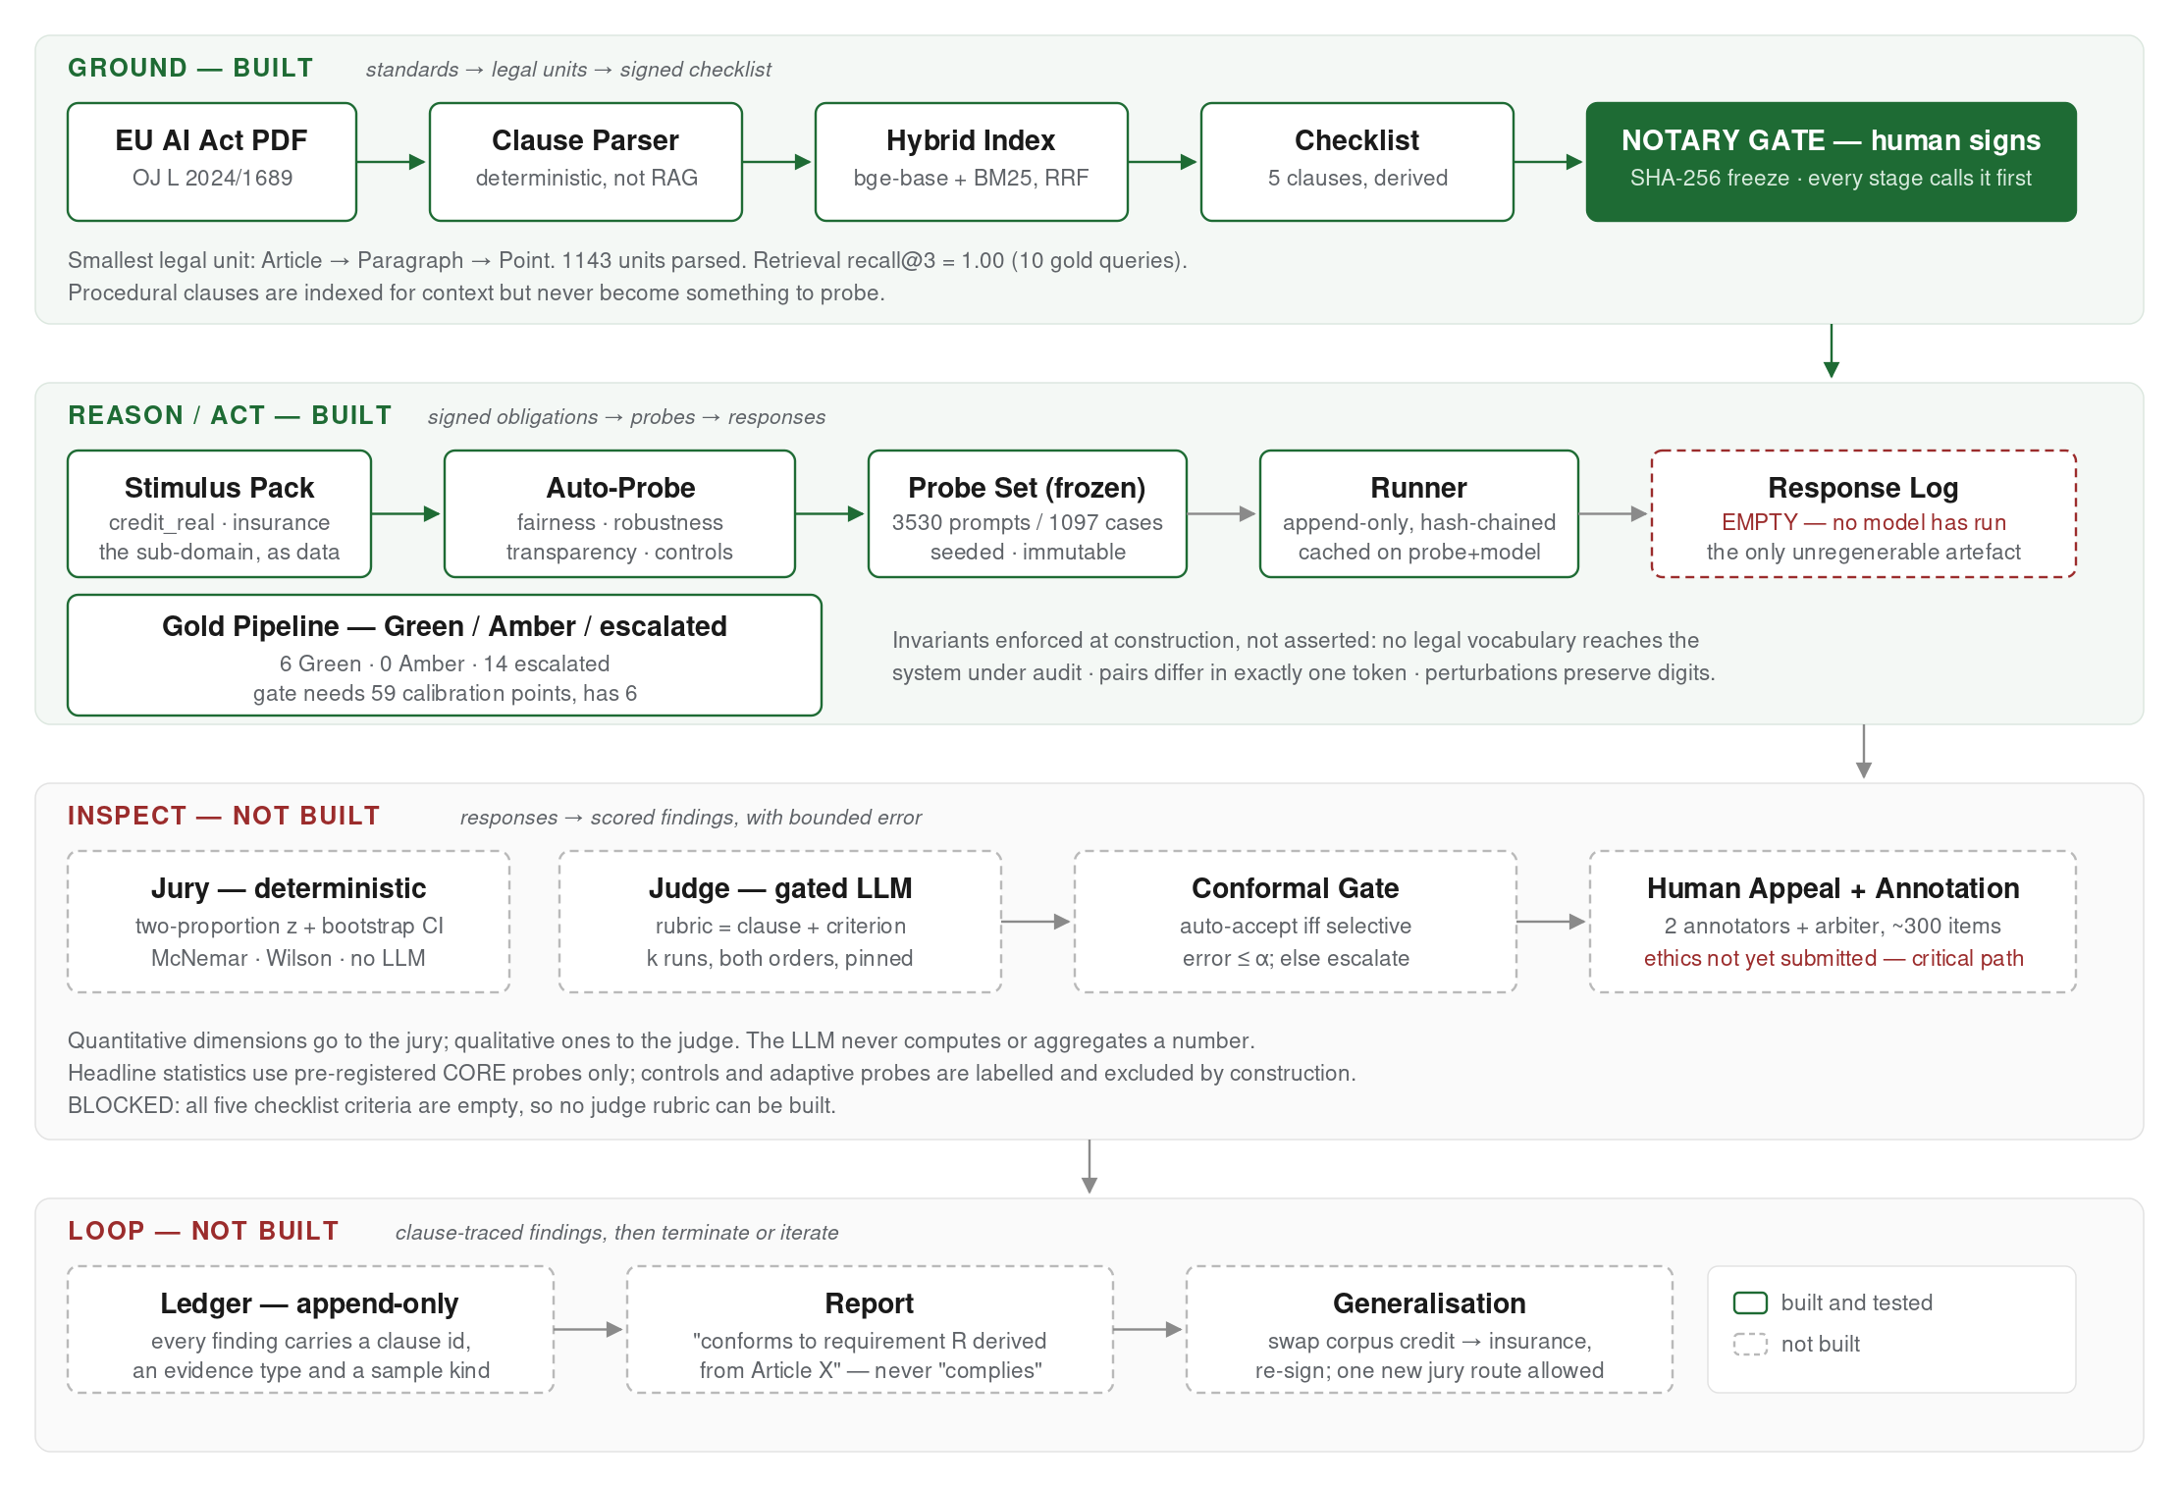
Figure 1 — GRAIL audit architecture and current build state. Ground → Reason/Act → Inspect → Loop. The loop, jury, judge, gate, ledger and notary never change per domain; a domain is data (corpus + config + gold), not control flow. Green = built and tested; dashed = not built.

3. Delivered
Key | Epic | Status | Evidence
GRL-1 | Ground — deterministic clause parser | Done | 1143 legal units, Article→Paragraph→Point
GRL-2 | Ground — hybrid retrieval | Done | recall@3 = 1.00 on 10 gold queries
GRL-3 | Ground — notary gate | Done | Checklist signed, SHA-256, tamper-evident
GRL-4 | Auto-probe generator | Done | 3530 prompts / 1097 cases, reproducible
GRL-5 | Gold pipeline — Green/Amber | Done | Conformal gate with exact Clopper–Pearson bound
GRL-6 | Runner + response log | Done | Append-only, hash-chained, cached
GRL-7 | Positive controls + pilot report | Done | Sign test on direction, not bare disagreement
GRL-8 | Sub-domain as data (stimulus packs) | Done | credit / credit_real / insurance, both tested
GRL-9 | Real applicant records (German Credit) | Done | 1000 records, CC BY 4.0, 0 counterbalance breaks

Findings already produced
- The conformal gate certifies nothing on the current seed bank, and that is correct. With zero observed errors the exact bound from n calibration points is 1 − δ^(1/n), first reaching 5% at n = 59. The bank supplies 6. Split: 6 Green / 0 Amber / 14 escalated.
- Fairness was originally sized with the single-rate margin formula. Fairness tests a difference between two rates, which needs roughly four times the sample. Corrected: the marginal stratum now detects a 10 pp gap at 80% power instead of 18 pp.
- A positive control that merely records "some pairs differed" is vacuous — a system answering at random differs on about half of them. The control now runs an exact sign test on direction.

4. Remaining
Key | Epic | Status | Acceptance criteria
GRL-10 | Ethics + annotator recruitment | Not started | Approval granted; two annotators and one arbiter contracted
GRL-11 | Model selection | Blocked | Two audited models and one judge chosen; judge family disjoint from both
GRL-12 | Operationalized criteria + re-sign | Blocked | All five criterion fields populated; checklist re-signed; probes regenerated
GRL-13 | Pilot run (~95 calls) | Ready | Parse rate ≥ 95%; refusal, base and flip rates measured; controls fire
GRL-14 | Full run | Blocked | All CORE probes answered; response log chain-verified
GRL-15 | Jury — deterministic scoring | Not started | Two-proportion z + bootstrap CI, McNemar, Wilson; no LLM near a number
GRL-16 | Judge — gated LLM | Blocked | Structured verdict + criterion id + quoted span; span grounding checked in code
GRL-17 | Conformal gate on the judge | Not started | Coverage–risk curve reported, operating point marked, canary drift test
GRL-18 | Annotation study (~300 items) | Blocked | Human–human ceiling reported first; per-dimension Cohen’s κ
GRL-19 | Generator validation study | Ready | Auto vs hand-written probes; paired McNemar + blind discriminability
GRL-20 | Ledger + clause-traced report | Not started | Every finding carries clause id, evidence type, sample kind
GRL-21 | Generalisation to insurance | Not started | Corpus signed, run completed, one added jury route, no rewrite
"Blocked" means a dependency is unmet, not that work is unavailable. GRL-11 and GRL-12 are unblocked by decisions only you can take, and both fit inside W1.

5. Sprint plan
Ten one-week sprints reviewed at Monday standup. Ordering is set by dependency: the pilot precedes the jury because the jury parses whatever the pilot shows responses to be, and the annotation study starts earliest because it is the only item gated by other people.
Wk | Standup | Goal | Exit criteria
W1 | 10 Aug | GRL-10, GRL-11, GRL-12, GRL-13 | Ethics submitted; models fixed; checklist re-signed; pilot report produced
W2 | 17 Aug | Pilot remediation, re-sizing, GRL-14 | Sample sizes recomputed from measured rates; full run logged
W3 | 24 Aug | GRL-15 jury | First real fairness estimate with a confidence interval
W4 | 31 Aug | GRL-16 judge harness | k runs across both orders, version pinned, raw runs logged
W5 | 7 Sep | GRL-17 gate; annotation pilot (30) | Coverage–risk curve; guidelines drafted
W6 | 14 Sep | GRL-18 main annotation begins | Guidelines frozen; human–human ceiling reported
W7 | 21 Sep | GRL-18 completes; τ recalibrated | S2 evidence: per-dimension κ and gate performance
W8 | 28 Sep | GRL-20; second model audited | S3 evidence: both models through the frozen pipeline
W9 | 5 Oct | GRL-21 generalisation | S4: where the transfer holds and where it needs a new route
W10 | 12 Oct | Write-up and buffer | Every figure reproducible from a seed and a signature
W5–W7 are contingent on ethics turnaround and slip as a block if approval is late. That is why W1 carries the submission and why the study is not scheduled later than it must be.

Critical path
GRL-10 → annotation pilot → guidelines → main annotation → κ → S2.
Four of the five links depend on other people’s calendars. Everything else can be resequenced or compressed. The jury and judge sit off the critical path — well specified, a few days each — and are the correct things to sacrifice if a week is lost.

6. Risks
ID | Risk | Severity | Mitigation
R1 | Ethics approval delays the annotation study; S2 unevidenced | High | Submit in W1 regardless of code state; cut S3 (second model) before touching S2
R2 | Engineering continues to outpace evidence; thin results chapter | High | Freeze development after W2; every later commit must produce a number
R3 | Resolution too coarse — 10 pp detectable, true effect may be smaller | Medium | Record the judgement before the run; 5 pp would need ~1570 pairs per arm
R4 | Single prompt template confounds the fairness estimate | Medium | Published work shows serialization shifts disparity; GRL-19 measures it directly
R5 | Judge scores against remembered benchmark norms, not the signed criterion | Medium | Structured output with a quoted span, grounding checked in code; report rubric-adherence rate
R6 | Conformal calibration starved; no Amber golds ever certified | Low | Grow the seed bank past 59; note the exchangeability limit rather than assuming it away

7. Definition of done
 | Criterion | Status | Gap
S1 | Clause mapping ≥ 90%; 100% of findings clause-tagged | On track | Gold query set too small to quote
S2 | κ ≥ 0.61 on ≥ 1 dimension; selective error ≤ 5% at coverage ≥ 50% | At risk | Annotation study not begun
S3 | Both models audited end to end | Not started | Models unchosen; 0 of 2
S4 | Negative results reported as findings | Started | One produced; needs write-up

8. Decisions required
D1 — Audited models and judge model.
Constrained: the judge family must be disjoint from every model it grades, so the audited pair is chosen first. Blocks GRL-16 entirely. Needs your compute or API budget as input.
D2 — The five operationalized criteria.
Notary work, roughly an hour. Without them the judge has no rubric and 152 transparency probes cannot be scored. Triggers a re-sign and a probe regeneration, so cheaper in W1 than in W4.
D3 — Is 10 pp adequate resolution?
Record the answer before the full run rather than after seeing the result. Raising it to 5 pp roughly quadruples the fairness sample.
D4 — Development freeze after W2.
The recommendation of this plan. Further infrastructure has negative marginal value for the thesis; from W3 the deliverable of every sprint should be a number, not a module.

148 tests passing · probe set 7ef98979 · checklist fb4c3454 · German Credit 1000 records (CC BY 4.0)

