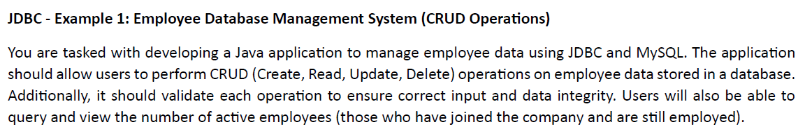

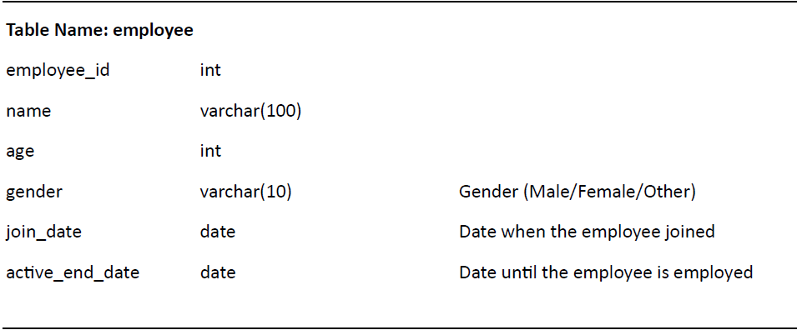

Query:

CREATE TABLE employee (

employee_id INT PRIMARY KEY,

name VARCHAR(100),

age INT,

gender VARCHAR(10),

join_date DATE,

ac􀆟ve_end_date DATE

);

INSERT INTO employee VALUES(1, 'John Smith', 30, 'Male', '2020-01-01', '2025-01-01');

INSERT INTO employee VALUES(2, 'Jane Doe', 25, 'Female', '2021-02-15', '2023-12-31');

INSERT INTO employee VALUES(3, 'Bob Brown', 40, 'Male', '2019-05-10', '2023-05-10');

INSERT INTO employee VALUES(4, 'Alice White', 50, 'Female', '2018-07-15', '2024-07-15');

INSERT INTO employee VALUES(5, 'Emily Davis', 35, 'Female', '2020-09-01', '2025-09-01');

