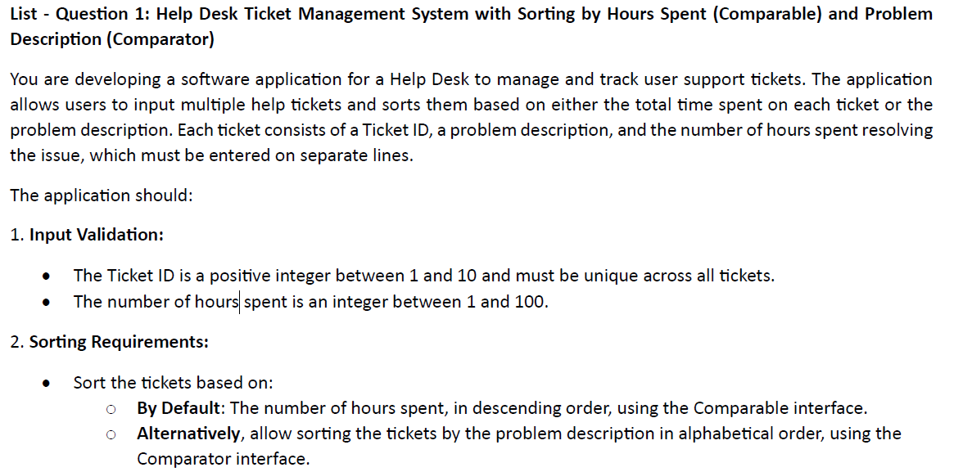

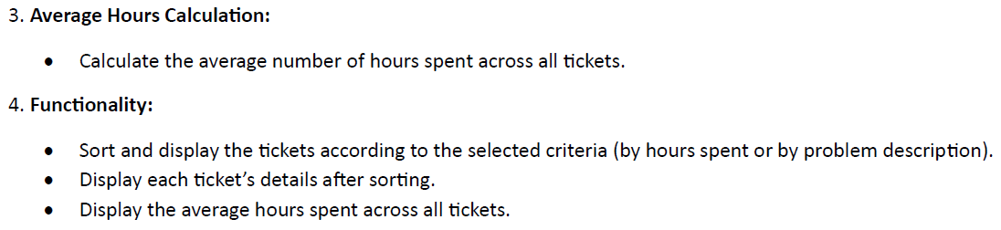

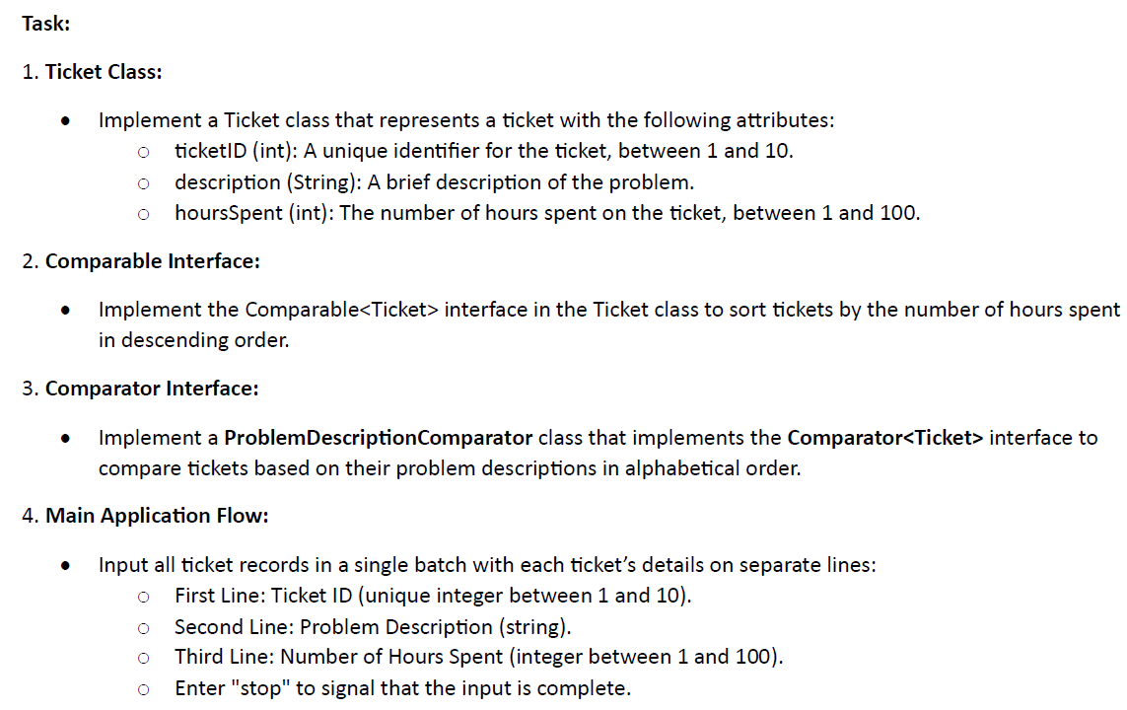

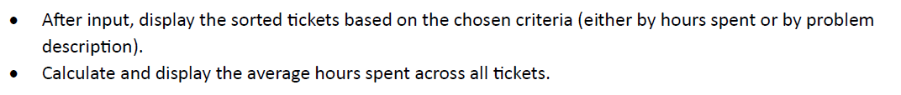

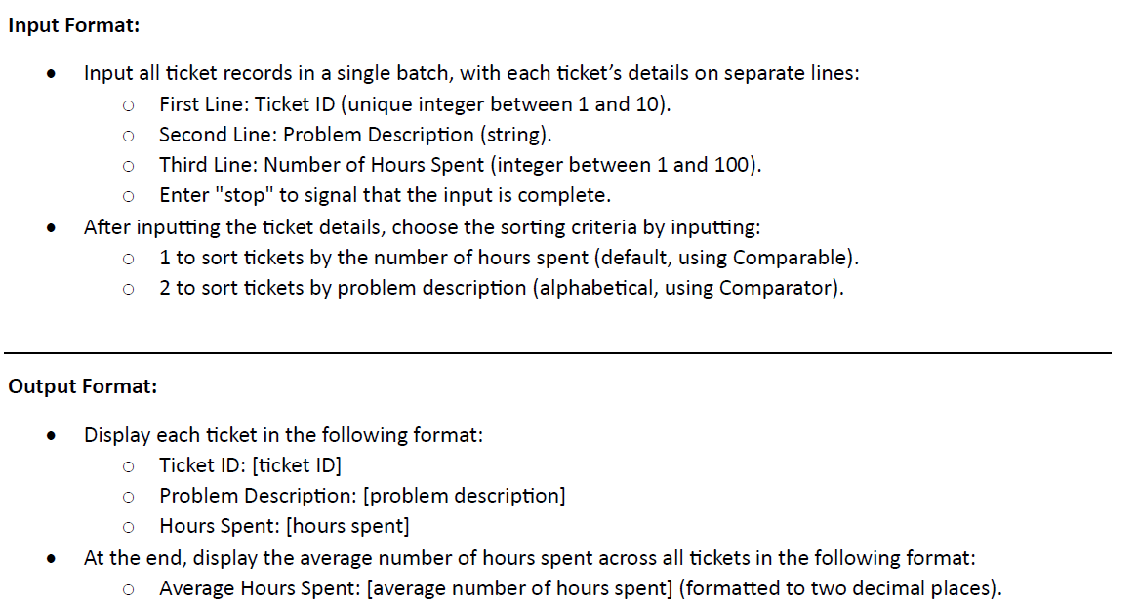

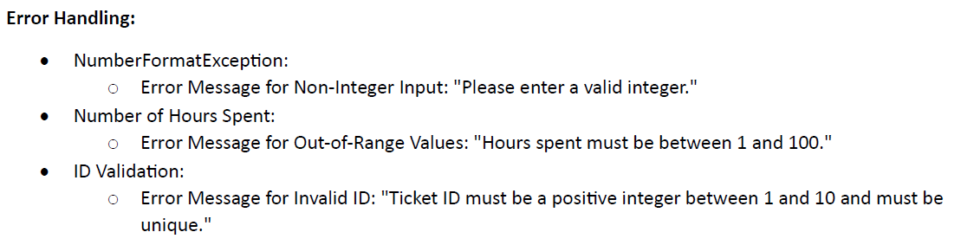

Sample Input 1:

1

So􀅌ware Installa􀆟on

10

2

Password Reset

5

3

Network Issue

20

4

System Crash

18

5

Backup Restore

15

stop

1

Sample Output 1 (Sorted by Hours Spent):

Ticket ID: 3

Problem Descrip􀆟on: Network Issue

Hours Spent: 20

Ticket ID: 4

Problem Descrip􀆟on: System Crash

Hours Spent: 18

Ticket ID: 5

Problem Descrip􀆟on: Backup Restore

Hours Spent: 15

Ticket ID: 1

Problem Descrip􀆟on: So􀅌ware Installa􀆟on

Hours Spent: 10

Ticket ID: 2

Problem Descrip􀆟on: Password Reset

Hours Spent: 5

Average Hours Spent: 13.60

Sample Input 2:

1

So􀅌ware Installa􀆟on

10

2

Password Reset

5

3

Network Issue

20

4

System Crash

18

5

Backup Restore

15

stop

2

Sample Output 2 (Sorted by Problem Descrip􀆟on):

Ticket ID: 5

Problem Descrip􀆟on: Backup Restore

Hours Spent: 15

Ticket ID: 4

Problem Descrip􀆟on: System Crash

Hours Spent: 18

Ticket ID: 3

Problem Descrip􀆟on: Network Issue

Hours Spent: 20

Ticket ID: 1

Problem Descrip􀆟on: So􀅌ware Installa􀆟on

Hours Spent: 10

Ticket ID: 2

Problem Descrip􀆟on: Password Reset

Hours Spent: 5

Average Hours Spent: 13.60

Sample Input 3 (Invalid Input):

one

Hard Drive Failure

12

2

Printer Error

7

3

System Down􀆟me

30

10

Data Corrup􀆟on

40

12

Connec􀆟on Error

25

stop

1

Sample Output 3:

Please enter a valid integer.

Ticket ID must be a posi􀆟ve integer between 1 and 10 and must be unique.

Sample Input 4 (Invalid Hour Value):

1

Account Setup

15

2

Email Setup

10

3

So􀅌ware Crash

30

5

Printer Jam

60

10

Data Loss Recovery

105

stop

1

Sample Output 4:

Hours spent must be between 1 and 100.