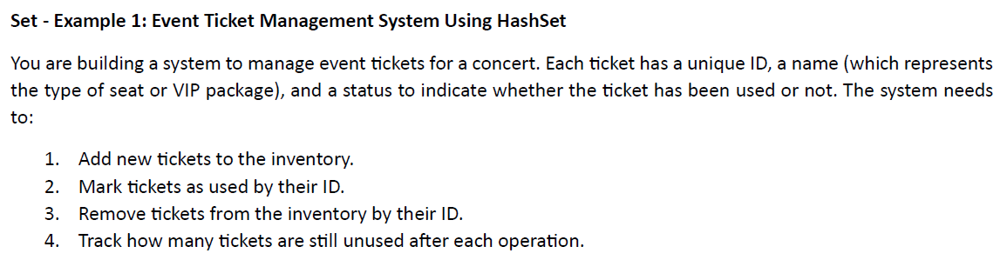

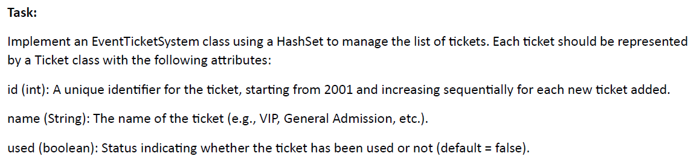

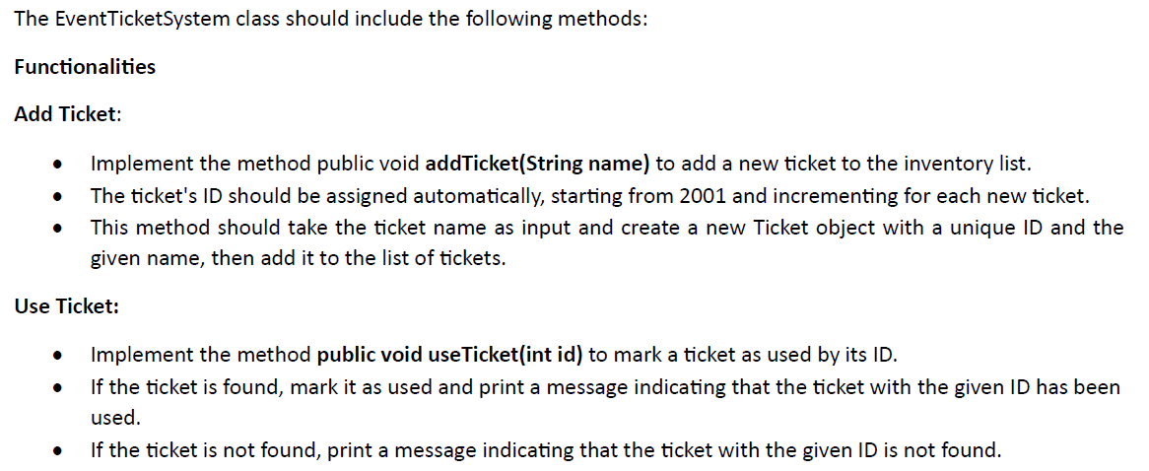

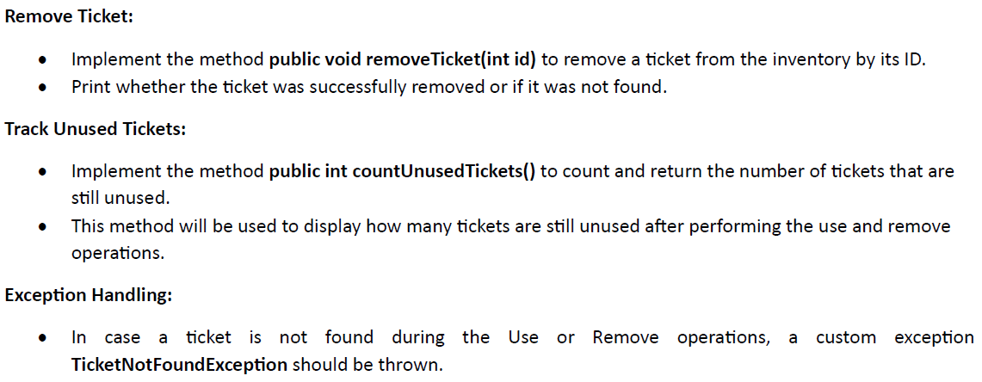

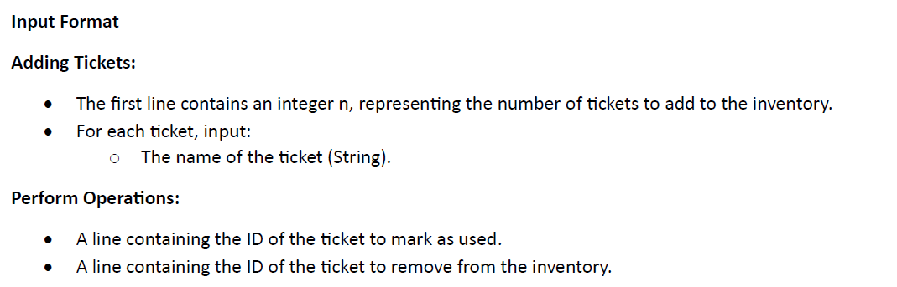

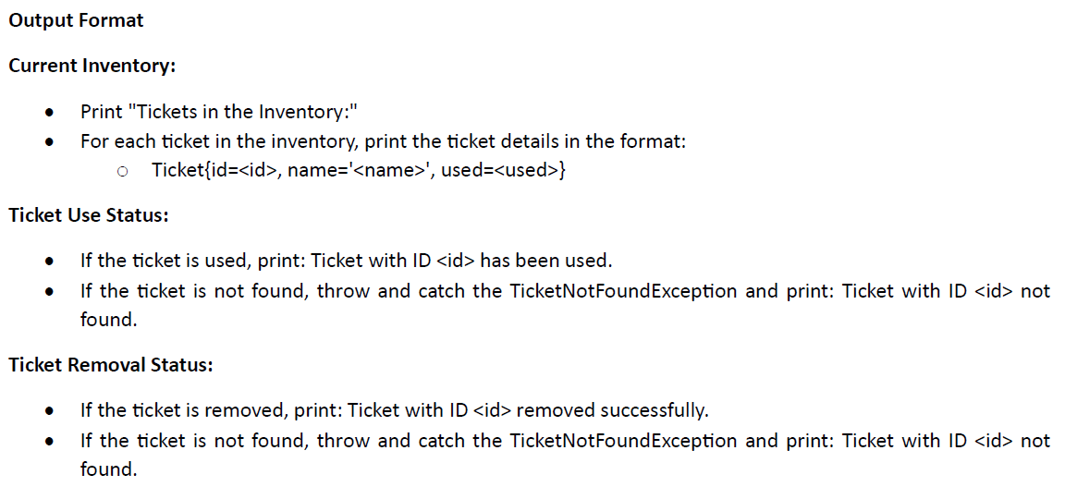

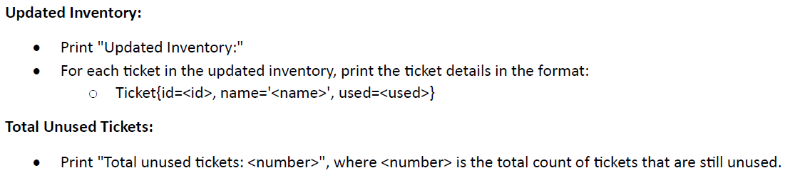

**Sample Input 1:**

3

VIP Front Row

General Admission

Backstage Pass

2002

2003

**Sample Output 1:**

Tickets in the Inventory:

Ticket{id=2001, name='VIP Front Row', used=false}

Ticket{id=2002, name='General Admission', used=false}

Ticket{id=2003, name='Backstage Pass', used=false}

Ticket with ID 2002 has been used.

Ticket with ID 2003 removed successfully.

Updated Inventory:

Ticket{id=2001, name='VIP Front Row', used=false}

Ticket{id=2002, name='General Admission', used=true}

Total unused 􀆟ckets: 1

**Sample Input 2:**

4

Regular Ticket

VIP Package

Early Bird

Group Discount

2005

2004

Sample Output 2:

Tickets in the Inventory:

Ticket{id=2001, name='Regular Ticket', used=false}

Ticket{id=2002, name='VIP Package', used=false}

Ticket{id=2003, name='Early Bird', used=false}

Ticket{id=2004, name='Group Discount', used=false}

Ticket with ID 2005 not found.

Ticket with ID 2004 not found.

Updated Inventory:

Ticket{id=2001, name='Regular Ticket', used=false}

Ticket{id=2002, name='VIP Package', used=false}

Ticket{id=2003, name='Early Bird', used=false}

Ticket{id=2004, name='Group Discount', used=false}

Total unused tickets: 4