**Problem Statement: Electricity Bill Calculator**

Create a Java program to calculate the electricity bill of a customer based on the number of units consumed. The billing rate varies according to the slab the consumed units fall into.

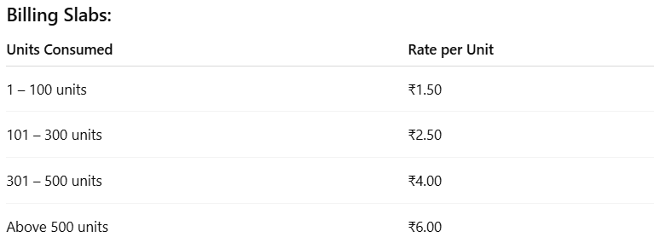

**Input Format:**

The input should be taken from the user via the console.

* 1. An integer representing **Units Consumed**

**Output Format:**

* Display the total bill amount in the following format:

**Total Bill: $<billAmount>**

**Sample Input 1:**

Enter Units Consumed:

95

**Sample Output 1:**

Total Bill: $142.50

**Sample Input 2:**

Enter Units Consumed:

320

**Sample Output 2:**

Total Bill: $1280.00

**Sample Input 3:**

Enter Units Consumed:

510

**Sample Output 3:**

Total Bill: $3060.00