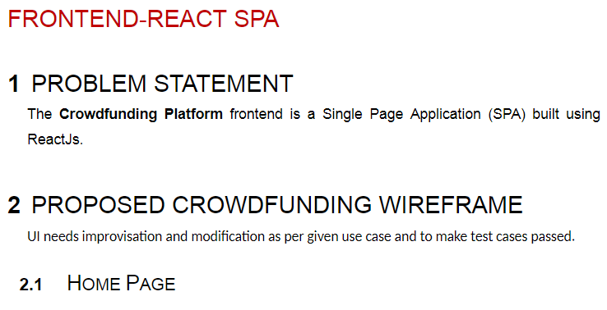

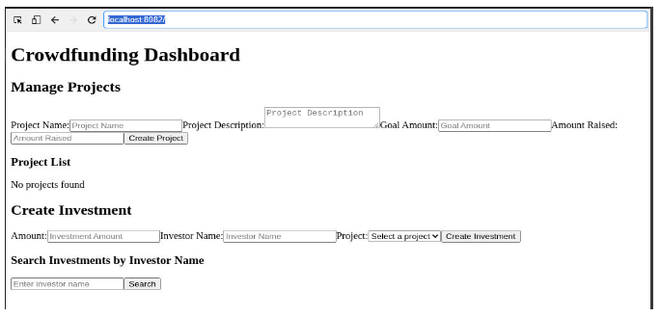

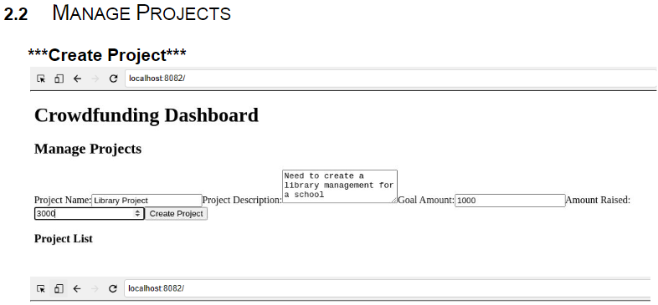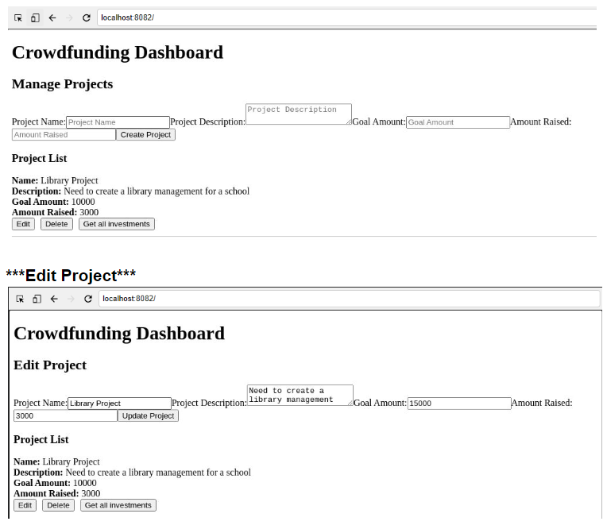

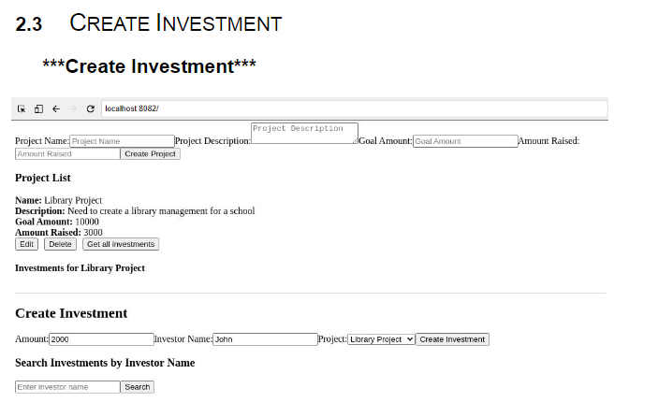

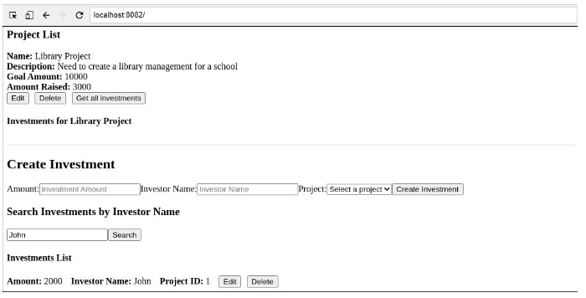

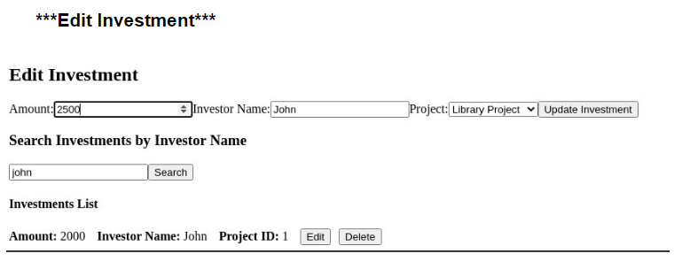

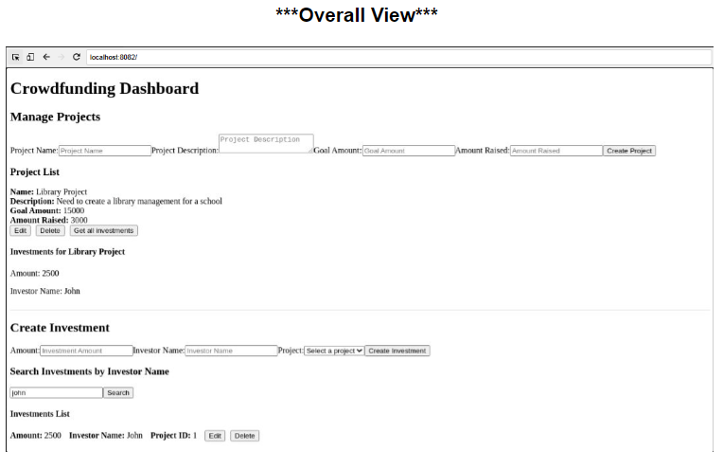

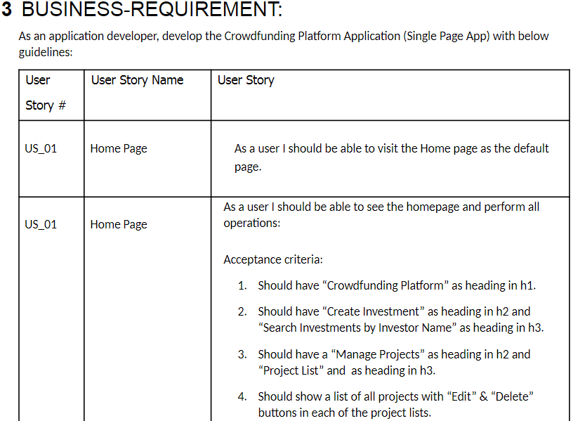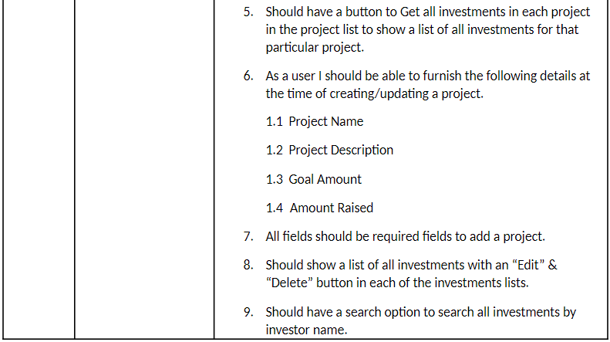

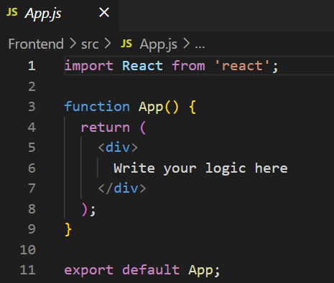

Crowfundingervice.js

const BACKEND_URL = "";

const crowdfundingService = {

    getAllProjects: async () => {

        // write your logic here

        return null

    },

    getProjectById: async (projectId) => {

        // write your logic here

        return null

    },

    createProject: async (projectData) => {

        // write your logic here

        return null

    },

    updateProject: async (projectId, projectData) => {

        // write your logic here

        return null

    },

    deleteProject: async (projectId) => {

        // write your logic here

        return null

    },

    getAllInvestmentsForProject: async (projectId) => {

        // write your logic here

        return null

    },

    getInvestmentById: async (investmentId) => {

        // write your logic here

        return null

    },

    createInvestment: async (investmentData) => {

        // write your logic here

        return null

    },

    updateInvestment: async (investmentId, investmentData) => {

        // write your logic here

        return null

    },

    deleteInvestment: async (investmentId) => {

        // write your logic here

        return null

    },

    getInvestmentsByProjectId: async (projectId) => {

        // write your logic here

        return null

    },

    getInvestmentsByInvestorName: async (investorName) => {

        // write your logic here

        return null

    },

};

export default crowdfundingService;

