IIHT

Capstone Project

Cab Booking application

# Road Map

Application will be developed in following

1. Spring Boot + Rest Controller + Spring Data JPA
2. Develop UI using ReactJS

# Problem Statement

To Create an Application for Online Cab Booking

Customer should be able to view the list of available cabs.

Customer should be able to book cab for desired location from a certain location.

Admin should be able to perform below operations:

- admin can add/update/delete/view the cabs

- admin can add/update/delete/view the driver

- admin can view and cancel the bookings

- admin can add/update/delete/view the customer

Customer should be able to perform below operations:

* Customer can register
* Customer can update their profile
* Customer can view all the available cabs
* Customer can book and cancel the booking
* Customer can view the booking history.

Customer should be able to perform below operations:

* Driver can view the booking details
* Driver can view the booking history

# Modules

Driver Management Module

User Module

Cab Management Module

Booking

Management Module

# Use case Diagram

**Participants have to create use case diagram based on problem statement**

**For your reference sample use case is added.**

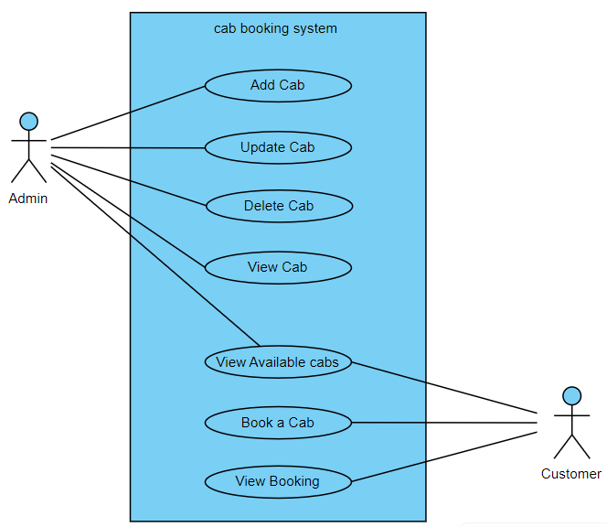

# Class Diagram

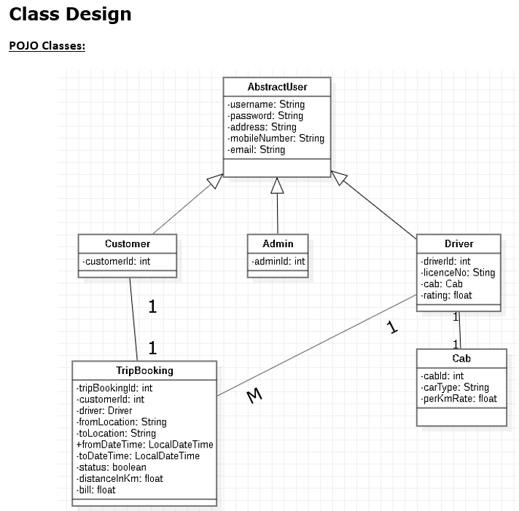

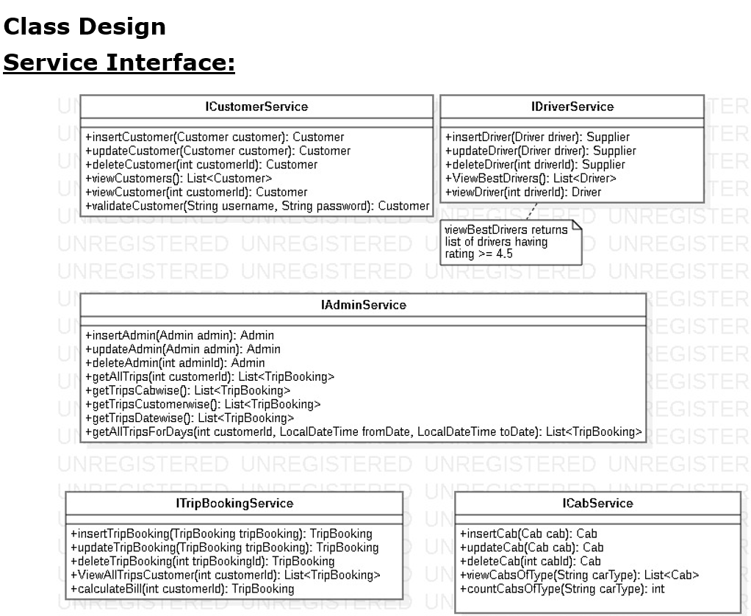

# Project Deliverables

Back End:

1. User stories based on the problem statement.
2. Use case Diagrams
3. Source code
4. Junit Testcases

Front End:

1. Create UI for the back end
2. ReactJS project Source code

Note:

You can feel free to add new features and create or update design diagrams if it is required.