IIHT

Capstone Project

Ayurveda Medicine Order App

# Road Map

Application will be developed in following

1. Spring Boot + Rest Controller + Spring Data Jpa

# Problem Statement

To Create an Application for **Ayurveda Medicine**

Customer should be able to search, buy, modify and order the medicine.

Admin should be able to perform below operations:

- view and delete customers

- add, update, delete and view medicine

- view and cancel orders

Customer should be able to perform below operations:

* register
* View available medicines
* Place order
* View and cancel order
* View order history

# Modules

User Module

Medicine Module

Order Module

# Use case Diagram

**Participants have to create use case diagram based on problem statement**

**For your reference sample use case is added.**

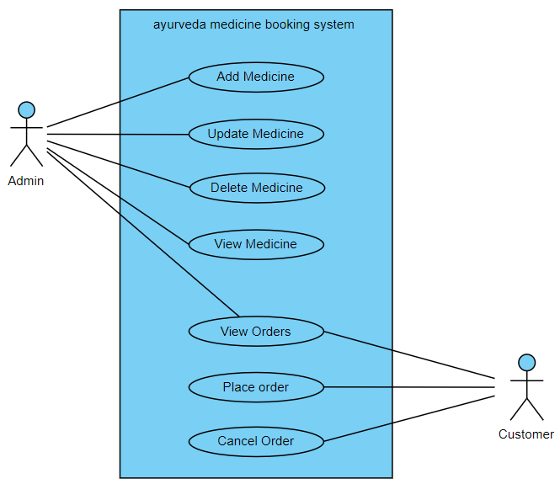

# Class Diagram

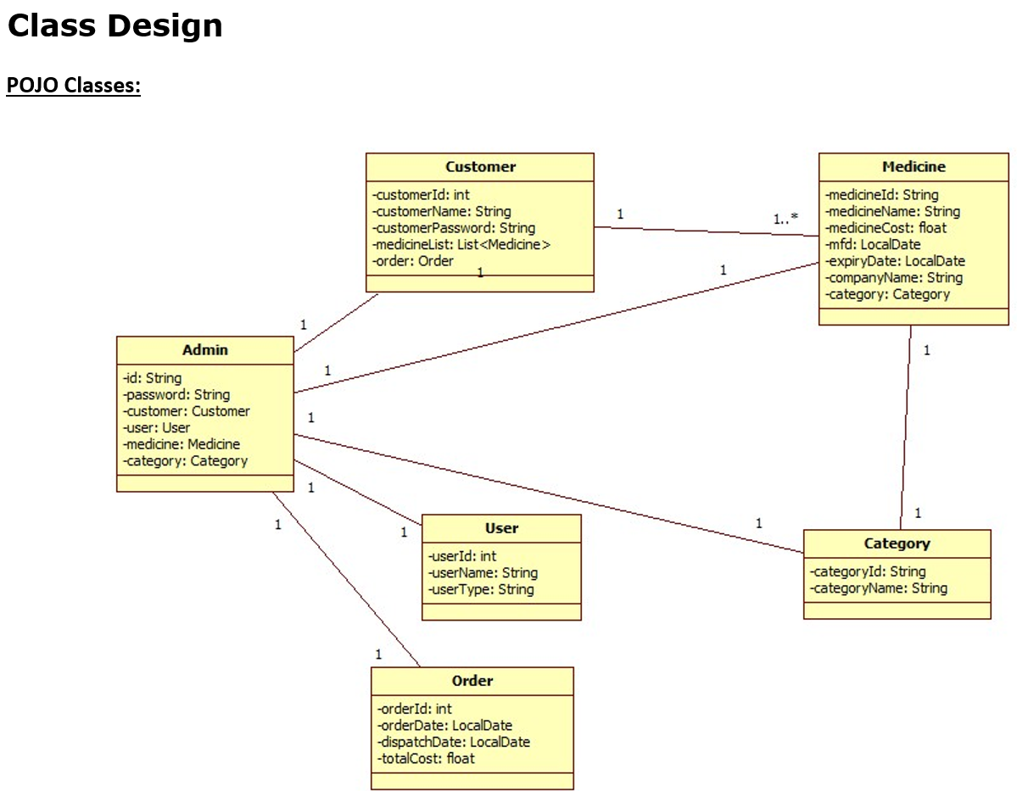

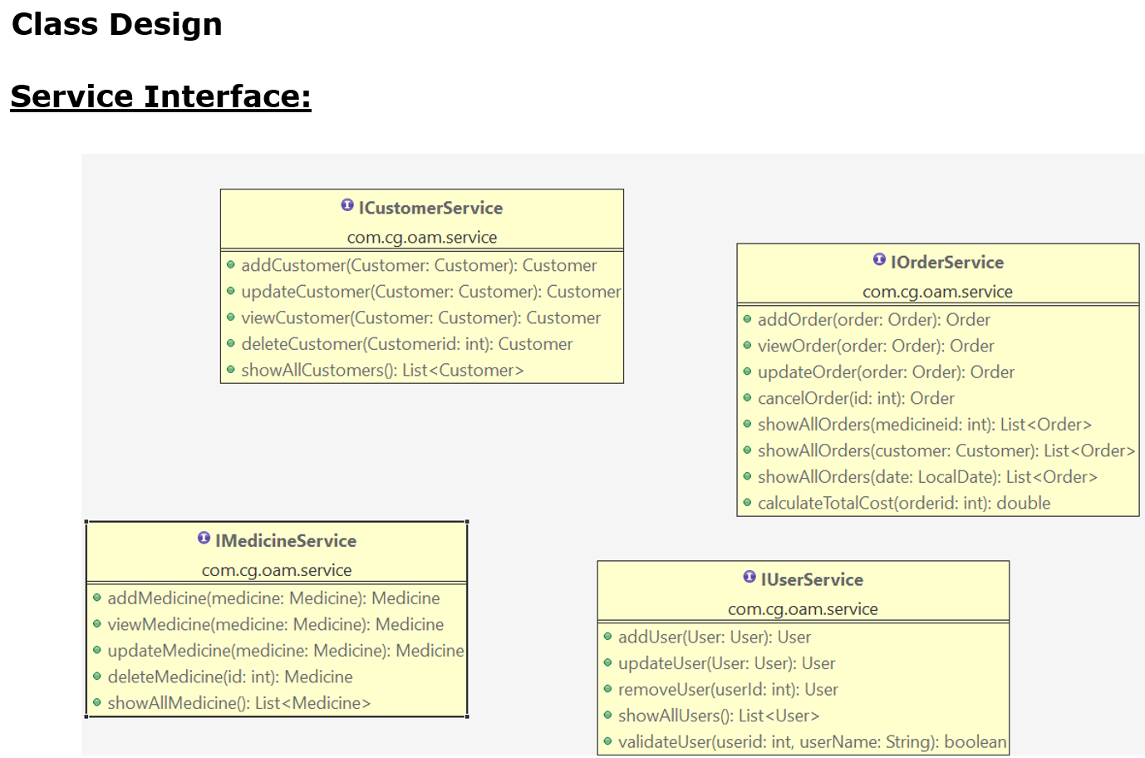

# Project Deliverables

1. User stories based on the problem statement.
2. Use case Diagrams
3. Source code
4. Junit Testcases

Note:

You can feel free to add new features and create or update design diagrams if it is required.