IIHT

Capstone Project

Flat Rental Application

# Road Map

Application will be developed in following

1. Spring Boot + Rest Controller + Spring Data Jpa

# Problem Statement

To Create an Application for **Flat Rental System**

Customer should be able to view list of flats able to book flat.

Admin should be able to perform below operations:

* + view, add and delete flats
  + view, add, block and delete tenants
  + view and cancel bookings
  + view, block and delete landlords

Landlord should be able to perform below operations:

* register
* Add and delete flats
* Accept and deny the bookings
* View tenant details

Tenant should be able to perform below operations:

* register
* View all available flats
* Request for booking
* View booking status

# Modules

Flat

Module

Flat Booking Module

Landlord Module

Tenant Module

# Use case Diagram

**Participants have to create use case diagram based on problem statement**

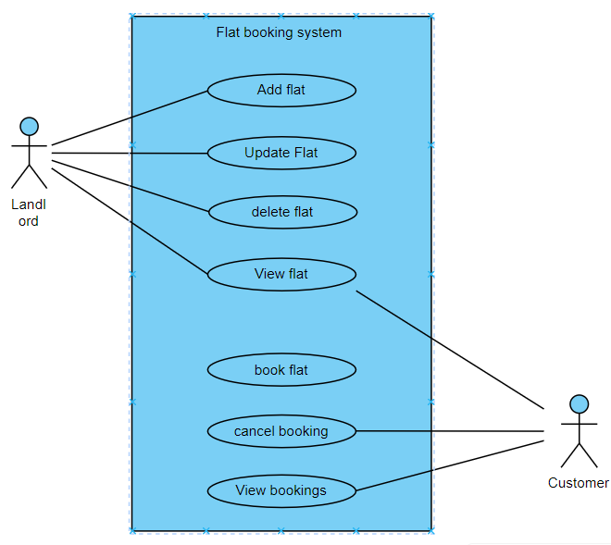

# Class Diagram

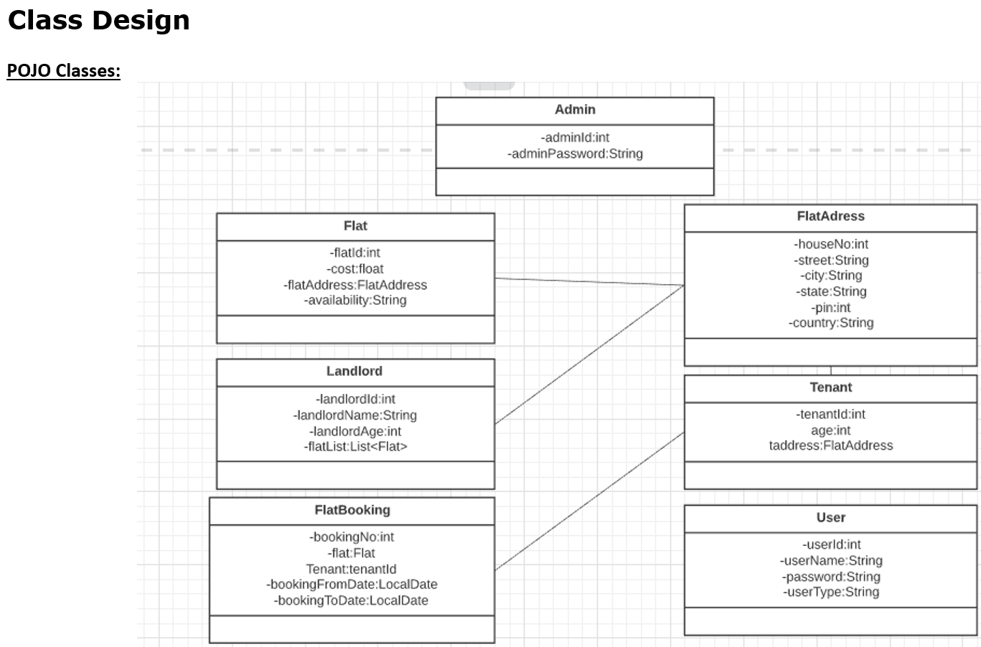

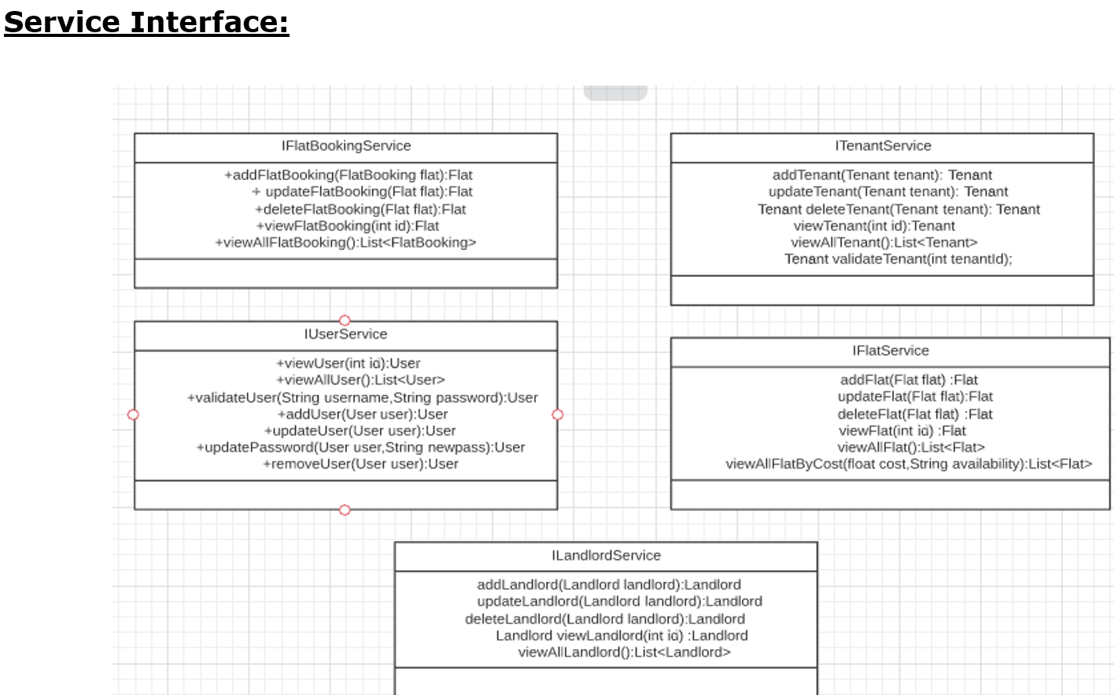

# Project Deliverables

1. User stories based on the problem statement.
2. Use case Diagrams
3. Source code
4. Junit Testcases

Note:

You can feel free to add new features and create or update design diagrams if it is required.