IIHT

Capstone Project

Hotel Booking Management

# Road Map

Application will be developed in following

1. Spring Boot + Rest Controller + Spring Data Jpa

# Problem Statement

To Create an Application for Hotel Booking Management System

Customer should be able to perform below operations:

* Customer should be able to view the list of hotels, rooms available.
* Customer should be able to book the rooms of the hotel.

Admin should be able to perform below operations:

1.Hotel Management

- add, update, delete, view hotels

2.Rooms management

- add, update, delete, view rooms

3. Payments

- accept and view the payments

# Modules

Hotel Management Module

Customer Module

Rooms Management Module

Payments

Management module

# Use case Diagram

**Participants have to create use case diagram based on problem statement**

**Sample use case diagram:**

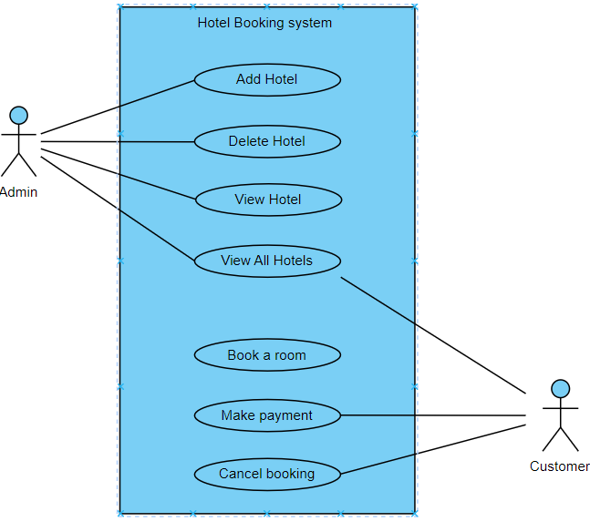

# Class Diagram

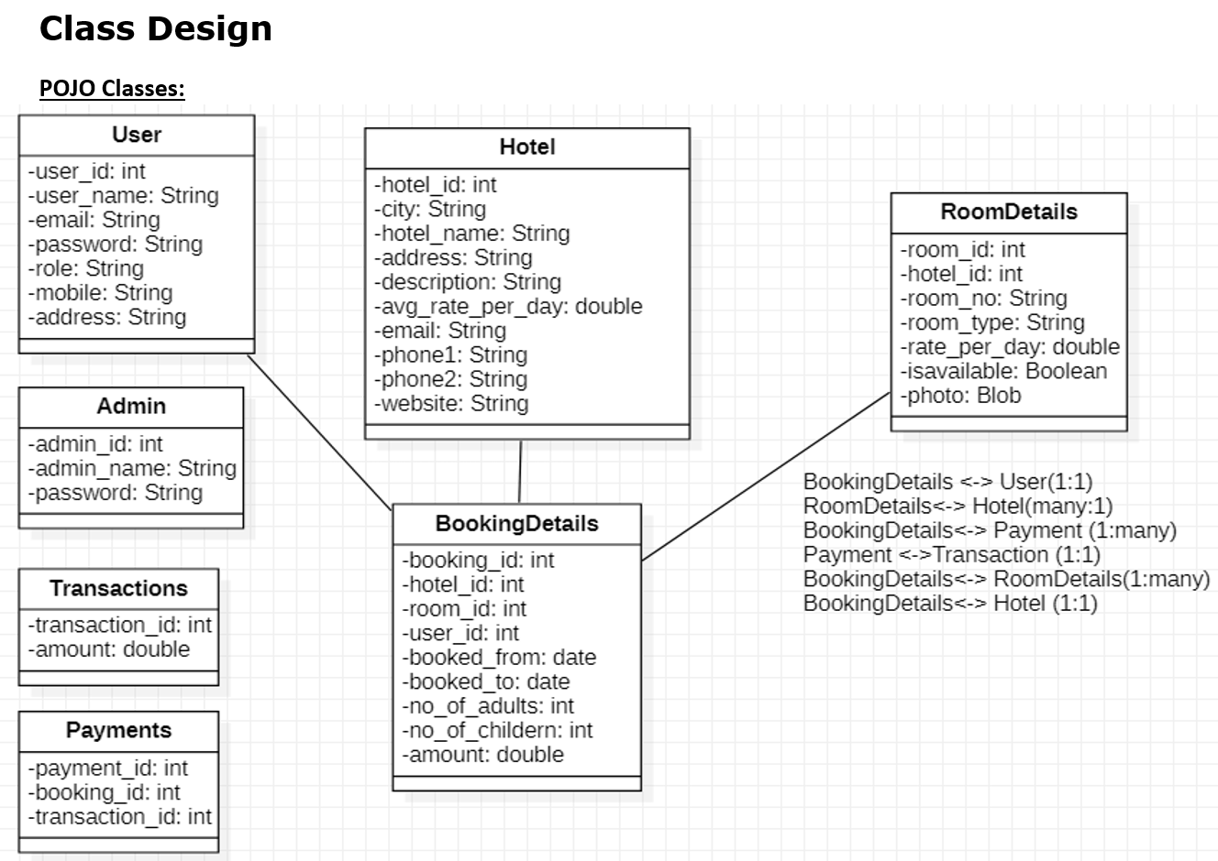

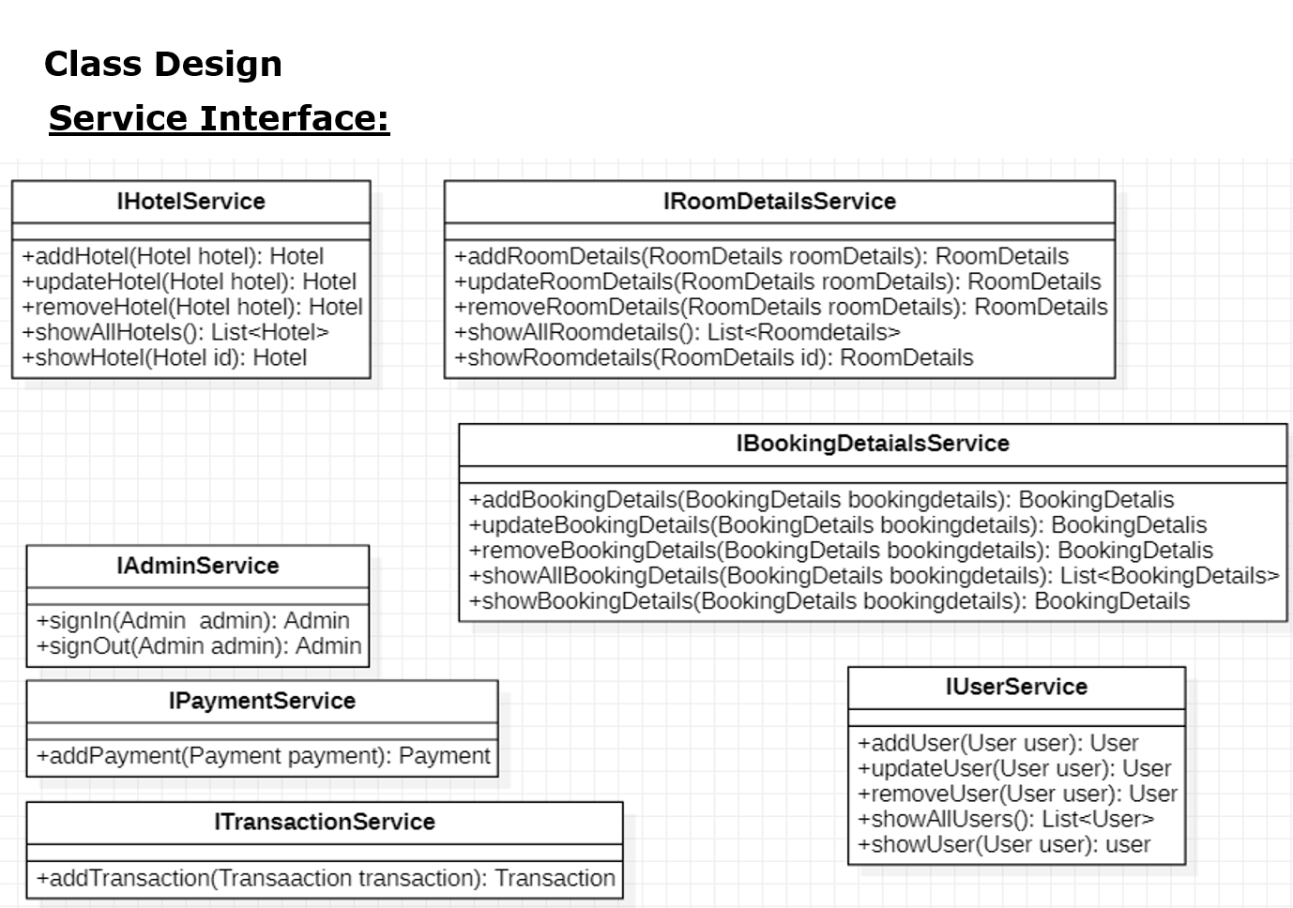

# Project Deliverables

1. User stories based on the problem statement.
2. Use case Diagrams
3. Source code
4. Junit Testcases

Note:

You can feel free to add new features and create or update design diagrams if it is required.