IIHT

Capstone Project

Mobile Store App

# Road Map

Application will be developed in following

1. Spring Boot + Rest Controller + Spring Data JPA

# Problem Statement

To Create an Application for **Mobile Store Application**

**Customer** should be able to perform below operations:

* Customer can search mobiles
* Customer can add mobiles to cart, view cart and update the cart
* Customer can buy the mobiles
* Customer can view order histroy

Admin should be able to perform below operations:

* Add, view, update and delete mobiles
* View and cancel orders
* View and delete customers

# Modules

Cart Module

Mobile Module

Order Module

# Use case Diagram

**Participants have to create use case diagram based on problem statement**

**Sample use case diagram:**

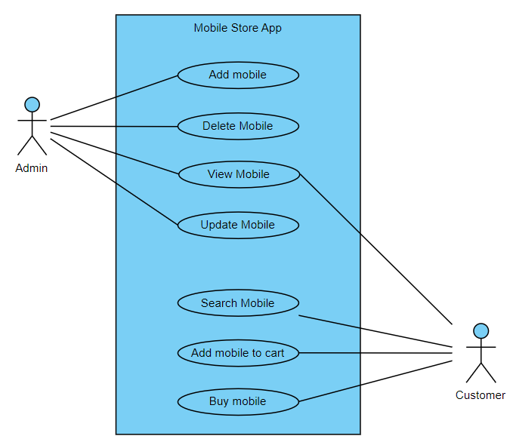

# Class Diagram

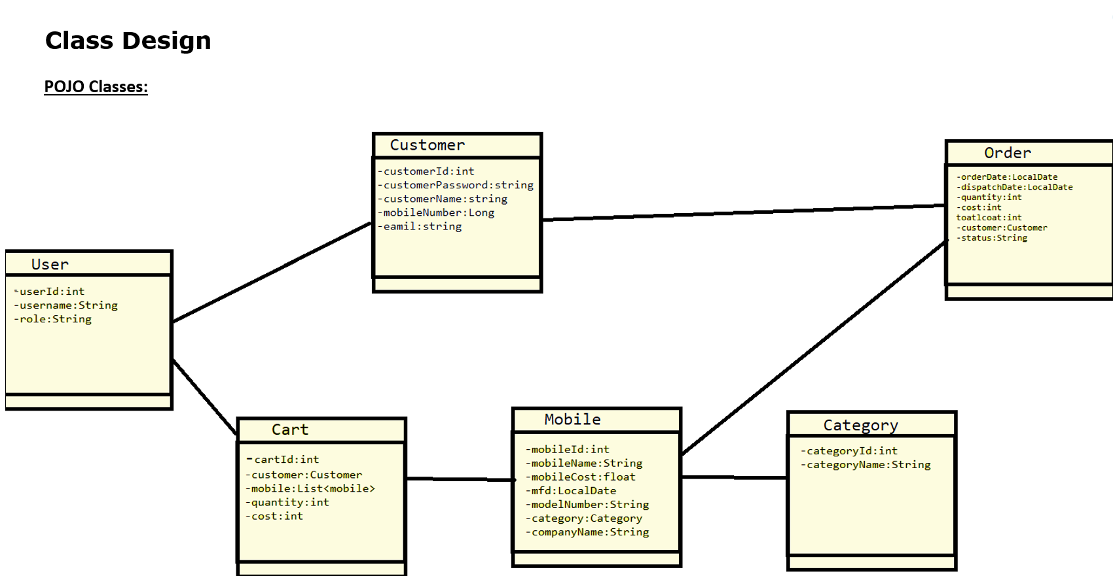

# Project Deliverables

1. User stories based on the problem statement.
2. Use case Diagrams
3. Source code
4. Junit Testcases

**Note:**

You can feel free to add new features and create or update design diagrams if it is required.