PERCENTILE REPORT

Percentile tells about the value exist within the range. Dividing whole dataset into five parts 25th, 50th,75th,99th,100th in terms of percentage.

REPORT

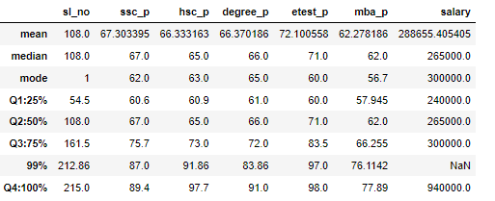

SSLC_P

Percentile of SSLC_P whole dataset in 25% data 60.6% students have got pass mark , and 50% data 67% students have got pass mark, and between data gap is 25%, so pass increase value only 6.4%. and 75% data 75.5% students have got pass mark, the different between (75%-50% data) 25% of the data so increase value only8.7%. and 99% data 87% students have got pass mark, the different between (99%-75% data) 24% of the data so increase value only 12.7%. and 100% data 89.4% students have got pass mark, the different between (100%-99% data) 1% of the data so increase value 2.4%.

HSC_P

Percentile of HSC_P whole dataset in 25% data 60.9% students have got pass mark , and 50% data 65% students have got pass mark, and between data gap is 25%, so pass increase value only 4.1%. and 75% data 73% students have got pass mark, the different between (75%-50% data) 25% of the data so increase value only 8%. and 99% data 91.86% students have got pass mark, the different between (99%-75% data) 24% of the data so increase value only 18.86%. and 100% data 97.7% students have got pass mark, the different between (100%-99% data) 1% of the data so increase value 5.84%.

DEGREE_P

Percentile of DEGREE_P whole dataset in 25% data 61% students have got pass mark , and 50% data 66% students have got pass mark, and between data gap is 25%, so pass increase value only 5%. and 75% data 72% students have got pass mark, the different between (75%-50% data) 25% of the data so increase value only 6%. and 99% data 83.86% students have got pass mark, the different between (99%-75% data) 24% of the data so increase value only 11.86%. and 100% data 91% students have got pass mark, the different between (100% -99% data) 1% of the data so increase value 7.14%.

ETEST_P

Percentile of ETEST_P whole dataset in 25% data 60% students have got pass mark , and 50% data 71% students have got pass mark, and between data gap is 25%, so pass increase value only 11%. and 75% data 83.5% students have got pass mark, the different between (75% -50% data) 25% of the data so increase value only 12.5%. and 99% data 97% students have got pass mark, the different between (99% -75% data) 24% of the data so increase value only 13.5%. and 100% data 98% students have got pass mark, the different between (100% -99% data) 1% of the data so increase value 1%.

MBA_P

Percentile of MBAS_P whole dataset in 25% data 57.94% students have got pass mark , and 50% data 62% students have got pass mark, and between data gap is 25%, so pass increase value only 4.06%. and 75% data 66.25% students have got pass mark, the different between (75% -50% data) 25% of the data so increase value only 4.25%. and 99% data 76.11% students have got pass mark, the different between (99% -75% data) 24% of the data so increase value only 9.855%. and 100% data 77.89% students have got pass mark, the different between (100% -99% data) 1% of the data so increase value 1.78%.

SALARY

Percentile of SALARY whole dataset in 25% students got salary P.N 2,40,000 and 50% of the students got salary P.N Rs.2,65,000,and between data gap 25%, so salary increase Rs 25,000. 75% of the students got salary P.N Rs.3,00,000 and between data gap(75%-50%) 25%, so salary increace Rs. 35,000. 100% of the students got salary P.N Rs.9,40,000, and between data gap (100%-75) 25%,so salary increase 6,40,000.