**Proposal to decrease overlapping on snow removal truck routes**

**Goal**

The goal of our group is to find out an optimal way for snow removal in the City of Syracuse, which utilizes the minimum plowing trucks to remove the snow in a certain area range at a given temperature with snow precipitation. Reducing the cost and increasing the plowing efficiency is our target on this project.

**Dataset**

Based on the information we found on the Syracuse Open Data, datasets are dropped in year of March, 2017 and January, 2018.we choose the 2018 dataset as our research data, since it is less likely to have lower temperature in March. Besides the consideration of weather, snow precipitation is our major reference on choosing the final dataset. As showed in figure-1, 4th of January in 2018 had the most snow precipitation(no dataset for 5th of January), which means plowing trucks were busy at that day.

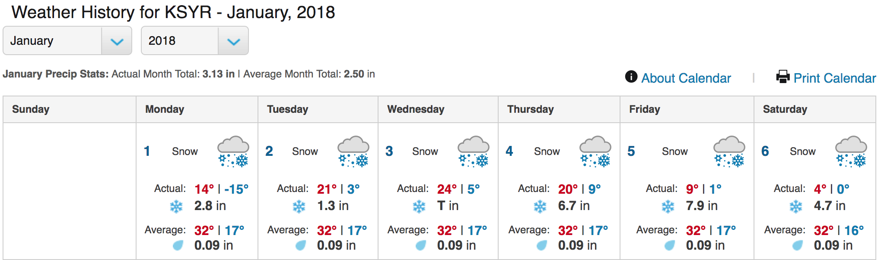

Figure - 1

We choose to keep all data in the current dataset, because we want to see how long did the plowing trucks work on snow removal.

**Analysis tool**

The major analysis tool we use is R with its data visualization package to plot the data.

**Findings**

As seen from figure – 2, trucks’ movement routes overlapped in some areas while some fields had never been plowed during the 4th of January.

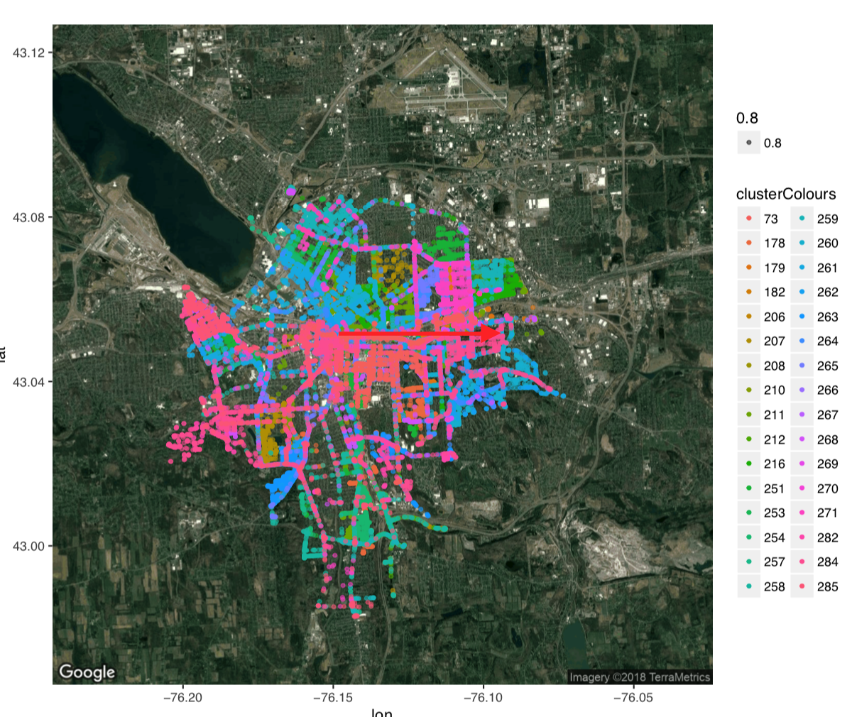

Figure - 2

Resource:

<https://www.wunderground.com/history/airport/KSYR/2018/1/4/DailyHistory.html>