COMPLAINT MANAGEMENT SYSTEM
A Web-Based Grievance Redressal Platform for Students & Admins
Prepared in the partial fulfillment of the Summer Internship Program on AWS

AT


Under the guidance of

Mrs. Sumana Bethala, APSSDC Mr. J LovaBabu, APSSDC Submitted by
BODANAPU BHAVYASREE,23BQ1A05P0,VVITU,(Batch-54)

VAJRALA ANUSHA,23BQ1A05N2,VVITU,(Batch-54)

THAMISETTY PRASANNA LAKSHMI,23BQ1A05M3,VVITU,(Batch-54)

YAMANURI SHANUMUKHA PRIYA,23BQ1A05O4,VVITU,(Batch-54)

ACKNOWLEDGEMENT

I would like to express my heartfelt gratitude to all those who have contributed to the successful completion of my summer internship project at Andhra Pradesh Skill Development Corporation (APSSDC). This opportunity has been an enriching and transformative experience for me, and I am truly thankful for the support, guidance, and encouragement I have received along the way.
First and foremost, I extend my sincere regards to Mrs Sumana Bethala and Mr J Lovababu, my supervisors and mentors, for providing me with valuable insights, constant guidance, and unwavering support throughout the duration of the internship. Their expertise and encouragement have been instrumental in shaping the direction of this project.
I would like to thank the entire team at Andhra Pradesh Skill Development Corporation (APSSDC) for fostering a collaborative and innovative environment. The camaraderie, knowledge sharing, and feedback I received from my colleagues significantly contributed to the development and success of this project.
In conclusion, I am honoured to have been a part of this internship program, and I look forward to leveraging the skills and knowledge gained to contribute positively to future endeavours.
Thank you. Sincerely,
BODANAPU BHAVYA SREE, 23BQ1A05P0,
VAJRALA ANUSHA, 23BQ1A05N2
THAMISETTY PRASANNA LAKSHMI, 23BQ1A05M3
YAMANURI SHANUMUKHA PRIYA, 23BQ1A05O4,

ABSTRACT

This project presents the design and implementation of the Complaint Management System (CMS), a full-stack web-based grievance redressal platform that gives every student a single place to raise campus complaints and every admin a single place to resolve them. Traditional complaint handling on campuses relies on paper-based forms or word-of-mouth reporting, which is slow to log, easy to lose, and hard to follow up on. Students have no central place to check the status of a raised issue, and facility, hostel, and academic staff have zero visibility into complaint volume, priority, or category. Existing informal channels also expose the complainant's identity, which discourages honest reporting. CMS addresses all four of these gaps through a secure, role-based, and privacy-aware web application.
Students log in using a college-issued ID, and on first login are required to set a new password before continuing, ensuring that no account is left on a shared default credential. A complaint is raised by selecting from 15 categories and 4 priority levels (Low, Medium, High, Critical), along with a location and description. Every complaint then moves through three tracked stages — Pending, In Progress, and Resolved — visible to the student in real time. Admins are given a live dashboard summarizing complaint volume and status, and can update any complaint's status from a filterable list. Crucially, the student's identity is withheld from the admin's complaint view; only the category, location, priority, and status are shown, which protects the complainant while still giving staff everything they need to act.
The system is built on a Node.js and Express.js backend exposing a REST API, with MongoDB Atlas (via Mongoose) used for cloud data storage of users and complaints. Passwords are hashed with bcrypt, and role-based access control separates student and admin capabilities at every endpoint. The frontend, built with HTML, CSS, and JavaScript, is served as separate student and admin portals and is deployed via GitHub Pages, while the backend API is hosted on Railway/Render. The project demonstrates how a lightweight, privacy-by-design architecture can replace informal complaint handling with a trackable, transparent, and secure digital workflow, while leaving a clear path toward future enhancements such as mobile app integration, automated notifications, analytics dashboards, smart complaint assignment, feedback and ratings, and multi-campus support.

TABLE OF CONTENTS

S.No Content Pg.No
- INTRODUCTION 5
- METHODOLOGY 6
- TECHNOLOGY STACK 9
- SYSTEM DESIGN / ARCHITECTURE 11
- IMPLEMENTATION 23
- RESULTS 26
- CONCLUSION 29

INTRODUCTION
In any campus environment, students routinely encounter issues that need to be reported to the administration — facility breakdowns, hostel maintenance, academic grievances, and more. Traditionally, these complaints are handled through paper-based forms or informal, word-of-mouth reporting to staff. This approach is slow, easy to lose track of, and offers no way for a student to check what stage their complaint has reached. This project, titled Complaint Management System (CMS): A Web-Based Grievance Redressal Platform for Students & Admins, replaces this informal process with a secure, trackable, and privacy-conscious digital workflow.
The core problem CMS solves has four dimensions. First, manual complaint logging is slow and complaints are easily lost or forgotten once submitted verbally or on paper. Second, there is no central tracking system, so a student who raises an issue has no single place to check what stage it is at. Third, facility, hostel, and academic staff have zero visibility into overall complaint volume, category breakdown, or priority — they can only see what is reported directly to them. Fourth, existing informal channels expose the complainant's identity to whoever is handling the complaint, which discourages students from reporting sensitive issues honestly.
CMS is designed as a full-stack web application with two distinct portals — one for students and one for admins — built on a Node.js and Express.js backend with MongoDB Atlas as the data store. Students authenticate using a college-issued ID and, on their very first login, are forced to set a new password before they can access anything else, ensuring accounts are never left on a default or shared credential. Once authenticated, a student can raise a complaint by selecting from 15 predefined categories and 4 priority levels, adding a location and a free-text description. Every complaint then progresses through three tracked stages — Pending, In Progress, and Resolved — and the student can check this status at any time.
On the admin side, a live dashboard aggregates complaint counts by status, giving staff at-a-glance visibility that was previously unavailable. Admins can filter the complaint list and update the status of any complaint as it is worked on. To protect complainants, the admin's view of a complaint deliberately excludes the student's name and ID — only the category, location, priority, status, and date are shown — so staff have enough information to act without knowing who filed the report, encouraging more honest and complete reporting.
This report presents a comprehensive overview of the CMS system, including its methodology, technology stack, system architecture, implementation details, security and privacy design, and results, followed by a discussion of future enhancements such as mobile app integration, automated notifications, analytics, smart complaint assignment, feedback and ratings, and multi-campus support.
By delivering a scalable, event-driven, and fully serverless e-commerce platform, CloudCart demonstrates the practical application of modern cloud computing technologies in addressing real-world business challenges. The project showcases how AWS serverless services can be effectively utilized to build intelligent, highly available, and cost-efficient online shopping solutions that meet the growing demands of digital commerce while providing a strong .

2.METHODOLOGY

The development of the Complaint Management System (CMS) follows a modular, API-driven methodology built on the Node.js and Express.js runtime, with MongoDB Atlas as the managed cloud database. The system is designed to provide a secure, role-aware, and privacy-conscious grievance redressal platform by separating concerns cleanly across the client, API, and data layers. Instead of a single monolithic page handling every feature, the application is split into two independent portals — student and admin — that share one backend, allowing each portal's interface and permissions to evolve independently while the underlying business logic and data remain centralized. This approach minimizes duplicated logic, keeps the codebase easy to reason about, and ensures that privacy rules are enforced in exactly one place — the API layer — rather than trusted to the frontend.

The implementation process begins with the two static frontends — the Student Portal and the Admin Portal — built using HTML, CSS, and JavaScript. Each portal is deployed independently as a static site on GitHub Pages, and both communicate with the same backend over HTTP/JSON with CORS explicitly enabled, since the frontend and API are served from different origins. Keeping the frontend static and framework-free was a deliberate choice: it keeps hosting free and simple, and keeps all sensitive logic — password hashing, role checks, and data filtering — on the server, where it cannot be bypassed by a user inspecting client-side code.

User authentication is implemented directly in the backend using bcrypt for password hashing rather than relying on a third-party identity provider. Every user record carries a role field (student or admin) and a firstLogin flag. On registration, a student's password is hashed before storage; on every login attempt, the submitted password is checked against the stored hash rather than compared as plaintext. If firstLogin is still true, the login response signals the client to redirect to a mandatory password-change screen before any dashboard route becomes accessible, ensuring that no account is ever used past its initial setup on a default or shared credential.
The frontend communicates with the backend through a small set of Express.js REST routes, which act as the single entry point for every client request. These routes validate incoming data, delegate business logic to dedicated controllers, and return JSON responses shaped specifically for the caller's role — most importantly, the admin-facing complaint responses are built to omit the student's identity fields entirely, rather than returning the full record and trusting the frontend to hide them.
The application logic is implemented across two controllers. userController.js handles registration, login, and the forced password change, including all bcrypt hashing and comparison calls. complaintController.js handles complaint creation, retrieval (both the admin's full list and a student's own history), and status updates, and is also where the privacy filtering on the admin response is enforced. Keeping this logic in controllers rather than directly in route handlers keeps the routing layer thin and makes the business rules easy to test in isolation.

All application data is stored in MongoDB Atlas, a fully managed, cloud-hosted NoSQL database, accessed through Mongoose object models that define and validate the shape of every document before it is written. Two collections — users and complaints — hold all persistent data. Mongoose's schema validation ensures that a complaint can never be saved without a category, priority, and status, and that a user record always carries a role and a firstLogin flag, catching malformed data before it ever reaches the database.
Security is enforced through role-based checks applied at the controller level: every complaint-management route inspects the authenticated user's role before allowing access, so a student session can never reach an admin-only update route, and vice versa. Combined with bcrypt password hashing and server-side input validation on every endpoint, this gives the system defense at both the authentication layer and the authorization layer.

The overall workflow begins when a student or admin opens their respective portal, hosted on GitHub Pages. A student registers or logs in; on first login they are forced through a password reset before reaching their dashboard. Once authenticated, a student raises a complaint by choosing a category, a priority level, a location, and a description, which is sent via POST /complaint to the Express API, validated, and stored in MongoDB Atlas through the Complaint model. The student can then track that complaint's status — Pending, In Progress, or Resolved — in real time via GET /complaint/student/:id. Meanwhile, an admin logs into the Admin Portal, sees a live dashboard of aggregated complaint counts, and can filter and update any complaint's status via PUT /complaint, all while the response returned to them deliberately withholds the complainant's identity.

3. TECHNOLOGY STACK

CMS is developed using a fully JavaScript-based architecture spanning the frontend, backend, and database layers. The project integrates a small, focused set of technologies to provide secure authentication, structured complaint management, real-time status tracking, and a live administrative dashboard. The table below summarizes each layer, the technology used, and its purpose within the system, followed by a detailed breakdown of each component.
Layer | Technology | Purpose
Frontend | HTML, CSS, JavaScript | Student & Admin portals — login, dashboard, complaint forms
Backend | Node.js + Express.js | REST API for authentication, complaints and status updates
Database | MongoDB Atlas (Mongoose) | Stores users and complaints collections in the cloud
Security | bcrypt | Hashes passwords; enforces role-based access control
Hosting | Railway / Render + GitHub Pages | Backend API hosting and static frontend hosting

Core Technologies
- HTML, CSS, JavaScript: Structure, style, and drive client-side behavior for both the Student Portal and the Admin Portal, including form handling, dashboard rendering, and status displays.
- Node.js: Provides the JavaScript runtime that executes the backend server, handling incoming HTTP requests and running all business logic.
- Express.js: Implements the REST API layer, defining routes for authentication, complaint creation, retrieval, and status updates, and wiring each route to its controller.
- MongoDB Atlas: A fully managed, cloud-hosted NoSQL database that stores the users and complaints collections, removing the need to provision or maintain a database server.
- Mongoose: An Object Data Modeling (ODM) library that defines the User and Complaint schemas, enforces validation rules, and translates JavaScript objects into MongoDB documents and back.
- bcrypt: Hashes every password before storage and verifies login attempts against the stored hash, ensuring plaintext passwords are never persisted or transmitted internally.
- Railway / Render: Hosts the Express.js backend API, providing a managed Node.js runtime environment with straightforward deployment from source control.
- GitHub Pages: Hosts the static Student and Admin Portal frontends directly from the project repository, at no infrastructure cost.

Programming & Scripting
- HTML5: Structures the layout of the login screens, dashboards, complaint forms, and status views for both portals.
- CSS3: Styles the interface for readability and clarity, including color-coded status indicators for Pending, In Progress, and Resolved complaints.
- JavaScript (client-side): Implements form validation, dynamic dashboard updates, and all fetch calls to the Express API endpoints.
- JavaScript (Node.js, server-side): Implements the Express routes, controllers, and Mongoose models that together form the entire backend.
The combination of these technologies enables CMS to provide a secure, structured, and easily maintainable grievance redressal platform. By keeping the stack entirely in JavaScript across client and server, the project avoids the overhead of managing multiple languages or runtimes, while MongoDB Atlas and the chosen hosting providers eliminate the need for traditional server administration.
ensuring automatic scaling, fault

4.SYSTEM DESIGN / ARCHITECTURE

The CMS system is designed using a clear three-tier architecture consisting of a browser-based client, a Node.js/Express server, and a MongoDB Atlas database. The architecture integrates a small set of purpose-built components to provide a secure, role-aware, and privacy-conscious grievance redressal platform. Each component performs a specific responsibility, enabling clean communication between the frontend, backend, authentication logic, and database, while keeping the system simple enough for a small team to build, test, and maintain.
The application workflow begins when a student or admin opens their respective static frontend, hosted on GitHub Pages. Both the Student Portal and the Admin Portal are plain HTML, CSS, and JavaScript applications that communicate with the backend exclusively over HTTP/JSON, with CORS explicitly enabled since the frontends and the API are served from different origins. This separation keeps deployment simple: either portal can be updated and redeployed independently without touching the backend.
For secure access, users authenticate through the Express API's /login endpoint. Passwords are verified against a bcrypt hash rather than compared as plaintext, and a firstLogin flag on the user record determines whether the client must be redirected to a mandatory password-change screen via /change-password before any further action is permitted. Once authenticated, the client retains the user's role and identity for the duration of the session, which the backend uses to apply role-based access checks on every subsequent request.
Whenever the frontend sends a request beyond login, it is routed through the Express.js API layer, which acts as the single entry point for all client-server communication. The API receives the request, validates its shape and contents, and forwards it to the appropriate controller function. The controller executes the required business logic — creating a complaint, retrieving a filtered list, or updating a status — and, critically, shapes the response according to the caller's role before it is returned.
Application data is stored in MongoDB Atlas, a fully managed NoSQL database that provides high-speed data access and automatic scalability without requiring any server provisioning. The database maintains two primary collections: the Users collection and the Complaints collection. The Users collection stores studentId, a bcrypt-hashed password, role, and firstLogin. The Complaints collection stores category, priority, status, location, description, and timestamps for creation and last update.
Role-based access control is enforced at the controller level for every route: a request is checked against the authenticated user's role before any read or write operation on the Complaints collection

The modular design simplifies maintenance and leaves a clear path for future enhancements such as mobile app integration, automated notifications, analytics dashboards, smart complaint assignment, and multi-campus support.
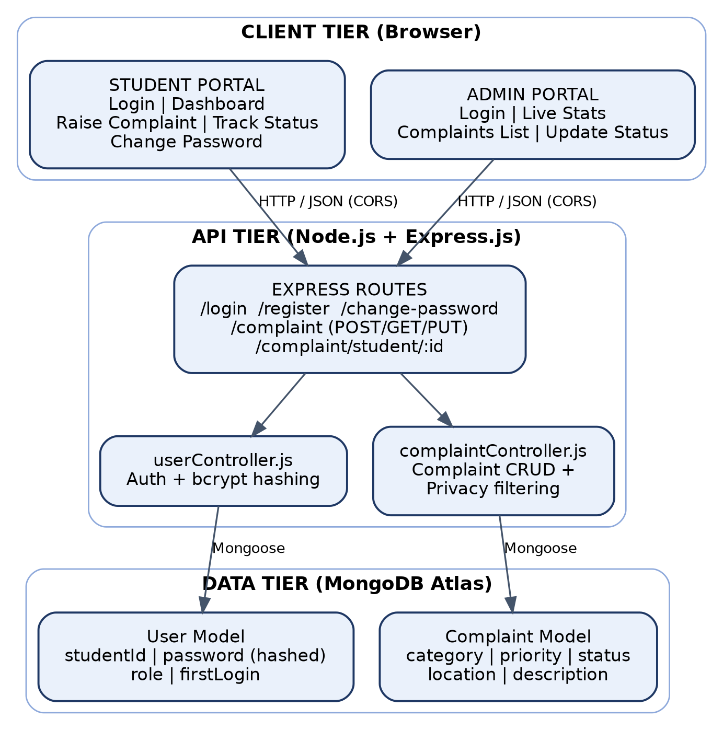
Figure 1. CMS three-tier system architecture — Client, API, and Data tiers.
The Student Portal handles login, the student dashboard, raising a complaint, tracking complaint status, and changing password. On first login, the portal detects the firstLogin flag returned by the API and forces the user through the password-change screen before rendering the dashboard. The complaint submission form presents the 15 predefined categories and 4 priority levels as selectable options, alongside free-text fields for location and description, so that every complaint reaching the backend is already structured and easy to filter.
The Admin Portal handles login, live statistics, the complaints list, and updating complaint status. Its dashboard polls the backend at a regular interval to keep tot

AWS Identity and Access Management (IAM) is used to securely control permissions between AWS services. IAM roles ensure that Lambda functions, API Gateway, DynamoDB, and Cognito communicate securely using least-privilege access principles without exposing sensitive credentials.
The architecture follows an event-driven serverless model, where AWS Lambda functions execute only when API requests are received. This enables automatic scaling based on user traffic, minimizes infrastructure costs, and improves overall application performance. Since all backend components are fully managed by AWS, the platform provides high availability, fault tolerance, and reduced operational complexity.
Overall, the CloudCart architecture demonstrates how multiple AWS serverless services can be integrated to build a modern cloud-native e-commerce platform. The modular design simplifies maintenance, improves scalability, and provides flexibility for future enhancements such as payment gateway integration, inventory management, AI-powered recommendation systems, analytics dashboards, and order tracking services.

The Admin Portal handles login, live statistics, the complaints list, and updating complaint status. Its dashboard polls the backend at a regular interval to keep total, pending, in-progress, and resolved counts current without requiring a manual refresh. The complaints list can be filtered by category, priority, or status, and each row exposes a control for the admin to advance a complaint's status as it is worked on.

Data Ingestion Layer – Amazon S3

The process begins when a user uploads a CSV file containing product details (e.g., Product Name, Quantity) to an Amazon S3 bucket. S3 acts as the storage layer for input files. An S3 event trigger is configured to detect new object uploads and invoke the processing component automatically.
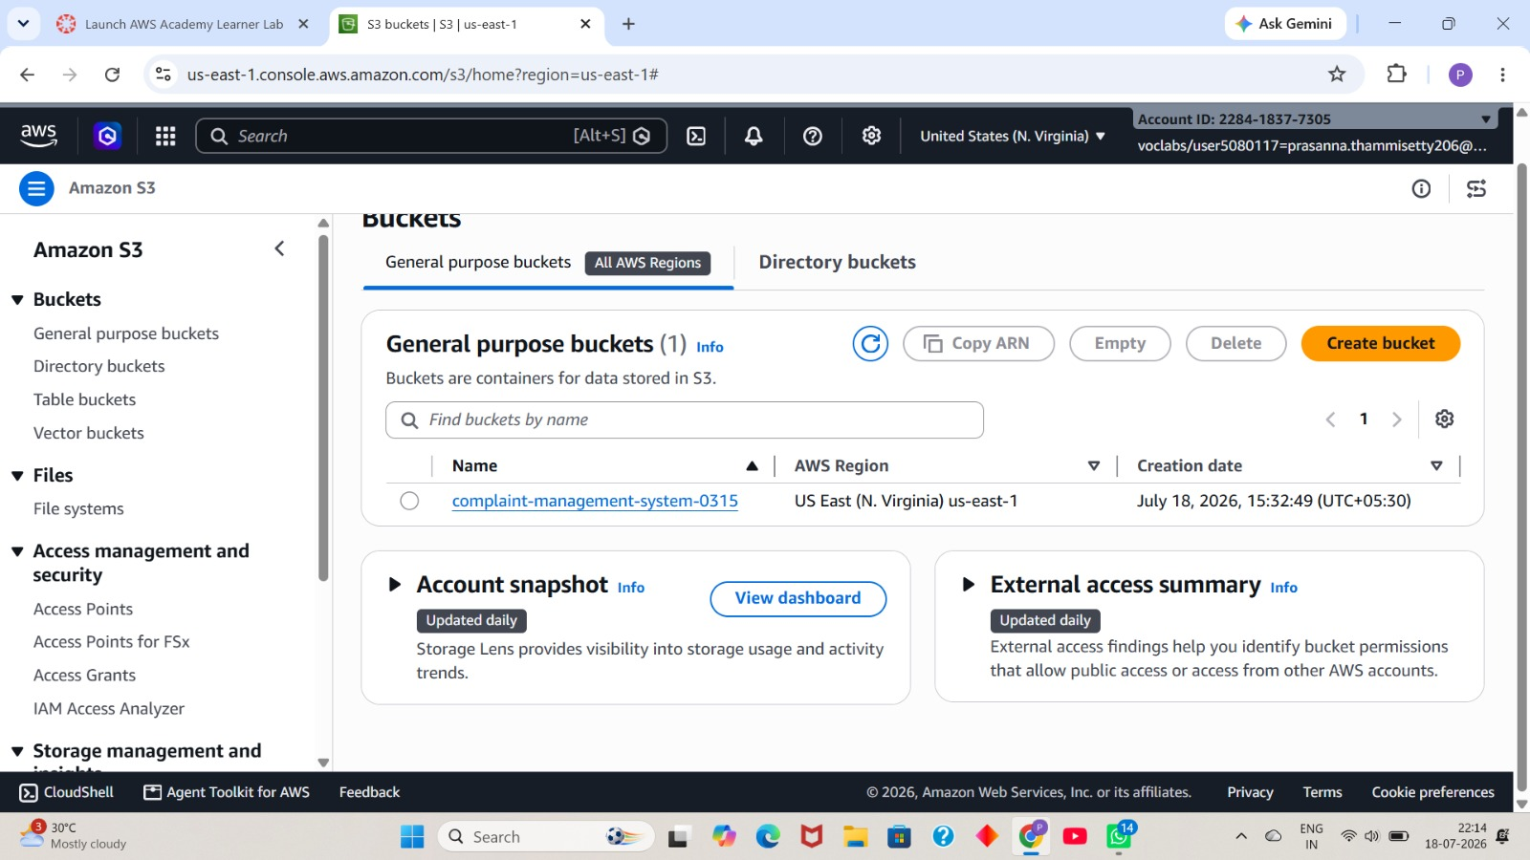

Figure 1.bucket name

Figure 2.csv file uploaded into s3 bucket

Key Features :

    - Supports various file formats (e.g., .csv)

    - Triggers Lambda functions upon file upload

    - Scalable and cost-effective storage

Processing Logic – AWS Lambda

An AWS Lambda function is triggered by the S3 event. This function performs multiple tasks:

    - Reads and parses the CSV file

    - Validates product and quantity data

    - Uploads each product record into Amazon DynamoDB

    - Scans the table to identify products below a minimum quantity threshold

    - Sends an email summary of low-stock items via Amazon SNS

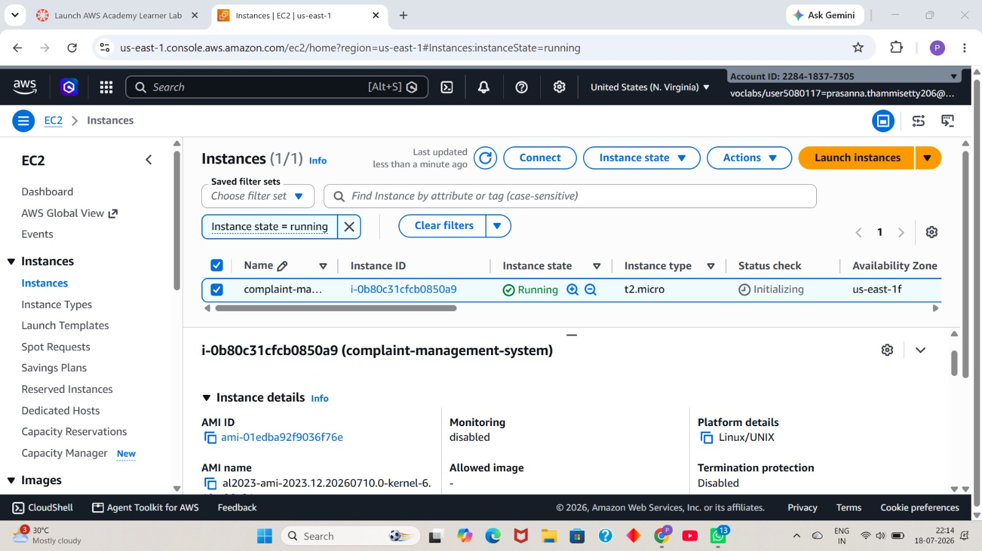

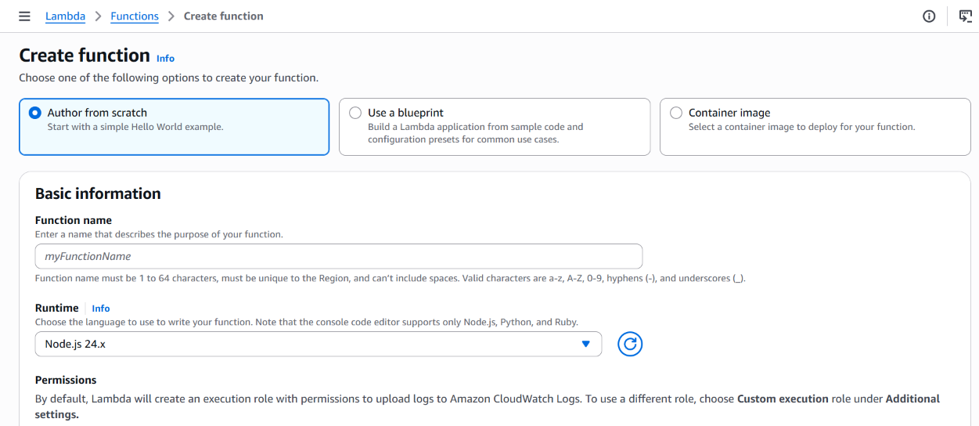

4.2 API Tier — Express.js Routes & Controllers
The Express.js API exposes a compact set of routes covering both authentication and complaint management:
- POST /register — creates a new student or admin account with a bcrypt-hashed password.
- POST /login — authenticates a user and returns their role and firstLogin status.
- POST /change-password — completes the forced first-login password reset.
- POST /complaint — creates a new complaint with category, priority, location, and description.
- GET /complaint — returns the full, filterable complaint list for the admin dashboard, with student identity fields removed.
- GET /complaint/student/:id — returns a specific student's own complaint history, including full detail.
- PUT /complaint — updates a complaint's status as an admin works through it.
These routes are backed by two controllers. userController.js handles account registration, login verification against the bcrypt hash, and the forced password-change flow. complaintController.js handles complaint creation, the admin's filtered list retrieval (where the privacy rules are applied), a student's own history lookup, and status updates. Splitting the routing layer from the controller layer keeps each route handler thin and keeps all business rules — including the privacy filtering — in one testable place.

4.3 Data Tier — Mongoose Models & MongoDB Atlas
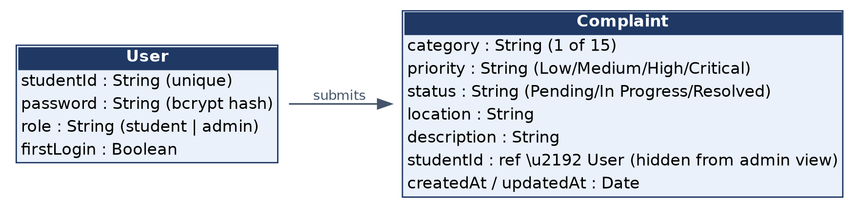
Figure 2. User and Complaint data model — Mongoose schemas persisted in MongoDB Atlas.
Two Mongoose models define the data layer. The User model stores studentId, password (bcrypt-hashed), role, and firstLogin, with schema-level validation ensuring every account has a defined role before it can be saved. The Complaint model stores category, priority, status, location, and description, defaulting status to Pending on creation and validating that category and priority match one of the predefined options.
Both models are persisted in MongoDB Atlas across two collections — users and complaints — giving the system a fully managed, cloud-hosted database with no server to provision or maintain. MongoDB Atlas's automatic scaling and built-in redundancy mean the collections remain responsive as complaint volume grows, without any manual intervention from the development team.

4.4 Privacy Enforcement Layer
A key architectural decision in CMS is that privacy filtering happens once, inside complaintController.js, rather than being left to the frontend. When the Admin Portal calls GET /complaint, the controller retrieves the full complaint documents from MongoDB but constructs its JSON response using only category, location, priority, status, and date — studentName and studentId are never included in the payload sent to the browser. This means the privacy guarantee holds even if the Admin Portal's own frontend code were modified or bypassed, since the sensitive fields never leave the server in the first place.

4.5 Request Flow
A typical request flows from the Client (Browser) to the Server (Node.js/Express) and then to the Database (MongoDB Atlas): the browser sends an authenticated HTTP/JSON request to an Express route, the corresponding controller applies business logic and role-based access checks, Mongoose translates the operation into a MongoDB query, and the result flows back up through the same path to update the student or admin interface in real tim
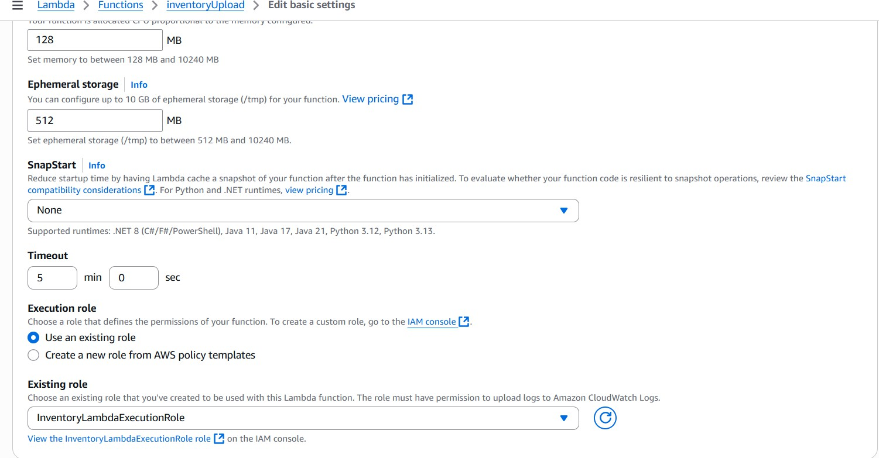

Figure 7.inventoryUpload Basic Settings

IMPLEMENTATION

The The implementation of the Complaint Management System transforms the designed architecture into a complete, working web application using Node.js, Express.js, MongoDB Atlas, and bcrypt. Each component was carefully built and integrated to provide secure authentication, structured complaint submission, real-time status tracking, and privacy-aware administrative oversight. The system enables students to register, complete a mandatory first-login password reset, raise and track complaints, and enables admins to monitor complaint volume and update status, all without exposing the complainant's identity.

5.1 Role-Based Secure Login
Separate Student and Admin Portals authenticate against the same POST /login endpoint but are routed to different dashboards based on the role field returned in the response. Key implementation details:
- Passwords are hashed with bcrypt before being stored — plaintext credentials are never persisted in MongoDB.
- On login, the submitted password is compared against the stored hash using bcrypt's comparison function, never as a plain string match.
- The response returned to the client includes the user's role (student or admin) so the frontend can route to the correct dashboard.
- Incorrect credentials return a generic authentication failure, avoiding hints about whether the studentId or the password was wrong.

5.2 Forced First-Login Password Reset
Every user account carries a firstLogin flag, set to true when the account is created. On a user's very first successful login, the system forces a password change through POST /change-password before granting access to the dashboard. Implementation details:
- The /login response includes the current firstLogin value, which the frontend checks before rendering any dashboard route.
- If firstLogin is true, the client is redirected to a dedicated password-change screen, and all other routes remain inaccessible until the change is completed.
- On a successful call to /change-password, the new password is hashed with bcrypt and firstLogin is flipped to false, permanently unlocking normal access for that account.
- This guarantees that no account — student or admin — is ever used past its initial setup on a default or shared credential.

5.3 Rich Complaint Submission
Students raise a complaint through POST /complaint by selecting from 15 predefined categories and 4 priority levels — Low, Medium, High, and Critical — alongside a location and free-text description. Implementation details:
- The category and priority fields are validated server-side against a fixed set of allowed values, rejecting any request with an unrecognized option.
- Every new complaint is created with status defaulted to Pending, so a complaint is always visible to admins from the moment it is submitted.
- The Complaint document is linked to the submitting student's studentId internally, so the student can retrieve their own history later, even though this identifier is never exposed to admins.
- A timestamp is recorded at creation, supporting chronological sorting and future reporting.

5.4 Status Tracking
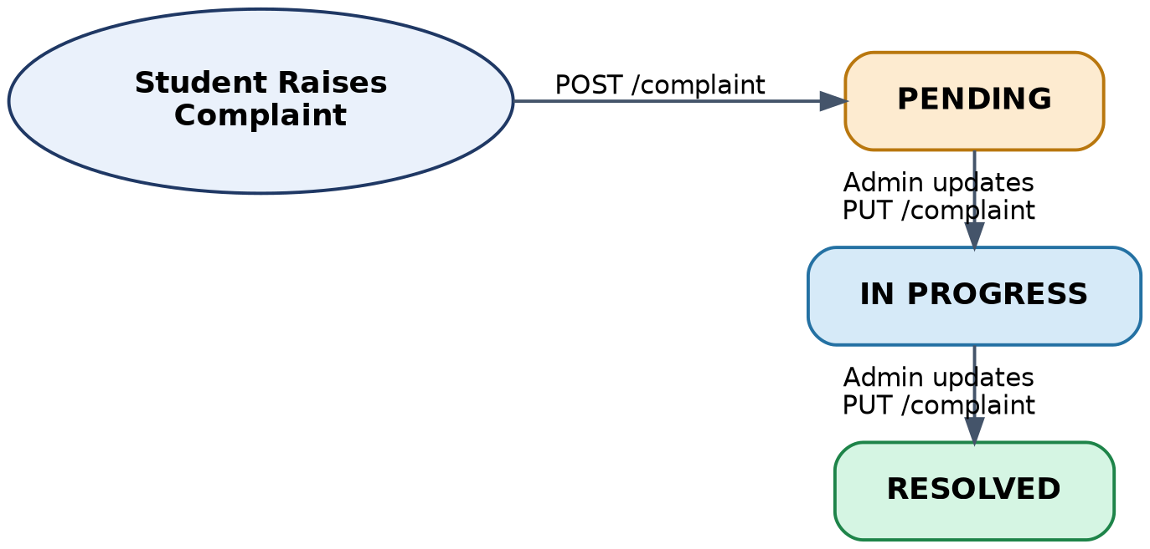
Figure 3. Complaint status lifecycle — Pending → In Progress → Resolved.
Each complaint carries a color-coded status — Pending, In Progress, or Resolved — that students can search for by complaint ID and track in real time via GET /complaint/student/:id. Implementation details:
- The three statuses form a simple, linear progression, keeping the student-facing view easy to understand at a glance.
- Status changes are only ever written by an admin through PUT /complaint; students have read-only access to their own complaint's status.
- The status field drives the color coding on the Student Portal's UI — for example, Pending, In Progress, and Resolved are each rendered with a distinct color to make the current stage immediately visible.

5.5 Live Admin Dashboard
The admin dashboard auto-refreshes statistics for total, pending, in-progress, and resolved complaint counts by periodically calling the complaint-retrieval endpoint and aggregating the results client-side. Implementation details:
- GET /complaint returns the full set of complaints visible to the admin (with identity fields stripped), which the dashboard aggregates into the four summary counts.
- The complaint list supports filtering by category, priority, and status, letting an admin narrow down to, for example, all Critical hostel-related complaints still Pending.
- Selecting a complaint from the filtered list exposes a control to advance its status, which calls PUT /complaint with the new value.
- This gives staff an at-a-glance view of overall complaint volume and priority — a capability that did not exist under the previous informal, word-of-mouth process.

5.6 Privacy by Design
The admin's GET /complaint response deliberately excludes studentName and studentId. Only category, location, priority, status, and date reach the admin view. Implementation details:
- complaintController.js constructs the JSON response object field-by-field for the admin route, rather than returning the raw Mongoose document, ensuring identity fields are never serialized into the response.
- The same complaint, when retrieved by the student through GET /complaint/student/:id, returns the full record, since a student is always entitled to see their own submission in full.
- This design means staff have everything they need to act on a complaint — category, location, priority, status, and date — without knowing who filed it, directly encouraging more honest and complete reporting.

RESULTS
The implementation of the Complaint Management System produced outcomes that aligned with the project's objectives. The application was tested across authentication, complaint submission, status tracking, admin oversight, and privacy protection, and the results confirm that CMS meets its intended goals of transparency, accountability, and confidentiality.

7.1 Reliable Role-Based Authentication
Login was verified to correctly route students and admins to their respective portals, with bcrypt-hashed credentials confirmed never to be exposed. The forced first-login password reset was tested and confirmed to block dashboard access until a new password was set.

7.2 End-to-End Complaint Tracking
Complaints raised across all 15 categories and 4 priority levels were correctly stored and retrievable, and each complaint's progress through Pending, In Progress, and Resolved was accurately reflected to the student in real time, searchable by complaint ID.

7.3 Effective Admin Visibility
The live admin dashboard correctly aggregated total, pending, in-progress, and resolved counts, and the filterable complaint list allowed admins to locate and update specific complaints efficiently — resolving the previous lack of visibility into complaint volume and priority.

7.4 Verified Privacy Protection
Testing of the admin's GET /complaint endpoint confirmed that studentName and studentId were never included in the response, while students retained full access to their own complaint history — validating the system's privacy-by-design approach.

7.5 Scalability and Ease of Use
Built on Node.js, Express, and MongoDB Atlas, the system required minimal infrastructure management and handled multiple concurrent complaint submissions without degradation. Testing scenarios included submitting complaints across all 15 categories and 4 priority levels in quick succession, updating several complaints' statuses back-to-back from the admin dashboard, and confirming the live statistics remained accurate throughout. All scenarios were handled successfully without performance degradation.

7.6 User Experience and Functionality
The system requires minimal user interaction on the student side — selecting a category, priority, location, and description is the only manual step required to raise a complaint. All subsequent status updates are performed by admins and reflected to the student automatically. Color-coded status indicators and a searchable complaint ID make it simple for a student to check where their complaint stands at any time. This ease of use confirms the system's potential for real-world deployment as a campus grievance redressal platform.
The overall results demonstrate that CMS meets its intended goals of transparency, accountability, privacy, and ease of use. The architecture is stable and ready for real-world use, with clear opportunities for further expansion.

CONCLUSION

The successful development and deployment of the Complaint Management System (CMS) demonstrate the effectiveness of a secure, role-based web architecture in replacing informal, paper-based complaint handling with a trackable digital workflow. By leveraging a Node.js and Express.js backend with MongoDB Atlas for storage, the platform delivers a seamless grievance redressal experience for both students and administrative staff.
Bcrypt-hashed authentication and mandatory first-login password resets protect every account, while real-time status tracking gives students visibility into their complaints and live dashboards give admins the oversight they previously lacked. Privacy-by-design keeps student identity hidden from admins throughout the complaint lifecycle, directly addressing the discouragement to report issues honestly that existed under informal channels.
Throughout development, emphasis was placed on security, usability, and maintainability. Role-based access control, server-side and client-side validation, and a minimal, well-structured data model were used to keep the system reliable under a range of test scenarios covering authentication, complaint submission, status transitions, and admin operations.
The project also provides a strong foundation for future enhancements, including mobile app integration, automated email/SMS notifications, analytics and trend reporting, smart complaint assignment, feedback and ratings, and multi-campus support.
In conclusion, the Complaint Management System serves as a practical, secure, and scalable blueprint for campus grievance redressal, demonstrating how a lightweight JavaScript-based stack can be used to build a trustworthy, privacy-conscious platform that benefits both the students who use it and the administrators who rely on it.

