**PRACTICAL NO : 1**  **A65_PRASANNA ANAJANKAR**

**AIM : A. Introduction to Cloud Computing and its Services.**

**B. Introduction to salesforce CRM.**

**THEORY :**

**A. Introduction to Cloud Computing and its Services.**

**What is Cloud?**

The term **Cloud** refers to a **Network** or **Internet.** In other words, we can say that Cloud is something, which is present at remote location. Cloud can provide services over public and private networks, i.e., WAN, LAN or VPN.

Applications such as e-mail, web conferencing, customer relationship management (CRM) execute on cloud.

**What is Cloud Computing?**

Cloud Computing refers to **manipulating, configuring,** and **accessing** the hardware and software resources remotely. It offers online data storage, infrastructure, and application.

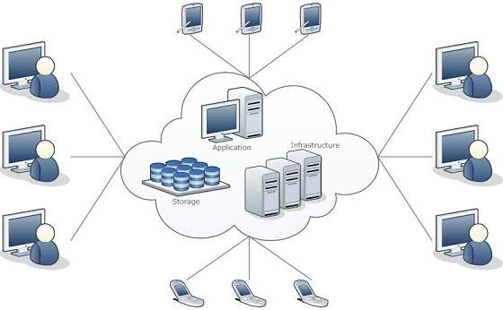

Cloud computing offers **platform independency,** as the software is not required to be installed locally on the PC. Hence, the Cloud Computing is making our business applications **mobile** and **collaborative.**

## Top benefits of cloud computing

Cloud computing is a big shift from the traditional way businesses think about IT resources. Here are seven common reasons organisations are turning to cloud computing services:

### Cost

Cloud computing eliminates the capital expense of buying hardware and software and setting up and running on-site datacenters—the racks of servers, the round-the-clock electricity for power and cooling, the IT experts for managing the infrastructure. It adds up fast.

### Speed

Most cloud computing services are provided self service and on demand, so even vast amounts of computing resources can be provisioned in minutes, typically with just a few mouse clicks, giving businesses a lot of flexibility and taking the pressure off capacity planning.

### Global scale

The benefits of cloud computing services include the ability to scale elastically. In cloud speak, that means delivering the right amount of IT resources—for example, more or less computing power, storage, bandwidth—right when it is needed and from the right geographic location.

### Productivity

On-site datacenters typically require a lot of “racking and stacking”—hardware setup, software patching, and other time-consuming IT management chores. Cloud computing removes the need for many of these tasks, so IT teams can spend time on achieving more important business goals.

### Performance

The biggest cloud computing services run on a worldwide network of secure datacenters, which are regularly upgraded to the latest generation of fast and efficient computing hardware. This offers several benefits over a single corporate datacenter, including reduced network latency for applications and greater economies of scale.

### Reliability

Cloud computing makes data backup, disaster recovery and business continuity easier and less expensive because data can be mirrored at multiple redundant sites on the cloud provider’s network.

### Security

Many cloud providers offer a broad set of policies, technologies and controls that strengthen your security posture overall, helping protect your data, apps and infrastructure from potential threats.

### Deployment Models

Deployment models define the type of access to the cloud, i.e., how the cloud is located? Cloud can have any of the four types of access: Public, Private, Hybrid, and Community.

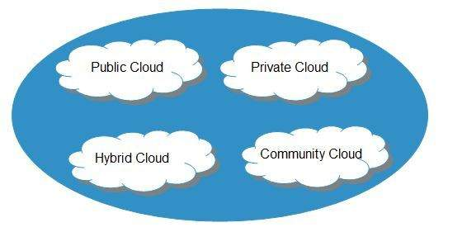

#### Public Cloud

The **public cloud** allows systems and services to be easily accessible to the general public. Public cloud may be less secure because of its openness.

#### Private Cloud

The **private cloud** allows systems and services to be accessible within an organization. It is more secured because of its private nature.

#### Community Cloud

The **community cloud** allows systems and services to be accessible by a group of organizations.

#### Hybrid Cloud

The **hybrid cloud** is a mixture of public and private cloud, in which the critical activities are performed using private cloud while the non-critical activities are performed using public cloud.

### Service Models of Cloud Computing :

Cloud computing is based on service models. These are categorized into three basic service models which are -

* Infrastructure-as–a-Service (IaaS)
* Platform-as-a-Service (PaaS)
* Software-as-a-Service (SaaS)

**Anything-as-a-Service (XaaS)** is yet another service model, which includes Network-as-a-Service, Business-as-a-Service, Identity-as-a-Service, Database-as-a-Service or Strategy-as-a-Service.

The **Infrastructure-as-a-Service (IaaS)** is the most basic level of service. Each of the service models inherit the security and management mechanism from the underlying model, as shown in the following diagram:

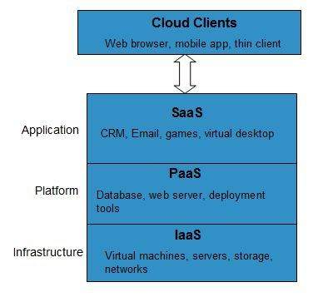

#### Infrastructure-as-a-Service (IaaS)

**IaaS** provides access to fundamental resources such as physical machines, virtual machines, virtual storage, etc.

#### Platform-as-a-Service (PaaS)

**PaaS** provides the runtime environment for applications, development and deployment tools, etc.

#### Software-as-a-Service (SaaS)

**SaaS** model allows to use software applications as a service to end-users.

## History of Cloud Computing

The concept of **Cloud Computing** came into existence in the year 1950 with implementation of mainframe computers, accessible via **thin/static clients.** Since then, cloud computing has been evolved from static clients to dynamic ones and from software to services. The following diagram explains the evolution of cloud computing:

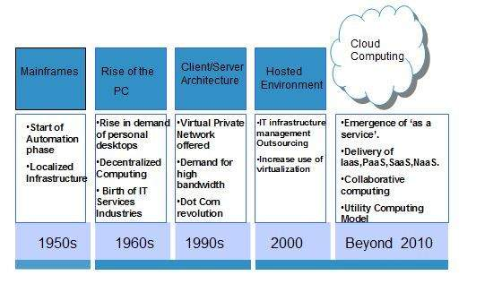

**B. Introduction to salesforce CRM.**

**What Is Salesforce?**

[Salesforce](https://www.salesforce.com/in/), Inc. is a famous American cloud-based software company that provides CRM services. Salesforce is a popular CRM tool for support, sales, and marketing teams worldwide.

Salesforce services allow businesses to use cloud technology to better connect with partners, customers, and potential customers. Using the Salesforce CRM, companies can track customer activity, market to customers, and many more services.

A CRM platform helps you go deeper with all your metrics and data; you could also set up a dashboard that showcases your data visually. In addition to this, you can also have personalized outreach with automation. Another significant benefit is that a CRM platform can also improve customer service's ability to help customers or a sales team's outreach efforts.

**Salesforce Architecture**

This tutorial will now briefly walk you through the Salesforce architecture. Here, you will be acquainted with the different layers of the Salesforce architecture individually.

1. Multi-tenant: Salesforce stores data in a single database schema. There can be a single instance of a software server with multiple tenants. Speaking about a multi-tenant architecture, there is a single shared application service to several clients.
2. This makes it cost-effective. On the contrary, in a single-tenant, the development and maintenance cost must be entirely owned by one client. Hence the multi-tenant architecture is a boon.
3. Metadata: Salesforce uses a metadata-driven development model. This allows developers to only focus on building the application. This metadata-driven platform makes customization and scaling up easy.
4. API: Salesforce provides a powerful source of APIs. This helps in developing and customizing the Salesforce1 Mobile App. Every feature of the Salesforce design has been planned and implemented precisely.

**Salesforce Services**

Moving on, you will explore the [Services](https://www.simplilearn.com/6-must-know-features-of-salesforce-platform-article) offered by Salesforce:

* SAAS (Software As A Service): Here, you can directly obtain the built-in software and make use of it.
* PAAS (Platform As A Service): PAAS offers you the framework and platform to build your websites and apps.
* IAAS (Infrastructure As A Service): IAAS plays a vital role in Salesforce development, although not very widely used.

# Features of Salesforce

* 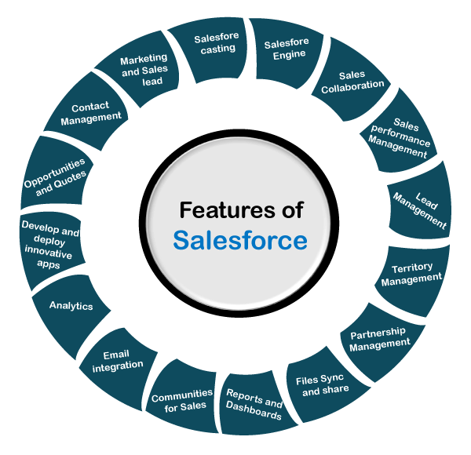
* Below are some popular features of Salesforce:

### 1. Account and Contact Management

* The account and contact management feature of Salesforce provides the complete information of each customer. It includes the ***activity history of each customer, communications done with customers, Key contacts***, etc. In simple words, it contains all the information related to customer communication.

### 2. Opportunity Management

* It enables us to manage all the sales deals with the Salesforce and keep connected with the people and information required to complete every deal. It also includes the stage of every deal and what move should we need to take to win the specific deal.
* Skip Ad

### 3. Salesforce Engage

* Salesforce engage feature allows us to share the marketing content with sales to enhance the company's selling power. It works like a bridge to fill the gap between sales and marketing. It gives real-time sales alerts as per the engagement with the customers.

### 4. Sales Collaboration

* The sales collaboration feature allows the sales team to collaborate with powerful social tools in Salesforce. It also helps to find the experts for sales, share competitive data among the team, etc., to grow the business from anywhere. It allows the sales teams to work together on various sales opportunities and check progress from anywhere.

### 5. Sales Performance Management

* Sales performance management is mostly categorized as compensation management, which varies due to different software tools. This improves the execution of the sales process day-by-day. It provides a metric-based goal setting for the teams and helps the sales team with continuous feedback and rewards.

### 6. Lead Management

* The lead management software solution helps the business by giving information on how the marketing activities impact the sales pipelines. It helps to invest our time in the crucial and trending deals firstly.

### 7. Salesforce Mobile App

* Salesforce Mobile app makes our mobile device a portable sales office. It allows us to **make calls, reply to each hot lead, work opportunities, and to see the checkerboards** from anywhere. We can manage meetings, events, and accounts update from a single app. [Salesforce CRM](https://www.javatpoint.com/salesforce-crm) can be accessed and update from anywhere with the help of the salesforce mobile app.

### 8. Workflow and Approvals

* It allows us to design and automate any business process with the drag-drop option of the visual workflow. It provides flexible approval processes for the sales discount, expenses, etc. It allows business processes to be completed automatically.

### 9. File Sync and Share

* With the File Sync and share feature, we can easily share our files, collaborate on these files, publish the best content, and track all these activities in real-time. We can easily find any file or content from anywhere as all the contents are put at the same place. It eliminates mistakes during sales by publishing the most relevant and accurate content.

### 10. Sales Forecasting

* This feature helps you to get the real-time observations of the entire team's forecast. We can also track the leader-board to know the top performer of the target. It provides a complete view of business so that we can take the required action if necessary.

### 11. Reports and Dashboards

* The dashboard provides a real-time view of the business at a glance. It allows us to create sales forecasting reports without any help from the IT person.

### 12. Email Integration

* Salesforce email-tracking software can be integrated with the Outlook CRM and Gmail to synchronize the contacts, events, and everything to work faster. With the help of Salesforce lightning, we can easily sync our important emails instantly to Salesforce, and it also provides a complete view of the connected customers. The salesforce email composer helps us to compose and send an email to any important contact instantly from anywhere.

### 13. Territory Management

* Territory management helps to build the logical structure of sales territories to provide the right sale to the right customer and get the maximum profit. It enables us to copy the territory model to safely find new alternatives, such as new assignment rules, hierarchies, etc. We can apply a single rule for multiple territories.

### 14. Partner Management

* The partner management builds the partner ecosystem quickly with the Salesforce CRM app. It enhances partner engagement in our business with **recruitment, training, and supporting the indirect sales channels**. It makes the sales process easier and faster for the partners.

## Difference between Traditional CRM Vs. Salesforce CRM

|  |  |
| --- | --- |
| **Traditional CRM** | **Salesforce CRM** |
| Hosted on the company’s server | Hosted on the cloud |
| Takes months or even years to set up | Can be set up in a few days or weeks |
| Difficult to understand and use | Easy to use and understand |
| Unused data | Manages all data in one place |
| No personalized service | Real-time customer data and personalized service |
| High client attrition | High customer lifetime value |

## How to access Salesforce?

Now in this Salesforce tutorial, let’s learn how to access Salesforce:

Salesforce has a 30-day free trial and we will register for the same.

**Step 1)** Go to link and

1. Add required information

2. Click on start free trial button

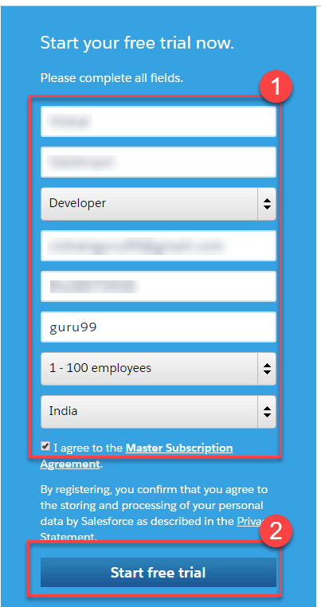

**Step 2)** Setup will take time

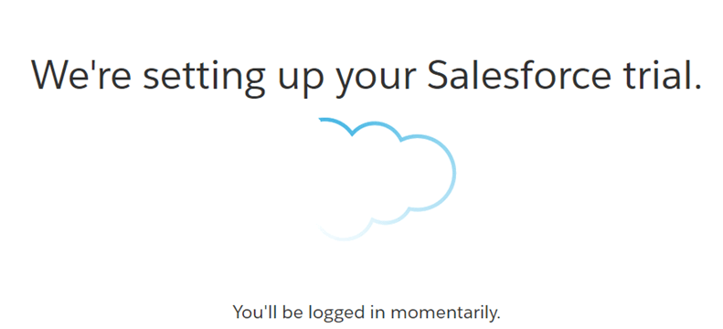

**Step 3)** You will see the welcome screen, with demo data

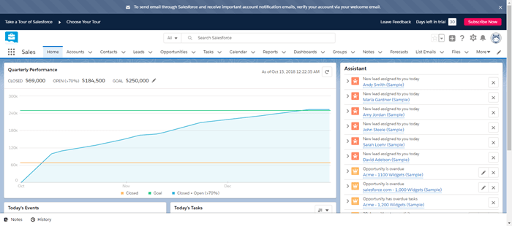

**Step 4)** Let’s create a new Account (Company). Click on Account > New

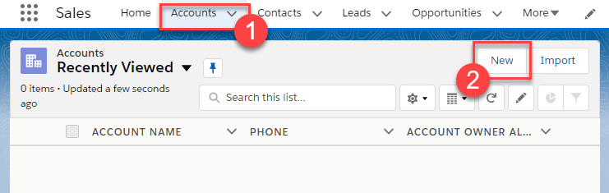

**Step 5)** In the popup Enter the required data Click save

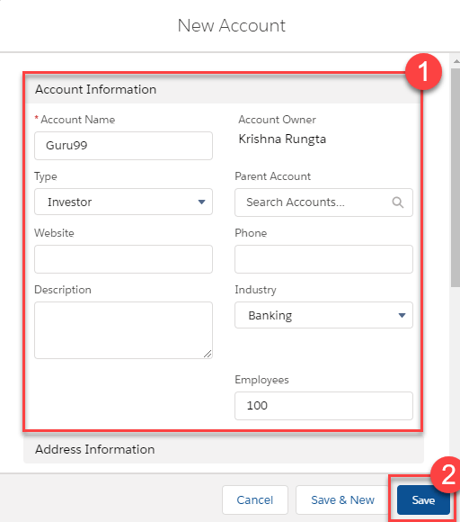

**Step 6)** Account is created

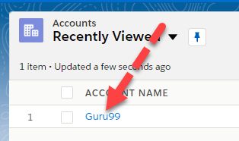

The UI of Salesforce very self-explanatory and likewise you can do other transactions.

**S**alesforce CRM Content simplifies content management by incorporating user-friendly features into the following tasks:

**Organizing :** Rather than keep files in folders that make content difficult to find, Salesforce CRM Content stores files in fully searchable file repositories known as libraries. Administrators can create multiple libraries based on any classification, such as department name, job function, or team, then configure user permissions within the library to balance content access with security. Salesforce CRM Content also provides private libraries, which allow users to reduce the clutter on their desktops while using content-management benefits such as document search and version control.

**Searching:** The powerful Salesforce CRM Content search engine scans the entire body of the document as well as content properties such as the title, description, tags, categorization data, and author name. You can filter searches by featured content, file format, author, tags, libraries, or custom fields and then view the results with various levels of detail, providing an easy way to find relevant content quickly. The “smart bar” graphic for downloads, comments, ratings, and subscribers allows you to compare documents within a search result set.

**Subscribing :** Once a file is located, subscribing to it ensures that you receive an email notification when new versions are published or changes are made to the file's properties. You can also subscribe to authors, tags, and libraries, thus reducing the time spent searching for new or updated content. Notification emails will arrive real-time or once daily, depending on your preferences.

**Previewing** **:** In Salesforce CRM Content you don’t need to download a large document to view it. If the document is a Microsoft PowerPoint, Word, Excel, or Adobe® PDF file, you can preview the entire file in your browser without downloading it. Some aspects of files may not be displayed in previews. Copy-protected PDFs can't be previewed.

**Contributing :** Uploading new or revised files in Salesforce CRM Content is fast and easy. During the upload process you choose a library and record type for your file or Web link, write a description, assign one or more tags, and fill out any customized fields that help categorize and define your content. Version management does not require checking files in and out, rather, you simply upload a new version of the file and Salesforce CRM Content maintains a version list accessible from the content details page. You can download past versions of a file and read all reason-for-change comments that an author may have included with a new version.

**Reviewing Usage and Providing Feedback :** Salesforce CRM Content provides several methods for determining whether content is valuable to readers. Featuring a piece of content increases its visibility in search results. Voting thumbs up or thumbs down on a file, Web link, or Google doc and adding comments allow you to participate directly in content improvement. You can also see who has subscribed to a file, link, or doc and how many times files have been downloaded. The Reports tab allows you to create standard or custom reports on Salesforce CRM Content data. If the content delivery feature is enabled, you can send content to colleagues, leads, and contacts and then track how often the content has been previewed or downloaded.

**Sharing Content in Salesforce :** Salesforce CRM Content is also integrated with leads, accounts, contacts, opportunities, cases, products, and custom objects. If Salesforce CRM Content functionality is enabled on the Opportunity tab, for example, Salesforce CRM Content uses the fields on the opportunity detail page to search for files that may be relevant to that opportunity. You can drill down in the search results as needed or run your own search and then attach one or more files to the opportunity. The most current version of the file will be available on the detail page for the life of the opportunity.

**CONCLUSION :** Thus, we have seen an introduction about cloud computing and salesforce.

**Name : Prasanna Rajendra Anjankar Registration No : 19010886**

**Roll No : 65 Class : 6CTA**

**Course Name : CRM Course Code : CT2370**