**Practical No : 02** **A65_Prasanna Anjankar**

**AIM : Creation of Custom Objects.**

**Theory :**

The organization’s data will always not fit into the existing standard objects. So we can extend and customize many sales force objects to meet this need. For example, a courier company can create a custom object to store the schedule and dispatch details for every week. So these objects store the data that is unique to the business. The custom objects can also have custom fields along with the standard fields available in Salesforce.

## Custom Object features

Following are the features available on Custom Objects. The features help you perform the following features −

* Build page layouts to control which fields users can view and edit when entering data for the custom object record.
* Import custom object records.
* Create reports and dashboards to analyze custom object data.
* Create a custom tab for the custom object, to display the object’s data.
* Track tasks and events for custom object records.
* Import custom object records.

To create custom object in Salesforce, perform the following steps:

1. Log in to your Salesforce account.
2. Click **Setup** at the upper-right corner.



1. Under the **Build** section, click **Create.**
2. To create a custom object, click  **Custom Object**.

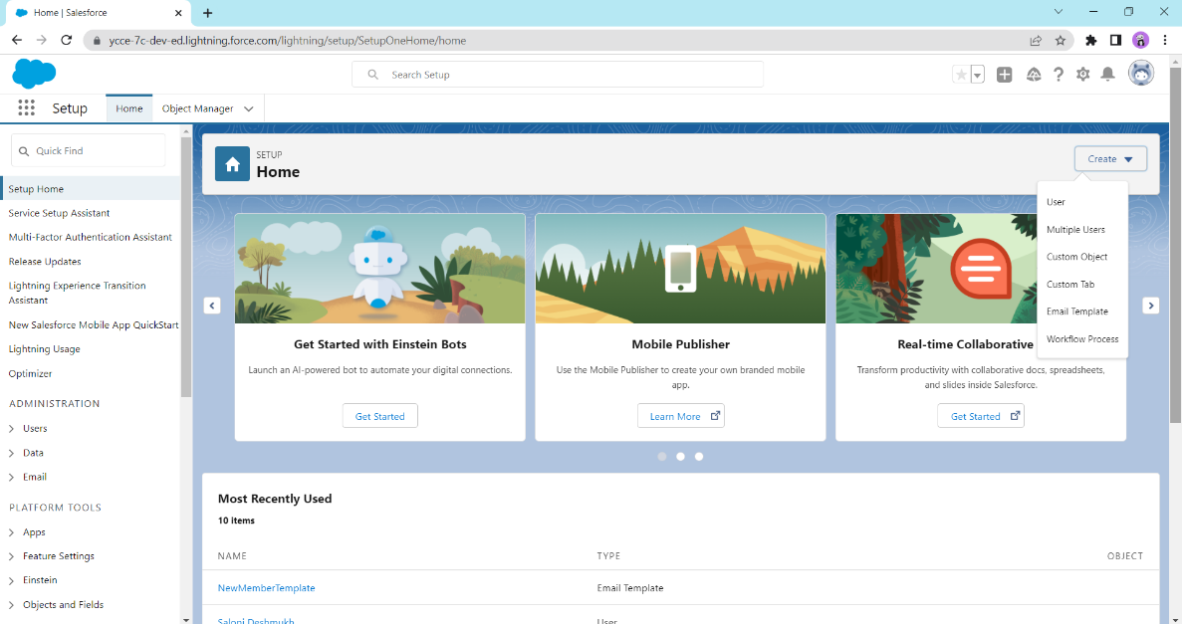

1. Enter the name of the Custom Object in **Label**, **Plural Label**, and **Object Name**.

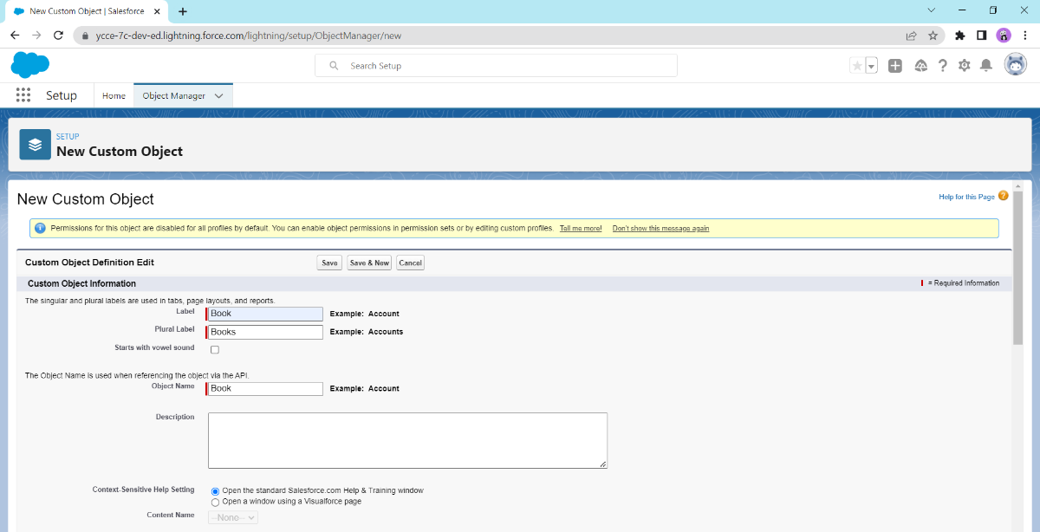

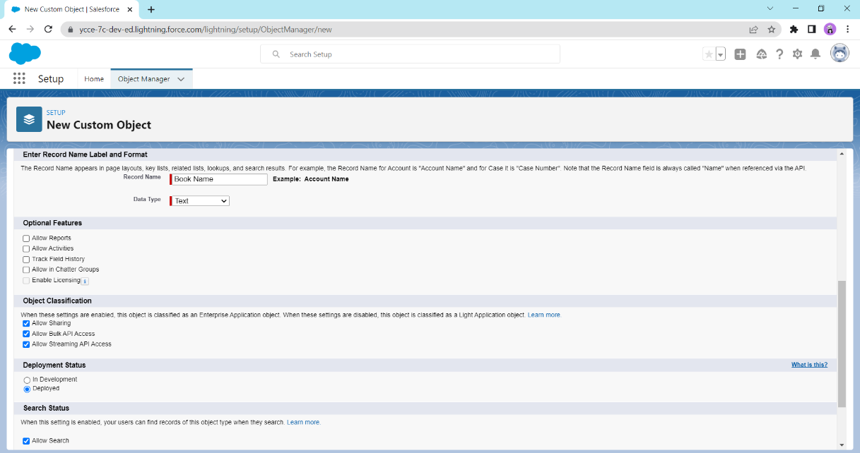

1. Select the**Launch New Custom Tab Wizard after saving this custom object** check box and click **Save**.

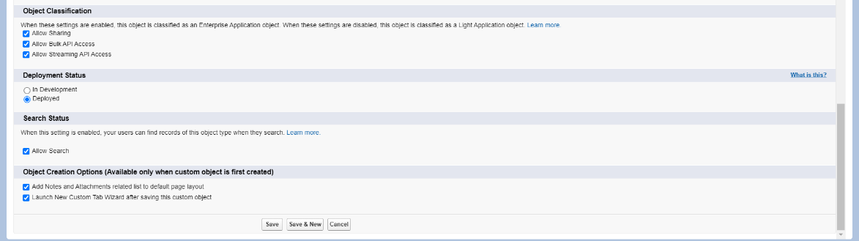

1. Click on create, then **Custom Tab.**

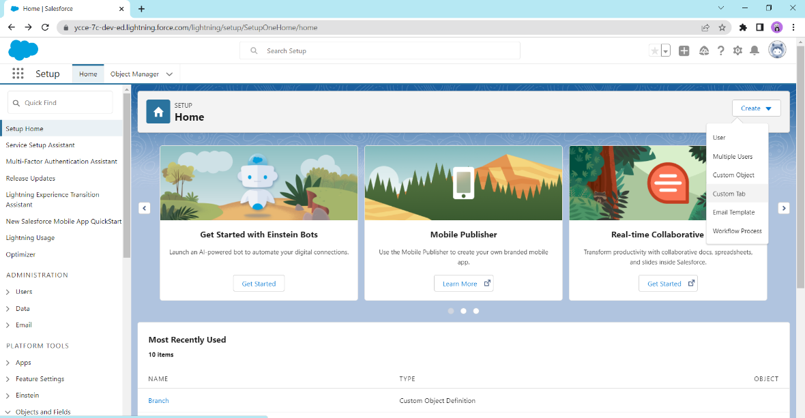

1. To select an icon for the tab, click the **Search** icon and click **Save**.

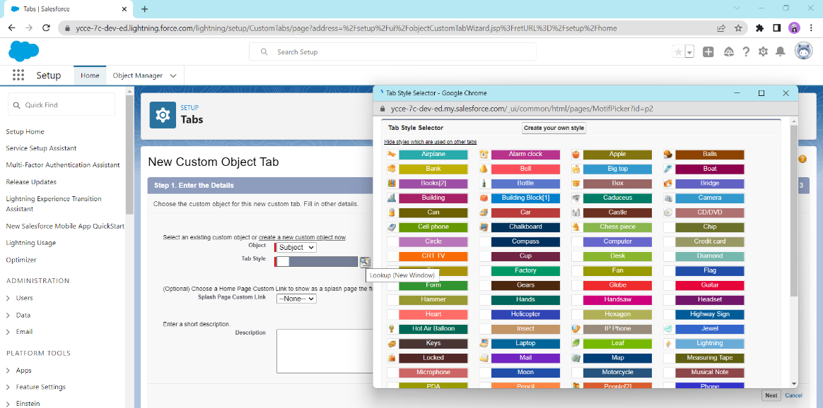

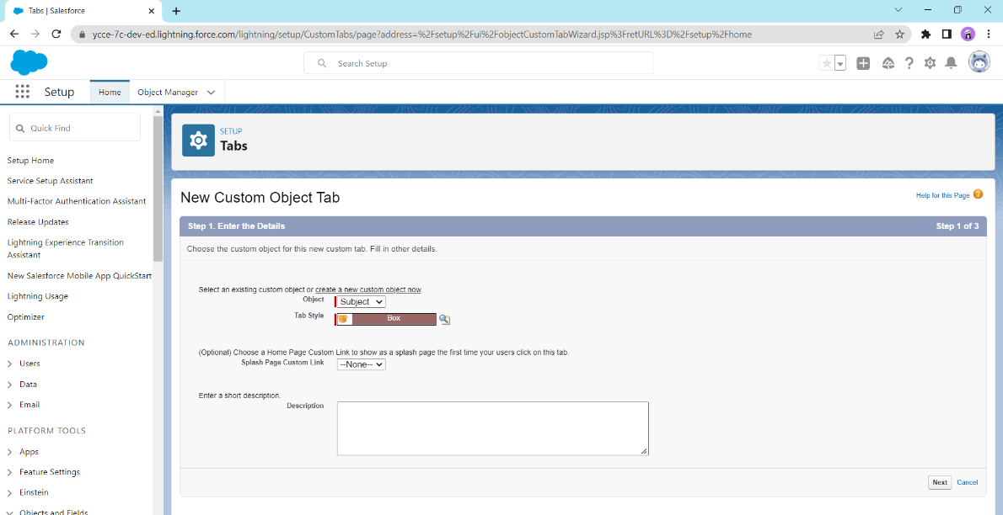

1. To make the Custom Object available to Profiles, select the appropriate option and click **Next**.

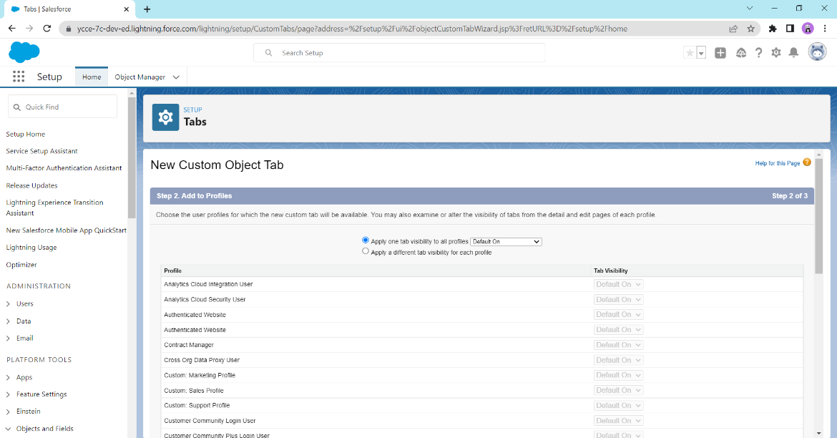

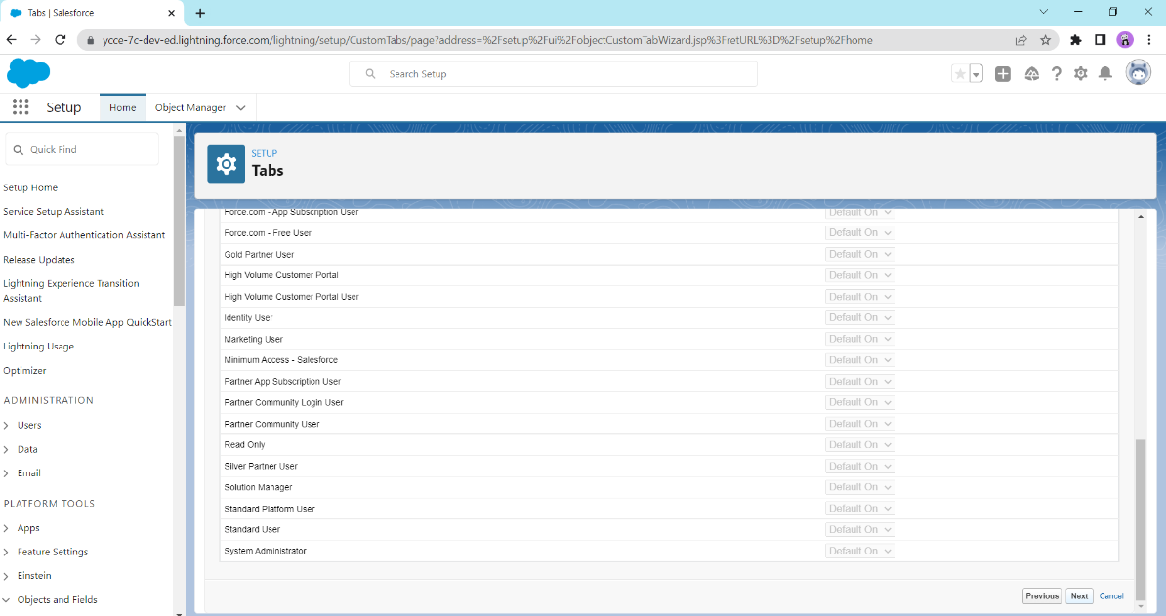

1. Choose the custom apps for which the new Custom tab is required and click **Save**.

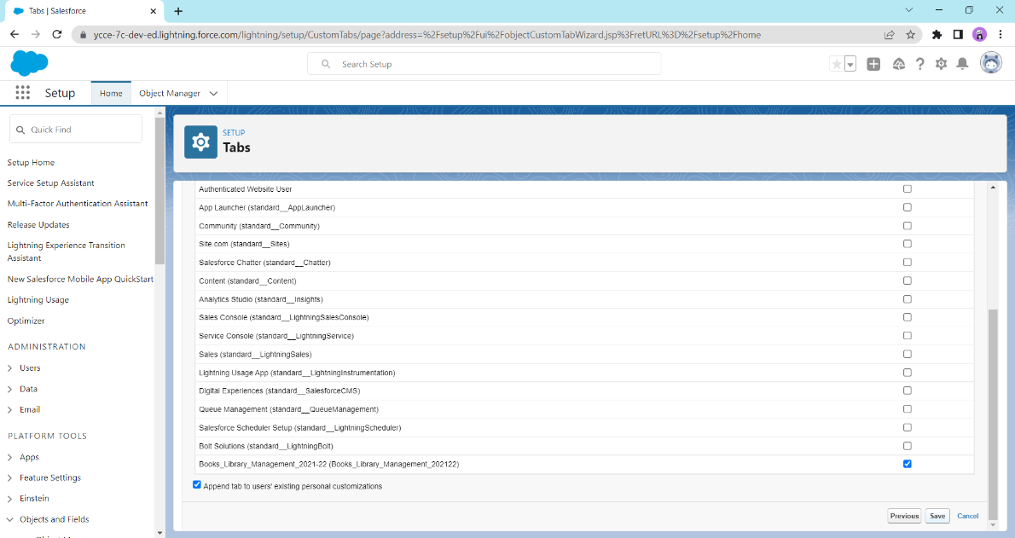

**Conclusion:** Thus, we have successfully created a custom object.

**Name : Prasanna Rajendra Anjankar Registration No : 19010886**

**Roll No : 65 Class : 6CTA**

**Course Name : CRM Course Code : CT2370**