**PRACTICAL NO : 03 A65_PRASANNA ANJANKAR**

**AIM :** To create LOOK UP and MASTER- DETAIL RELATIONSHIP with objects .

**THEORY :**

LOOK-UP RELATIONSHIP

* This type of relationship can be used when we just need to have the relationship between two objects but not a direct dependency on each other.
* This is a loosely coupled relationship.
* These are used to reference commonly shared data, such as reference data.
* The maximum number of lookup relationships in a field can be 40.
* They are used to link two objects together when we do not want to have the behavior of the master-detail like sharing rules, profile permissions, and cascade delete.
* Lookups are used when we need to relate multiple ‘parents’ to the record of detail.
* Deletion of the parent just deletes the related field in the child but not the whole record.
* This type of relationship is also like a one-to-many relationship.

MASTER-DETAIL RELATIONSHIP

* It is a tightly coupled record that has a direct dependency between the two objects. It can also be described as a parent-child relationship.
* The record of detail cannot be created without a master.
* The sharing rules are inherited from the master to the detail record.
* We cannot update the relationship to the master in a master-detail relationship.
* The number of master-detail relationships that can be used is limited to 2.
* Master-detail relationships are automatically included in report record types.
* We also cannot set the profile object permissions for the record of detail.
* If a master record is deleted then the record of its detail also gets deleted along with it, that is, it implements cascade delete.

**SCREENSHOTS :**

**Lookup Relationship Steps:**

**Step 1:** Open Object manager then open member object.

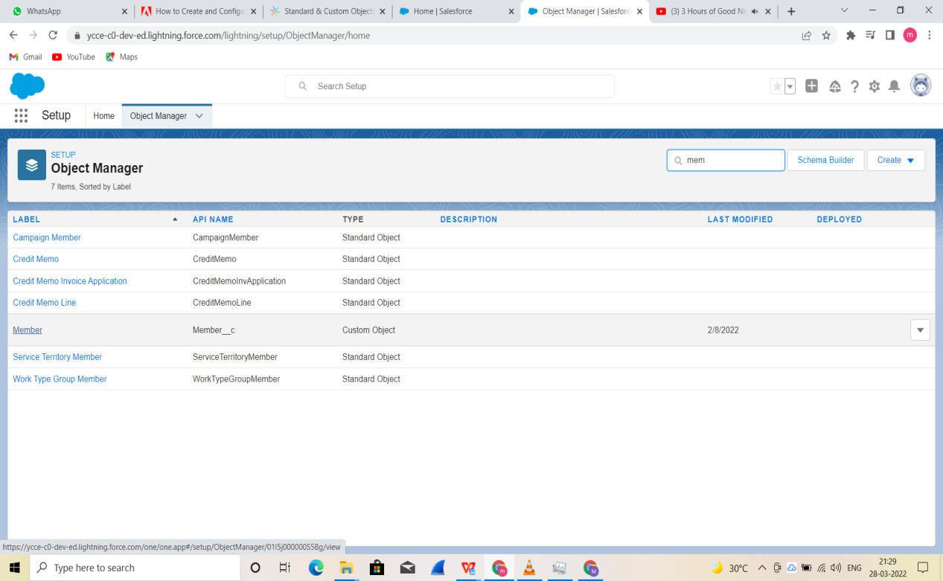

**Step 2:** Select Lookup relationship.

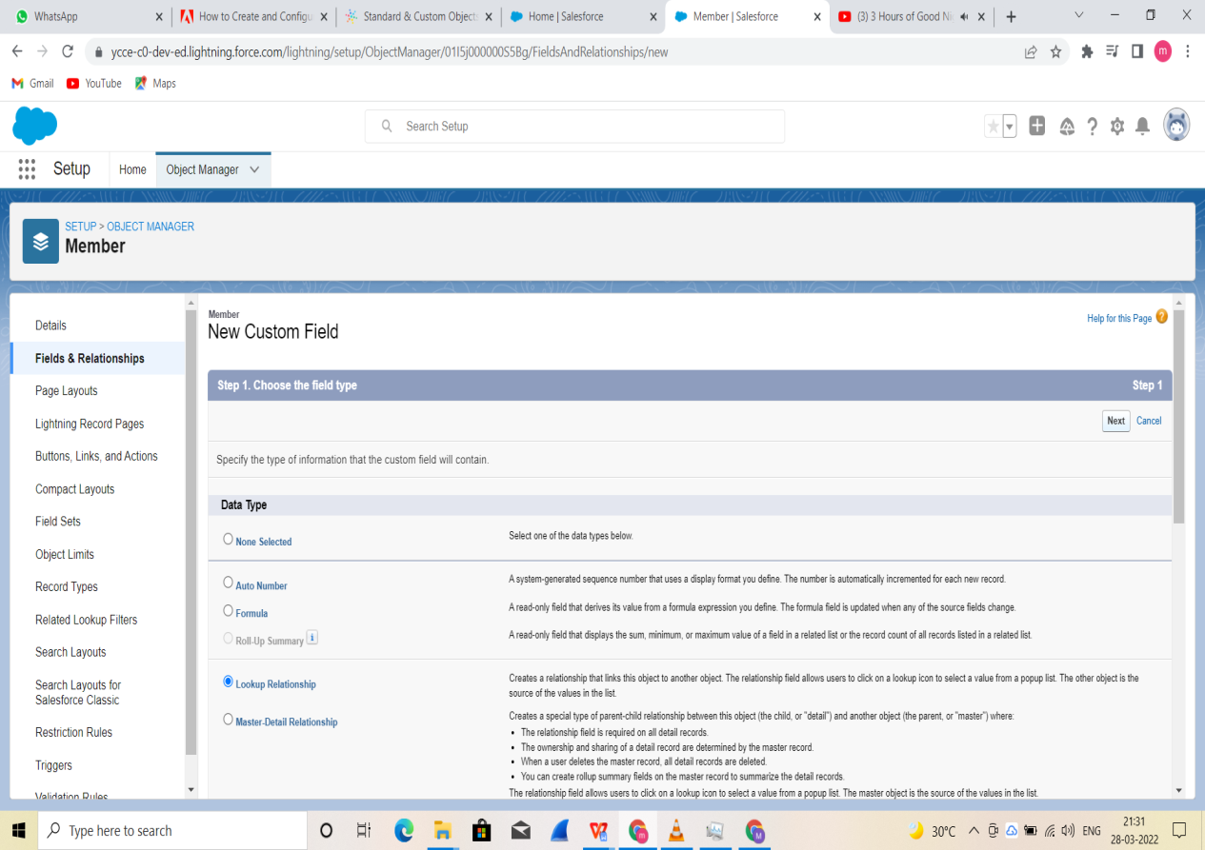

**Step 3:** Select Branch for related field.

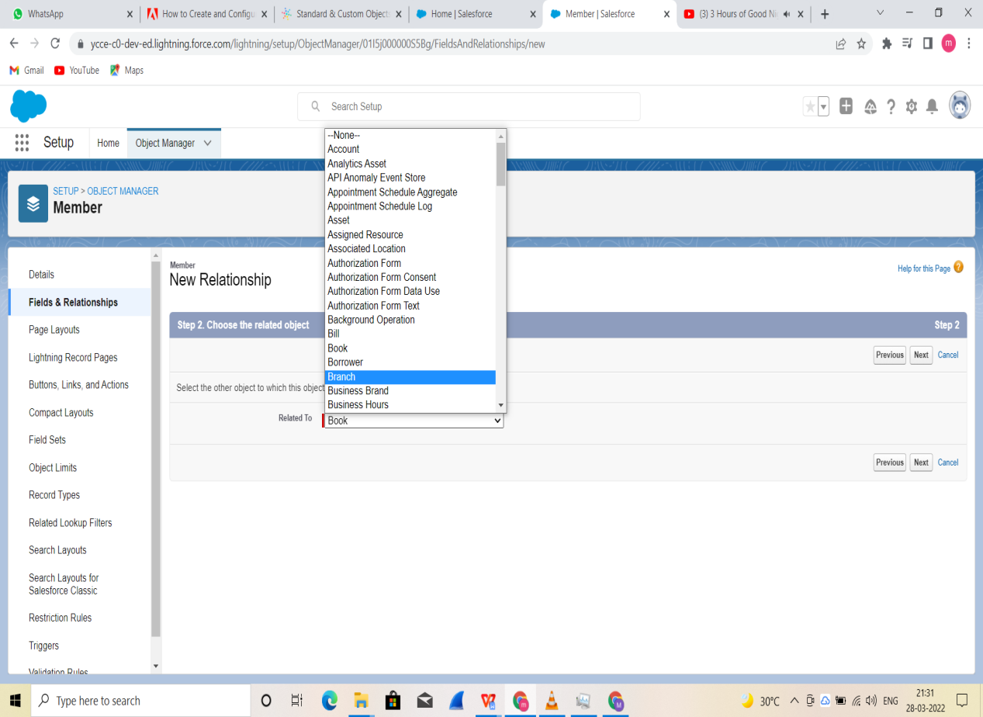

**Step 4:**  Fill all the fields.

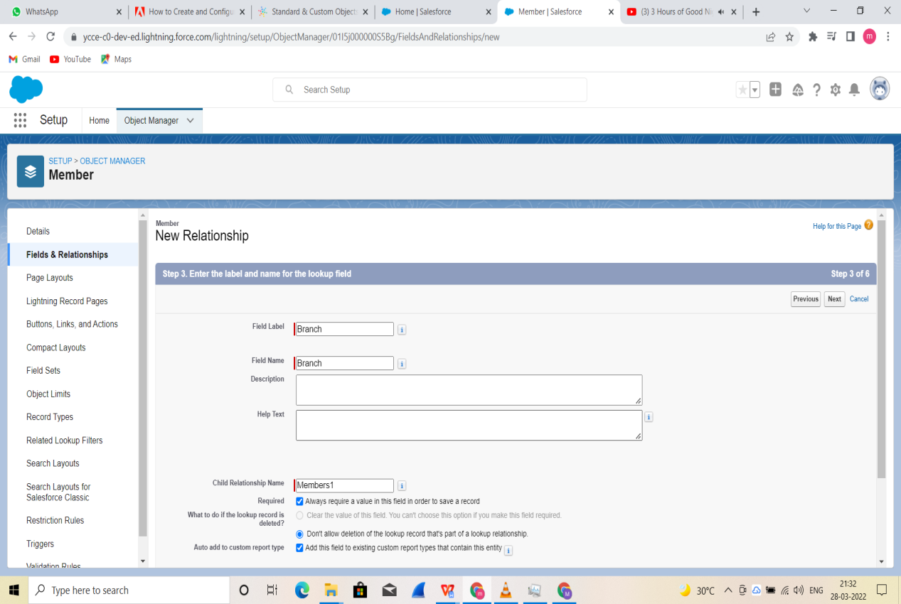

**Step 5:**

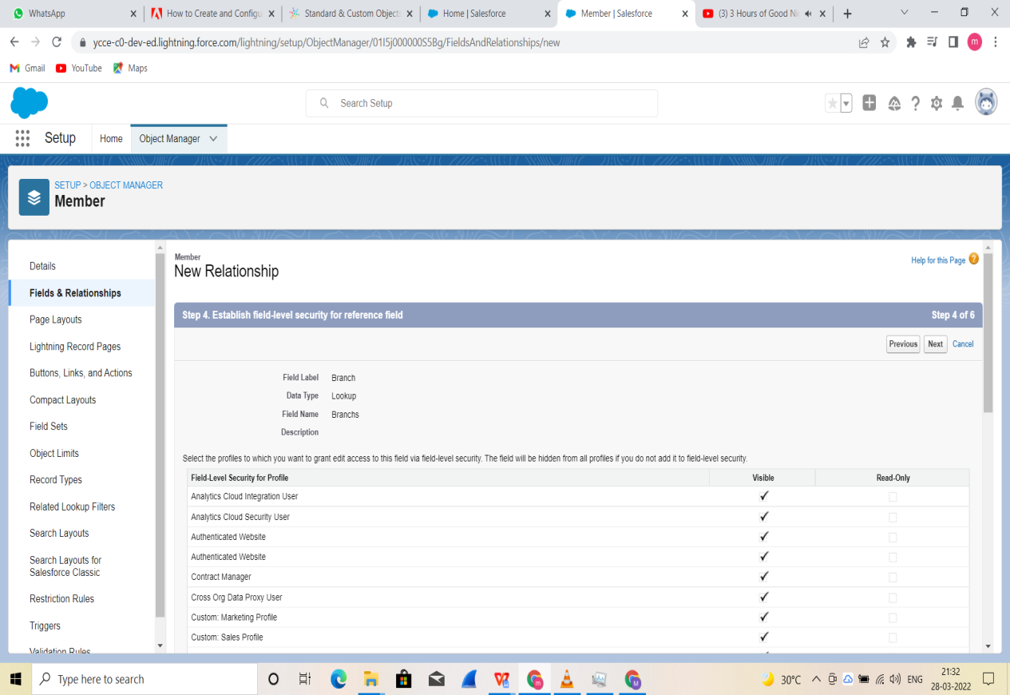

**Step 6:**

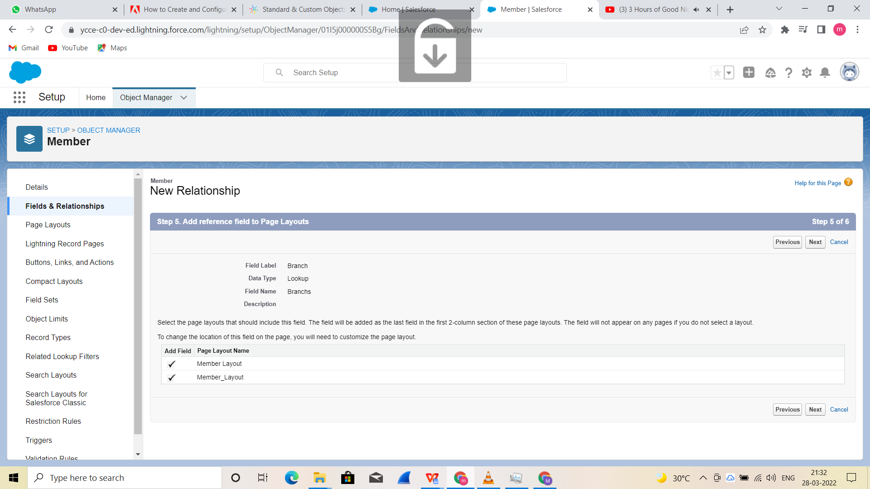

**Step 7:**

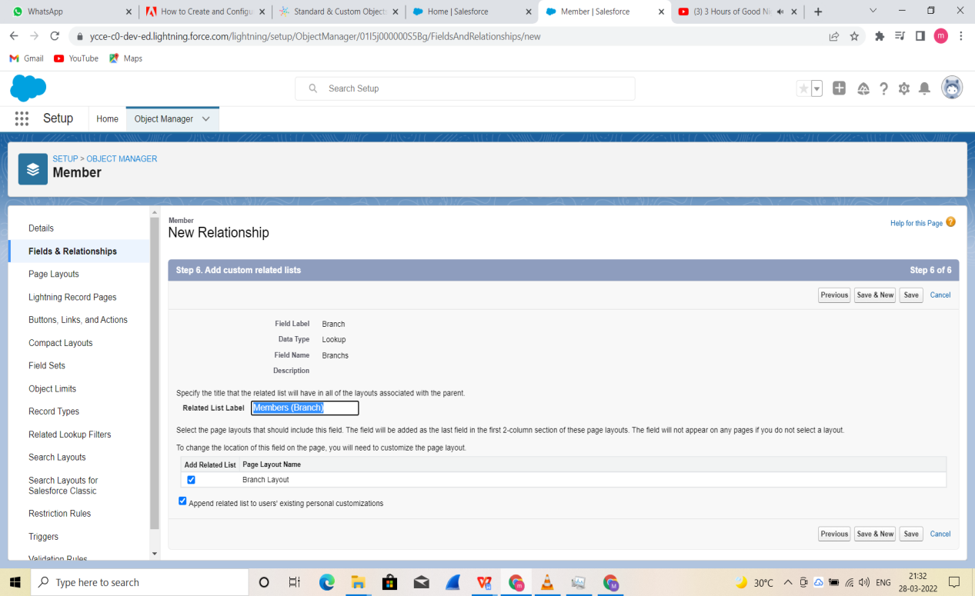

**Step 8:** A lookup relationship is created.

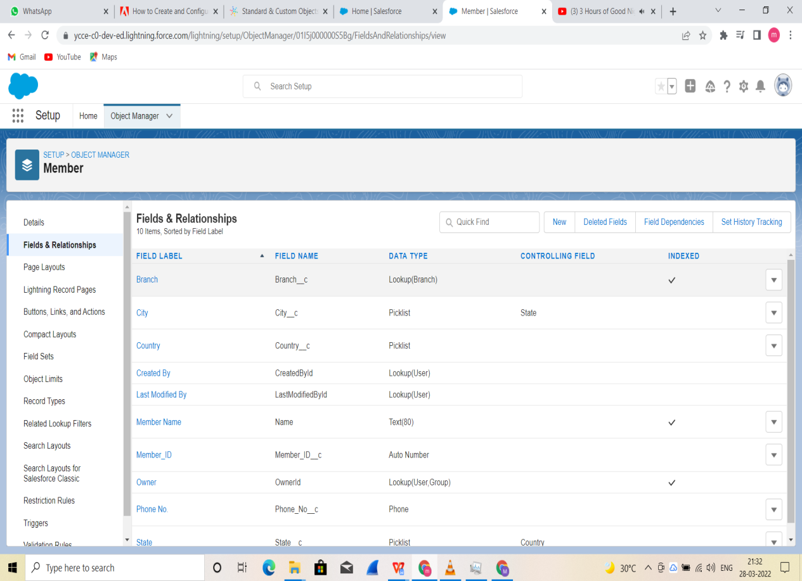

**Master Relationship steps:**

**Step 1:** Go to Object Manager and select Book Object.

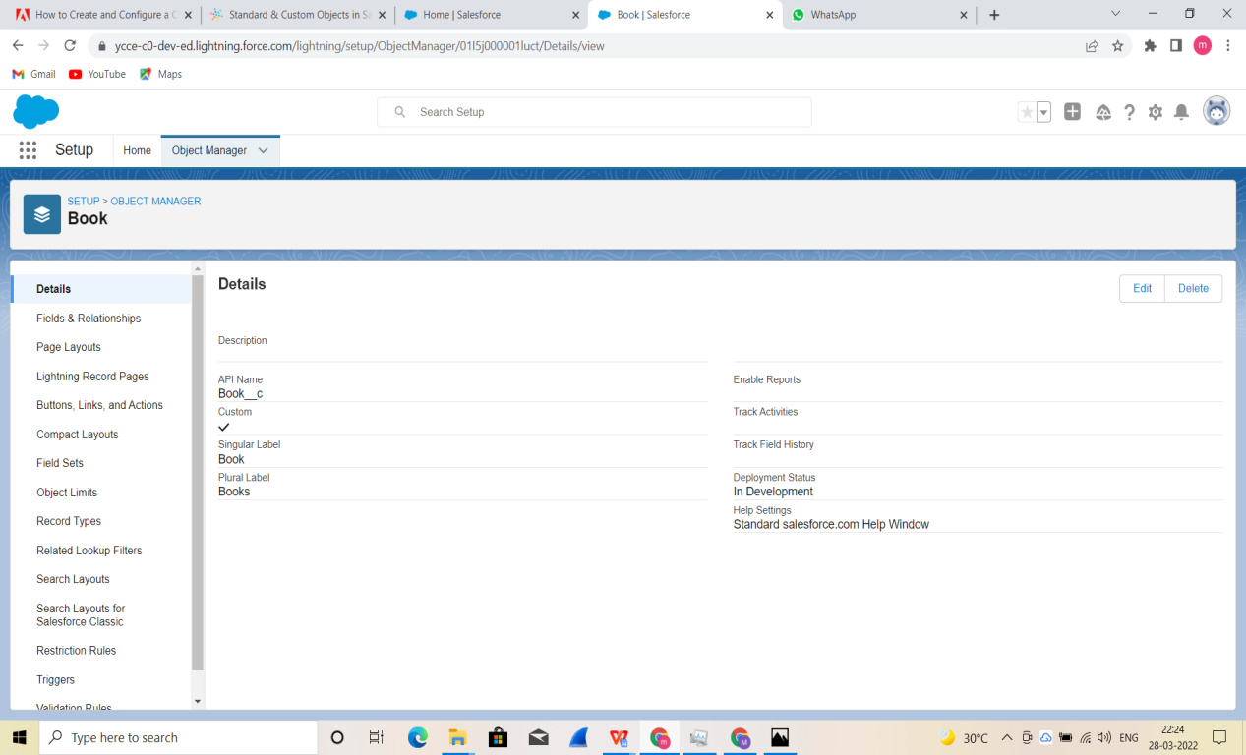

**Step 2:** Create new Field.

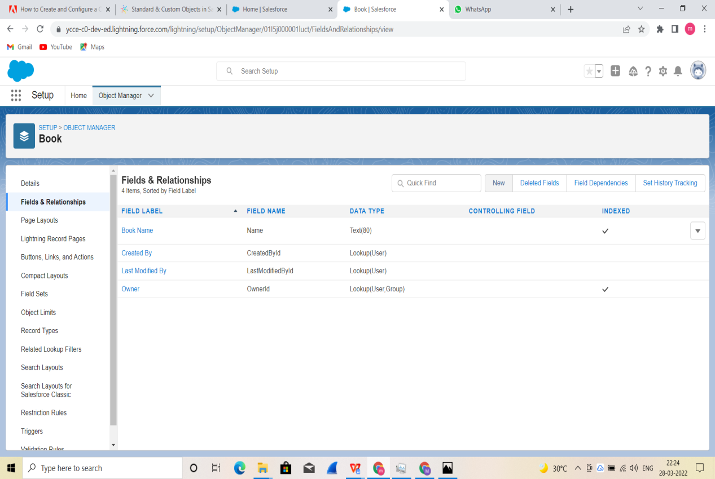

**Step 3:** Select Master-Detail Relationship.

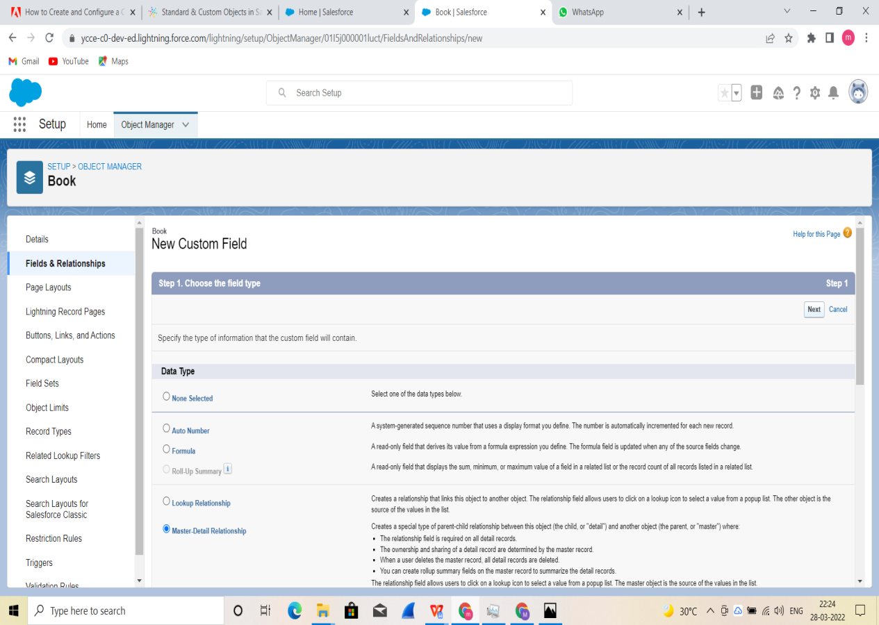

**Step 4:** Select Branch for related to field.

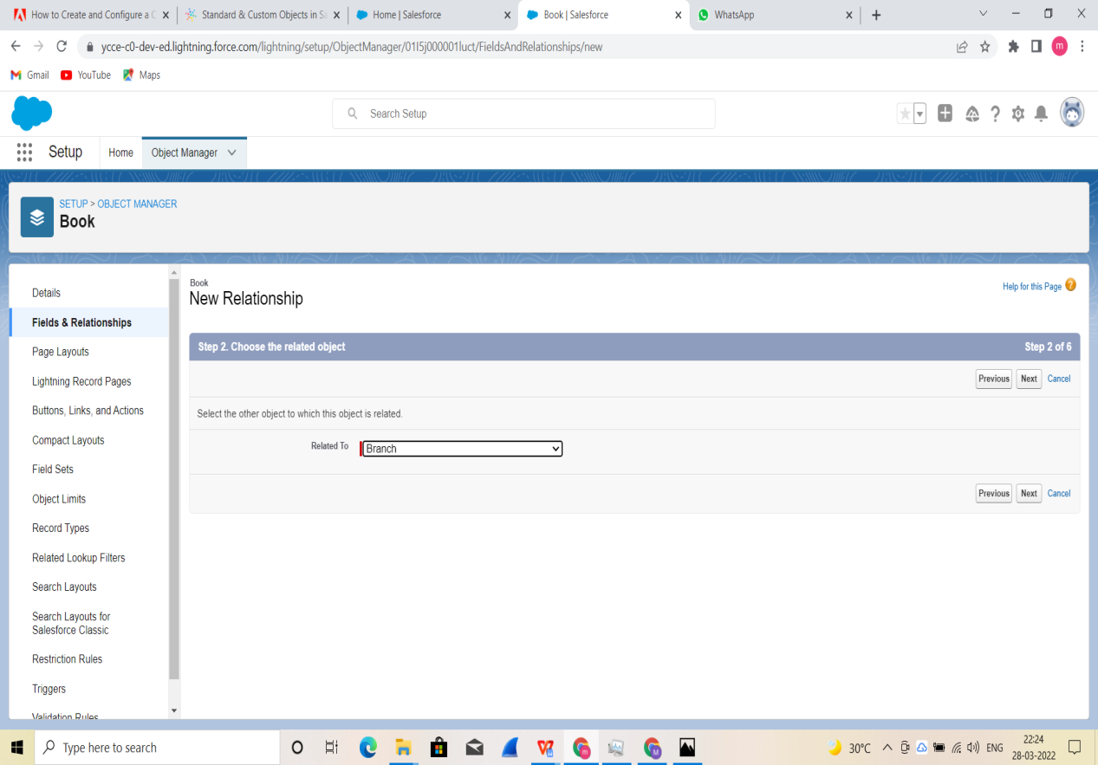

**Step 5:** Fill all the fields.

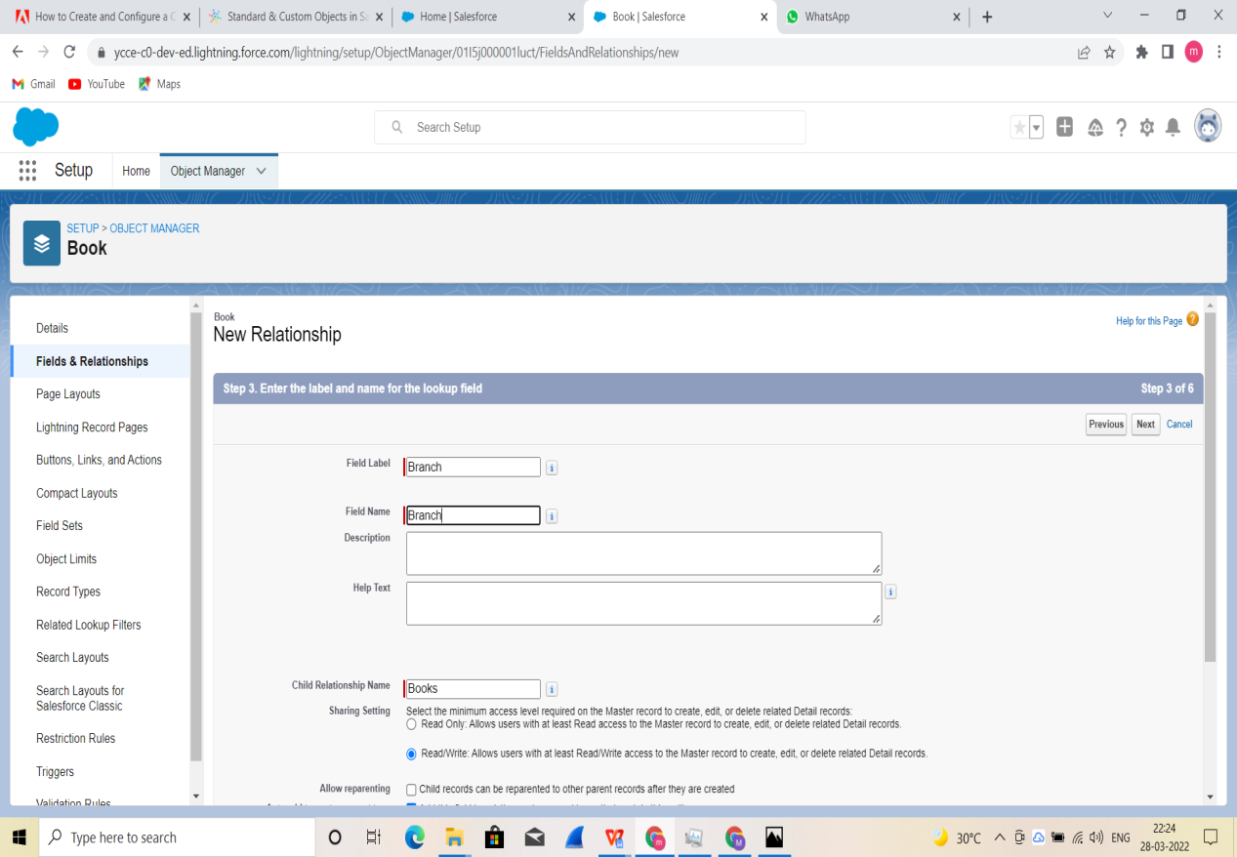

**Step 6:** Click save.

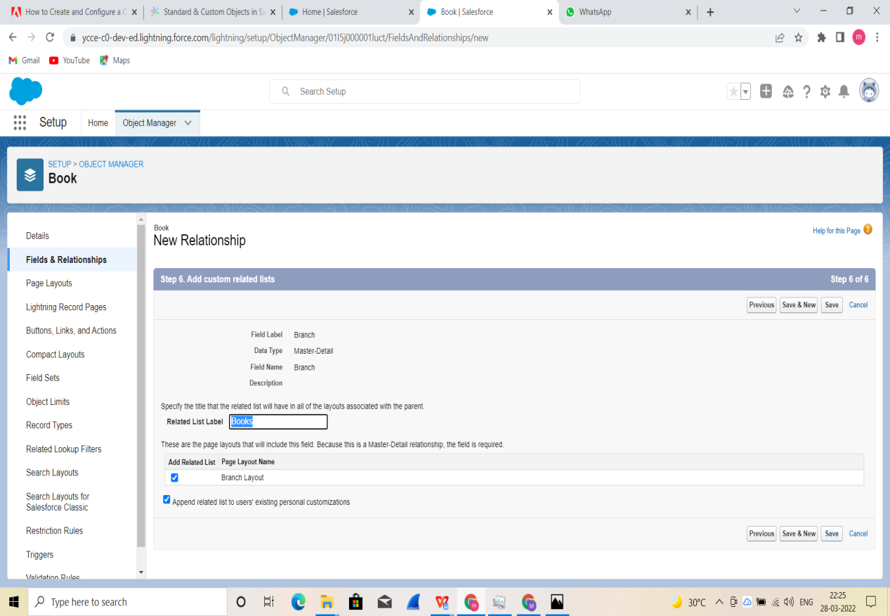

**Step 7:** A Master-Detail realtionship is created.

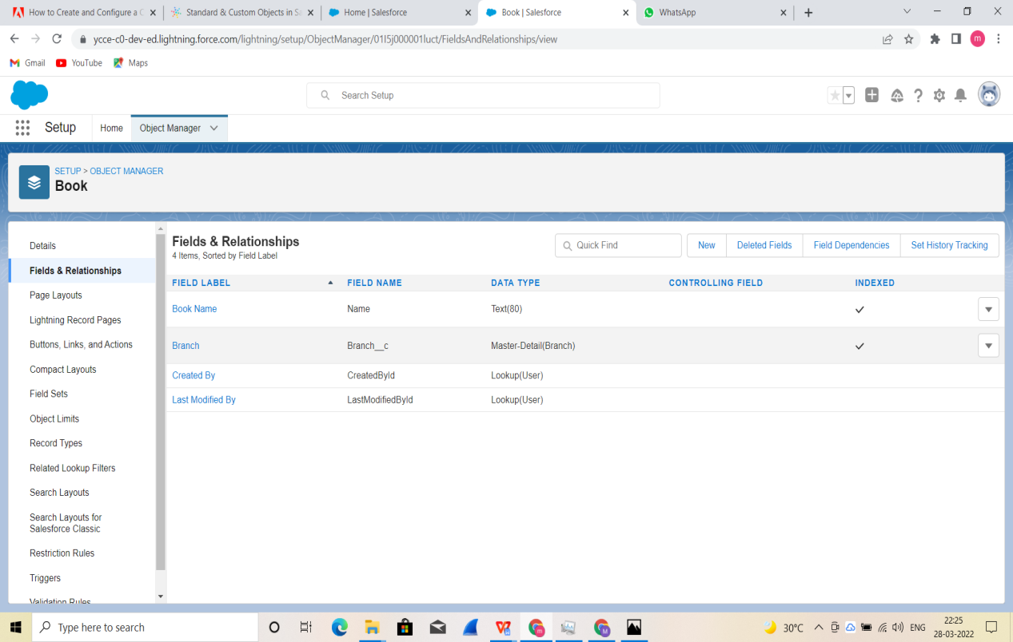

**CONCLUSION :** Hence we created a Lookup and Master-Detail realtionship in the org.

**Name : Prasanna Rajendra Anjankar Registration No : 19010886**

**Roll No : 65 Class : 6CTA**

**Course Name : CRM Course Code : CT2370**