**Practical No : 04** **A65_Prasanna Anjankar**

**AIM :** A] To implement formula field.

1. To form dependencies among fields.

**THEORY :** Salesforce Formula Field is a read-only field that derives its value from a formula expression you define. The formula field is updated when any of the source fields change. Sometimes we need to change the value based on the other source field value then we need a formula field.

* Formula Field in a read-only field.
* Formula Field derives the value from Formula expression.
* When the source field gets changed automatically the Formula field changes (Updated).
* The formula in Salesforce is used to calculate custom fields, validation rules, Flow logic, etc.
* Using Formula Editor, we create a formula in Salesforce.

**Screenshots:-**

**Step 1:** Create a Custom field with data type phone.

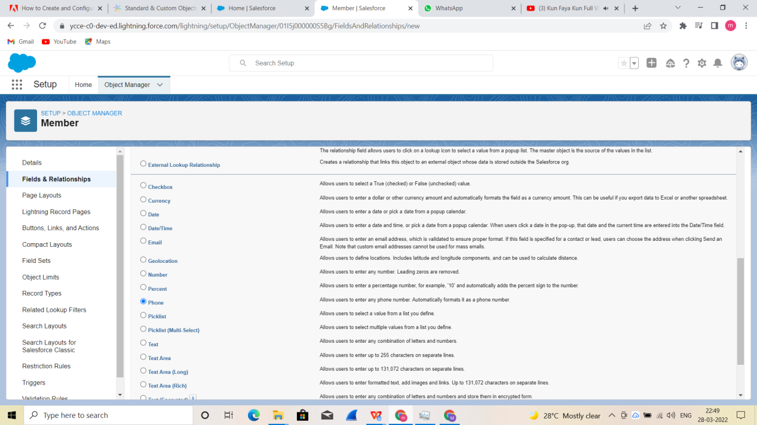

**Step 2:** A field “Phone No.” of type phone is created, then select validation rules.

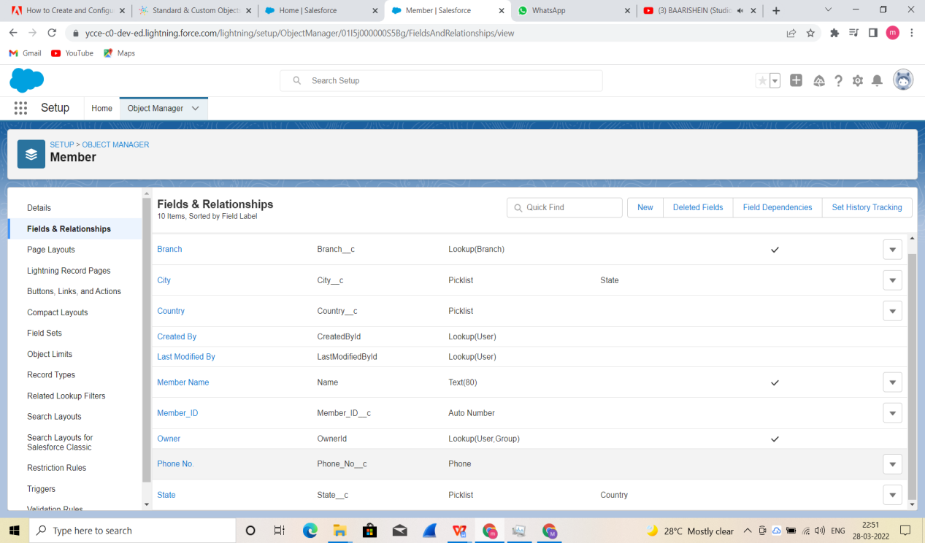

**Step 3:** Create new validation rule and use this formula for phone no. Validation,then click save and assign this validation to Phone No. Field.

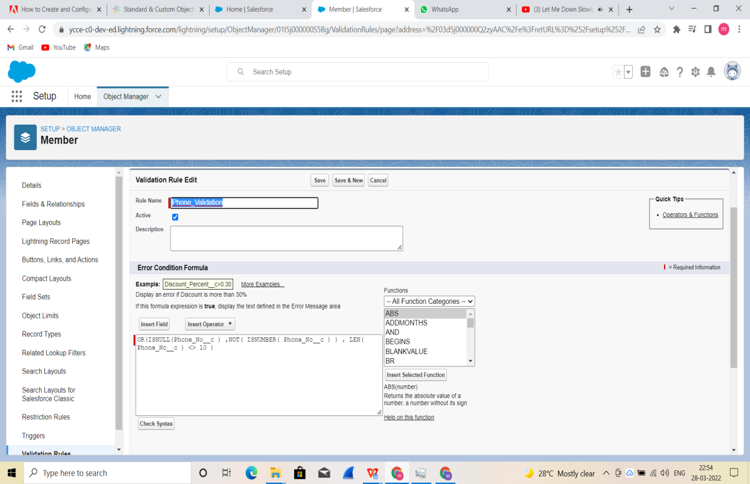

**B] To form dependencies among fields.**

**Field Dependencies in Salesforce** are the filters that allow user to change the contents of a picklist based on the value of another field.

**Example:** Here there are two field called Country and State. We have to display all states that are related to Country Field. Likewise, Districts that are related to States. Here one field is dependent on another field.

In Field Dependencies, we have to learn about two fields they are

1. **Controlling Field.**
2. **Dependent field.**

* **Controlling Field:** A controlling field is that which controls the available values in one or more corresponding dependent field.
* **Dependent Field:** A dependent field displays values based on the value selected.
* Custom picklists can be both Controlling and dependent field.
* Standard picklists field can only be used for controlling.
* Default values can be set for controlling field.
* We cannot set default values for dependent picklist.
* Multi Select picklists can be dependent.
* Controlling field must be added to page layouts.
* In controlling field, we can add up to 300 values.

[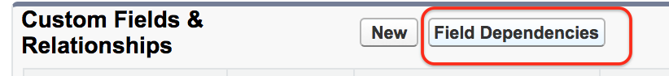](https://www.tutorialkart.com/wp-content/uploads/2017/02/Field-Dependencies-in-Salesforce.png)

* Click on Field Dependencies as shown above.

[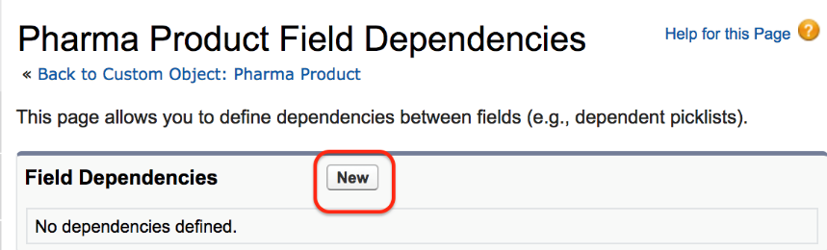](https://www.tutorialkart.com/wp-content/uploads/2017/02/Field-Dependencies-in-Salesforce1.png)

As there are no Field dependencies in the object click on New button.

[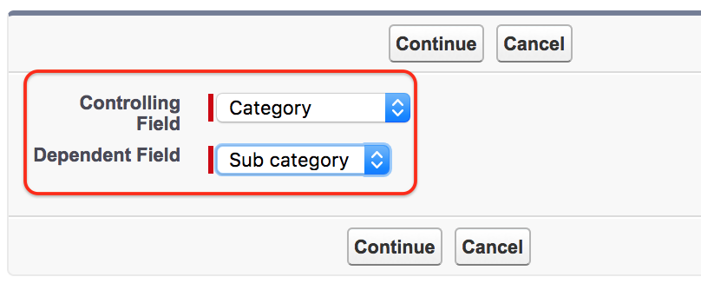](https://www.tutorialkart.com/wp-content/uploads/2017/02/Field-Dependencies-in-Salesforce2.png)

[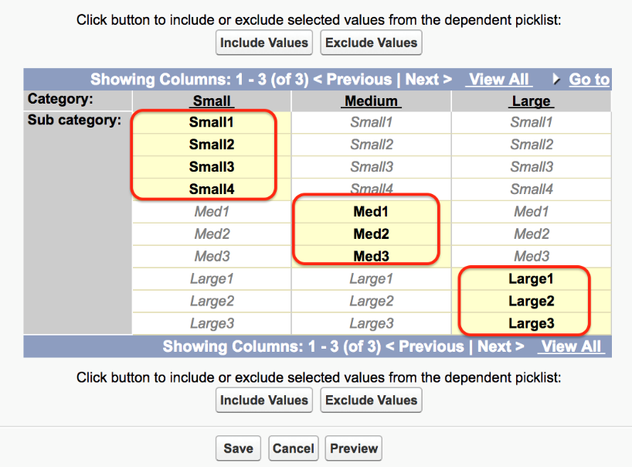](https://www.tutorialkart.com/wp-content/uploads/2017/02/Field-Dependencies-in-Salesforce3.png)

Now select controlling field and Dependent field. Here we have selected controlling field as Category and dependent field as Sub Category.

To includes values double click on the values. We have selected for category Small, Medium and Large. Finally click on **Save button.**

**CONCLUSION : Hence, we have learnt about Formula Field and Field Dependencies in Salesforce and applied them respectively.**

**Name : Prasanna Rajendra Anjankar Registration No : 19010886**

**Roll No : 65 Class : 6CTA**

**Course Name : CRM Course Code : CT2370**