**Practical No : 05** **A65_Prasanna Anjankar**

**Aim:** A. To study different layouts.

B. To implement a workflow.

**Theory:**

1. **To study different layouts:**

**There are two types of Layouts in Salesforce :**

1. **Page Layout**
2. **Compact layout**

**Page Layout:**

Page Layouts in Salesforce control the layout. It is a set of custom links, buttons, fields, S-controls, visualforce and [related lists](https://www.tutorialkart.com/salesforce/how-to-enable-field-history-tracking-in-salesforce/) on the object record page. Using ***Page Layouts in Salesforce*** we can determine which fields are set to visible, read-only and mark that field as required

In Salesforce.com, when we open a particular record all the fields that are associated with that object are listed down. If we want to customise the visual appearance of the field, modifying the page layout. Every object in Salesforce, Standard objects or [Custom object](https://www.tutorialkart.com/salesforce/how-to-create-salesforce-custom-objects/) should have one minimum Page Layout which is called default page layout. A page layout gets created default when we create an object in Salesforce.

* Page Layouts in Salesforce is created with Object name by default.
* There will be one minimum page layout for every object by default.
* Multiple page layout can be created to an object.

What you see when you log in to Salesforce for the first time is just the start. You can customize and personalize many things on a given object record page using page layouts.

The page layout editor lets you:

* Control which fields, lists of related records, and custom links users see
* Customize the order that the fields appear in the page details
* Determine whether fields are visible, read only, or required
* Control which standard and custom buttons appear on records and related lists
* Control which quick actions appear on the page

**Compact Layout:**

A compact layout displays a record’s key fields at a glance in the Salesforce mobile app, Lightning Experience, and in the Outlook and Gmail integrations.

Compact layouts are used to display the key fields of a record whenever the minimum required details of the record is needed. Compact layouts control which fields users see in the highlights panel at the top of a record.

In Lightning Experience, up to the first seven fields in a compact layout appear in the highlights panel of an object record.

Creating and customizing compact layouts for objects isn't required, because system defaults are provided out of the box. However, we recommend using compact layouts to put important fields into object record headers—and elsewhere—to help your users get the information they need quickly.

In the Salesforce mobile app, the fields that you assign to a compact layout appear in:

* An object record’s highlights area (shows up to ten fields)
* Expanded lookup cards on a record’s related information page (shows the first four fields)

In Lightning Experience, up to the first seven fields in a compact layout appear in the highlights panel of an object record. (On smaller screens, the highlights panel displays fewer fields.) When a user hovers over a lookup relationship field on the object record page, a highlights panel for that field also displays the first seven fields from the compact layout. Highlights panels display the first field from the compact layout at the top in an accented font.

1. **Workflows in Salesforce:**

Workflow in Salesforce is a force.com platform business logic engine that allows you to define rules to automate certain actions when a particular criteria is met.

Workflow rules are considered as a container that consists of two components:

a. Criteria:

It consists of the condition which if found true then the actions should take place.

b. Actions:

It consists of the actions that should be performed when the criteria for workflow rule are met.

Every Workflow rule must be based on a single object because when a rule is defined this object influences the fields that will be available to set the criteria.

There are 3 types of evaluation criteria for Workflows in Salesforce:

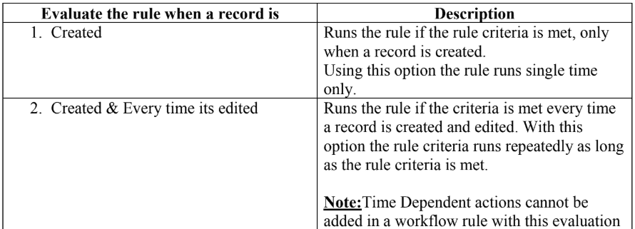

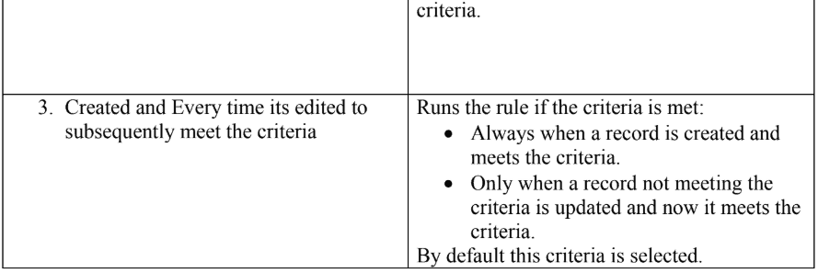

Criteria for rules can be represented as a condition or a formula. Actions in workflow rules are of 2 types based on when they are executed:

### **1. Immediate Actions:**

These actions are executed immediately when the criteria for a rule is met.

### **2. Time-Triggered Actions:**

These actions execute at a specific time which is specified when creating this type of action.

In these types of actions when the date or time comes on which the action needs to be executed, it again verifies that the record is still meeting the criteria or not. If yes then it executes the respective action otherwise not.

**There are 4 actions which can be specified in a workflow rule:**

### **1. Email Alert:**

It sends automated emails using an email template.

Salesforce provides functionality to create email templates that can be used to send emails.

There are 4 types of Email templates:

#### **Text:**

#### All users can create or change text email templates.

#### **HTML with letterhead:**

#### Administrators and Users with “Edit HTML Templates” permission can create HTML email templates based on a letterhead.

#### **Custom HTML:**

Administrators and users with “Edit HTML Templates” permission can create HTML email templates without using a letterhead.

#### **Visualforce:**

Administrators & Developers can create templates using Visualforce.  Visualforce email templates allow for advanced merging with a recipient’s data where the content of a template can contain information from multiple records.

[Email templates](https://help.salesforce.com/articleView?id=admin_emailtemplates.htm&type=5) are stored in folders. There are 2 folders already present in every Salesforce org:

#### **Unified public Email Templates**

Email Templates in this folder are available to every user in the organization.

#### **My Email Templates**

This folder stores the email templates which are used personally by a particular user.

### **2. Field Update:**

Field updates allow automatic change of a field value on the record that initially triggered the workflow rule. If “Re-evaluate Workflow Rules after Field Change” is enabled for a field update action then Salesforce re-evaluates all workflow rules on the object if the field update results in a change to the value of the field.

Only workflow rules that didn’t fire before will be retriggered. Cross Object field updates are also available for changing the values of fields on a related master record. But it is not available when re-evaluation is checked.

### **3. Tasks:**

It simply assigns a task to a single user, owner, or a role. We can also make sure that a notification email is sent to the assignee when a task is automatically assigned. Tasks should be assigned to roles if they have only one user assigned to that role. If there are more than one user assigned to that role then the task automatically gets assigned to the owner of the workflow rule Users who triggered the workflow rule.

### **4. Outbound Message:**

An outbound message sends particular information to a designated endpoint such as an external service. These types of messages can be listened to using a SOAP API.

All the above actions can be used as an immediate action as well as time trigger actions. Time-triggered actions which are already triggered are visible in Time Based Workflow Queues.

Administrators can also set default workflow users. Default Workflow users are the users that will be visible when the user that triggered the rule is not active.

**Screenshot Of Execution :**

**A.Page Layout:s**

**Step 1: First login to your Salesforce account, and in your Salesforce org, click on Setup.**

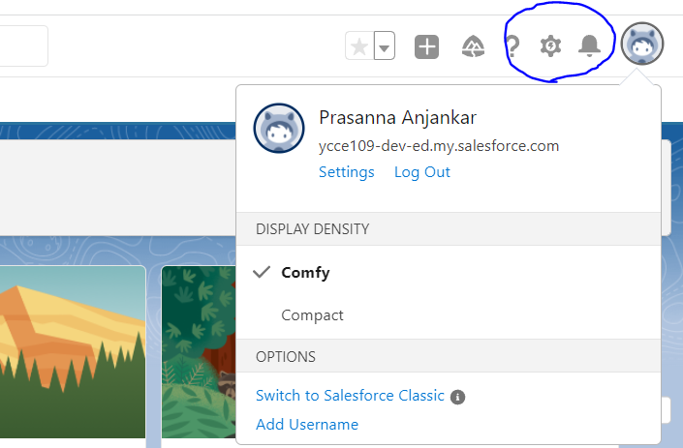

**Step 2: Click on the Object Manager tab. If you couldn’t find it, use the Quick Find Box to find it.**

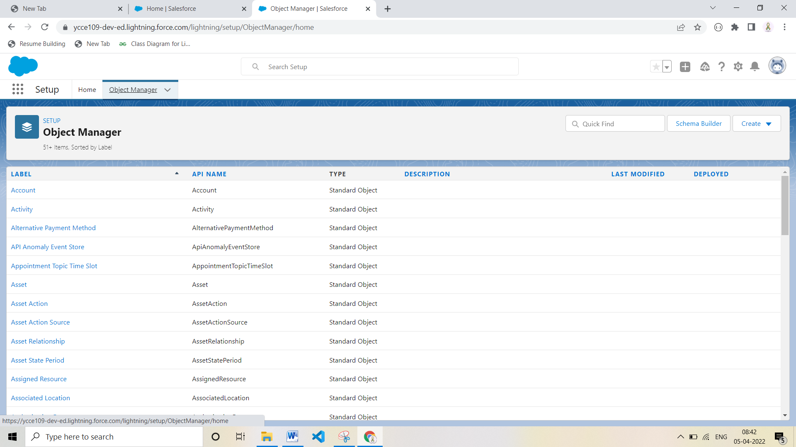

**Step 3: Select Member Custom Object.**

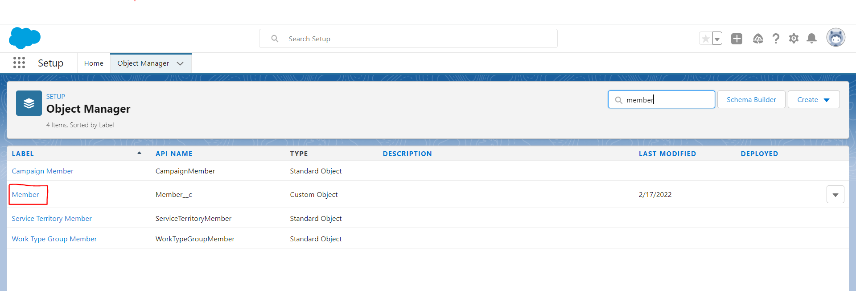

**Step 4: Select Page Layout**

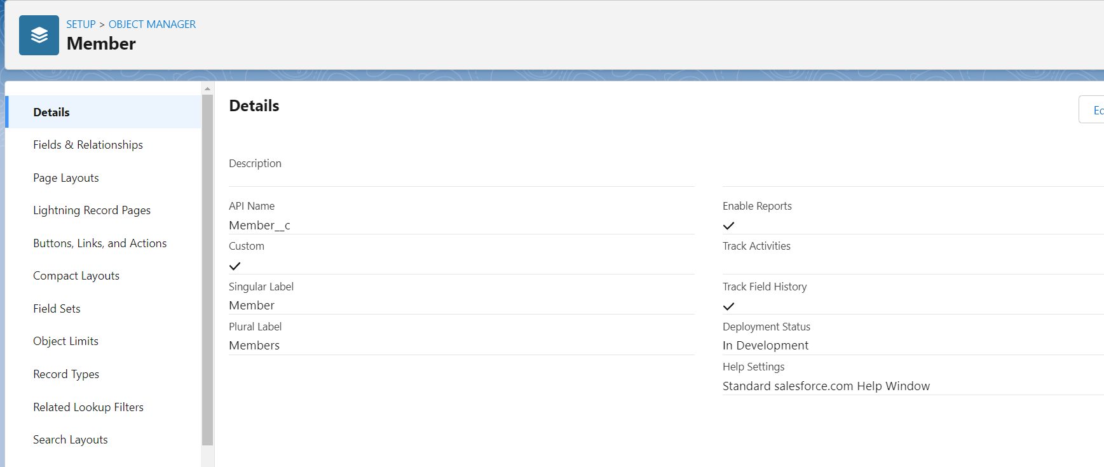

**Step 5: Click Member Layout.**

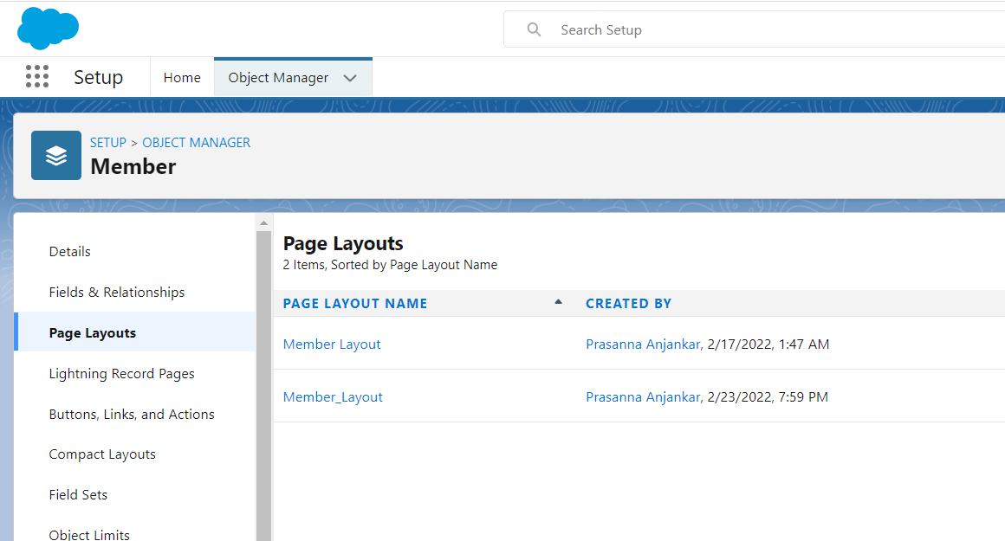

**Step 6: Change the Member Details Layout and Save.**

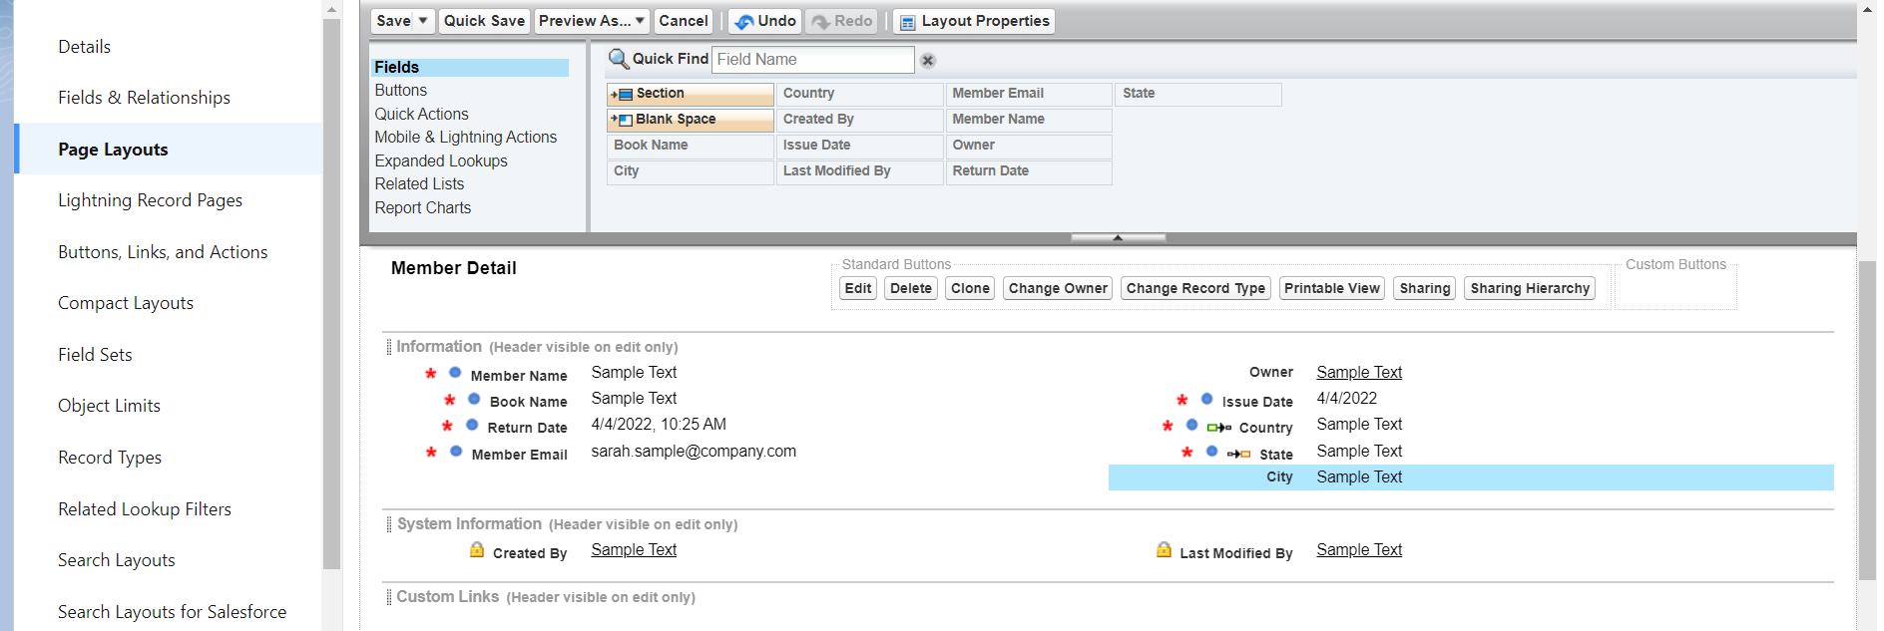

**Step 7:Members Page Layout**

**Before**

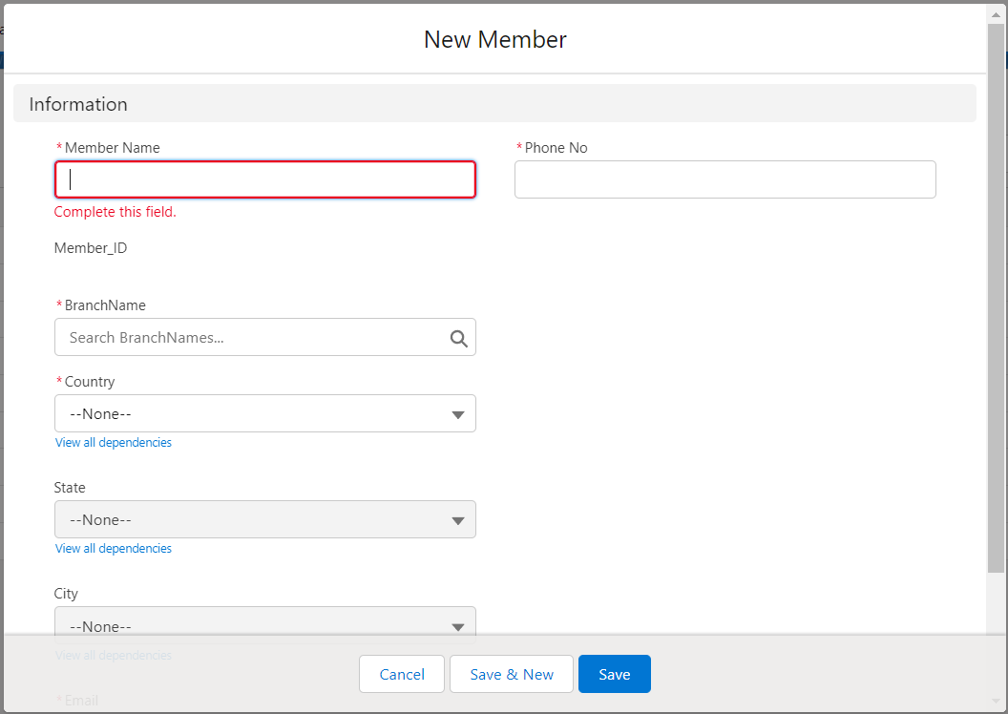

**After**

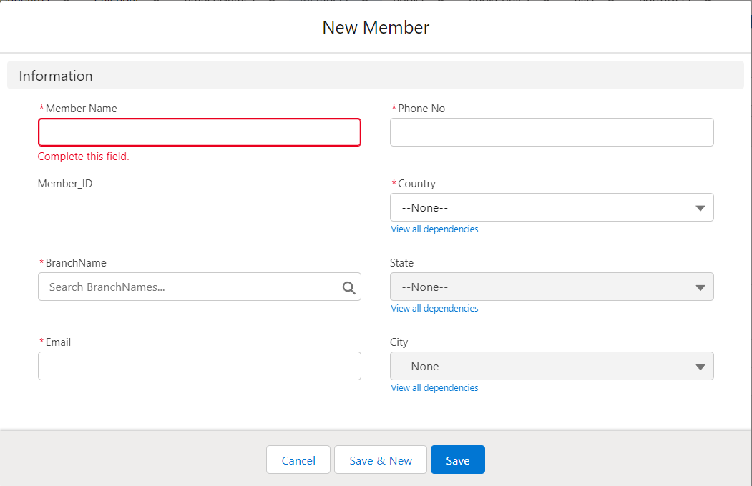

**B.Compact Layout:**

**Step 1: First login to your Salesforce account, and in your Salesforce org, click on Setup.**

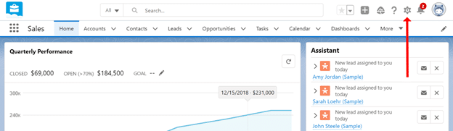

**Step 2: Click on the Object Manager tab. If you couldn’t find it, use the Quick Find Box to find it.**

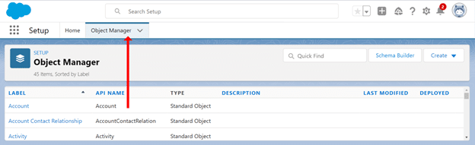

**Step 3: Select Member Custom Object.**

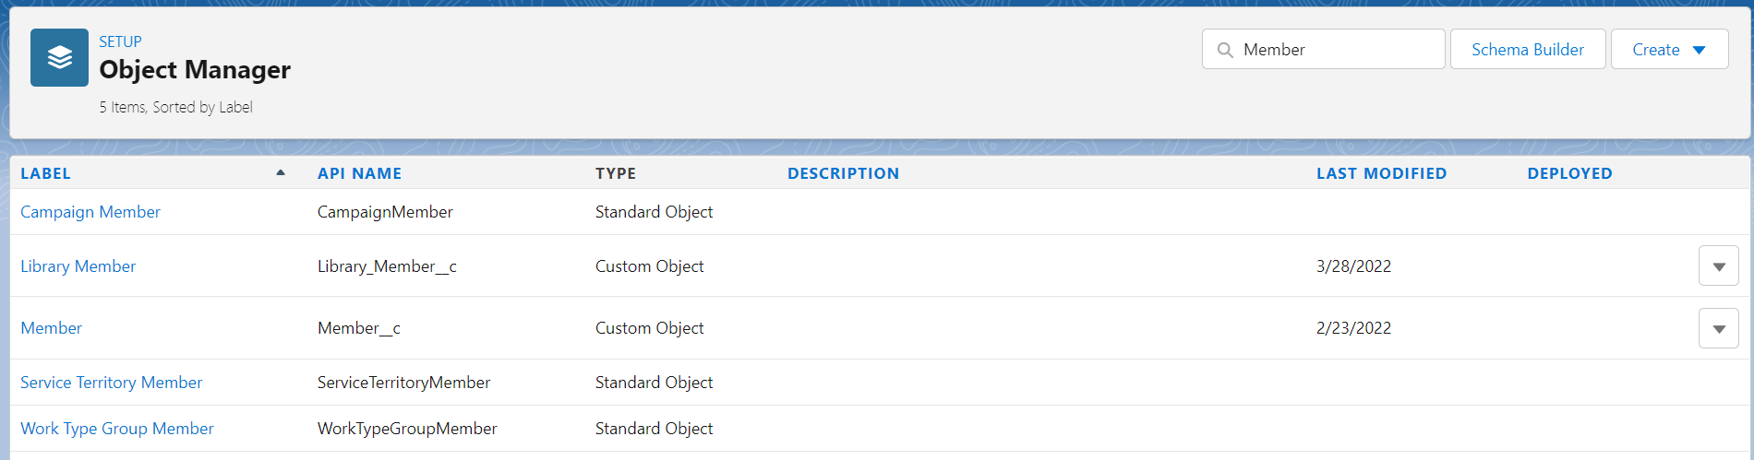

**Step 4: Select Compact Layout**

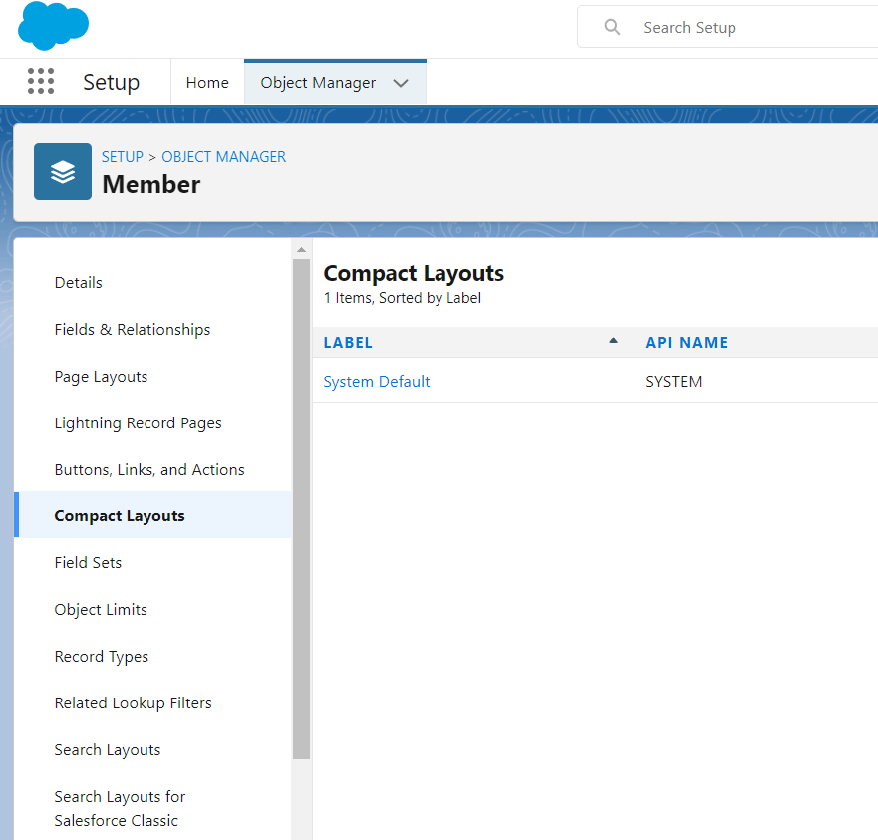

**Step 5: Click New and create new compact layout and save.**

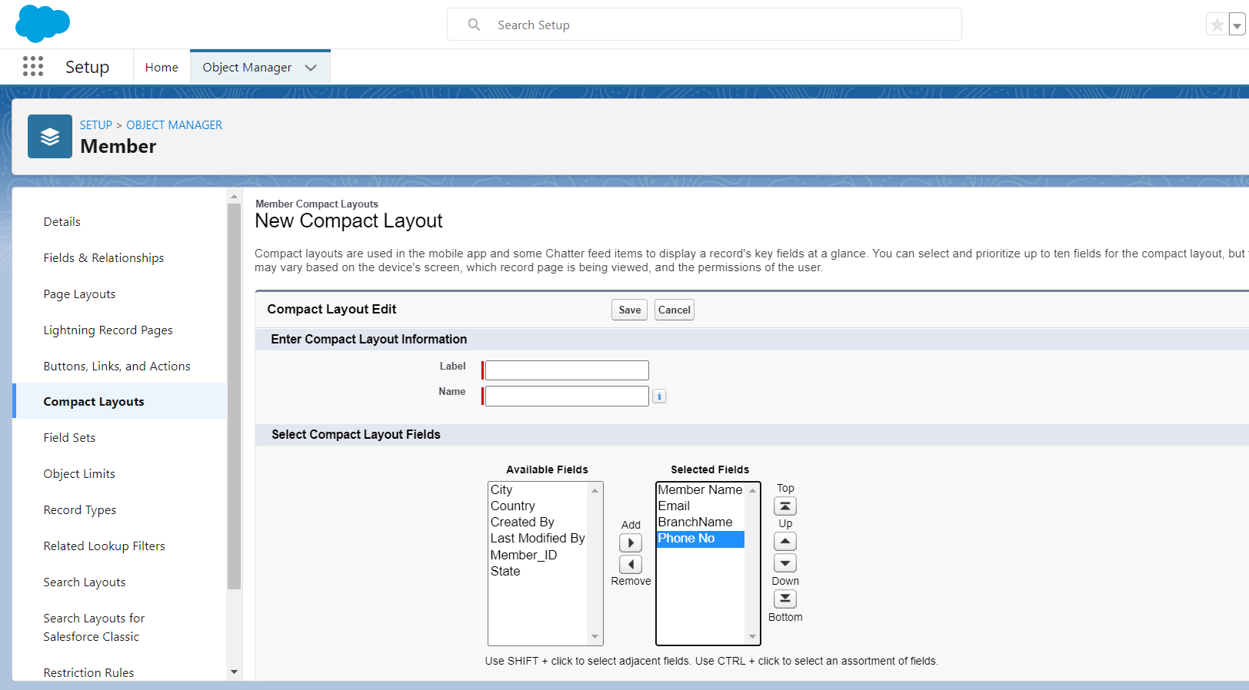

**Step 6: Select Compact Layout Assignment.**

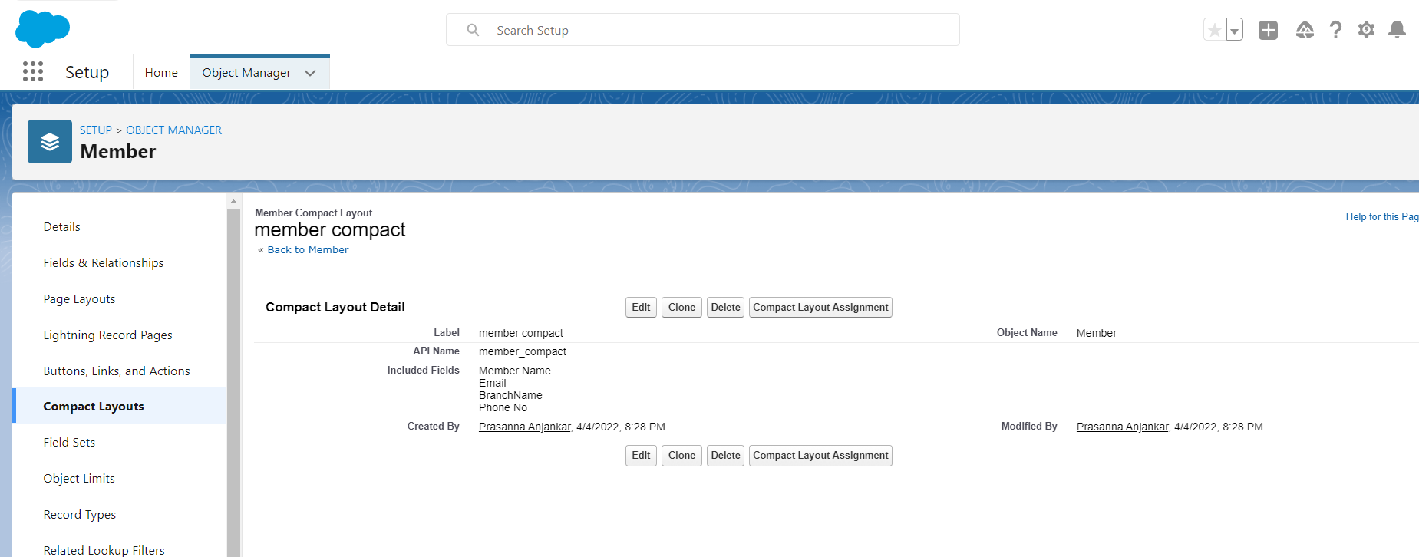

**Step 7: Select Member Compact Layout and Save.**

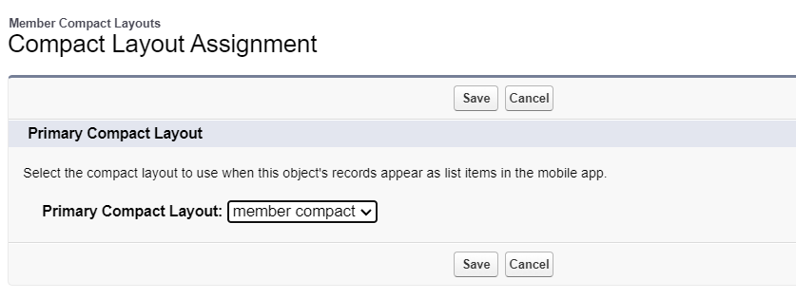

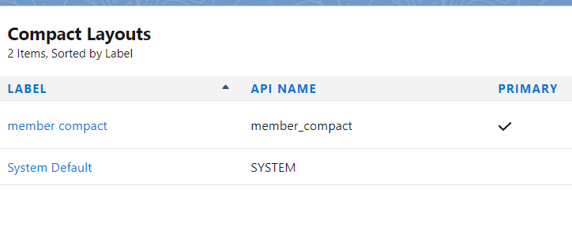

**8. Comparison**

**Before :**

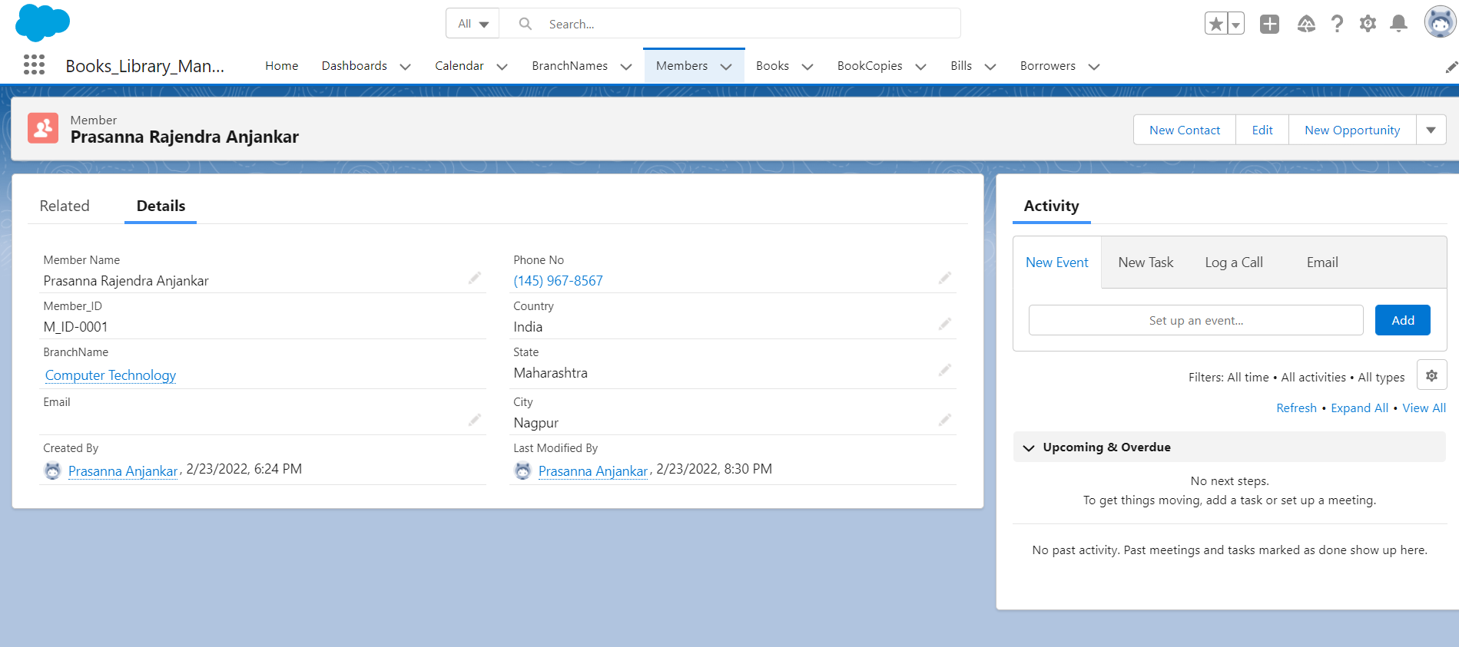

**After :**

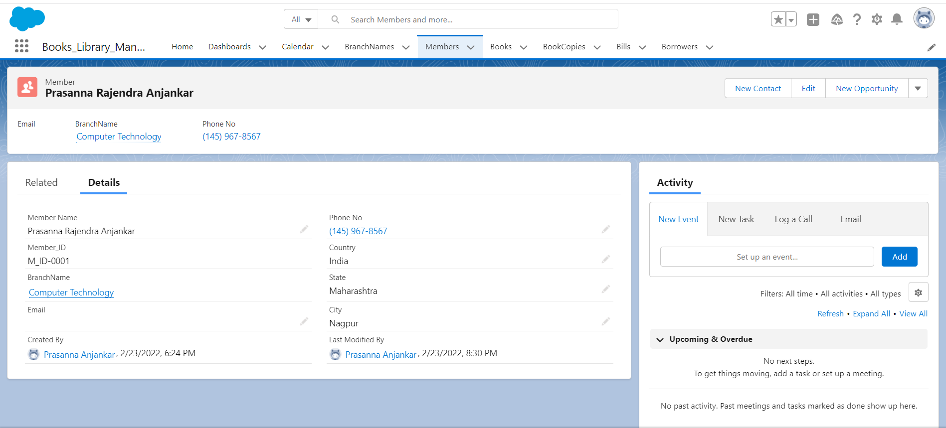

**C.Workflow:**

**Step 1: First login to your Salesforce account, and in your Salesforce org, click on Setup.**



**Step 2: Click on the Object Manager tab. If you couldn’t find it, use the Quick Find Box to find it.**



**Step 3: Search Email Alerts in Quick Find Box and Select Email Alerts and Click on New Email Alert and Click Save.**

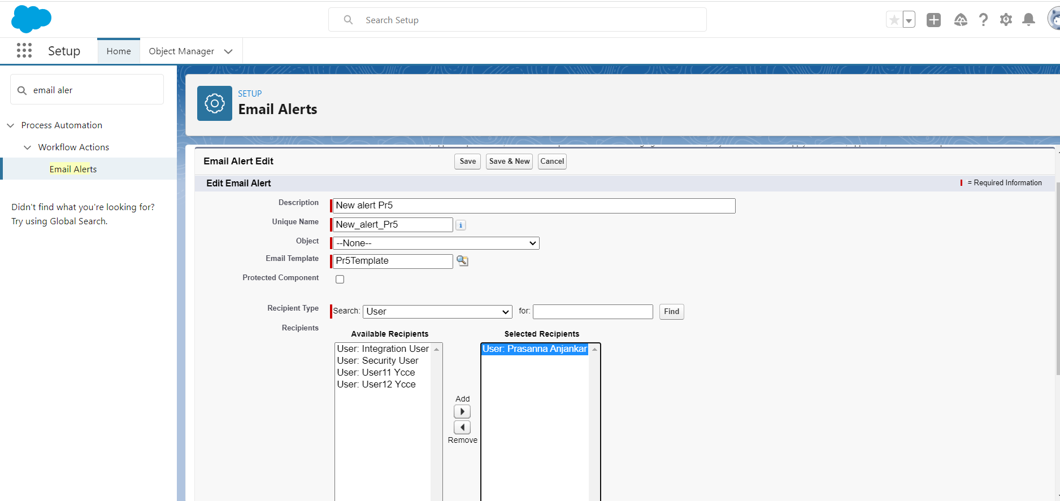

**Step 4: Search Process Builder in Quick Find Box and Select Process Builder .**

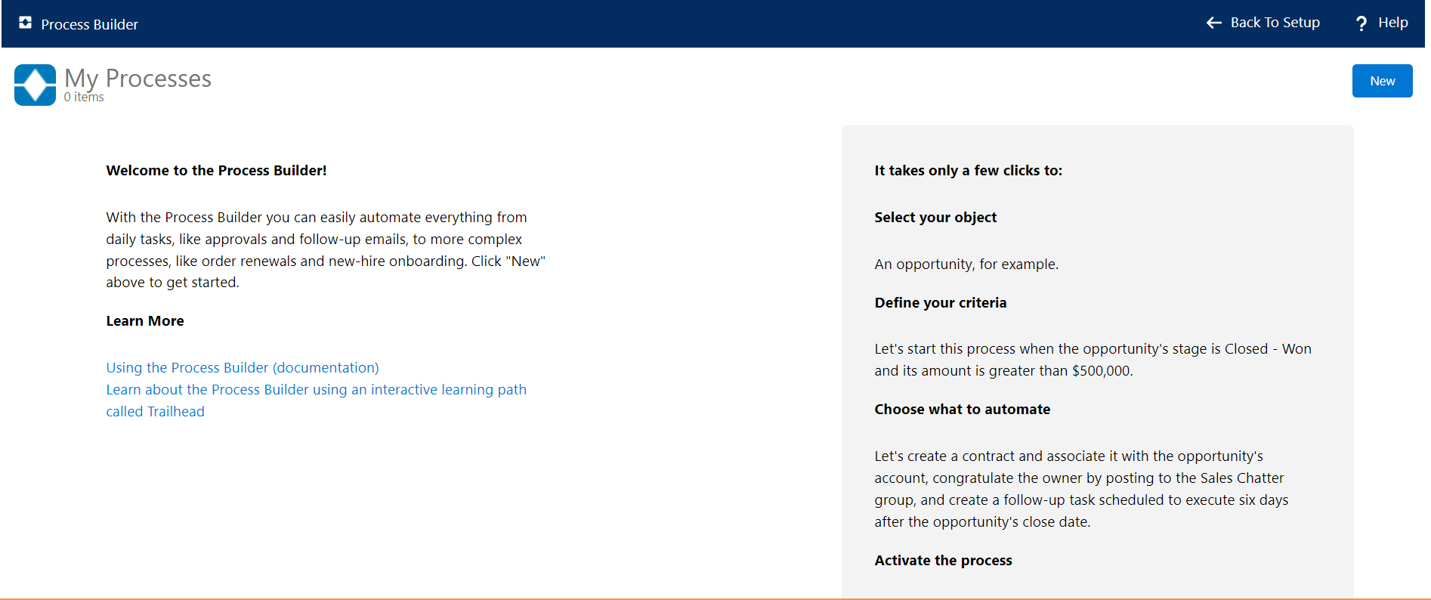

**Step 5: Click New and Click Continue to Process Builder and New Process Appears.**

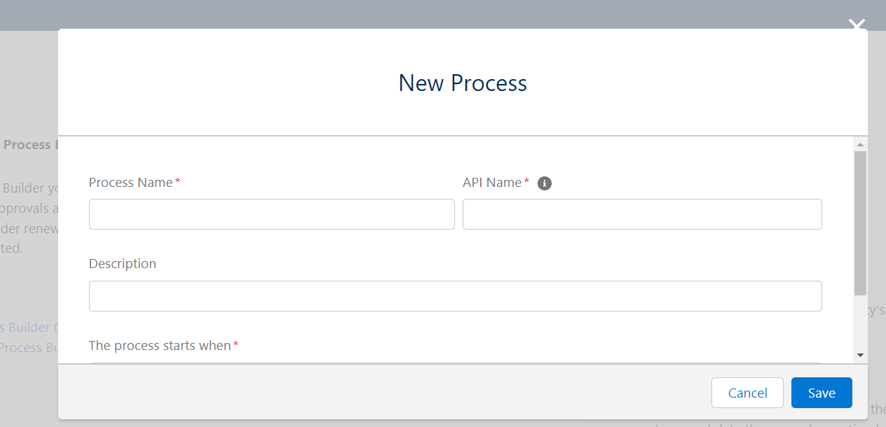

**Step 6: Enter Process Name and Save .**

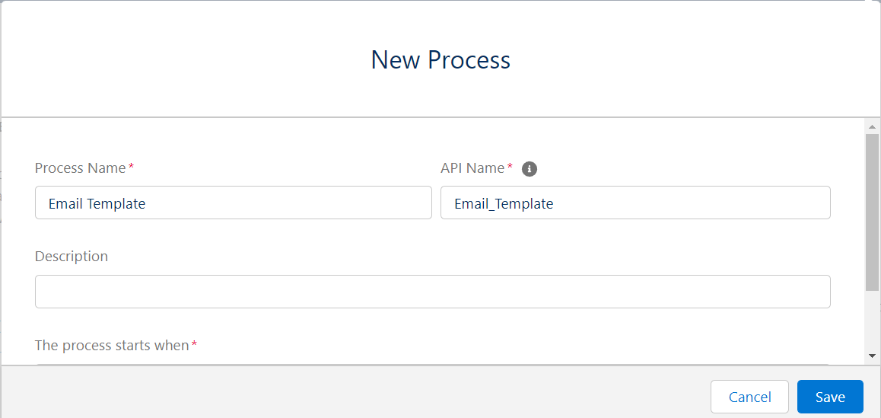

**Step 7:Create a Process Builder and Save and Activate.**

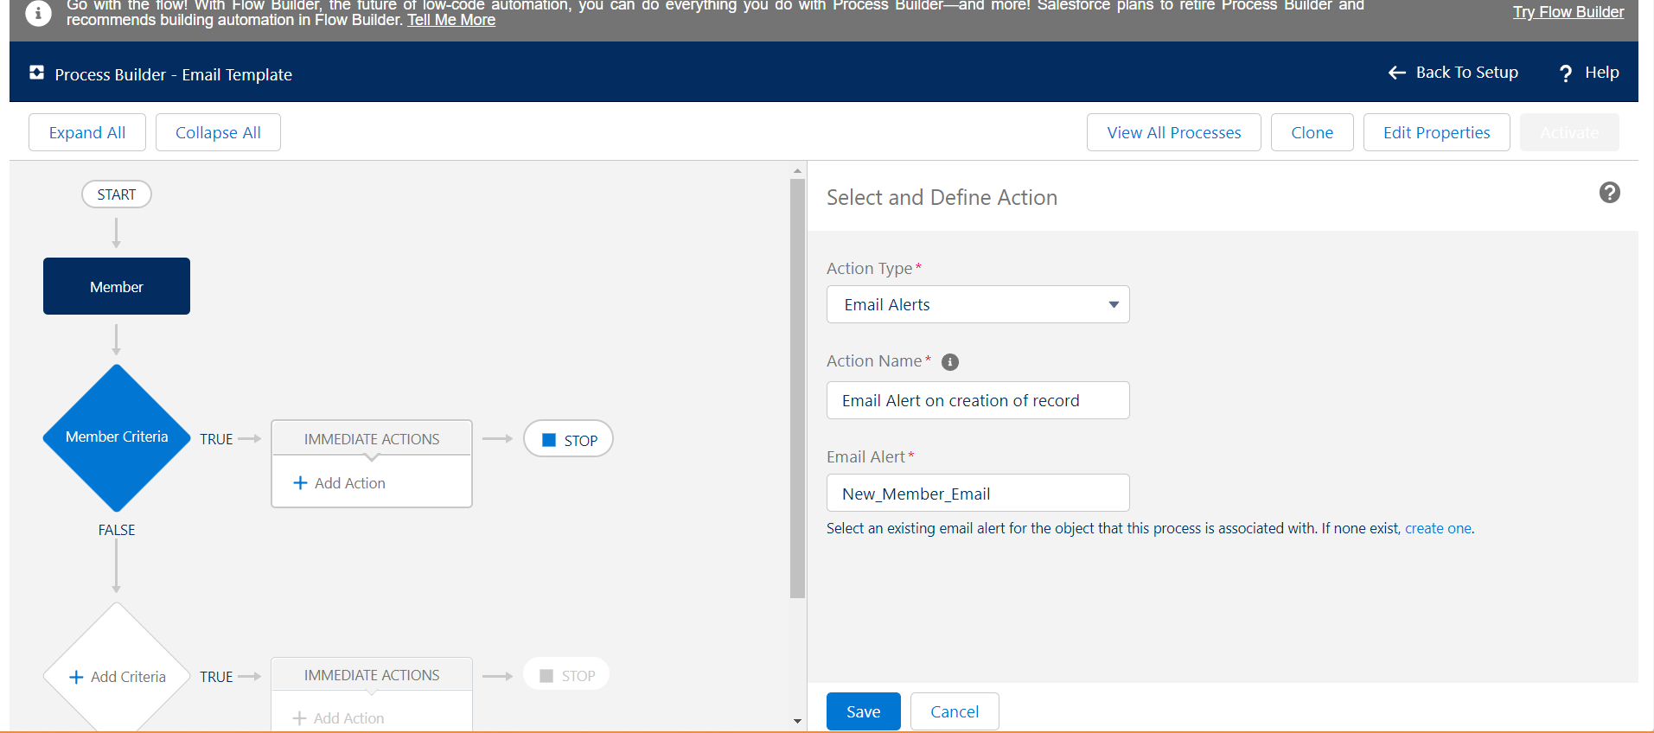

**Create a record of member and will receive a email alert.**

**Conclusion:** Thus,I have successfully studied different layouts and implemented Workflow on custom Member object on Salesforce Platform.

**Name : Prasanna Rajendra Anjankar Registration No : 19010886**

**Roll No : 65 Class : 6CTA**

**Course Name : CRM Course Code : CT2370**