**PRACTICAL NO : 06 A65_PRASANNA ANJANKAR**

**Aim:** Customize process flow using process builder.

**Theory:** Process Builder is an automated Salesforce tool that allows you to control the order of actions or evaluate the criteria for a record.

Process Builder gives you the ability to use straightforward ‘If/Then’ logic to easily add automation to your Salesforce environment. Process Builders consist of a triggering event, criteria, then an action that will take place (you can also make these time dependent).

For example, If a user updates a field/creates a new record that matches the criteria Then the system will trigger an action. The UI of Process Builder allows creators to ‘point and click’ to create automation which lends itself nicely for a technical Business Analyst or a less technical system admin persona – however, it doesn’t come with as many ‘bells and whistles’ as Flows.

**Limitations of Process Builder**

* Each Process Builder only relates to one object that you set up to start on
* Once you have the triggering object, you can only use child objects in relation to the current object
* Cannot delete records
* Cannot do more complex actions
* Actions are evaluated in the order they appear in process builder

**Key actions you can complete with Process Builder**

* Launch Apex *this will only show apex classes with an invokable method
* Updating a field
* Creating a record
* Sending an Email Alert
* Post to Chatter
* Processes * Allows you to launch invokable processes
* Quick Actions
* Quip
* Send Custom Notifications
* Send Survey Invitation
* Submit for approval

**Process Builder supports three types of processes for automation in Salesforce. These types determine what will trigger the process:**

• A change in a record starts whenever the record is updated or created.

• An event process starts whenever an event message is received.

• An invocable process starts whenever another process requests it.

**Each of the above-mentioned processes consist of:**

• Components of a Process

• Trigger in Process Builder

• Criteria in Process Builder

• Actions in Process Builder

• Process Types

**Components of a Process**

There are three major components of a process. The components include a trigger, minimum one criteria node, and at least one action.

**Trigger in Process Builder**

With the help of the trigger, you can identify when the process should start running.

Basically, the trigger helps in determining which objects and changes the process should pay attention to. The following are the changes that the process can pay attention to:

• Only at the creation of a record

• When a record is created or edited

**Criteria in Process Builder**

Criteria helps in determining whether or not the actions to be executed. When a process receives one trigger, multiple criteria nodes can be added. Each criteria node monitors and controls whether or not the associated actions will be executed by the process. The process skips the associated actions if the record does not meet the criteria and moves on to the next criteria node in the process. On the contrary, if the record meets the criteria, the associated action is executed.

**Each criteria allows you to do the following:**

• Set filter conditions.

• Give a customized formula. For example, in case of validation rules, the formula must arrive at the result of true or false.

• Always execute the associated actions repeatedly by opting out of the criteria in the

process.

**Actions in Process Builder**

Actions determine what the process should do. When a criteria node evaluates to true, the process executes the associated actions or waits to execute them at a scheduled time.

• As soon as the criteria evaluates to true, the action is immediately executed.

• There is a specified time when each scheduled action is executed. For example, eight

days before the date of record closure or two days from now. When this specified date arrives, Salesforce ensures that the associated criteria node still evaluates to true. If so,

then the scheduled action is executed. Schedule actions can be based on either of the

following:

▪ The particular or specified date or time field on the record when the process was

started.

▪ Duration or time for which the process ran.

**Process Types**

There are different process types that a Process Builder can automate. Some of the important process types are mentioned below:

• **Record Change:** A Process Builder starts the process when a record is created or edited.

• **Invocable:** The process is started, by Process Builder, when it is called by another

process.

• **Platform Event:** The process starts when a platform event message is received.

**Screenshots:**

**Step 1:** After logging in, Search for Process Builder in Search Bar.

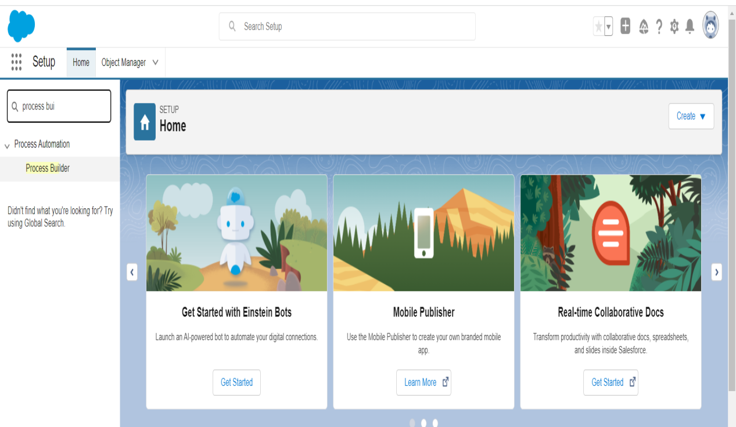

**Step 2:** After Entering the window of process builder click on new to create a new process builder.

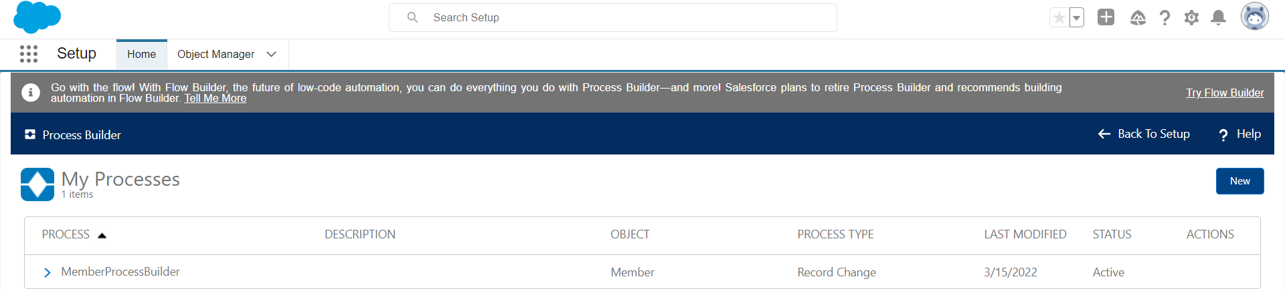

**Step 3:** Now, give your process a name and pick an option from picklist of “The Process starts when”.

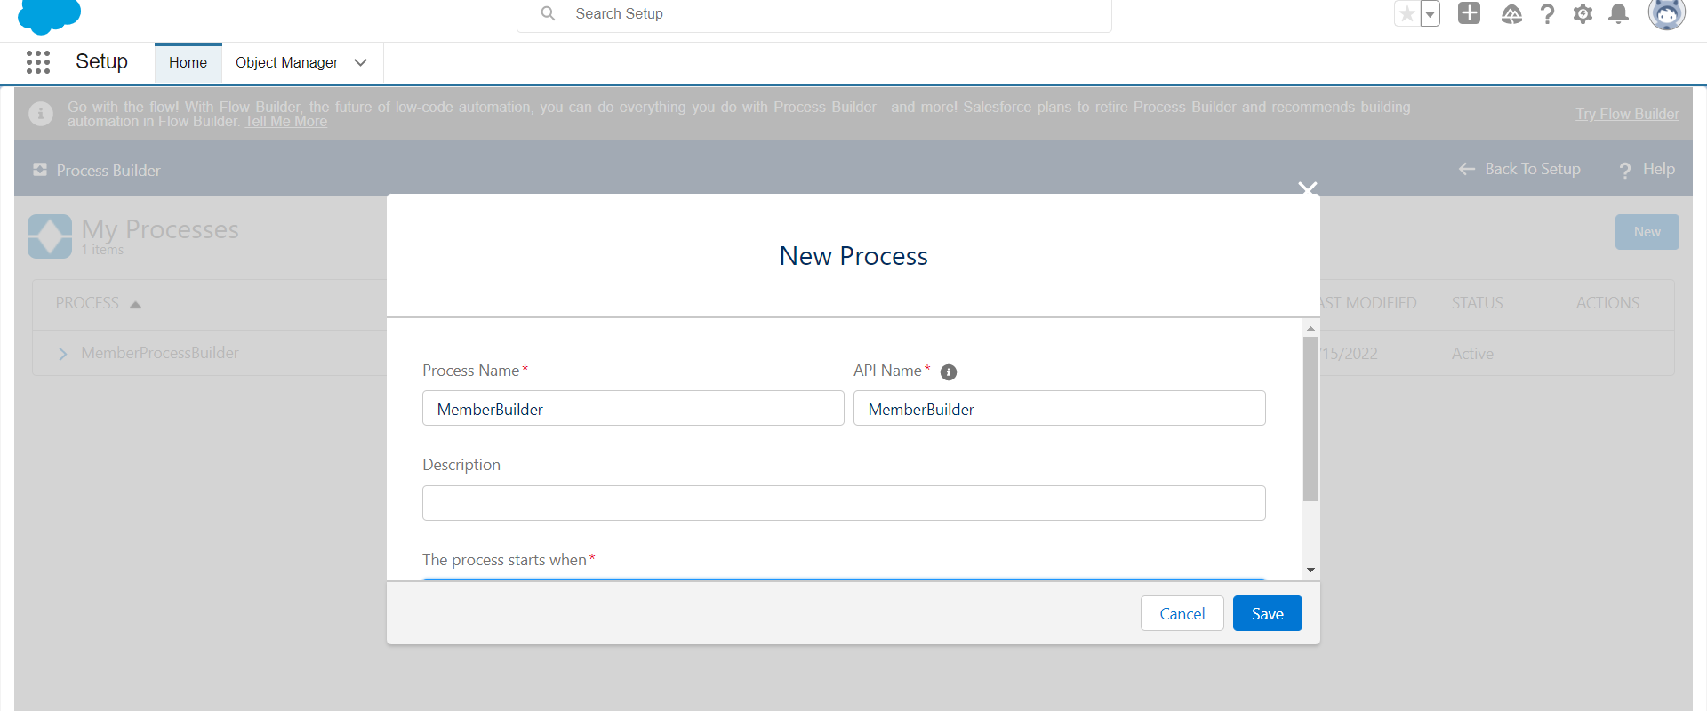

**Step 4:** Now, Step by Step complete the process builder. Click on add object and on the right hand side fill all the details.

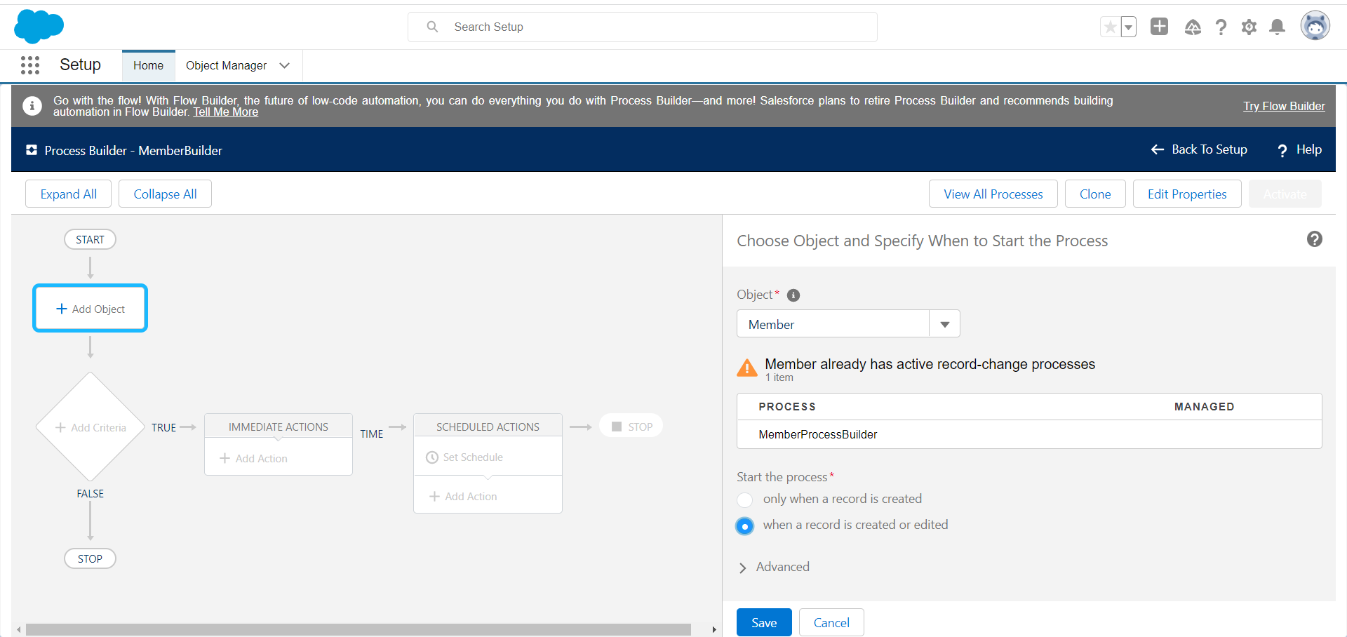

**Step 5:** Add a criteria.

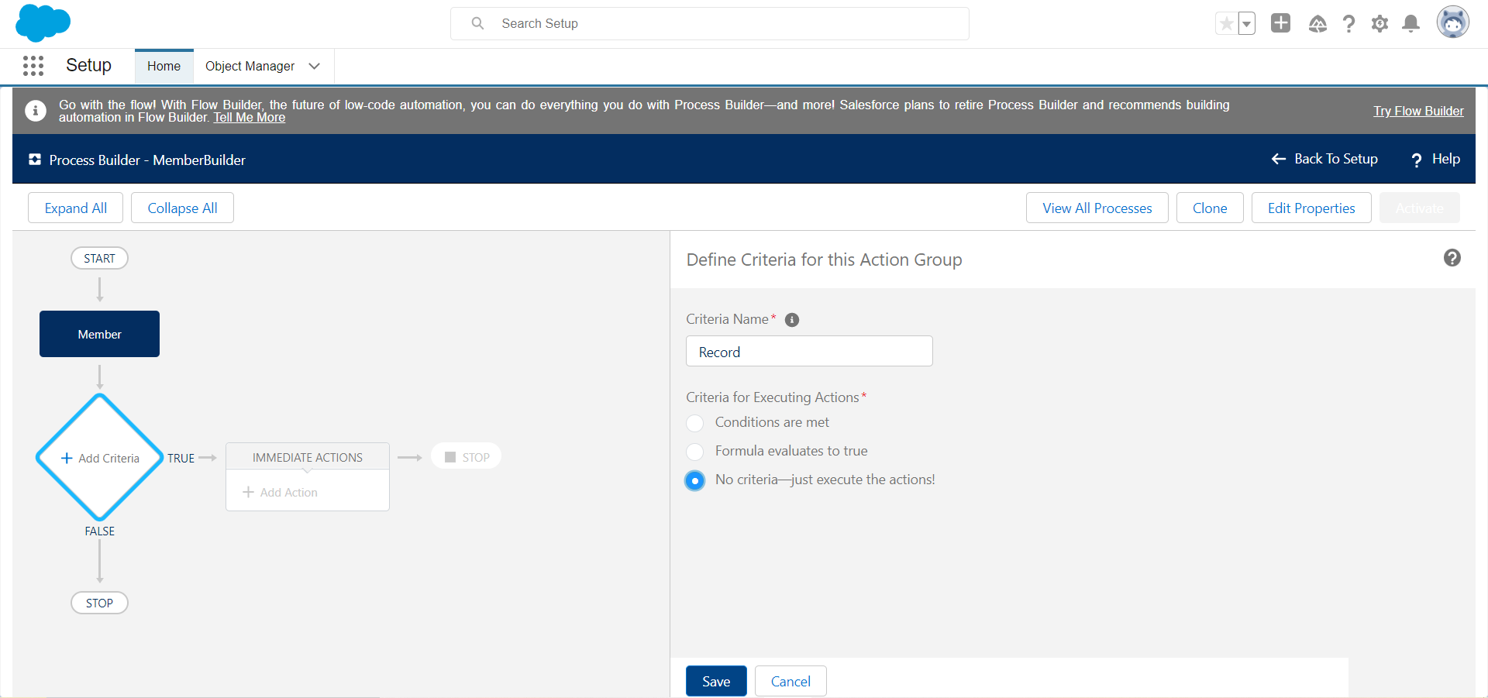

**Step 6:** Add an immediate action and click on save ,Finally click on activate.

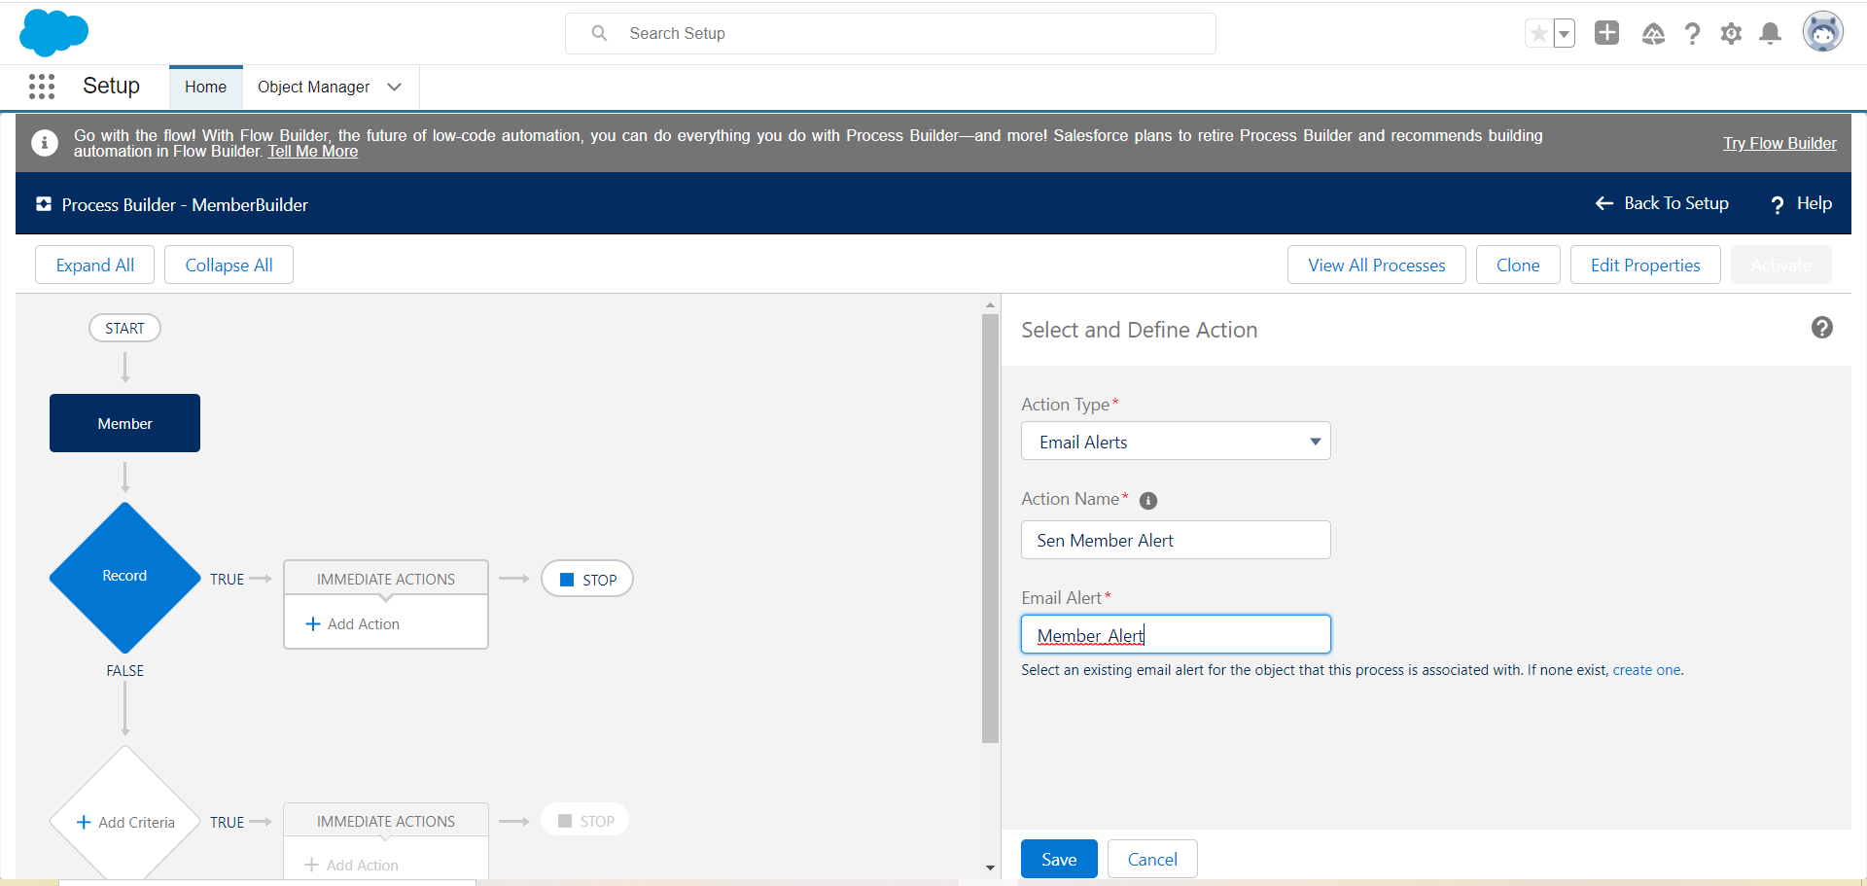

**Conclusion:** Hence I have implemented process flow using process builder.

**Name : Prasanna Rajendra Anjankar Registration No : 19010886**

**Roll No : 65 Class : 6CTA**

**Course Name : CRM Course Code : CT2370**