**PRACTICAL NO : 07 A65_PRASANNA ANJANKAR**

**Aim:** To create clone user and assigned permissions.

**Theory:**

Salesforce administrator can perform many user management functions like creating and managing users in salesforce, assigning user licenses, changing passwords, granting permissions to access certain data in salesforce.

**Who is a User?**

User is a person who have credentials to log in to Salesforce and use the application. By default every user in salesforce will have a user account. The User account identifies the user and the settings determines its features.

• Every user account in salesforce will have username.

• Email address.

• Every user account must have a licence. User licenses depends upon the Salesforce license we use.

• Profile and Role.

Depending upon the number of user, the organization must purchase that number of licenses and assign to every user.

To view and manage the users in your organization, from Setup, enter Users in the Quick Find box, then select Users. The user list shows all the users in your organization. From the list, you can:

• Create one or more users.

• Reset passwords for selected users.

• View a user's detail page by clicking the name, alias, or username.

• Edit a user's details.

• Log in as any user if the system permission is enabled or if the user has granted you system administrator login access.

**Keywords while creating a user:**

• **Usernames:** Each user has both a username and an email address. The username must be formatted like an email address and must be unique across all Salesforce organizations. It can be the user's email address, so long as it is unique.

• **User Licenses:** A user license determines which features the user can access in Salesforce. For example, you can allow users access to standard Salesforce features and Chatter with the standard Salesforce license. But, if you want to grant a user access

to only some features in Salesforce, you have a host of licenses to choose from. For example, if you have to grant a user access to Chatter without allowing them to see any data in Salesforce, you can give them a Chatter Free license.

• **Profiles:** Profiles determine what users can do in Salesforce. They come with a set of permissions which grant access to particular objects, fields, tabs, and records. Each user can have only one profile. Select profiles based on a user’s job function (the Standard User profile is the best choice for most users). Don’t give a user a profile with more access than the user needs to do their job. You can grant access to more items the user needs with a permission set.

• **Roles:** Roles determine what users can see in Salesforce based on where they are located in the role hierarchy. Users at the top of the hierarchy can see all the data owned by users below them. Users at lower levels can't see data owned by users above them, or in other branches, unless sharing rules grant them access. Roles are optional but each user can have only one. If you have an org with many users, you may find it easier to assign roles when adding users. However, you can set up a role hierarchy and

assign roles to users at any time. Roles are only available in Professional, Enterprise, Unlimited, Performance, and Developer editions of Salesforce.

• **Alias:** An alias is a short name to identify the user on list pages, reports, or other places where their entire name doesn't fit. By default, the alias is the first letter of the user's first name and the first four letters of their last name.

**Screenshots:**

**Step 1:** Search for users in search bar.

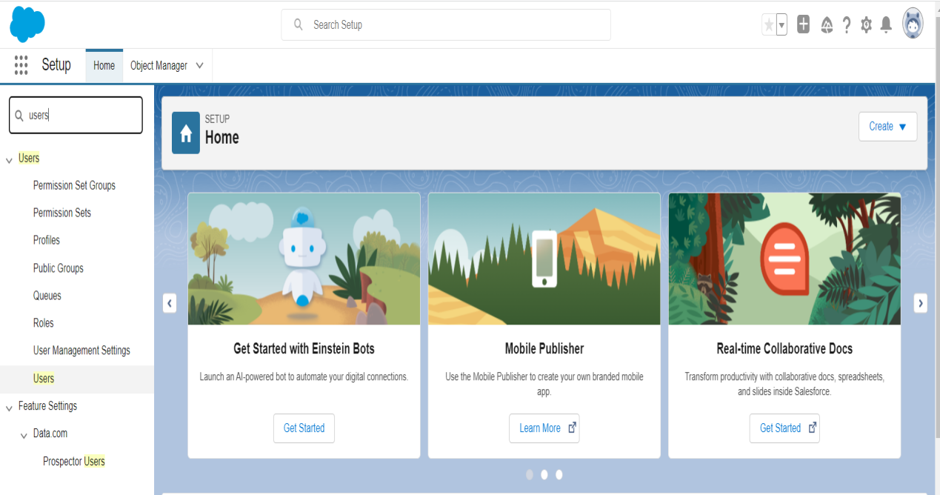

**Step 2:** Click on new user .

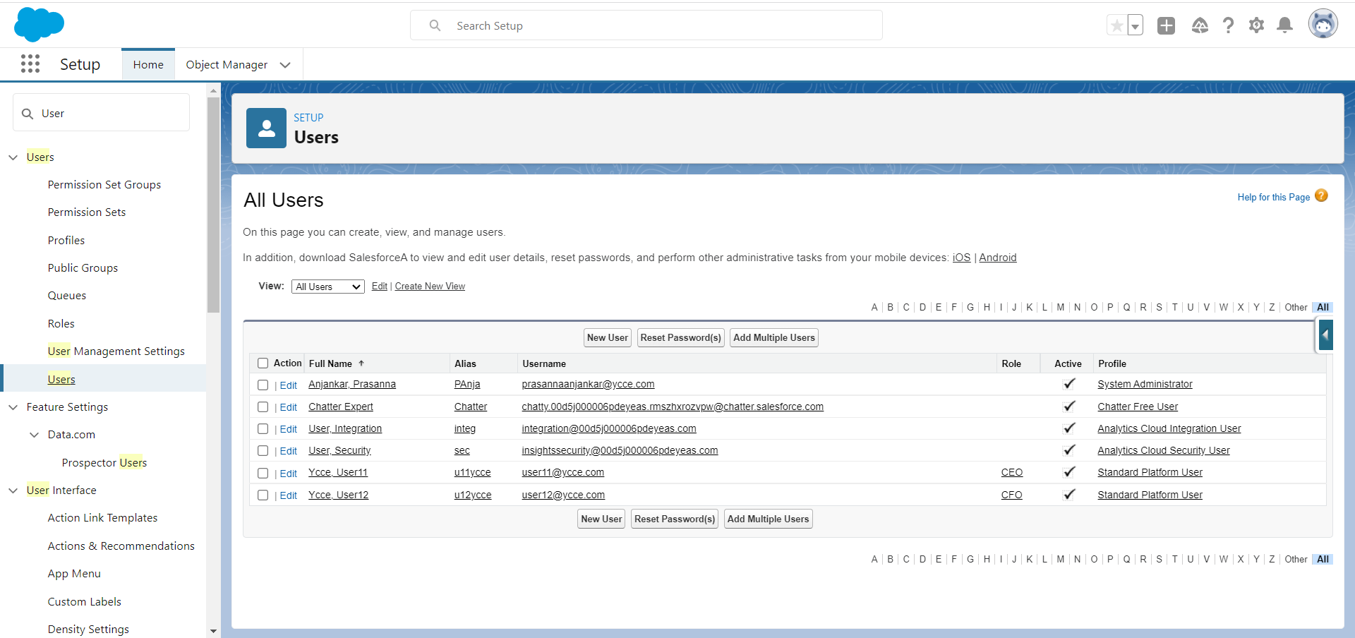

**Step 3:** Select Role as standard platform user and Fill all the details.

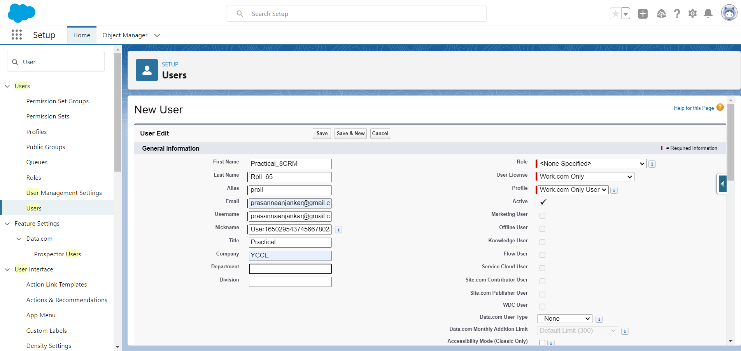

**Step 4:** A new user is created.

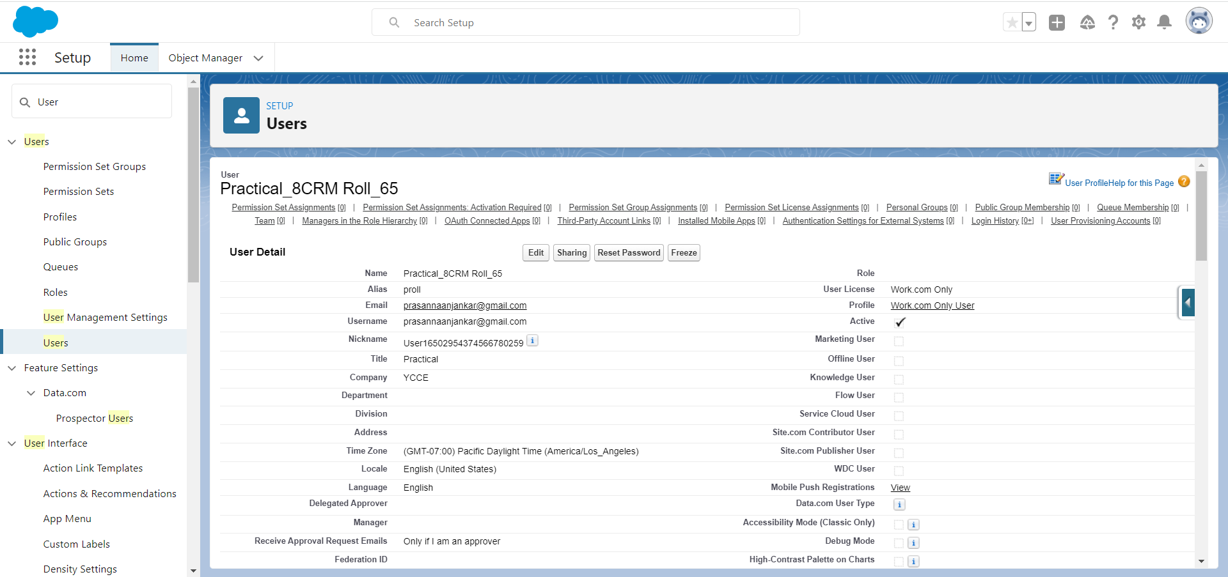

**Step 5:** Search for user management settings in Search bar.

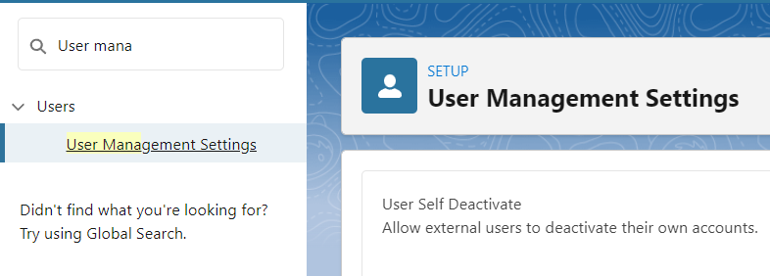

**Step 6:** Enable Enhanced Profile user interface.

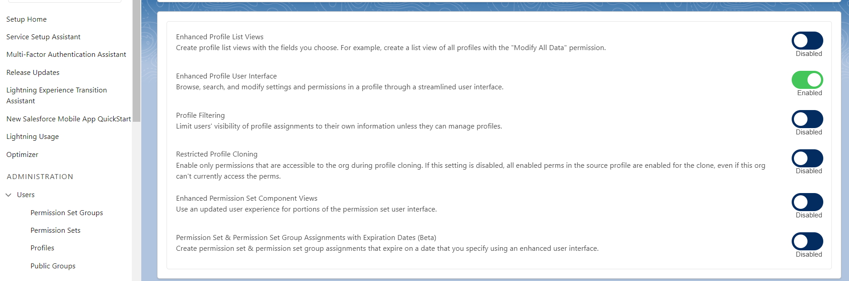

**Step 7:** In profile, Select standard platform user profile.

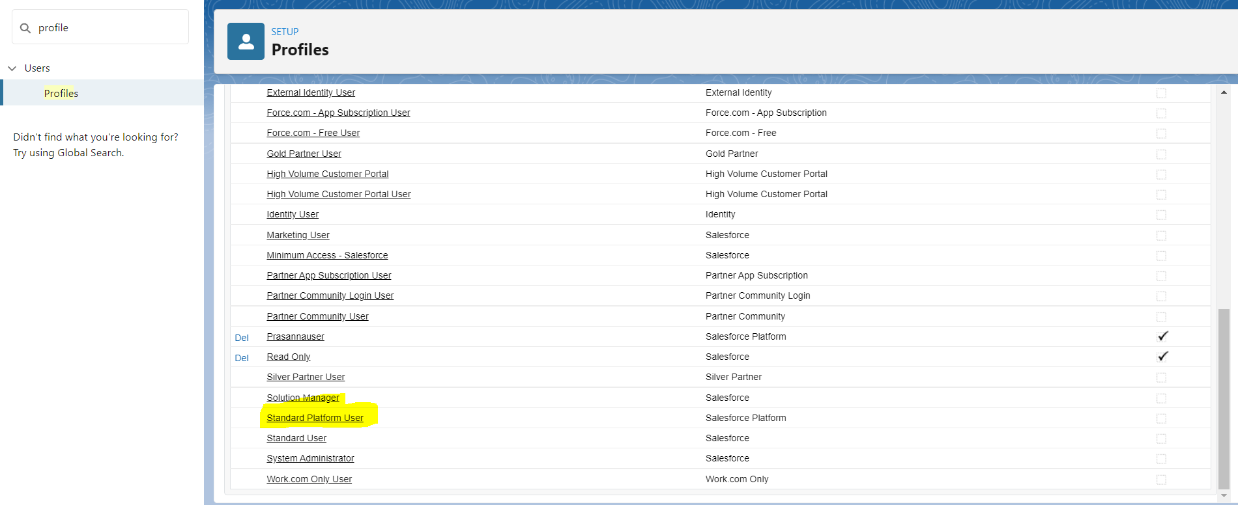

**Step 8:** The created user is in the list of standard platform user and have access over all the assigned apps of the profile.

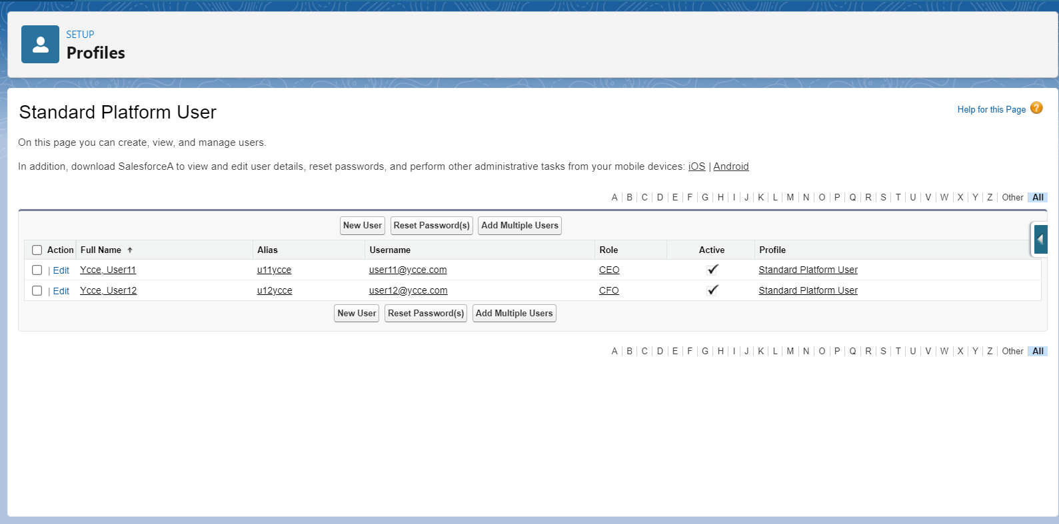

**Conclusion:** Hence I have created a new user and assigned permissions to that user.

**Name : Prasanna Rajendra Anjankar Registration No : 19010886**

**Roll No : 65 Class : 6CTA**

**Course Name : CRM Course Code : CT2370**