**PRACTICAL NO : 08 A65_PRASANNA ANJANKAR**

**Aim :** Email Templates.

**Theory :**

Salesforce allows us to create some sort of email templates which can be plain text or can be rich text formatted template. These templates can be used to increase productivity by just creating it once and using it multiple times to send an email. We can merge data from Salesforce records inside templates to make it more dynamic and look more personalized.

### ****Types of Email Template****

Salesforce allows us to create four type of classic email templates like ,

1. **Text**
2. **HTML with Classic Letterhead**
3. **Custom (HTML Without Classic Letterhead)**
4. **Visualforce**

* **Text Template :** This is text template which contains only text data. Text can be hard coded or field's data from records.This template allows us to merge field's data from recipient object and the object from which the email send action is fired.

**Who can create** : All users.

* **HTML with Classic Letterhead :** This email template required to have classic letterhead for creation. Letterheads define the look and feel of HTML email templates. HTML email templates can inherit the logo, color, and text settings from a letterhead. This template can contains formatted text, images, hyperlinks etc. Text can be hard coded or field's data from records. This template allows us to merge field's data from recipient object and the object from which the email send action is fired.

**Who can create** : Administrators and users with the “Edit HTML Templates” permission.

* **Custom HTML :** This template can be designed using standard HTML language. Inside HTML body we can insert hard coded text content and to make it dynamic we can also add merged fields. This template can contains formatted text, images, hyperlinks etc. we can merge field's data from recipient object and the object from which the email send action is fired.

**Who can create** : Administrators and users with the “Edit HTML Templates” permission.

* **Visualforce :** This email templates allow for advanced merging with a recipient's data, where the content of a template can contain information from multiple records.

**Who can create** : Administrators and developers can create templates using Visualforce.

### ****How to create classic email template****

### Let's move ahead, Now have overall idea of what email template is and what are its types. So we will create our first classic email template. For this article I demonstrate how to create Text email template. So steps to Create Email Templates are :

1. In quick find box search " Classic Email Templates " and click on it.
2. Click New Template button.
3. Choose the Text template type, and click Next.
4. Choose a folder in which to store the template.
5. To make the template available for use, select the Available For Use checkbox.
6. Enter a name in Email Template Name.
7. Enter a Description for the template if required.
8. Enter a Subject for the message.
9. Enter the text of the message.
10. If desired, enter merge fields in the template subject and text body. When you send an email,these fields are replaced with information from your records.
11. Click Save.

Use email templates to increase productivity and ensure consistent messaging. Email templates with merge fields let you quickly send emails that include field data from Salesforce records like contacts, leads, or opportunities. You can use email templates when emailing groups of people—with list email or mass email—or just one person.

* [**Standardize Email with Email Templates**](https://help.salesforce.com/s/articleView?id=email_templates_standardize.htm&type=5&language=en_US)  
  Use email templates to increase productivity and ensure consistent messaging. Email templates with merge fields let you quickly send emails that include field data from Salesforce records. You can create your own, or use templates created by others in your organization. Associate a letterhead to your email template to standardize your branding and increase productivity.
* [**Email Template Allocations per Edition**](https://help.salesforce.com/s/articleView?id=allocations_templates_general.htm&type=5&language=en_US)  
  See the allocations for email and email templates per edition.
* [**Types of Email Templates**](https://help.salesforce.com/s/articleView?id=email_templates_three_types.htm&type=5&language=en_US)  
  Different email templates types have different features and advantages. Review the table to determine which email template type works best for you: Salesforce Classic, Lightning Experience, or Email Template Builder (created in Lightning Experience).
* [**Select an Email Template When You Compose an Email**](https://help.salesforce.com/s/articleView?id=email_use_a_template_to_standardize_email.htm&type=5&language=en_US)  
  When composing an email, use an email template to speed things up and make sure you’re sending the right message. You can use your own email template, or one from your company.
* [**Considerations for Using Content from External Sources in Email Templates**](https://help.salesforce.com/s/articleView?id=creating_emailtemplates_cut_n_paste.htm&type=5&language=en_US)  
  If you copy and paste content from external sources, such as Microsoft Word or a web page, to an email template, you can get strange formatting results. Review these suggestions to avoid the problem.
* [**Email Template Permissions**](https://help.salesforce.com/s/articleView?id=email_templates_perms.htm&type=5&language=en_US)  
  Enable email template features and manage permissions and access for administrators and end users.
* [**Rendering HTML Tags in Outlook**](https://help.salesforce.com/s/articleView?id=email_templates_html_rendering.htm&type=5&language=en_US)  
  You can use HTML tags in Lightning email templates and in templates created with Email Template Builder. Ensure that these tags appear correctly in Outlook emails.
* [**Use Merge Fields in Email Templates and Letterheads**](https://help.salesforce.com/s/articleView?id=merge_fields_parent.htm&type=5&language=en_US)  
  A merge field is a placeholder in an email template or letterhead. When you send the email, the placeholder is replaced with the Salesforce data from the record or records of the people you are emailing. When using merge fields, it’s a good idea to understand how they work and what to expect in your merged emails.
* [**Email Templates in Lightning Experience**](https://help.salesforce.com/s/articleView?id=email_templates_lightning_parent.htm&type=5&language=en_US)  
  Use email templates to increase productivity and ensure consistent messaging. Email templates with merge fields let you quickly send emails that include field data from Salesforce records.
* [**Email Template Builder**](https://help.salesforce.com/s/articleView?id=email_template_builder_parent.htm&type=5&language=en_US)  
  The email template builder is a visual tool for creating rich, engaging email templates.
* [**Email Templates in Salesforce Classic**](https://help.salesforce.com/s/articleView?id=admin_emailtemplates.htm&type=5&language=en_US)  
  Use email templates to increase productivity and ensure consistent messaging. Email templates with merge fields let you quickly send emails that include field data from Salesforce records.

**Screenshot :**

1. **Click on Classic Email Templates :**

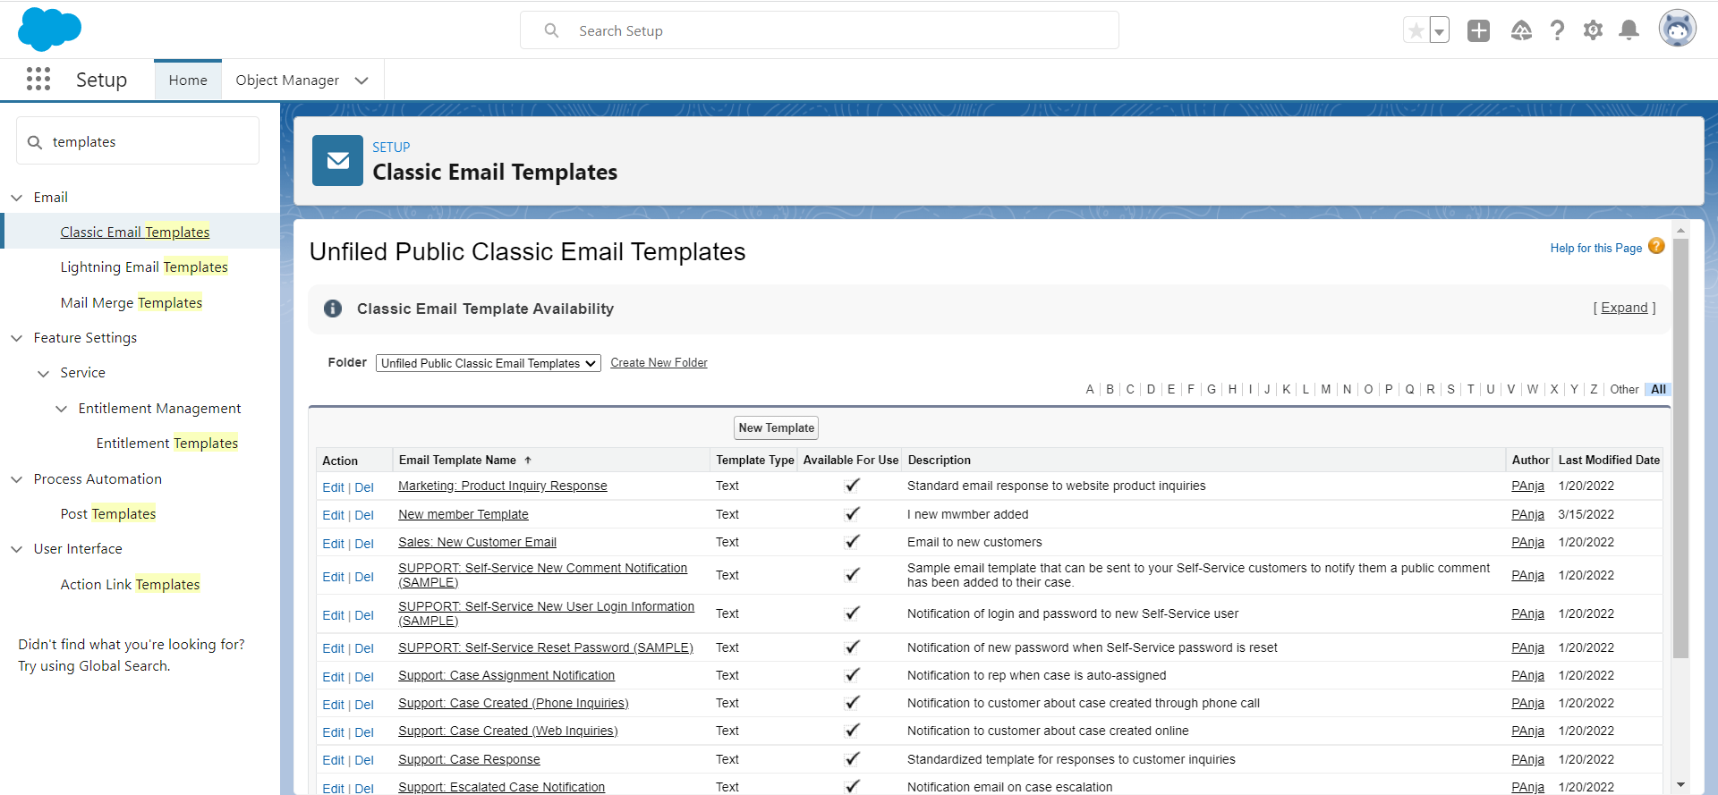

1. **Click on New Template.**

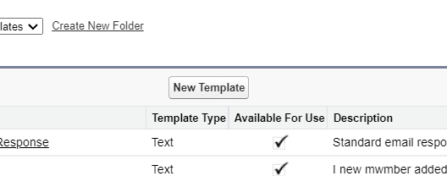

1. **Select typr**

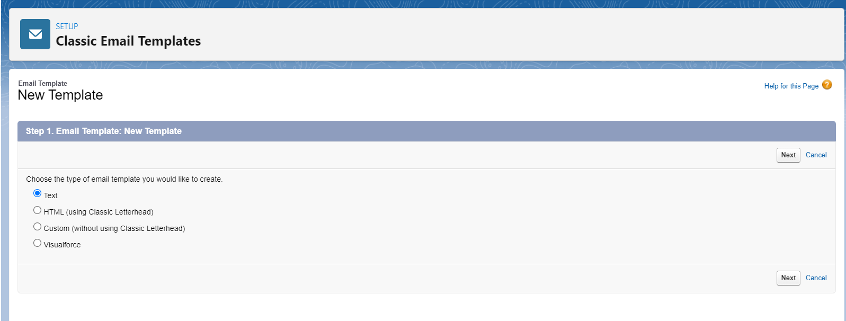

1. **Fill required information and the Template you want to use in the email.**

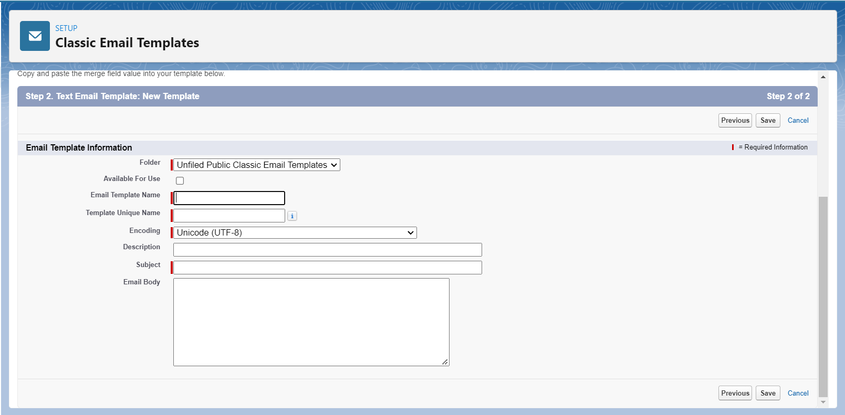

1. **Example :**

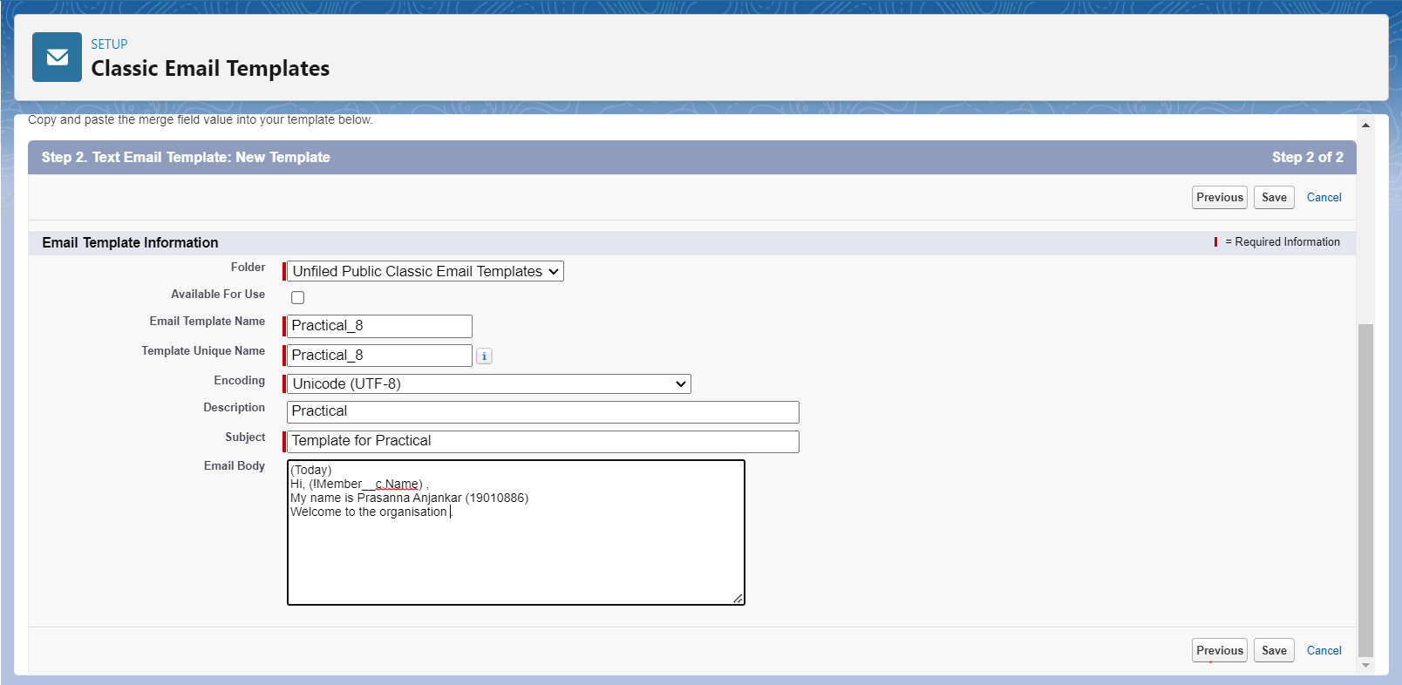

1. **Make Template Available for use.**

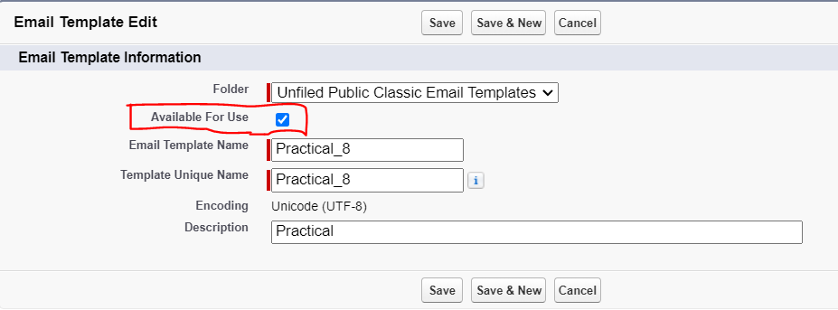

1. **Save the template and use it using the Email alerts.**

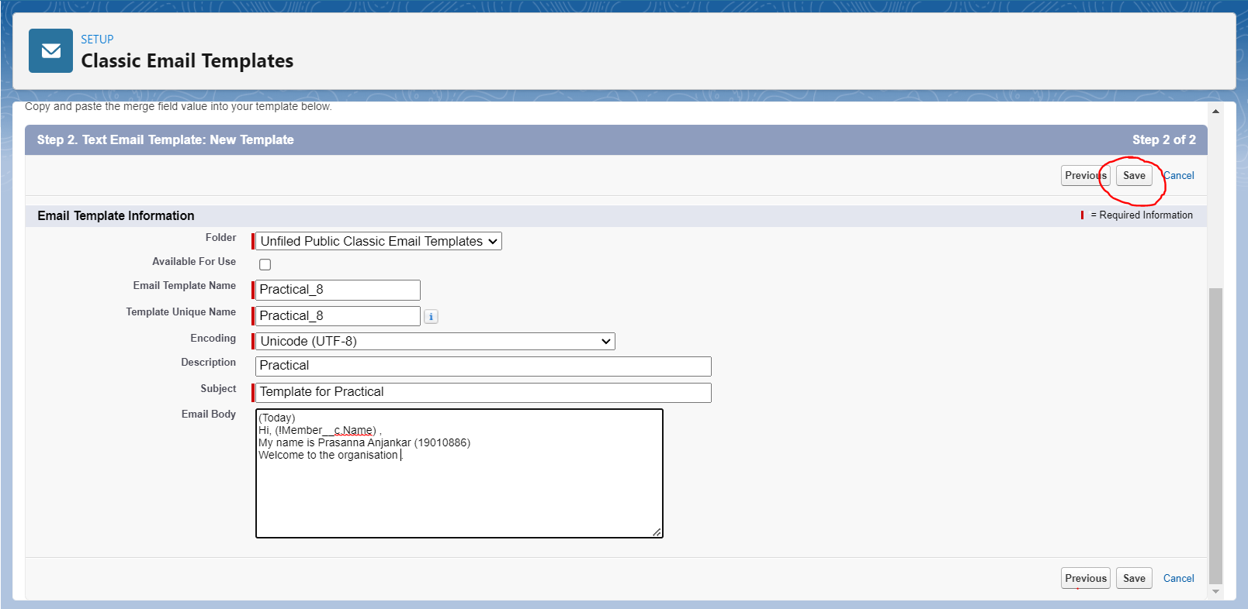

1. **To verify the Email Template.**

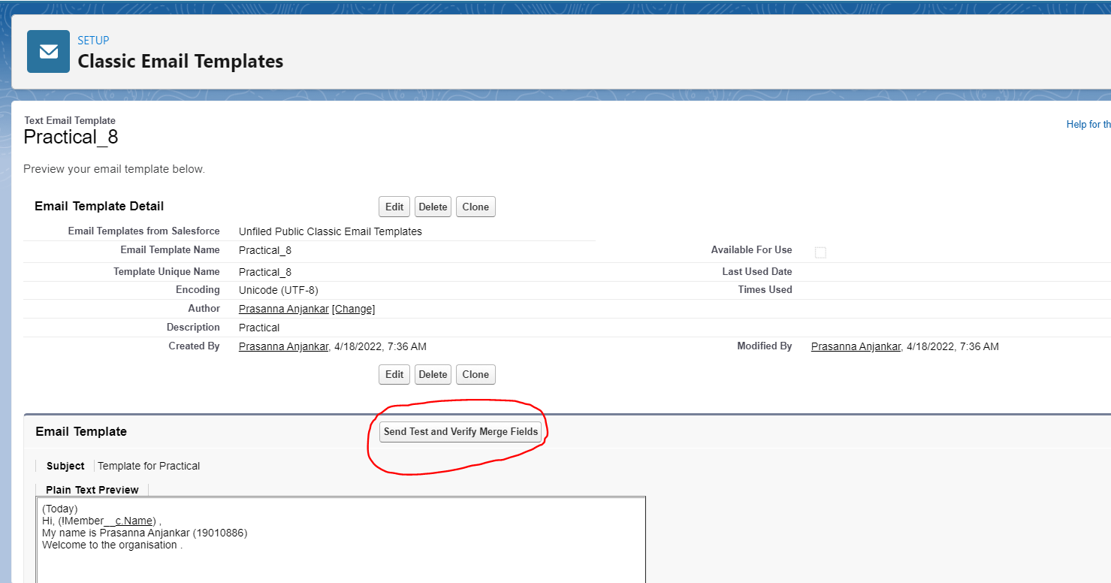

**Conclusion :** Hence I have successfully created the Email Template.

**Name : Prasanna Rajendra Anjankar Registration No : 19010886**

**Roll No : 65 Class : 6CTA**

**Course Name : CRM Course Code : CT2370**