Road Crash Injury Severity Prediction Using A Graphical Neural Network Framework
Road traffic accidents remain one of the leading causes of fatalities and severe injuries worldwide, demanding accurate and timely injury severity prediction to improve emergency response and resource allocation. Traditional statistical and machine learning models often fail to capture the complex spatial, temporal, and relational dependencies in crash data. This study proposes a Graph Neural Network (GNN) framework to predict road crash injury severity by leveraging the interconnections between crash features, road networks, and environmental factors. By modeling crash events as graph structures, the proposed system enables better feature representation and improved prediction accuracy. The framework integrates heterogeneous data sources—such as traffic conditions, weather, road topology, and vehicle attributes—to provide actionable insights for transportation agencies and emergency services.
In propose work we have used Naïve Bayes and Random Forest algorithms, gnn for Road Crash Injury Prediction on original and Smote based oversampling data. Smote algorithm will generate synthetic records for under-sampling classes to make dataset balanced.
After balancing dataset both algorithms got little improvement in accuracy. Each algorithm performance is evaluated in terms of accuracy, precision, recall, FSCORE and confusion matrix classification graph. Among all algorithms Random Forest with SMOTE giving high accuracy.
To implement this project we have designed following modules
- New User Sign up: using this module user can sign up with the application
- User Login: user can login to system
- Upload Dataset:After login user can run this module to upload datset.
- Load & Processed Dataset: after Upload dataset can run this module to load and normalized dataset using Standard Scaling and then convert all non-numeric data to numeric values using Label Encoder class. This module will split dataset into train and test where application using 80% data for training and 20% for testing and then will plot fraud and non-fraud transaction to show data imbalance
- Balanced Data using ML: all processed training data will be input to SMOTE algorithm balanced dataset and then plot graph of balanced dataset class labels
- Train ML Models: 80% training data will be input to both ML models with and without smote training data and then apply trained model on 20% test data to calculate prediction accuracy
- Detect Fraud: using this module user can upload test data and then best ML model will be applied to predict weather test data contains Road Crash Injury Accident Type.
SCREEN SHOTS
Install python 3.8.0 and then install all packages given in requirements.txt file and then install MYSQL database and then copy content from ‘database.txt’ file and paste in MYSQL console to create database
To run project double click on ‘runWebServer.bat’ file to start python server and then will get below page
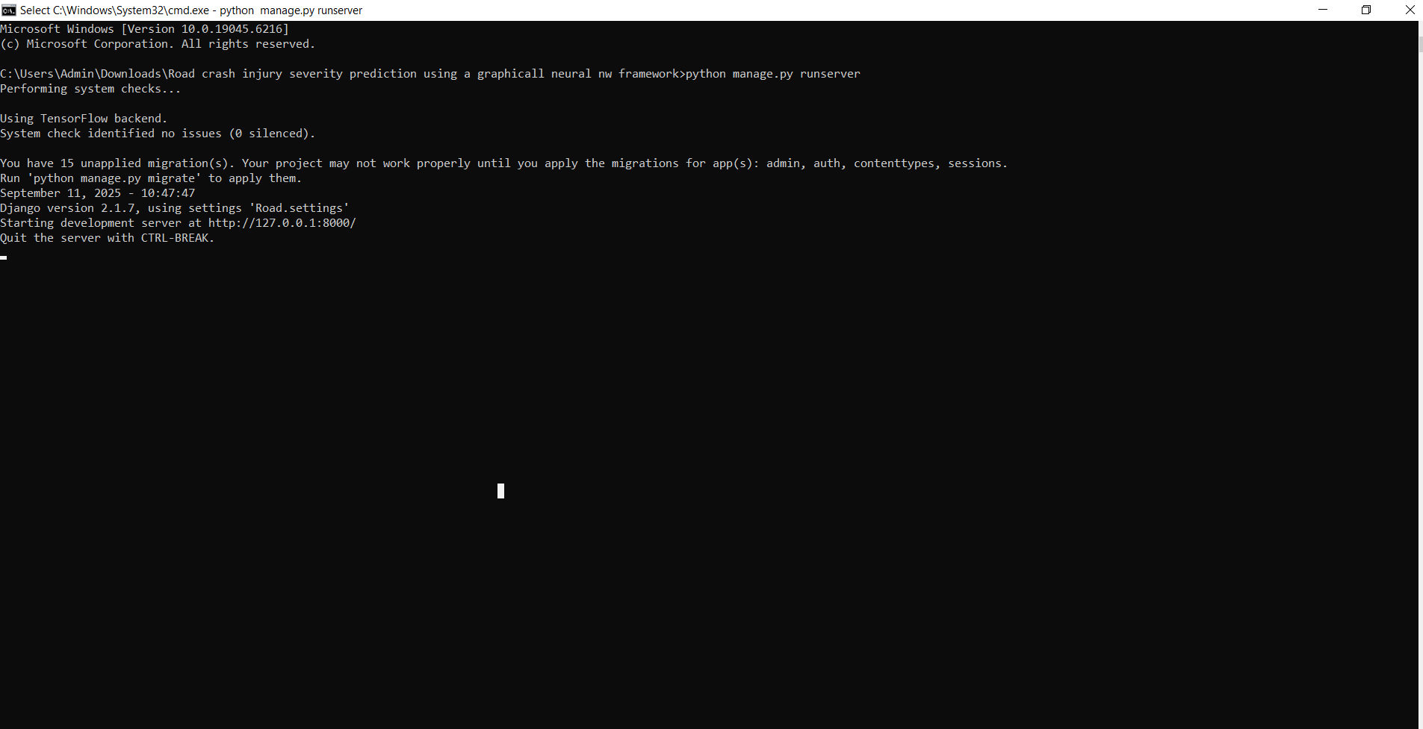
In above screen python server started and now open browser and enter URL as http://127.0.0.1:8000/index.html and then press enter key to get below page
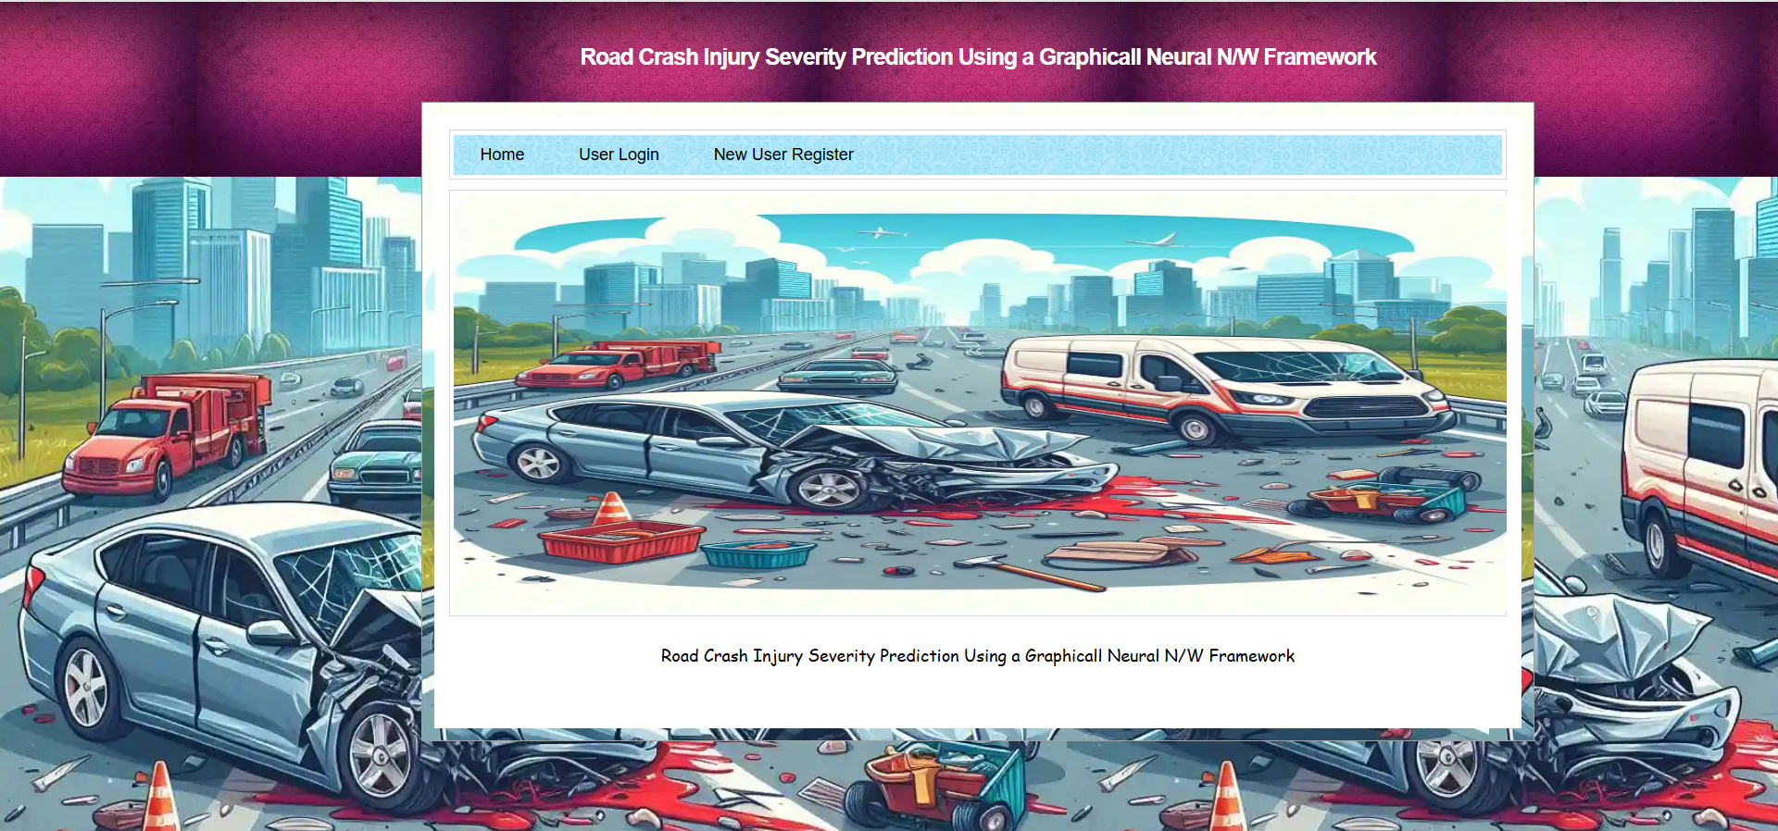
In above screen click on ‘New User Register’ link to get below page

In above screen user is entering sign up details and then press button to get below page

In above screen user sign up completed and now click on ‘User Login’ link to get below page
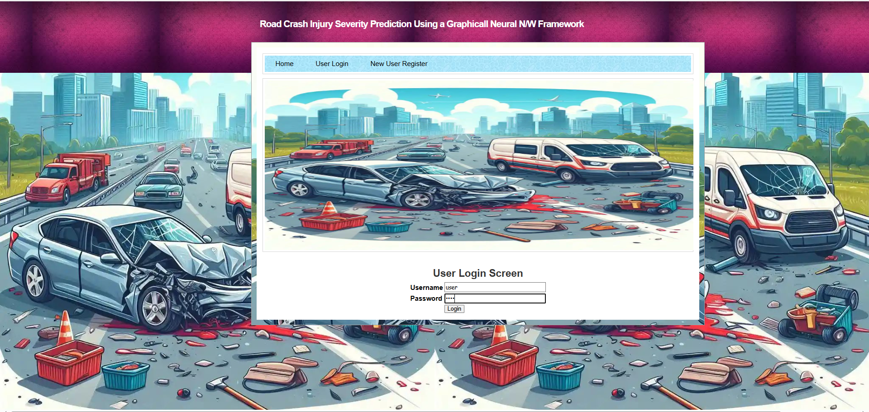
In above screen user is login and after login will get below page
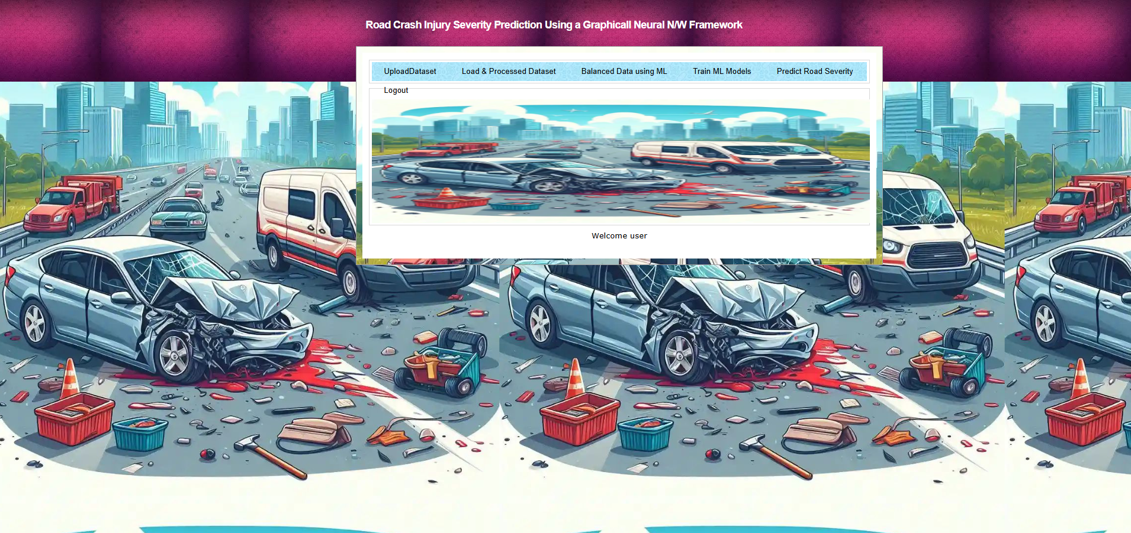

In above screen click on ‘UploadDataset’ link to browse dataset and then will get below page
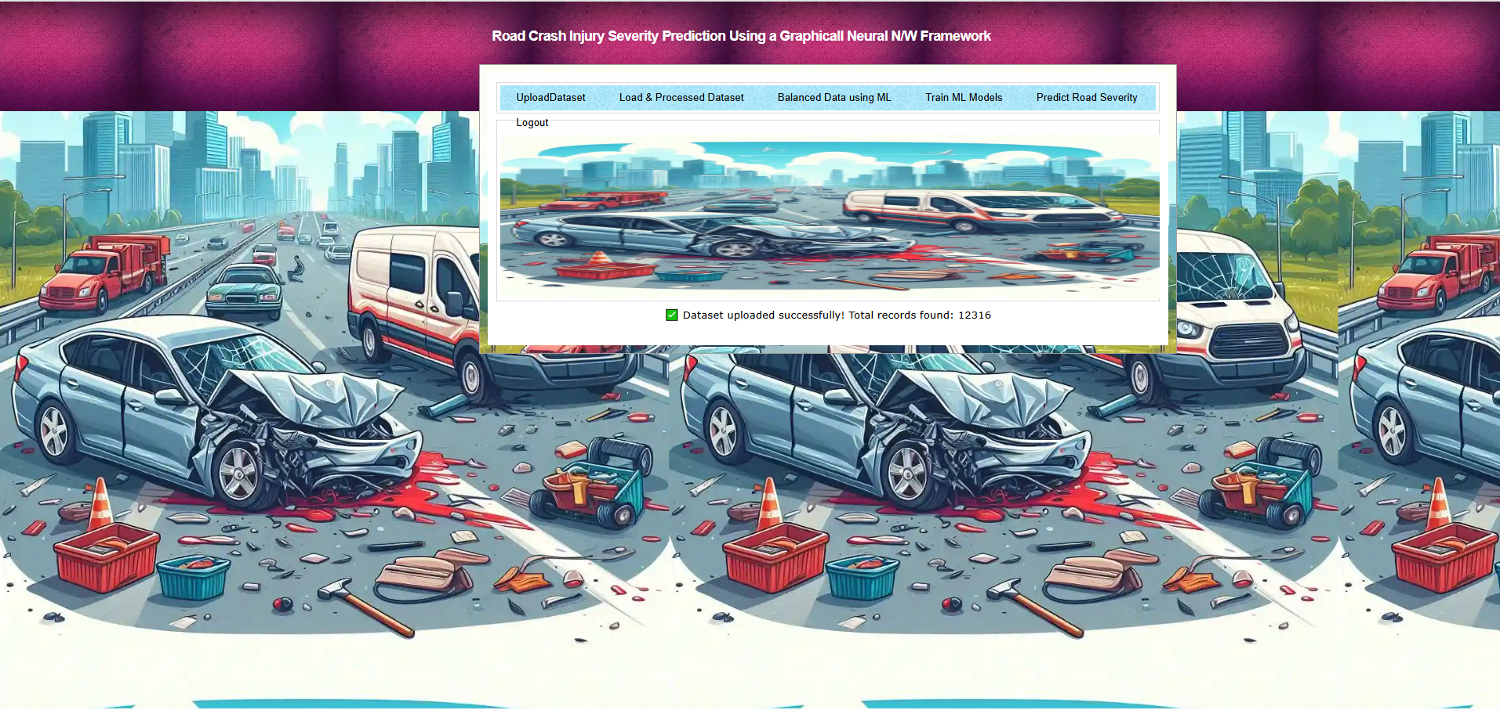
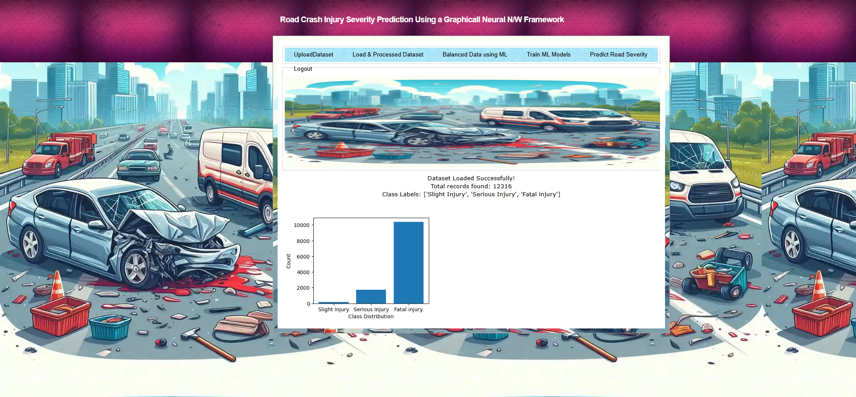
In above screen click on ‘Load & Processed Dataset’ link to load and process data and then will get below page In above screen dataset loaded and can see dataset contains nearly 22570 records and can see available class labels as ‘Slight ,Serious &fatal Injury. which make dataset highly imbalance. Now click on ‘Balanced Data using ML & GNN’ link to balanced dataset and then will get below page

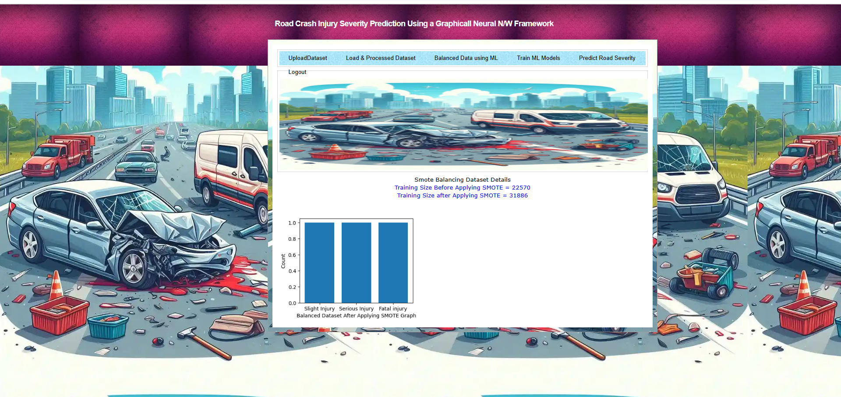
In above screen dataset loaded and can see dataset contains nearly 22570 records and can see available class labels as ‘Slight ,Serious &fatal Injury. which make dataset highly imbalance. Now click on ‘Balanced Data using ML & GNN’ link to balanced dataset and then will get below page

In above screen can see training records before smote is 22570 and after applying smote data size increased to 31886 and in graph can see both class labels have equal number of records. Now click on ‘Train ML Models’ link to train ML algorithms with and without smote and then calculate prediction accuracy
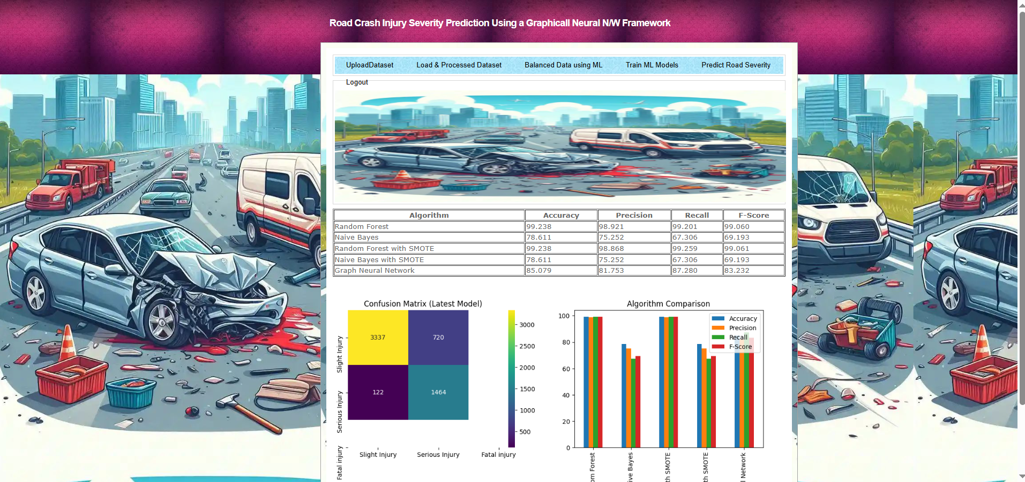
In above screen in table format can see ML algorithm accuracy with and without smote and in above screen can see Random Forest with smote got more than 99% accuracy. In confusion matrix graph x-axis represents ‘Predicted Labels’ and y-axis represents True Labels and then yellow and light green boxes in diagonal represents correct prediction count. Both blue boxes got incorrect prediction count which are very few. In bar graph showing comparison between all algorithms where x-axis represents algorithm names and y-axis represents accuracy and other metrics in different colour bars. In all algorithms Random Forest with smote got high accuracy. Now click on ‘Predict Road Jujury’ link to get below page



