**Virtual Art Gallery Shema DDL and DML**

mysql> show databases;

+--------------------+

| Database |

+--------------------+

| Banking_system |

| HMBank |

| information_schema |

| mysql |

| performance_schema |

| practice |

| ProjectManagement |

| sys |

| testdb |

+--------------------+

9 rows in set (0.03 sec)

mysql> create database VirtualArtGallery;

Query OK, 1 row affected (0.01 sec)

mysql> use VirtualArtGallery;

Database changed

mysql> CREATE TABLE Artists (

-> ArtistID INT PRIMARY KEY,

-> Name VARCHAR(255) NOT NULL,

-> Biography TEXT,

-> Nationality VARCHAR(100));

Query OK, 0 rows affected (0.01 sec)

mysql> desc Artists;

mysql> CREATE TABLE Categories (

-> CategoryID INT PRIMARY KEY,

-> Name VARCHAR(100) NOT NULL);

Query OK, 0 rows affected (0.01 sec)

mysql> desc Categories;

mysql> CREATE TABLE Artworks (

-> ArtworkID INT PRIMARY KEY,

-> Title VARCHAR(255) NOT NULL,

-> ArtistID INT,

-> CategoryID INT,

-> Year INT,

-> Description TEXT,

-> ImageURL VARCHAR(255),

-> FOREIGN KEY (ArtistID) REFERENCES Artists (ArtistID),

-> FOREIGN KEY (CategoryID) REFERENCES Categories (CategoryID));

Query OK, 0 rows affected (0.01 sec)

mysql> desc Artworks;

mysql> CREATE TABLE Exhibitions (

-> ExhibitionID INT PRIMARY KEY,

-> Title VARCHAR(255) NOT NULL,

-> StartDate DATE,

-> EndDate DATE,

-> Description TEXT);

Query OK, 0 rows affected (0.01 sec)

mysql> desc Exhibitions;

mysql> CREATE TABLE ExhibitionArtworks (

-> ExhibitionID INT,

-> ArtworkID INT,

-> PRIMARY KEY (ExhibitionID, ArtworkID),

-> FOREIGN KEY (ExhibitionID) REFERENCES Exhibitions (ExhibitionID),

-> FOREIGN KEY (ArtworkID) REFERENCES Artworks (ArtworkID));

Query OK, 0 rows affected (0.01 sec)

mysql> desc ExhibitionArtworks;

mysql> INSERT INTO Artists (ArtistID, Name, Biography, Nationality) VALUES

-> (1, 'Pablo Picasso', 'Renowned Spanish painter and sculptor.', 'Spanish'),

-> (2, 'Vincent van Gogh', 'Dutch post-impressionist painter.', 'Dutch'),

-> (3, 'Leonardo da Vinci', 'Italian polymath of the Renaissance.', 'Italian'),

-> (4, 'Michelangelo', 'Italian sculptor and painter.', 'Italian'),

-> (5, 'Andy Warhol', 'American pop artist.', 'American');

Query OK, 5 rows affected (0.01 sec)

Records: 5 Duplicates: 0 Warnings: 0

mysql> select * from Artists;

mysql> INSERT INTO Categories (CategoryID, Name) VALUES

-> (1, 'Painting'),

-> (2, 'Sculpture'),

-> (3, 'Photography');

Query OK, 3 rows affected (0.01 sec)

Records: 3 Duplicates: 0 Warnings: 0

mysql> select * from Categories;

mysql> INSERT INTO Artworks (ArtworkID, Title, ArtistID, CategoryID, Year, Description, ImageURL) VALUES

-> (1, 'Starry Night', 2, 1, 1889, 'A famous painting by Vincent van Gogh.', 'starry_night.jpg'),

-> (2, 'Mona Lisa', 3, 1, 1503, 'The iconic portrait by Leonardo da Vinci.', 'mona_lisa.jpg'),

-> (3, 'Guernica', 1, 1, 1937, 'Pablo Picasso\'s powerful anti-war mural.', 'guernica.jpg'),

-> (4, 'The Creation of Adam', 4, 1, 1512, 'Michelangelo’s famous fresco.', 'creation_adam.jpg'),

-> (5, 'Campbell’s Soup Cans', 5, 1, 1962, 'Pop art masterpiece by Warhol.', 'soup_cans.jpg'),

-> (6, 'David', 4, 2, 1504, 'Michelangelo’s marble statue.', 'david.jpg'),

-> (7, 'The Thinker', 4, 2, 1904, 'Famous sculpture by Rodin.', 'thinker.jpg'),

-> (8, 'The Last Supper', 3, 1, 1495, 'Leonardo’s large mural painting.', 'last_supper.jpg'),

-> (9, 'Sunflowers', 2, 1, 1888, 'Still-life painting by Van Gogh.', 'sunflowers.jpg'),

-> (10, 'Marilyn Monroe', 5, 3, 1962, 'Pop art portrait by Warhol.', 'marilyn.jpg');

Query OK, 10 rows affected (0.01 sec)

Records: 10 Duplicates: 0 Warnings: 0

mysql> select * from Artworks;

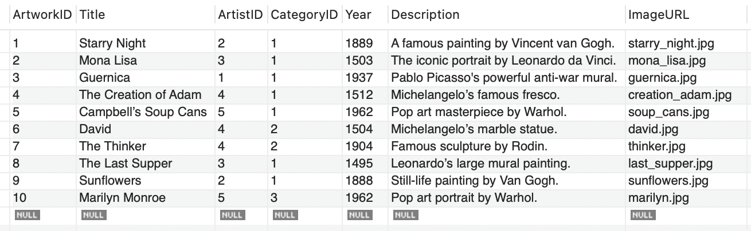

mysql> INSERT INTO Exhibitions (ExhibitionID, Title, StartDate, EndDate, Description) VALUES

-> (1, 'Modern Art Masterpieces', '2023-01-01', '2023-03-01', 'A collection of modern art masterpieces.'),

-> (2, 'Renaissance Art', '2023-04-01', '2023-06-01', 'A showcase of Renaissance art treasures.'),

-> (3, 'Sculpture Wonders', '2023-07-01', '2023-09-01', 'Display of famous sculptures.');

Query OK, 3 rows affected (0.00 sec)

Records: 3 Duplicates: 0 Warnings: 0

mysql> select * from Exhibitions;

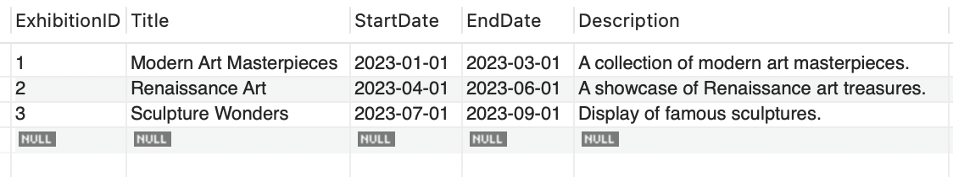

mysql> INSERT INTO ExhibitionArtworks (ExhibitionID, ArtworkID) VALUES

-> (1, 1),

-> (1, 2),

-> (1, 3),

-> (1, 5),

-> (1, 10),

-> (2, 2),

-> (2, 4),

-> (2, 8),

-> (3, 6),

-> (3, 7);

Query OK, 10 rows affected (0.00 sec)

Records: 10 Duplicates: 0 Warnings: 0

mysql> select * from ExhibitionArtworks;

1. Retrieve the names of all artists along with the number of artworks they have in the gallery, and list them in descending order of the number of artworks.

mysql> SELECT a.Name, COUNT(b.ArtworkID) AS ArtworkCount

-> FROM Artists a

-> LEFT JOIN Artworks b ON a.ArtistID = b.ArtistID

-> GROUP BY a.Name

-> ORDER BY ArtworkCount DESC;

2.List the titles of artworks created by artists from 'Spanish' and 'Dutch' nationalities, and order them by the year in ascending order.

mysql> SELECT a.Title, a.Year, b.Name, b.Nationality

-> FROM Artworks a

-> JOIN Artists b ON a.ArtistID = b.ArtistID

-> WHERE b.Nationality IN ('Spanish', 'Dutch')

-> ORDER BY a.Year ASC;

3. Find the names of all artists who have artworks in the 'Painting' category, and the number of artworks they have in this category.

mysql> SELECT a.Name, COUNT(ar.ArtworkID) AS PaintingCount

-> FROM Artists a

-> JOIN Artworks ar ON a.ArtistID = ar.ArtistID

-> JOIN Categories c ON ar.CategoryID = c.CategoryID

-> WHERE c.Name = 'Painting'

-> GROUP BY a.Name

-> ORDER BY PaintingCount DESC;

4. List the names of artworks from the 'Modern Art Masterpieces' exhibition, along with their artists and categories.

mysql> SELECT ar. Title, a.Name AS Artist, c.Name AS Category

-> FROM Artworks ar

-> JOIN ExhibitionArtworks ea ON ar.ArtworkID = ea.ArtworkID

-> JOIN Exhibitions e ON ea.ExhibitionID = e.ExhibitionID

-> JOIN Artists a ON ar.ArtistID = a.ArtistID

-> JOIN Categories c ON ar.CategoryID = c.CategoryID

-> WHERE e.Title = 'Modern Art Masterpieces';

5. Find the artists who have more than two artworks in the gallery.

mysql> SELECT a.Name, COUNT(ar.ArtworkID) AS ArtworkCount

-> FROM Artists a

-> JOIN Artworks ar ON a.ArtistID = ar.ArtistID

-> GROUP BY a.Name

-> HAVING COUNT(ar.ArtworkID) > 2;

6. Find the titles of artworks that were exhibited in both 'Modern Art Masterpieces' and 'Renaissance Art' exhibitions.

mysql> SELECT ar.Title

-> FROM Artworks ar

-> JOIN ExhibitionArtworks ea ON ar.ArtworkID = ea.ArtworkID

-> JOIN Exhibitions e ON ea.ExhibitionID = e.ExhibitionID

-> WHERE e.Title IN ('Modern Art Masterpieces', 'Renaissance Art')

-> GROUP BY ar.Title

-> HAVING COUNT(DISTINCT e.Title) = 2;

7. Find the total number of artworks in each category.

mysql> SELECT c.Name AS Category, COUNT(ar.ArtworkID) AS TotalArtworks

-> FROM Categories c

-> LEFT JOIN Artworks ar ON c.CategoryID = ar.CategoryID

-> GROUP BY c.Name;

8. List artists who have more than 3 artworks in the gallery.

mysql> SELECT a.Name, COUNT(ar.ArtworkID) AS ArtworkCount

-> FROM Artists a

-> JOIN Artworks ar ON a.ArtistID = ar.ArtistID

-> GROUP BY a.Name

-> HAVING COUNT(ar.ArtworkID) > 3;

Empty set (0.00 sec)

9. Find the artworks created by artists from a specific nationality (e.g., Spanish).

mysql> SELECT ar.Title, a.Name, a.Nationality

-> FROM Artworks ar

-> JOIN Artists a ON ar.ArtistID = a.ArtistID

-> WHERE a.Nationality = 'Spanish';

10. List exhibitions that feature artwork by both Vincent van Gogh and Leonardo da Vinci.

mysql> SELECT e.Title

-> FROM Exhibitions e

-> JOIN ExhibitionArtworks ea ON e.ExhibitionID = ea.ExhibitionID

-> JOIN Artworks ar ON ea.ArtworkID = ar.ArtworkID

-> JOIN Artists a ON ar.ArtistID = a.ArtistID

-> WHERE a.Name IN ('Vincent van Gogh', 'Leonardo da Vinci')

-> GROUP BY e.Title

-> HAVING COUNT(DISTINCT a.Name) = 2;

11. Find all the artworks that have not been included in any exhibition.

mysql> SELECT ar.Title

-> FROM Artworks ar

-> LEFT JOIN ExhibitionArtworks ea ON ar.ArtworkID = ea.ArtworkID

-> WHERE ea.ExhibitionID IS NULL;

12. List artists who have created artworks in all available categories.

mysql> SELECT a.Name

-> FROM Artists a

-> JOIN Artworks ar ON a.ArtistID = ar.ArtistID

-> JOIN Categories c ON ar.CategoryID = c.CategoryID

-> GROUP BY a.Name

-> HAVING COUNT(DISTINCT ar.CategoryID) = (SELECT COUNT(*) FROM Categories);

Empty set (0.02 sec)

13. List the total number of artworks in each category.

mysql> SELECT c.Name AS Category, COUNT(ar.ArtworkID) AS TotalArtworks

-> FROM Categories c

-> LEFT JOIN Artworks ar ON c.CategoryID = ar.CategoryID

-> GROUP BY c.Name;

14. Find the artists who have more than 2 artworks in the gallery.

mysql> SELECT a.Name, COUNT(ar.ArtworkID) AS ArtworkCount

-> FROM Artists a

-> JOIN Artworks ar ON a.ArtistID = ar.ArtistID

-> GROUP BY a.Name

-> HAVING COUNT(ar.ArtworkID) > 2;

15. List the categories with the average year of artworks they contain, only for categories with more than 1 artwork.

mysql> SELECT c.Name AS Category, AVG(ar.Year) AS AvgYear

-> FROM Categories c

-> JOIN Artworks ar ON c.CategoryID = ar.CategoryID

-> GROUP BY c.Name

-> HAVING COUNT(ar.ArtworkID) > 1;

16. Find the artworks that were exhibited in the 'Modern Art Masterpieces' exhibition.

mysql> SELECT ar.Title

-> FROM Artworks ar

-> JOIN ExhibitionArtworks ea ON ar.ArtworkID = ea.ArtworkID

-> JOIN Exhibitions e ON ea.ExhibitionID = e.ExhibitionID

-> WHERE e.Title = 'Modern Art Masterpieces';

17. Find the categories where the average year of artworks is greater than the average year of all artworks.

mysql> SELECT c.Name AS Category, AVG(ar.Year) AS AvgYear

-> FROM Categories c

-> JOIN Artworks ar ON c.CategoryID = ar.CategoryID

-> GROUP BY c.Name

-> HAVING AVG(ar.Year) > (SELECT AVG(Year) FROM Artworks);

18. List the artworks that were not exhibited in any exhibition.

mysql> SELECT ar.Title

-> FROM Artworks ar

-> LEFT JOIN ExhibitionArtworks ea ON ar.ArtworkID = ea.ArtworkID

-> WHERE ea.ExhibitionID IS NULL;

19. Show artists who have artworks in the same category as "Mona Lisa."

mysql> SELECT DISTINCT a.Name

-> FROM Artists a

-> JOIN Artworks ar ON a.ArtistID = ar.ArtistID

-> WHERE ar.CategoryID = (SELECT CategoryID FROM Artworks WHERE Title = 'Mona Lisa');

20. List the names of artists and the number of artworks they have in the gallery.

mysql> SELECT a.Name, COUNT(ar.ArtworkID) AS ArtworkCount

-> FROM Artists a

-> LEFT JOIN Artworks ar ON a.ArtistID = ar.ArtistID

-> GROUP BY a.Name

-> ORDER BY ArtworkCount;

