What is Django:
- Django is a free and opensource framework that is used for building web applications with python.
- We can build web application in less time with less code.
Features of Django:
- It gives an admin interface to manage our data as a huge time saver.
- It also has Object Relation Mapper (ORM) for databases.
- It also comes with authentication for identifying users.
- It also has package for caching data. Etc.
How the web works:
- All the requests are sent from the user to the server and server responds by giving the webpage that is required for the user.
- There are two ways to respond to a client.
- Generate the requested page from the server and return the html document to the client.
- Return the data that is need to the requested page. And client generates the webpage for it. It is done because if we push the responsibility to the client then we can free up the server so that server can be more scalable and it can sever more clients. It is considered as the industry best practice.
- Client-side tools:
  - React
  - Angular
  - Vue
- Server-side tools used to build web apps:
  - Django
  - Express
  - Asp .net core
- If we pus the responsibility of generating the webpage to the client the sever essentially becomes the gateway to the data.
- On the server we can provide endpoints that can client talk to, to get or save various pieces of the data.
- Ex: for example, we can provide one endpoint to get the list products i.e. /products etc.
- All these points represent the interface that clients used to talk to the server. In tech terms we say it as server provides an API to client
- API’s are essentially like buttons on a remote control. All these buttons represent the interface or an API that is used to interact.

To create and start an new project we use Django-admin in the desired folder where .venv is created.
Commands used:
- django-admin
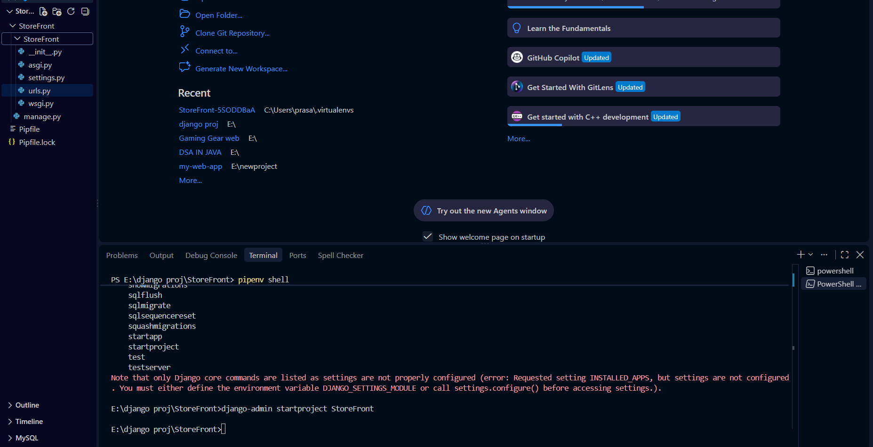
- django-admin startproject StoreFront : After running this command some directories and files are created in another same directory named same as the project directory.

- django-admin startproject StoreFront . : this command is used to startproject in the current directory without creating new directory. In the above image the files created.

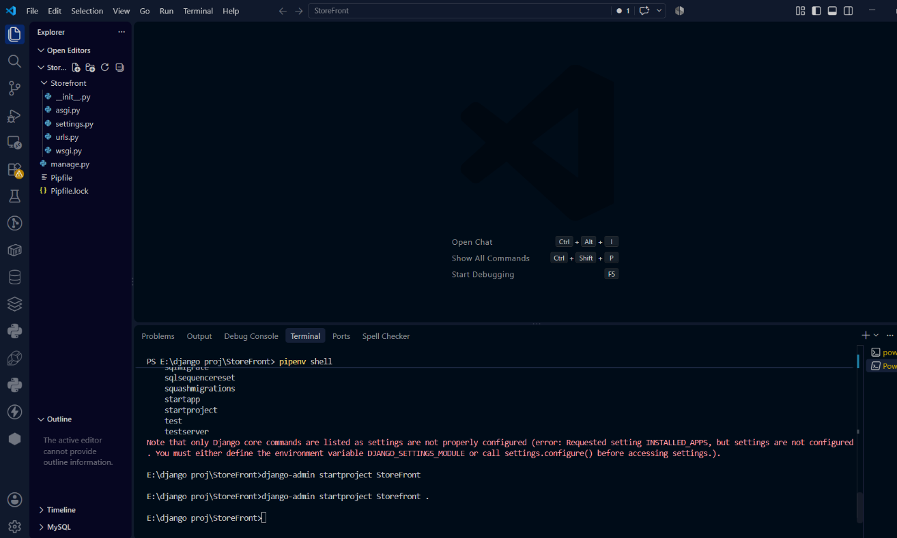

  - manage.py is the wrapper file around Django admin. Instead of django-admin we can use manage.py. The reason is manage,py takes the settings of the project into the count
  - settings.py is used to define the settings for our project.
  - urls.py is used to manage he URLs of our project

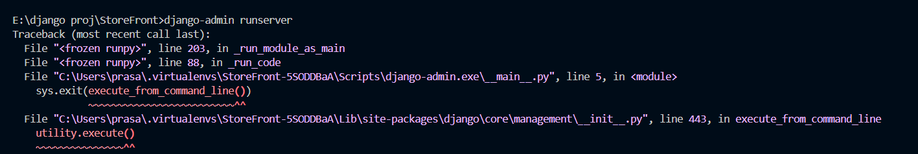

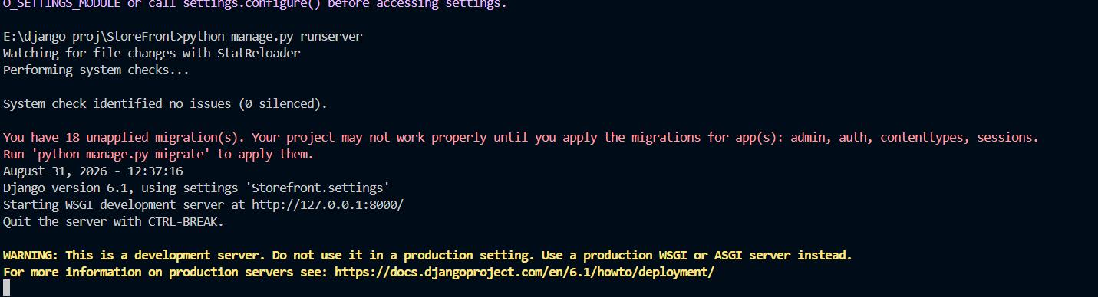

Note: Every Django project is the collection of apps, each provide certain functionality.

- Python manage.py startapp playground: this command is used to start an app that is named as playground in this command. After running this command, a directory is created using the
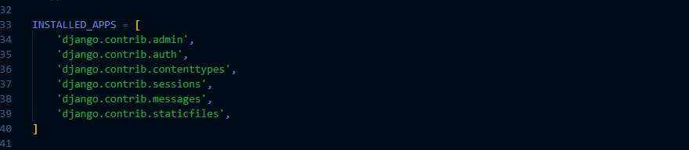
- In the settings.py app there will be application definition of the INSTALLED_APPS.

given below.
- We have migrations folder for generating databases.
- We have admin.py module where we define how the admin interface of the app is going to look like.
- In app.py we will configure the app.
- Then we have models.py module where we define the module classes for the app. We use model classes to pull the data from the database and present from the user.
- We have test.py module where we write unit tests.
- View.py module used to create views.
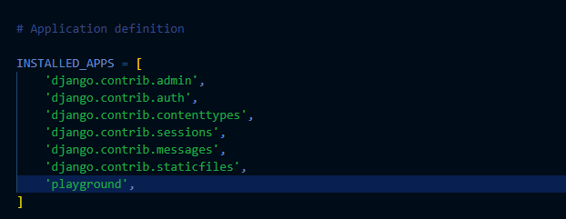
- So, we created a playground app. So we need to register it in settings module that is settings.py under the application definition in INSTALLED_APPS like shown below.

Creating a view:
- View function takes request and returns the response; hence it is called as request handler. In some framework we call this request handlers as action but in Django we call it as views.
- To create a view, we need to go the views.py module under that we can create our own views.
- These views can pull data from the database, transform data, send email etc.
- After creating a view, we need to map it with the url so when we click the url this view function is called.
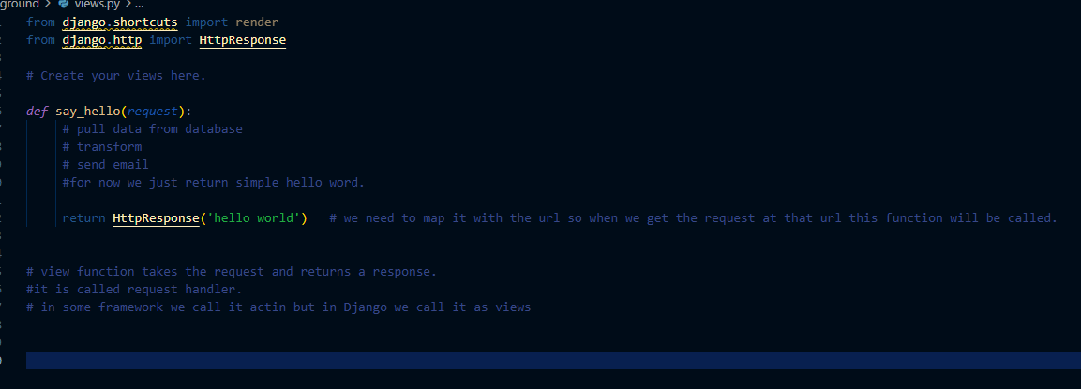

Mapping URLs with the views:
- First, we need to create urls.py the name can be anything but urls.py is the standard convention in python.
- Now import the path from Django.urls library and then import views “from .”.
- Then create an urlpatterns as an array of objects then add the path and the route, view, if you want to pass the extra data you can pass.
- Urlpatterns is a list of URL that routes for this app.
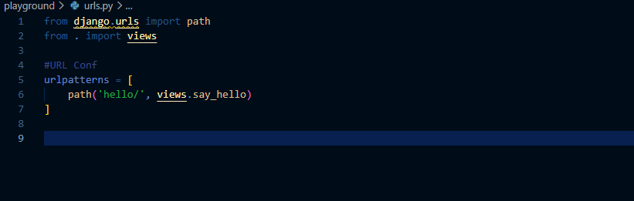
- from the above image first we imported the modules required and then we created urlpatterns which is the list of urls that routes for this app.
- In the urlpattern there is the path with route hello/ and view called say_hello in the views.py module in playground app.
- So when the path is hello/ Django should run the views.say_hello function. So this is the function in the playground/views.py
- So if my main project contains Storefront/urls.py has:
  - path('playground/', include('playground.urls')) Django combines the both part playground/ + hello/ and final url becomes http://127.0.0.1:8000/playground/hello/
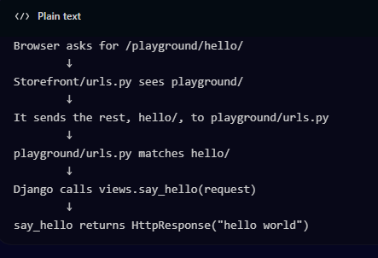

Using Templates:
- in this we return the html templates from the views insted of plain text.
- To do this we use render module from the Django.shortcuts pakage then in the function we return the render with request parameter and with the name of the templates. When we type the url with /playground/hello the template will the called and returned instead of just hello world text.
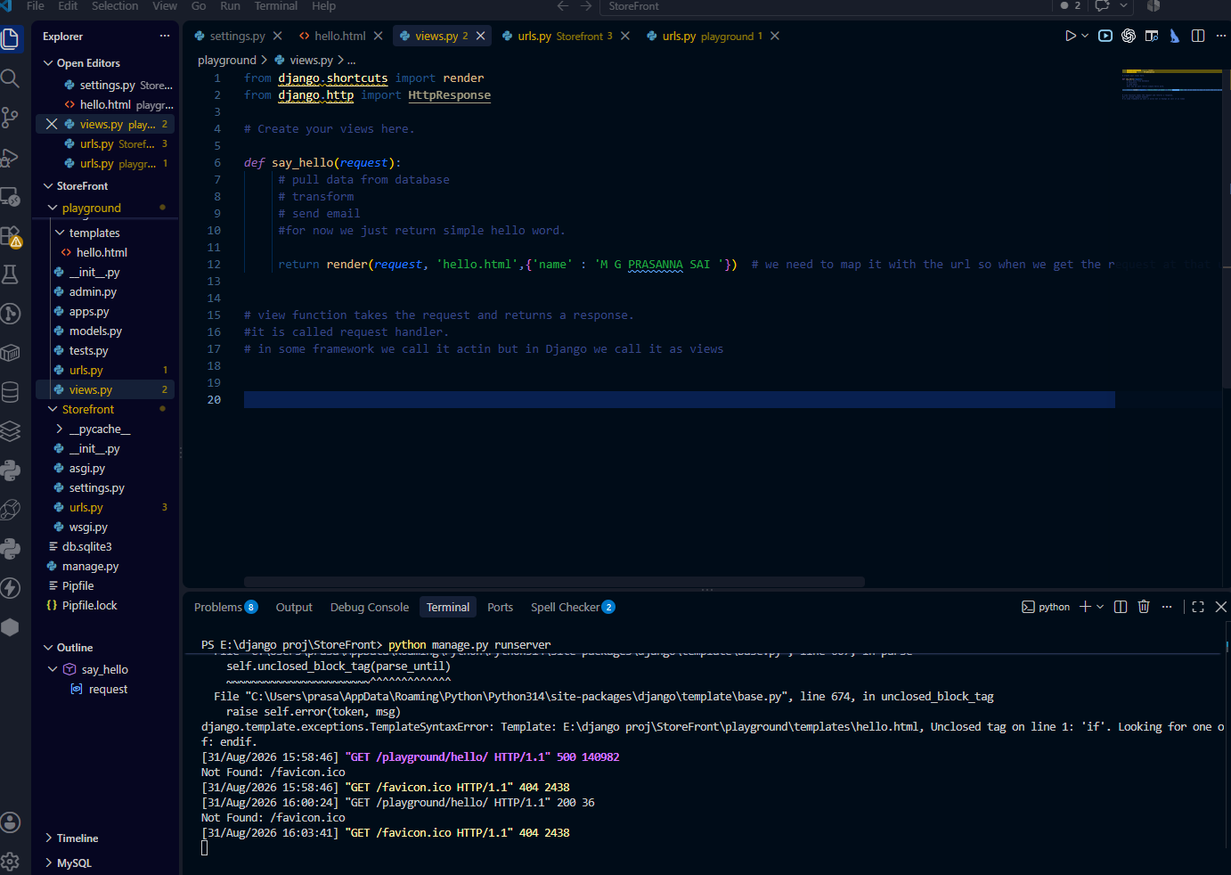
- We can return any html template by using these views.

- render () this function does 3 things .

  - find the template hello.html
  - Sends the data to the template {‘name’ : ‘M G P RASANNA SAI’} and Django replaces the name (M G PRASANNA SAI) to the template where it is like “ <h1>Hello {{ name }}</h1>”
  - It displays the template in to the user or client. And if any of the content is not given in the render. It will not send the data to the template. This is how we handle the templates in the Django.

Creating a Data models and understating how Django’s ORM generates the SQL queries for CRUD operations:
What is model:
- Model is a class that Maps directly to a database table.
- Each attribute in the class of model represents the database fields.
- The Django’s ORM automatically generates the SQL queries for CRUD operations.
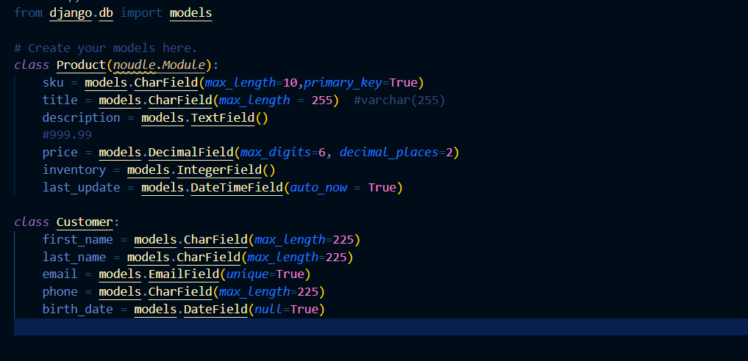
Example models:

Choice Fields:
- Choice fields in data models are used to limit the data field with fixed set of values, ensures data consistency and validation.
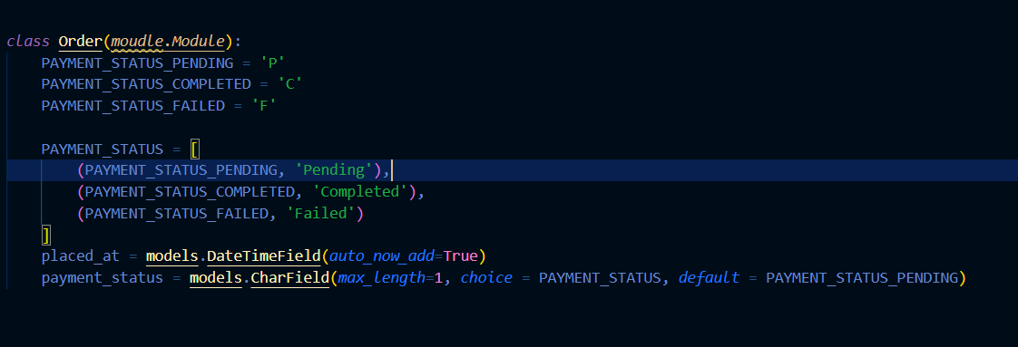
Example of choice fields:

Defining one-to-one Relationship:
- Think of a situation that one customer should have only one address. So, in that case the relation between the customer and address become one-to-one relation.
- To define this, we need to use OneToOneField().
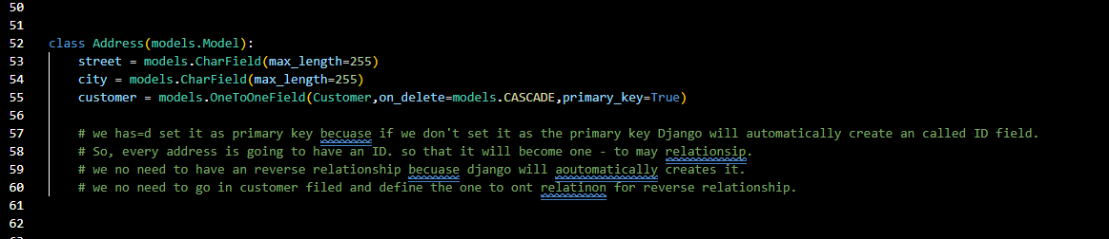
Example of defining one-to-one relation:

Defining one-to-many relationship:
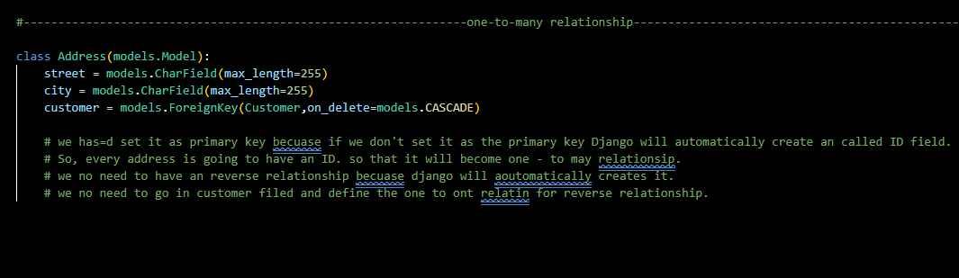
- Now let us assume customer can have multiple address so it becomes one-to-many relationship.

Defining many-to-many relationship:
- To define many to many relationship we use ManytoManyField()

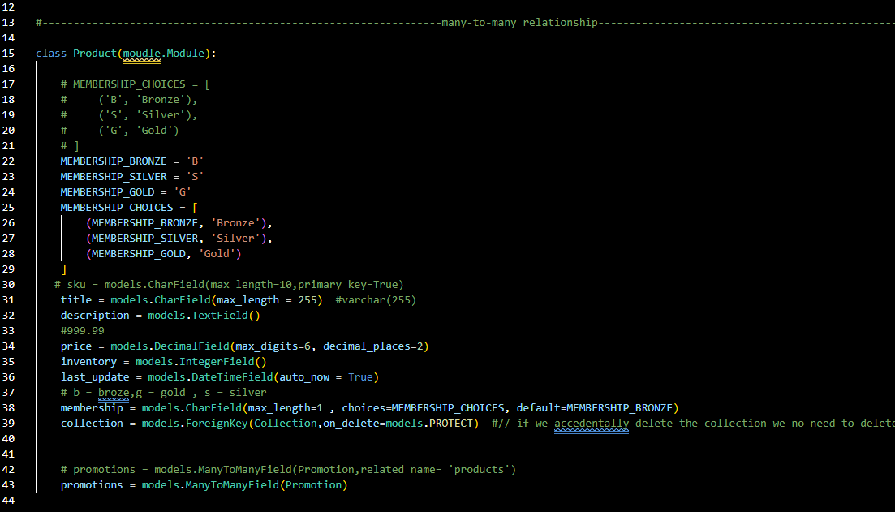
Resolving circular relationship:
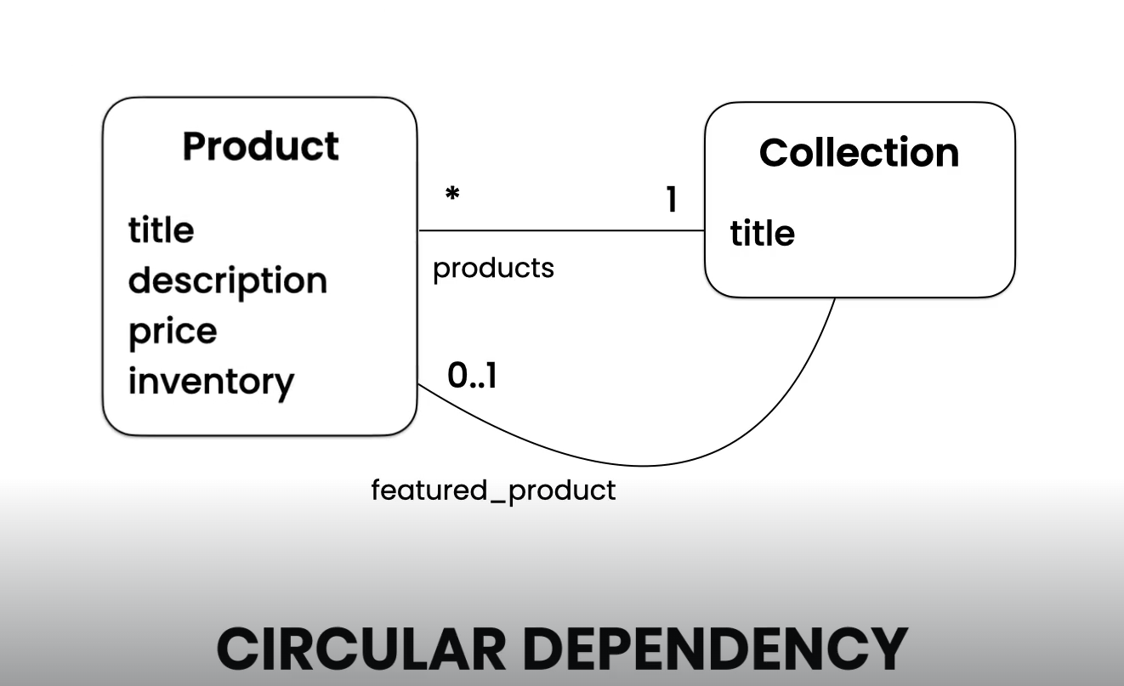
- Think of the above situation. From the above situation we implemented one relation that is many to one or one to many. But there is another relation need to be implemented. So here two classes depending on each other.
- The circular dependency occurs when the two classes dependent on each other. Here product class is depending on the collection class and the same time collection class is dependent on the product class. This is where the circular dependency occurs.
- The circular dependency in your Django models happens because Collection needs Product, while Product also needs Collection.
- Collection has a feature_product that points to Product.
- Product has a collection that points to Collection.
- When Django reads the models, Collection is defined before Product.
- Python would complain because Product has not been defined yet.
- To solve this, Django allows us to use a string reference:
models.ForeignKey('Product', ...)
- The string tells Django to resolve the Product model later, after all models have been loaded.
- Therefore, the circular model relationship can be defined safely.
- Important: String references don't remove the circular relationship. They only solve the problem of referencing a model before it has been defined.

'Product' → lazy/string reference
Product → direct Python reference
related_name='+' → disables reverse relationship
- "I don't need to find the Product class right now. I'll resolve this reference after all the models have been loaded." this is called Lazy relationship.
What is a Generic Relationship?
A Generic Relationship in Django allows one model to create a relationship with multiple different models.
For example, suppose we have:
- Product
- Video
- Article
- Course
and we want to attach tags to all of them.
Instead of creating separate foreign keys such as:
product = models.ForeignKey(Product, ...)
video = models.ForeignKey(Video, ...)
article = models.ForeignKey(Article, ...)
we can use Django's GenericForeignKey.
The basic idea is:
Tag
↓
TaggedItem
↓
Can point to Product, Video, Article, Course, etc.

2. Why Do We Need Tags?
A tag is simply a label that can be attached to an object.
For example, a product could have:
Product: iPhone
Tags:
- electronics
- smartphone
- featured
- sale
A video could have:
Video: Django Tutorial
Tags:
- programming
- python
- django
An article could have:
Article: Introduction to AWS

Tags:
- cloud
- aws
- beginner
The important point is that the same tagging system should work for all these different models.

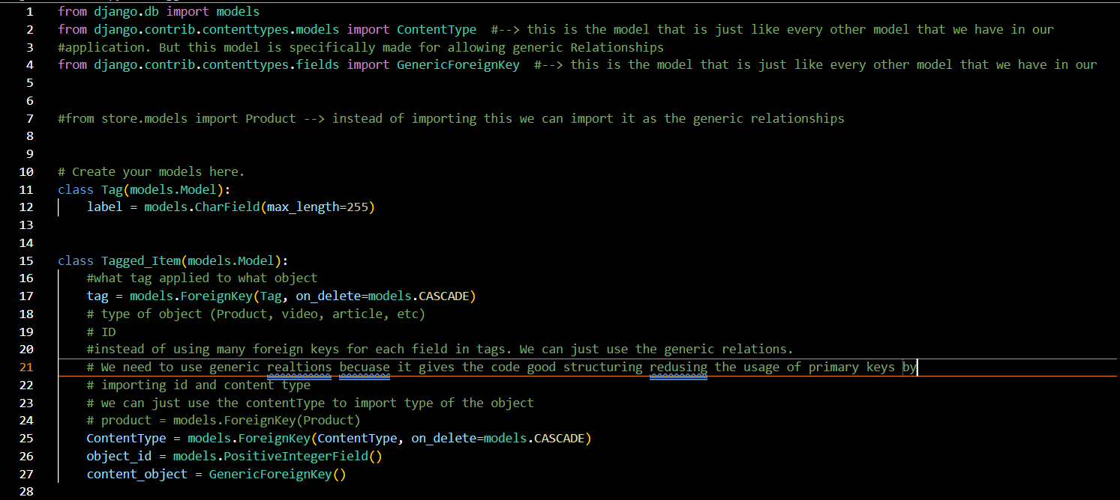

Creating migrations:
To make migrations in django we use the following command.
- Python manage.py makemigrations this helps us to create the migrations.
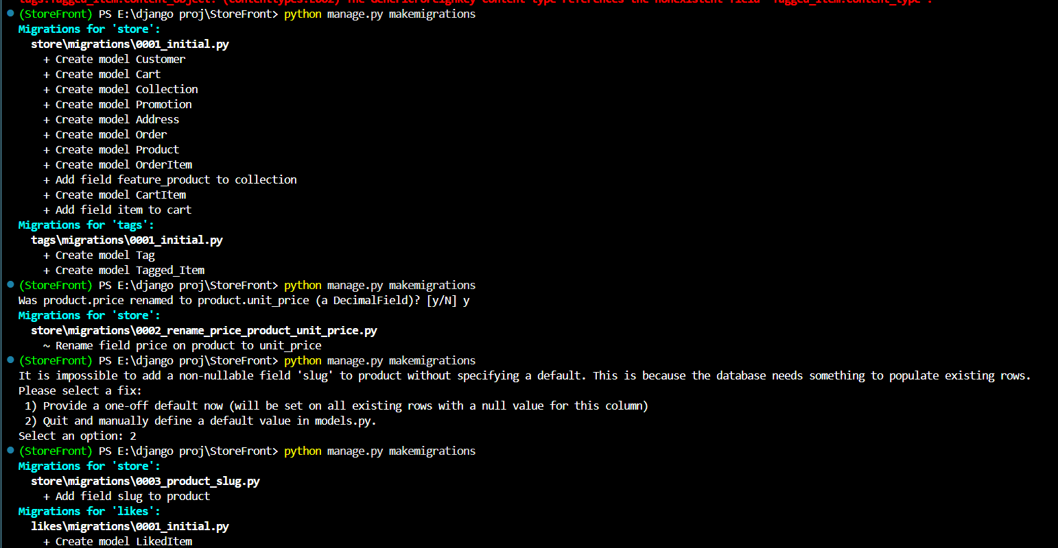
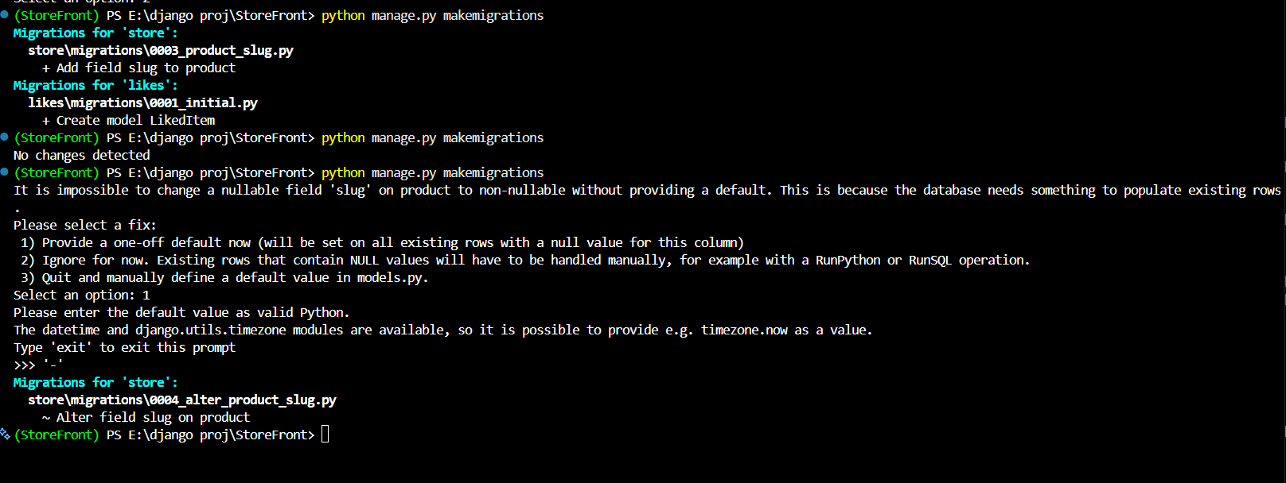
How to run migrations:
- The command used to run the migrations is :
  - Python manage.py migrate
- Each migration describes a set of changes.
- Each migration is like a commit in a version control system like git.
- We need to run our migrations to generate our database schema.
- Django goes through all the apps and execute the pending migrations.
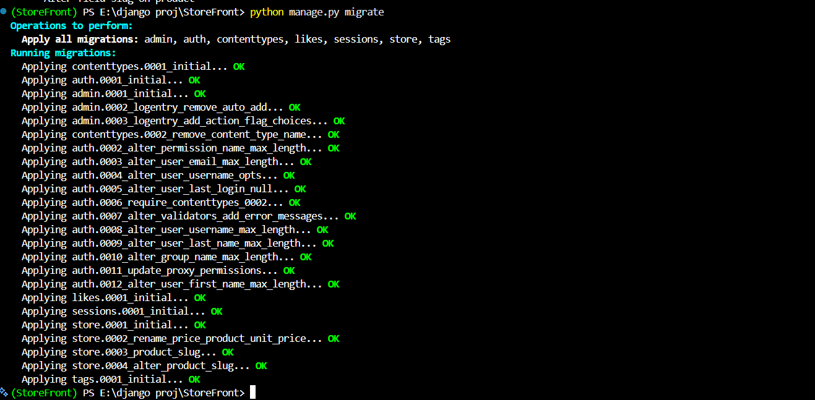
- Another commad that is used to see actual sql code that is sent to the sql or sqlite database.
  - python manage.py sqlmigrate store 0004 using this command we can see what sent to the database during the specific migration like I used 4th migration.
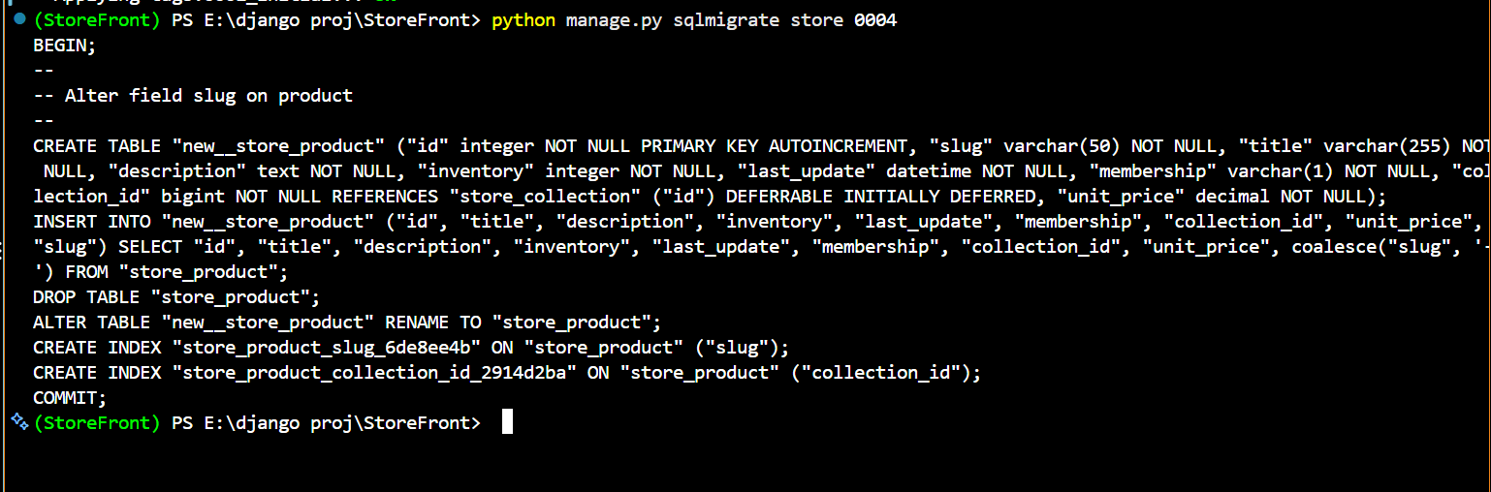
Customizing Database schema:
- Some times we need more control over the database schema. For example, you need to overwrite the name of a table, or you want to add an index to a couple of the columns etc.
- Django allows us to customize the database schema using the Meta class. In this example, db_table changes the default table name to store_customers, while indexes creates a composite index on last_name and first_name to improve query performance. Additionally, unique=True creates a uniqueness constraint on the email field, and null=True allows the birth date column to store NULL values.
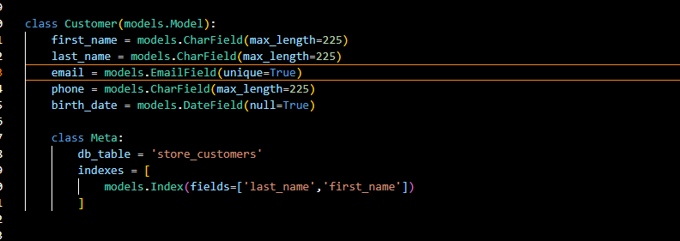

Reverting migrations:
- Suppose if the previously applied migrations was an mistake, we can revert it in couple of ways.
- If we want to selectively undo the what we have did in the previous migration. We have to create a new migration. Suppose in last lesson we did to things that are renaming the table and creating the index.
- If we want to keep the index but remove the renaming of the table_name we remove that line and save the changes and create the new migrations and then apply it.
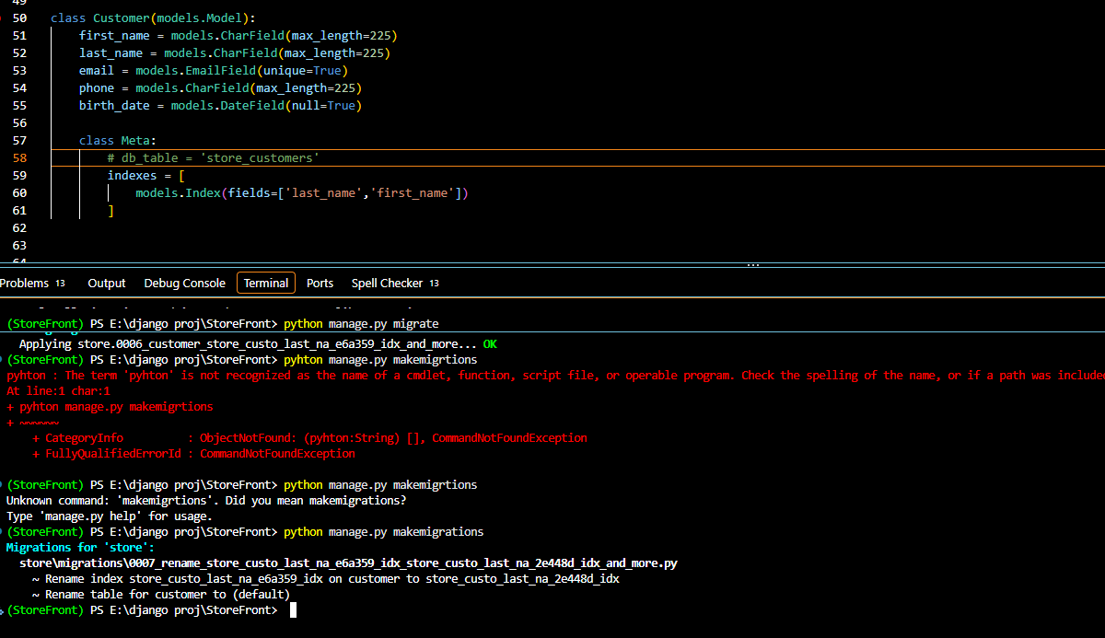
- If we want to revert the whole migrations then we need to roll back to the previous migrations done. For suppose had done 6th migration accidentally then I need to revert it to 0005th migration then we use the command below
  - Python manage.py migrate <app_name> <migration_num>
  - Ex: python manage.py migrate store 0005 this rolebacks to the 5th migration to the current migration.
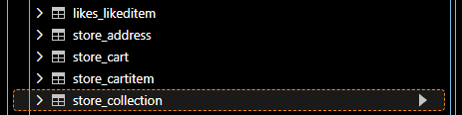
- After running the above commands our database will be successfully revert to the previous state but the migration fill be lift out without delete. When you create the migration again and migrate it to the database the changes will we reverted again so to avoid this we need to delete the code and the files again. This is where the version control system like git comes into picture. So, we can rollback to the previous commit without deleting manually.

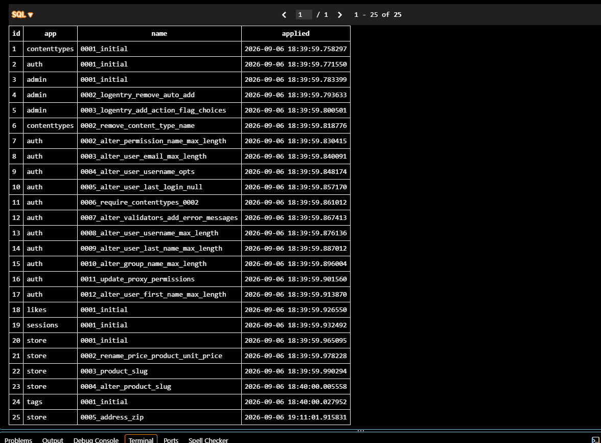
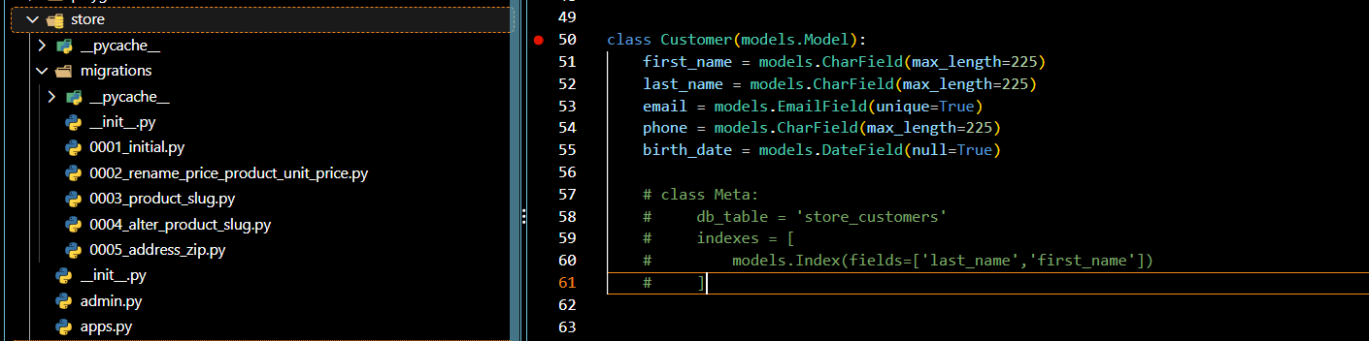
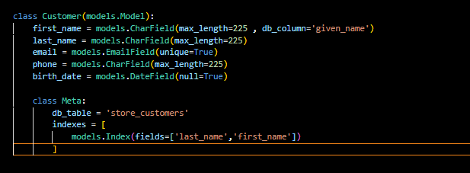
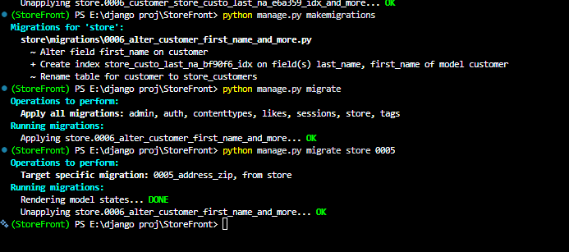
- Renamed first_name to given name and then migrated and reverted it again

Connecting to MySQL in Django:
- MySQL Clients:
  - MySQL workbench (free)
  - TablePlus
  - DataGrip
- In this project we are going to use DataGrip as an MySQL client. We need to establish the connection successfully and then lets start working with it.

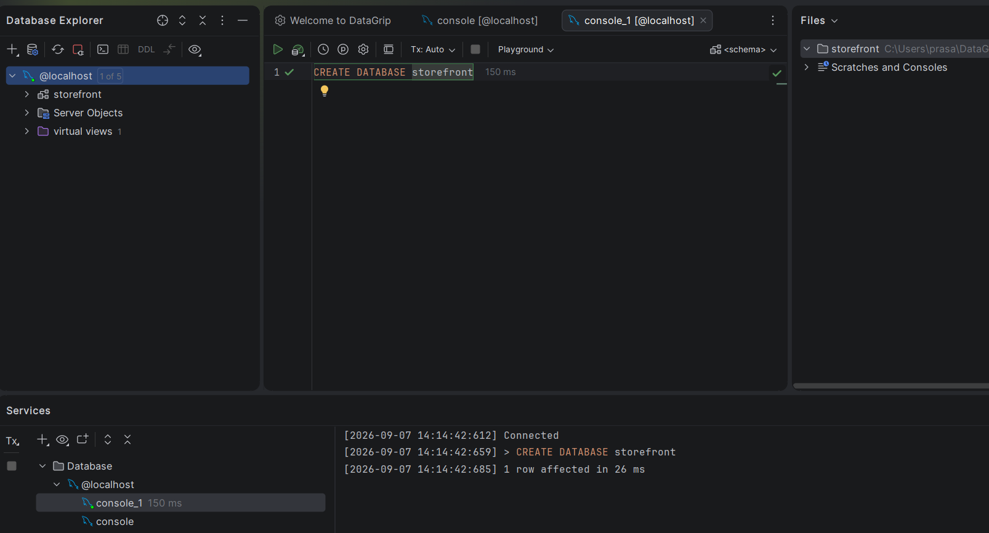
Using MySQL in Django project:
- To connect our project with MySQL we need to install a package called MySQL Client
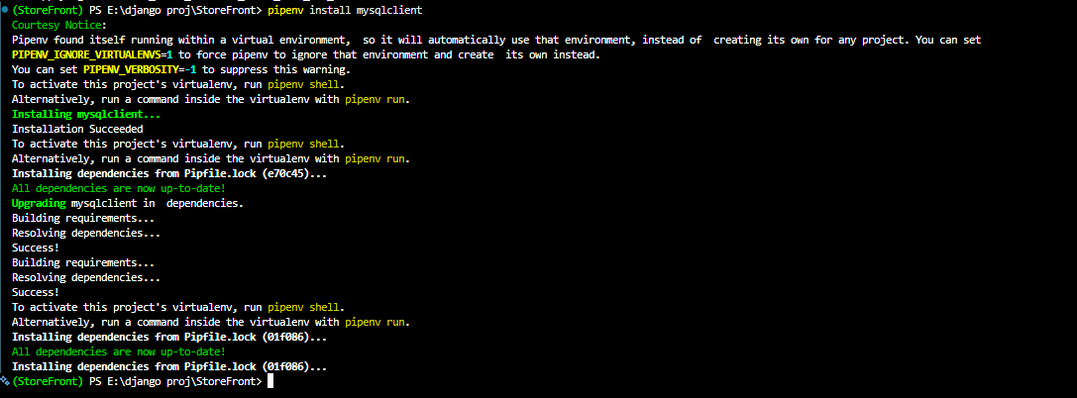

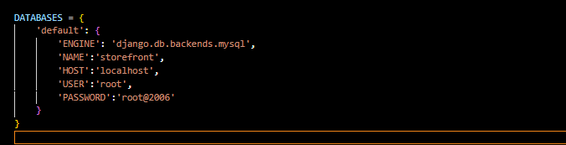
- To setup the database successfully we need to go to the settings.py module in the storefront directory and then in settings.py in databases we need to update the details as shown below.
- After updating we need to run the migrations so we can get all the data into stormfront database
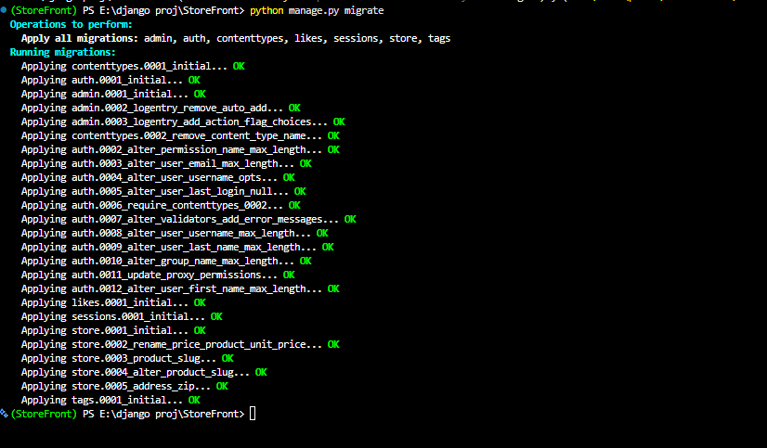
  - Python manage.py migrate

Running Custom SQL:
- Sometimes we need full control over generating or updating database schema. To do that we need to create empty migration and write query there.
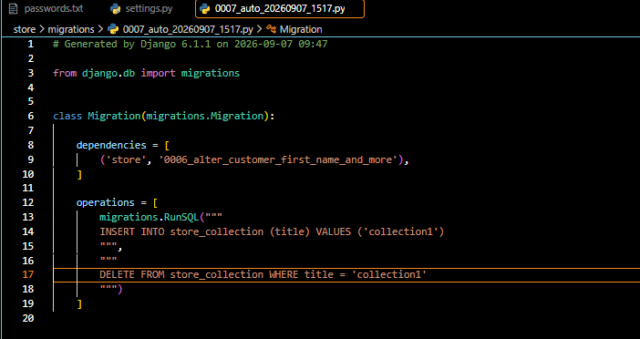
  - Python manage.py makemigration store –empty So this commad creates empty migration in the store directory then we will write our own query in it as shown below.

Generating Dummy data:
To generate dummy data in the database I used Mockaroo.com to generate the dummy data of 1000 records and exported the data in the form of sql file. And then in the datagrip I had executed all the queries.
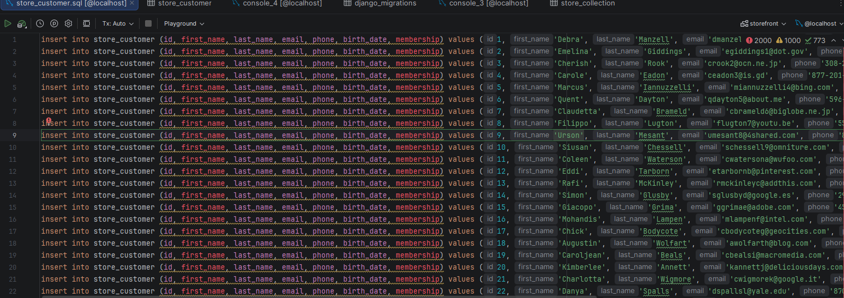
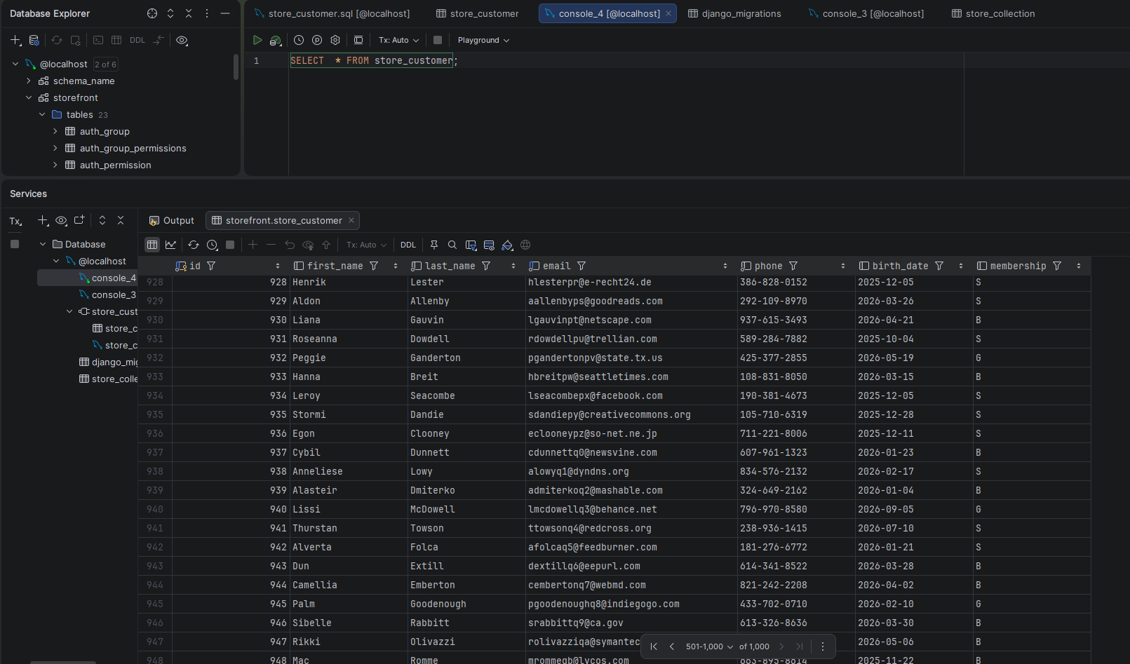

Django ORM:
- Object-Relational Mappers (ORM) The data in the relational model is stored in the form of tables and columns. So, when we pull the data from the relational database we need to map these rows into objects.
- Model class is also part of the Django’s RM. All our model class inherit the functionality to query or manipulate data from the base model class.

Managers and QuerySets:
- Managers are like interface to the databases. It is like remote control with lot of buttons so we can talk to our database.
- In the given below image the like products.objects , here the objects is a manager used to talk with the database and all is the one of the methods to pull the data.
- Most of the methods return the query_set, like all() methods return the query_set .
- Query_set is an object that encapsulates the query. So at some point Django is going to extract the query_set and generate the right sql statement to generate to the database.
- This happen in few situvations:
  - When we iterate through the query_set as shown in the image
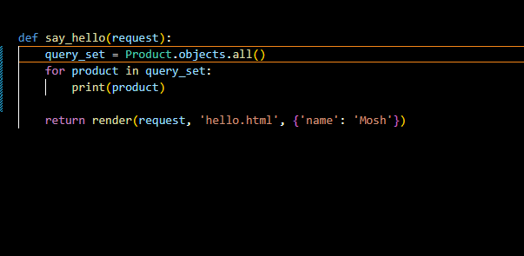

Back in the browser after refreshing we can see the sql queries executed by Django in the Django toolbar
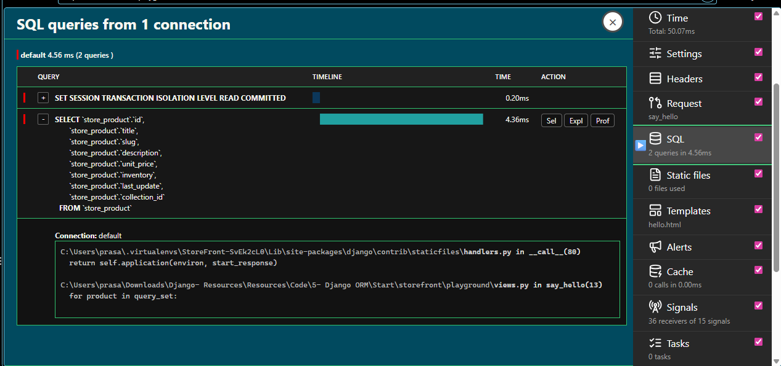

- Another situation is where we can where we can convert it into list
- And another scenario is where we access individual element using index or using slicing.
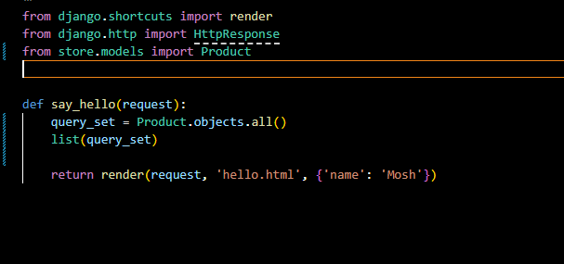

- Query_sets are lazy which means they will be evaluated at a later point.
- A QuerySet is lazy because Django does not immediately execute the SQL query when you create a QuerySet. Instead, Django builds and stores the query internally and waits until you actually need the results. This is useful because it allows Django to modify, combine, and optimize the query before sending it to the database. For example, customers = Customer.objects.filter(first_name="John") does not immediately hit the database. The SQL is executed only when the QuerySet is evaluated, such as when you iterate over it, convert it to a list, call len(), check its truth value, or otherwise request the actual results.
Retriving objects:
- There are different methods used to retrieve the objects in the objects class. Like all(), get(), count etc.
- To retrive an single object from the table we use get method with an id. We can use pk argument in this because Django automatically translated to the primary key field. And also get method returns the object not the query set. Because it returns one row so there is no point in filtering ad sorting that row so it returns an object than temperature.
- There is one disadvantage of this pk argument if the object with the id number doesn’t exist then it gives an exception. To handle this we use exception handling.
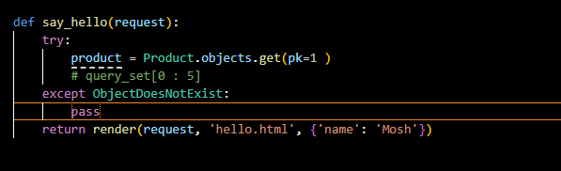

- There are lot more ways to do it. Instead of using try cache we can use filter method. Where it return the query_set and if the table is empty it return NONE.
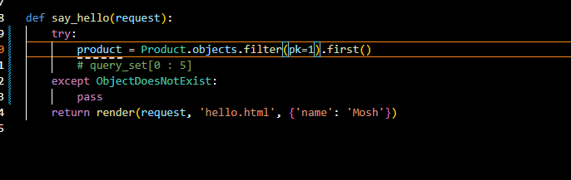
- We can use exists method to check weather the object is existing or not

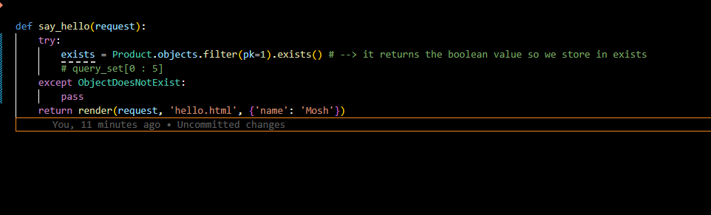
Filtering data:
We doesn’t use the comparison operators because it return the Boolean value, in this we use lookups .
1. Comparison Lookups
These are the most important ones to remember:
Lookup | Meaning | Example
__gt | Greater than | price__gt=100
__gte | Greater than or equal | price__gte=100
__lt | Less than | price__lt=100
__lte | Less than or equal | price__lte=100
__exact | Exactly equal | price__exact=100
__iexact | Case-insensitive exact match | name__iexact="john"

Examples:
- Product.objects.filter(unit_price__gt=100)
- Product.objects.filter(unit_price__gte=100)
- Product.objects.filter(unit_price__lt=100)
- Product.objects.filter(unit_price__lte=100)

Lookup | Meaning
__contains | Contains the text, case-sensitive
__icontains | Contains the text, case-insensitive
__startswith | Starts with
__istartswith | Starts with, case-insensitive
__endswith | Ends with
__iendswith | Ends with, case-insensitive

Examples:
- Customer.objects.filter(first_name__contains="John")
- Customer.objects.filter(first_name__icontains="john")
- Customer.objects.filter(first_name__startswith="A")
- Customer.objects.filter(email__endswith="@gmail.com")
- Customer.objects.filter(id__in=[1, 2, 3, 4])
- Product.objects.filter(unit_price__range=(100, 500))
- Customer.objects.filter(birth_date__isnull=True)

Complex Lookups using Q:
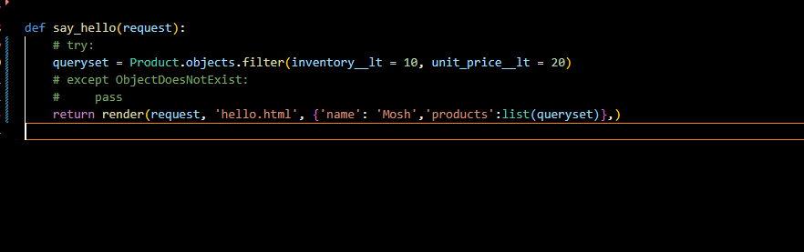
- Let us say we want to find all products with the inventory < 10 and and unit price < 20. One way to do this is to pass the multiple arguments.

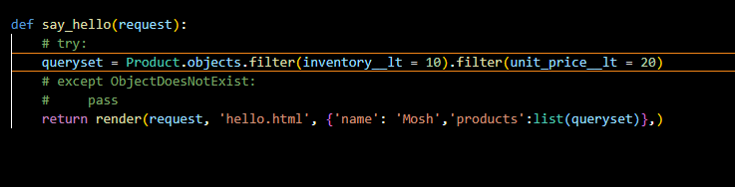
- Another way of doing this is using a query_set and applying a second filter on it.

- Both give the same output.

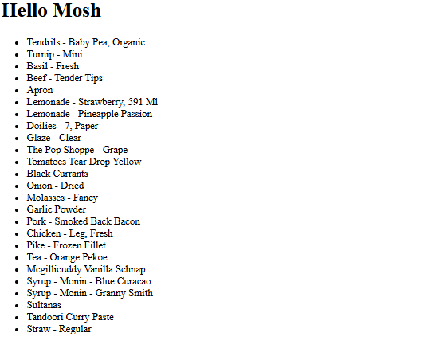
- In the above filter method the query is executed using and condition in SQL.
- To combine queries using OR we need to import Q class. This convrts bitwise OR ‘|’ logical OR in the Query.
- We can even use bitwise and & but syntax Is little bit verbose so we don’t really need that.
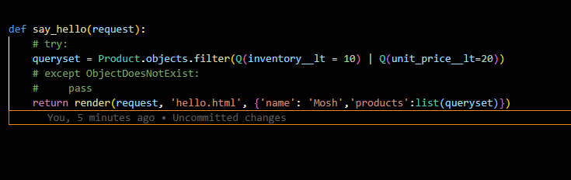
- Even we can negate operator ‘~’ this turn into NOT operator in SQL query.
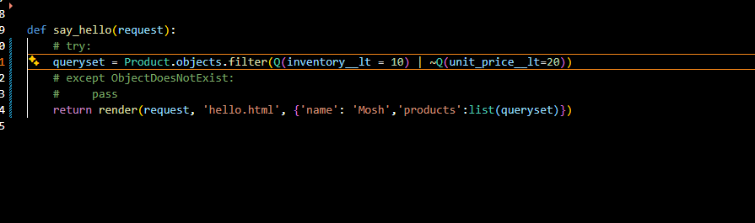
Referencing Fields using F objects:
- Sometimes when we are filtering the data we need to reference a particular field.
- Suppose think of retrieving all the products where inventory equals to the unit_price.
- To do this we are going to use the F class in Django

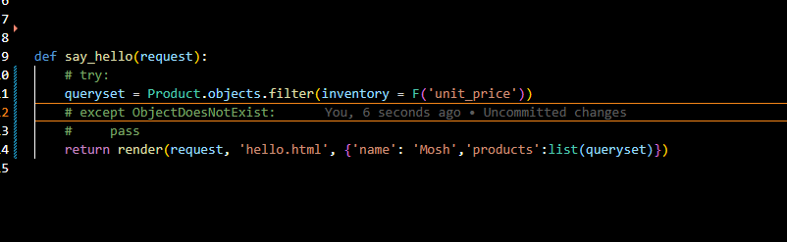
- We can also refer a field to a related table
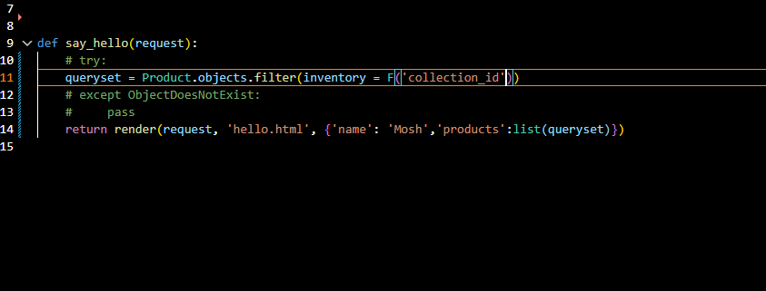
Sorting Data:
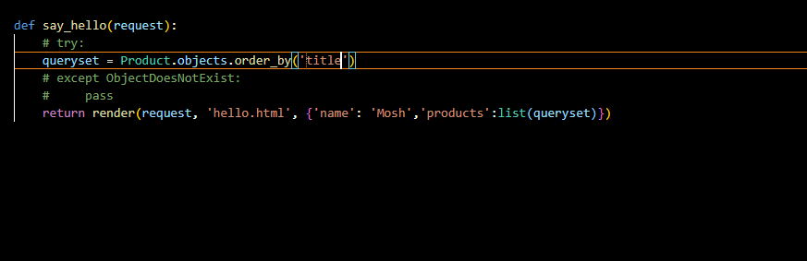
- To sort the objects, we use order_by() method to sort the data \

- To sort in descending order we need to use the – sign.

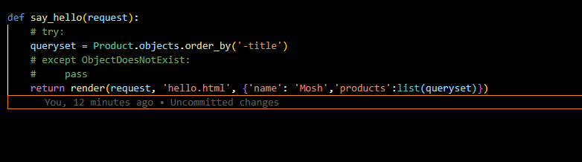

- We can also sort the data based on the multiple fields. We can sort the multiple fields one in ascending and descending both.
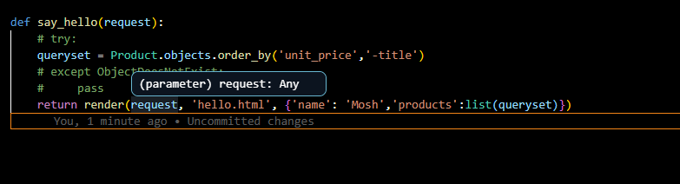
- We can use .reverse() method to reverse the direction of the sort.
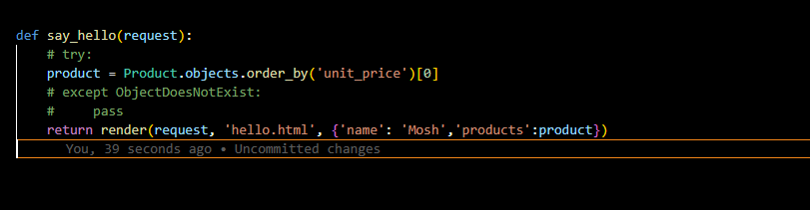
- If we want to sort the data and we need to get the 1st object we do the thing as shown below in the image.

- Instead of using order_by() method and retrieving 1st object through index, we can use earlist() and latest() method. This method returns the objects rather than returning the querysets.

- earlist() this method returns the 1st object after ordering in ascending order.

- latest() this method returns the 1st object after ordering in descending order.

Limiting results and selecting fields to query:
- We use values() method to limit the result but this gives us bunch of dictionaries.
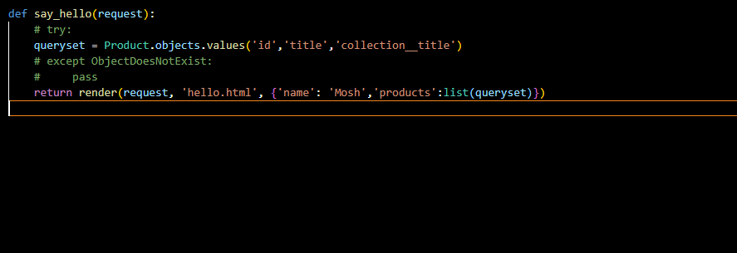
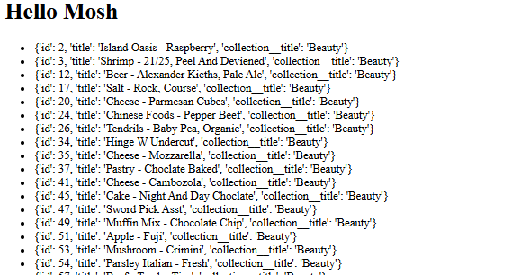

- And values_list() method gives us the bunch of lists.
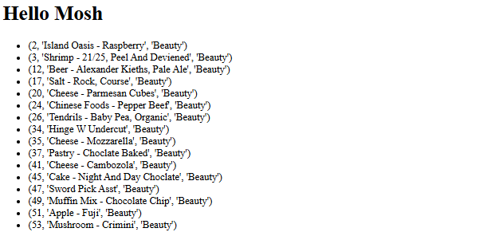
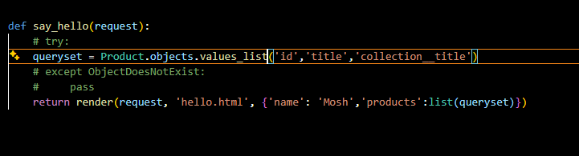

- They help limit the columns/fields retrieved from the database, instead of fetching the entire model.
- Example: Customer.objects.values(“first_name”, “email”) gets only those two fields.
- To limit the number of rows, use slicing like Customer.objects.values(“first_name”)[:10].

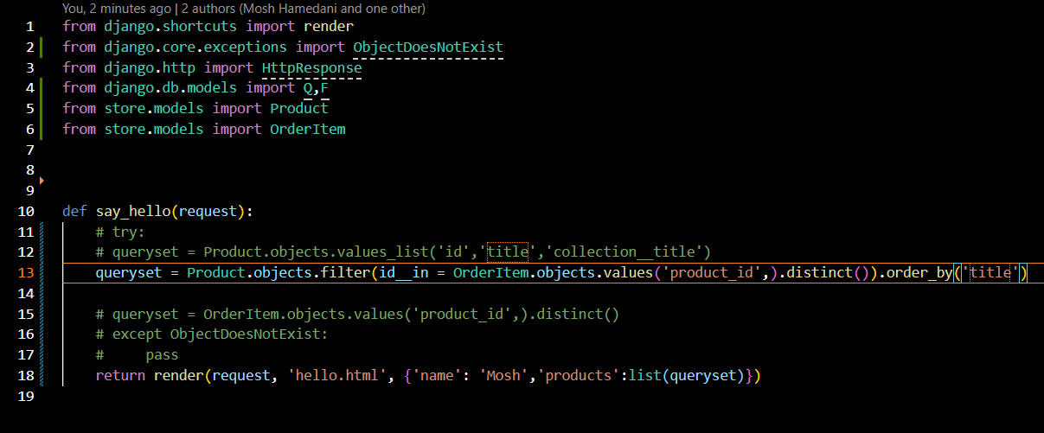
Here we are retriving the products which are be ordered.
Differing Fields:
- only() method:
  - We have a method called only() With this method we can specify the fields that we want to read from the database.
  - This method will the get the instance of the product class with values method we will get the dictionaries.
  - We need to be careful with this method, when we try to render the field which is not mentioned in the only method, we will endup with lot of queries sent to our database.
- Differ() method:
  - With this method we can set the learning of the certain fields to later.
  - This has the same behaviour as the only() method.
Selecting related objects:
- When we use all() method and retrieve the objects but if any non-related field is rendering then the Django is going to send lot of unwanted queries to the database to retrieve that data, instead we preload the specific field we require.
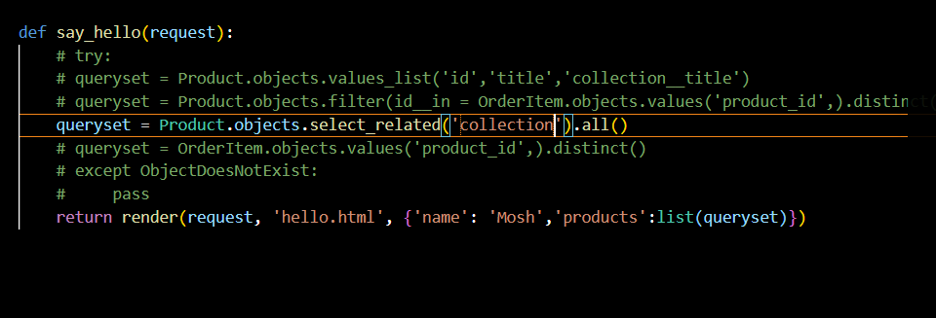
- If we want to preload the specific field in collection then we can do it as shown below. 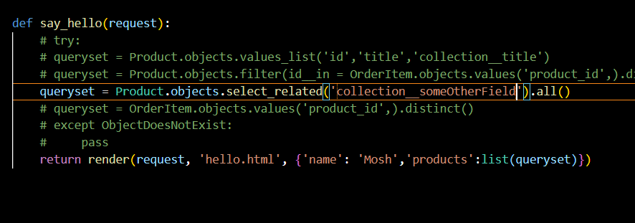
- We use selected related when the other end of the relationsip has one instance. For example, like a product has one collection.
- We use the prefetch() method when the other end of the relationship has many to many. For example, one product can have many promotions.
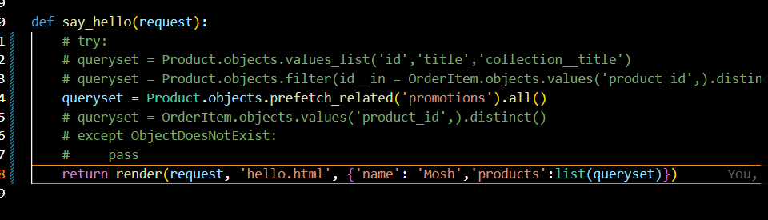
- We can use this both methods at a time. Think of the situation, getting all the products with collections and promotions then we use both methods.
Aggregating objects:
- We use aggregations to calculate sum, count, min, max, avg operations.
- To perform this operations we import the aggregate model from the Django.db.models
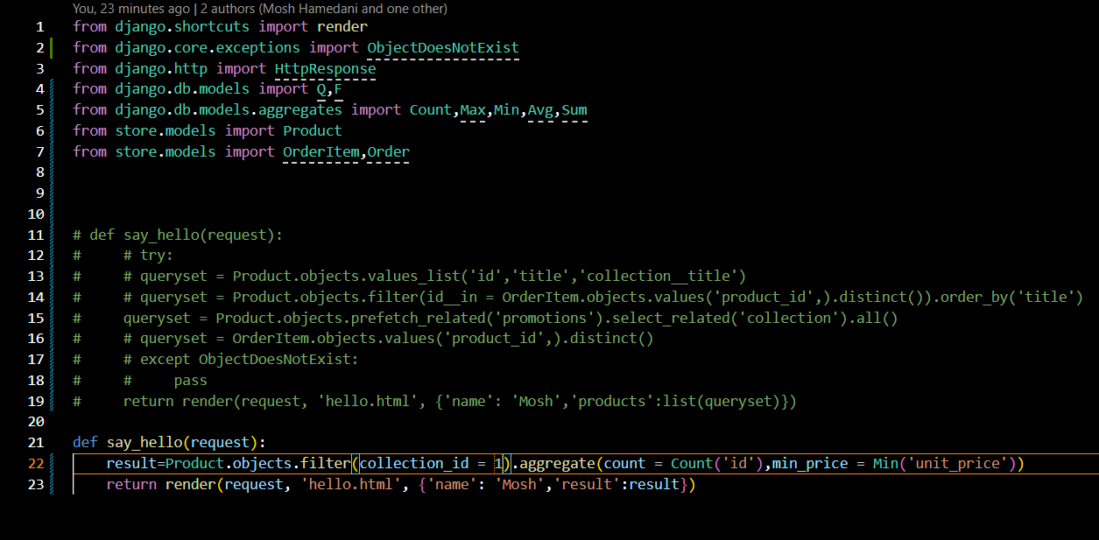
- And then we perform the operations as shown below.

Annotating the objects:
- Sometimes we need to add additional attributes to our objects while querying this is where we use annotations.
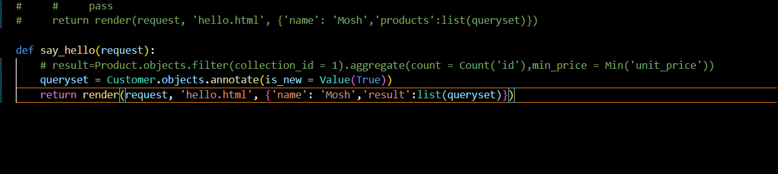
- In annotate() method we cannot pass the Boolean directy. The reason is this method is designed to add the database expression not an value directly.

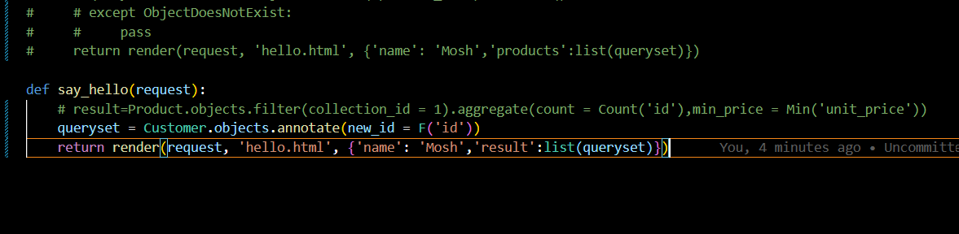
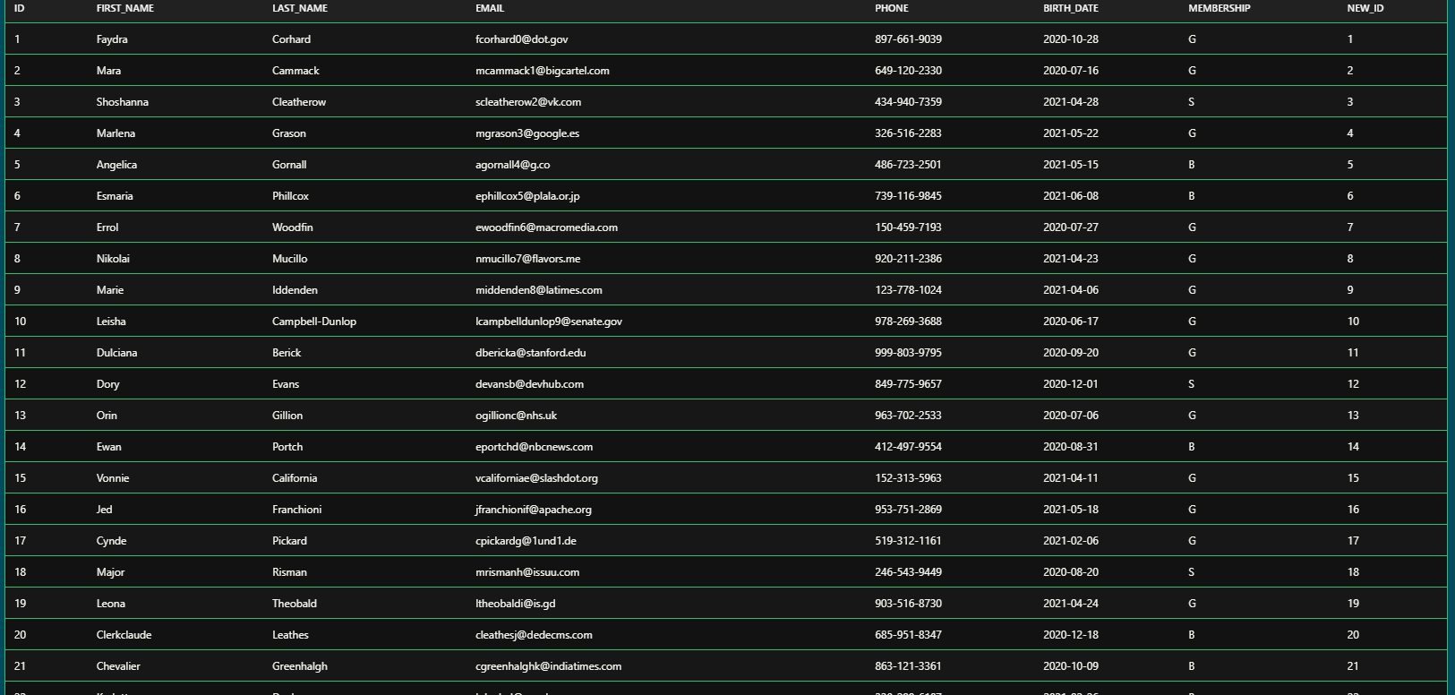

Calling Database Functions:
- Suppose if we want to contact first name and last name of the customer then we use func() method and then we use the function = ‘CONCAT’ as shown below
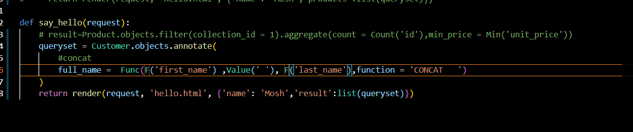
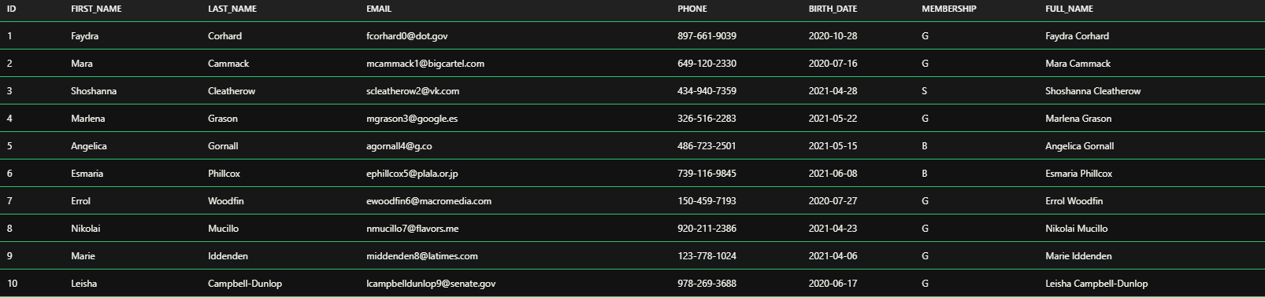

- Even we can do this in short way by importing the concat function from db module.
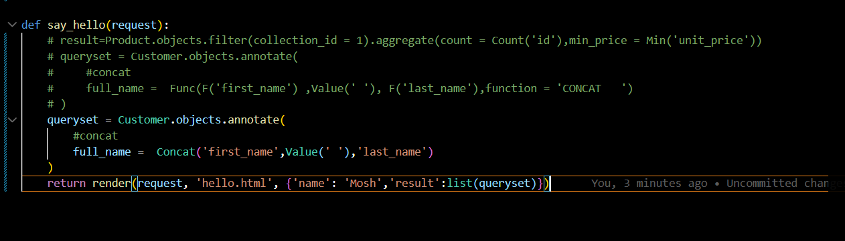
Grouping the data:
- annotate() + aggregate → Django automatically performs grouping based on the selected fields.
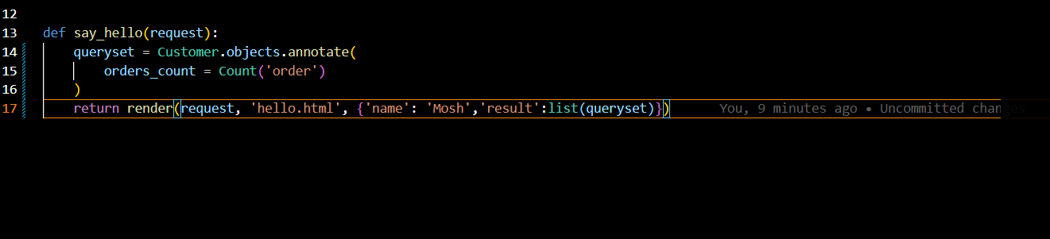
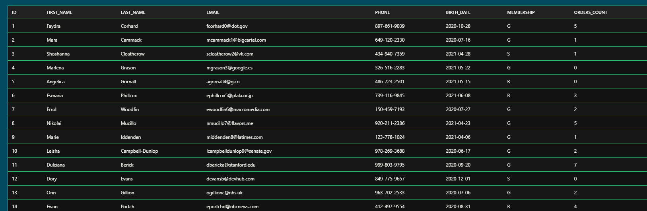

Django ORM Expression | What it is used for | Example | SQL idea
Expression | Base concept for anything Django can translate into a SQL expression | F('price') * 2 | price * 2
Value() | Represents a constant Python value | Value(True) | TRUE
F() | References an existing database field | F('price') | price
Func() | Applies a database function | Func(F('name'), function='UPPER') | UPPER(name)
Aggregate | Performs calculations across multiple rows | Count('orders') | COUNT(orders)
ExpressionWrapper() | Wraps an expression and explicitly specifies its output data type | ExpressionWrapper(F('price') * 1.1, output_field=DecimalField()) | price * 1.1

Working with Expression Wrappers:
- let us think Take the unit_price field and multiply it by 0.8.
- The problem is that this is a calculated expression, and Django may not be able to determine the exact output field type from the combination of fields/values.
- ExpressionWrapper is mainly used when Django needs help determining the type of a calculated expression.
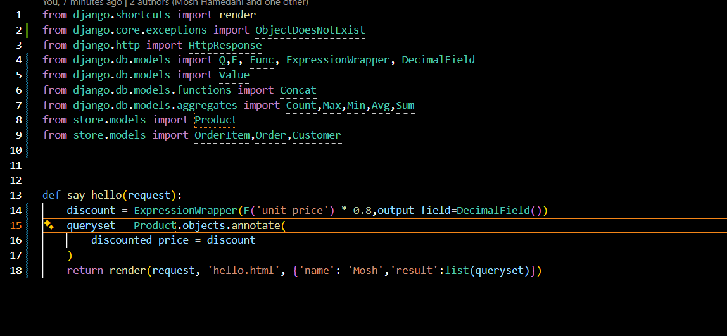
Querying Generic relationships:
- In your code, you query a generic relationship by using ContentType and object_id: ContentType.objects.get_for_model(Product) gets the ContentType representing the Product model, and then TaggedItem.objects.filter(content_type=content_type, object_id=1) finds all TaggedItem records that belong to Product with ID 1. Here, content_type tells Django which model the object comes from (Product), while object_id tells Django which specific object (Product #1); select_related('tag') then uses a SQL JOIN to efficiently fetch the related Tag at the same time.
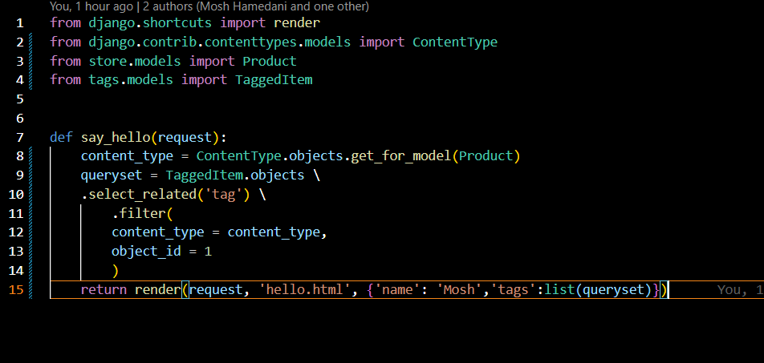
Custom Managers:
- Here, the custom manager is used to create a reusable method specifically for querying TaggedItem objects involved in the generic relationship.
- TaggedItemManager extends models.Manager, and objects = TaggedItemManager() replaces Django's default manager with your custom one. Therefore, instead of writing the ContentType and filtering logic every time, you can simply call something like TaggedItem.objects.get_tags_for(Product, 1).
- Inside the method, get_for_model(Product) gets the content type for Product, and filter(content_type=content_type, object_id=1) finds the TaggedItem records linked to that particular product. The main purpose is to encapsulate commonly used database-query logic into a reusable method on TaggedItem.objects.
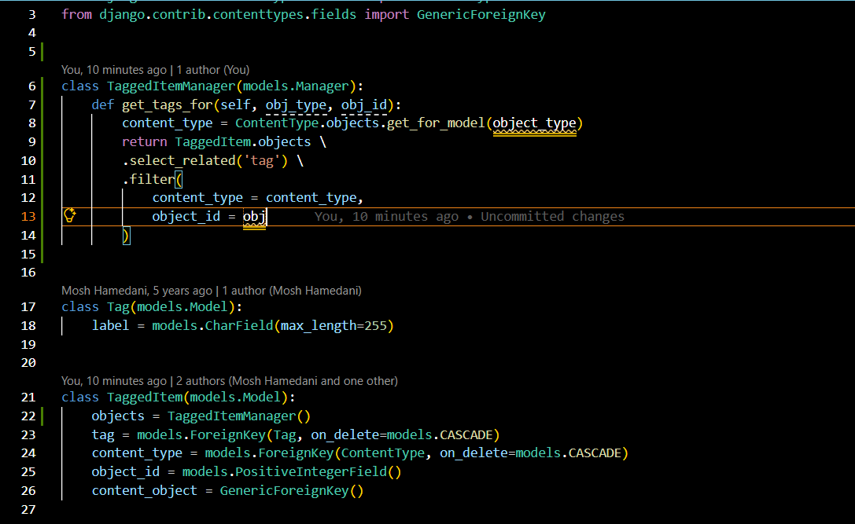
Understanding Queryset caching:
- When the queryset is loaded, Django automatically caches the retrieved queryset so when we need to access it again , Django retrievers the data from the cache and then displays it to the user.
- Cachin happens only when the entire queryset is evaluated.

Creating objects:
In this code, you are creating a new Collection object in memory, assigning values to its fields, and then saving it to the database:
- collection = Collection(title='Video Games')
This creates a Python/Django model object but does not yet insert it into the database. Then:
- collection.title = 'Video Games'
sets/updates the title field (this line is redundant because you already set it). Next:
collection.featured_product = Product(pk=1)
creates a Product object representing the product with primary key 1 and assigns it to the featured_product ForeignKey. Finally:
- collection.save()
actually inserts the Collection into the database.
So the basic pattern is:
Collection(...) → create object in memory
↓
assign fields
↓
.save() → store object in database
Important: Product(pk=1) does not fetch Product #1 from the database; it creates a Product instance with id=1. If you want to retrieve the existing product, use:
- product = Product.objects.get(pk=1)
- collection.featured_product = product
- collection.save()

Updating the Objects:
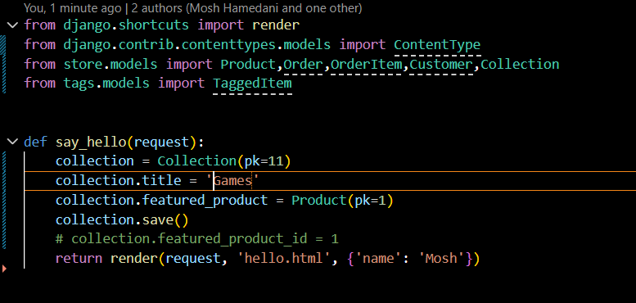
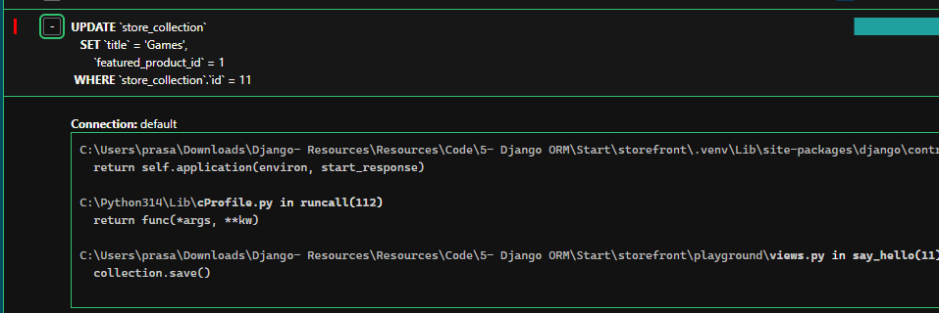

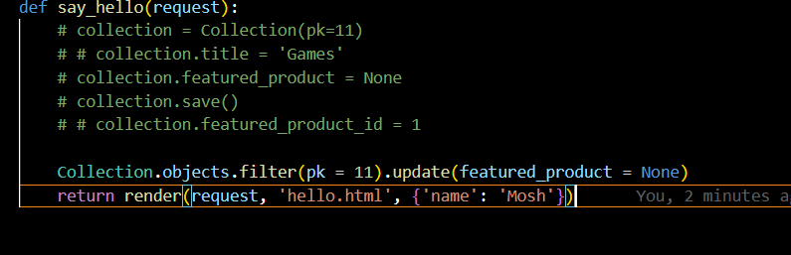
- in the given above images I had updated collections using the native way. And also we can update this in the other way by using update() method.
- But here we need to make sure that we are doing it properly. After removing the collection.title it automatically creates the empty string that is ‘’ as a product title. This is done by the Django by default.

Deleting the objects:
We have two ways of deleting the objects one is deleting single and multiple objects:
- To delete single object we use delete() method.
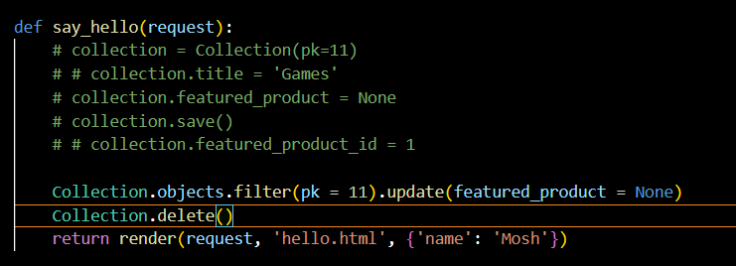
- To delete multiple objects we need to get the query sets.
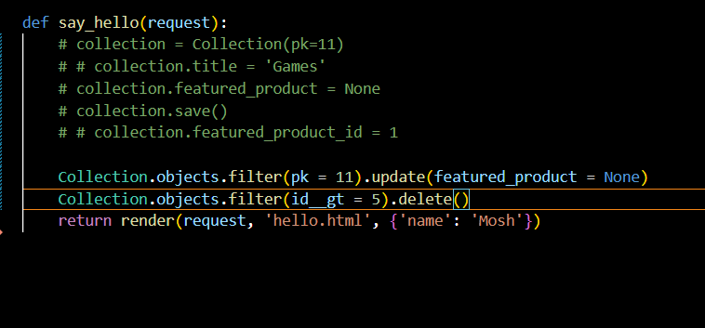

Tansactions:
- Sometimes we need to make the changes to the database in atomic way, meaning all changes should be saved together.
- If one fails all the changes should rollback.
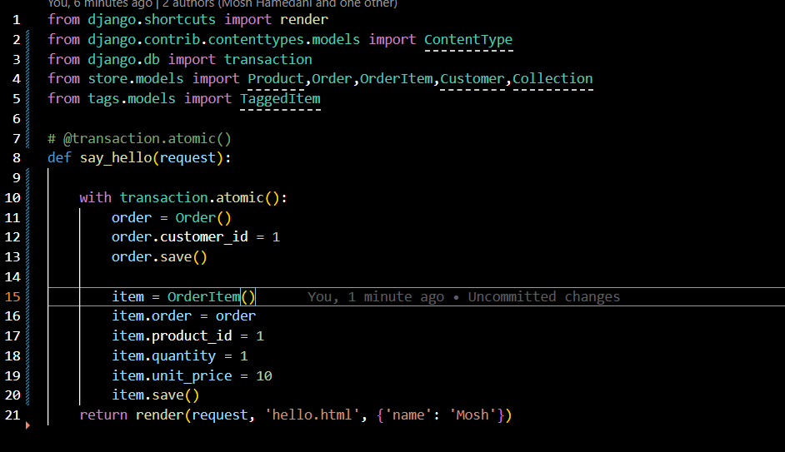
- In your code, transaction.atomic() is being used to make both database operations succeed together or fail together.
- What does with transaction.atomic() do?
- with transaction.atomic(): basically tells Django:
- "Start a database transaction here. If everything inside succeeds, commit it. If something goes wrong, roll everything back."
- @transaction.atomic makes the entire function a single all-or-nothing database transaction, so either all database operations inside the function succeed and are committed, or any failure rolls them all back.
- transaction.atomic() makes the creation of your Order and its OrderItem a single all-or-nothing database operation.
Executing raw sql queries:
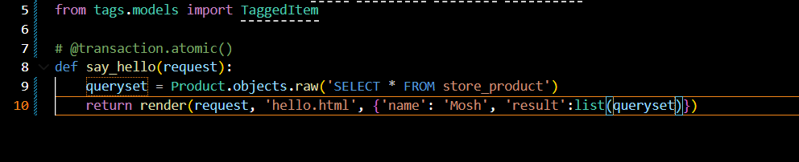
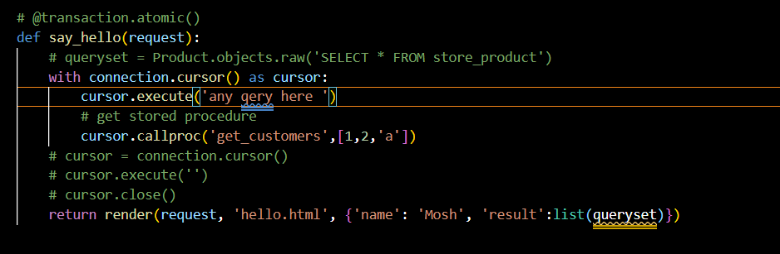
- connection.cursor() gives you a database cursor, and cursor.execute() allows you to send raw SQL directly to the database from Django.
Setting up the admin site:
To create the admin user we use the command given below:
- python manage.py create superuser
- after that we can open the admin page and customize the admin page as done below.
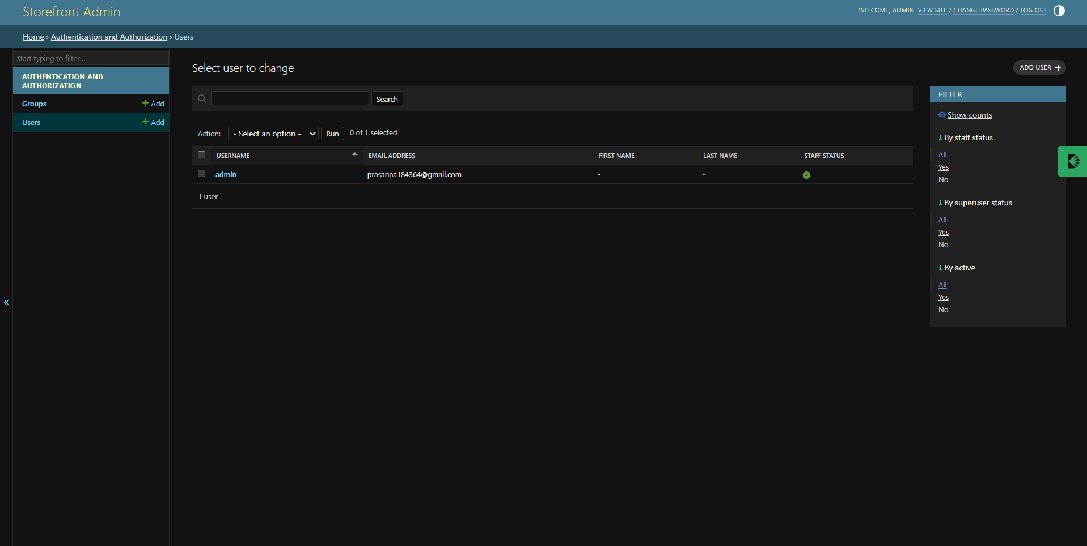
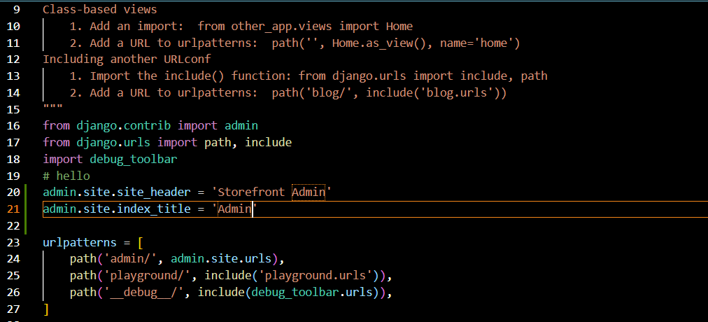
Registering models:
- To customize the admin pannel we need to use the go to admin.py module and then we will need to write the code there to customize.

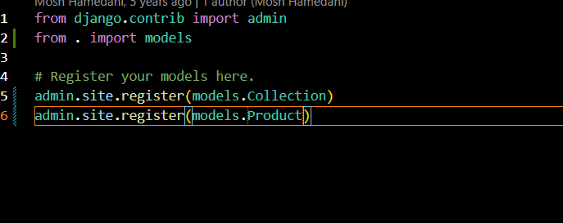

Now to display this products we need to make some changes in models.py as done below
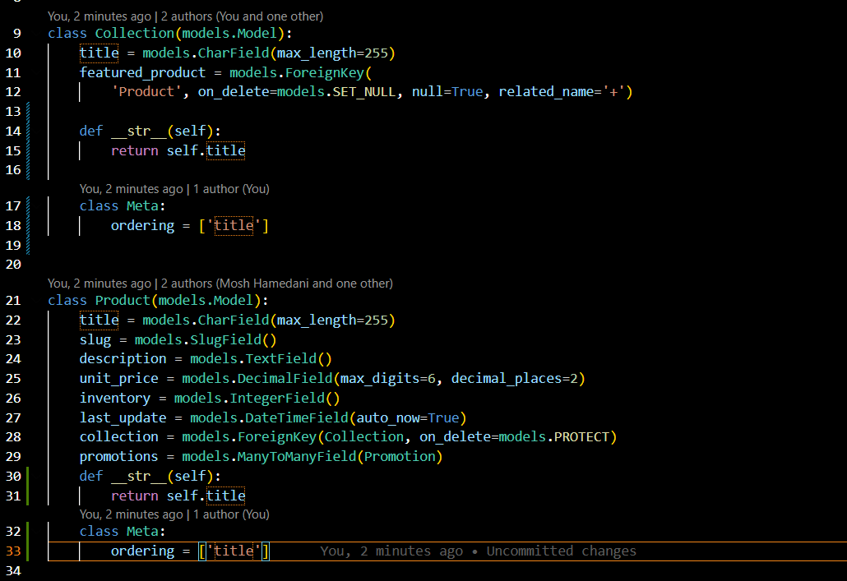
Customizing the list page:
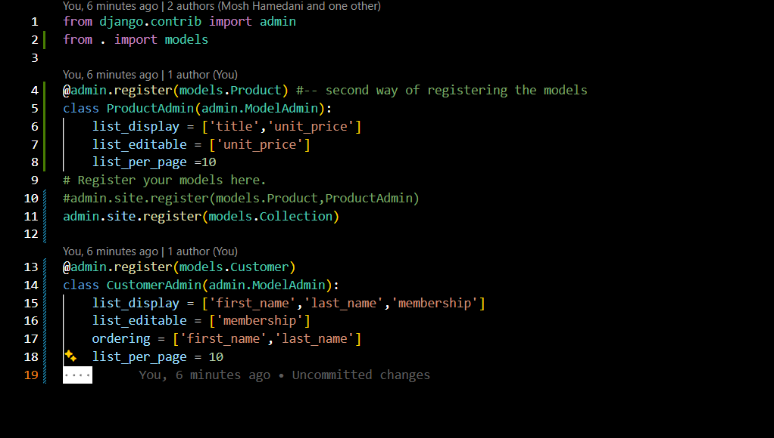

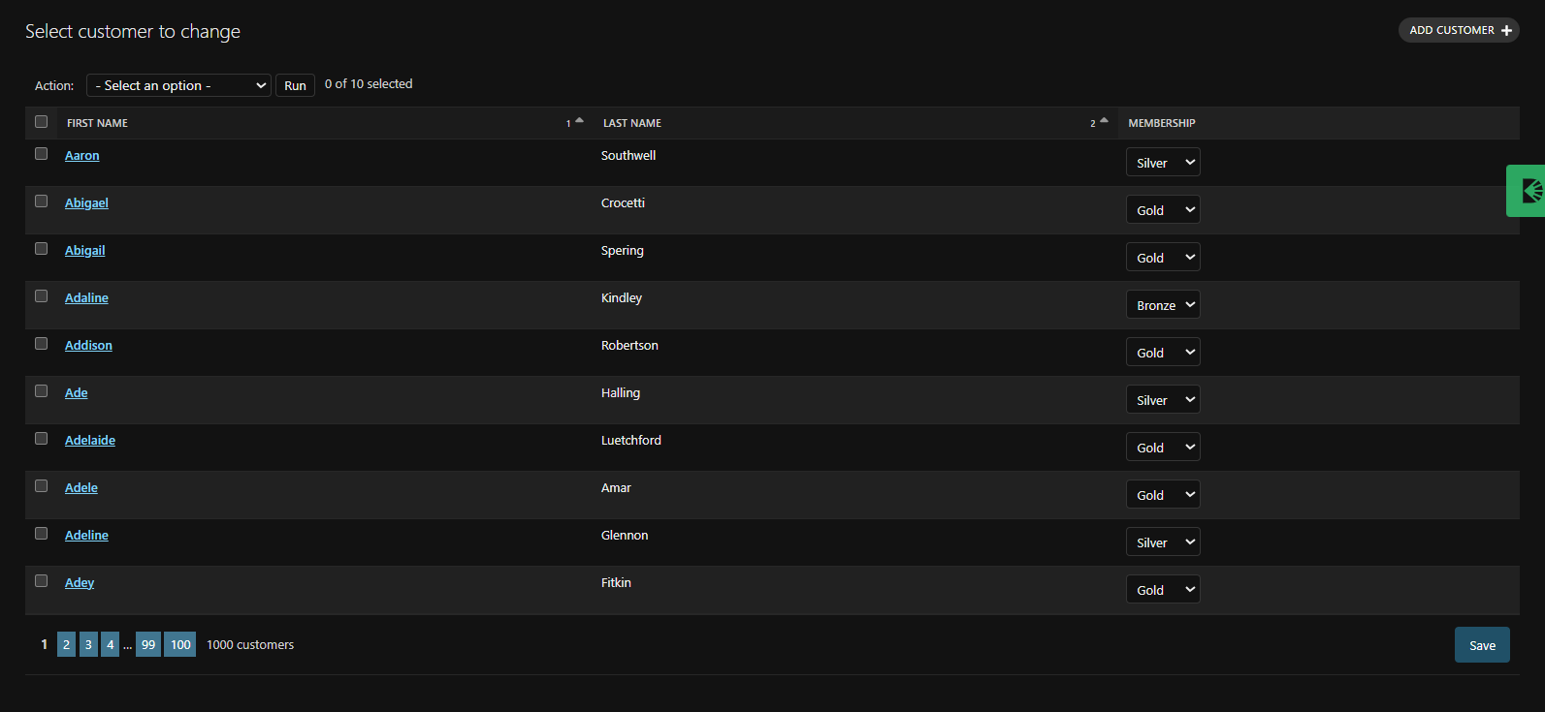
Adding Computed columns:
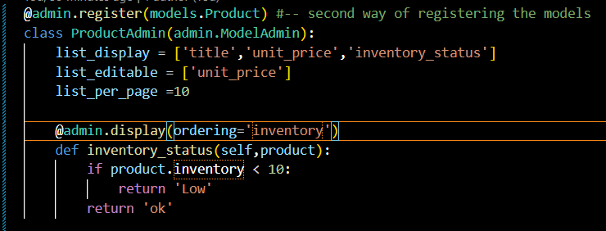

Selecting related object:
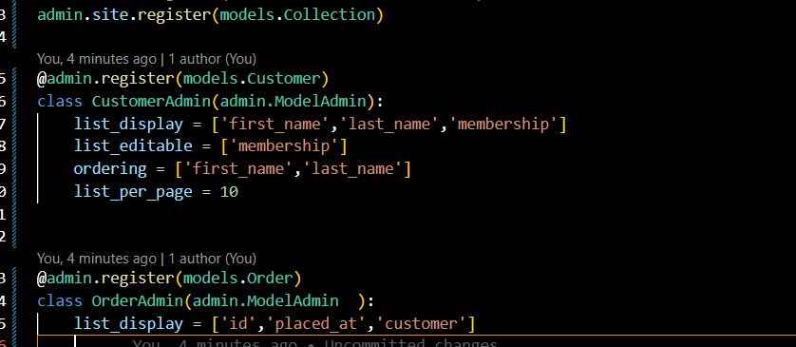

Overriding the base query_set:
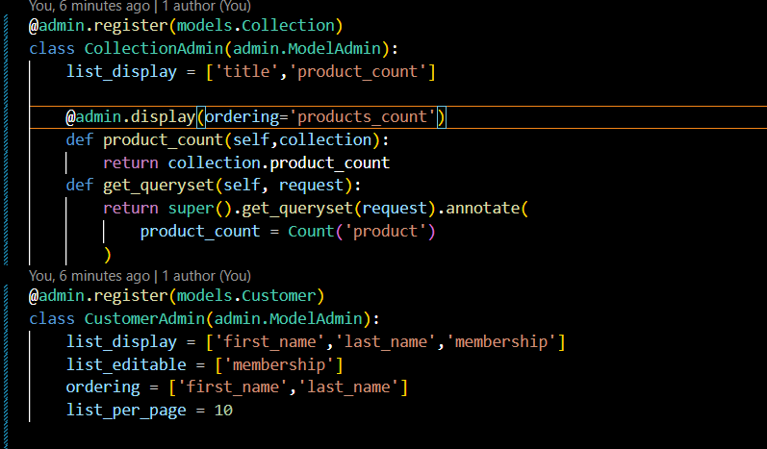

Providing likes to other pages:
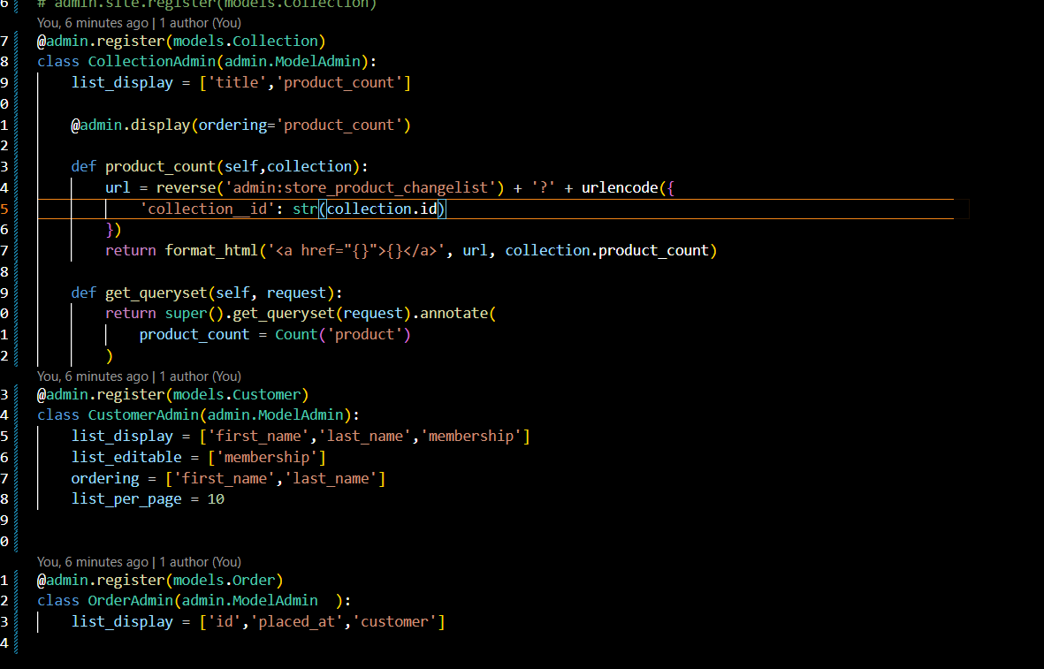
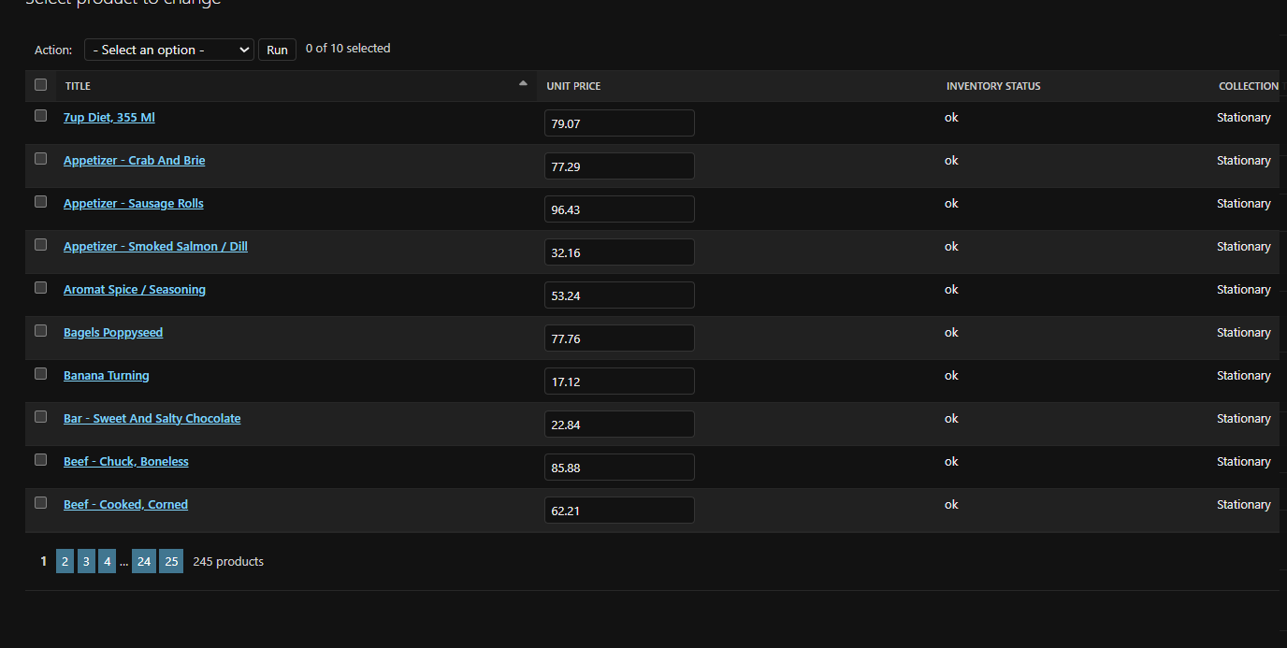
Adding search to the list page:
- We use search_fields() function to add search bar based on the fields
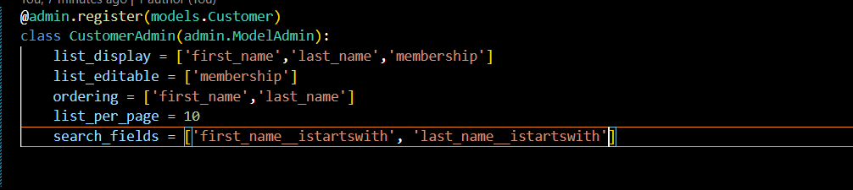
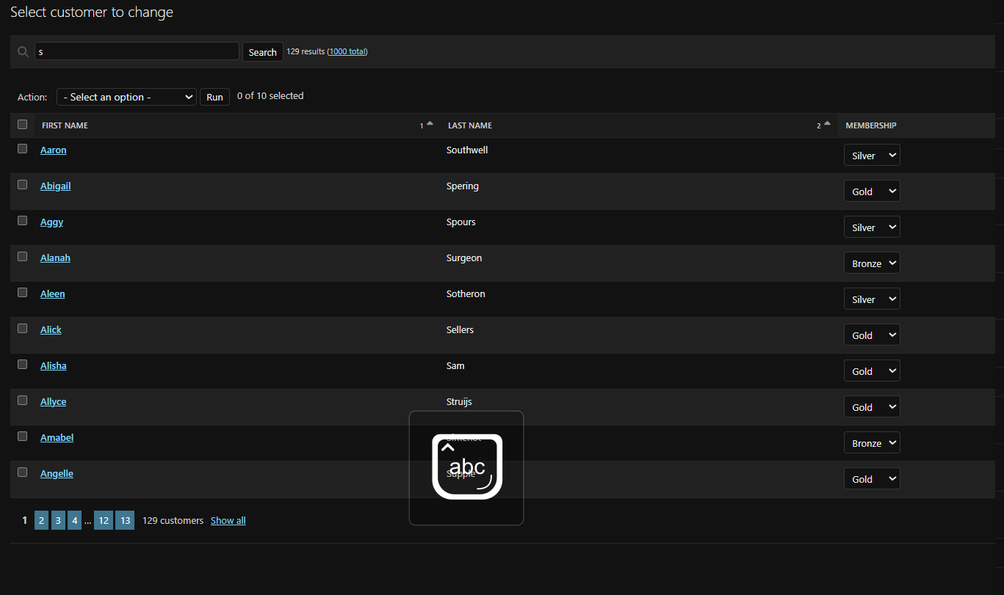

Adding filters to the list page:
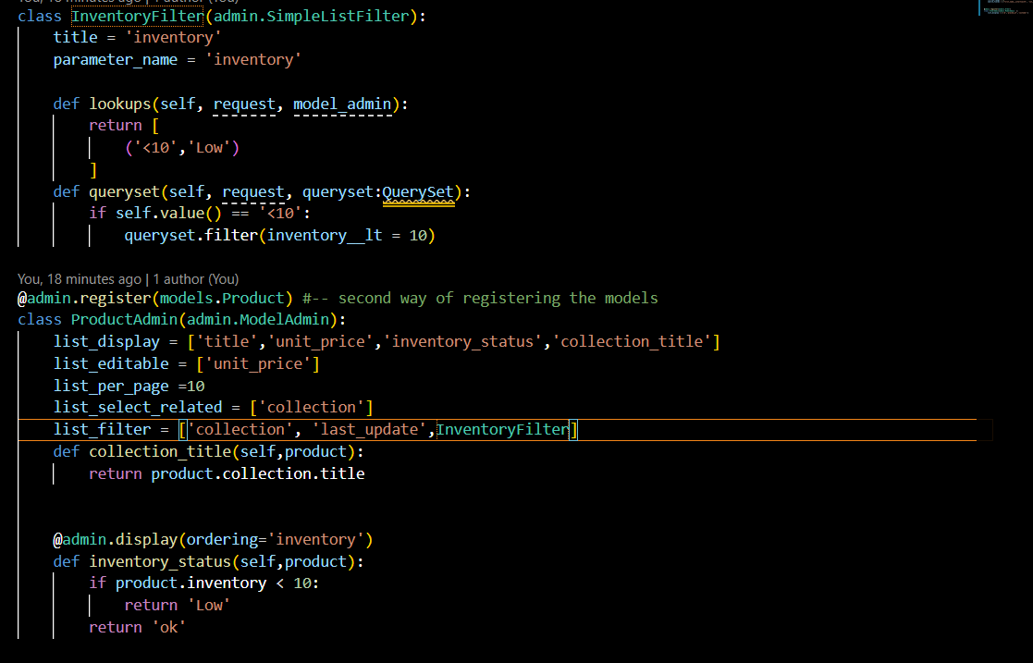
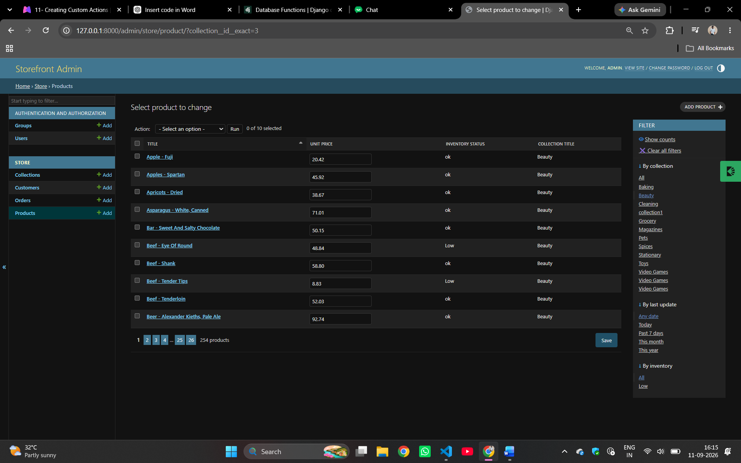

Creating Custom actions:
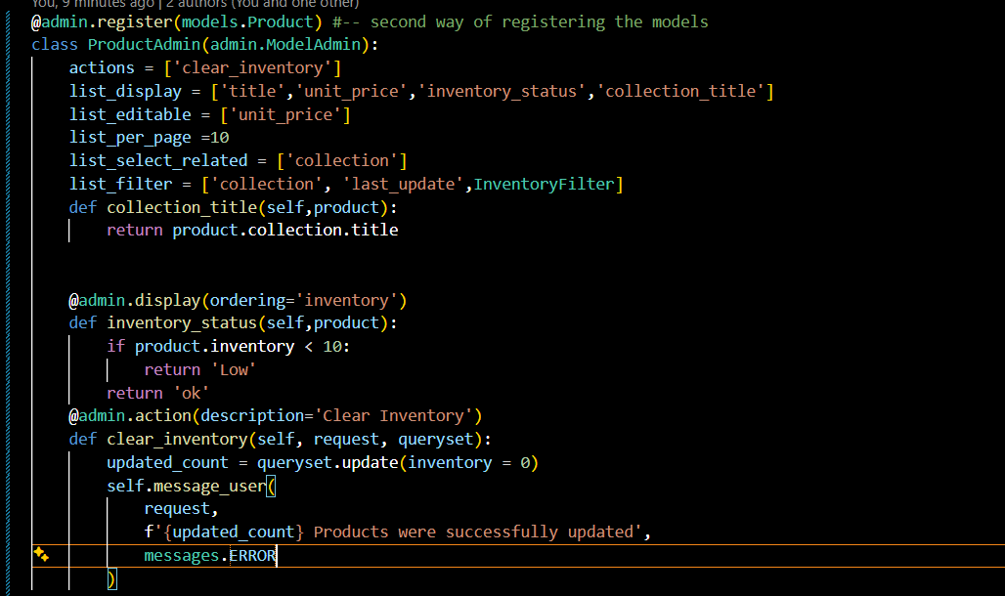
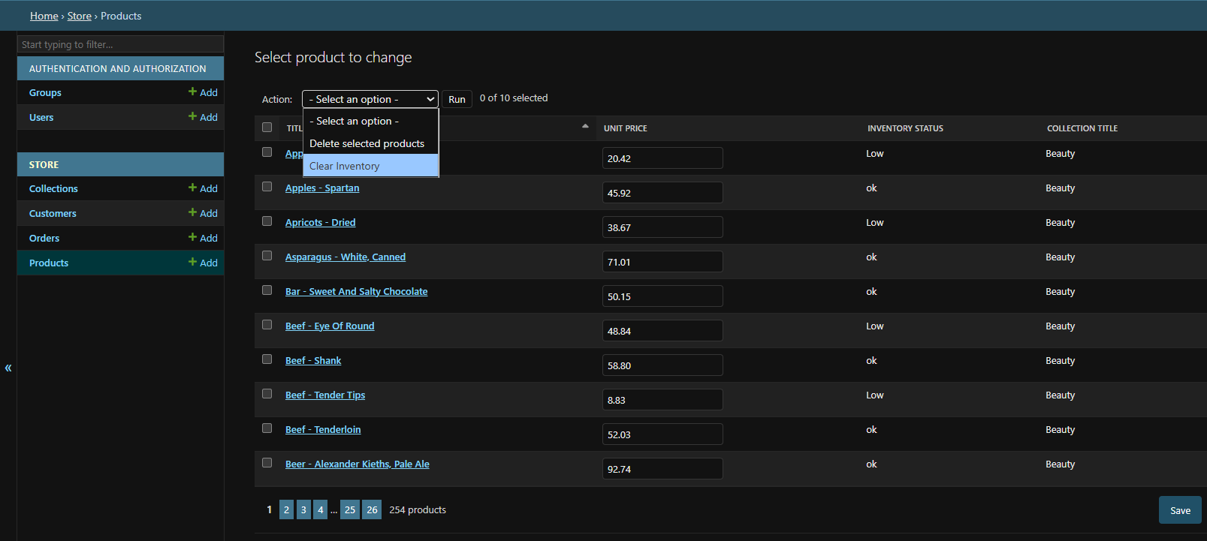

Customizing forms:

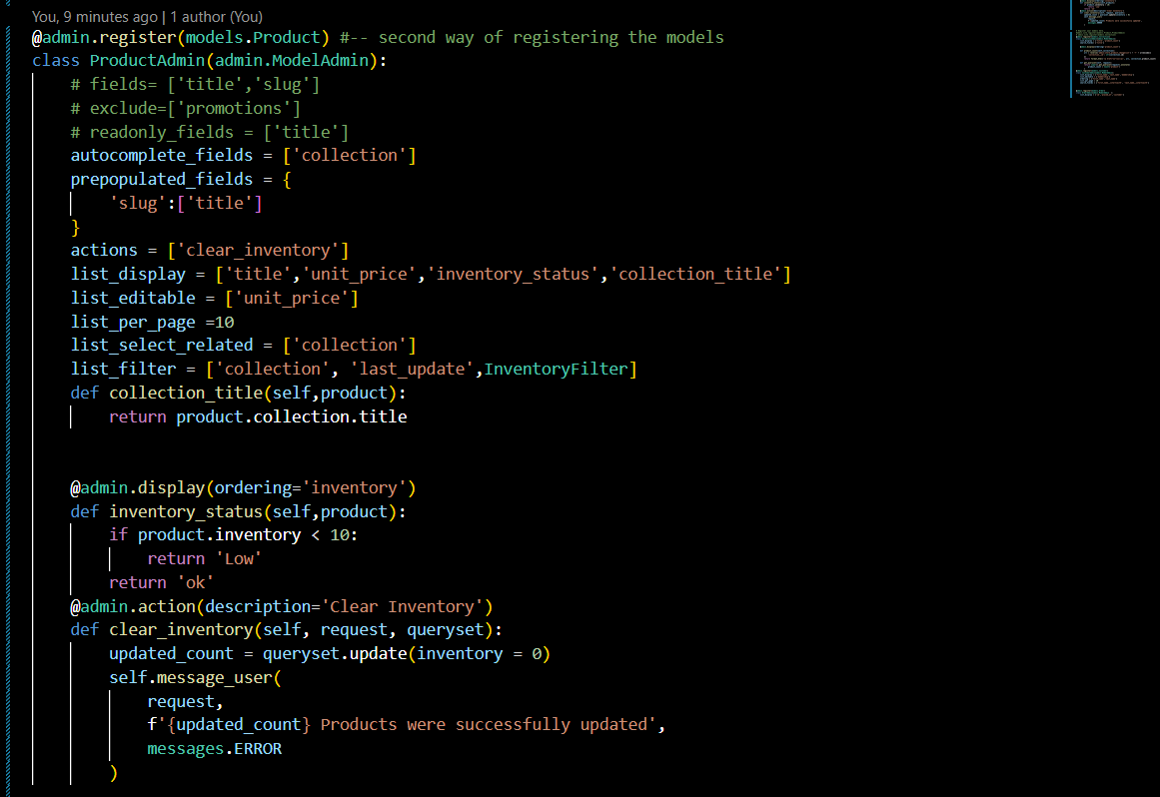
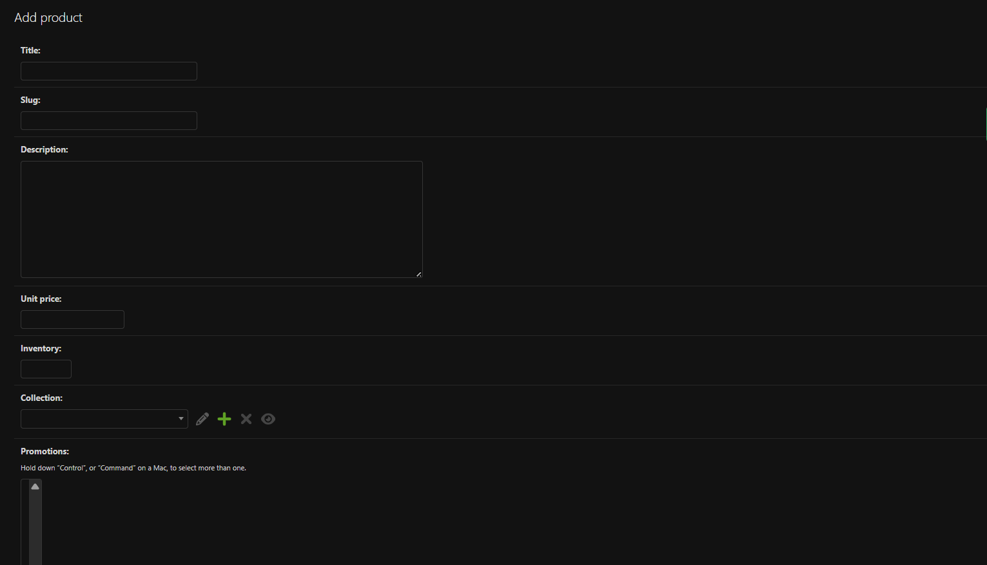

Adding data validation:
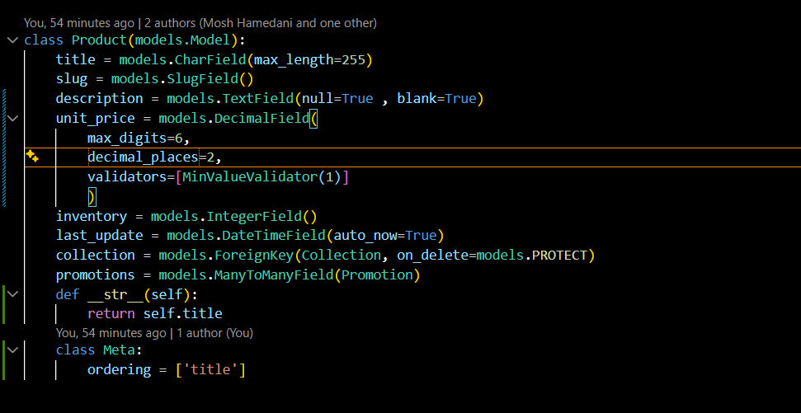
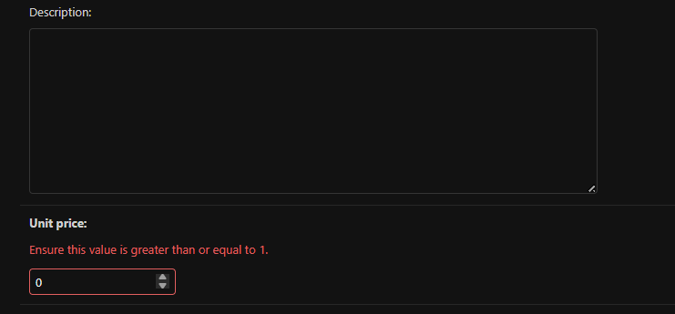
Editing Children using inline:
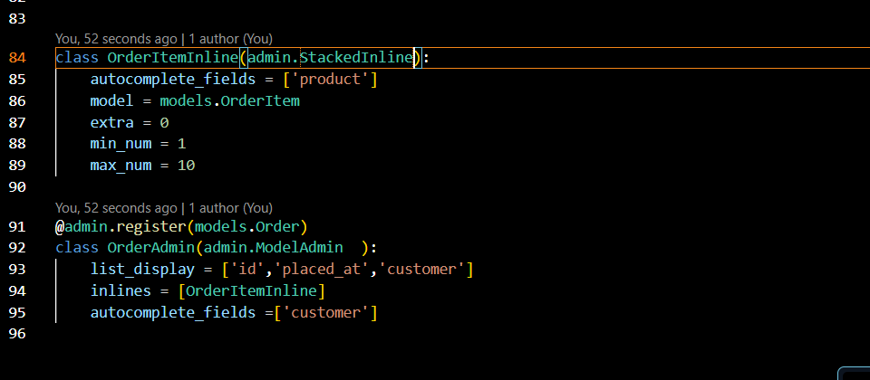
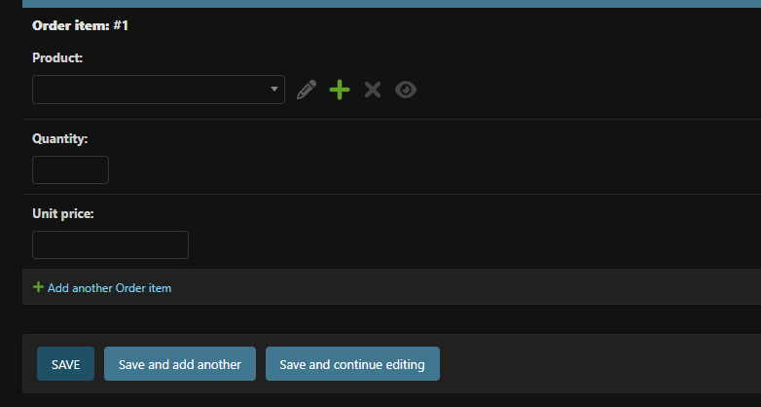
Using Generic Relations:
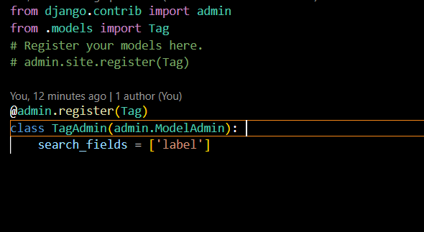
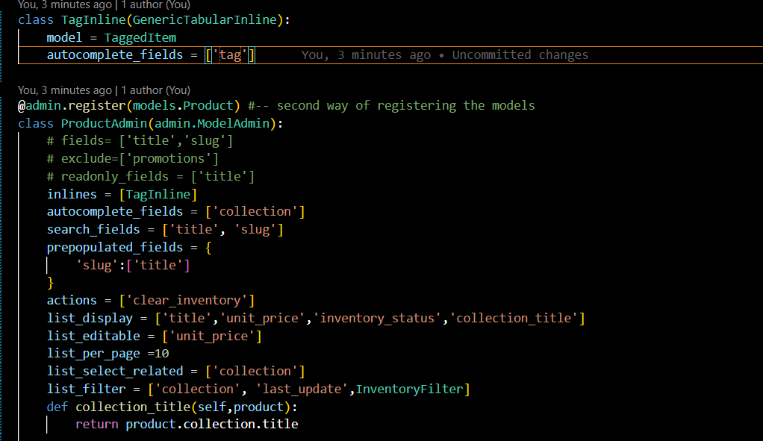

PART-2
Rest API’s:
There are three things that every one should know about the REST API’s:
- Resource
- Resource Representation
- HTTP methods
Resource:
- Resource is like an object representation in our application like product, collection, shopping cart etc. These can be accessed using URL’s.
- Each and every object like product, collection, shopping etc in our application have the resource. These resources are represented by URL’s
- And a resource can also contain other resources.
- For example if you have an product page and you access the resource in the project using the url : https/gamingstore/products/
- Now to access an individual product we use its id in the url : https/gamingstore/products/1
- Now to view the revies of the product with id 1 then we access it with the url:
https/gamingstore/products/1/reviews this is the example of that resource can contain other resources
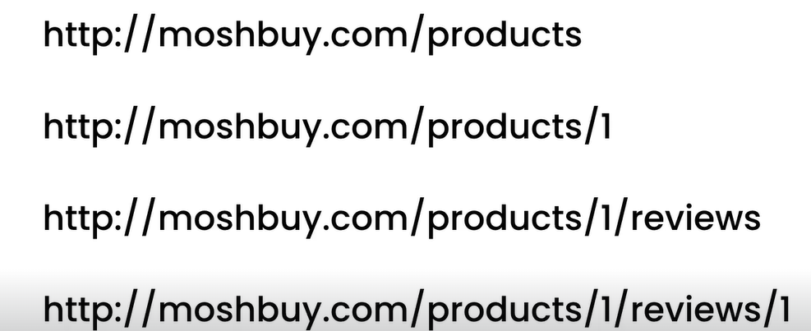
- So basically, the above pattern is the attribute of the REST API’s so following this pattern make familiar and easy to understand to others.
Resource Representation:
- So if we hit the URL the server is going to return the resource in the certain representational format for representing the data like html or xml or json etc.
- None of this are the internal representation of the server. On the server we identify the resource ex: product using an object or an instance of an python class. But when we return this object to client, we are because these are the formats that client understands.
- If there are many formats the client should specify that, in what format does the client need the data.
HTTP Methods:
- When we are building restful Api’s, we expose one or more end points to the client. Each endpoint supports various kinds of operations.
- Some endpoints may allow only reading the data and while others allow to modify data also. This is where http methods involve.
- http method defines the methos like :
  - GET
  - POST
  - PATCH
  - DELETE
- Let say if we want to create a product in our client app we need to send the post request, so the server knows. We gona insert it in the form of json object.
{
‘title’ : ‘shoe’,
‘price’ : 10
}

- To update the product if we want to update all properties we need to send the PUT request else to update specific subsequent we need to send the PATCH request.
  - Ex: PATCH /product/1 this url refers to specific product not an entire collection.
- Also we use delete to delete specific product
  - DELETE /product/1
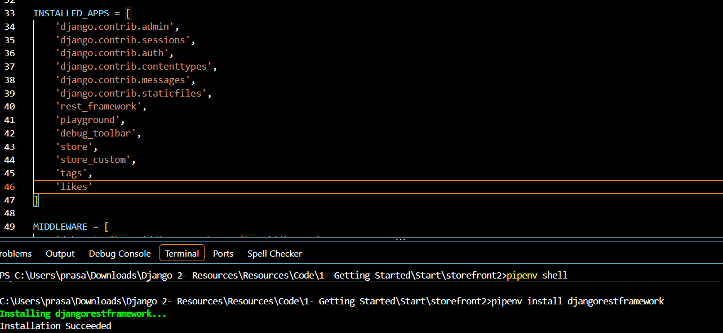
Installing Django REST framework:

Creating API views:

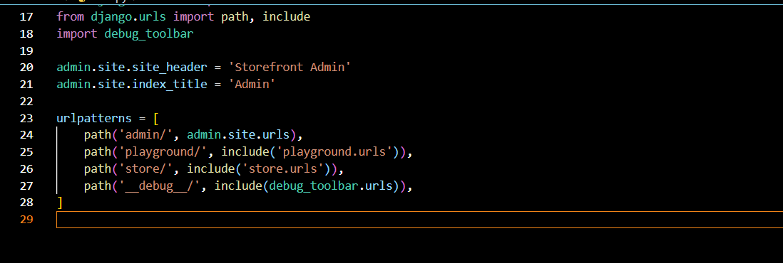
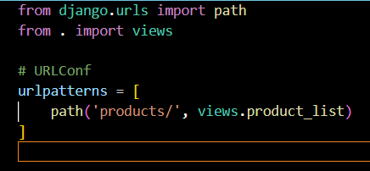
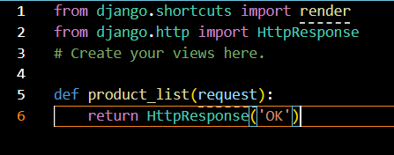
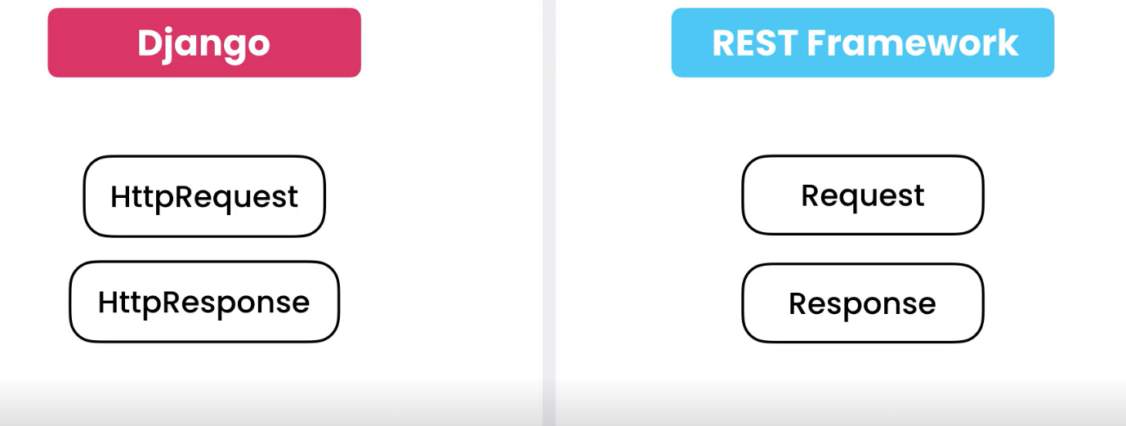

- As Django has two classes HttpRequest and HttpResponse rest framework also have 2 classes called request and response.
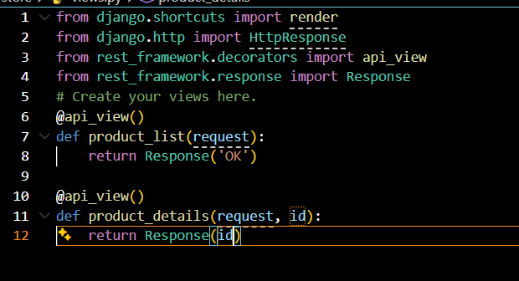

- To create an api view we will use the response class from the rest framework.response module. Ans also we need to import api_views from the rest_framework.decorators module.
- And then we create a view and map it with the url.
Creating Serializers:
- In Rest framework there is a class called JSONRender and in that class we have a method called render(dict).
- This render() methods takes a dictionary object and returns a json object. So, if we convert a product object into python dictonary then we can pass it to the render() method get json object.
- This is where the serializers come into picture.
- Serializer converts the model instance into dictonary.
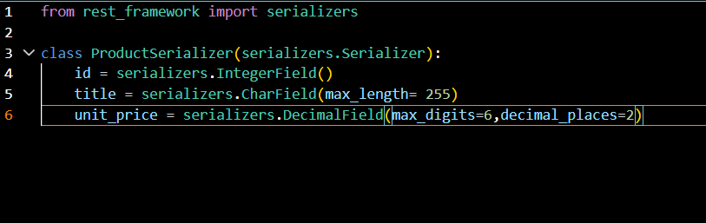
This is how we create serializers. By importing the serializers from the framework and then we display the external data required.

Serializing objects:
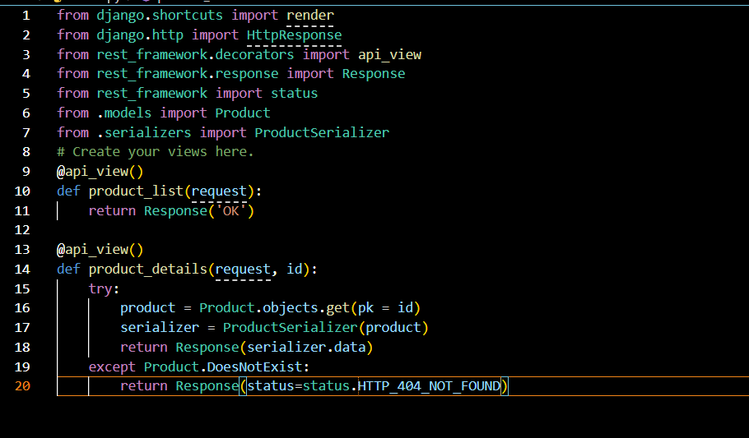
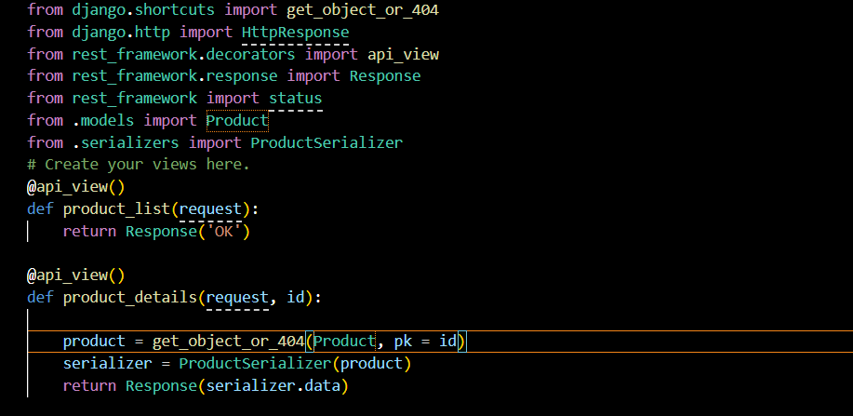
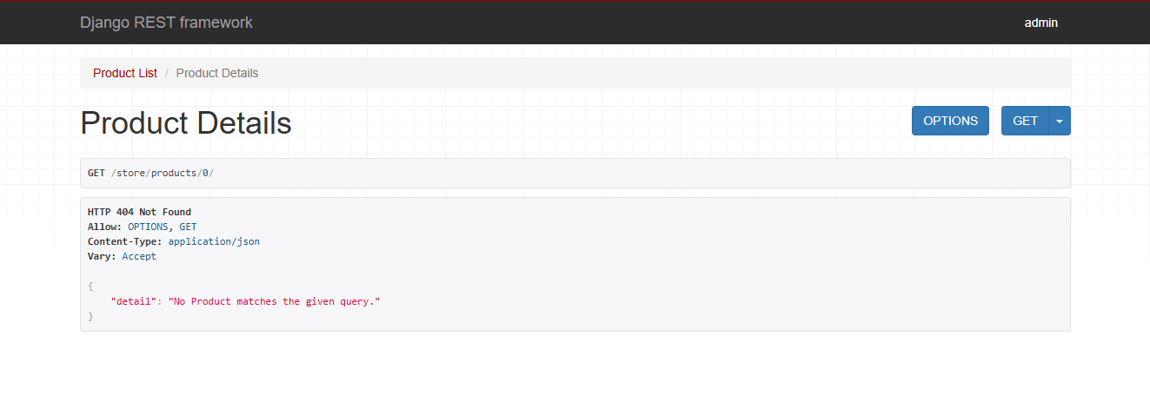
- First we imported product class from the models module and then we imported productSerialixers from the serializers module then we created the view and then in that we we written the same thing as we written in the Products class in the models.py module so that will the external data to be displayed to the client. So we are going to enter only the required fields.
- In the above first image the serializer converts the Product object into the python dictionary object then the serializer.data returns it in the form of json object.
- And also above we used error handling and also to avoid writing code for error handling for each item we use the function named get_404_not_found() function as shown in the above. If the item does not exist then trest framework automatically handles the error.
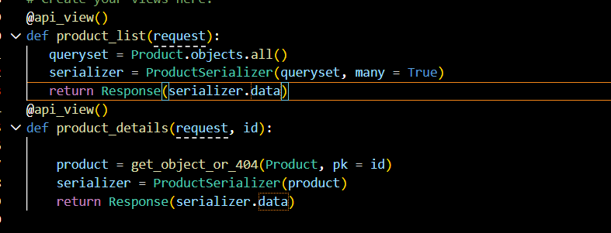
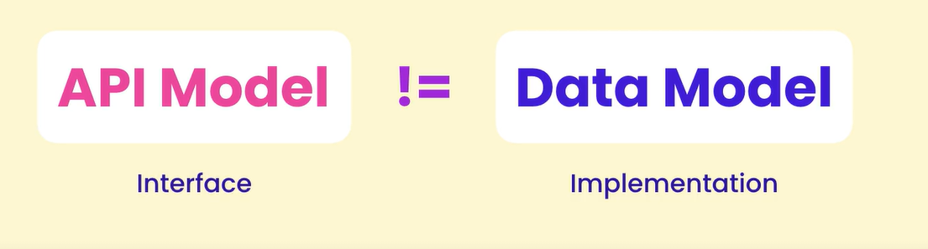
Creating Custom serializers Fields:

- Api represents the interface and the data model represents the implementation. All the implementation is need not to be displayed in the interface.
- So, we need to keep our api model stable. Otherwise, existing client may break.
- So if we want to change the api, we need to carefully study the impact of the change.
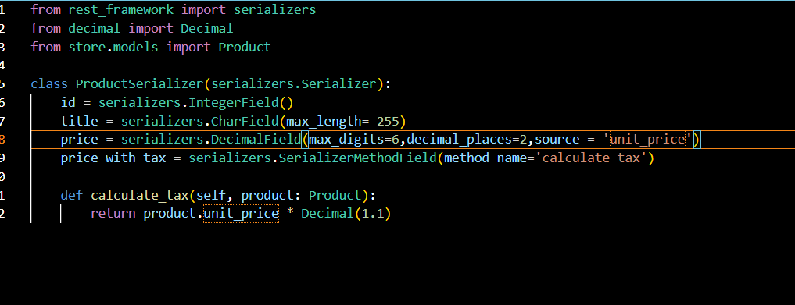

Serializing relationships:
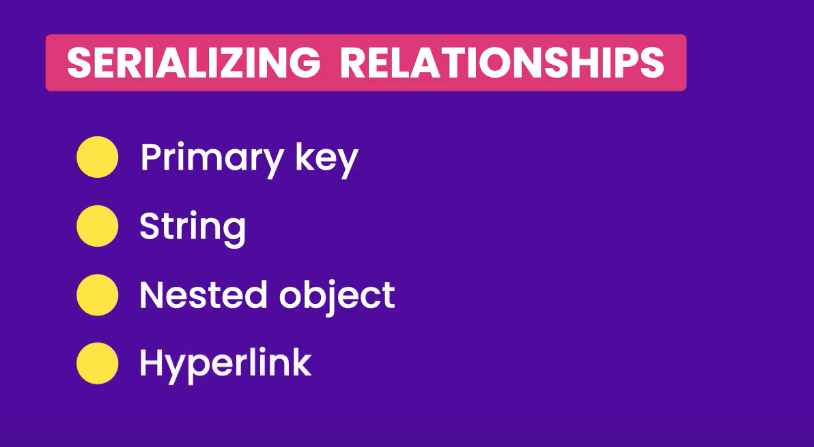
- When returning a product, we can include a related object like a collection. We can do this in many ways:

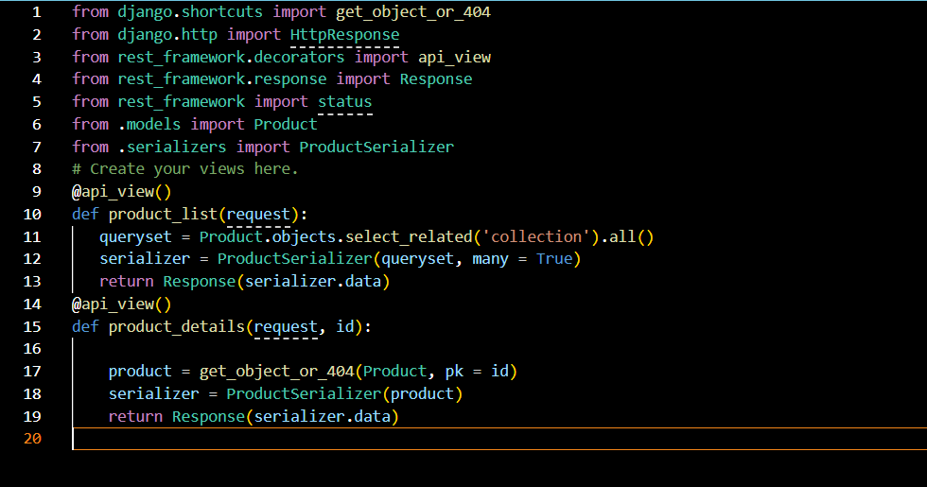
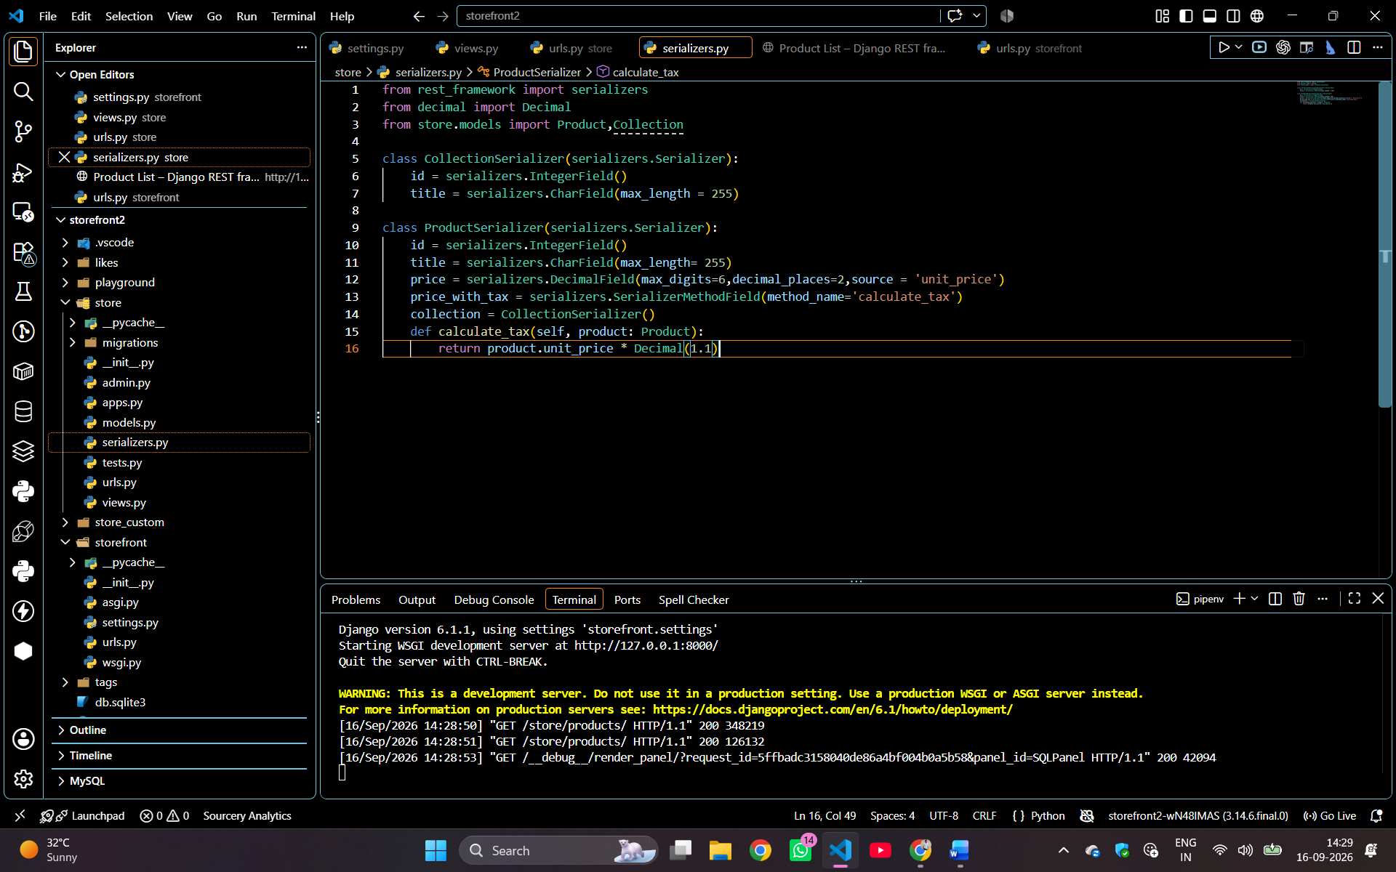
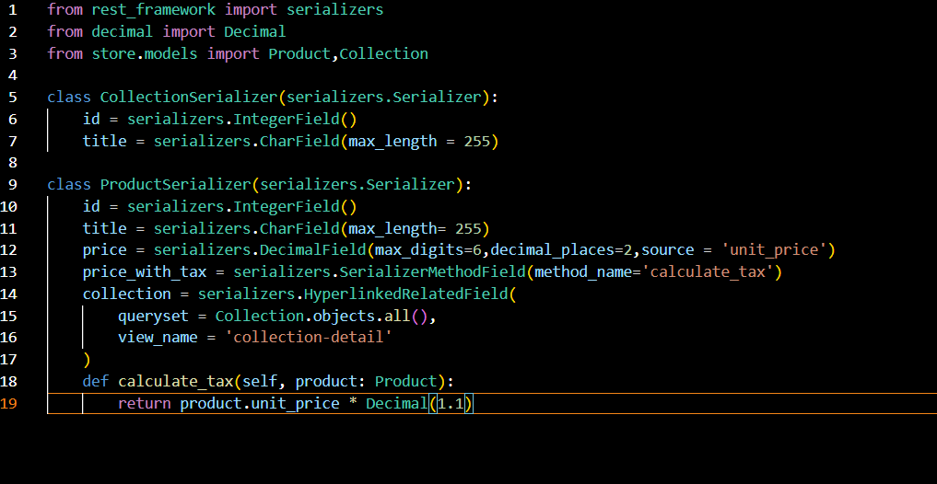

Model Serializers:
- A ModelSerializer is a special serializer provided by Django REST Framework (DRF) that automatically creates serializer fields based on your Django model.
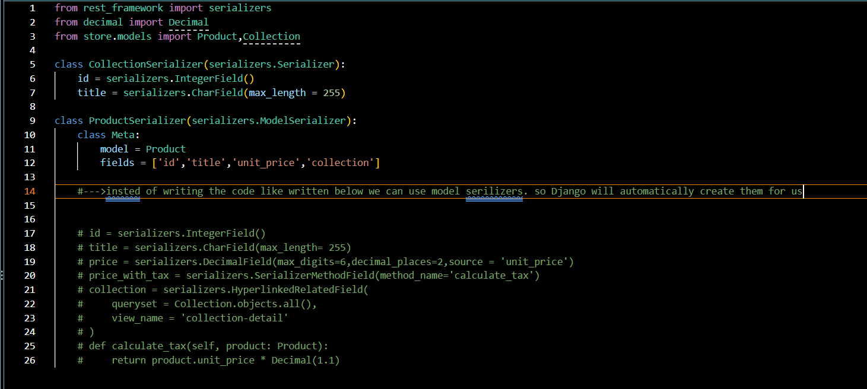
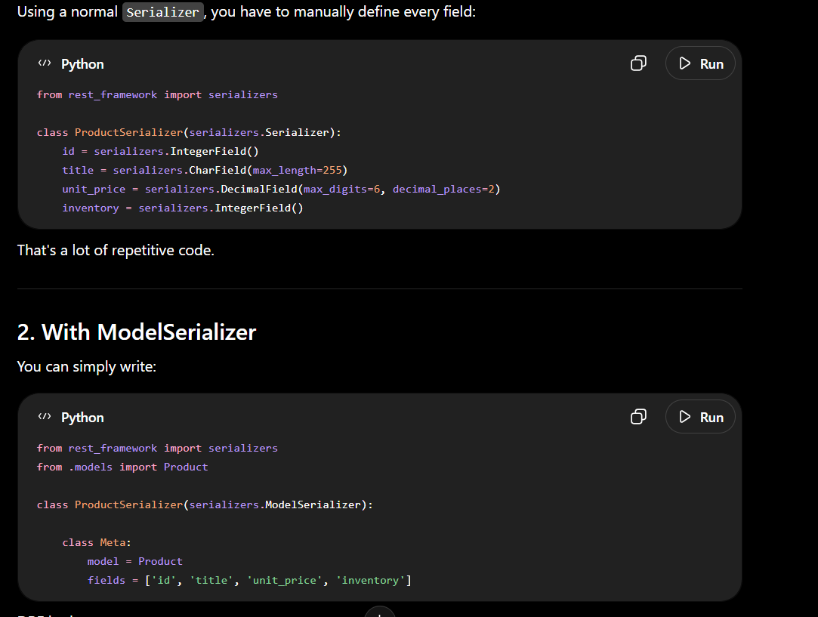
- In our project for the collection field we have primarykey related filed. So by default model serializers uses the primarykey(). If want we can customize it.
Deserialization:
- It is the opposite of serialization. It happens when we receive the data from the client.
- If client want to create a new product we need to use post request to the products end point.
- In the body of the request we need to include a product object. Now the server need to read the body of the data and deserialize it so we get a product object and store it in database.
- In the below image we can see the deserialization happens when the request method is equal to post this is when we receive the data from the client.

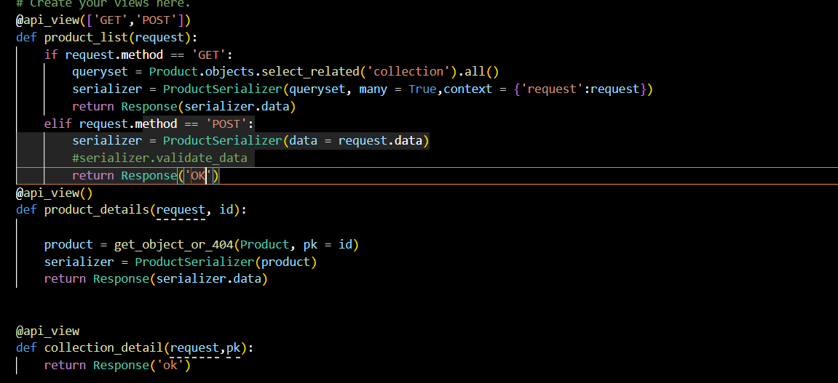

Data validation:
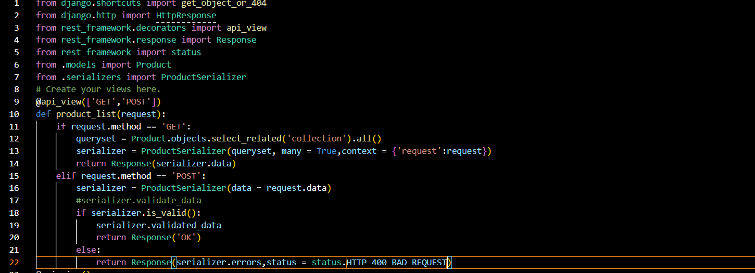
- In the above code the data is validated. If the empty object is passed from the client then the validation message occurs as shown below.
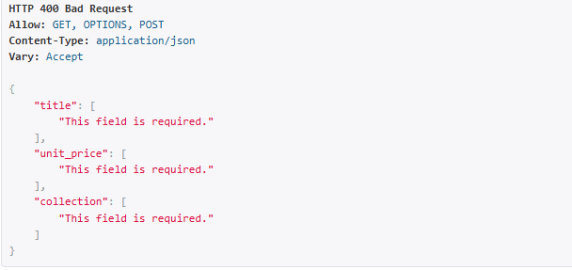

- There is another way to write the code for validating the data.
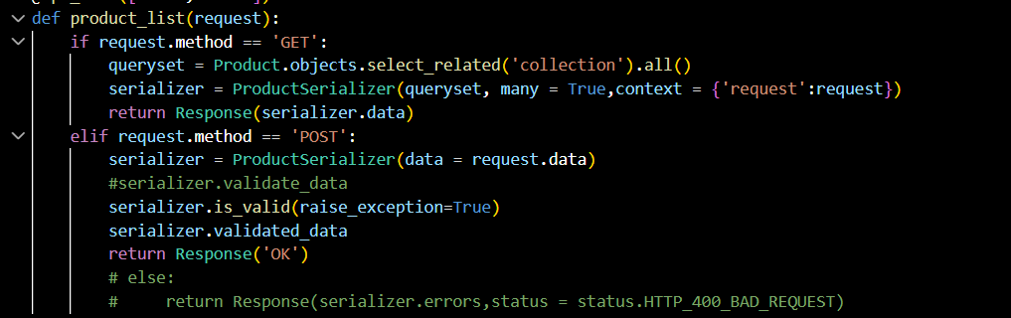

- After validating we need to save the data in the database.

Saving the objects:
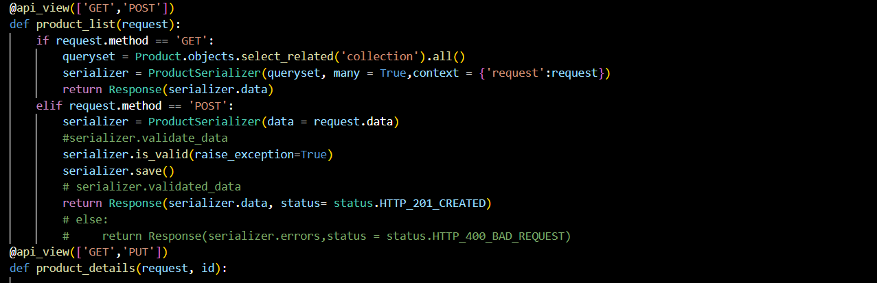
- Our ProductSerializers is inheriting the model seria lizer class. So this serializers class have same method that we can use for saving or creating the object.

Deleting the objects:
- To delete the objects we use the method called delete() method from the serializer class.
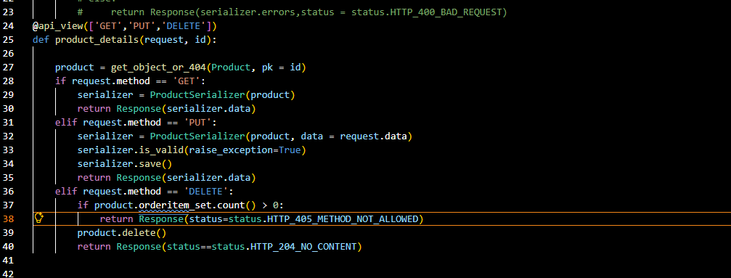
Advanced API Concepts:
- Django rest framework also supports class based views, which make our code cleaner and more concise, with lot of reuse oppurtunities.
- Instead of naïve views we can use class based views so that our code looks better and easy to understand and debug.
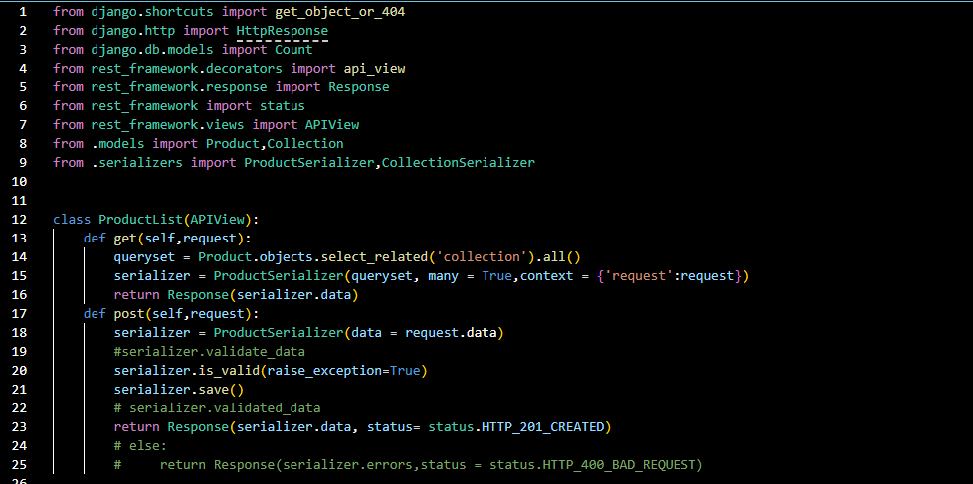
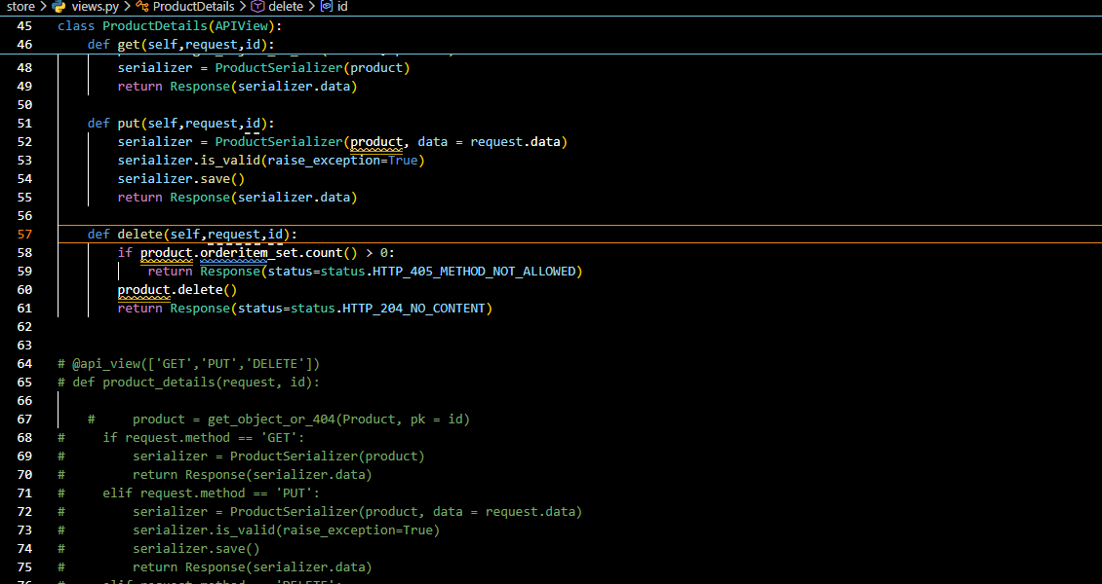
Mixins:
In our productlist views and collectionlist views we have common code in creating views. This is where the mixins come from. To use this mixins we need to import it from the rest framework.

Generic views:
- This generic views combines two mixins those are listModemixins and CreateModeMixins and provides to methods one is get and post.
- Generic views are the concrete class that combines one or more mixins and provides the handler methods like get(),post() etc.
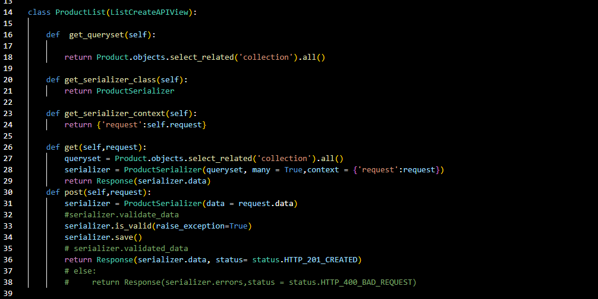
Customizing generic views:
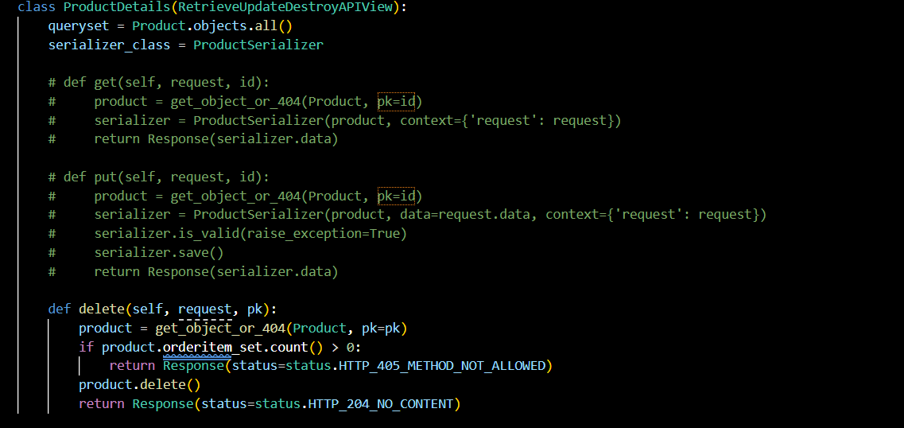

ViewSets:
- Uing view sets we can combine multiple related views in a single class.
- Viewsets means set of related views. From the rest framework.viewset we need to import ModelVIewSet.
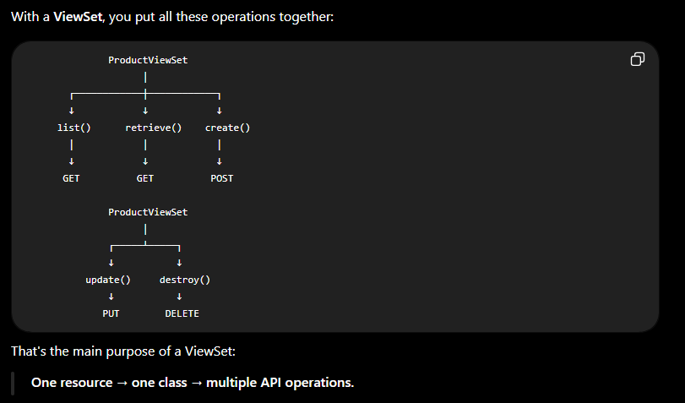
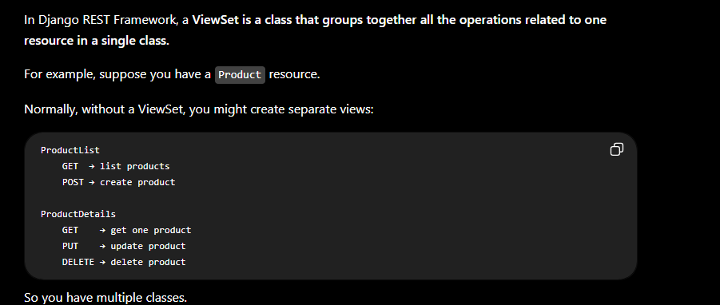

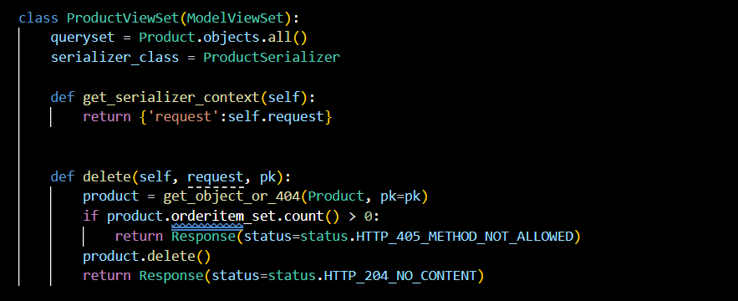
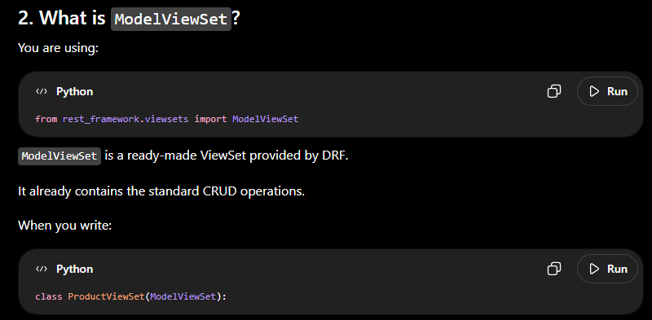

Routers:

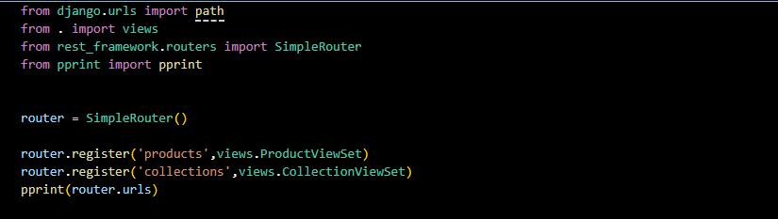
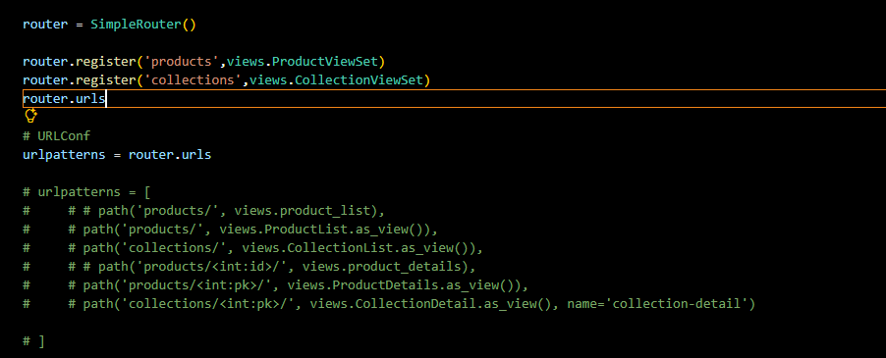
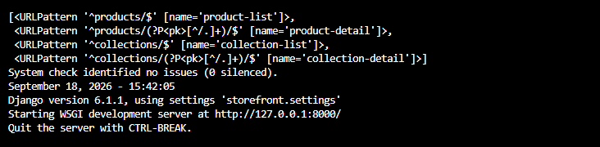

Destroy method():
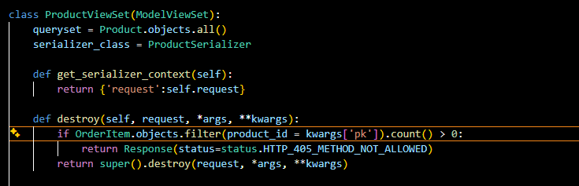

Building the reviews api:
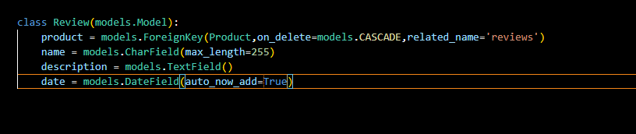
- After creating the models we need to create the migrations and then we need to migrate it to the database
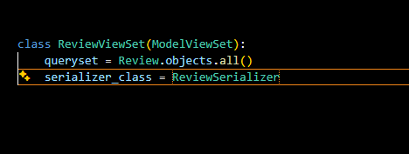
- After this we need to create the views.

Nested Routers:

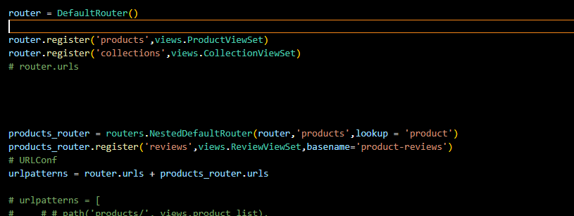
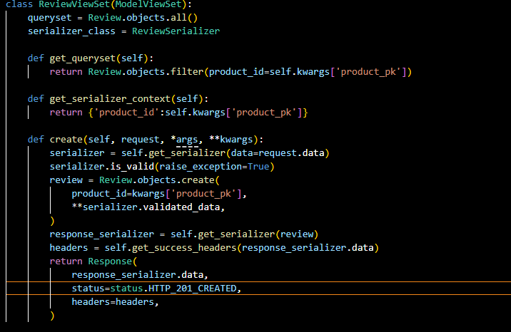
Filtering:
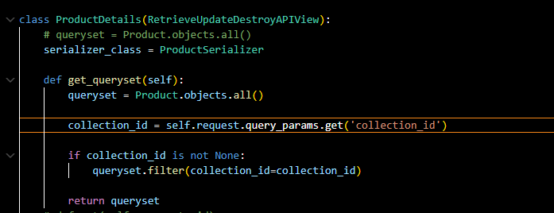
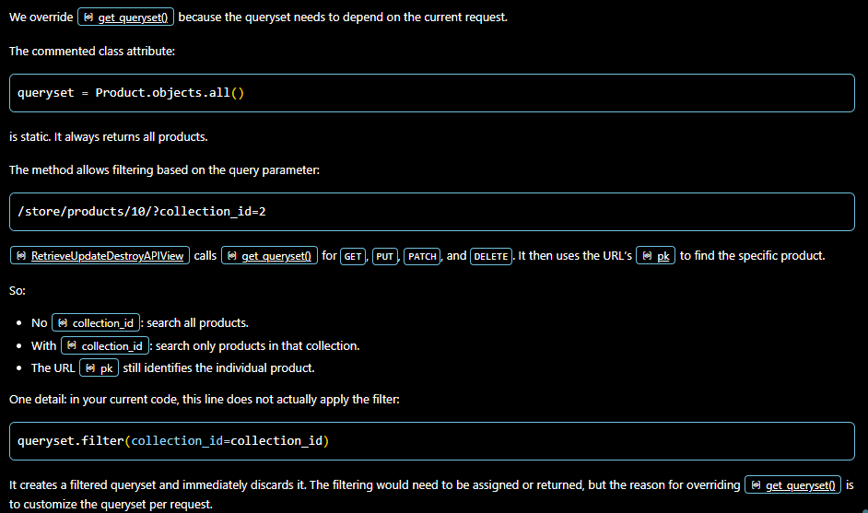
Generic Filtering:
- Think we want to filter the products based on the given collection id then the above process is more complex. To solve this issues we use generic filtering. To do generic filtering we need to import it from the module
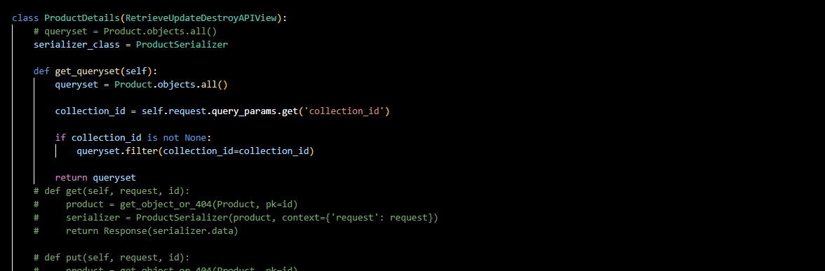
Searching:
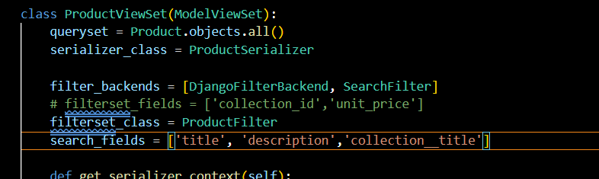
To implement search we need to import the search filter from the restframework.filters module.
Sorting :
To implement the sorting we need to import the from rest_framework.filters import SearchFilter,OrderingFilter
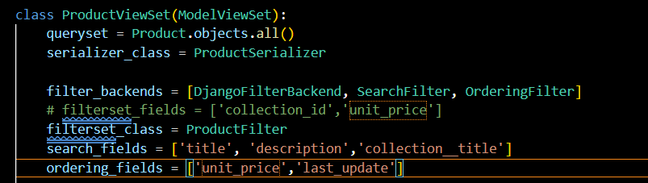
Pagination:
For implementing pagination we need to import from rest_framework.pagination import PageNumberPagination.
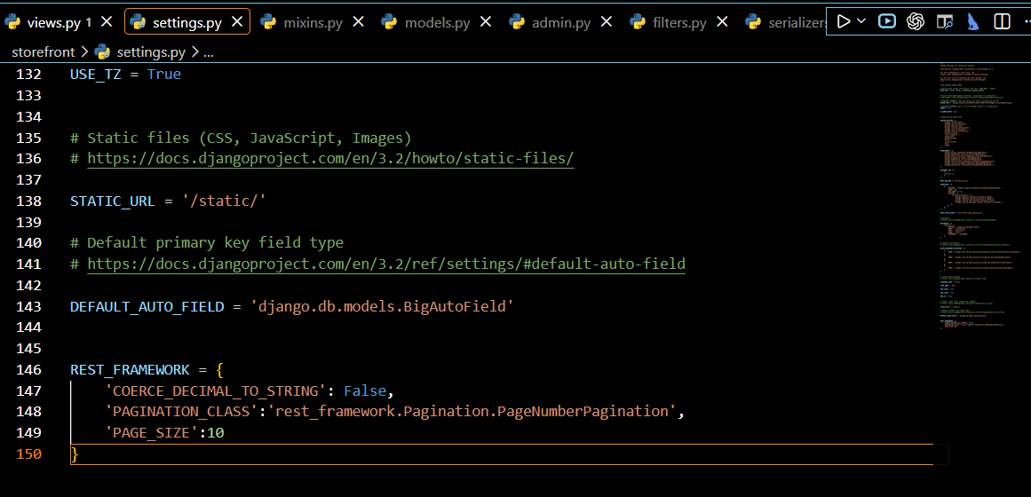
This is used for default pagination.
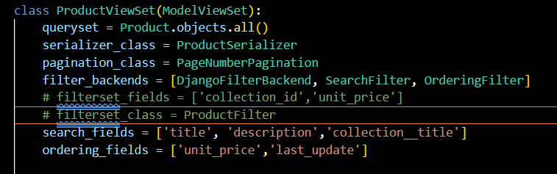

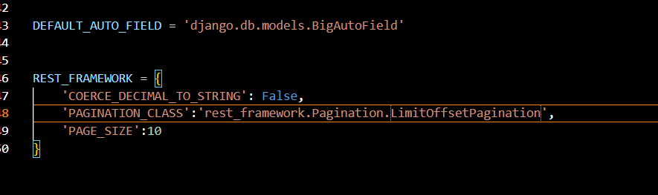
Designing and implementing cart item:
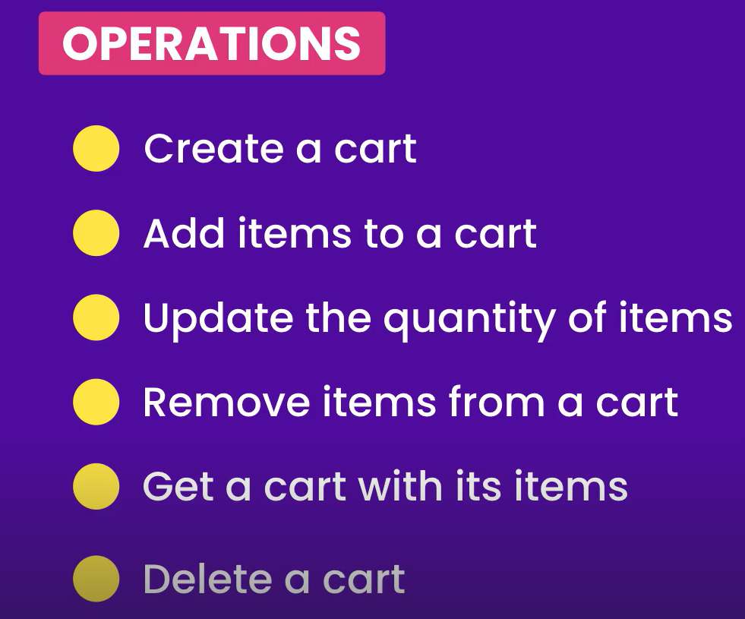
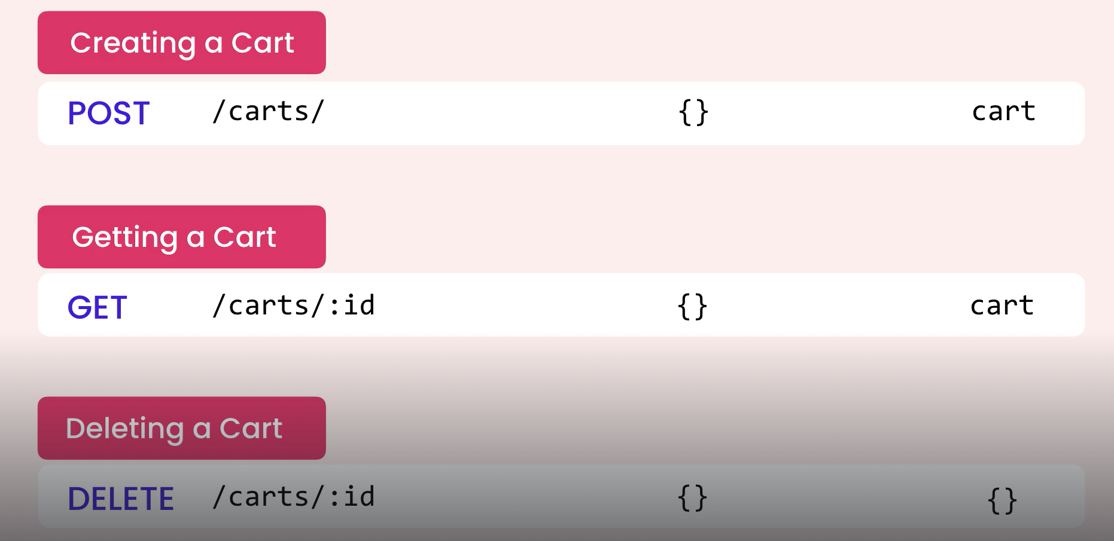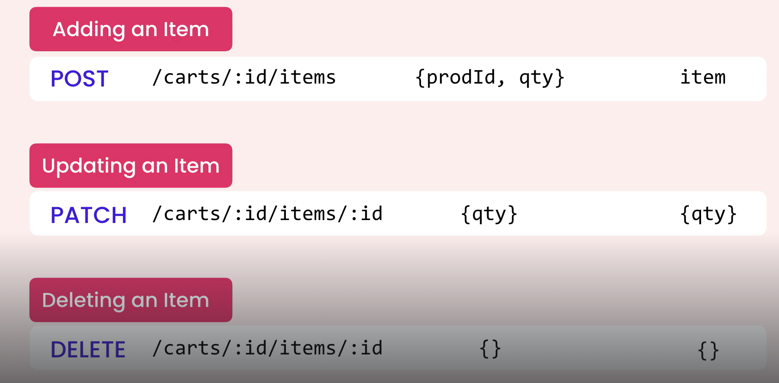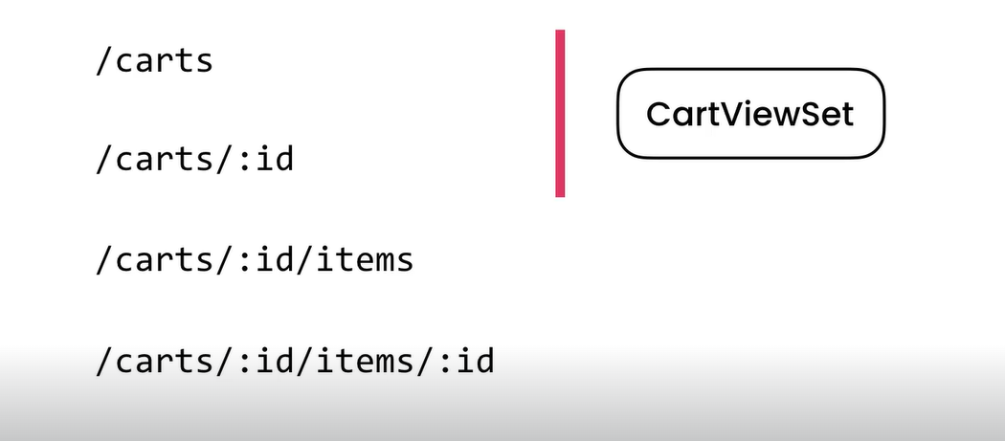

Revising the DataModel:

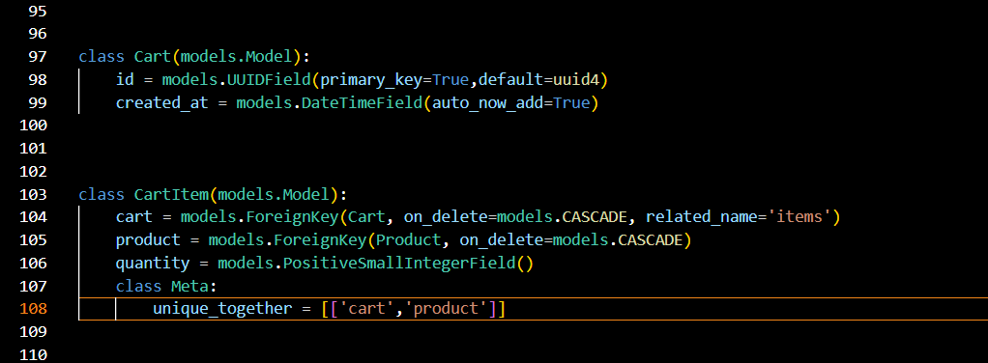
Creating cart:
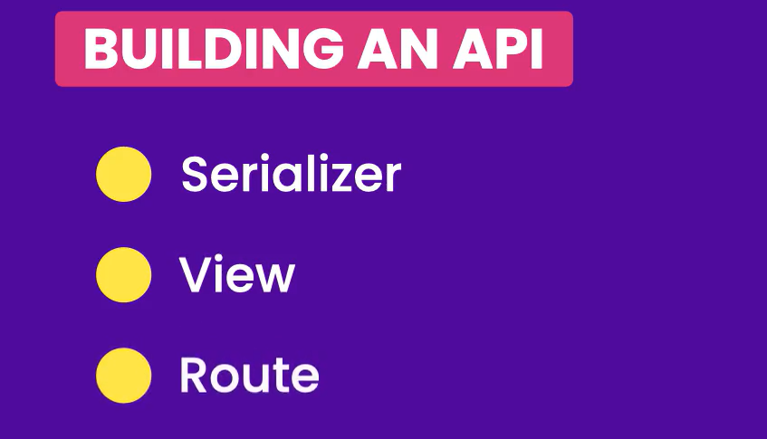

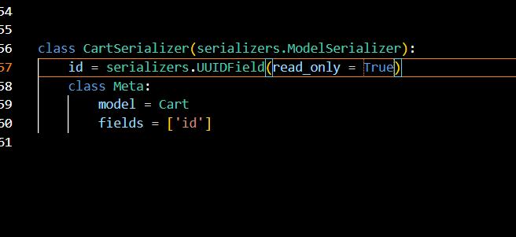
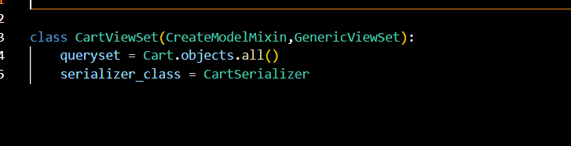
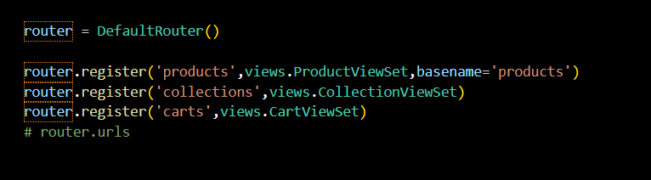

Getting a cart: 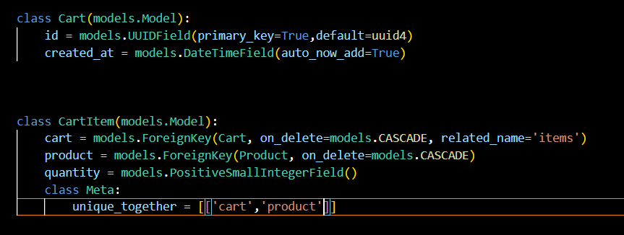
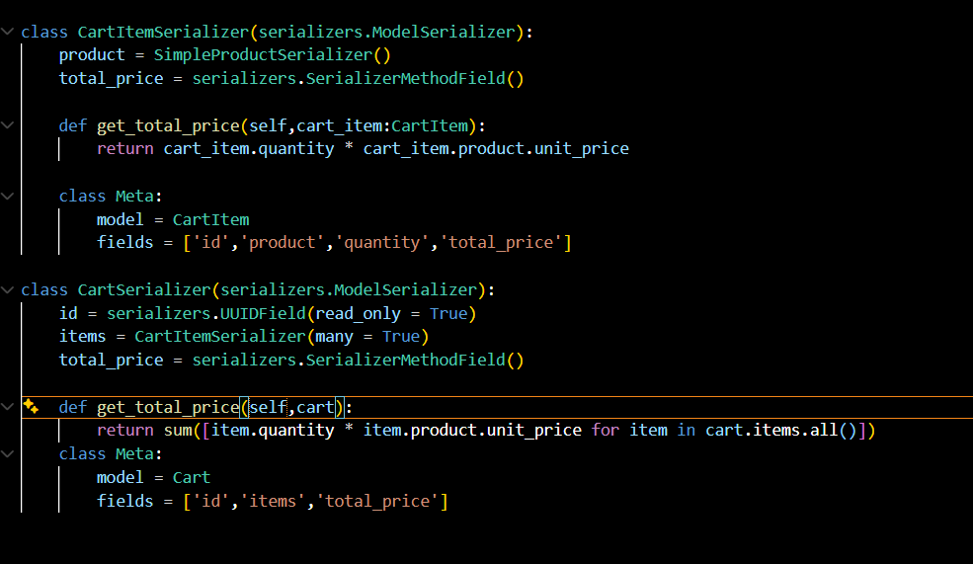

Deleting cart:
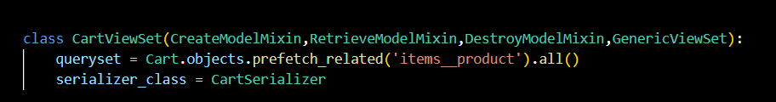
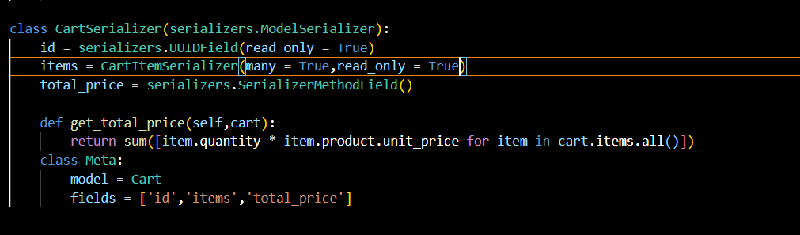

Getting a cart item:
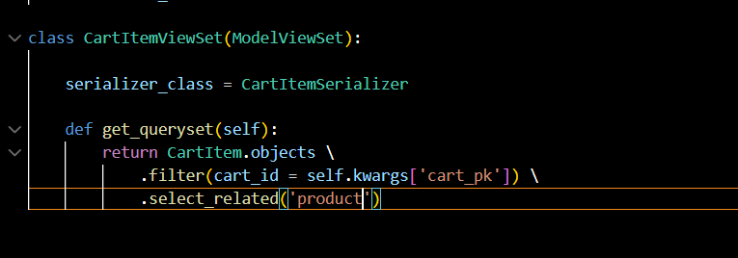
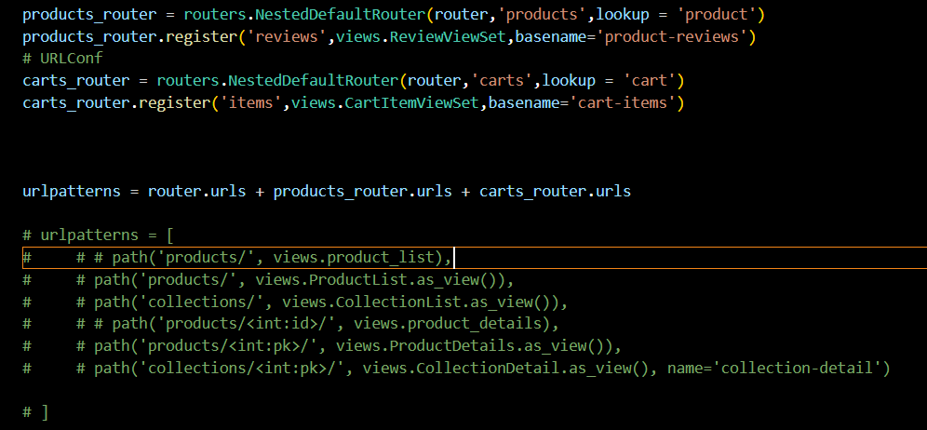
Adding Cart Item:
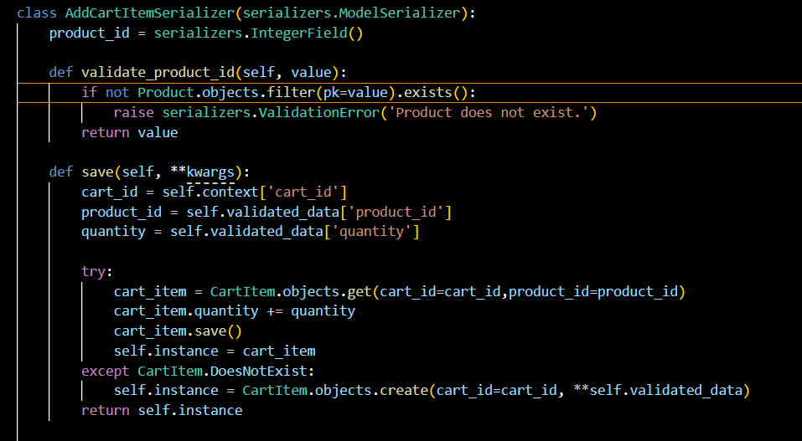
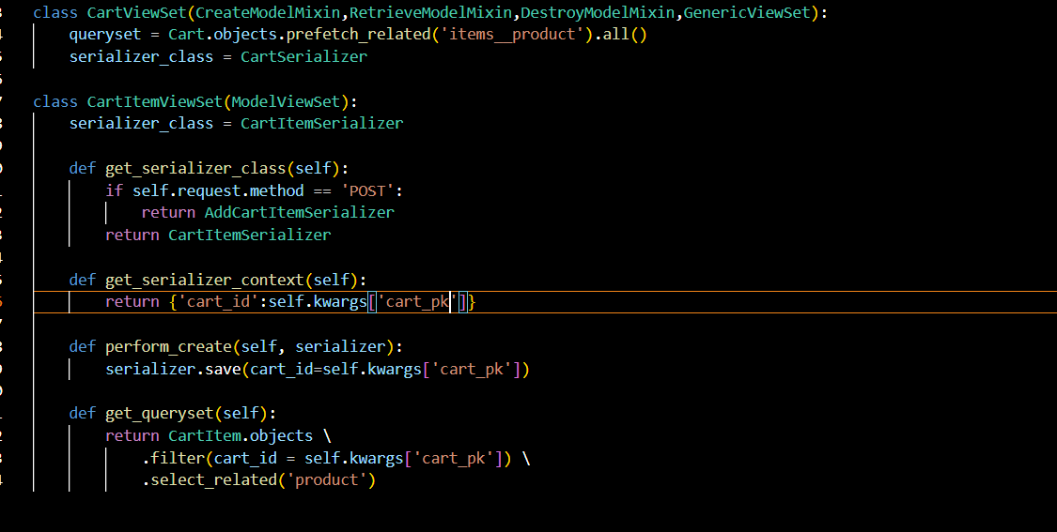
Updating a cart item:
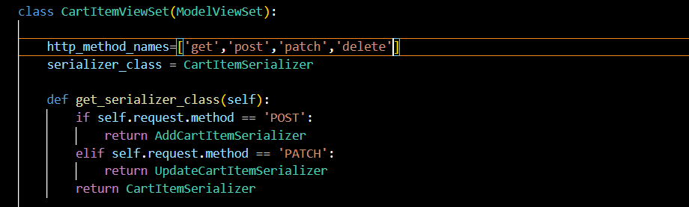
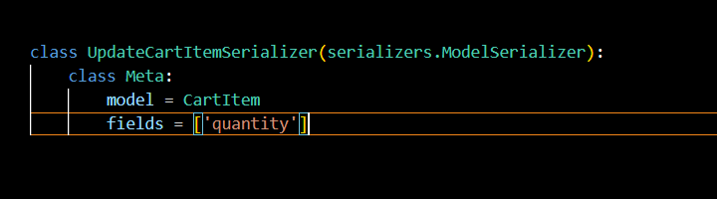

Deleting the cart item:
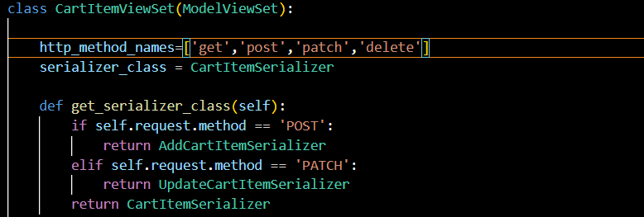

Django Authentication System:
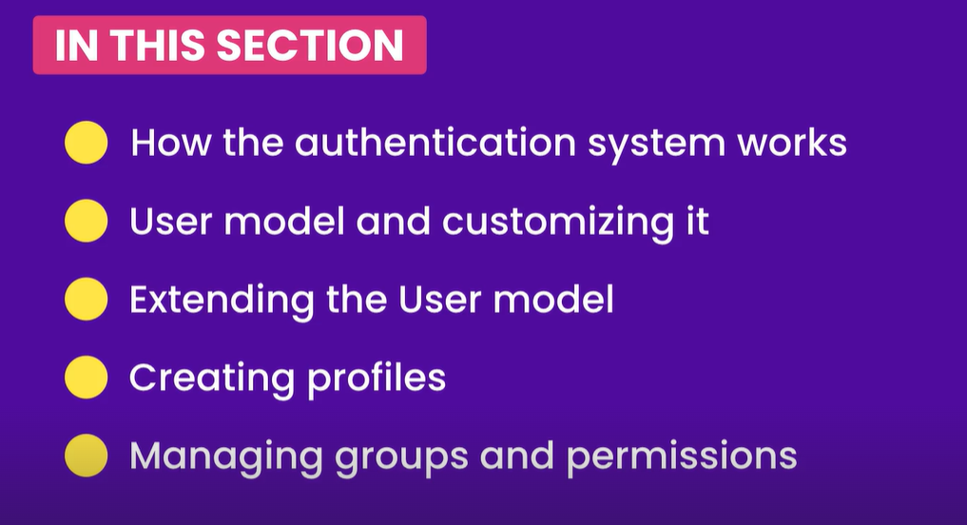
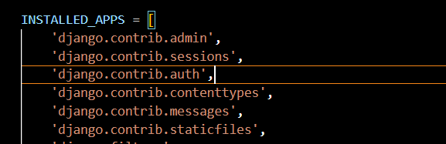
- Django.contrib.auth is the authenticating system used for authenticating the users.
- Django authentication is the system used to identify users and verify their login credentials, mainly through usernames/emails and passwords.
- Django provides built-in authentication with a User model, password hashing, login, logout, sessions, permissions, and groups.
- After successful login, Django creates a session and stores authentication information, while the browser receives a session cookie that is sent with future requests.
- Middleware is involved because Django needs to identify the logged-in user for every request. SessionMiddleware manages the session, and AuthenticationMiddleware uses it to make the user available through request.user.
- The basic flow is: User logs in → credentials are verified → session is created → middleware identifies the user → request.user provides the user to the view → permissions can be checked → logout ends the session.
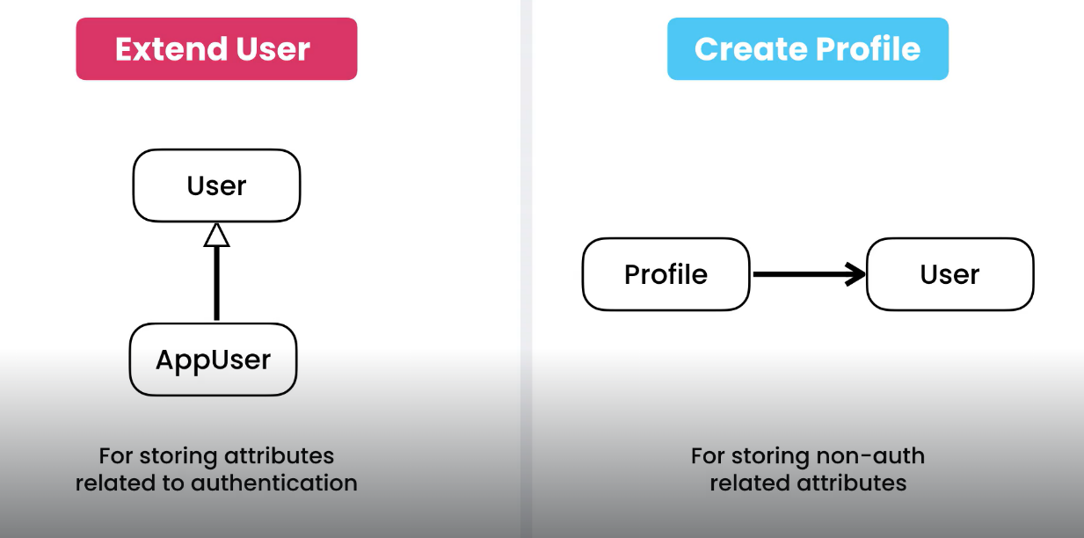
Customizing the user Model:

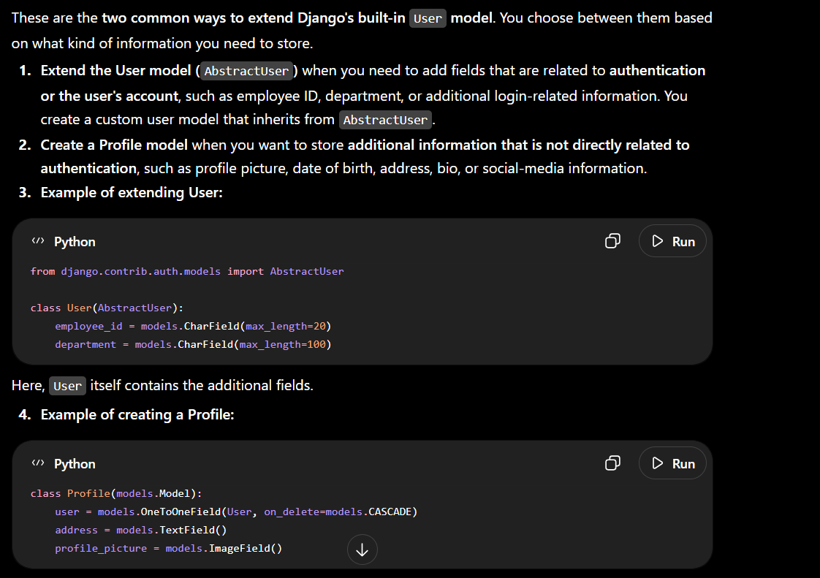
Extending the user model:
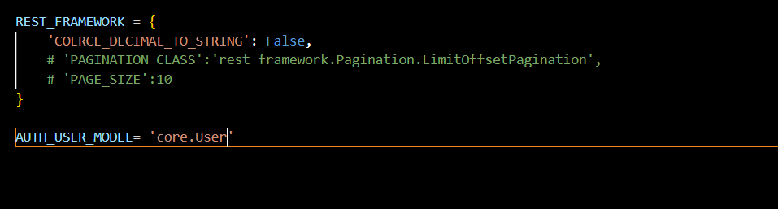
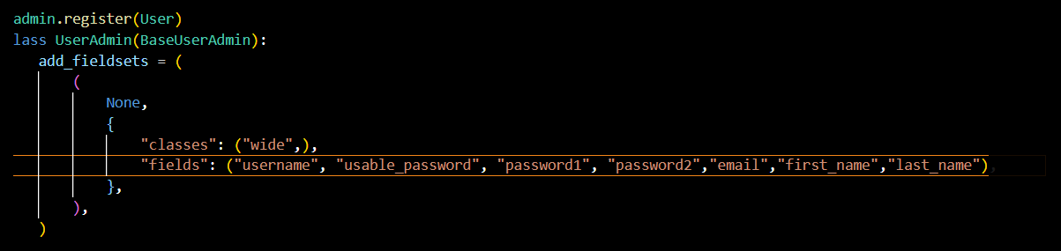
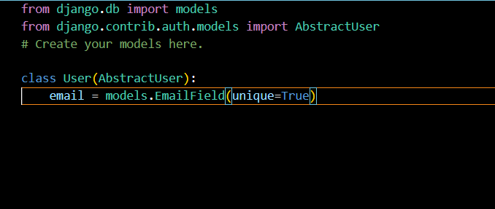
Creating User profile:
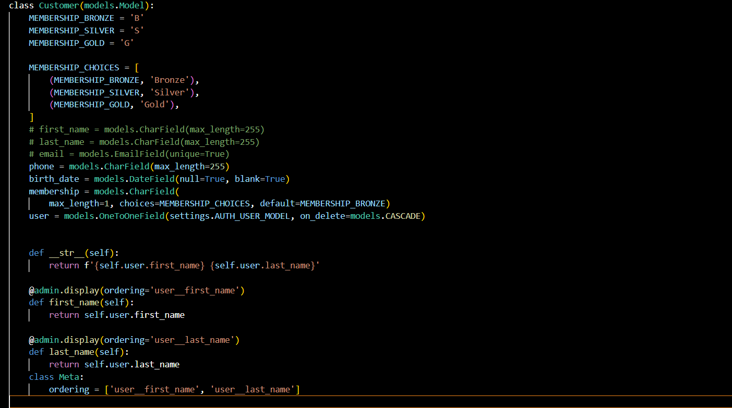

Groups and permissions:
A group is a collection of permission
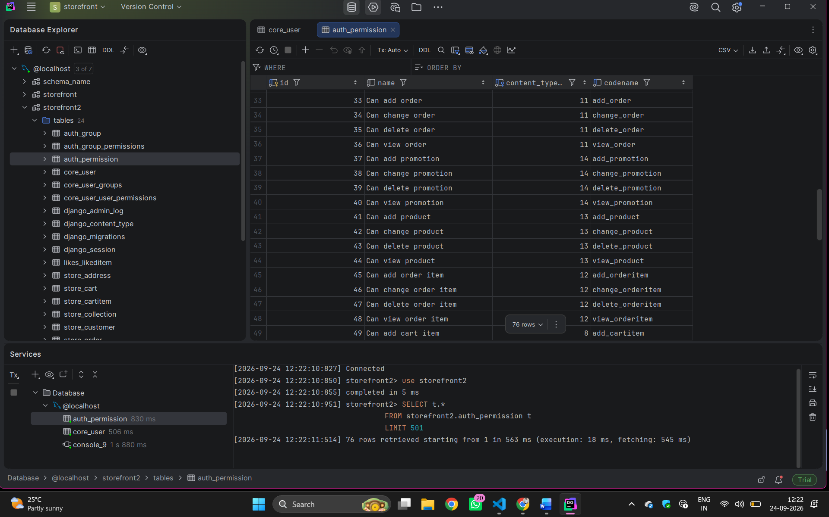

Creating Custom permissions:
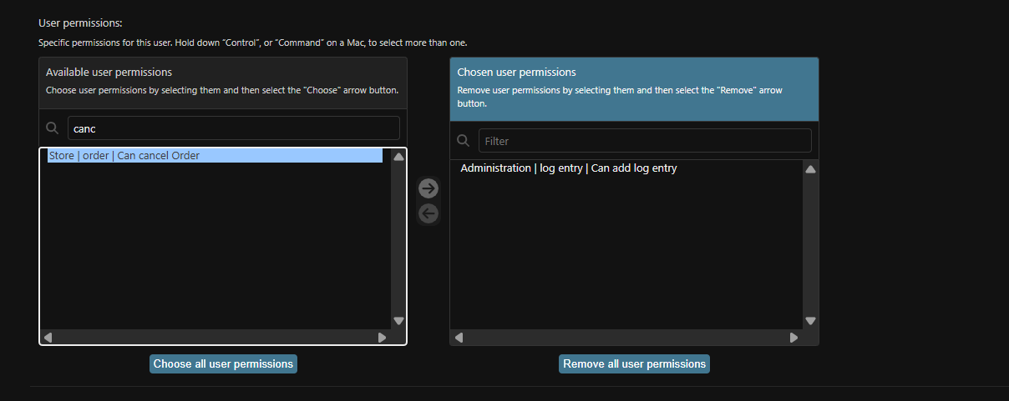
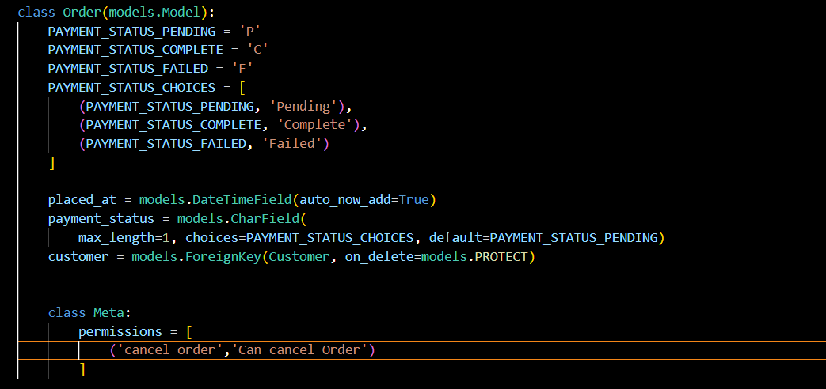
Securing Apis:
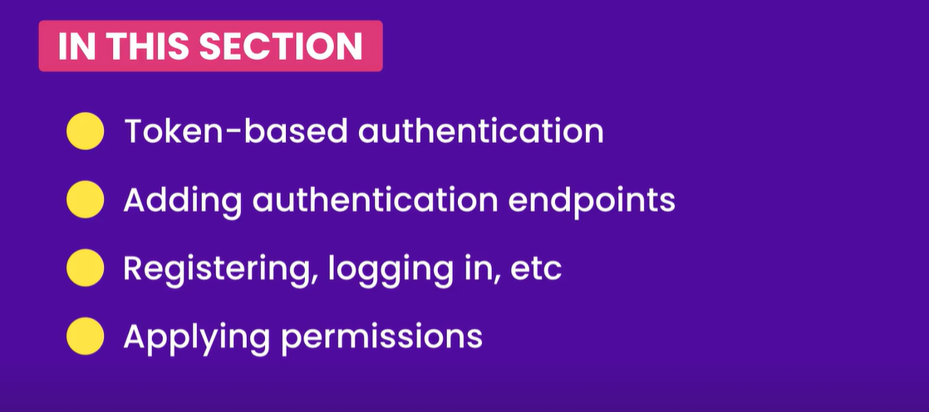

Adding the authentication Endpoints:
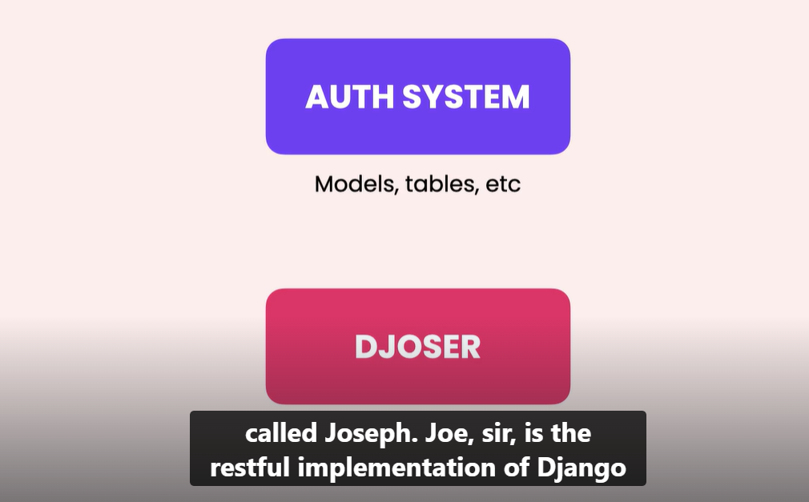
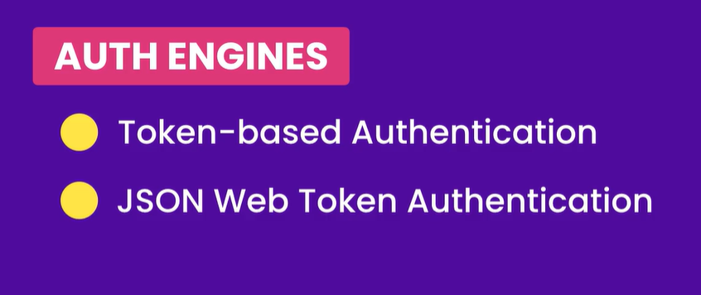
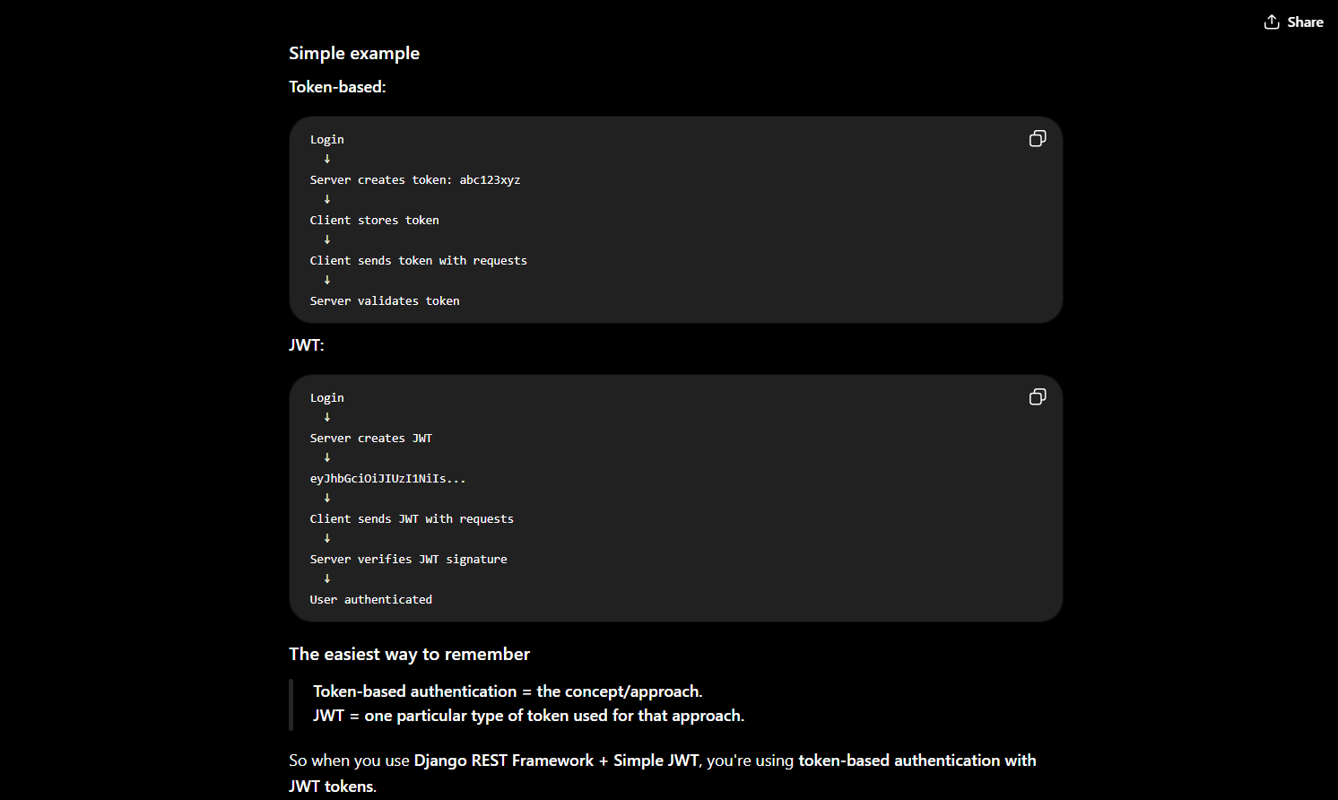
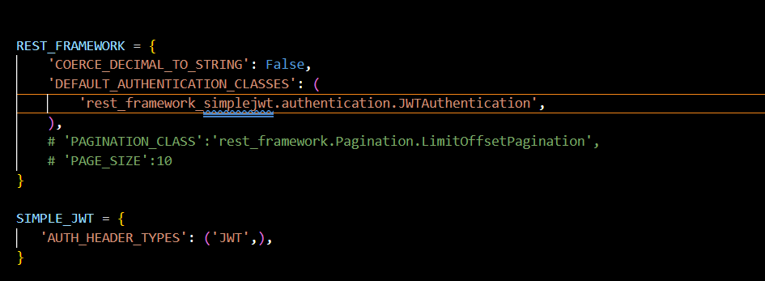
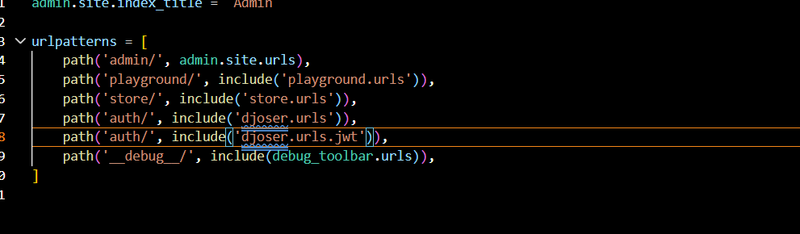
Registering User:
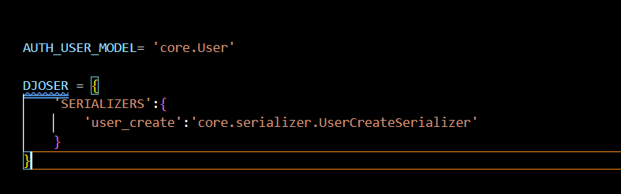
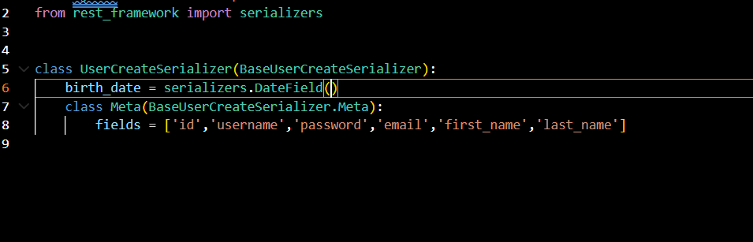
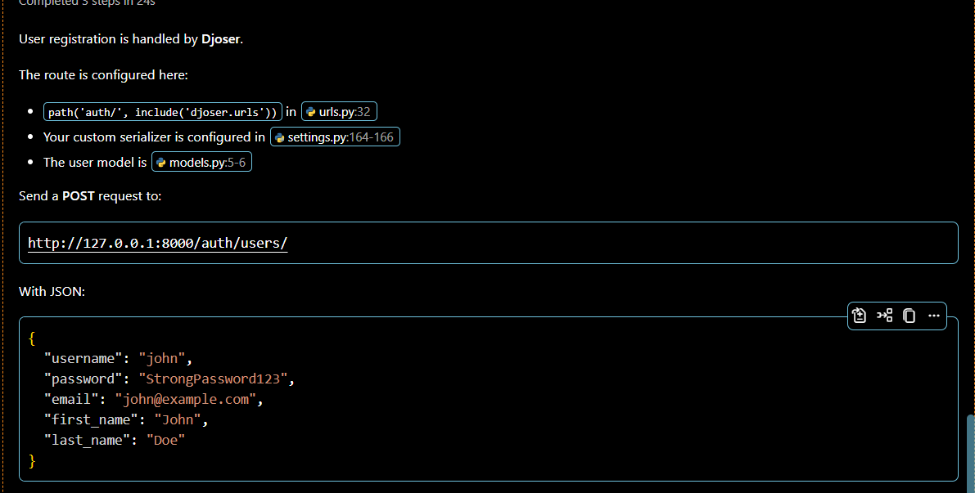
Building profile:
Djoser doesn’t have any end points for user profiles.
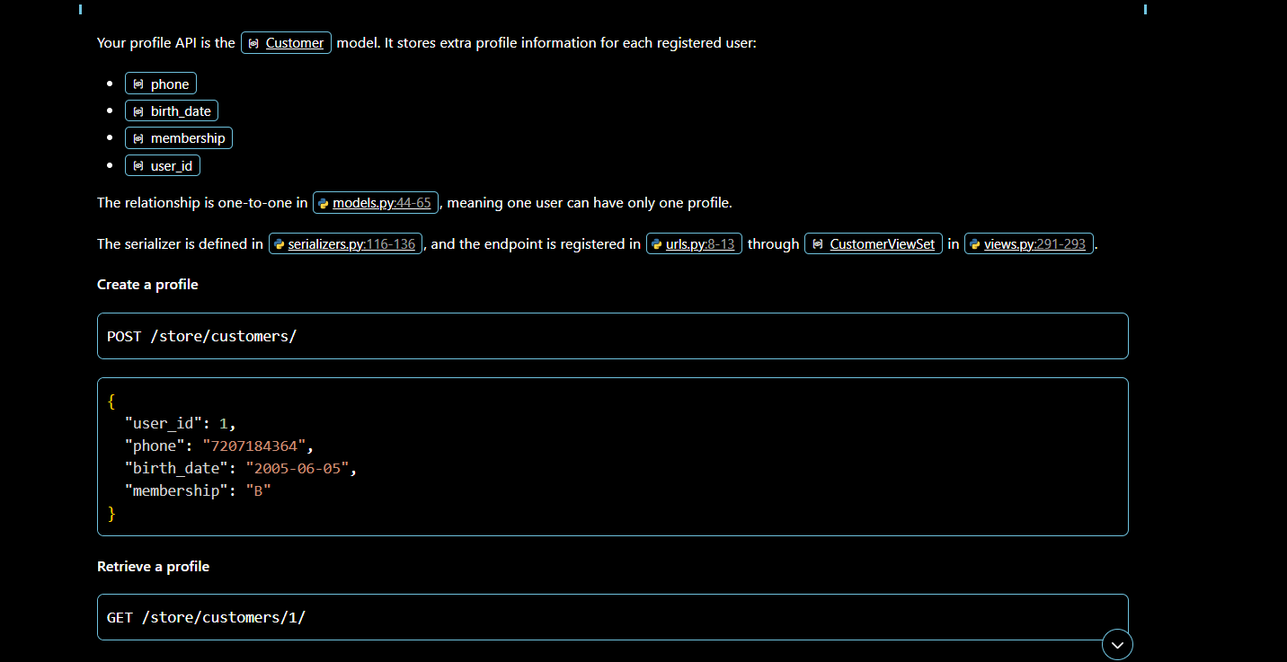
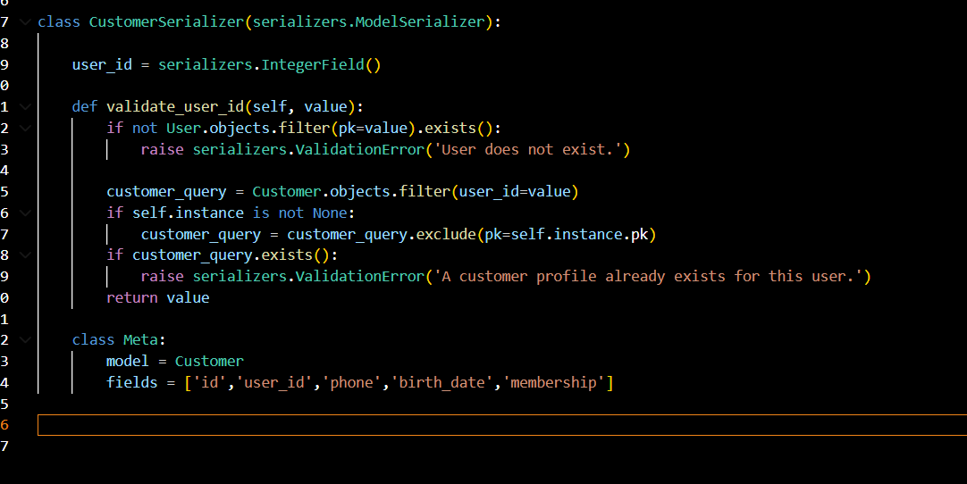
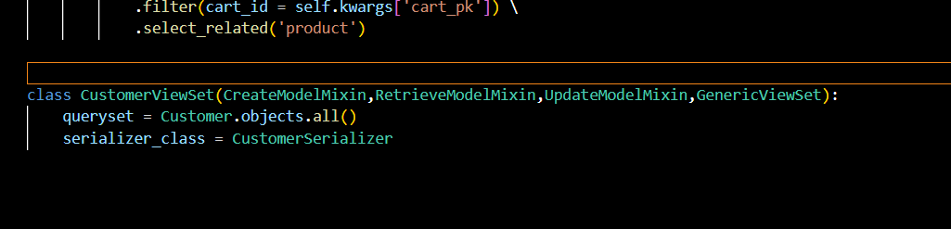
Logging in :
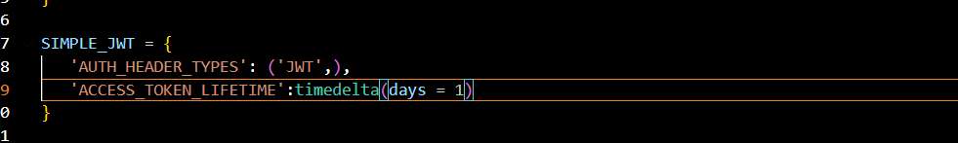
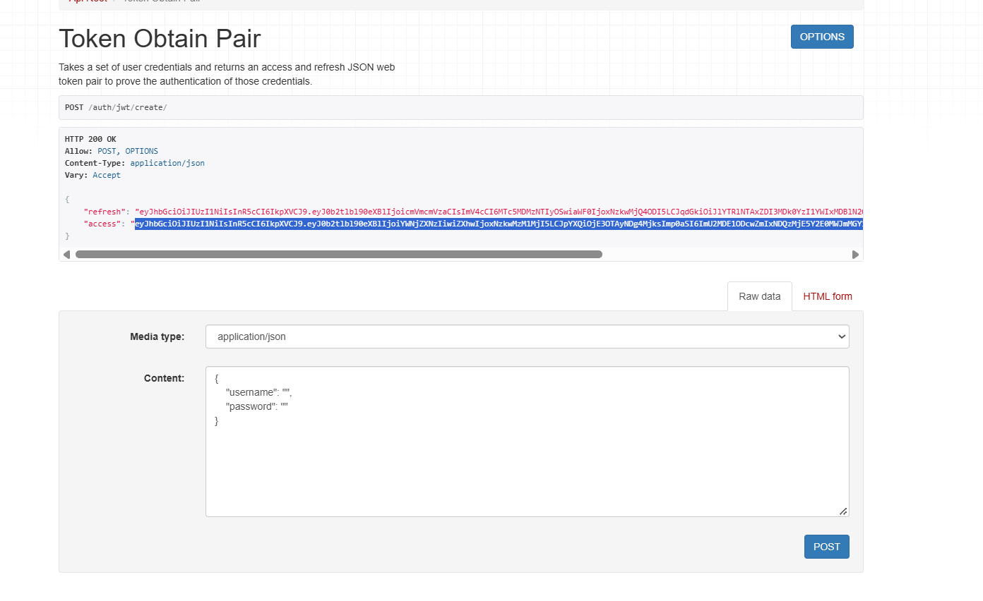
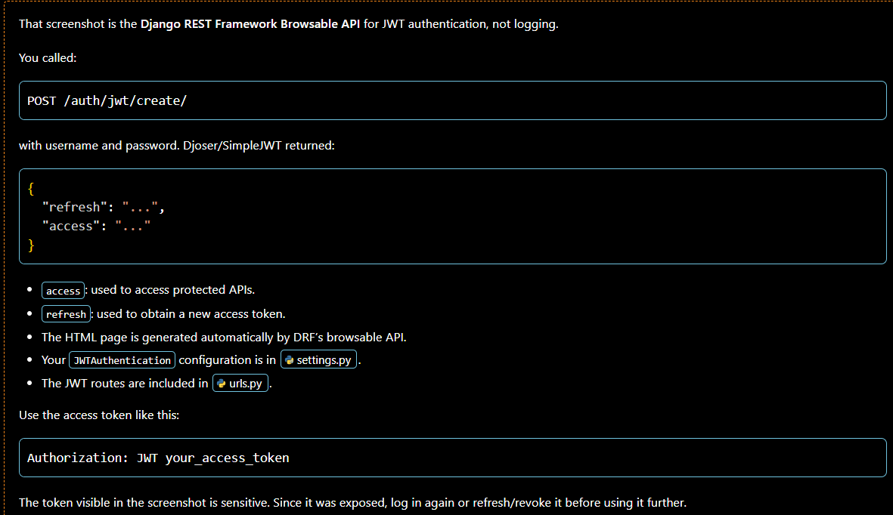
Inspecting JWT token:
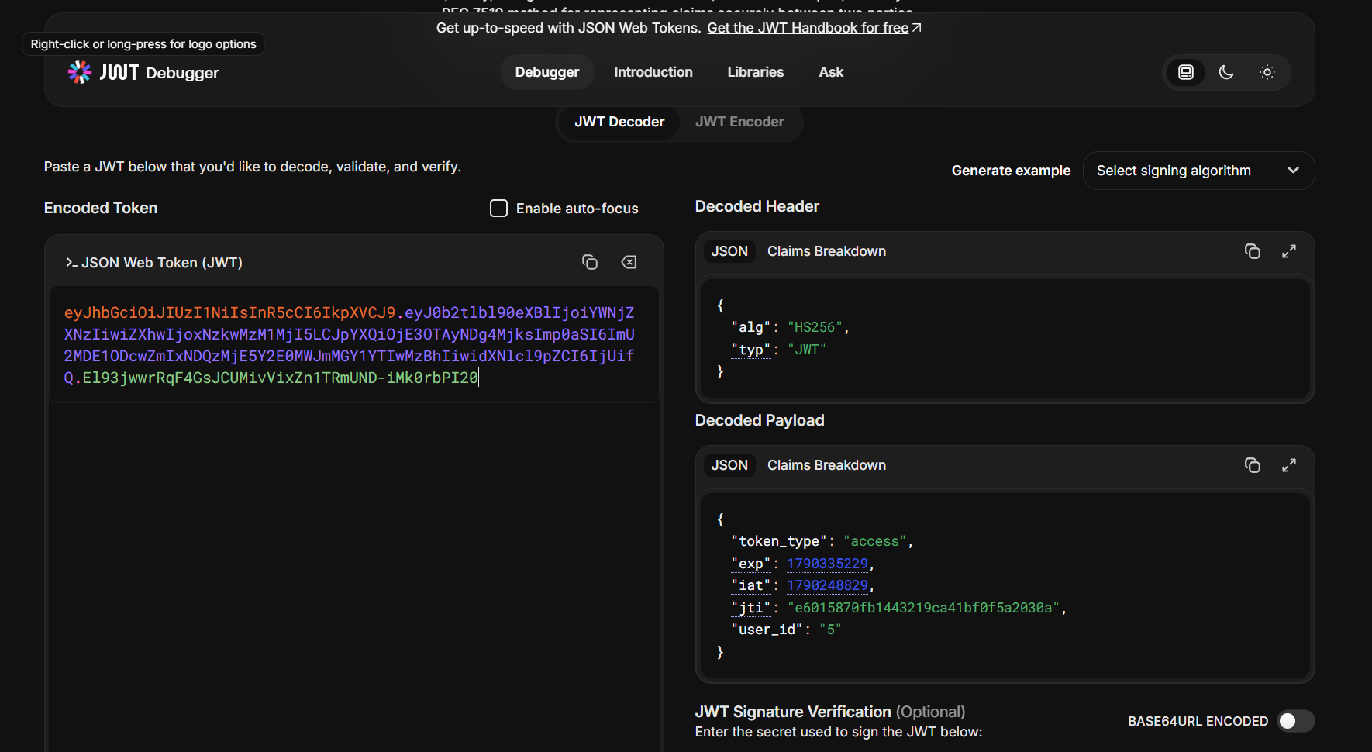
Refreshing the tokens:
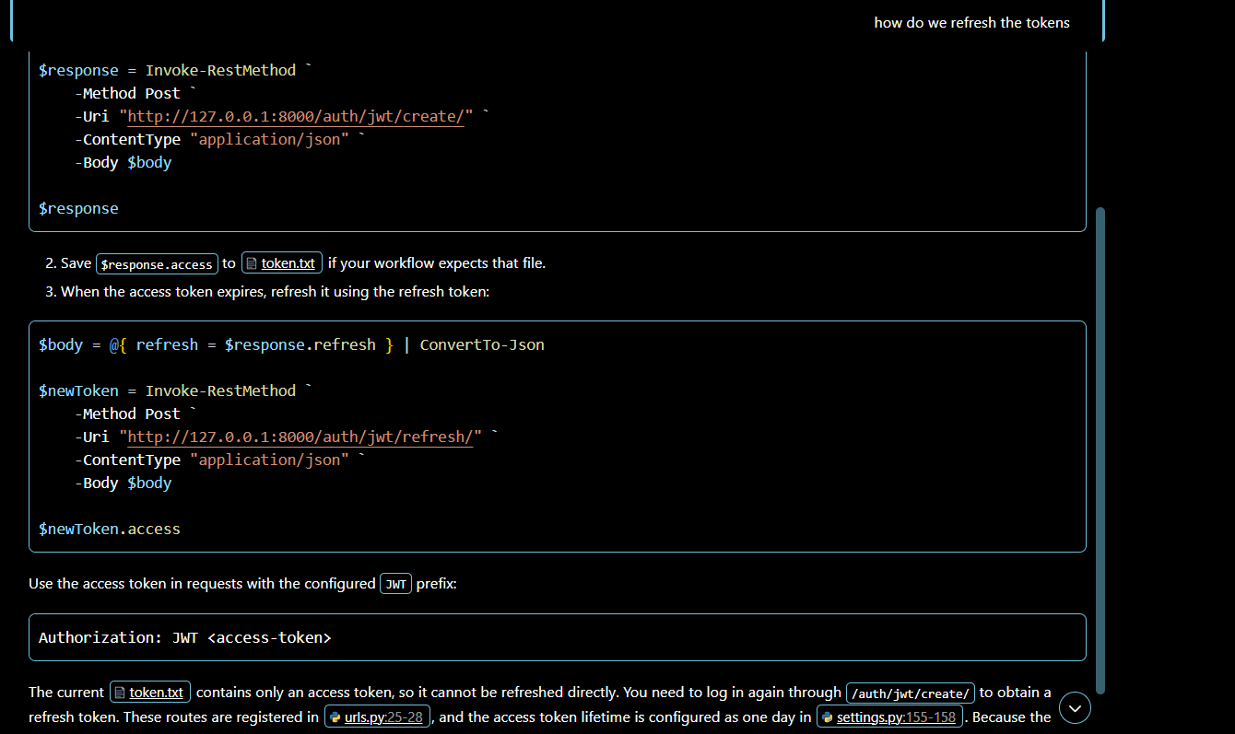
"http://127.0.0.1:8000/auth/jwt/refresh/"
We can go the above link and then enter the refresh token and generate the new token.

Getting the current user:
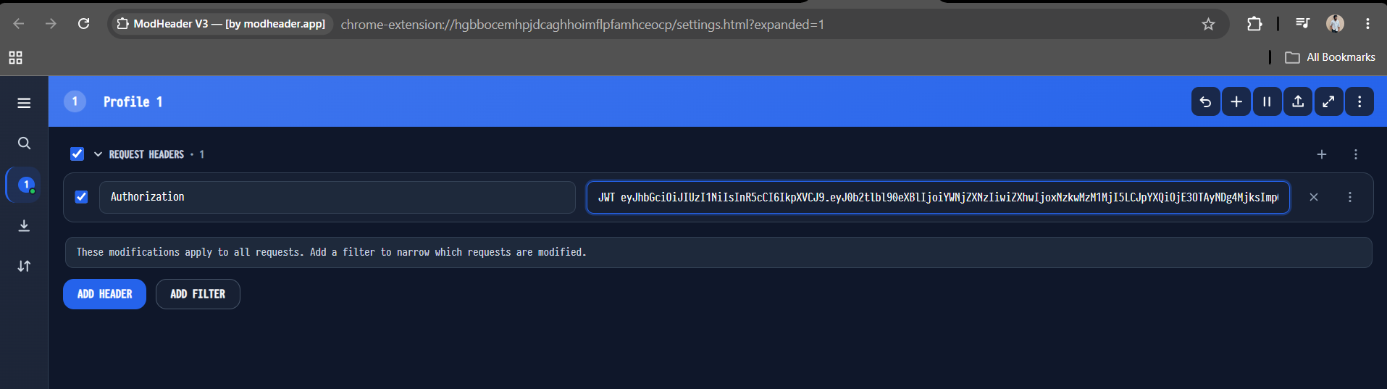
We enter our token with JWT as prefix and then load the user/me endpoint again so we can access the restricted end point
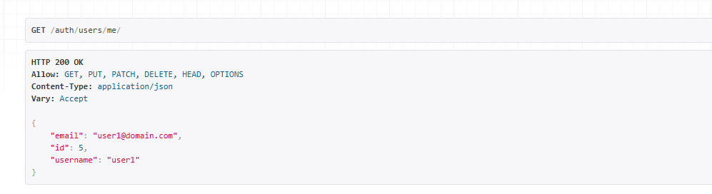

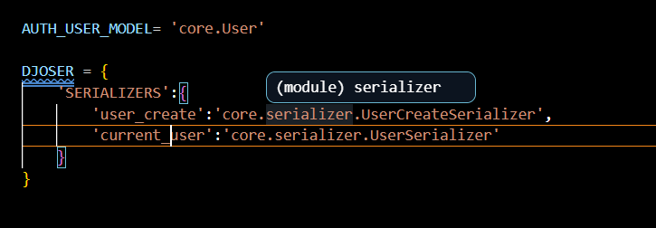
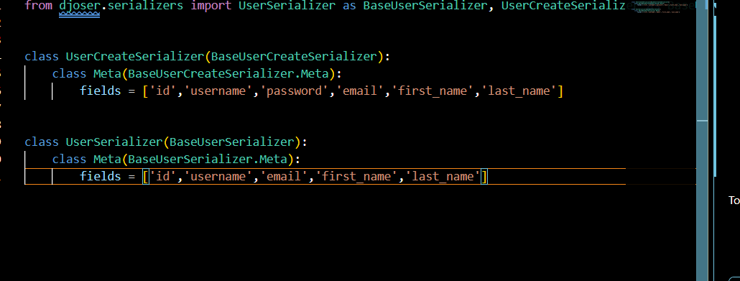
Getting current user profile:
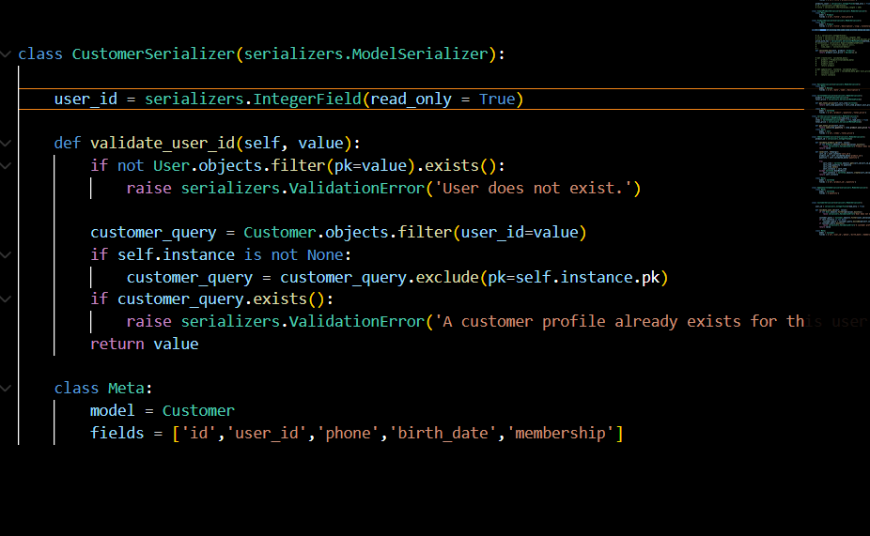
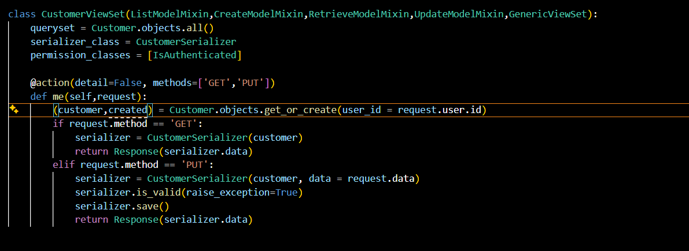
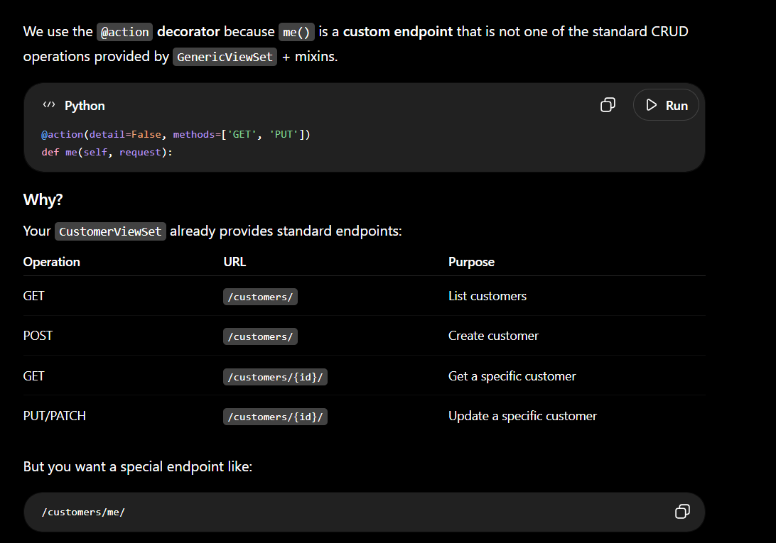
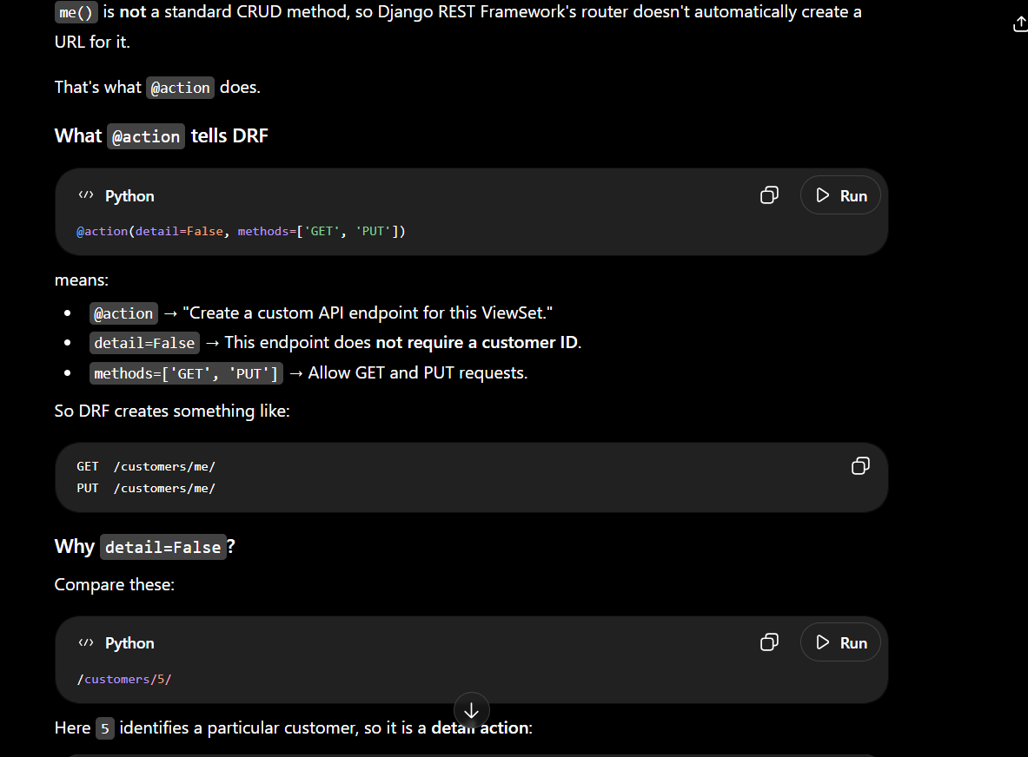
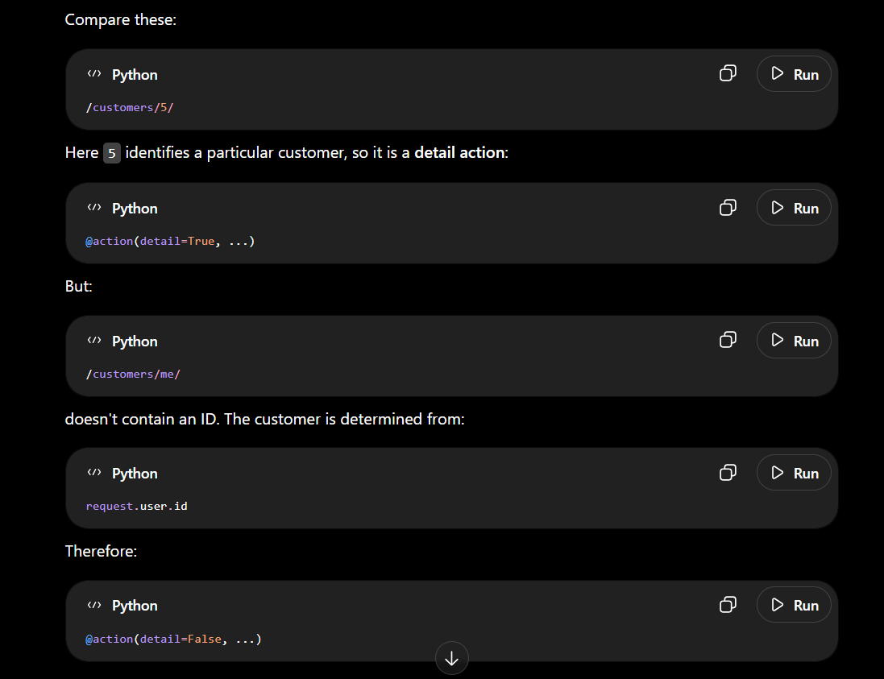
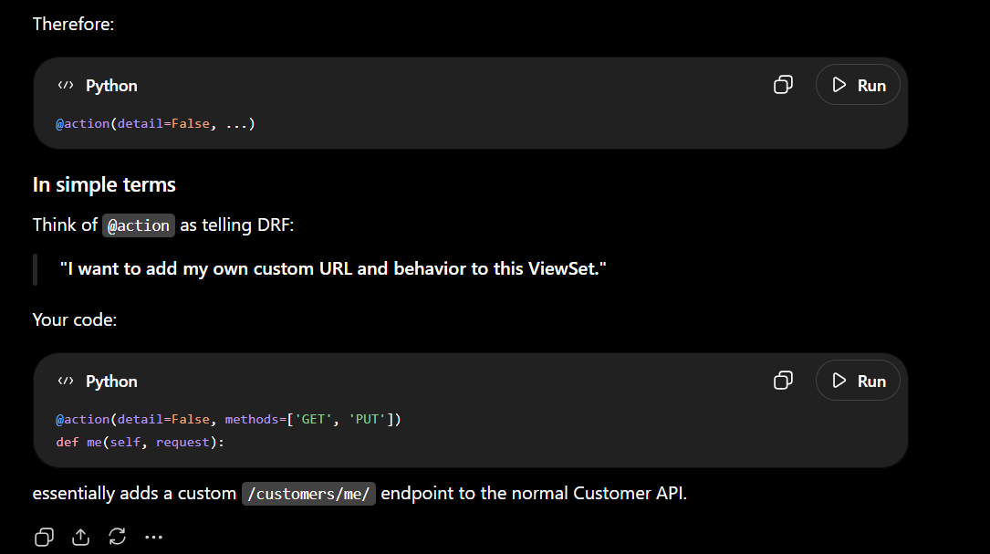

Applying Permissions:
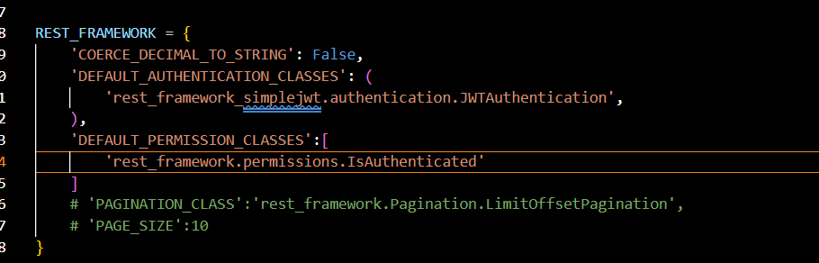
- Applying the default permissions to all the users by default
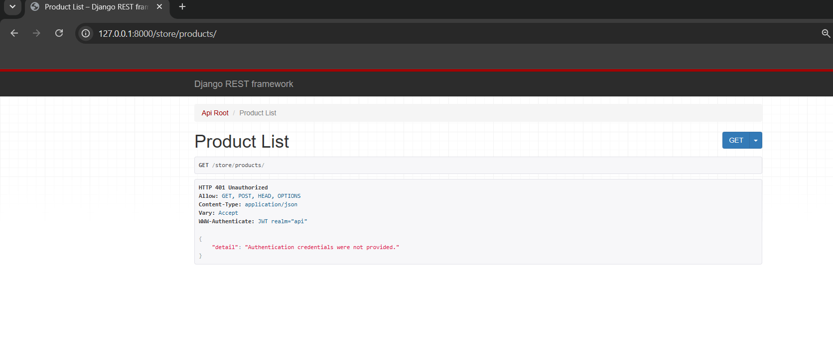
After applying default permissions if we open incognito tab and then try to access products we need to authenticate first
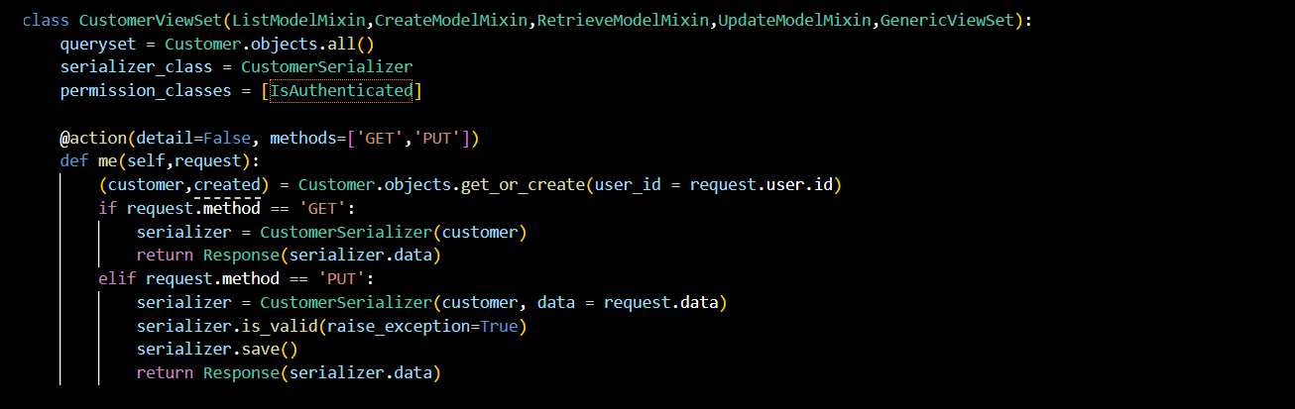
If we want to have different permission for different methods like post and get. For that we need to ovetride the get methods.
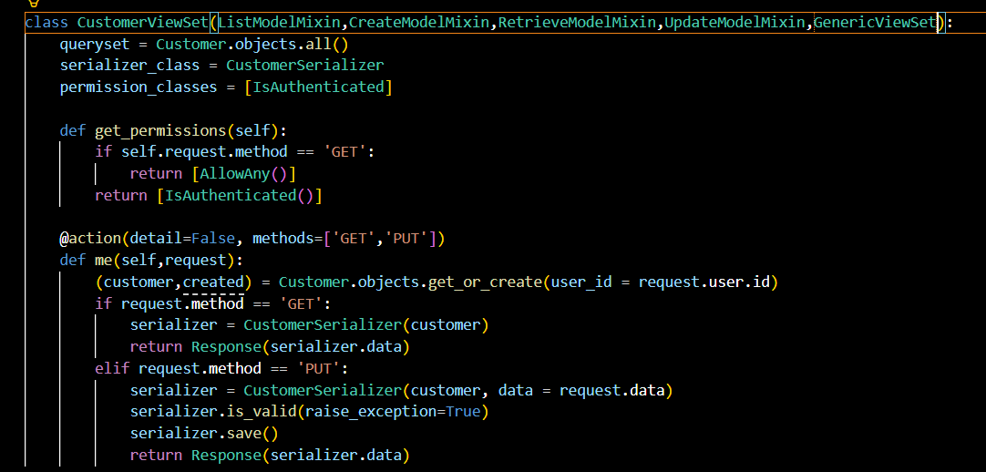
Applying custom permisisons:
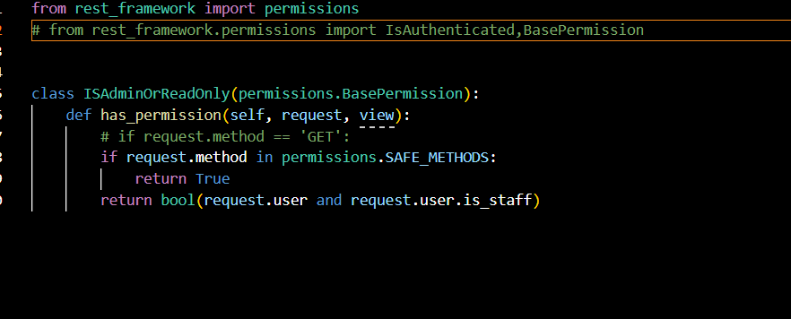
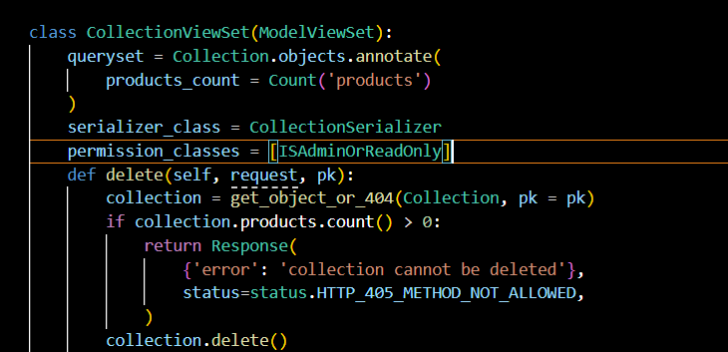

Applying model permissions:
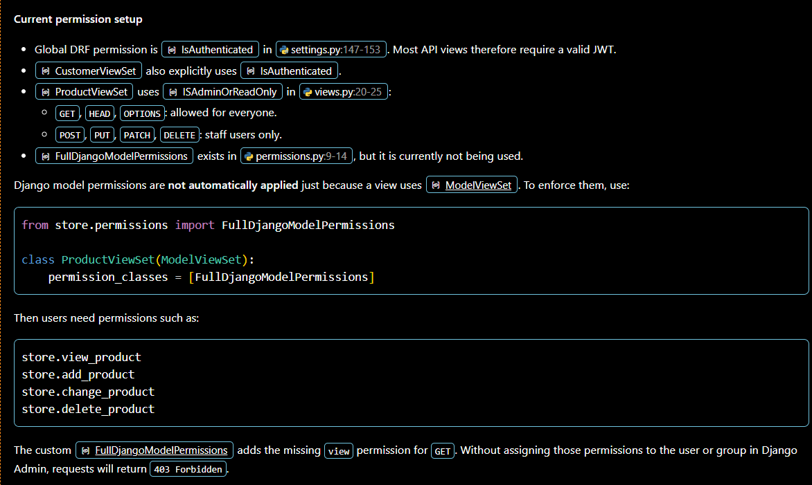
Applying custom model permissions:
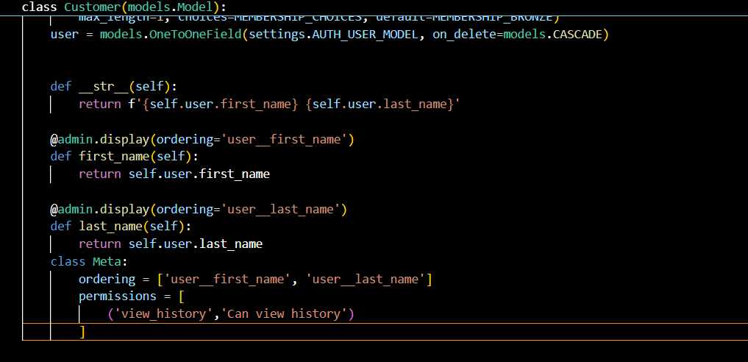
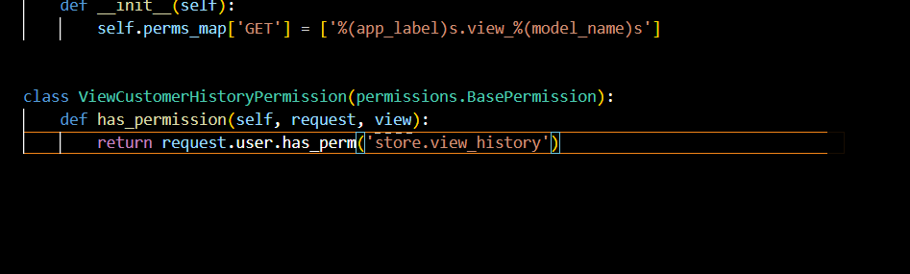
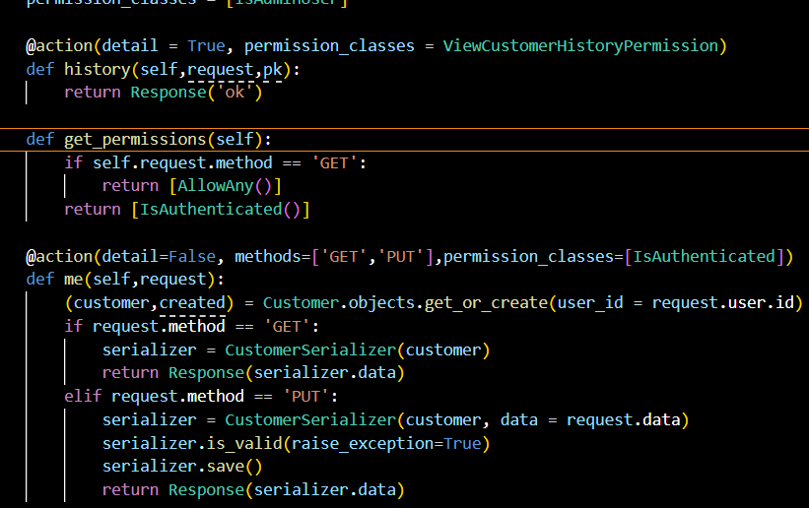

Designing and building the orders API:
Designing the Api :
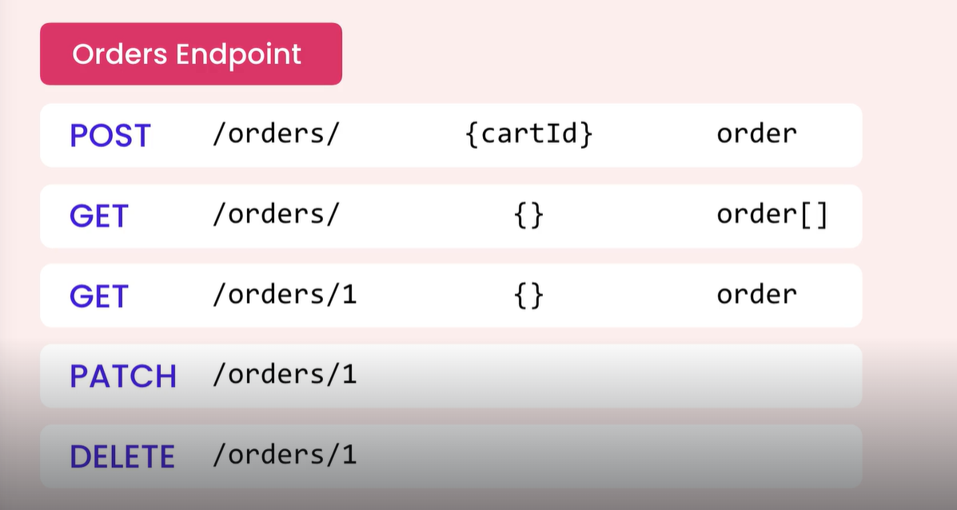

Getting the Orders:
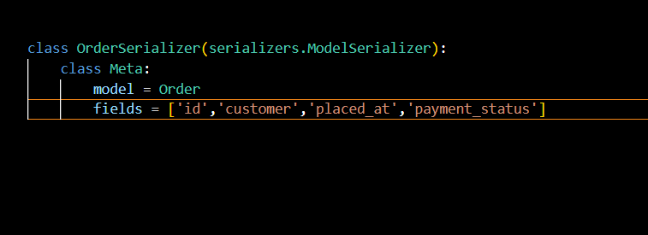
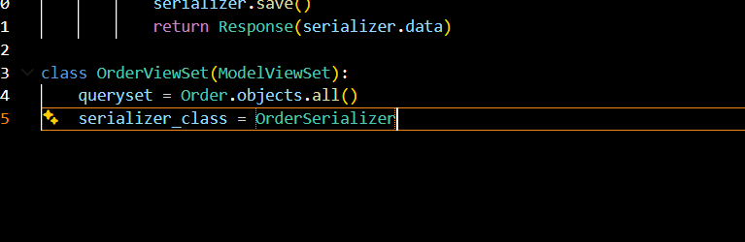
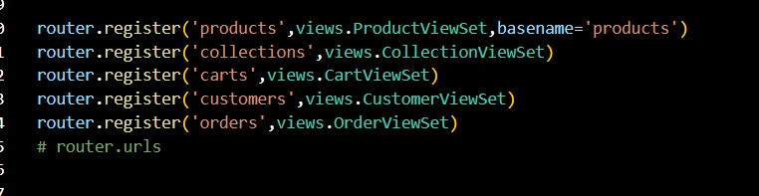

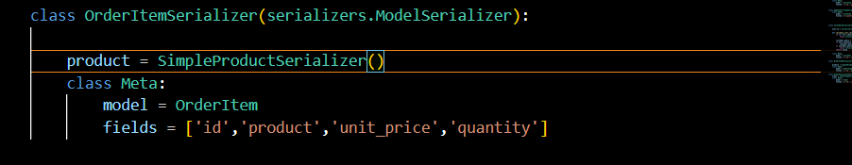

Applying permissions:
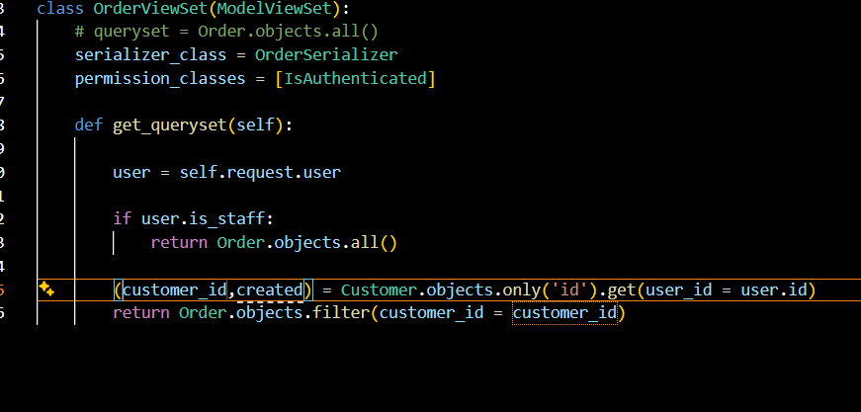
Creating an Order:

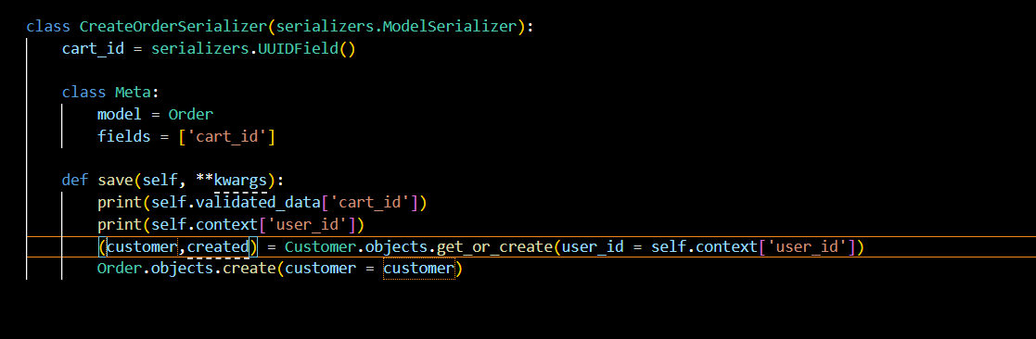
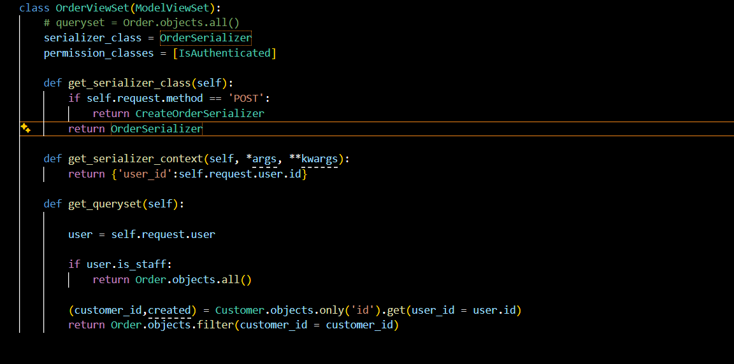
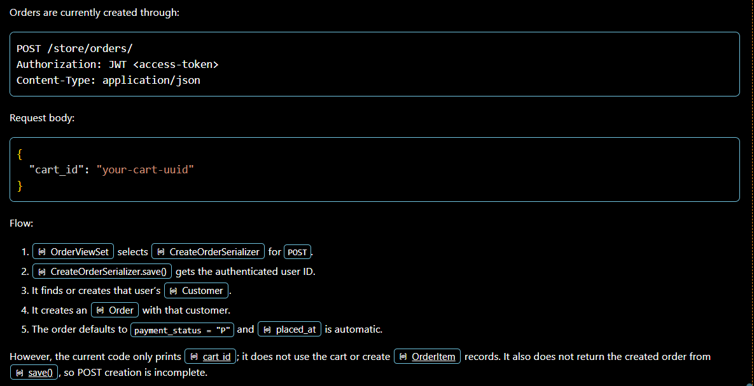
Creating Order Item:
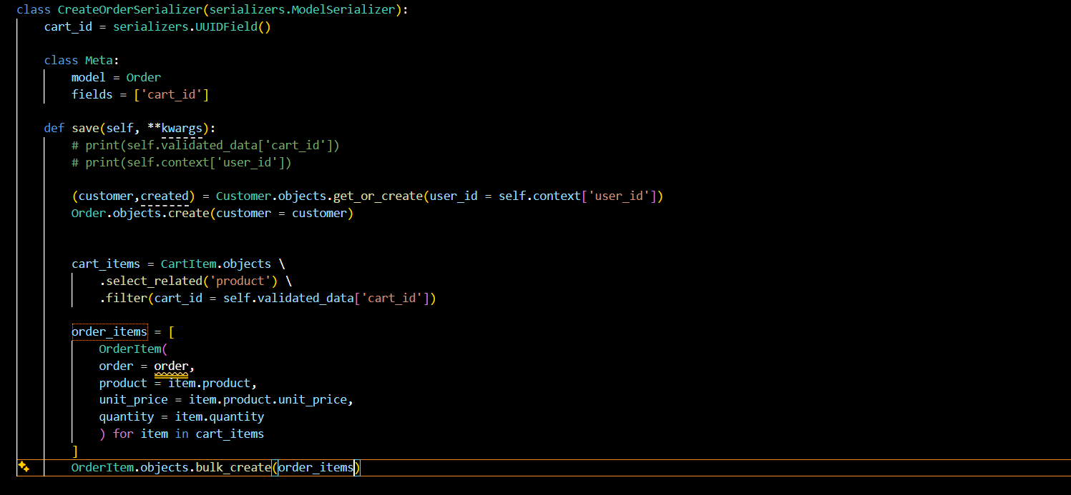
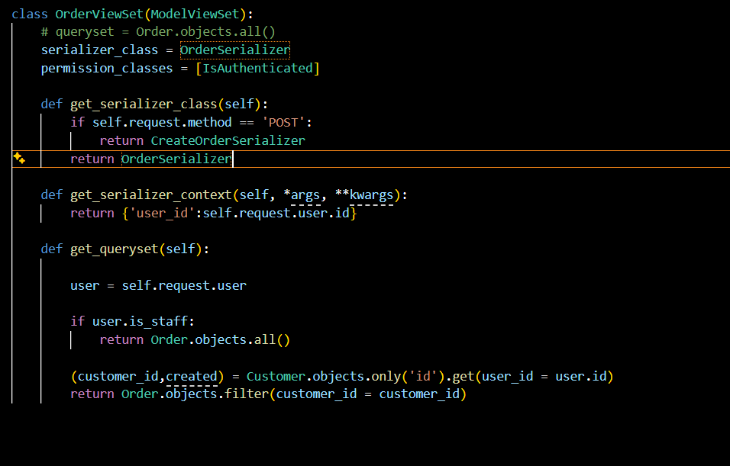
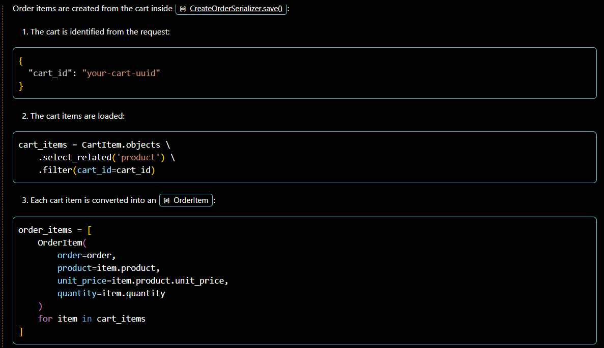
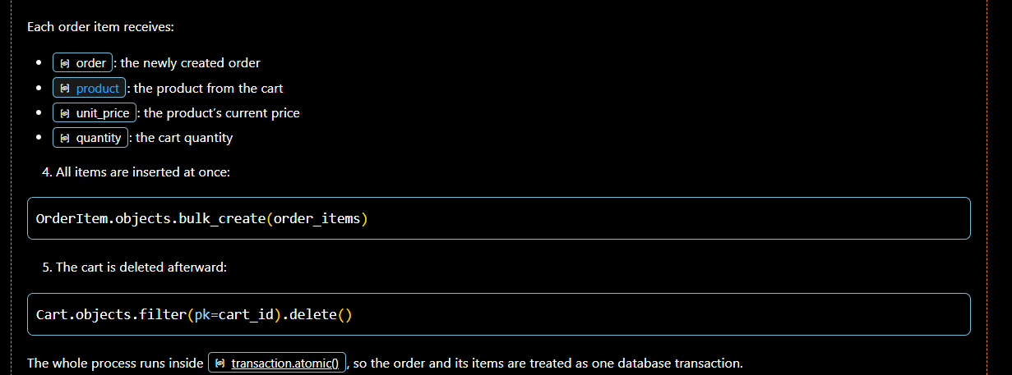
Returning the Order:
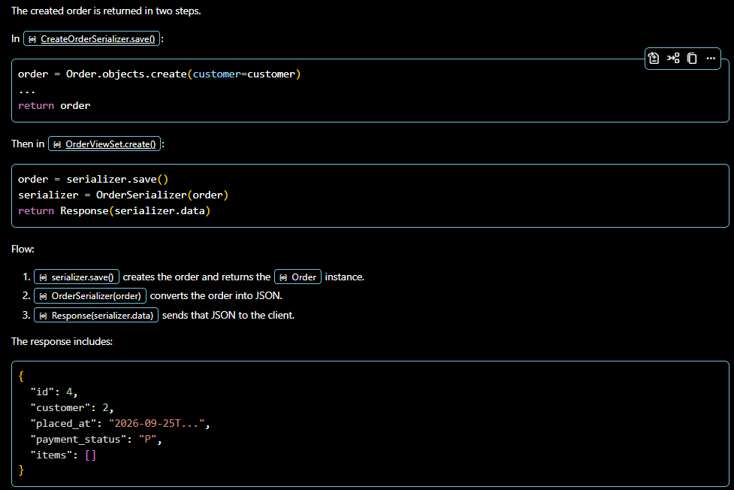
Data Validation:
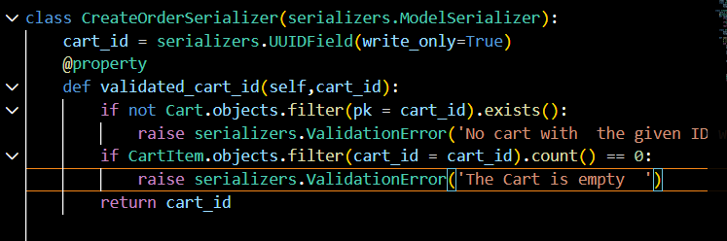
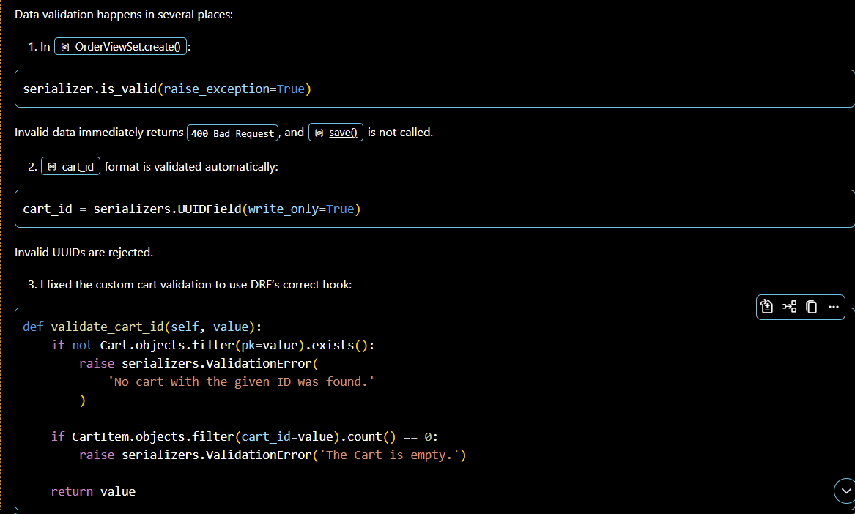
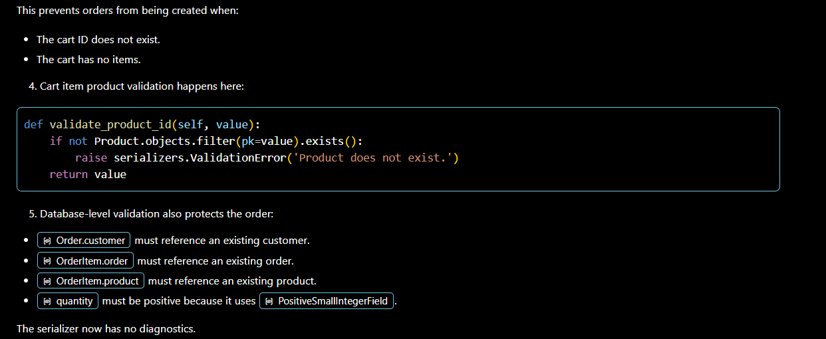
Revising the permissions:
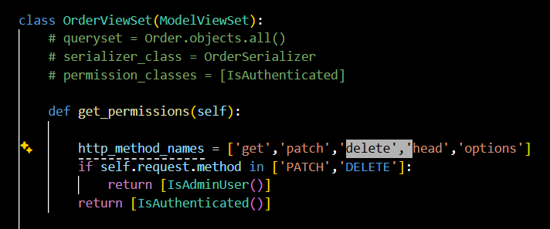
Updating an Order:
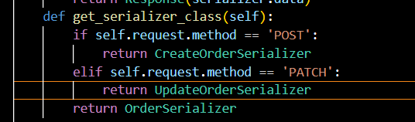
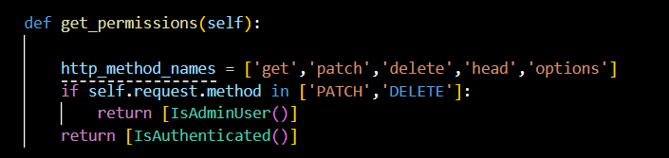
Signals:
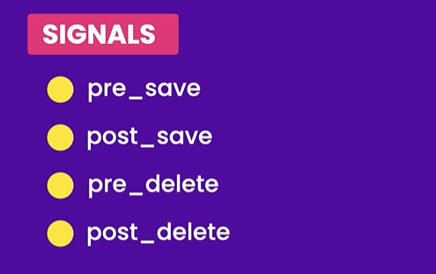
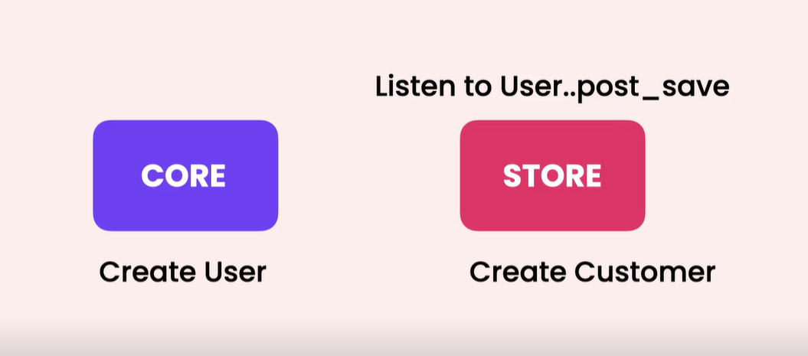

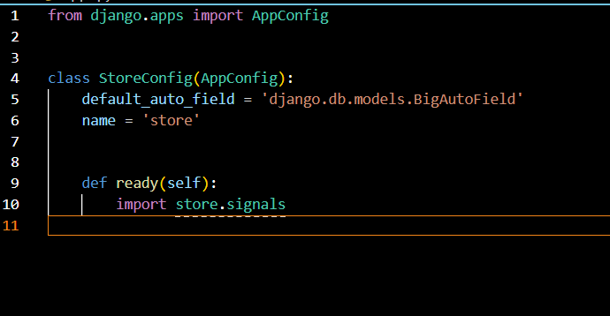
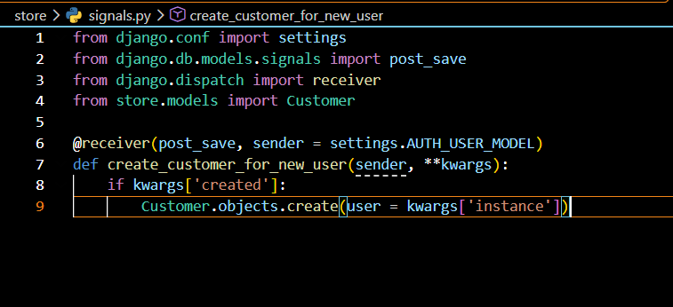
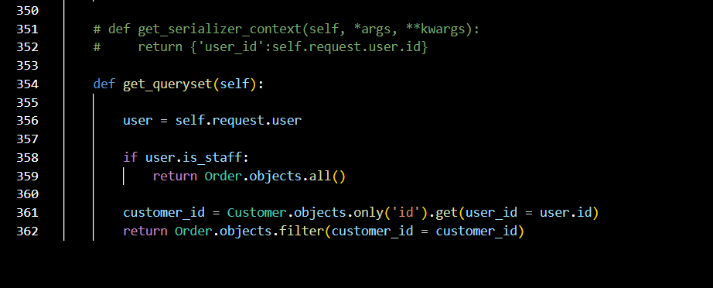

Django signals are a built-in notification system that allows decoupled applications to get notified when specific actions or events occur elsewhere in the framework
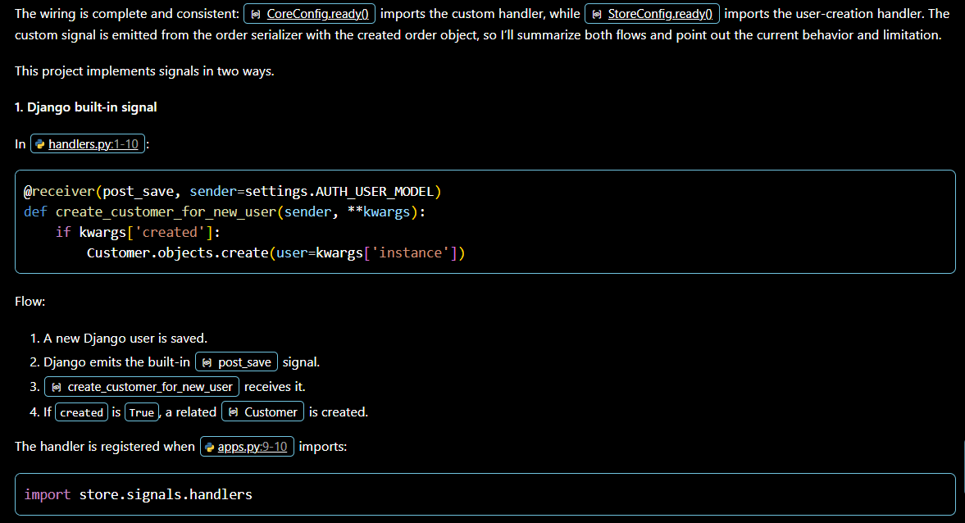
- **kwargs is required because Django sends values such as instance and created as keyword arguments.
Creating Custom Signals:
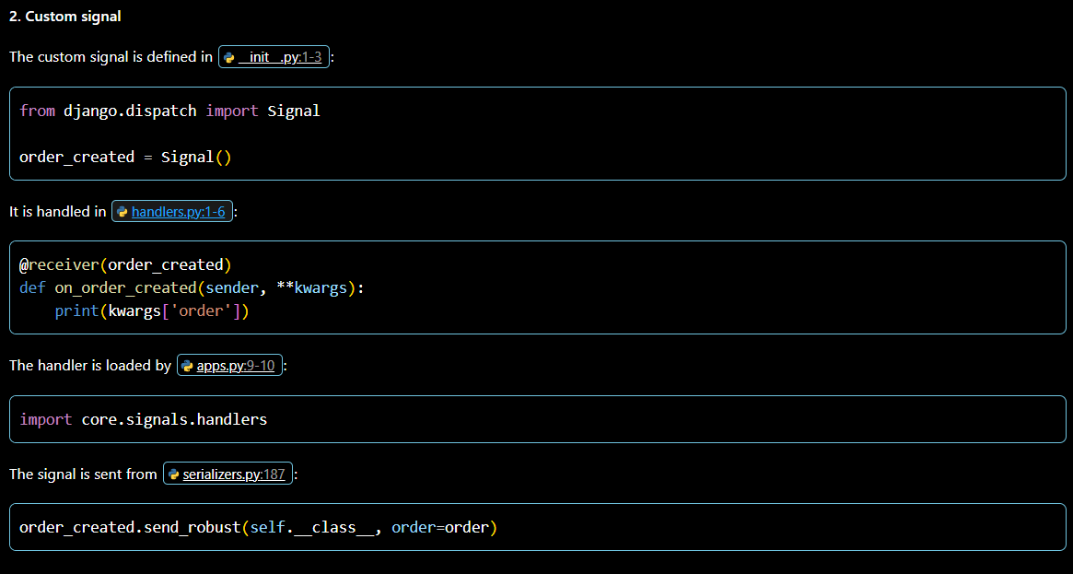
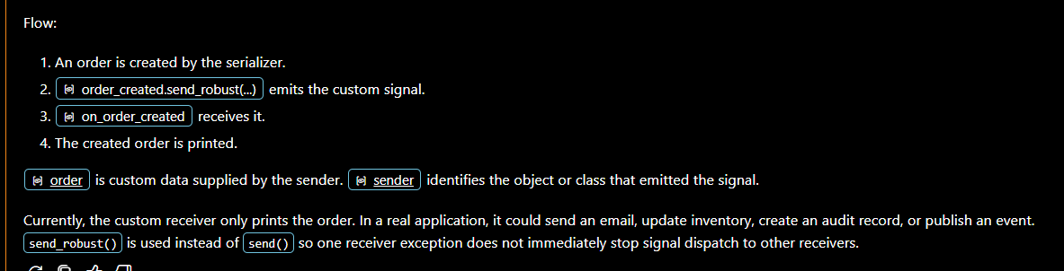
Importance of signals:
Signals are important because they let different parts of an application react to events without tightly coupling their code.
For example, in this project:
- When a new user is created, the post_save signal automatically creates a related Customer.
- When an order is created, the custom order_created signal can trigger extra actions such as sending an email, updating inventory, or recording an audit entry.
This keeps the main code focused on its primary job. The order serializer creates the order, while separate signal handlers manage secondary tasks.
Signals are useful for:
- Automatically maintaining related data
- Sending notifications
- Updating caches or search indexes
- Creating audit logs
- Triggering background processing
- Keeping business logic organized
However, signals should not be overused. They can make program flow harder to follow because actions happen indirectly. Use them for independent side effects, but keep critical business rules visible in the main service or view logic.

Uploading files:
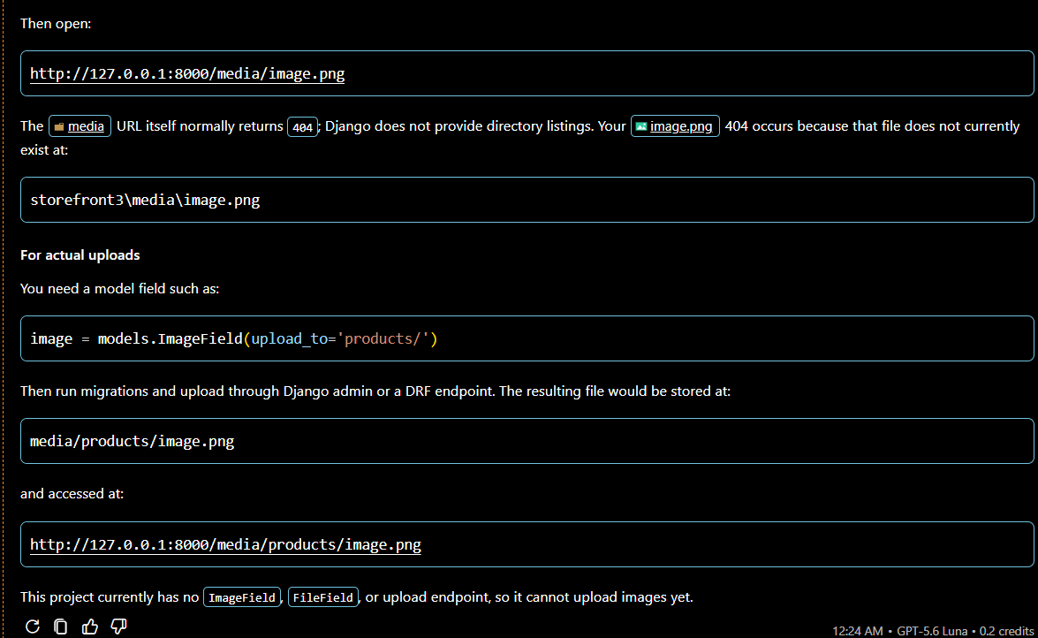
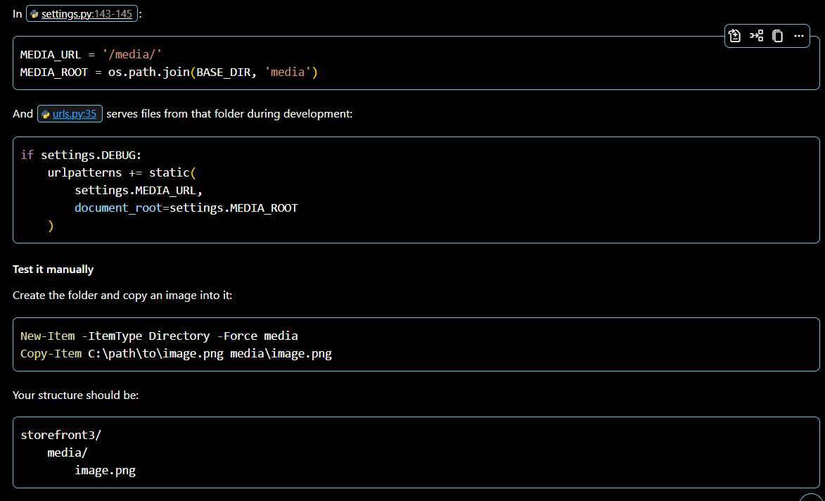
Managing media Files:

Adding images to products:
- TO add an images to the products we need to create an model in the models.py module.
- And also as we are using the ImageField() we need to install the module called pillow
- After that we need to create the migrations and run the the migrations
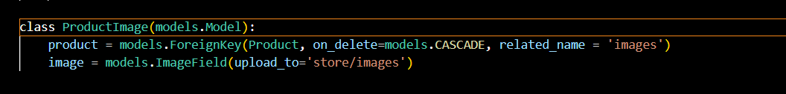

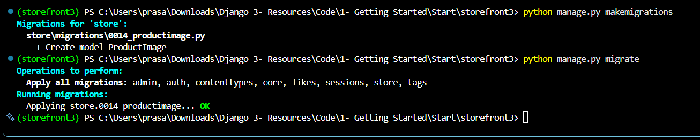
Building the apis to upload images:
- We are going to build the api endpoint like given below
  - /products/1/images/1
- We are going to use nested routers to implement this
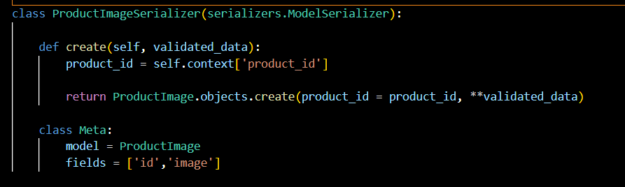
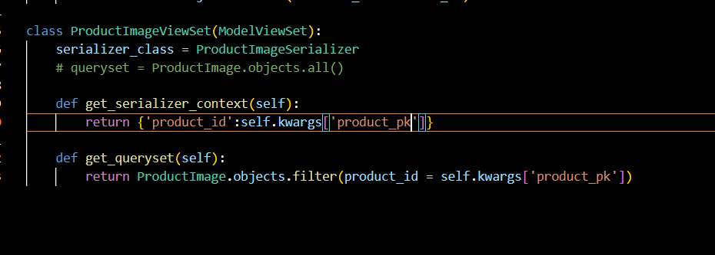
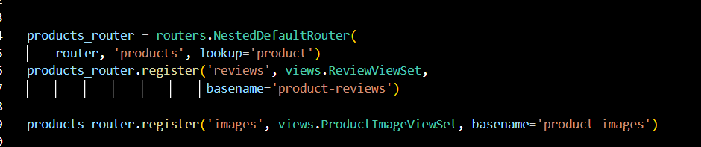
Returning the images from the API:
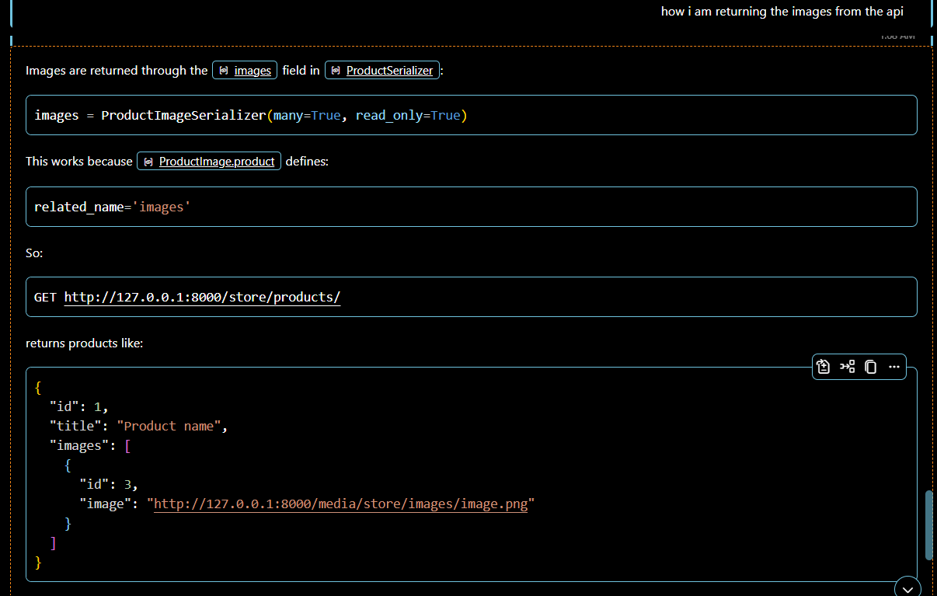
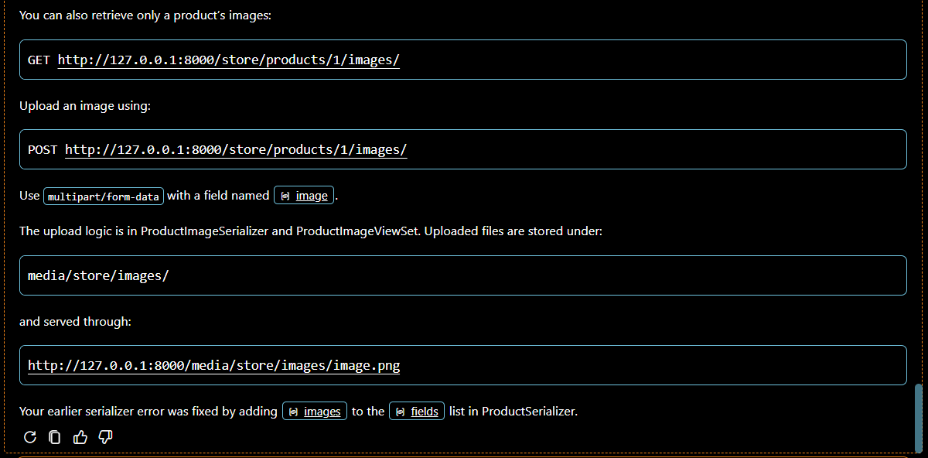
Validating the uploaded files:
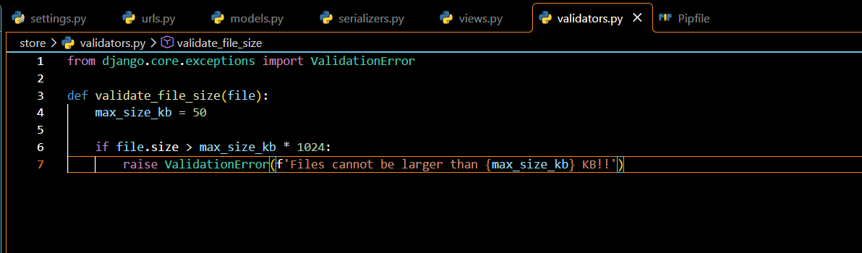
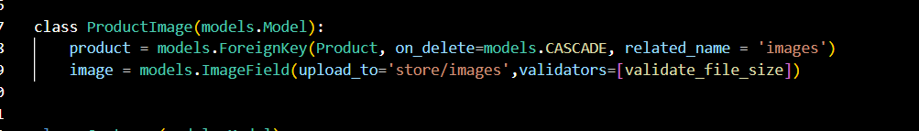
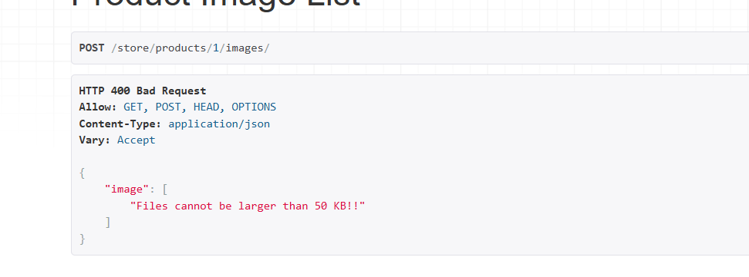
- Here we create the validators.py and create the validations in it.

Setting up the client app:
- Extracted the templates and node project from the source and runned it.
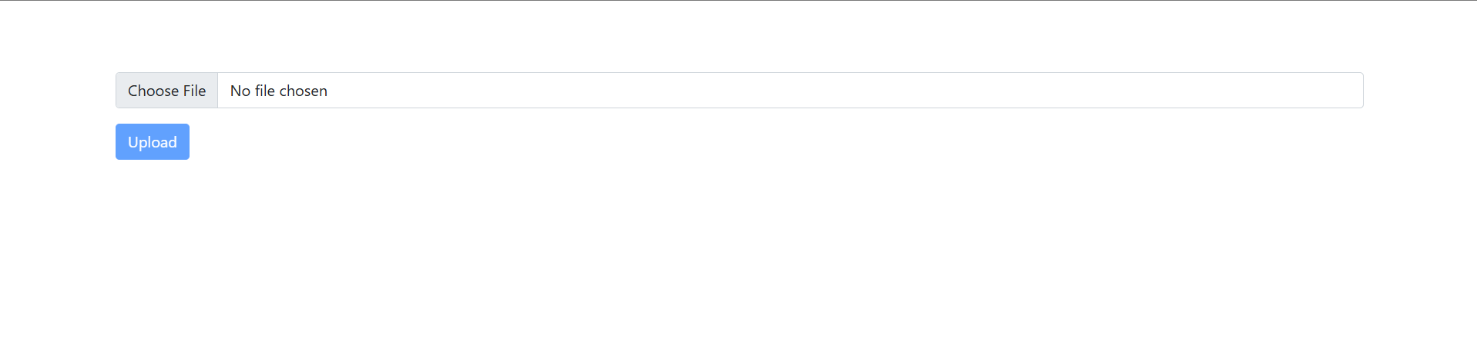
Enabling cores:

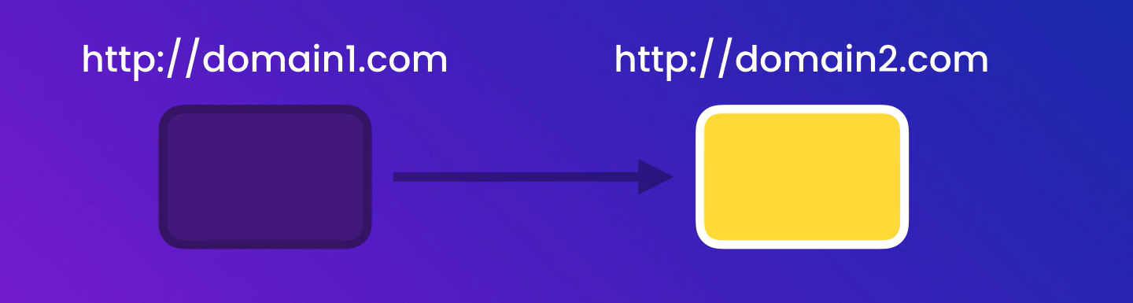
It prevents an app posted on one domain afrom sending request to app posted on other domain.
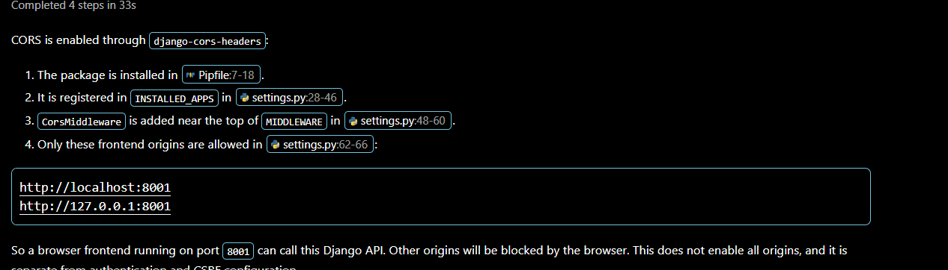

Managing the images on the Admin:
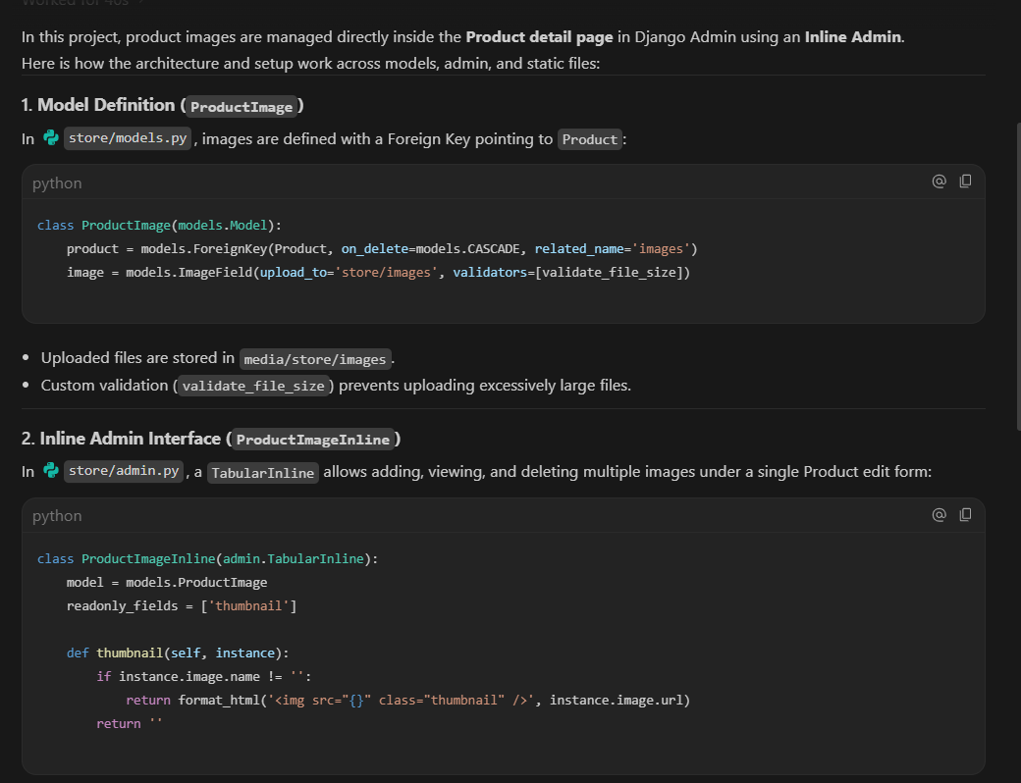
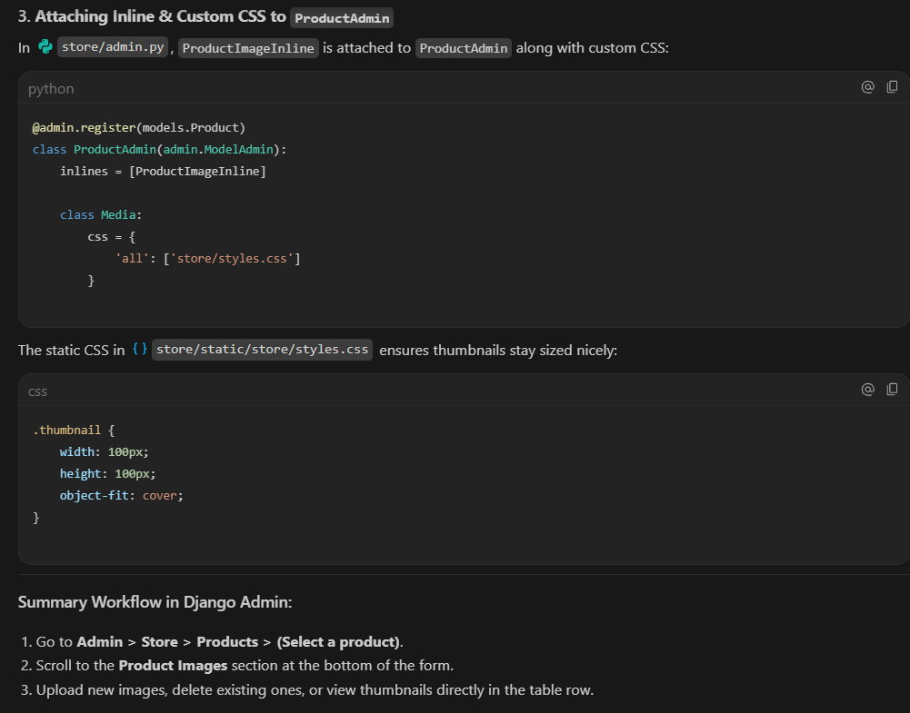
Sending Emails:
Setting up Fake SMTP:
- To Send an emails we need an SMTP server.
- To set up an fake smtp server we use smtp4dev and install it using the docker command
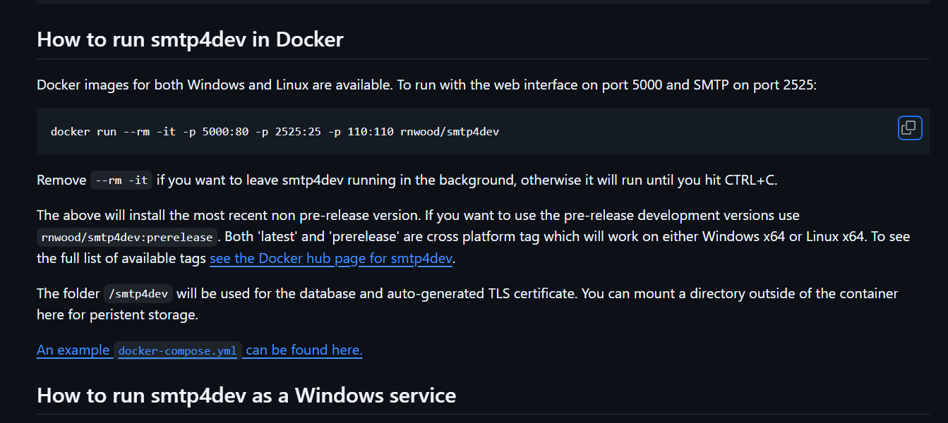
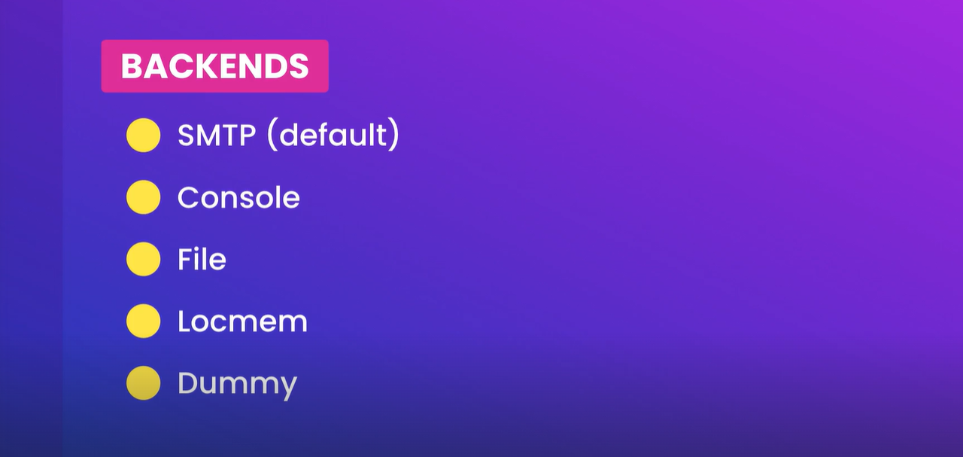
Configuring the Email Backend:
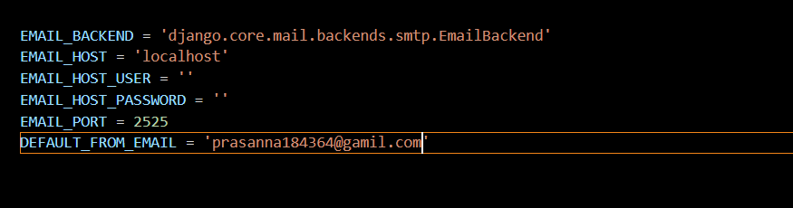
Sending emails in Django:
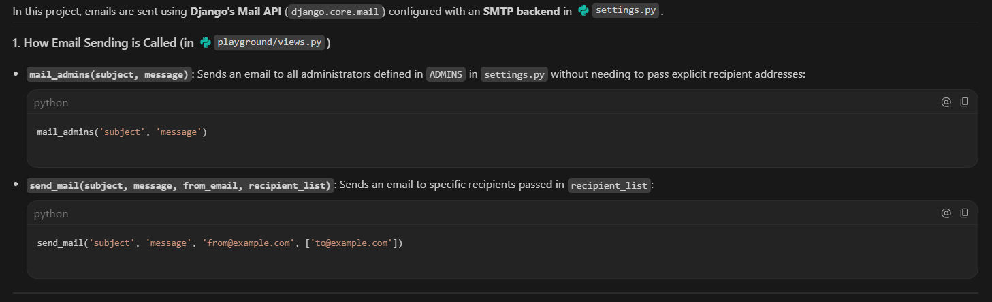
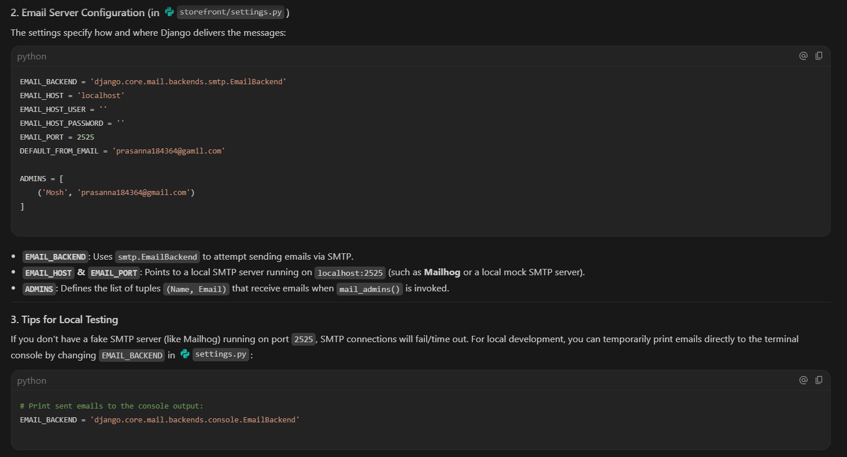

Attaching Files:
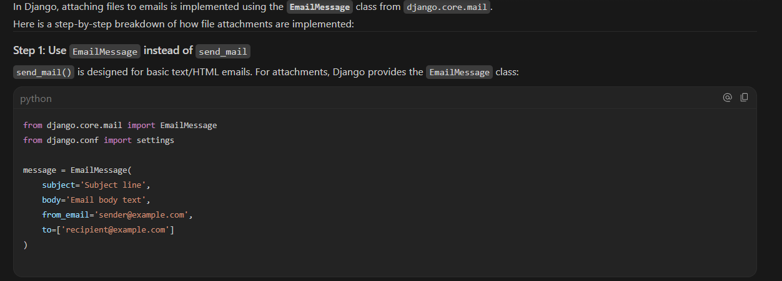
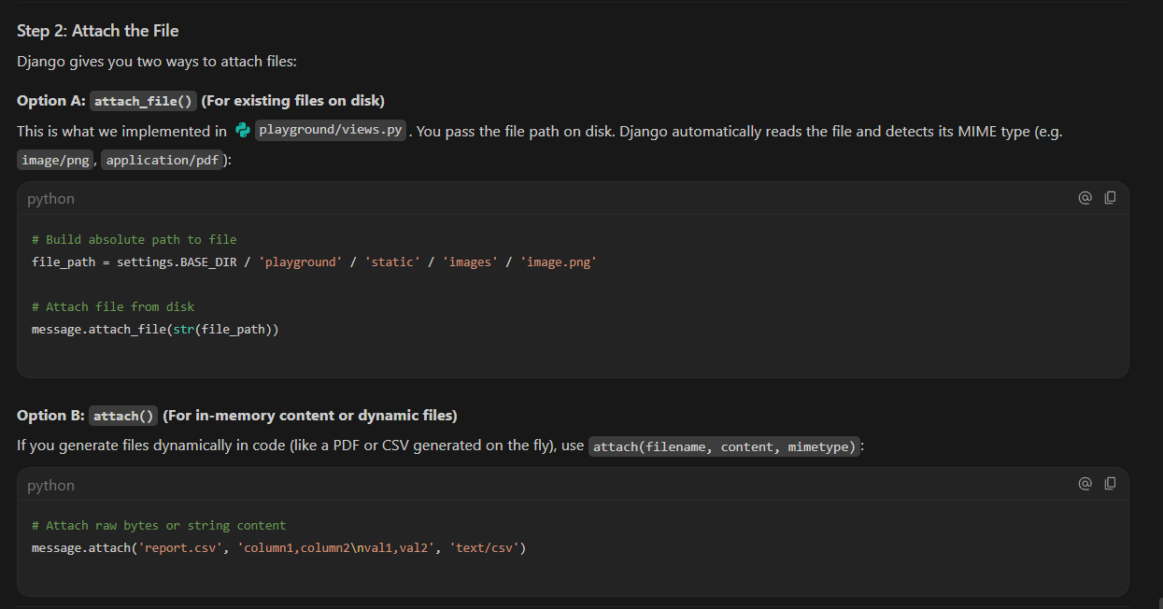
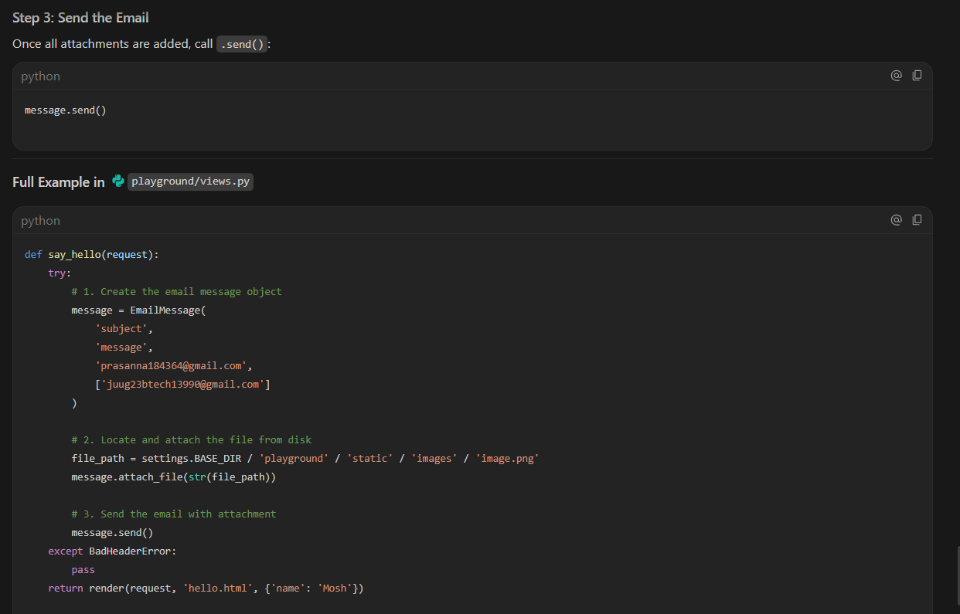

Sending the templated emails:
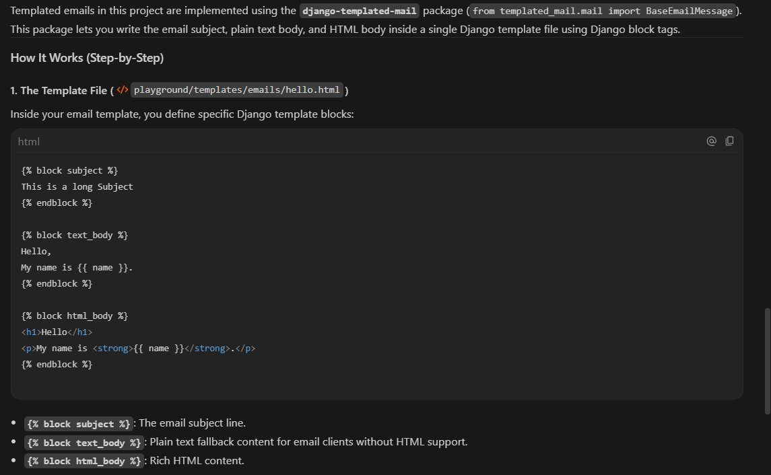
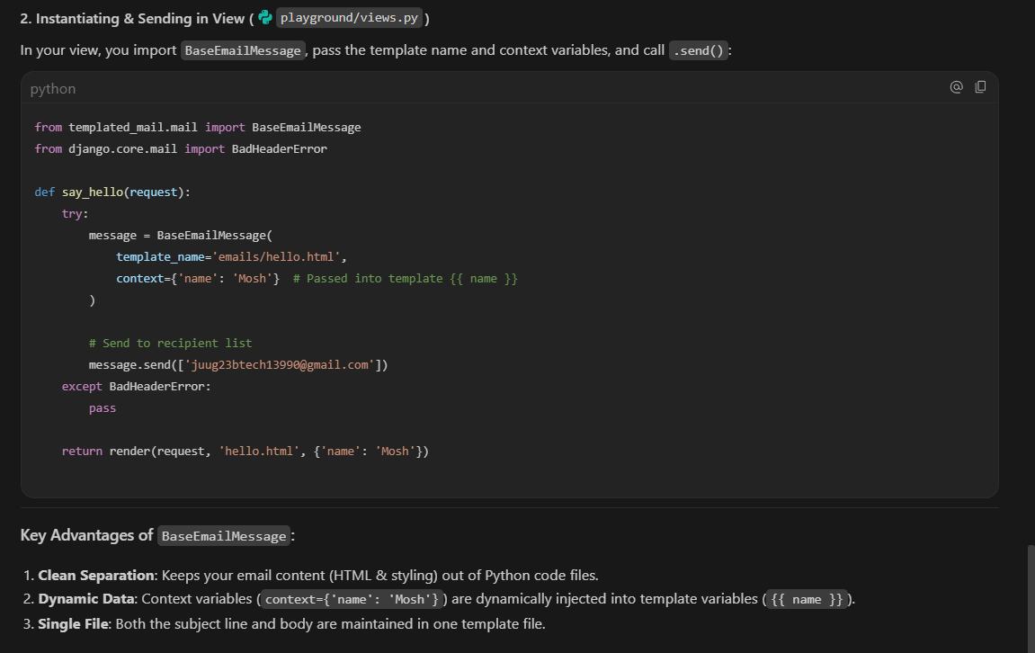

Running background tasks:
Celery is a popular open-source tool used to run time-consuming or heavy tasks in the background outside of the main application flow
What Celery Does
- Asynchronous Processing: It lets your app hand off slow jobs (like sending emails, processing payments, or generating large reports) to the background so your website or app stays fast and responsive for users.
- Task Queues: It acts as a queue manager, organizing tasks and handing them over to background workers to execute them one by one or all at once.
- Scheduled Jobs: It can run recurring tasks automatically on a regular schedule (using a feature called Celery beat).

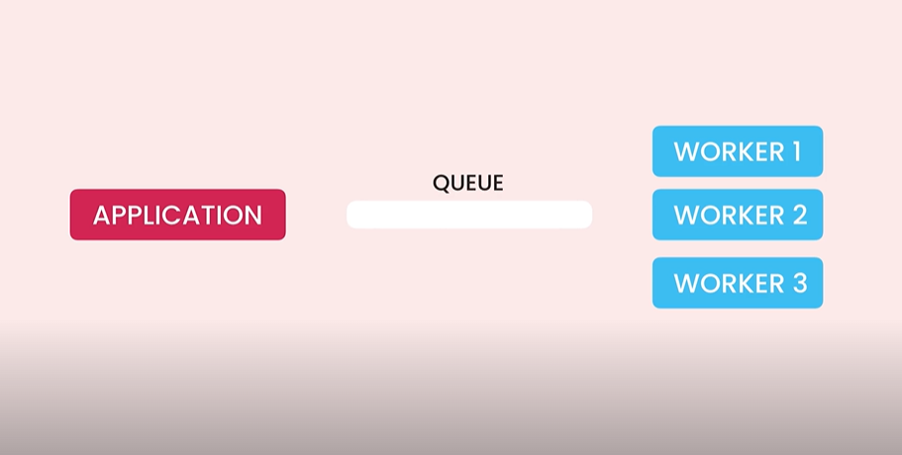

Message Brokers:
- Application communicates with the workers in the celery with the help of queue.
- With the help of the queue messages will be passes in order.
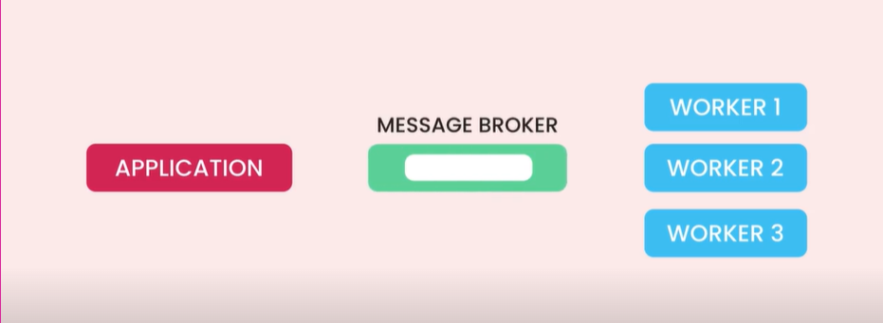

- Message brokers are responsible for sending the messages from one application to another.
- If the receiver is not available then the broker keeps the message and passes it to the receiver when available.
- We can setup the cluster of message broker so that when one broker goes offline other can work.
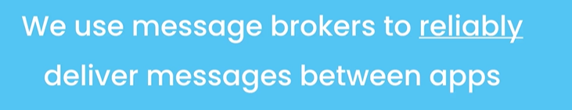

- Start with redis and incase if the requirements doesn’t meet the expectations then we can easily switch to RabbitMQ.

Setting up the redis:
We need to set up the redis and install it in the terminal.
Using pipenv install redis

Setting up the celery :
Celery is an asynchronous task queue / background job processor for Python web applications.
It allows your Django web application to offload long-running, heavy, or background tasks to separate worker processes so your website remains fast and responsive for users.

The Real-World Problem Celery Solves
Imagine a user signs up on your website or completes a order:
❌ Without Celery (Synchronous execution):
- User clicks "Submit Order".
- Django saves the order to the database.
- Django sends 1,000 promotional & confirmation emails (takes 15–20 seconds).
- The user's browser hangs & spins for 20 seconds waiting for the HTTP response.
- If the connection times out, the user gets a server error!
✅ With Celery (Asynchronous execution):
- User clicks "Submit Order".
- Django saves the order to the database.
- Django delegates the email task to Celery in 1 millisecond using send_email_task.delay().
- Django immediately returns "Order Successful!" to the user.
- Celery Worker processes and sends the 1,000 emails in the background without affecting the user's web page speed.

Restaurant Analogy
- The Web User: A customer placing an order at a restaurant counter.
- Django (The Waiter): Takes the order ticket, hands it to the kitchen, and immediately gives you a receipt so the next customer in line can order.
- Redis (The Order Board): Holds the tickets waiting to be cooked.
- Celery Worker (The Chef): Works in the kitchen picking up order tickets off the board and cooking the meals independently.

Common Use Cases for Celery in Django
- Sending Emails & SMS notifications (welcome emails, password resets, newsletters).
- File & Image Processing (generating thumbnails, compressing videos, converting PDFs).
- Third-party API Requests (payment processing callbacks, web scraping, external sync).
- Scheduled / Recurring Tasks (Cron Jobs) (nightly database cleanups, generating daily sales reports).

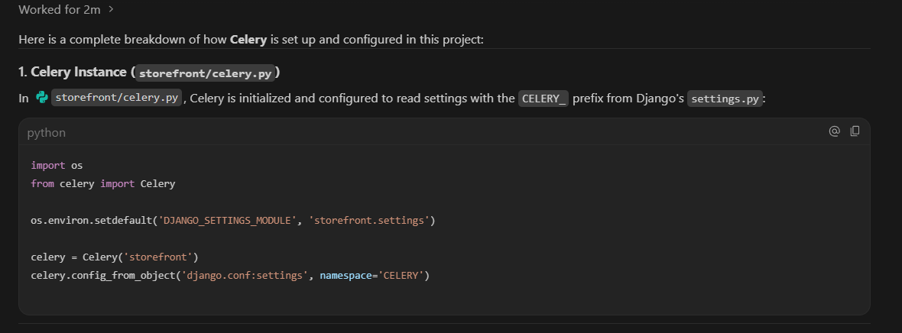
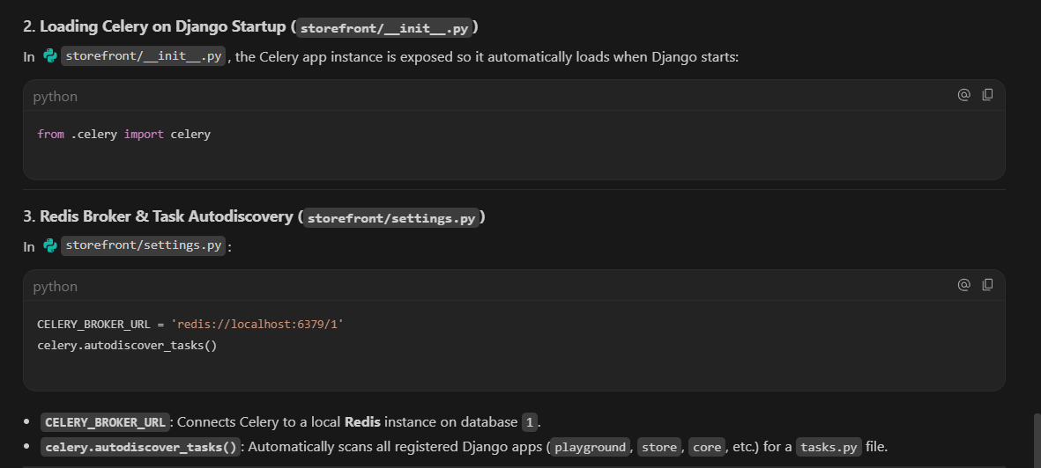
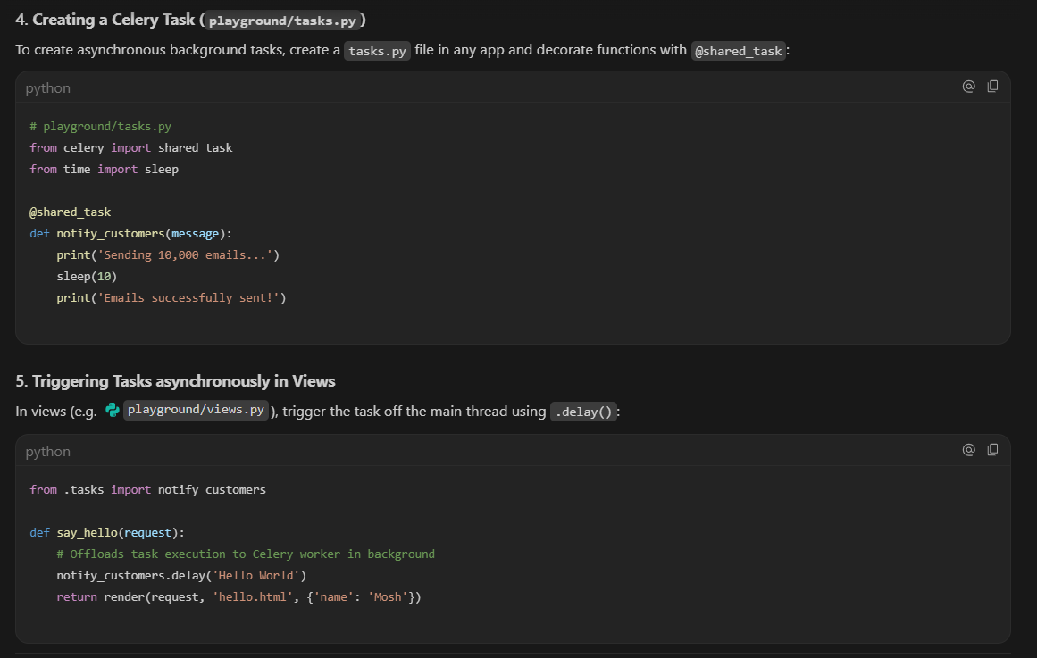
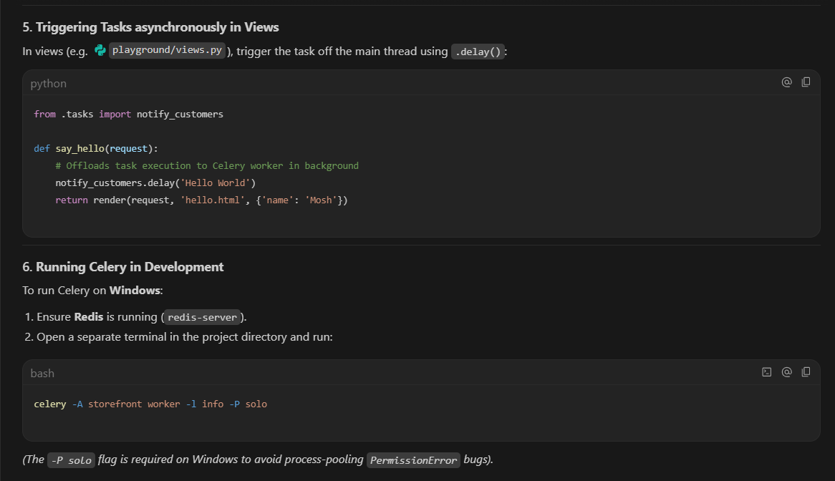

Creating and executing tasks using celery :
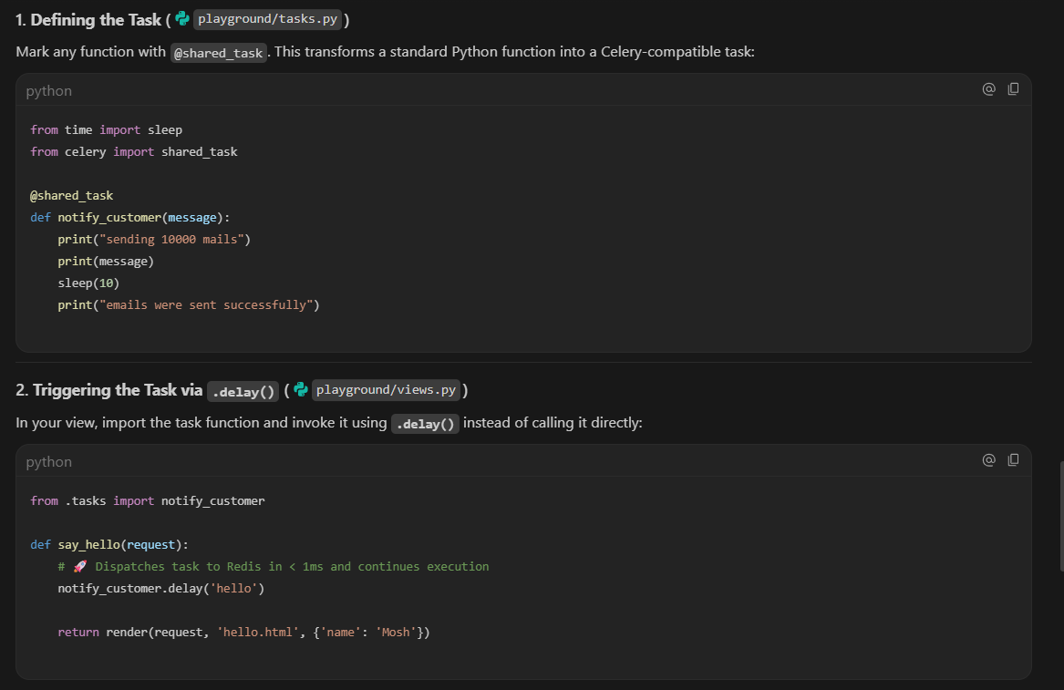
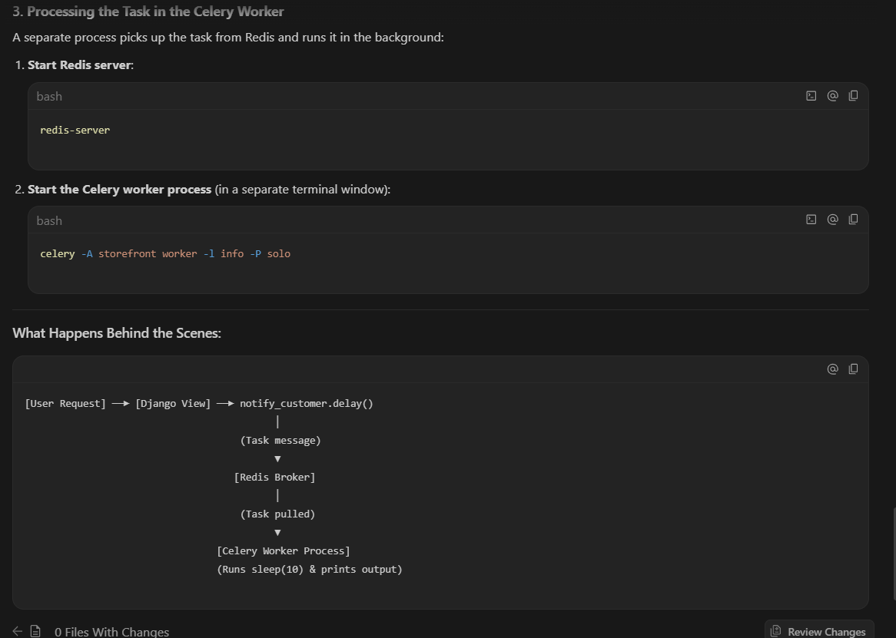
- Difference: Calling notify_customer('hello') directly would freeze Django for 10 seconds. Calling notify_customer.delay('hello') places a task ticket in Redis and lets Django return the HTTP response immediately.
Sheduling peroidc tasks:
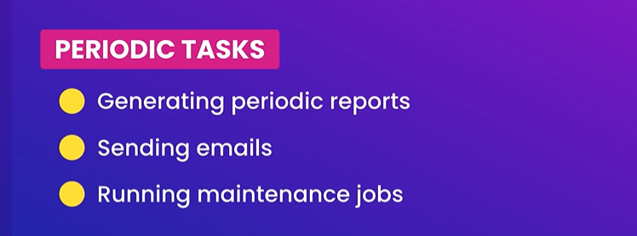
For this we use celery beats

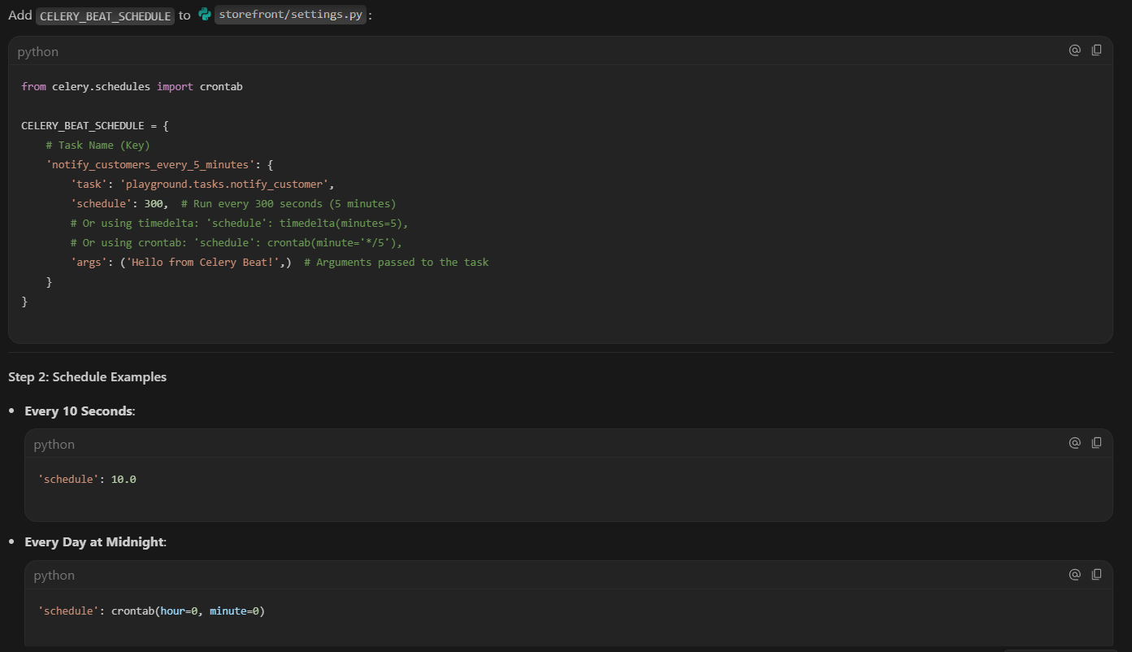
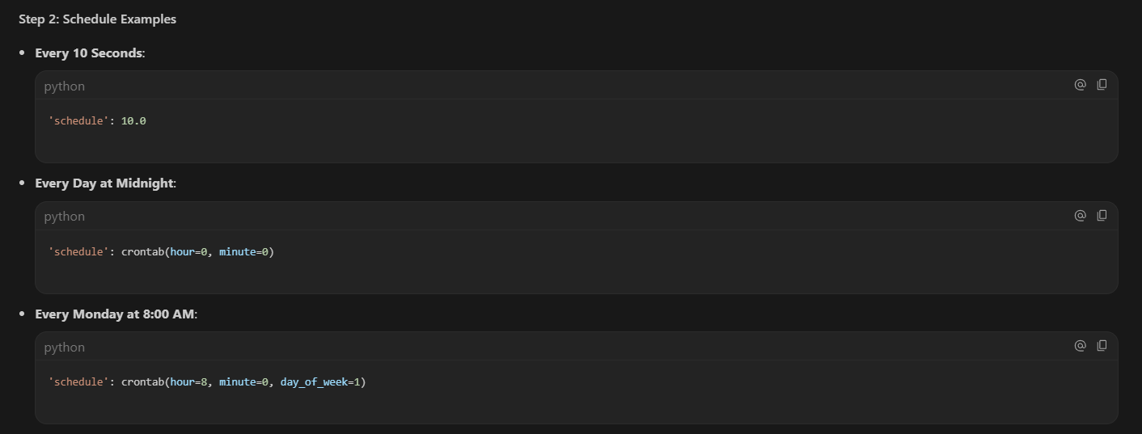
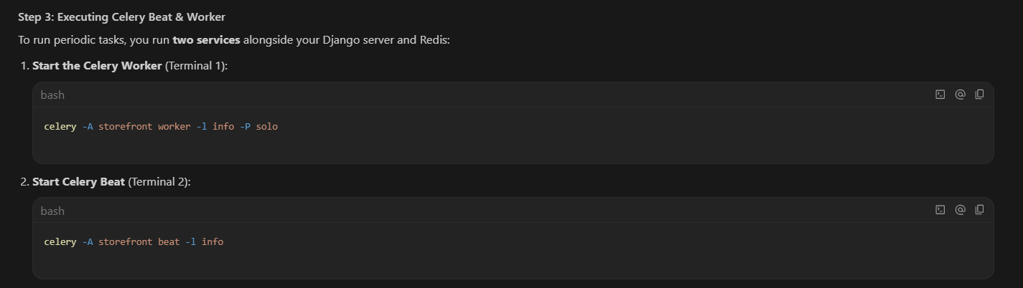
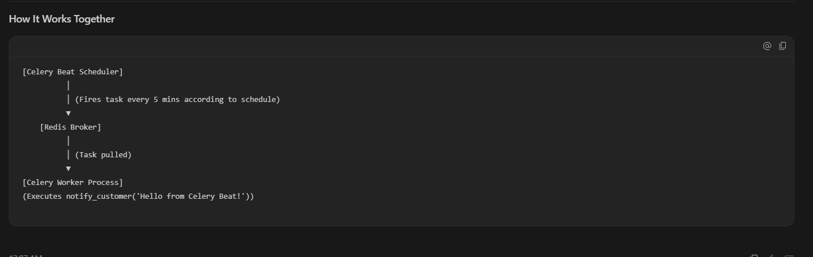
Monitering Celery tasks:
- TO moniter celery tasks we use flower .
- We install the dependencis by using pipenv install flower
- We can access it in the url http://localhost:5555/
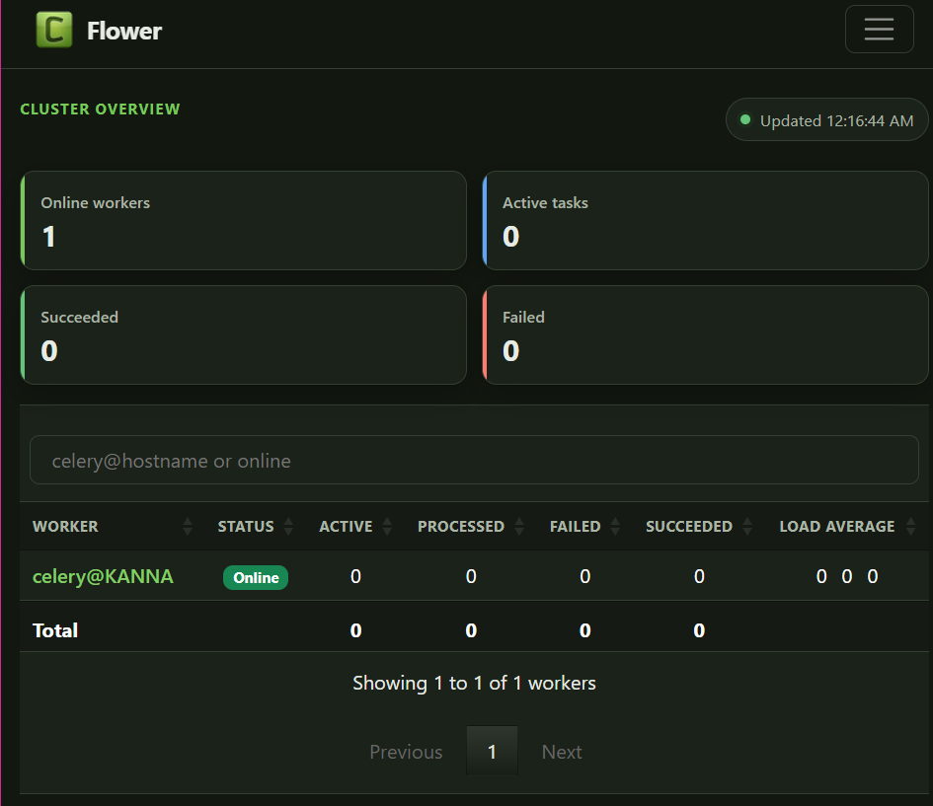

Automated testing:
With automated testing we can write code to test our endpoints and make the tasks easier to understand and complete.
Automated testing makes us to perform many tests and run then in seconds without wasting time. But it need to be done in proper way else the things get complicated.
Test Behaviours not implementations:
- Lot of people test the implementations, but we need to test the behaviours not the implementations.
- We need to test the behaviours of the end points and observe how they behaviours

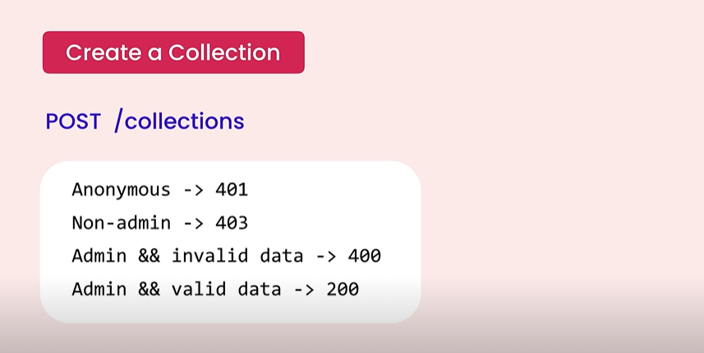

Tooling:
- Test frameworks gives us an structure for writing tests as well as program to give us the test report.

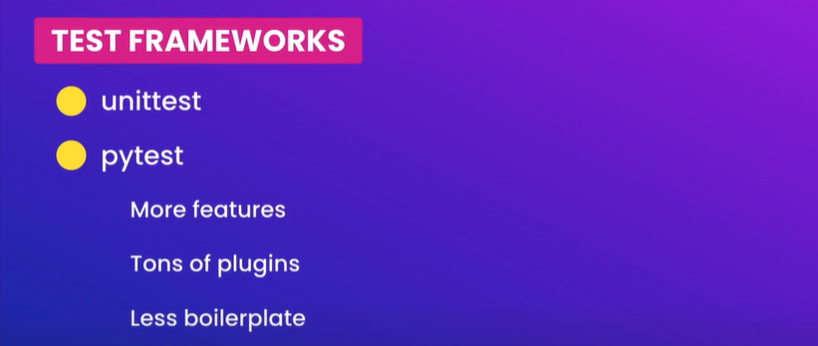

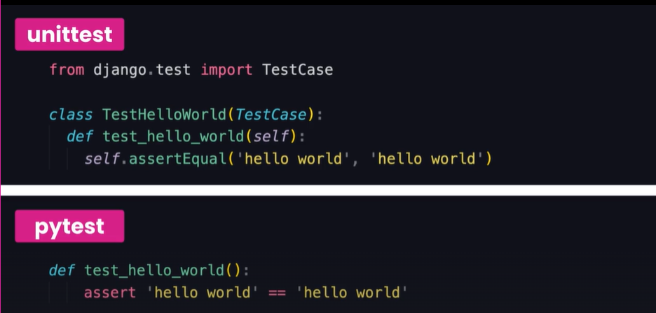
Side by side comparison of unit test and pytest:
- To install the above testing frameworks, we use the below commands
  - pipenv install –dev pytest
  - pipenv install –dev pytest-django

writing our first tests:
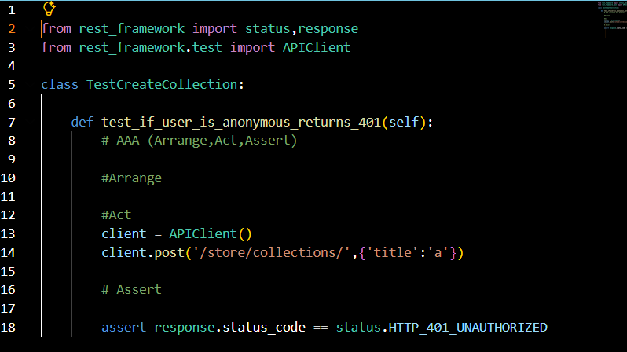
Running tests:
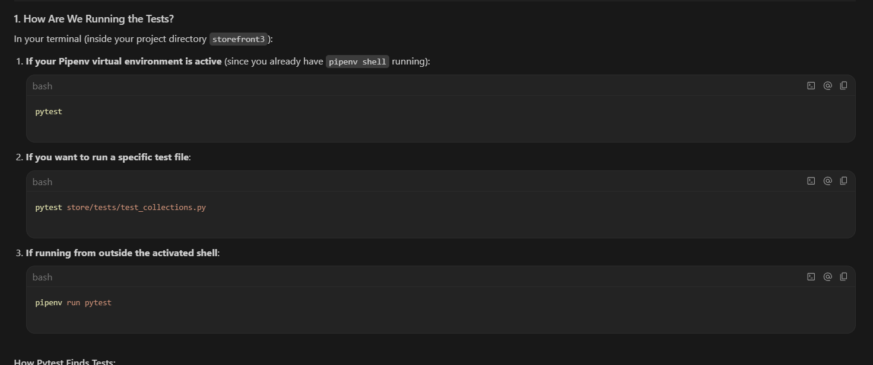
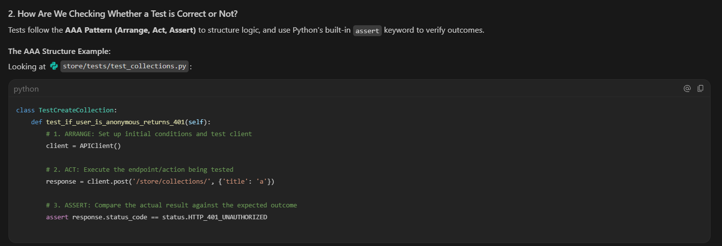
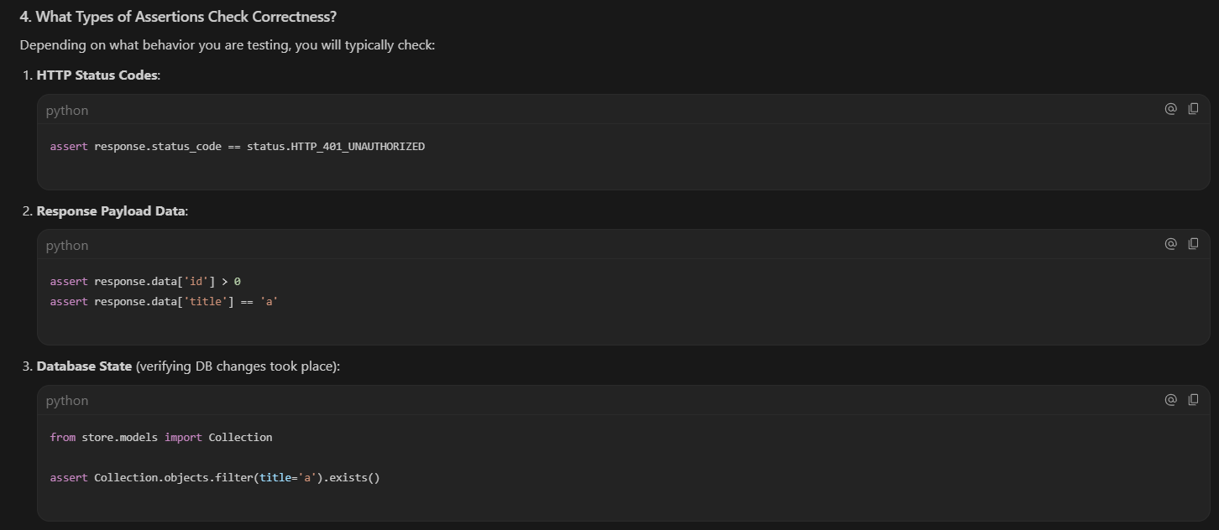
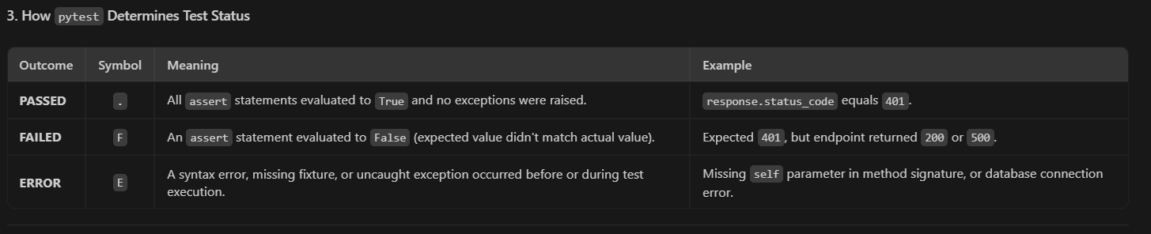

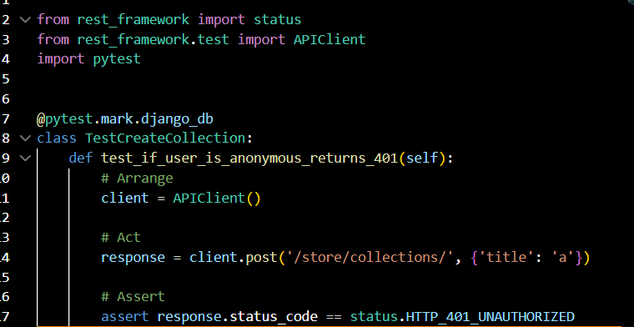
Skipping tests:
- When we get some failed test but we are at the middle of something and fixing those failed things takes time then we can skip the test by adding the below decorator

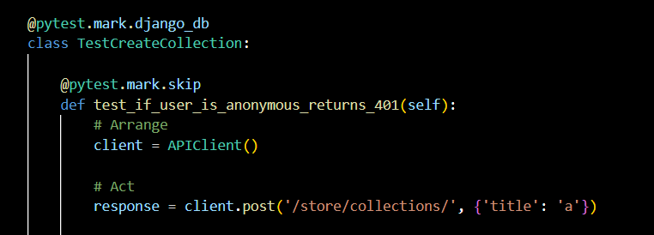
  - @pytest..mark.skip

Continuous testing:
- There are two ways to run our tests:
  - We can run them on demand before deploying
  - We can run the test all time. continuous tests
To run the continuous testing we need to install the plugin called watch
- pipenv install –dev pytest-watch
- to the continuous test we run simple the below command
  - ptw
- it tests out code every time we change it

Running and debugging tests in the VS code:

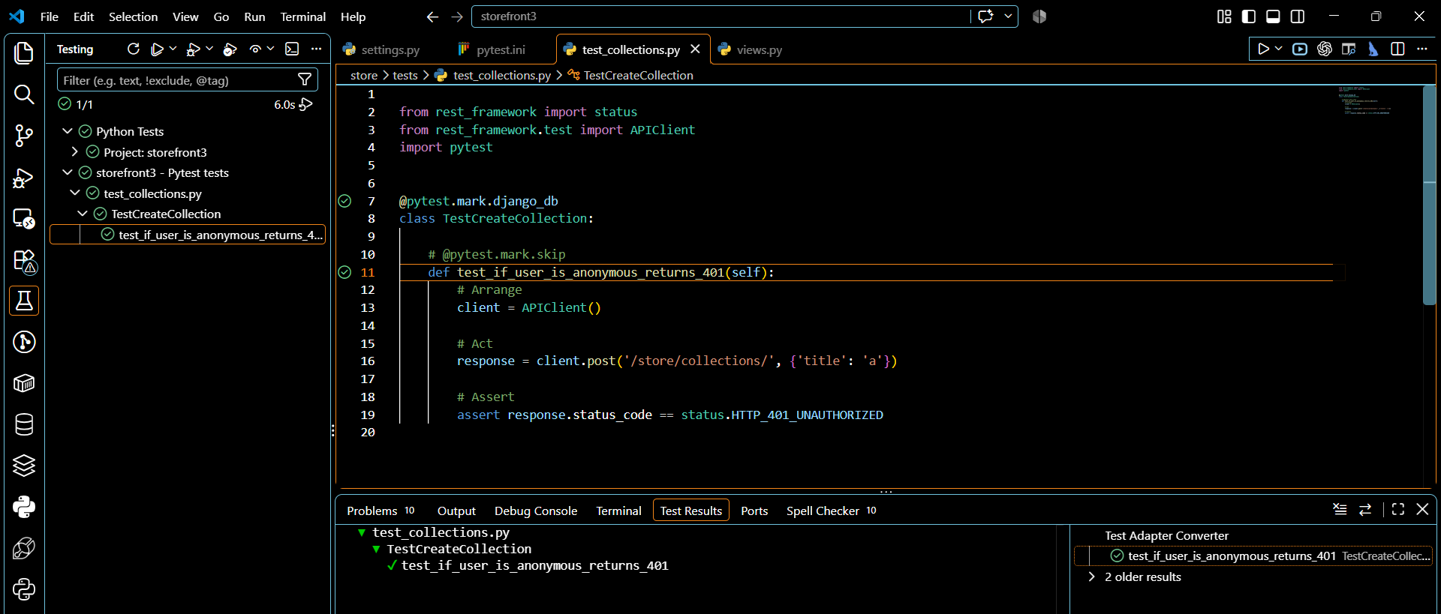
Authenticating the user:
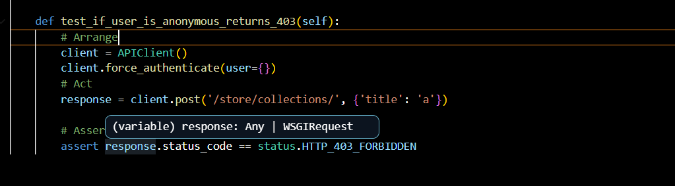
- To authenticate the user we will use the method called
  - client.fore_authenticate(user={})

Single or multiple assretions:

- But is doesn’t mean that test should have single assert statements
- Tests should not be coupled to the implementations
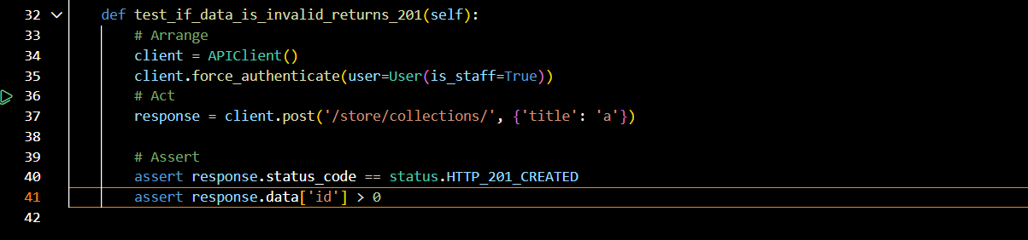
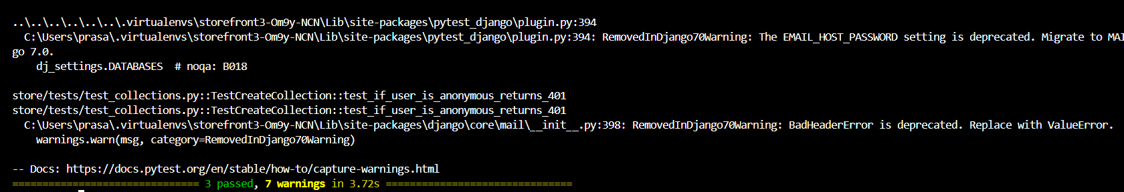
Fixtures:
- Using fixtures we can remove the duplicates in our code.

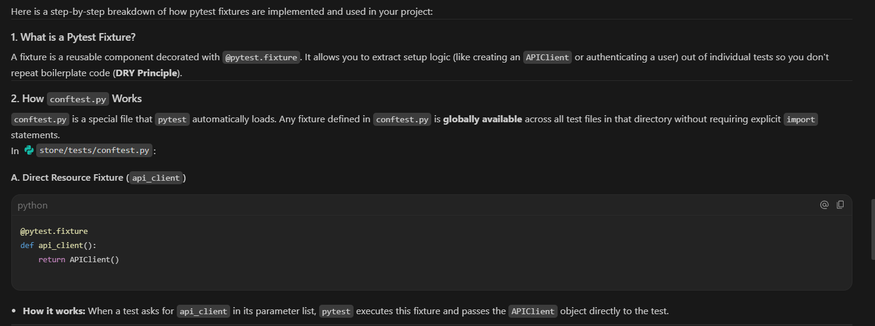
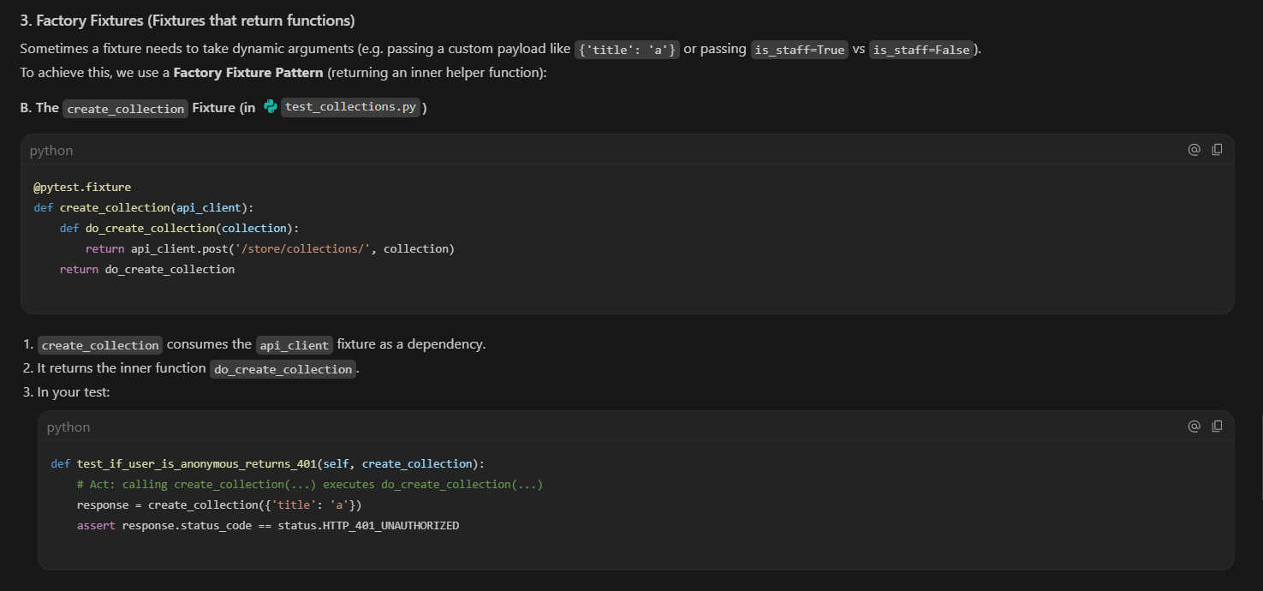
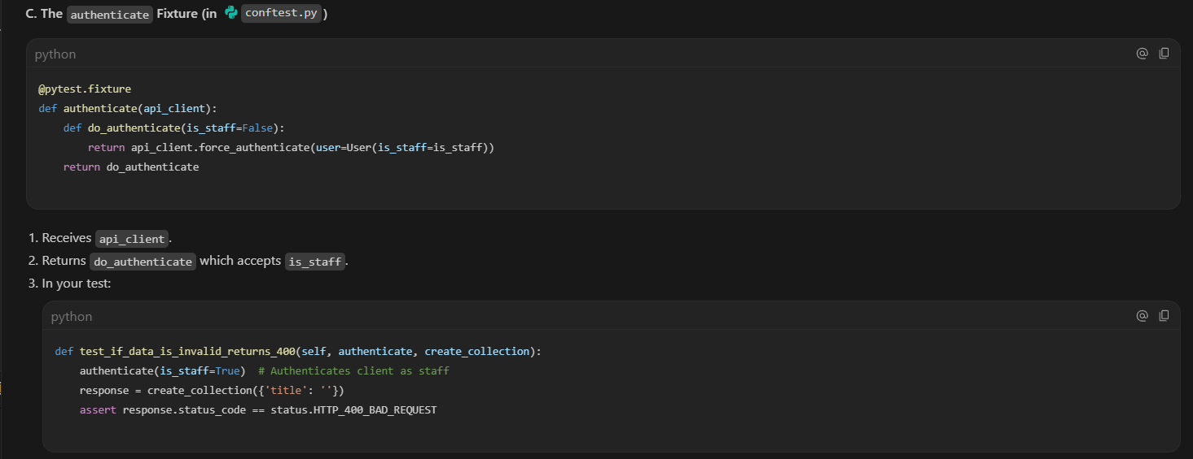
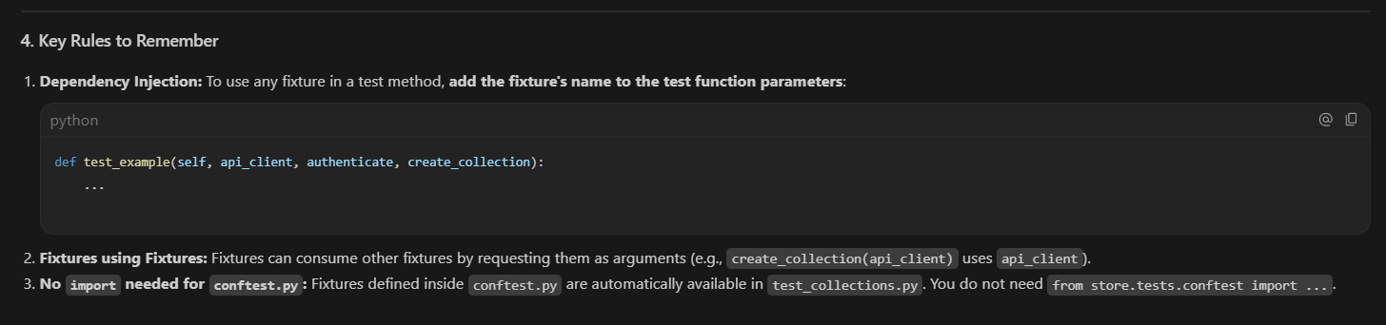

Creating Model instances:
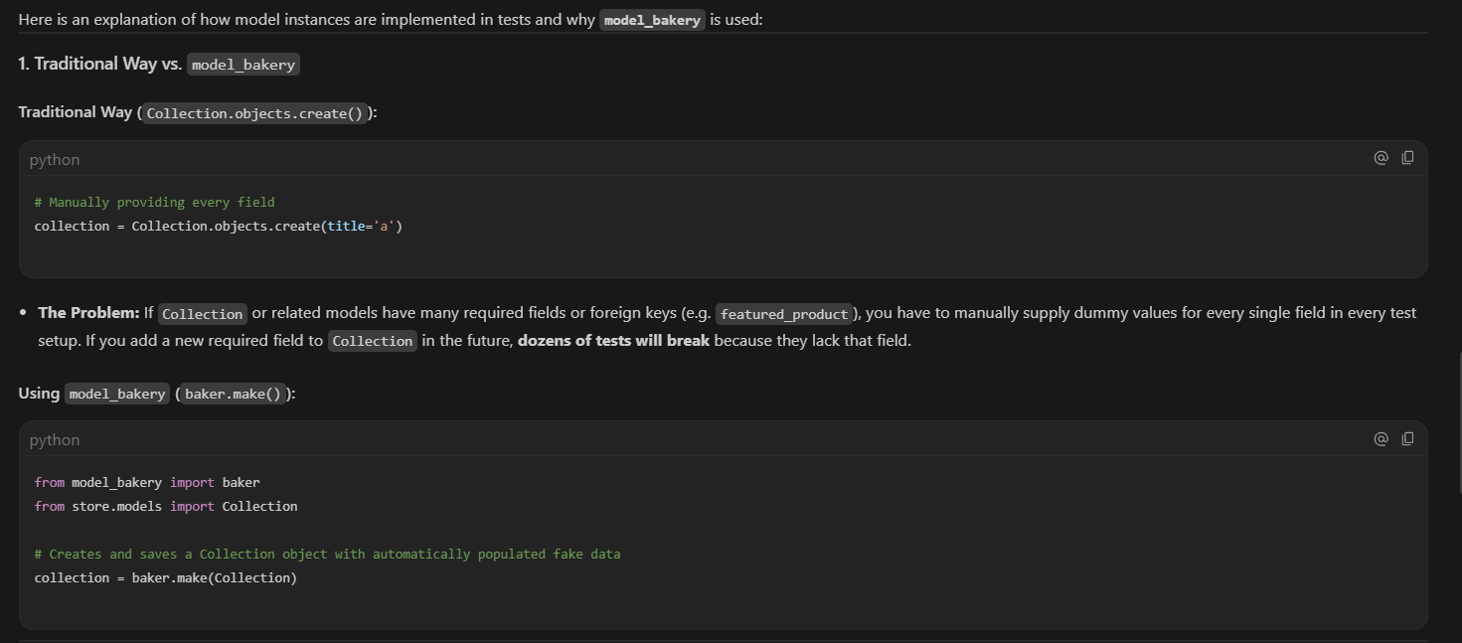

Performance testing:
Performance testing is essential because it evaluates an application's speed, stability, scalability, and reliability under expected and peak workloads, preventing costly production failures.
Key Reasons Why Performance Testing Matters
- Identifies Bottlenecks: It uncovers hidden issues like slow database queries, memory leaks, and network congestion before users encounter them.
- Improves User Experience: Fast load times and responsive interfaces keep users engaged and satisfied, lowering bounce rates.
- Protects Revenue and Conversions: Reliable performance during high-traffic events (such as major sales or product launches) prevents application crashes and direct financial losses.
- Ensures Scalability: It confirms whether a system can handle a growing user base or increased data volume without performance degradation.
- Saves Costs: Detecting and fixing performance flaws early in the development lifecycle is significantly cheaper than resolving emergency failures in a live production environment.
Installing Locust:
- Locust is the performance testing tool used to perform the performance testing.
- To install it we use the below command
  - pipenv install –-dev locust
Creating test scripts :
Core usecases:
- Browse Products
- Register , sign in, sign out
Running testscripts:
To execute the test scripts we use the below command
- locust -f locustfiles/browse_products.py
Running perfomence tests:
We create a bug and see how it recats to the perfomence test.
Perfomence Optimization:

Profiling with silk:
- Most od the time the issue lies in the query or in the database.
- To identify where exactly the problem is we use the toll called Django-silk

Verifying the Optimizations:
After implementing the optimization techniques we need to compare the performance testing again from previous implementations to optimized implementations.
Stress testing:
Stress testing is a specific subset of performance testing that evaluates how a software system behaves under extreme workloads that exceed its normal or anticipated operating capacity. While standard performance testing checks if a system works correctly under expected conditions, stress testing deliberately pushes the application past its breaking point to see how it fails and how gracefully it recovers. [1, 2, 3]
Core Objectives
- Find the Breaking Point: Identify the exact threshold where the system slows down, errors out, or crashes entirely. [1, 2]
- Evaluate Robustness: Check if the system handles extreme traffic spikes or resource limitations without corrupting data. [1, 2]
- Test Recovery Capabilities: Determine if the system can automatically recover and return to a normal state once the heavy workload subsides. [1, 2]
- Expose Hidden Vulnerabilities: Uncover memory leaks, data synchronization issues, and error-handling bugs that do not appear under normal usage. [1, 2]
Caching:
Caching is the process of storing a temporary copy of frequently accessed data in a fast-access storage layer so future requests for that data can be served faster. [1, 2]
How Caching Works
- Cache Hit: When requested data is found in the cache, allowing the system to return it instantly without querying a slower primary database or recomputing it.
- Cache Miss: When requested data is not in the cache, forcing the system to fetch it from the primary source, then save a copy in the cache for next time.
- Eviction / Invalidation: The process of removing or updating old data in the cache so users do not see outdated or stale information.
Cache backends
- Local Memory
- Memcached
- Redis
- Database
- File System
Simulating slow api’s:
Getting baseline performance bench mark :
Installing redis:

Configuring caching:

Using low level cache api:
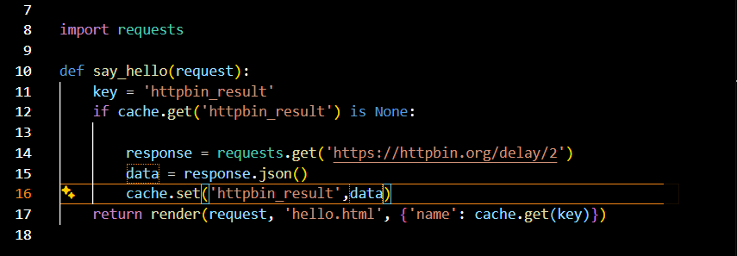
Caching views:
Instead of caching in the above way we can use the decorator to reduce the reusability of the code.
To do that first we need to import Django.views.decorators.cache import cache_page

