2403a51254

Laxmi prasanna

Batch 11

**AI-ASSISTED-CODING**

**Assignment-5.4**

**Task Description #1:**  
• Prompt GitHub Copilot to generate a Python script that collects user data (e.g., name, age,  
email).

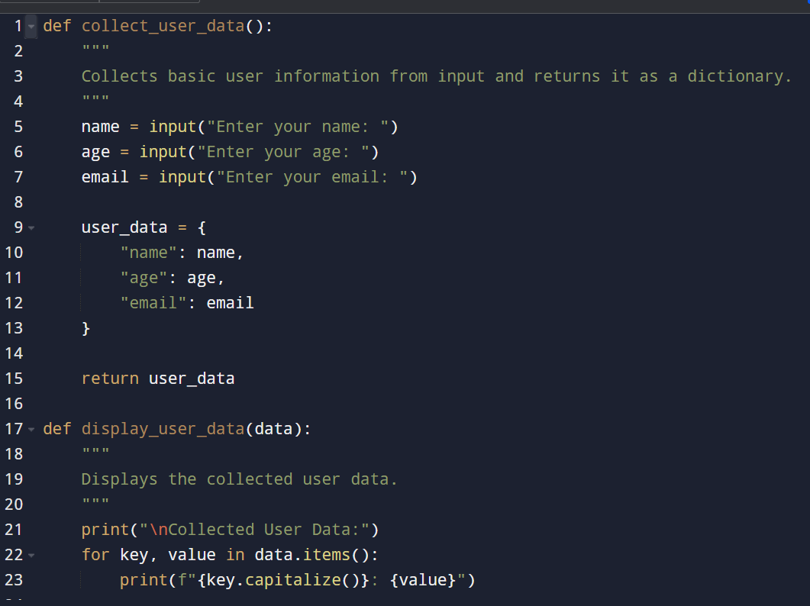

Then, ask Copilot to add comments on how to anonymize or protect this data.

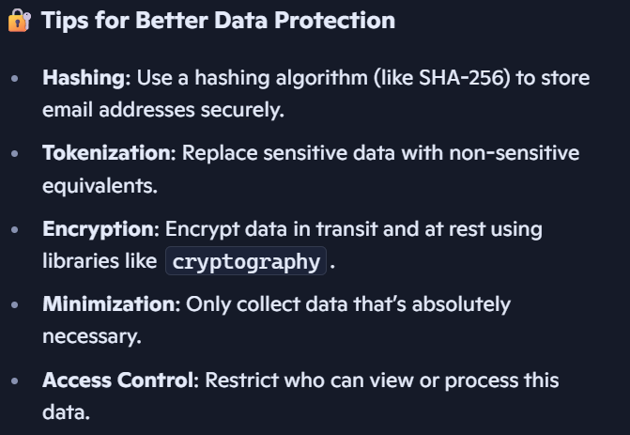

**Task Description #2:**• Ask Copilot to generate a Python function for sentiment analysis. Then prompt Copilot to  
identify and handle potential biases in the data

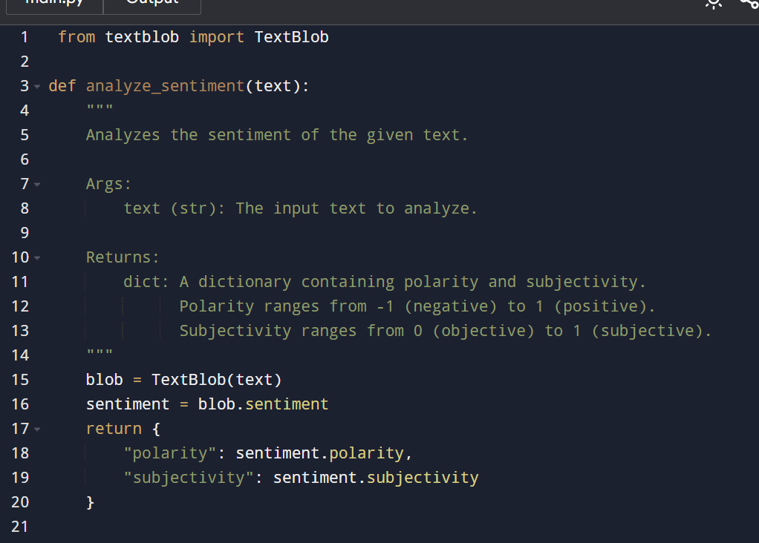

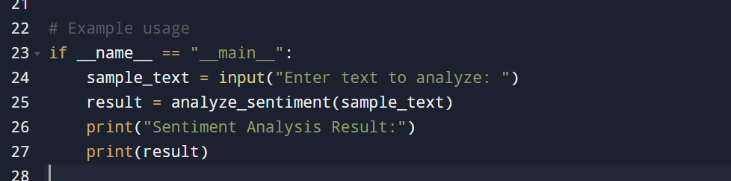

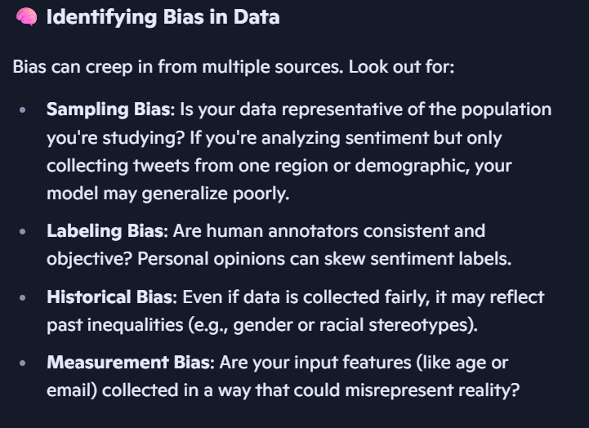

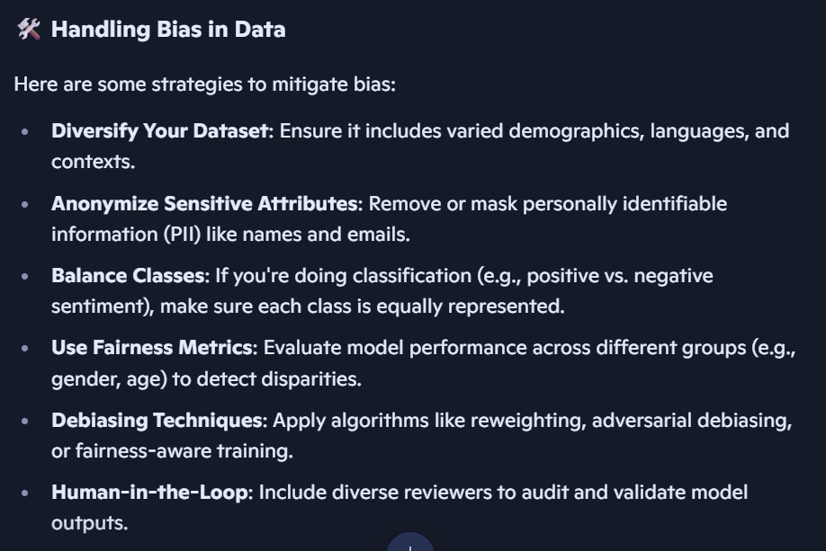

**Task Description #4:**  
• Prompt Copilot to generate logging functionality in a Python web application.

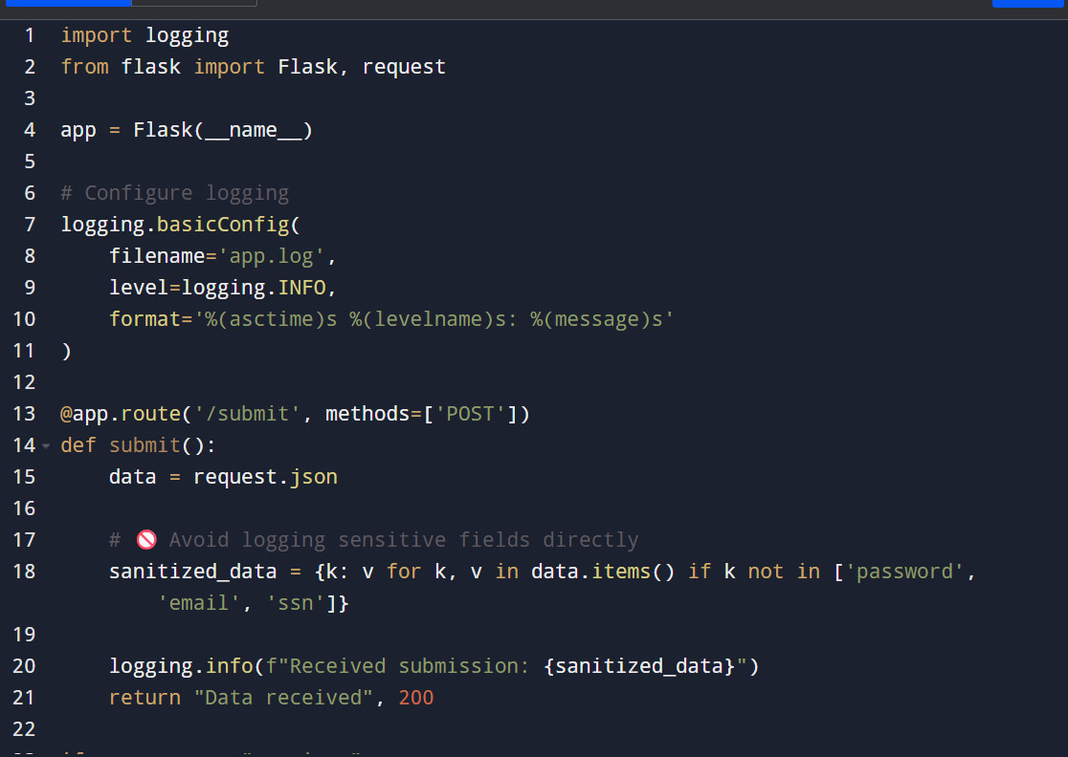

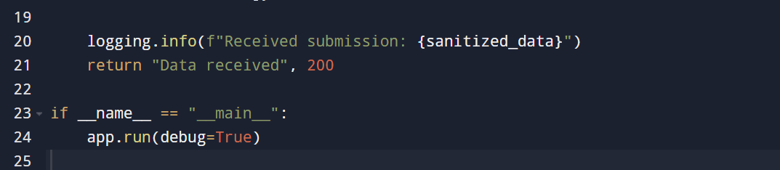

Then, ask it to ensure the logs do not record sensitive information.

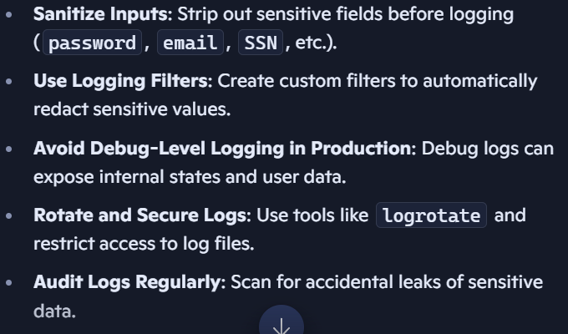

**Task Description #4:**  
• Prompt Copilot to generate logging functionality in a Python web application.

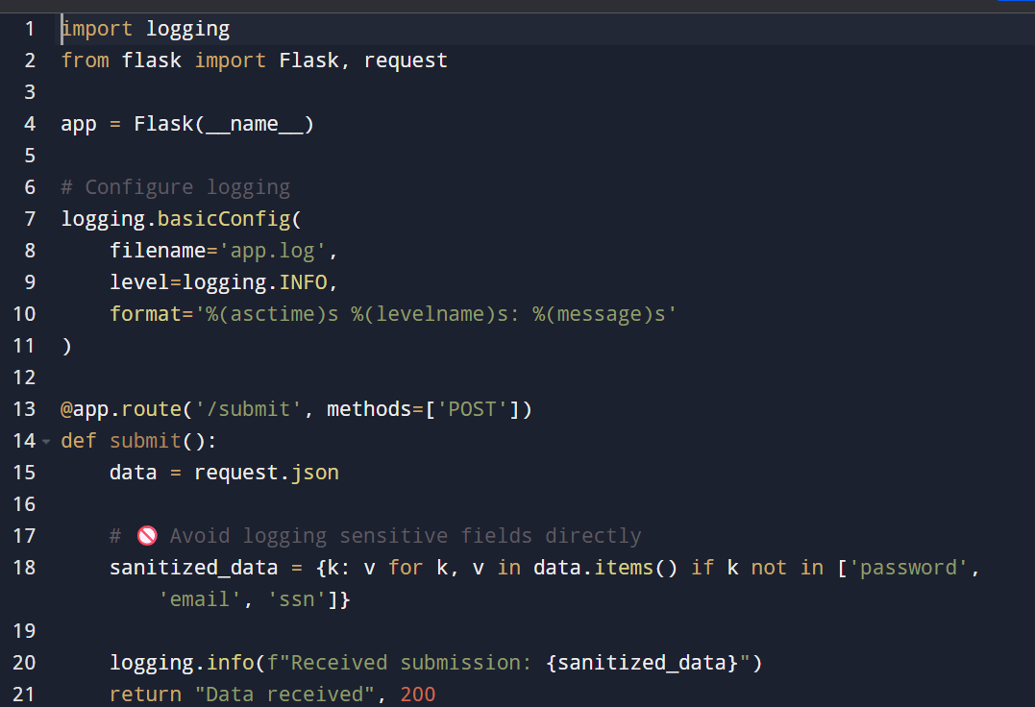

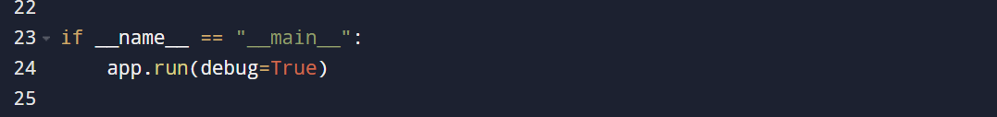

Then, ask it to ensure the logs do not record sensitive information.

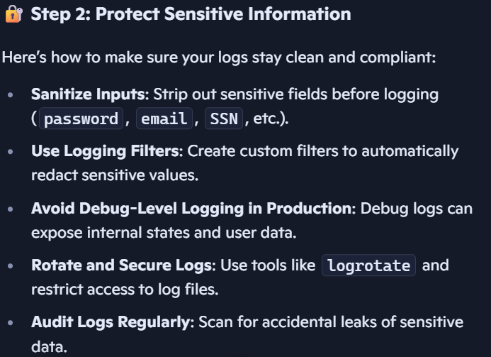

**Task Description #5:**• Ask Copilot to generate a machine learning model.

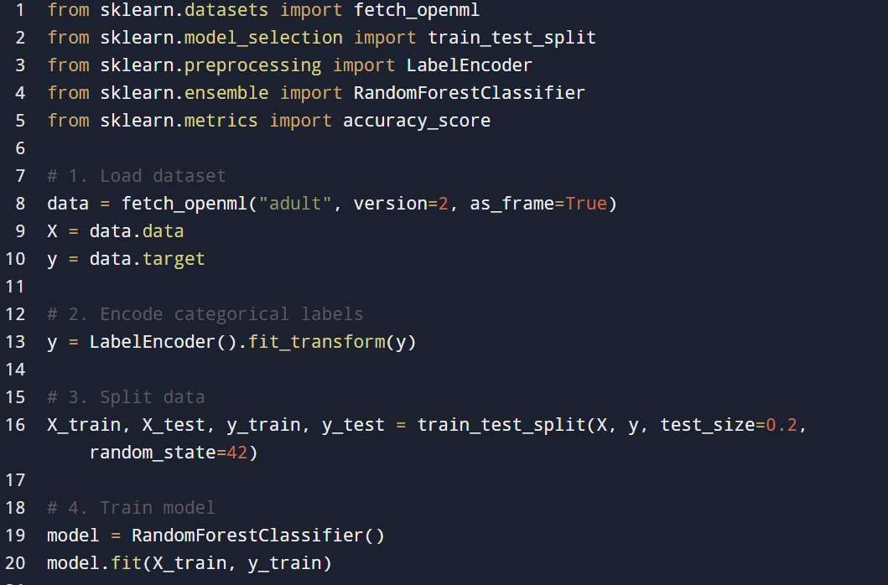

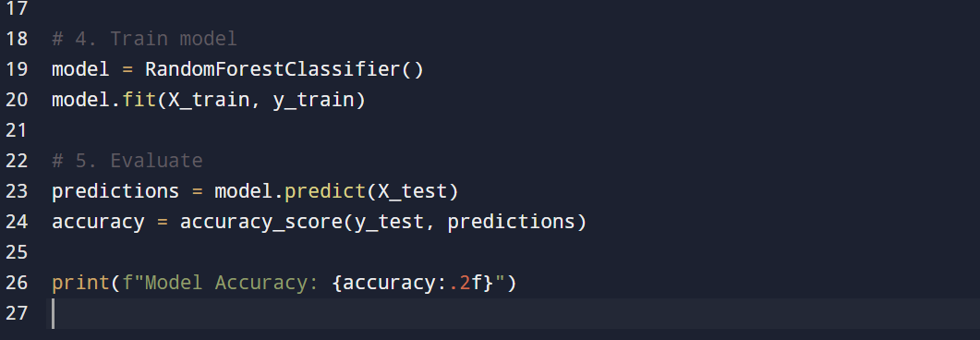

Then, prompt it to add documentation on how to use the model responsibly (e.g., explainability, accuracy limits)

