Mandatory Task 1: Register on FutureSkills Prime (FSP)

Step 1: Create an account on FutureSkills Prime
https://www.futureskillsprime.in/

Step 2: Log in to your account

Step 3: Enroll in the course:
Digital Application Fundamentals (STEM)
https://www.futureskillsprime.in/journey/daf-stem/

For quick guidance, refer to this video:
https://www.youtube.com/watch?v=hskRDGntFTw

Note: Registration on the FSP platform is mandatory for participation in this program.

━━━━━━━━━━━━━━━━━━━━━━

Mandatory Task 2: Create Your ServiceNow (SNU) Learning Account

Please create your SNU account using the link below:

SNU Account Creation Link:
https://learning.servicenow.com/now/lxp/home

For step-by-step guidance, refer to this document:
https://skillwalletapp.s3.ap-south-1.amazonaws.com/ServiceNow+Nowlearning+Account+Creation+%26+Enrollment.pdf

Note: SNU account creation is mandatory to participate in the technical training and project activities.

━━━━━━━━━━━━━━━━━━━━━━

Mandatory Task 3: Complete the Gen AI Beginner Lab

Beginner Lab Link:
https://www.cloudskillsboost.google/paths/118

👉 https://www.youtube.com/watch?v=hskRDGntFTw

Note: Registration on the FSP platform is mandatory for participation in this program
Mandatory Course:
Mandatory for All Tracks*

FSP Registration: https://www.futureskillsprime.in/
SNU Account Creation: https://learning.servicenow.com/now/lxp/home
Gen AI Beginner Lab: https://www.cloudskillsboost.google/paths/118
APSCHE Gen AI Form: https://forms.gle/c6uftHssuoxrciDfA
Salesforce Agentblazer Champion: https://trailhead.salesforce.com/content/learn/trails/become-an-agentblazer-champion-2026
Trailhead URL Collection Form: https://forms.gle/g5xjeBFTDvUQjmxo8

- FSP Registration
- SNU Account Creation
- Gen AI Beginner Lab

What customer wants:
- Quality Products and Services
- Customer Service
- Value for Money
- Transparency and Honesty

Data Visualization : Its Graphical representation of Data using visual Element i.e Chart, Graph and Maps
Need:
Simplifies Complexity:
Identity Patterns
Supports Decision Making

Data Analytics is the practice of utilizing data, statistical methods, and technology to extract meaningful insights and make decisions accordingly.

Data Analytics Process:
- Define Problem
- Data Collection: Gather Relevant data
- Data Cleaning: Prepare the data for analysis by removing inaccuracy and Inconsistencies
- Data Processing: Transform raw data into a format suitable for analysis
- Data analysis: apply statistical methods to extract insights from the data
- Interpretation: Translate the results into actionable insights
- Communication: Present the insights and recommendations to stakeholders

Types of Analytics:
- Descriptive Analytics- What happened?
- Diagnostic Analytics: Why did it Happened?
- Predictive Analytics: What is Likely to happen?
- Prescriptive Analytics: What should we do?

Difference between Bi Tools and Excel
- Scalability
- Data Integration
- Analytics
- Visualization and Dashboards

Tableau was founded in 2003 but it was acquired by salesforce in 2019
Tableau Products:
- Tableau Desktop
- Tableau Prep
- Tableau Server
- Tableau Public
- Tableau Online

Till Feb 2025, Tableau Desktop Professional Edition to student free for 1 Year
Tableau Prep

Tableau Desktop Public Edition for Students:

Tableau Prep Builder
Tableau Prep: https://www.tableau.com/products/prep/download

Dataset Link: https://help.tableau.com/current/prep/en-us/prep_get_started.htm

In Order Central
Region Field is Missing,Separate columns for date, year and month in Orders and Ship, Data type of Discounts

In West- State with abbreviated values

In East- sales as prefix of USD

Central:
Calculated Field 1
Name- region
Expression- “Central”

Calculated Filed 2
Name- Order Date
Expression-MAKEDATE([Order Year],[Order Month],[Order Day])

Calculated Field 3
Name- Ship Date
Expression-MAKEDATE([Ship Year],[Ship Month],[Ship Day])

Remove Fields- Order Year, Order Month, Order Day, Ship Year, Ship Month, Ship Day

Discount- replace None with 0 and Change Data type to Number Decimal

West- Renames all States

East- Removed prefix from sales
Click on Sales> Clean>Remove Letters

Import Return Reason table and remove unwanted fields

Splitted Notes Column to Notes and Approver Name

In Approver name > Group Values > Common Characters

Join Operation between Orders and Returns table through Left Join
Based on Order Id and Product Id

Removed Order Id-1 and Product Id-1

Name- Returned:
Expression:
If ISNULL([Return Reason]) then "No"
else "Yes"
End

Days to Ship
DATEDIFF('day',[Order Date],[Ship Date])

Extract as output

In Sample Superstore 2024
Orders
People
Returns

Orders

Text/categorical fields
ShipMode- First Class, Same Day, Second Class and Standard Class
Segment- Consumer , Corporate and Home Office
Country- Canada and US
Region- Central, East, South and West
Category- Furniture, Office Supply and technology
Sub- Categories-17- Paper, Binders, Labels, Chair, Arts etc
Product Name-

Product> Sub-Category> Category

Numerical Fields
Sales, Quantity, Discount and Profit

Count vs Count Distinct
Sum, Avg, max, Mean

As we load data in tableau, tableau automatically assigns role and type to each field

Type- Data Type
Role- Dimension and Measure

Qualitative Data
Describe Qualities, Characteristics, Categories
Cannot Perform Calculations like Sum, Average or Max

Ex: Student Name, Gender, Blood Group

Quantitative Data
Numerical Data
Counted or Measured using Numbers
Ex: Age, Marks, Height

Dimension are denoted with Blue Color Pills
Measure are denoted with Green Color Pills

Tableau Autogenerates 1 Dimension and 4 Measure

Sales, Quantity, Discount

Revenue= Sales *Quantity-Discount

Data Visualization:
Univariate Analysis
Bivariate Analysis
Multivariate Analysis

Bar Chart
Average Sales by Different Sub Categories

C- Sub Category
R- Avg(Sales)
Col- Sub-Category

Stack Bar Chart
Sales By Segment for Different Categories:
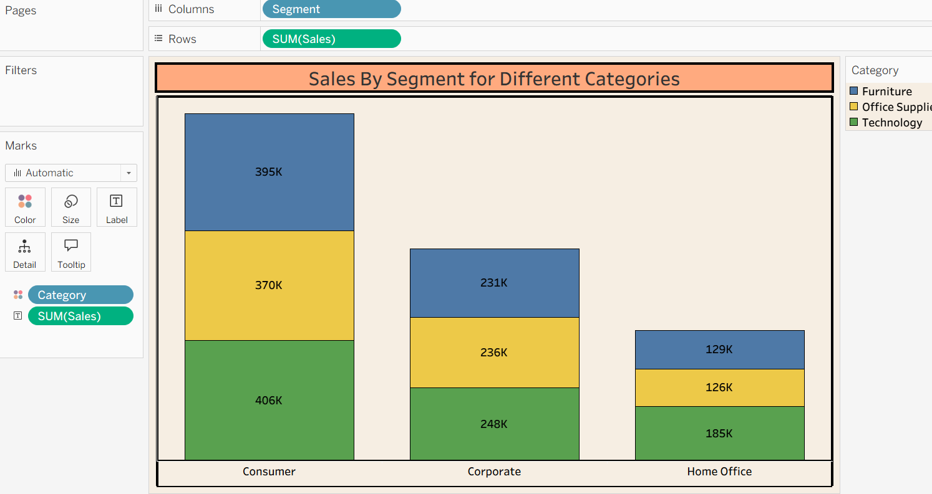

Side By Side Bar Chart
Revenue by Ship Mode For different Category
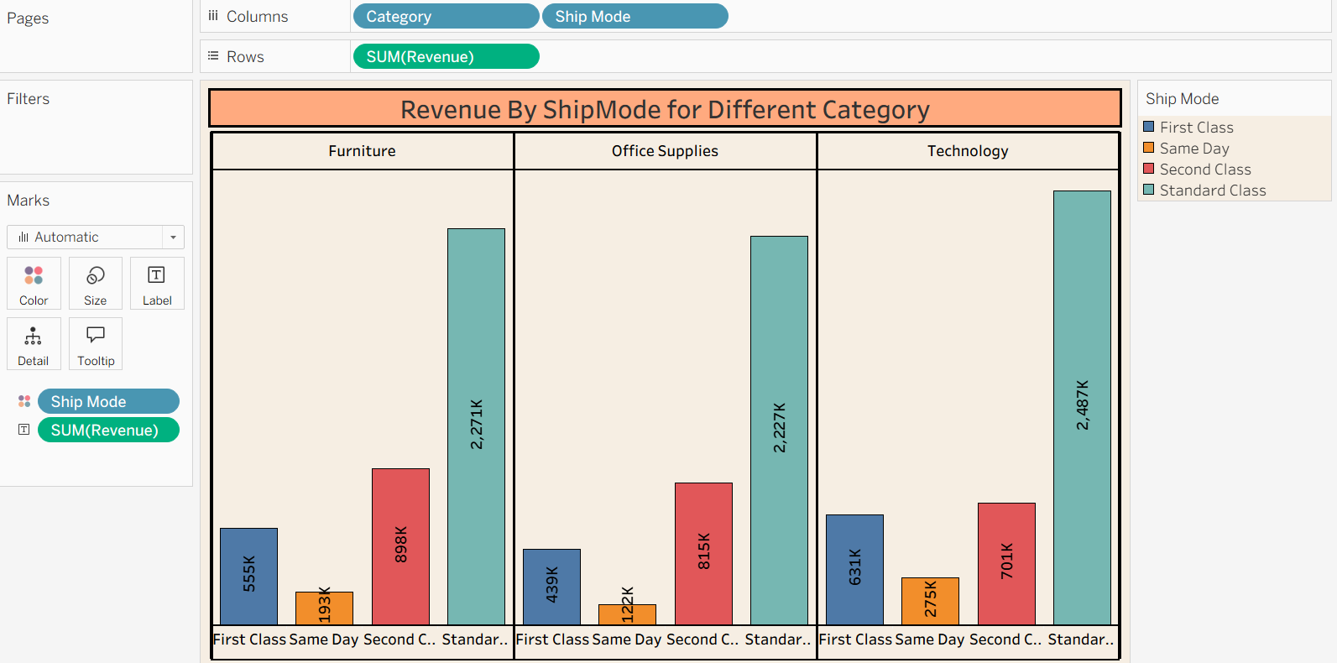

Line Chart
Month wise Revenue

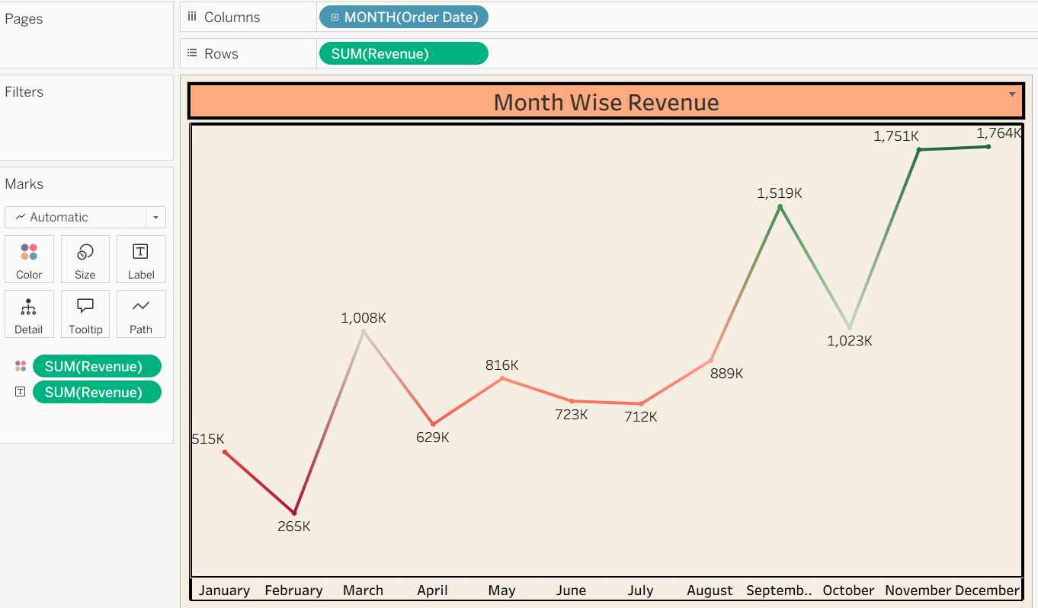

Line Chart

Month wise Profit
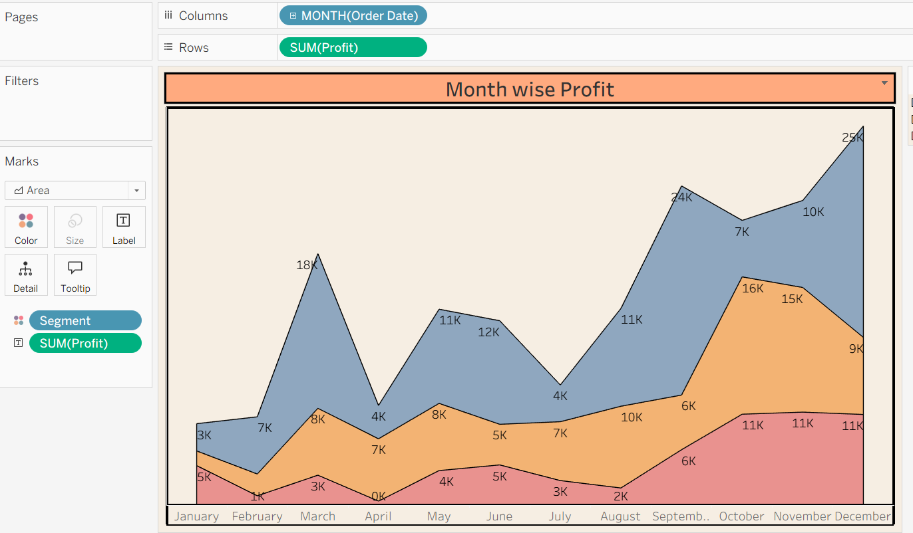

Pie Chart
Region wise Profit
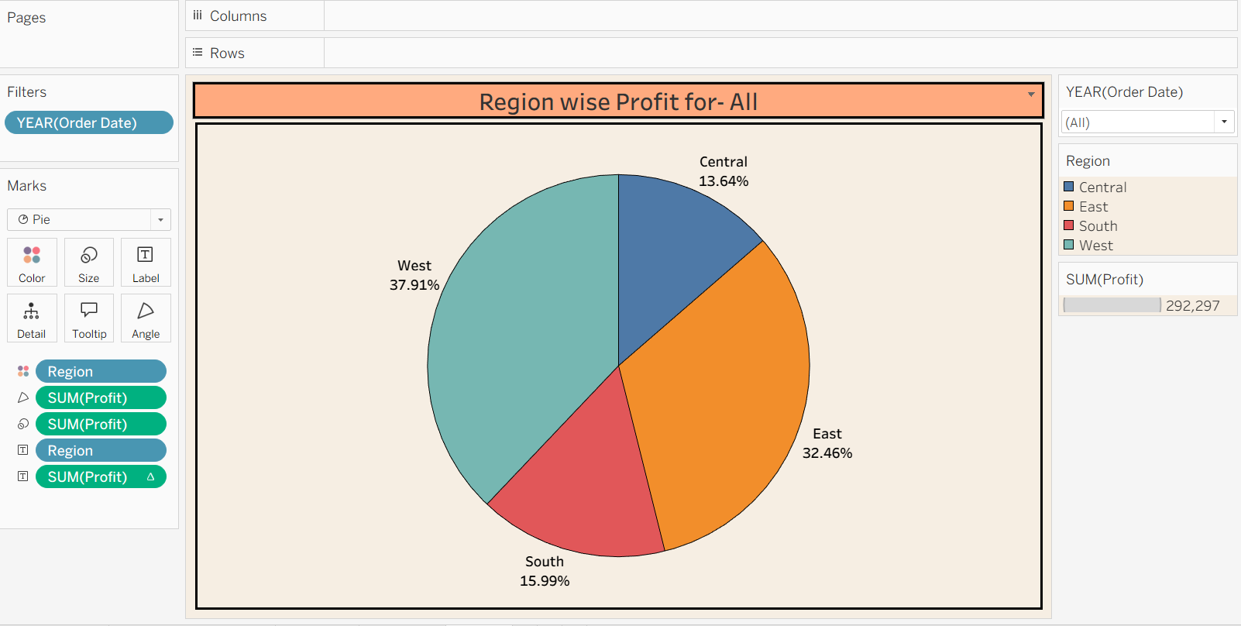

Box Plot:
Ref Link: https://help.tableau.com/current/pro/desktop/en-us/buildexamples_boxplot.htm
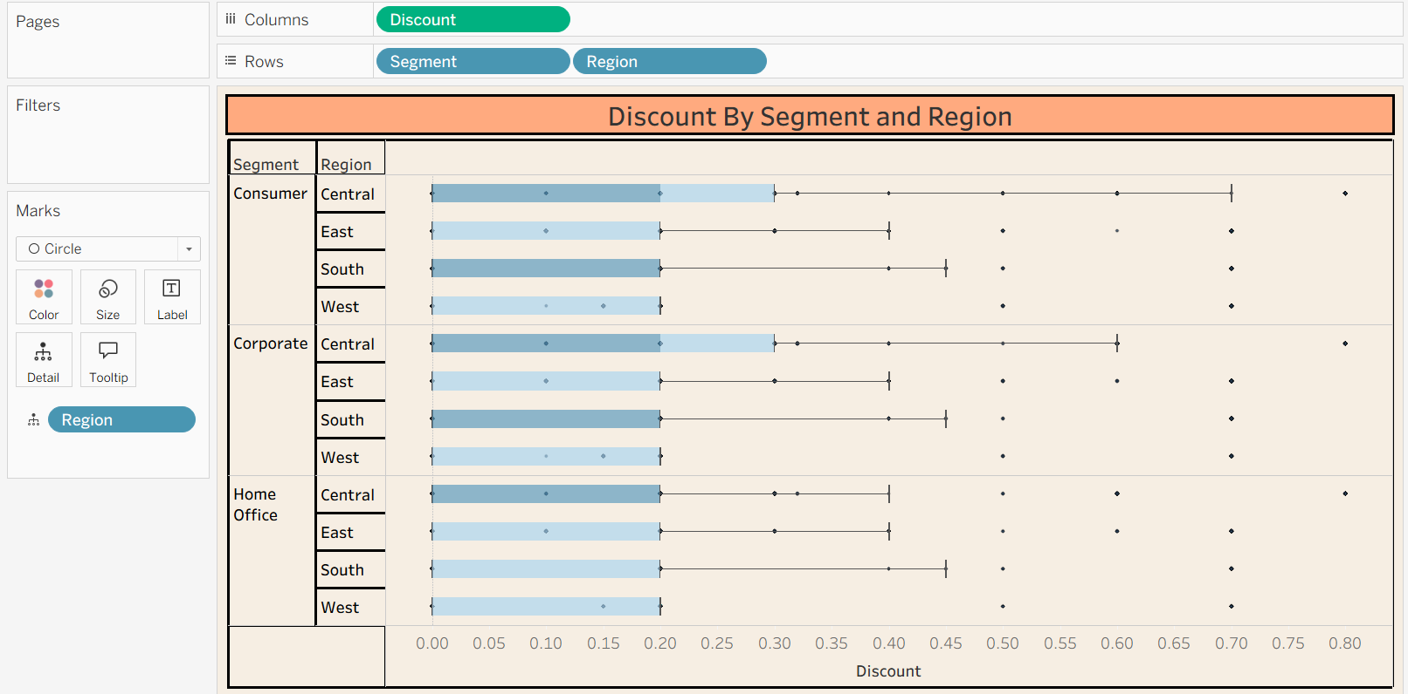

Histogram
https://help.tableau.com/current/pro/desktop/en-us/buildexamples_histogram.htm
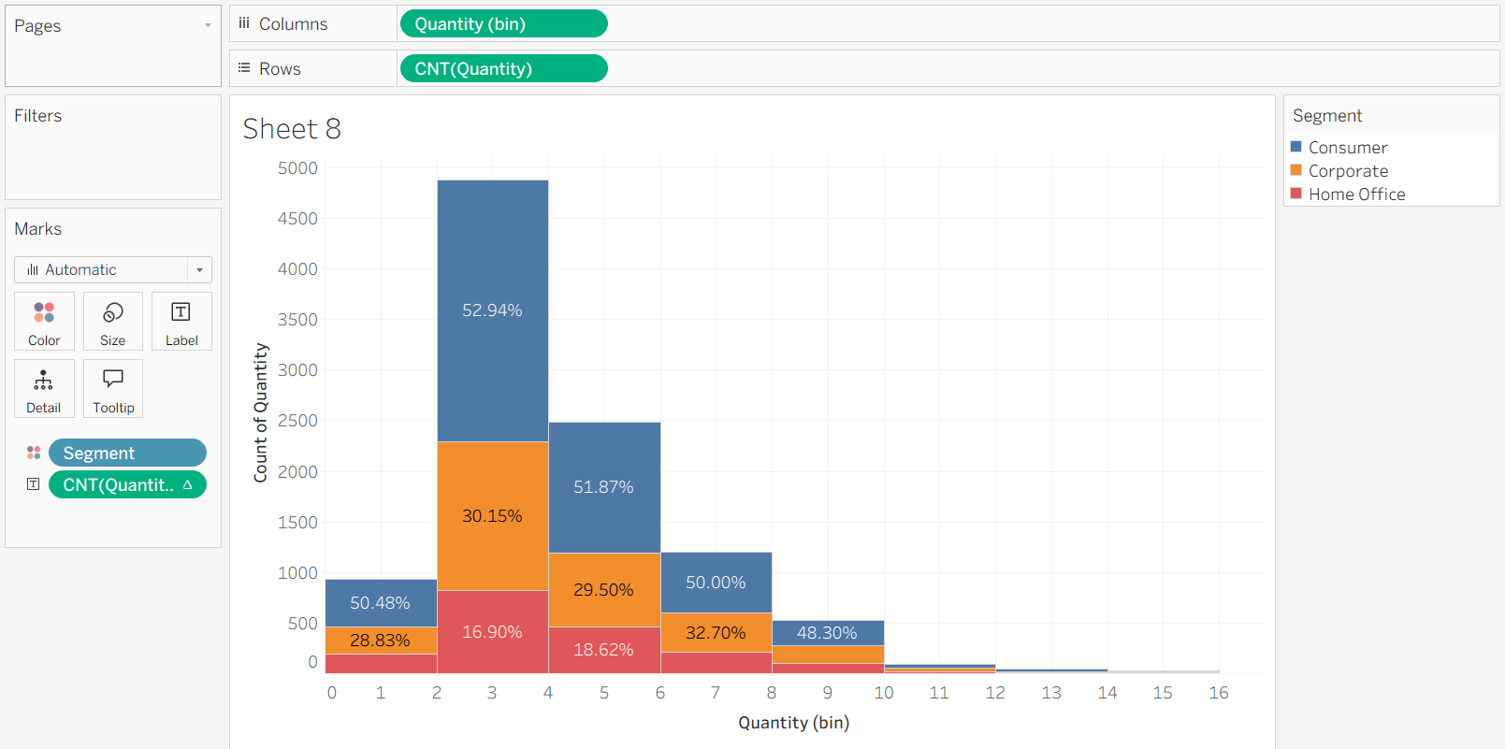

Tree Map
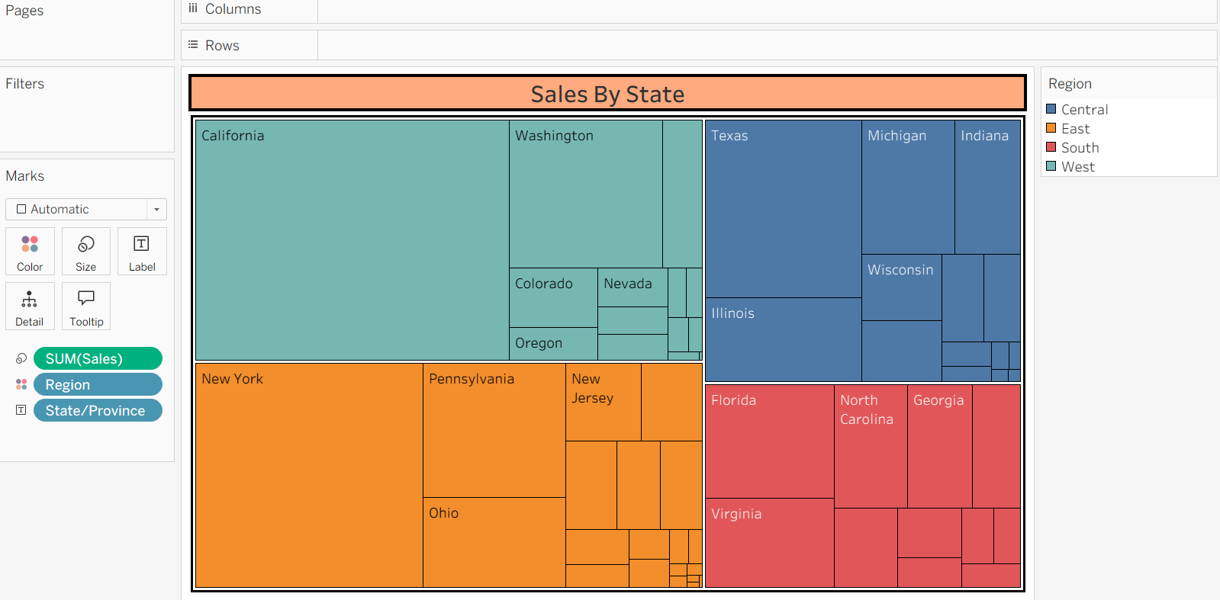

Scatter Plot
https://help.tableau.com/current/pro/desktop/en-us/buildexamples_scatter.htm
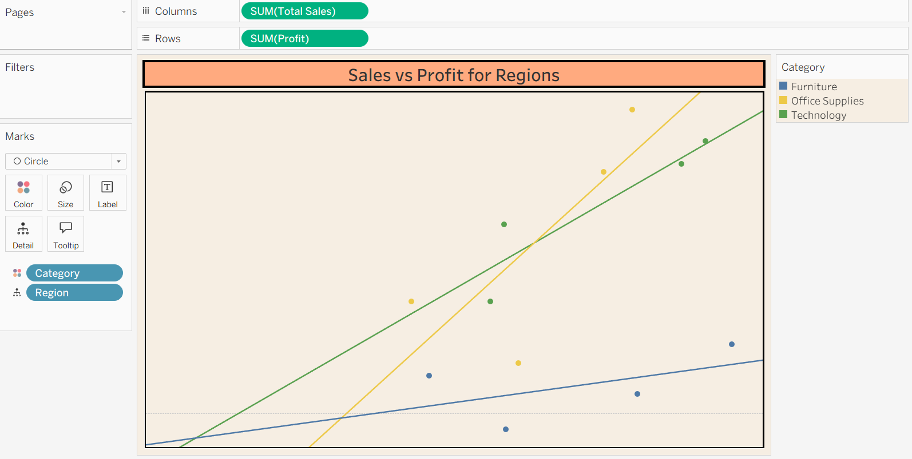

Highlight Table
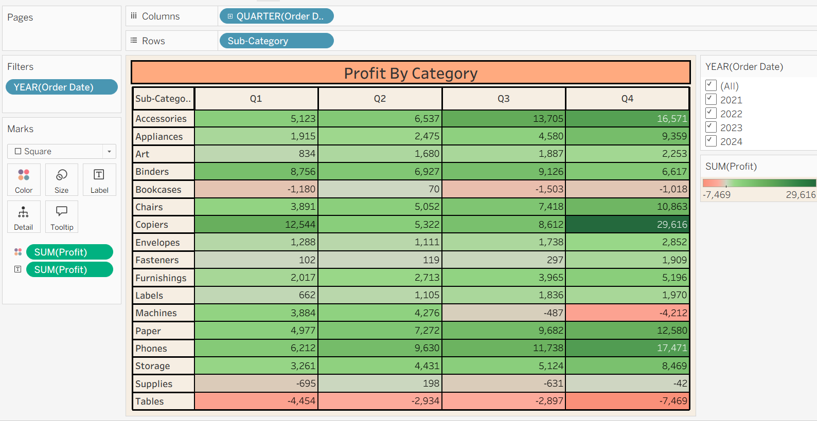

Text table
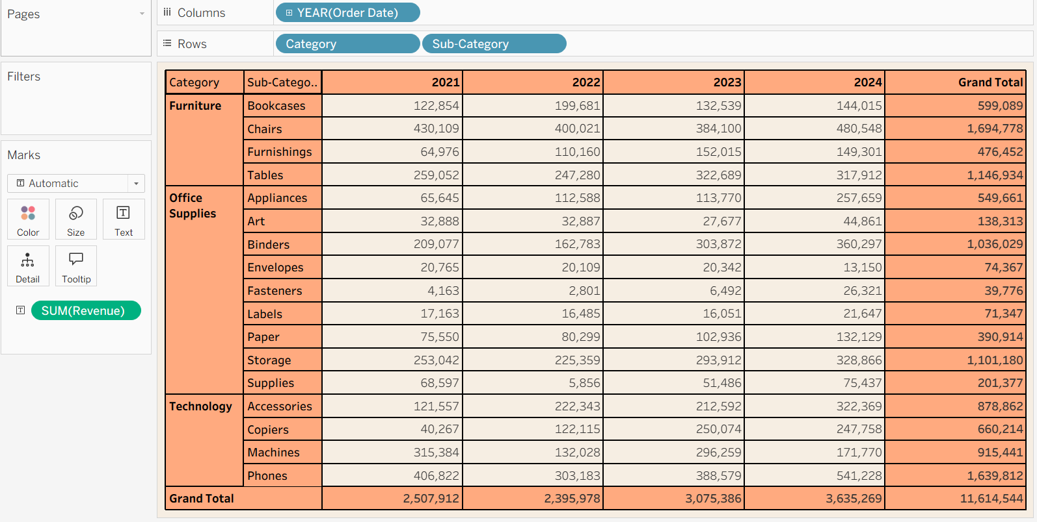

Heat Map
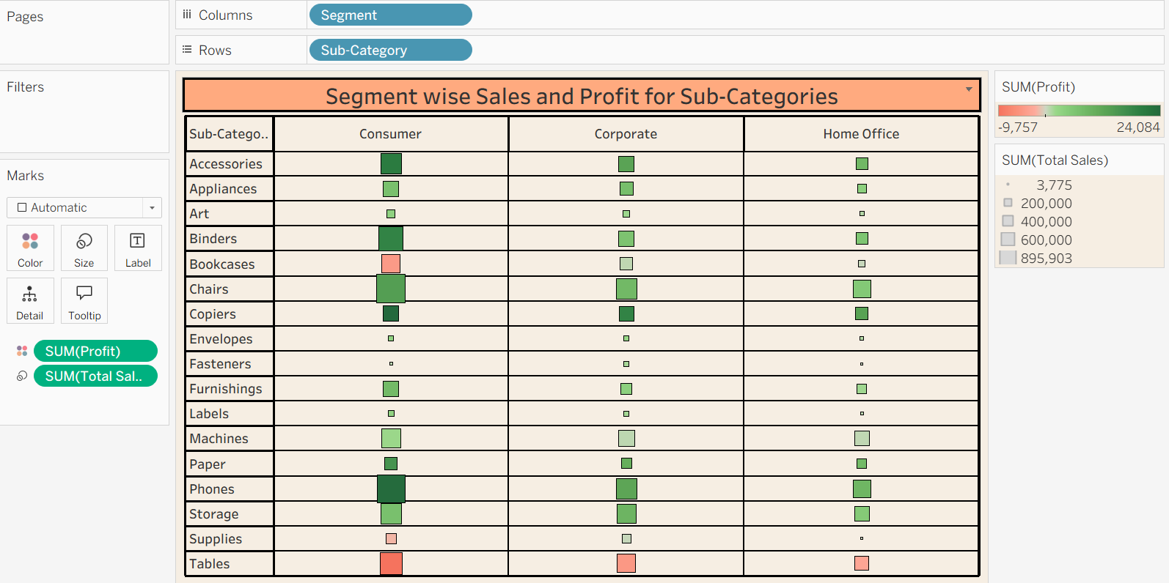

Bullet Chart
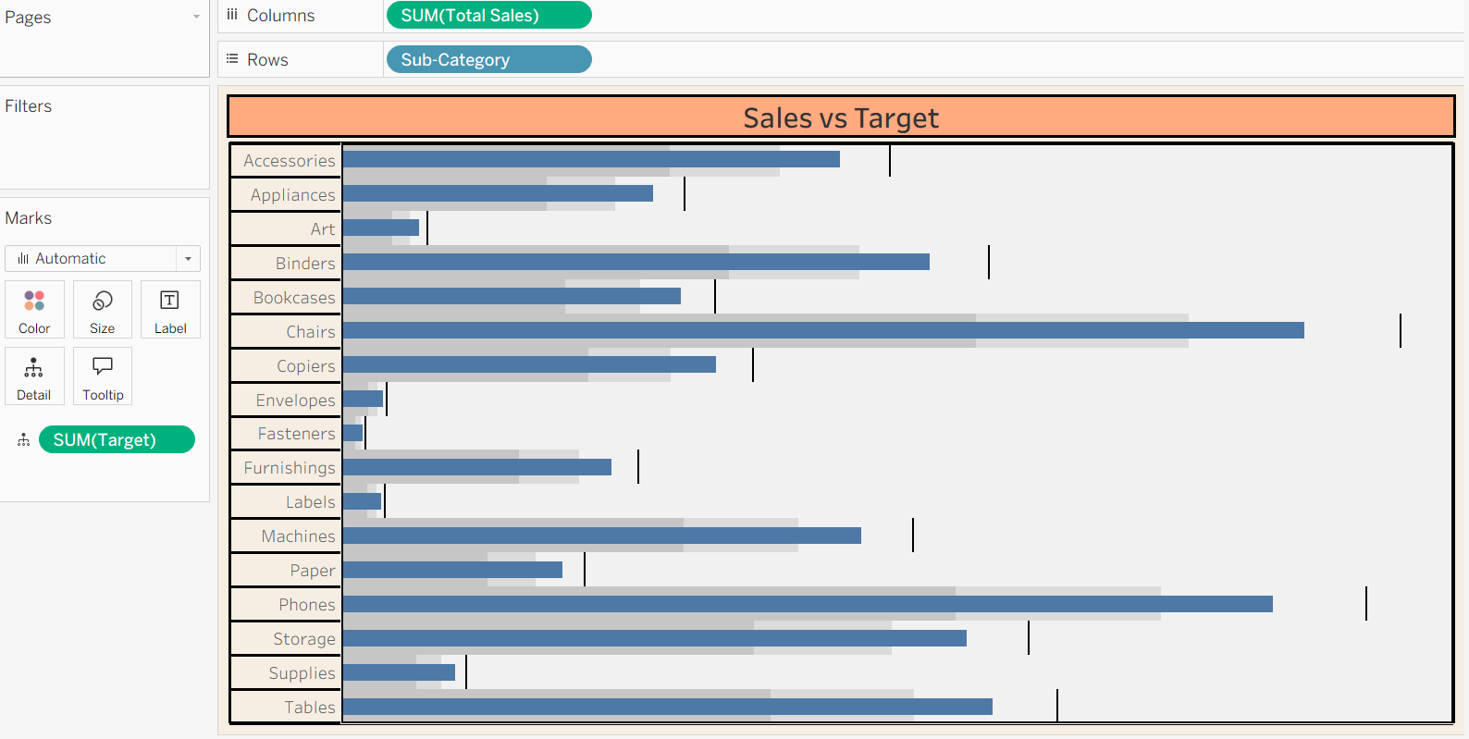

Donut Chart

Revenue By Segment

Create Pie Chart with Column as Segment and Rows as Sales
In Rows type Avg(0) and Hit enter, Repeat it one more time
Remove all the pills from 2nd Agg Avg(0) in Marks Section

Go To second Agg Avg(0) in rows> Click on Drop down and select dual axis
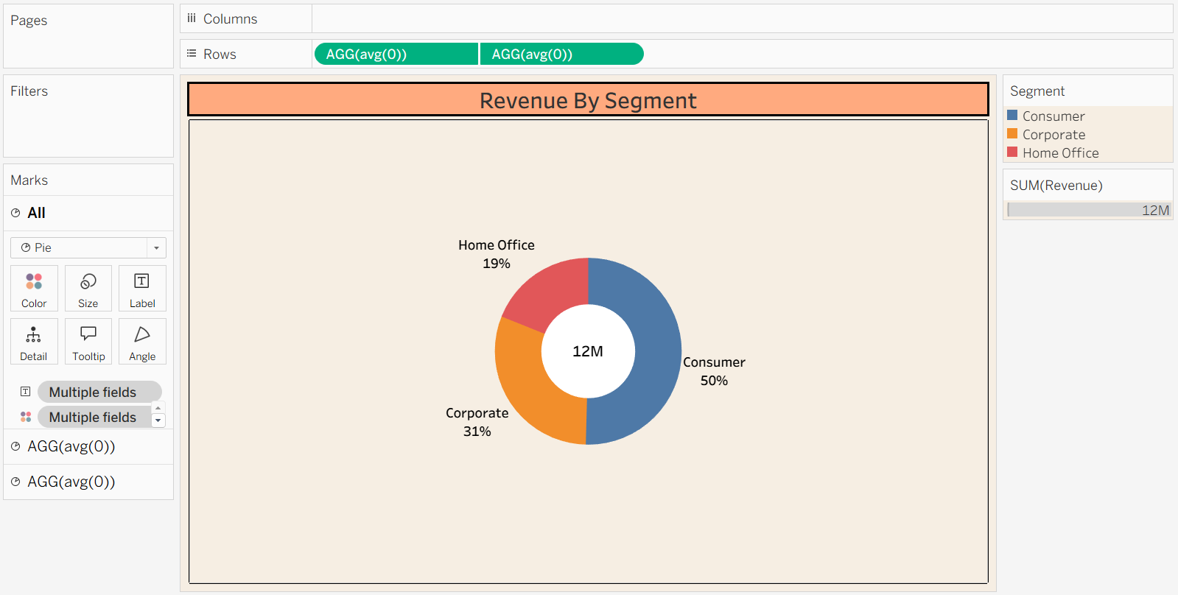

Lollipop Chart
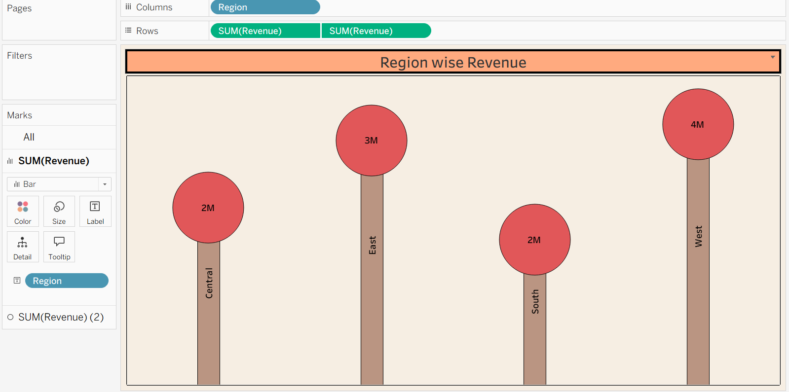

Funnel Chart
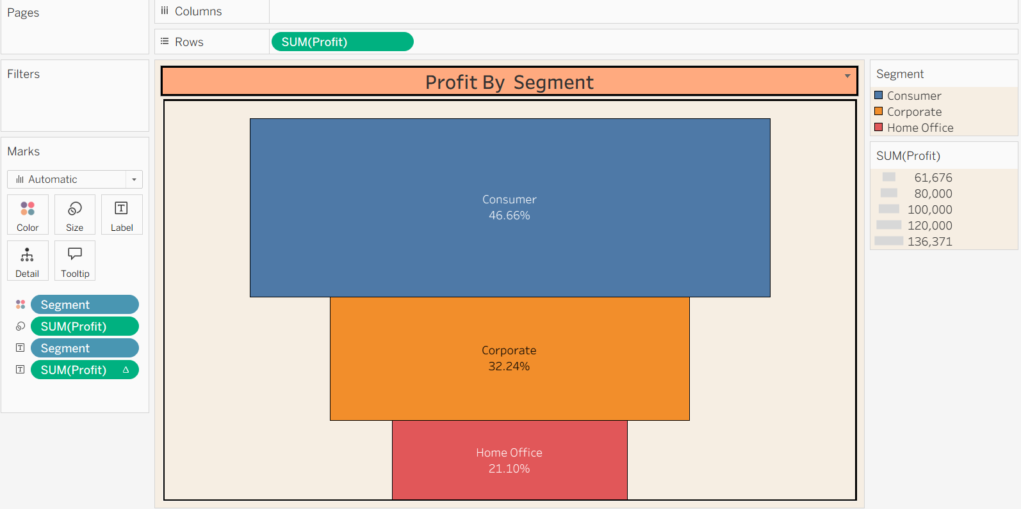

Waterfall Chart
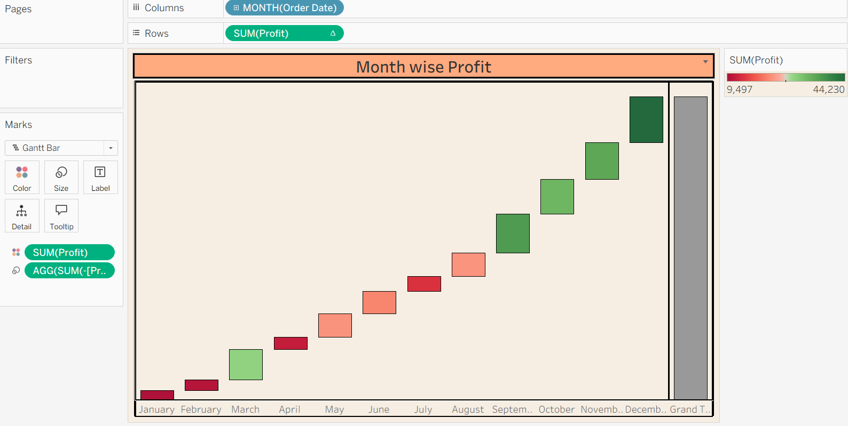

Data Models In Tableau: We can Connect data from one or more tables
Eg
Customer Table-Cust Id, Name, City
Order Table- Order ID, Cust Id, Sales

Different layers in Tableau Data Model
- Physical Layer
- Logical Layer

Physical Layer (Bottom Layer)-This layer tells us how the tables are physically combined
-Tables are combined using Joins
-Creates a single physical table
- Data is merged before analysis
- Can create duplicates if not used carefully

Logical Layer( Top Layer)- This layer tells how the tables are connected logically without merging rows
- Introduced in 2020.2 onwards
- Tables are connected using Relationships
- Tables remain separate
- Tableau decide how to combine the data at query level

Joins( Traditional Method)
It combines the data from two or more tables using common field
Created in Physical layer
When we are connecting to tables at physical layer through Joins you need to choose the type of Join
- Inner Join: Keeps all the matching records from both tables
- Left Join: Keeps all the record from left table and matching records from right table
- Right Join Keep all the records from right table and matching records from left table
- Full: Keeps all the records from both table.

Disadvantage of Joins
- Duplicate Records
- Slower Performance
- Wrong results if the join is incorrect
- Joins happens before aggregation

Relationships: Its a logical connection between the tables that tells tableau how the tables are related without physically merging them.

Cardinality- Describes how the records in one table is related to records in another table
One to One- One record in table A matched to one record in table B
One to Many
Many to One
Many to Many

- Keeps table separate
- Aggregates the measure correctly
- Combine only needed result.

Union
Data Blending: Combines the data from two different data sources in worksheet level to analyse them together
Primary Datasource is denoted in Blue color
Secondary datasource is denoted in Orange color

Cross database Join: Allows you to join tables coming from different data sources at data source level

Sets:
Custom subset of data based on certain conditions or criteria
In set - Members which meets the condition or we have selected
Out set- Members which do not meet the condition or we have not selected

- Static Set: Contains members that are manually selected and remain the same until you edit the set
- Dynamic Set: Members change based on the condition you define.
- Combined Set: By Combining two existing sets

Filters: Displays only the data needed and hide the rest
https://help.tableau.com/current/pro/desktop/en-us/filtering.htm
- Extract Filter ( Tableau Desktop Professional Edition)
- Data Source Filter
- Context Filter
- Dimension Filter
- Measure Filter

Live Connection: Directly queries the database everytime
Extract: Stores snapshot of data in Tableau .hyper extract file

- Extract Filter: Used to filter the data before creating extract file, only the filtered data is stored in extract
  - Eg: sales 2023,2024,2025—100000 record
  - 2025- 25000records

- Data Source Filter: Filters data at the data source level
- Context Filter:
- Dimension Filter: Filters applied on dimensional data are called dimensional filters
- Measure Filter: Filters applied on measure data are called measure filter

Hierarchy

Directors> Dean>HODs>Professors>Assistant Professors> Staff>Peons

Year -> Quarter-> Month -> Day
Category> Sub Category> Product name

Parameters: It allows the users to enter or select a value , to control the visualization dynamically
- Top N and Bottom N
- Date Field Parameter
- Dynamic Dimension
- Dynamic Measure
- Reference Parameter

Top N:
Take States to filter, under top tab select create new parameter, give it name as Top N
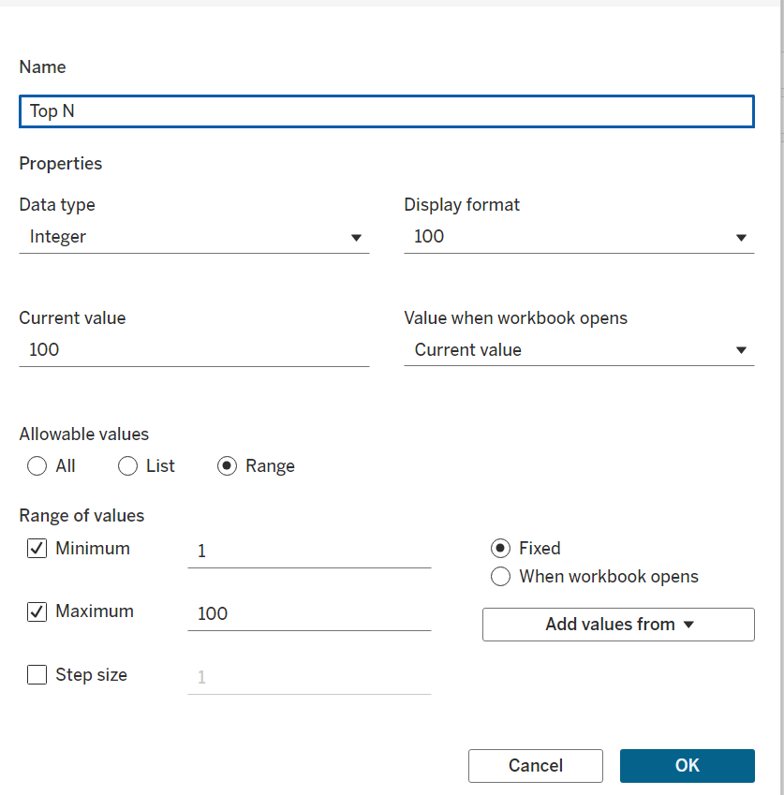

Bottom N:
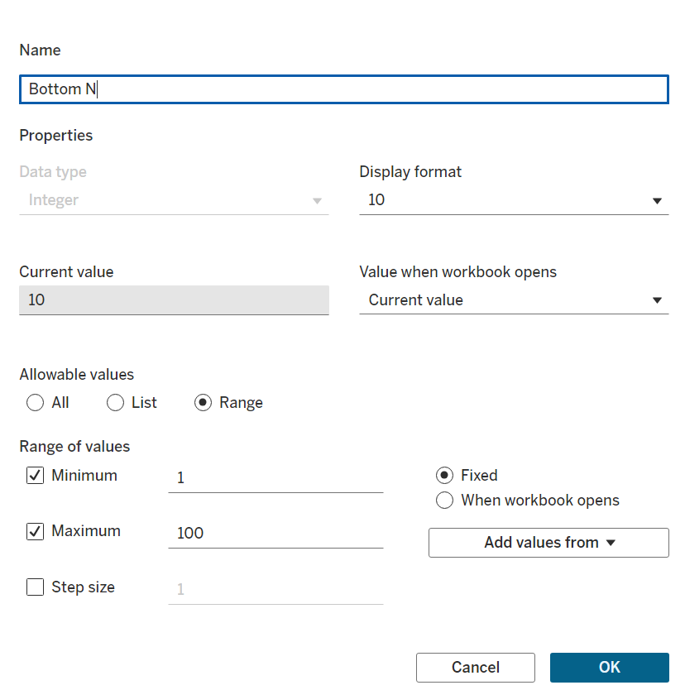

Date Field Parameter
Parameter
Calculated field
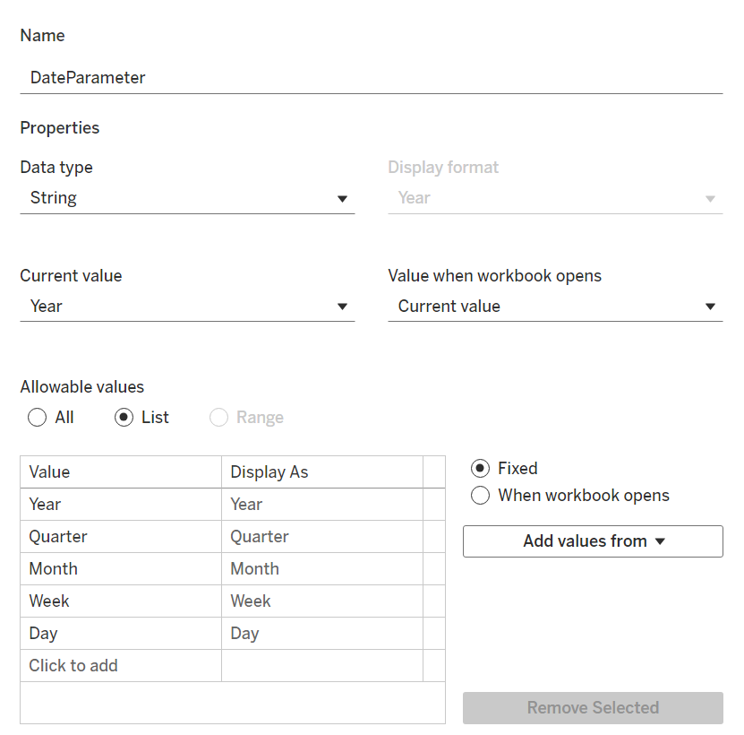

CASE [DateParameter]
WHEN 'Year' THEN STR(YEAR([Order Date]))
WHEN 'Quarter' THEN 'Q' + STR(DATEPART('quarter', [Order Date]))
WHEN 'Month' THEN DATENAME('month', [Order Date])
WHEN 'Week' THEN STR(DATEPART('week', [Order Date]))
WHEN 'Day' THEN STR(DATEPART('day', [Order Date]))
END

Dynamic Dimension

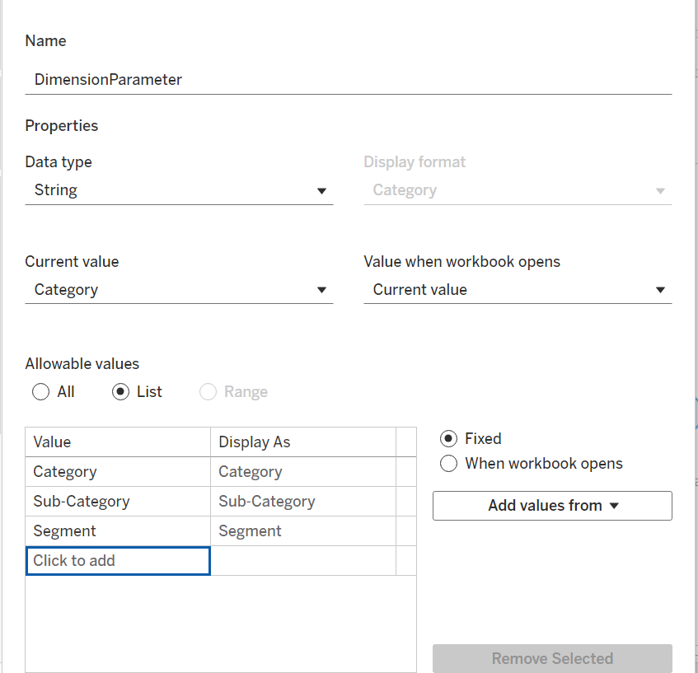

CASE[DateParameter]
When "Category" Then [Category]
when "Sub-Category" Then [Sub-Category]
When "Segment" Then [Segment]
END

Dynamic Measure
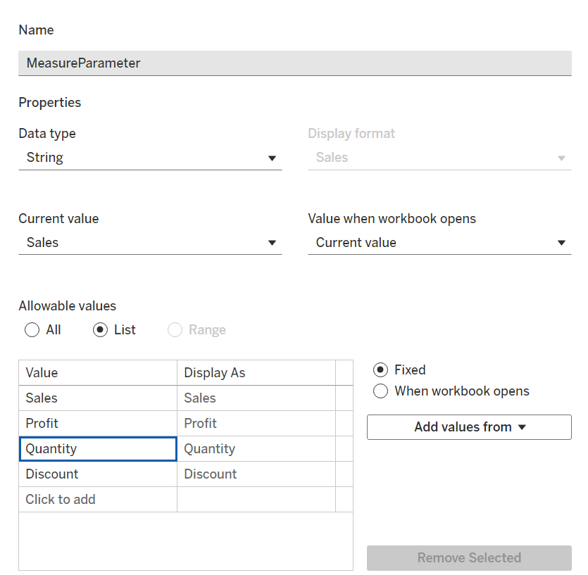
CASE [MeasureParameter]
WHEN "Sales" Then [Sales]
WHEN "Profit" THEN [Profit]
WHEN "Quantity" THEN [Quantity]
WHEN "Discount" THEN [Discount]
END

Reference Line Parameter
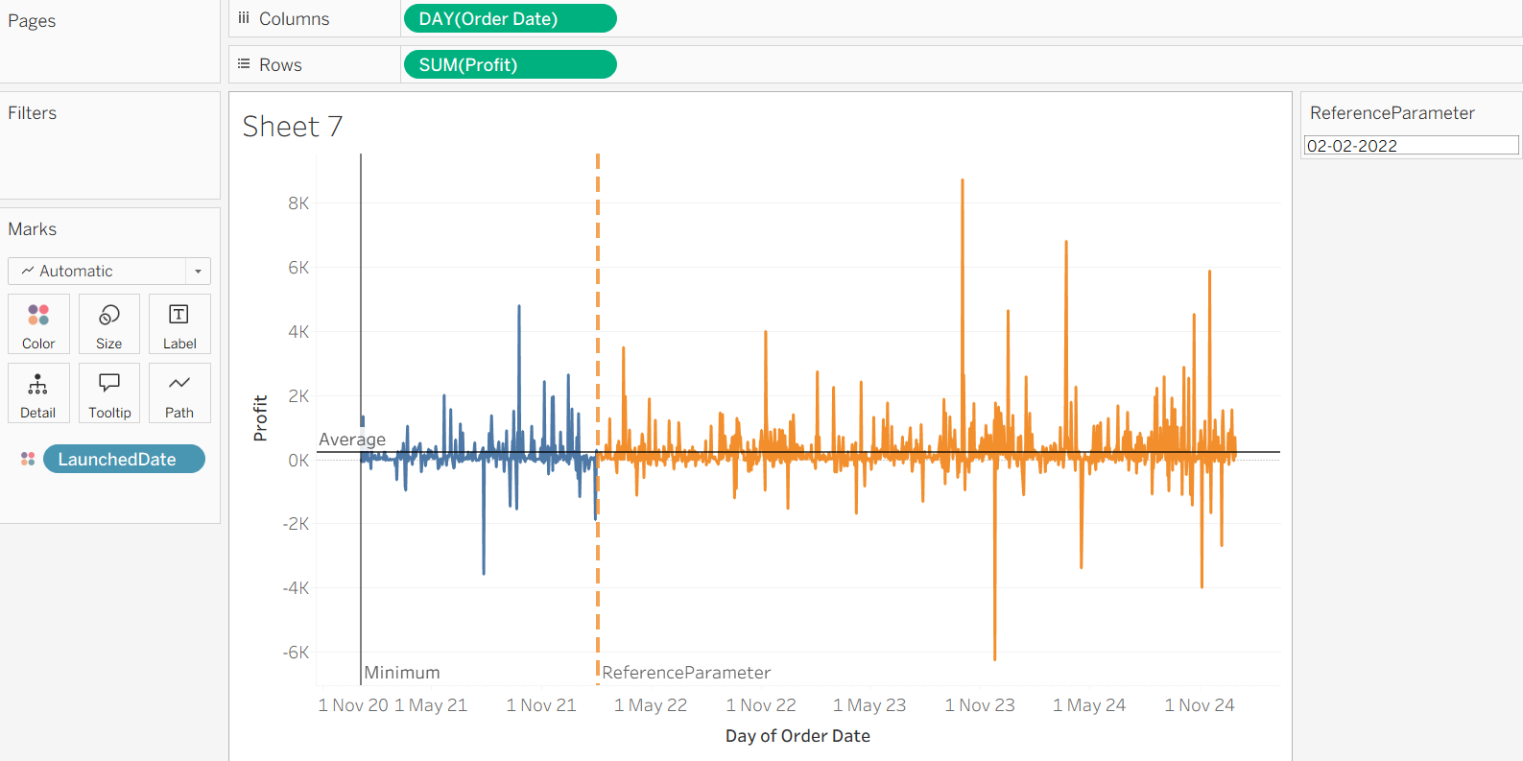
Parameter with Set
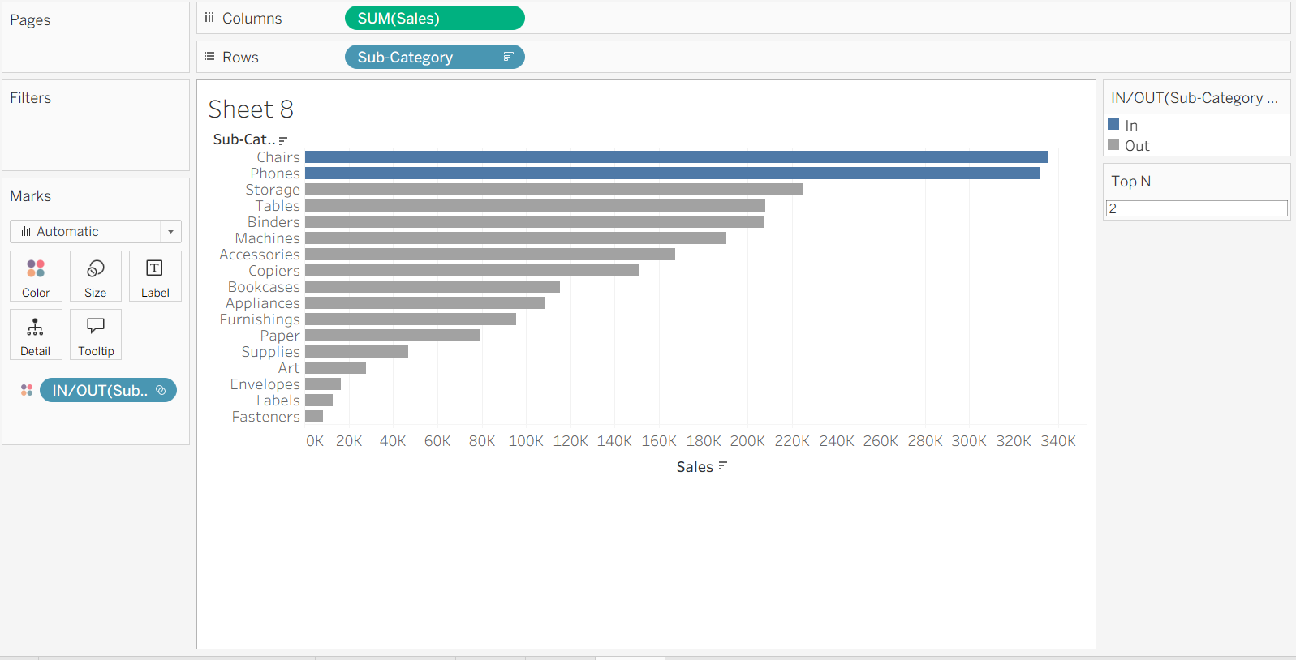

Null Values
- Identify Null Values
    - ISNULL([Sales])

- Text IFNULL([Region],"Unknown")
- Numerical IFNULL([Sales] , 0)

- Zn() it replaces missing values with 0.

- Filter out Null values using filters
  - For dimension exclude Null
  - For measure >Special>Non null Values

LOD Expression- Level of Detail allows you to control the level of granularity in you calculation , independent of the view in visualization, It helps you to perform aggregation at different level of detail.

Granularity- how detailed you data is.
Higher the Granularity more specific the data
Lower the Granularity more summarised data

Sales of certain Product
Country >State> City> District
District will have the highest Granularity (More Detailed)
Country will have lowest granularity (More Aggregated )

2 Points to Note
- What is level you need
- What is the Aggregation- Sum, Avg, Count, Max

Types:
- Fixed LOD
- Exclude LOD
- Include LOD

Syntax:
{type[Dim] : Aggregate()}

FIXED LOD: Calculates values at specific level of detail ignoring the view’s dimension
{ FIXED [DIM1},[DIM2]: Aggregation(Measure)}

EXCLUDE LOD:Removes certain dimension from the calculation , aggregating at higher level
{EXCLUDE [DIM]: Aggregation(Measure)}

INCLUDE LOD:Adds more detail to the existing view considering additional dimension
{INCLUDE[DIM]: Aggregation(Measure)}

Fixed 1: Calculating Total Sales regardless of Category, Region and Segment
{FIXED:SUM(Sales)}

Fixed 2: Total Sales for Category regardless of Region and Segment
{Fixed[Category]:SUM([Sales])}

Fixed 3: Calculate Total Sales for Category and Region regardless of Segment
{FIXED[Category],[Region]: Sum([Sales])}

Exclude1: Calculated the Average Sales of Region Excluding the Category
{Exclude[Category]:Avg(Sales)}

Exclude 2: Total Profit excluding the segment
{EXCLUDE [Segment]:SUM([Profit])}

Include: Avg Region Profit in Category sales
Avg({INCLUDE[Region]:SUM([Profit])})

Map
Country,States

Total Sales
Regional Sales
Average Sales

1.Profit ratio
Profit/Sales

2. Sales with Tax
[Sales]*1.18

3. Discount Category
IF [Discount]=0 THEN "No Discount"
ELSEIF [Discount]<=0.2 THEN "Low Discount"
ELSE "High Discount"
END

4. Order Size
IF [Quantity]<=2 THEN "Small Order"
ELSEIF [Quantity]<=5 THEN "Medium Order"
ELSE "Large Order"
END

5. Yearly Sales

6 Days to Ship

DATEDIFF('day', [Order Date],[Ship Date])

7. High Order
IF [Sales]>1000 Then "High Value"
ELSE "Normal"
END

8. Segmented Profit
IF [Profit]<0 then "Loss"
else "Profit"
End

9. Order Month
DATENAME('month',[Order Date])

10 Region
CASE [Region]
WHEN "East" then "E"
WHEN "West" then "W"
WHEN "South" then "S"
WHEN "Central" then "C"
END

Quick Table Calculations
- Running Total: Calculates the Cumulative sum of Measure over dimensions
- Percent of Total: Calculates the percentage contribution of each datapoint to the total
- Difference: Calculate the difference between two consecutive data points
- Percent Difference: Calculate the percentage difference between two consecutive data points.
- Moving Average: Calculates the Average of Measure over a moving window of datapoints
- Percentile: It Indicates the percentage of data points that fall below a particular value
- Rank: Assigns positions to values
- YTD (Year to Date Total)- Calculates the Cumulative sum of measure from the beginning of the year upto current datapoint
- YTD Growth: Calculates the Year over Year Growth rate of a measure from the beginning of the year upto current datapoint
- YOY- Calculates the percentage change in measure compared to the same period in previous year
- CAGR- Measure the growth over multiple periods considering compounding

Visual Analytics Pane
- Constant Line
- Average Line
- Reference Line
- Total
- Trend
- Clusture
- Forecast

Projects

Use cases

- Heart Disease Analysis
- Strategic Product Placement Analysis: Unveiling Sales Impact with Tableau Visualization
- India's Agricultural Crop Production Analysis
- Food Ordering Behaviour and Consumer Trends: A Structured Analysis of Choices and Habits
- Visualization Tool for Electric Vehicle Charge and Range Analysis
- Heritage Treasures: An In-Depth Analysis of UNESCO World Heritage Sites in Tableau
- Visualizing Housing Market Trends: An Analysis of Sale Prices and Features using Tableau
- Plugging into the Future: An Exploration of Electricity Consumption Patterns Using Tableau
- Cosmetic Insights : Navigating Cosmetics Trends and Consumer Insights with Tableau
- Comprehensive Analysis and Dietary Strategies with Tableau: A College Food Choices Case Study

