AI ASSISTED CODING
LAB-12:Algorithms with AI Assistance – Sorting, Searching, and
Optimizing Algorithms
Name:Damera Prasanna Latha
Roll No:2503A51L37
Batch:25BTCAICSB20
Task Description #1:
(Sorting – Merge Sort Implementation)
• Task: Use AI to generate a Python program that implements the
Merge Sort algorithm.
• Instructions:
o Prompt AI to create a function merge_sort(arr) that sorts a
list in ascending order.
o Ask AI to include time complexity and space complexity
in the function docstring.
o Verify the generated code with test cases.
• Expected Output:
o A functional Python script implementing Merge Sort with
proper documentation

PROMPT: Generate a Python program that implements the
Merge Sort algorithm create a function merge_sort(arr) that sorts a
list in ascending order include time complexity and space complexity
in the function docstring.Verify the generated code with test cases.
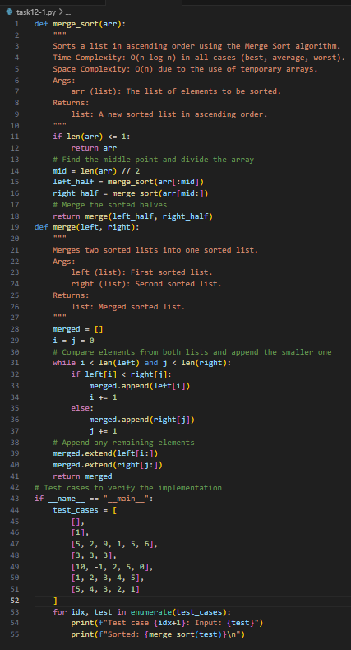
OUTPUT:
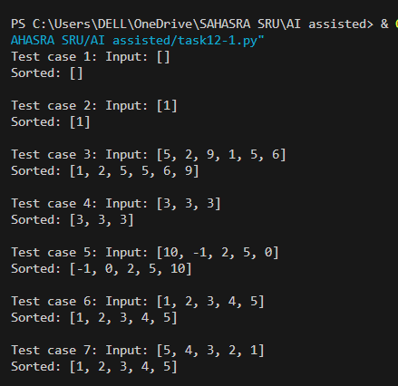
Observation: AI generated the merge_sort(arr) function using the divide-and-conquer strategy. It included a detailed docstring explaining time complexity (O(n log n)) and space complexity (O(n)), which made the algorithm clearer. After running the AI-generated code with test cases, I observed that the list was sorted correctly. This showed me how AI can not only implement the algorithm but also document and verify it systematically
Task Description #2
(Searching – Binary Search with AI
Optimization)
• Task: Use AI to create a binary search function that finds a target
element in a sorted list.
• Instructions:
o Prompt AI to create a function binary_search(arr, target)
returning the index of the target or -1 if not found.
o Include docstrings explaining best, average, and worst-
case complexities.
o Test with various inputs.
• Expected Output:
o Python code implementing binary search with AI-
generated comments and docstrings.

PROMPT: create a binary search function that finds a target
element in a sorted list.create a function binary_search(arr, target)
returning the index of the target or -1 if not found.Include docstrings explaining
best, average, and worst-case complexities.Test with various inputs.
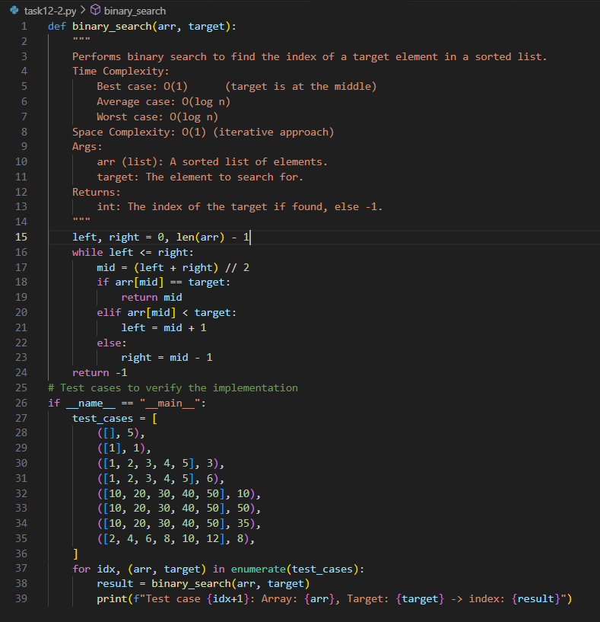
OUTPUT:
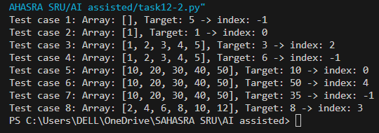
Observation: AI implemented the binary_search(arr, target) function by repeatedly dividing the sorted list into halves. The function returned the correct index if the element was found, and -1 otherwise. The AI also explained best, average, and worst-case complexities directly in the docstring, which made it easier to connect theory with practice. Testing with multiple inputs confirmed the accuracy, and I learned how AI-generated code can be both optimized and self-explanatory.
Task Description #3

(Real-Time Application – Inventory
Management System)
• Scenario: A retail store’s inventory system contains thousands of
products, each with attributes like product ID, name, price, and
stock quantity. Store staff need to:
1. Quickly search for a product by ID or name.
2. Sort products by price or quantity for stock analysis.
• Task:
o Use AI to suggest the most efficient search and sort
algorithms for this use case.
o Implement the recommended algorithms in Python.
o Justify the choice based on dataset size, update frequency,
and performance requirements
Expected Output:
o A table mapping operation → recommended algorithm →
justification.
o Working Python functions for searching and sorting the
inventory

PROMPT: Scenario: A retail store’s inventory system contains thousands of
products, each with attributes like product ID, name, price, and
stock quantity. Store staff need to:
1. Quickly search for a product by ID or name.
2. Sort products by price or quantity for stock analysis.
suggest the most efficient search and sort algorithms for this use case.
o Implement the recommended algorithms in Python.
o Justify the choice based on dataset size, update frequency,
and performance requirements
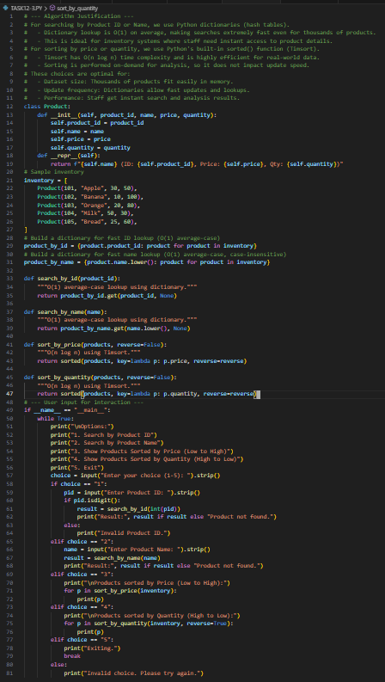

OUTPUT:
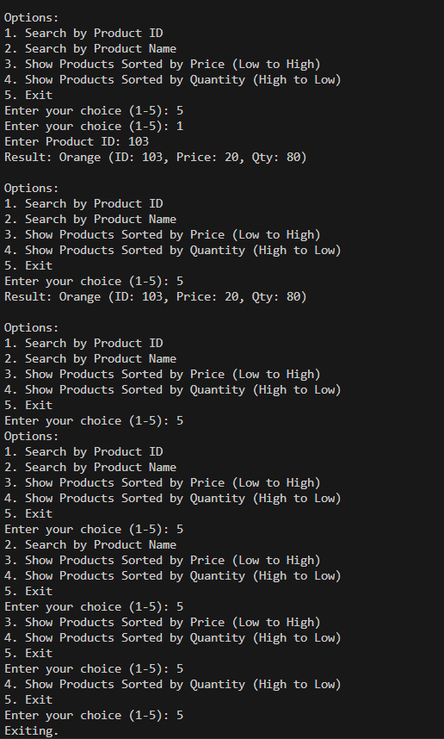
Observation:
For the inventory system scenario, AI suggested using Binary Search for quick product lookups and efficient sorting algorithms (Merge Sort/Quick Sort) for arranging products by price or quantity. It justified these choices based on dataset size and performance requirements. The AI also provided a Python implementation that allowed searching by ID/name and sorting using options. Through this, I observed how AI applies theoretical algorithms to solve real-world problems, while also justifying the decisions with clear reasoning.

