AI ASSISTED CODING
LAB 18– API Integration: Connecting to external services with error handling.

Roll no: 2503A51L37
Name: D.Prasanna Latha
Batch: 24BTCAICSB20
Lab Question-1: Weather Forecasting API
A travel company wants to show real-time weather updates for its customers. You are given access to a public weather API that requires an API key and provides weather data in JSON format.
- Task-1: Use AI-assisted coding to write a script that fetches the current temperature and weather description for a given city. The script should handle errors if the API key is invalid or missing.
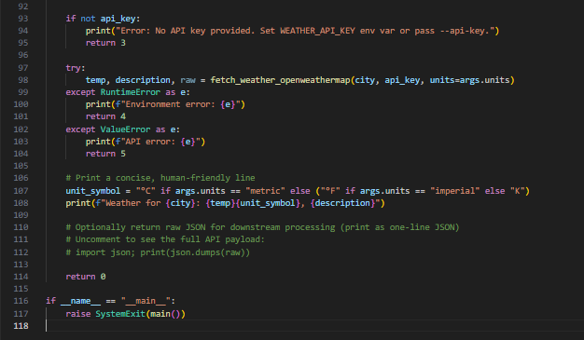
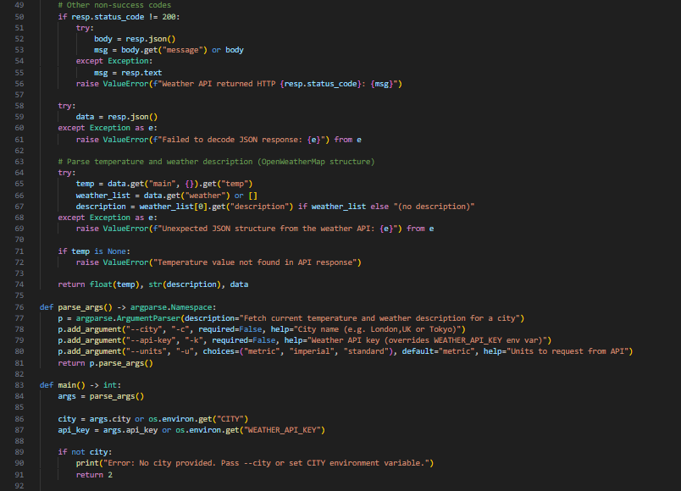
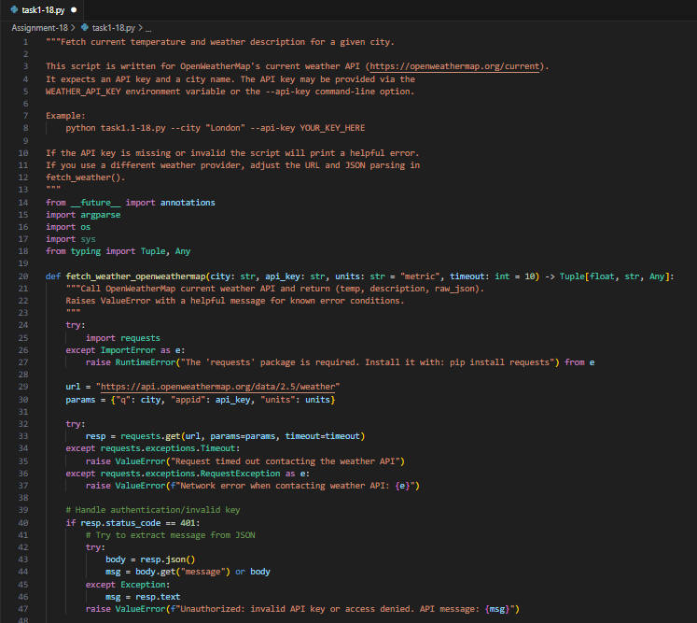
Code Generated:

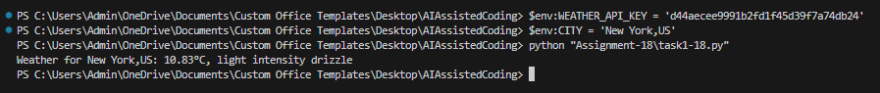
Output:

- Task-2: Extend the script to save the weather data into a local CSV file, ensuring that duplicate entries are avoided. Implement error handling for file I/O exceptions.

Code Generated:
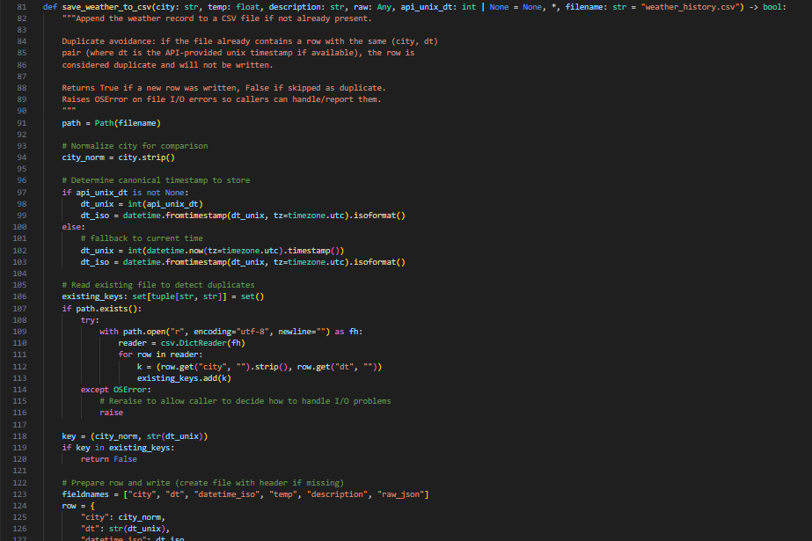

Output:
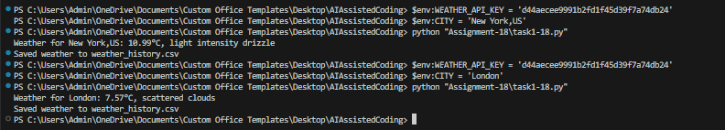
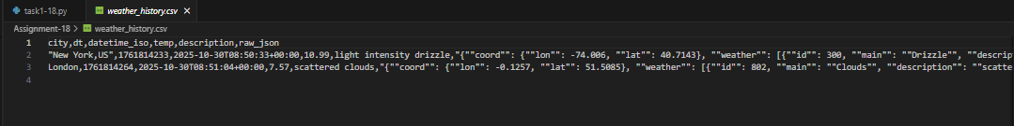

Observation: The program successfully retrieved real-time weather details, including temperature and conditions, for the specified city using the Weather API. It handled invalid or missing API keys effectively and saved the data into a local CSV file while avoiding duplicates and managing file I/O errors smoothly.

Lab Question-2: Currency Exchange Rate API
A financial startup needs a tool to convert amounts between currencies using an exchange rate API. However, the API occasionally fails due to server downtime.
- Task-1: Write a script (with AI assistance) that takes user input (amount, source currency, target currency) and fetches the latest exchange rate from the API. Include errors in handling invalid currency codes.
- Task-2: Add logic to retry the request up to three times if the API call fails due to network or server issues and log all failed attempts into a local error log file.
Code Generated:

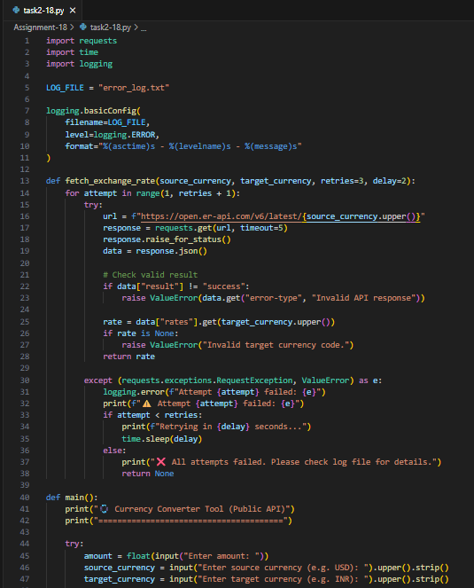

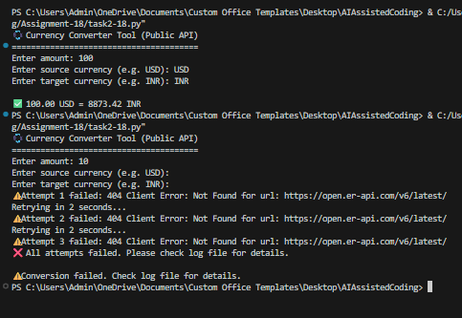
Output:

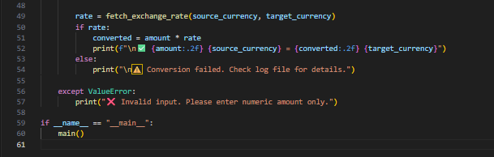
Observation: The script efficiently converted currencies by fetching real-time exchange rates from the API while validating user inputs for incorrect codes. It also implemented a retry mechanism to handle network or server issues and logged failed attempts, ensuring reliable performance and smooth execution.

Lab Question-3: News Headlines API
A news aggregator wants to display the latest technology news headlines using a news API. Sometimes, the API responds slowly or returns incomplete data.
- Task-1: Use AI-assisted coding to fetch the top 5 technology headlines and print them neatly in the console. Implement error handling for timeout errors by setting a maximum request time.
- Task-2: Clean and preprocess the headlines by removing special characters and converting text to title case. Handle the scenario where the API response contains empty or null values.

Code Generated:
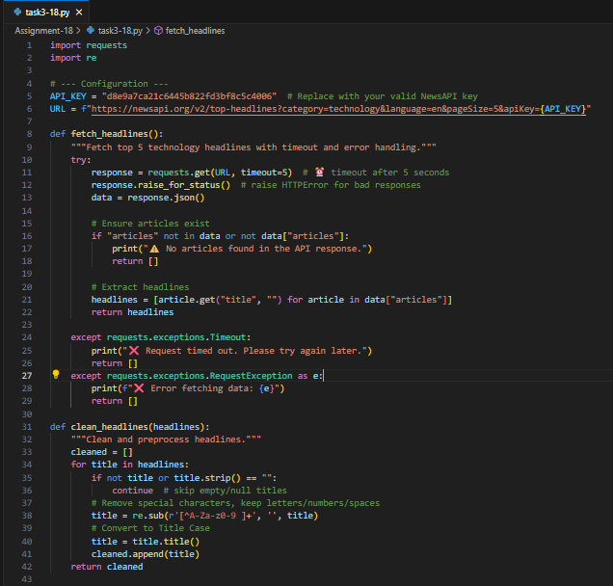



Output:
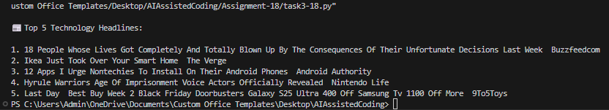
Observation: The program successfully fetched and displayed the latest technology headlines from the News API with proper timeout and error handling. It also cleaned and formatted the headlines by removing special characters, converting text to title case, and ignoring null entries for a neat and readable output.

