HEC-HMS Model Preparation and Calibration for Runoff Simulation; Case Study of the Red Butte Creek Watershed, Utah
Semester Project Report

Prasanna Dahal
Sal Bir Limbu

Masters Students in Civil and Environmental Engineering,
Utah State University

Prepared for:
Dr. Richard Peralta
CEE 6450- Hydrologic Modeling

May, 2016

- Introduction
  - HEC-HMS
The hydrologic model HEC-HMS (Hydrologic Engineering Center, Hydrologic Modeling System) is developed by the US Army Corps of Engineers. It is a commonly used software that is designed to simulate the precipitation–runoff processes of dendritic watershed systems (HEC, 2000). HEC-HMS is a lumped model that offers a wide variety of methods for basin loss, channel routing, infiltration modeling and so on, hence the model was used for the project. It is often used in combination with the Geospatial Hydrologic Modeling Extension, HEC-GeoHMS. HEC-GeoHMS is an ArcGIS extension that helps create the input files for HEC-HMS. HEC-GeoHMS was used to prepare input files based on SCS loss and transform method.
  - Study Area
Figure1. Red Butte Creek River basin with its River and subbasins.
Red Butte Creek Basin is a small watershed located in Eastern side of the Salt Lake City. It covers an area of 18.8 km² with elevation between 1500 m to 2400 m. The Red Butte Creek (RBC) is a small creek flowing from the watershed, which is especially large at the time of rainfall. Although small, the creek flows thought the watershed into the dense Salt Lake City, hence any flood in the creek can potentially create damages in the downstream urban area. The goal of the project is to create a HEC-HMS rainfall-runoff model to simulate discharge in the creek, thereby helping water resources engineers plan for any flood protection, or other water management issues. The outlet of the watershed is located at lower left part of the watershed as can be seen from Fig.1. The outlet is upstream to a reservoir. The outlet just above the reservoir was chosen because of the proximity of the outlet to a United States Geological Survey (USGS) station with station no: 101722000, which has historical daily flow recordings. The discharge data from the USGS station was used for model calibration.

- Methodology
  - Data Acquisition
    - Gridded Dataset
A 30-meter grid of USGS Digital Elevation Model (DEM), 30-meter National Land Cover Dataset (NLCD) dataset, 30 m impervious percent gridded data was downloaded using a Python Script (Dahal, 2016) that downloads the data calling the ArcGIS services. These data could also be downloaded from the USDA:NRCS:Geospatial Data Gateway (2016). All of the data was downloaded in 30m resolution to maintain the consistency in data used. Figure 2 contains the dataset for the Red Butte Creek watershed.
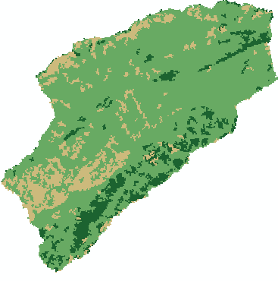
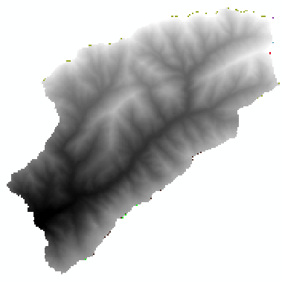
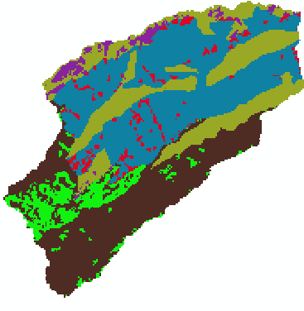
Figure 2. Gridded files for the RBC watershed; CN grid, NLCD land Use and DEM respectively from right
    - NRCS- Soil Data
The USDA:NRCS:Geospatial Data Gateway (2016) was used to download the National Resources Conservation Service (NRCS) high resolution soil dataset SSURGO (Soil Survey Geographic Dataset). The SSURGO data contains the data required for SCS method such as Hydrological Soil Group (HSG) soil data, which was derived using a Python Script (Dahal, 2016). The HSG soil data along with the NLCD land use data were used to derive CN grid.
Similarly, SSURGO database was used to extract soil texture class located in the region. For each of those class, Rawls et al (1983) lookup table was used to calculate the soil related properties such as Saturated Hydraulic conductivity, suction pressure, saturated soil moisture. Initial soil moisture was approximated somewhere between the field capacity and the effective porosity.
    - Rainfall / Meteorological Data
The rainfall data from the four GAMUT (Gradients along Mountain to Urban Transitions) rainfall stations, and four other nearby rainfall stations were considered for the study. GAMUT stations are high resolution ecohydrologic observatory to study water (iUTAH GAMUT, 2014). The four GAMUT sites in the watershed are: 1) Red Butte Creek above Red Butte Reservoir Climate (Site Code: RB_ARBR_C), 2) Green Infrastructure Climate (Site Code: RB_GIRF_C), 3) Knowlton Fork Climate (Site Code: RB_KF_C), and 4) Todd's Meadow Climate (Site Code: RB_TM_C). Stations were used to calibrate the model. Also, other rainfall stations were considered because the data form GAMUT sites were marked “Provisional, and subject to revision”. The non-GAMUT climatic stations considered are 1) Bountiful- val verda, 2) City Creek WTP, 3) Salt Lake Triad, 4) Hardscrabble, 5) Lookout Peak, and 6) Louis meadow, derived from Ames, Daniel P., et al (2012).
      - Rainfall Data Variation
The GAMUT climatic stations are fairly new sites that have started recording measurements for only about three years, and the quality of data is marked “Provisional”. Also, the data from other climatic statins seem to vary quite a bit. The measurements from the four GAMUT climatic stations, and from the four nearby climatic stations are shown in the Fig.7 and Fig8 in Appendix B. The mean and max value of rainfall is shown in the tables below, one for GAMUT sites, and one for non-GAMUT sites. This table helps us see the discrepancy in the rainfall data measurements in the six rainfall station located very close to one another. This could be a result of variation in elevation, or difference in microclimate of the region, or inaccuracy in measurement.
Looking at the discharge in the USGS streamflow gage, the climatic stations with very high precipitation did not make sense, in terms of volume balance of the watershed (see table 6a and Table 6b). The high rainfall measured in the stations result in very low rainfall-runoff coefficient, lower than 0.1. Hence, for the project, two climatic stations with lower mean precipitation were considered, Salt Lake Triad from non-GAMUT site, and Green Infrastructure (SiteCode: RB_GIRF) were considered for the model, with the aim to select one precipitation station that gives consistent result when compared to observed runoff at the outlet.

Table1: GAMUT Climatic stations and USGS discharge station near Red Butte Creek
Site Code | Site Name | Latitude | Longitude | Elevation
RB_GIRF_C | Green Infrastructure Climate | 40.7608 | -111.830 | 1487.120
RB_ARBR_C | RBC Above Red Butte Reservoir Climate | 40.7806 | -111.807 | 1666.037
RB_TM_C | Todd's Meadow Climate | 40.789 | -111.796 | 1763.001
RB_KF_C | Knowlton Fork Climate | 40.810 | -111.767 | 2178.101
USGS 10172200 | USGS streamflow gage | 40.77 | -111.9 | 1763.001

The location of these stations are highlighted in the map below:
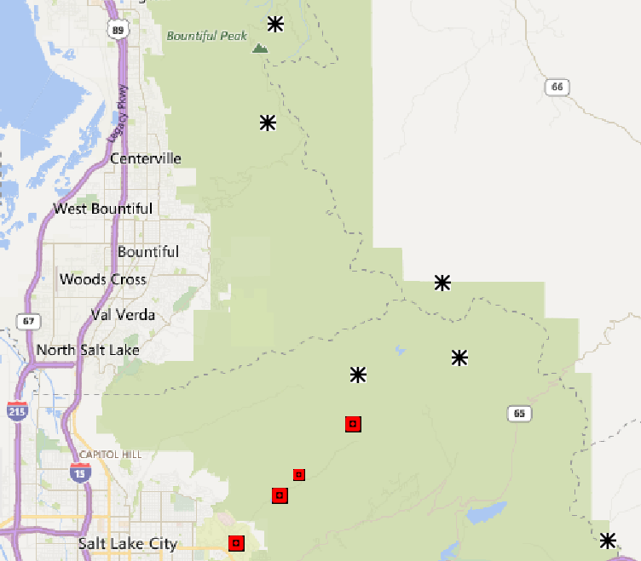
RB_GIRF_C
RB_ARBR_C
RB_TM_C
RB_KF_C
Salt Lake Traid
USGS discharge station, outlet
Figure 3. Some of the Climatic stations, and USGS discharge stations used in the analysis
Table-2a: Non GAMUT Climatic station and mean and max precipitation in record over the period of 01/01/2000 to 05/29/2012
Climate Station | Time period | Mean daily precipitation (mm) | Max daily Precipitation (mm)
BOUNTIFUL- VAL VERDA, UT, (GHCN) | 01/01/2000 – 05/29/2012 | 1.651 | 60.7
CITY CREEK WTP, UT (GHCN) | 01/01/2000 – 05/29/2012 | 1.836 | 58.2
SALT LAKE TRIAD CTR, UT, (GHCN) | 01/01/2000 – 05/29/2012 | 1.118 | 30.5
Hardscrabble, Source SNOTEL | 01/01/2000 – 05/29/2012 | 2.877 | 86.4
Lookout Peak, (SNOTEL) | 01/01/2000 – 05/29/2012 | 3.255 | 111.8
Louis Meadow, (SNOTEL) | 01/01/2000 – 05/29/2012 | 2.416 | 81.3

Table-2b: GAMUT Climatic Station and mean and max precipitation in record over the period of 01/01/2015 to 12/31/2015
GAMUT Climatic Stations | Time Period | Mean Precipitation (mm) | Median Precipitation (mm) | Max Precipitation (mm) | Runoff / rainfall
RB_ARRC_C_QC (Above red butte creek climatic site) | 1/1/2015 -12/31/2015 | 2.15 | 0.8 | 43.1 | 0.091
RB_TM_C_QC (Todds Meadow Climate site) | 1/1/2015 -12/31/2016 | 3.01 | 0.9 | 62 | 0.065
RB_KF_C_QC (Knowlton Fork Climate) | 1/1/2015 -12/31/2017 | 3.81 | 2.1 | 83 | 0.051
RB_GIRF (Green infastructure) | 1/1/2015 -12/31/2018 | 2.00 | 0.8 | 34.3 | 0.098

      - Rainfall Comparison to Other Stations
  - Model Description
HEC-HMS model was prepared using HEC-GeoHMS, with the final Model schematic shown in the Fig.4. Detail screencast of how the model was prepared is given in Appendix F. The DEM and river shapefile were used to generate most of DEM related data, such as flow direction, flow accumulate, etc. and finally the subbasins. The summary of the steps undertaken in HEC-GeoHMS are listed in Appendix E. The detail screencast of the process is shown in Appendix F.
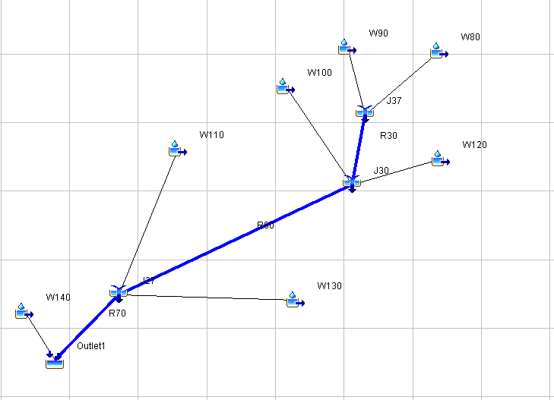
    - Subbasin
Figure 4. HMS Model Schematic of the Model for the RBC watershed
There are seven subbasin in the model; W80, W90, W100, W110, W120, W130 and W140. The gridded curve number (CN) technique enables spatially distributed infiltration calculations. Infiltration capacity is quantified in a parameter derived by the Soil Conservation Service (SCS) called the CN. The CN is a method for determining storm runoff over an area based on land use, soil and land cover type, and hydrologic soil group (US SCS, 1986). Soil groups are determined based on type and infiltrability of a soil. The infiltration loss method is derived from a set of empirical equations that define the partitioning of rainfall into infiltration and runoff,
$Q= \frac{{(P- I_{a})}^{2}}{P- I_{a}+S}$ ----- (1)
I_{a} =0.2S ---- (2)
$S= \frac{1000}{CN}-10$---(3)
Substituting Eq. (2) into Eq. (1) gives
$Q= \frac{{(P- 0.2*S)}^{2}}{P+0.8*S}$----- (4)
Where,
Q = runoff in inches
P = rainfall in inches
S = potential maximum retention
Ia = initial abstraction
CN = runoff curve number

Figure 5. The seven subbasins in the Red Butte Creek watershed
This CN parameter was derived for each grid cell using a script (see Appendix I) that combines SSURGO soils data with the National Land Cover Dataset (NLCD) data layer, using Table3 (also in Appendix C) which is a lookup table that maps NLCD land cover to Hydrologic Soil Group (HSG) and CN no. For the Red Butte Creek watershed, the soils are uniformly classified into Hydrologic Soil Group A, B, and C.
However, the land cover in the entirety of watershed is mostly forest and bushes. Hence the average value for CN for most subbasin are approximately in the range 60–75. Initial abstraction is a variable parameter that takes into account losses prior to the start of runoff such as interception and depression storage. Evapotranspiration losses are considered negligible for the preliminary model due to several factors: the intensity of the storm being modeled, the continuous saturation of the air, and the resulting assumption that ET volume is negligible compared to runoff volume.

Table 3. Lookup table for NLCD land use and Hydrologic Soil Group (HSG) and CN value
NLCD Land Use Category | Land Use Code | CN value for Hydrologic Soil Group
NLCD Land Use Category | Land Use Code | A | B | C | D
Open Water | 11 | 0 | 0 | 0 | 0
Perennial Ice/Snow | 12 | 0 | 0 | 0 | 0
Developed, Open Space | 21 | 57 | 72 | 81 | 86
Developed, Low Intensity | 22 | 63 | 77 | 85 | 88
Developed, Medium Intensity | 23 | 81 | 88 | 91 | 93
Developed, High Intensity | 24 | 89 | 92 | 94 | 95
Barren Land | 31 | 77 | 86 | 91 | 94
Barren Land (Rock/Sand/Clay) | 31 | 77 | 86 | 91 | 94
Deciduous Forest | 41 | 36 | 60 | 73 | 79
Evergreen Forest | 42 | 36 | 60 | 73 | 79
Mixed Forest | 43 | 36 | 60 | 73 | 79
Dwarf Scrub | 51 | 35 | 56 | 70 | 77
Shrub/Scrub | 52 | 35 | 56 | 70 | 77
Herbaceous | 72 | 35 | 56 | 70 | 77
Grassland/Herbaceous | 71 | 49 | 69 | 79 | 84
Sedge/Herbaceous | 72 | 35 | 56 | 70 | 77
Lichens | 73 | 77 | 86 | 91 | 94
Moss | 74 | 68 | 79 | 86 | 89
Hay/Pasture | 81 | 49 | 69 | 79 | 84
Pasture/Hay | 81 | 49 | 69 | 79 | 84
Cultivated Crops | 82 | 49 | 69 | 79 | 84
Woody Wetlands | 90 | 30 | 55 | 70 | 77
Emergent Herbaceous Wetlands | 95 | 30 | 58 | 71 | 78

Table 4. Subbasin characteristics
Subbasin | Area (mi2) | CN | Impervious Percent (%) | Longest Flowpath (m) | Lag time (min) | Downstream | Loss Method | Transform Method
W80 | 0.88 | 65.6 | 1.0 | 2614 | 18.4 | J37 | SCS & Green Ampt | SCS
W90 | 0.51 | 69.6 | 0.0 | 2454 | 11.1 | J37 | “ | “
W100 | 0.22 | 70.0 | 1.0 | 2443 | 7.89 | J30 | “ | “
W110 | 1.63 | 68.4 | 1.0 | 2494 | 28.4 | J27 | “ | “
W120 | 0.77 | 70.0 | 1.0 | 2293 | 17.0 | J30 | “ | “
W130 | 2.15 | 74.8 | 0.0 | 2260 | 24.7 | J27 | “ | “
W140 | 1.04 | 78.4 | 0.0 | 2200 | 10.2 | Outlet1 | “ | “

    - Loss Method
      - SCS Loss Method
SCS Curve Number method was used as the subbasins’ loss method. The SCS method of loss requires data for Curve and Impervious percentage in the basin. The CN for each basin is derived from the CN grid prepared earlier, and the Impervious Percentage grid downloaded using the ArcGIS web services. For RBC watershed, the CN values varies from 65 – 78. The impervious percentage for each watershed is below 1.0%.
      - Green & Ampt Loss Method
Green & Ampt model is a conceptualization of the actual physical processes in which the hydraulic conductivity is assumed to decrease exponentially from the saturated condition, as is often found in real soils. This means that it is less likely to estimate the infiltration better at early time during a storm event. Because of this reason, Green & Ampt Loss method was used. The details of Green & Ampt values used for each subbasin in the region is given in Appendix A.
    - Transform Method
The total precipitation that falls in any watershed does not convert as surface runoff, there are different losses such as infiltration, evapotranspiration etc. Only a portion of total precipitation contribute to direct runoff, which is calculated by the Transform method. The transform method used was the SCS unit hydrograph method. This method requires values for Lag Time in minutes. The value is calculated by HEC-GeoHMS, but can also be calculated manually. Lag time is a function of the average CN value for the subbasin, the longest flow path, slope of the basin etc. The equation 5 and 6 shows the calculations of the lag time, in hour.
$$Lag time \left(in hour\right)=0.6* T_{c}$$
$$T_{c}= \frac{l^{0.8} {(S+1)}^{0.7}}{1140 Y^{0.5}}$$

Where,
L = Lag (in hour)
Tc = time of concentration (hour)
l = flow length (ft)
Y = average watershed land slope (%)
S = maximum potential retention (inch)
= 1000/CN - 10
    - Baseflow Method
Baseflow is an important parameter in most rainfall runoff model because it defines a minimum river depth over which additional runoff accumulates. Models that neglect baseflow may underestimate water levels and therefore fail to simulate the discharge in the reaches. Baseflow for the discharge at the USGS stations was separated using the Web Based Hydrograph Analysis Tool (WHAT analysis tool) provided by Purdue University. The average monthly summation of the baseflow provided by the tool was considered the baseflow for the outlet point. The total baseflow value per month (table below) was divided into each of the seven subbasins based by using the weighted average of the each subbasin area.
Table5A: Monthly Baseflow separated by WHAT for the outlet for the time period of 2015 Jan - 2015 Dec.
Month | Total baseflow at outlet (cfs) | W80 | W90 | W100 | W110 | W120 | W130 | W140
Month | Total baseflow at outlet (cfs) | 12.2% | 7.1% | 3.0% | 22.7% | 10.7% | 29.9% | 14.4%
Jan | 0.585 | 0.071 | 0.042 | 0.018 | 0.133 | 0.063 | 0.175 | 0.084
Feb | 1.061 | 0.129 | 0.075 | 0.032 | 0.241 | 0.114 | 0.317 | 0.153
Mar | 1.065 | 0.13 | 0.076 | 0.032 | 0.242 | 0.114 | 0.318 | 0.154
Apr | 1.198 | 0.146 | 0.085 | 0.036 | 0.272 | 0.129 | 0.358 | 0.173
May | 3.031 | 0.369 | 0.216 | 0.091 | 0.688 | 0.326 | 0.905 | 0.437
Jun | 2.709 | 0.33 | 0.193 | 0.081 | 0.614 | 0.291 | 0.809 | 0.391
Jul | 1.206 | 0.147 | 0.086 | 0.036 | 0.274 | 0.13 | 0.36 | 0.174
Aug | 0.585 | 0.093 | 0.054 | 0.023 | 0.173 | 0.082 | 0.227 | 0.11
Sep | 0.576 | 0.07 | 0.041 | 0.017 | 0.131 | 0.062 | 0.172 | 0.083
Oct | 0.943 | 0.078 | 0.046 | 0.019 | 0.146 | 0.069 | 0.192 | 0.093
Nov | 0.477 | 0.058 | 0.034 | 0.014 | 0.108 | 0.051 | 0.142 | 0.069
Dec | 0.106 | 0.013 | 0.008 | 0.003 | 0.024 | 0.011 | 0.032 | 0.015

Table5B: Monthly Baseflow separated by WHAT for the outlet for the time period of 2010 Oct- 2011 Sept
Month | Total baseflow at outlet (cfs) | W80 | W90 | W100 | W110 | W120 | W130 | W140
Month | Total baseflow at outlet (cfs) | 12.2% | 7.1% | 3.0% | 22.7% | 10.7% | 29.9% | 14.4%
Oct | 1.14 | 0.139 | 0.081 | 0.034 | 0.259 | 0.122 | 0.341 | 0.164
Nov | 1.35 | 0.165 | 0.096 | 0.041 | 0.306 | 0.145 | 0.403 | 0.195
Dec | 1.66 | 0.202 | 0.118 | 0.05 | 0.377 | 0.178 | 0.496 | 0.239
Jan | 1.99 | 0.242 | 0.142 | 0.06 | 0.451 | 0.214 | 0.594 | 0.287
Feb | 2.1 | 0.256 | 0.149 | 0.063 | 0.476 | 0.226 | 0.627 | 0.303
Mar | 4.22 | 0.514 | 0.3 | 0.127 | 0.957 | 0.453 | 1.261 | 0.609
Apr | 11.6 | 1.414 | 0.825 | 0.348 | 2.631 | 1.246 | 3.465 | 1.673
May | 24.92 | 3.037 | 1.773 | 0.748 | 5.653 | 2.677 | 7.445 | 3.594
Jun | 23 | 2.803 | 1.636 | 0.691 | 5.217 | 2.471 | 6.871 | 3.317
Jul | 8.15 | 0.993 | 0.58 | 0.245 | 1.849 | 0.876 | 2.435 | 1.176
Aug | 4.51 | 0.55 | 0.321 | 0.135 | 1.023 | 0.485 | 1.347 | 0.651
Sep | 2.77 | 0.338 | 0.197 | 0.083 | 0.628 | 0.298 | 0.827 | 0.4

    - Reach
There are three reaches in the watershed model. R30, R60 and R70. The information in the reach section of the model requires information based on which the routing is performed. The model prepared here uses Muskingum method. This method of routing requires values for two Muskingum constants; K (in hour) and X. These values are initially estimated to be 0.6 and 0.2 respectively, but later calibrated using the observed flow to obtain a more precise value.
    - Meteorological Data
Multiple runs were made using the different meteorological time series from different rainfall stations. Also, different time period of rainfall was used for different runs. The summary of the runs is provided in the Table 2 and Table 3.
    - Control Time
There were multiple model runs prepared in the process to obtain a model that best simulates the rainfall-runoff pattern in the region. As mentioned before, two sources of precipitation data were used; one from GIRF (GAMUT) climatic site, and the other from Salt Lake Triad station (non-GAMUT site) were used. The GIRF station was a new one, so we did not want to use data that they measured when they just began operating. Hence, model was run with the precipitation data form 01/01/2015 to 12/31/2015. However, for the Salt Lake Triad station, time period of 01/10/2010 to 30/09/2011 selected.
    - Discharge Data
The discharge data (daily average flow in CFS) was obtained from the USGS gage 10172200 located very close to the outlet of the HEC-HMS model. Appendix G contains the time series data (observed discharge as well as precipitation data) used in the model during the calibration phase, and for the comparison of simulated discharge.
    - Model Calibration
Model was calibrated using the flow data from the USGS station at the outlet of the watershed. The daily average data, which are “Approved” in quality was used to calibrate the model routing parameters (Muskingum k and x) for the three reaches present in the model.
For model runs that considered SCS Loss method, different value of initial abstraction was tested to calibrate the model. Similarly, for Green & Ampt Loss method, different values of initial soil moisture content were considered to calibrate the model. The value was kept as low as the field capacity, and as high as the saturation content (or effective porosity) to calibrate the model.
- Results and Discussions
  - Model Runs
Multiple model runs were completed using different parameters, and different rainfall records, as well as different run period. Two loss methods were accounted for, SCS loss method, and Green & Ampt loss method, because SCS loss method gave a poor result, and proper calibration of the model was not achieved. Green & Ampt method gave a better result, and hence was adopted in the final calibrated model. The summary of the runs created, and the figure to the results are tabulated below in Table 6a and Table 6b below.
The results have been shown in the form of figures with combined plot of simulated and observed hydrograph at the outlet. The blue line represents the simulated discharge at the outlet, while the black line represents the observed flow at the USGS discharge station.
Table 6a: Model Run Results Summary for Green & Ampt Loss Method
Runs | PPT Stations | Control Period | Simulated Discharge | Result Figure | Runoff - Rainfall Coefficient (Observed) | Runoff - Rainfall ratio (Simulated) | Percent error in runoff - rainfall
Run1 | Salt Lake Traid | 01/10/2010 to 30/09/2011 | Baseflow + Direct runoff | Fig-H1 | 0.865 | 0.666 | -23%
Run2 | ARBR_C, TM_C, and KF_C | ” | ” | Fig-H2
Run3 | GIRF | 01/01/2015 to 12/31/2015 | ” | Fig-H3 | 0.098 | 0.078 | -20%
Run4 | ARBR_C | ” | ” | Fig-H4 | 0.091 | 0.073 | -20%
Run5 | TM_C | ” | ” | Fig-H5 | 0.065 | 0.054 | -17%
Run6 | KF_C | ” | ” | Fig-H6 | 0.051 | 0.043 | -16%
Run7 | KF_C | ” | ” | Fig-H7 | 0.051 | 0.043 | -16%
Run8 | KF_C | ” | Direct Runoff | Fig-H8 | 0.0259 | 0.005 | -80%
NOTE: Run7 was ran with 15-min rainfall data. For other runs, 24-hrs rainfall was considered
Run5, highlighted in green, is the model selected as final model for the Green & Ampt loss method

Table 6b: Model Run Results Summary for SCS Loss Method
Runs | PPT Stations | Control Period | Simulated Discharge | Result Figure (Appendix H) | Runoff - Rainfall Coefficient (Observed) | Runoff - Rainfall ratio (Simulated) | Percent error in runoff – rainfall calculations
Run9 | GIRF | 01/01/2015 to 12/31/2015 | Baseflow + Direct runoff | Fig-H9 | 0.098 | 0.945 | 864%
Run10 | ARBR_C | 01/01/2015 to 12/31/2015 | ” | Fig-H10 | 0.091 | 0.949 | 943%
Run11 | TM_C | 01/01/2015 to 12/31/2015 | ” | Fig-H11 | 0.065 | 0.962 | 1380%
Run12 | KF_C | 01/01/2015 to 12/31/2015 | ” | Fig-H12 | 0.051 | 0.961 | 1783%
Run13 | Salt Lake Traid | 01/10/2010 to 30/09/2011 | ” | Fig-H13 | 0.865 | 1.495 | 73%
Run14 | Salt Lake Traid | 01/10/2010 to 30/09/2011 | Direct Runoff | Fig-H14 | 0.865 | 0.863 | -0.2%
Run14, highlighted in green, is the model selected as final model for the SCS loss method

From these different model runs, two models for the Run5 and Run14 were considered as the final models for the project, which was able to simulate the condition most accurately. Run5 is for Green & Ampt Loss method, and the other model is for SCS loss method. Results from Run 5 and Run14 is shown below in Fig. 6a and Fig. 6b respectively.
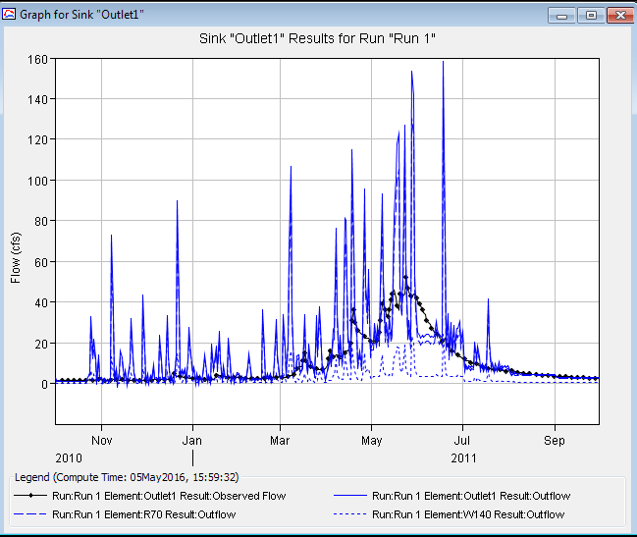
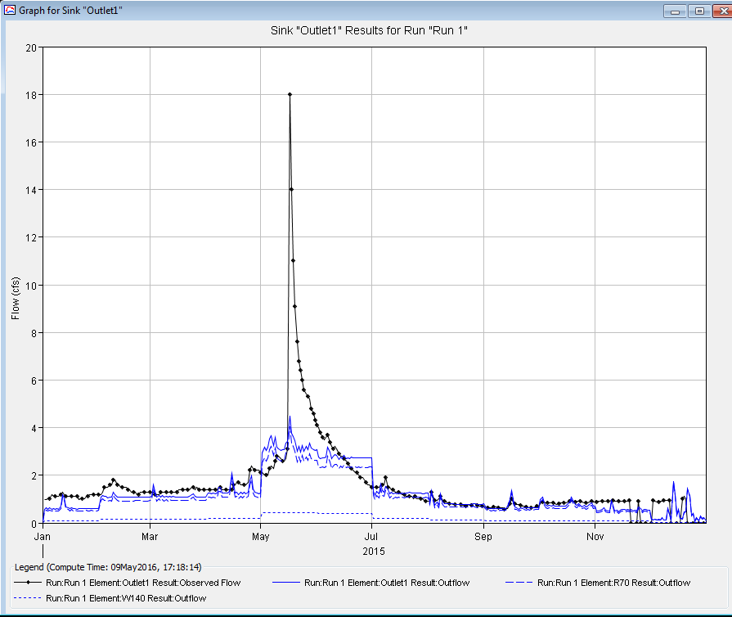
Figure 6b. The simulated and observed flow at the outlet using precipitaiton from the Salt Lake Traid for time period of Oct01-2010, Sept31-2011
Model Summary:
Loss Method: SCS
Transform: Muskingum
Time Step: 1-Day
Error (in %) in runoff/rainfall ratio: -0.2%
Figure 6a. The simulated and observed flow at the outlet using precipitaiton from the Knowlton Fork Climate (RB_KF_C, iUtah) for time period of Jan01-2015, Dec31-2015
Model Summary:
Loss Method: Green & Ampt
Transform: Muskingum
Time Step: 1-Day
Error (in %) in runoff/rainfall ratio: -17%
*Other Details for the final Models can be found in Appendix J.

  - Public Model Access
All the model, including the final calibrated model can be found in GitHub, the link to the repository being https://github.com/prasanna310/HEC_HMS_RBC. The repository contains the final report of the model, the streamflow data, rainfall data as well as the baseflow separated data. It also contains the step-by-step instruction of how to prepare the model.
- Conclusion
A HEC-HMS model was prepared for the study region of Red Butte Creek watershed, and calibrated. Rainfall data from 10 different climatic stations were considered, and later two were chosen for the model; Salt Lake Triad and Green Infrastructure climatic sites. The loss method considered were SCS, which gave a poor result, and hence Green & Ampt loss method was considered (see Tables 6a and 6b for details). Transform method considered was SCS, and the baseflow was considered constant per month, separated using the WHAT analysis tool. The DEM and NLCD Land use data was downloaded using ArcGIS services, from the USGS. The SSURGO database for the area (UT612) was downloaded, and most soil properties required for Green & Ampt method was obtained from it.
The final model simulated flow closely resembled the observed flow. SCS loss method was unsatisfactory for loss accounting. In watershed like Red Butte Creek which is small and covered with thick forest, a proper loss method is required, and Green & Ampt method was suitable for the purpose.
Acknowledgement
We would like to express deep thanks to Prof. Dr. Richard Peralta for his constant support, encouragement and guidance throughout the project. His patience, motivation, and immense knowledge has guided us towards a fruitful completion of the project.

References
Ames, Daniel P., et al. "HydroDesktop: Web services-based software for hydrologic data discovery, download, visualization, and analysis." Environmental Modelling & Software 37 (2012): 146-156.
Chow et al., 1988 V.T. Chow, D.R. Maidment, L.W. Mays Applied Hydrology
McGraw-Hill, New York (1988)
Clark, 1945 C.O. Clark Storage and the unit hydrograph
Transactions: American Society of Civil Engineers, 110 (1945), pp. 1419–1488
Dahal P., 2016 SSURGO_Extract_ArcGIS. GitHub Repository, <https://github.com/prasanna310/SSURGO_Extract_ArcGIS>
HEC, 2000 HEC Hydrologic Modeling System: Technical Reference Manual
US Army Corps of Engineers Hydrologic Engineering Center, Davis, CA (2000)
iUTAH GAMUT Working Group (2014), iUTAH GAMUT Network Raw Data Above Red Butte Reservoir Advanced Aquatic Site (RB_ARBR_AA), 1.0, iUTAH Modeling & Data Federation, http://repository.iutahepscor.org/dataset/iutah-gamut-network-raw-data-above-red-butte-reservoir-advanced-aquatic-site-rb-arbr-aa
Rawls, W. J., D. L. Brakensiek, and B. Soni. 1983. Agricultural management effects on soil water processes: Part I Soil Water Retention and Green-Ampt Paramters. Transactions ASAE 26(6):1747–1752.
S SCS, 1986 US Soil Conservation Service, 1986. Urban Hydrology for Small Watersheds (Technical Release 55). US Department of Agriculture.
USDA:NRCS:Geospatial Data Gateway:Home. (2016). Gdg.sc.egov.usda.gov, <https://gdg.sc.egov.usda.gov/> (May 4, 2016).

