[Enter Post Title Here]

Roles in Ansible

1.Login to the server and create a folder for ansible role with this command.

ansible-galaxy init name #creating role folder

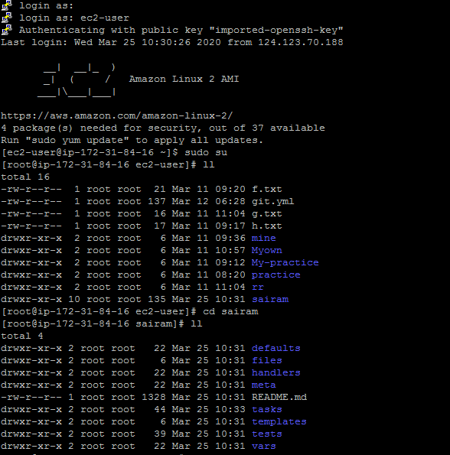

2.Goto🡪Tasks🡪 Write playbook and include them in main.yml file



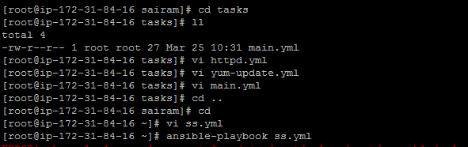

3.Now create a playbook and add roles to it and run.

