GITHUB

Git is a version control system and scm .It help us to maintain and keep track our source code history.It is a tool.

GitHub is a cloud based hosting service for git repositories.

1.create github account using [www.GitHub.com](http://www.GitHub.com)

2**.Repository**:It contains a directory named .git where git keeps all of its metadata for the repository.The contents of .git repository are private to git.

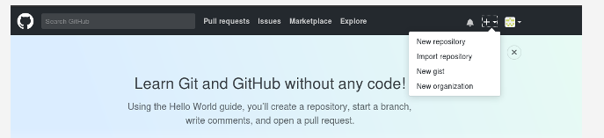

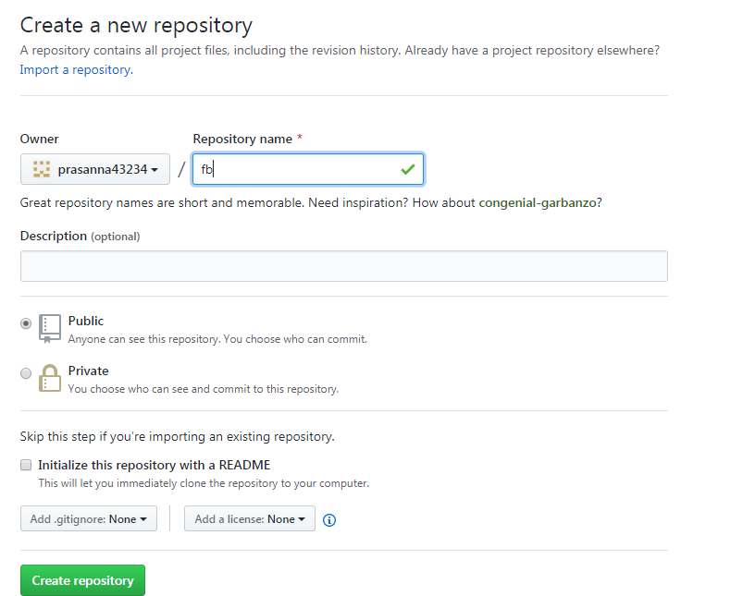

After creation of repository it will look like this.

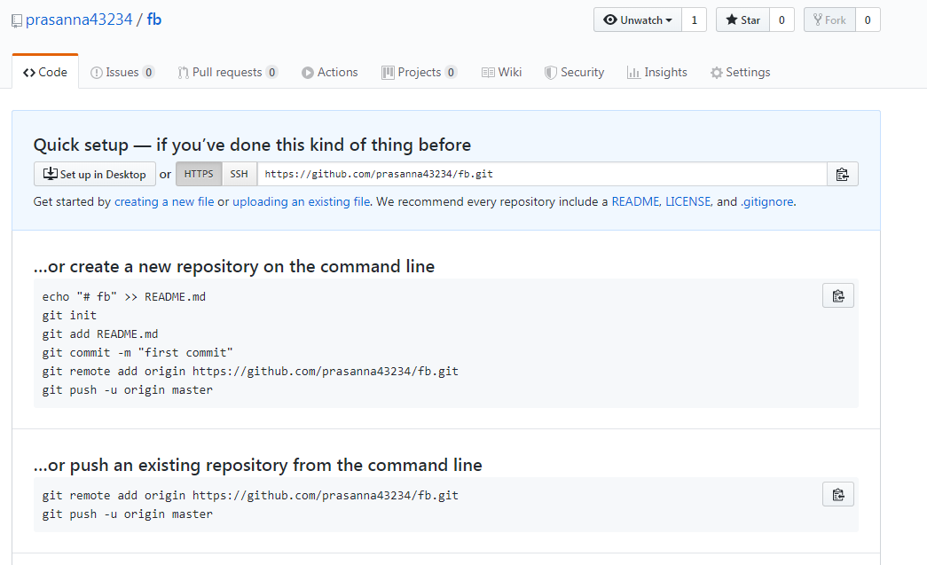

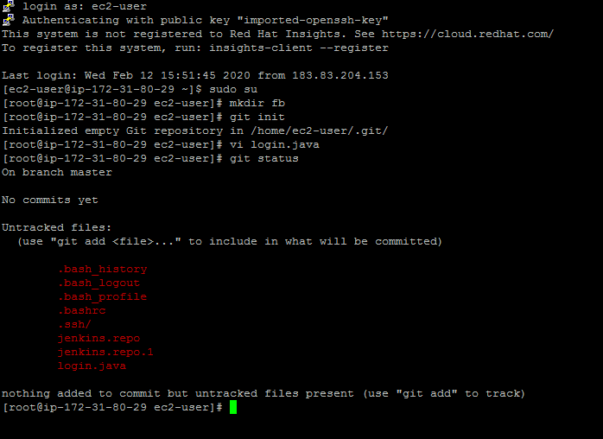

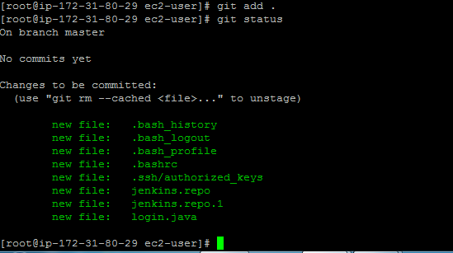

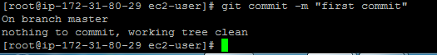

Conncet your computer to github with this comment .

To connect local repository to the github server ,you need t add a remote repository.



To push local repository to github server.

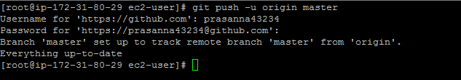

Git pull command which will fetch and merge remote master branch to local master branch.

Git is doing git fetch (Which downloads the latest changes from the remote repository)and then git merge(which merges them into local

Repository).If you don’t wanna merge the code immediately(you may want to review the changes first),you can do a git fetch.

Git pull::It fetch the latest commits from remote repository and merge them into local repository.

Git fetch::It only shows the latest commits but doesn’t merge.