ATM SYSTEM

Case Study

Customer uses bank ATM to Check Balances of his/her bank accounts & Withdraw Cash. When Customer enter his/her pin, ATM Machine Verify it. Bank database will monitor all the activity of Customer. After transaction the ATM will Eject the card and the bank will send a transaction successful message to the customer. The bank will also keep the transaction record to its database.

w

Customer

ATM

Bank

Withdraw

amount

Update

Details

Cancel

Transaction

Check

Balance

Verify

Pin

Login

include

>>

<<

Use Case Diagram For ATM System

Dispatch

Card

Send Transaction

Message

# Class Diagram For ATM System

BankDB

ATM

Customer

id: int

-

-

name: string

accountNo: string

-

balance: double

-

-

login

()

()

insertCard

-

-

()

WithdrawMoney

atmID: string

-

location: string

-

-

verifyPin

()

-

Withdraw

()

()

-

DispatchCard

-

()

RecordTransaction

-

name: string

-

updateAccount

()

()

-

saveTransaction

1

1..*

1..*

1

## Collaboration Diagram For ATM System

2: VerifyPin()

4: ShowBalance()

Customer

ATM

Bank

()

InsertCard

1:

()

CheckBalance

3:

5:

WithdrawMoney

()

()

DispatchMoney

8:

9:

()

DispatchCard

Balance Available

VerifyBalance

6:

7:

()

Activity Diagram For ATM

System

Customer

ATM Machine

Bank

Phase

Insert Card

Enter Pin

Authorize

Check Account

Balance

Enter Amount

Debit Account

Take Money From

Slot

Show Balance

Eject Card

Take Card

]

Valid Pin

[

Balance >= Amount

[

]

Invalid Pin

]

[

[

]

Balance < Amount

Sequence Diagram For ATM System

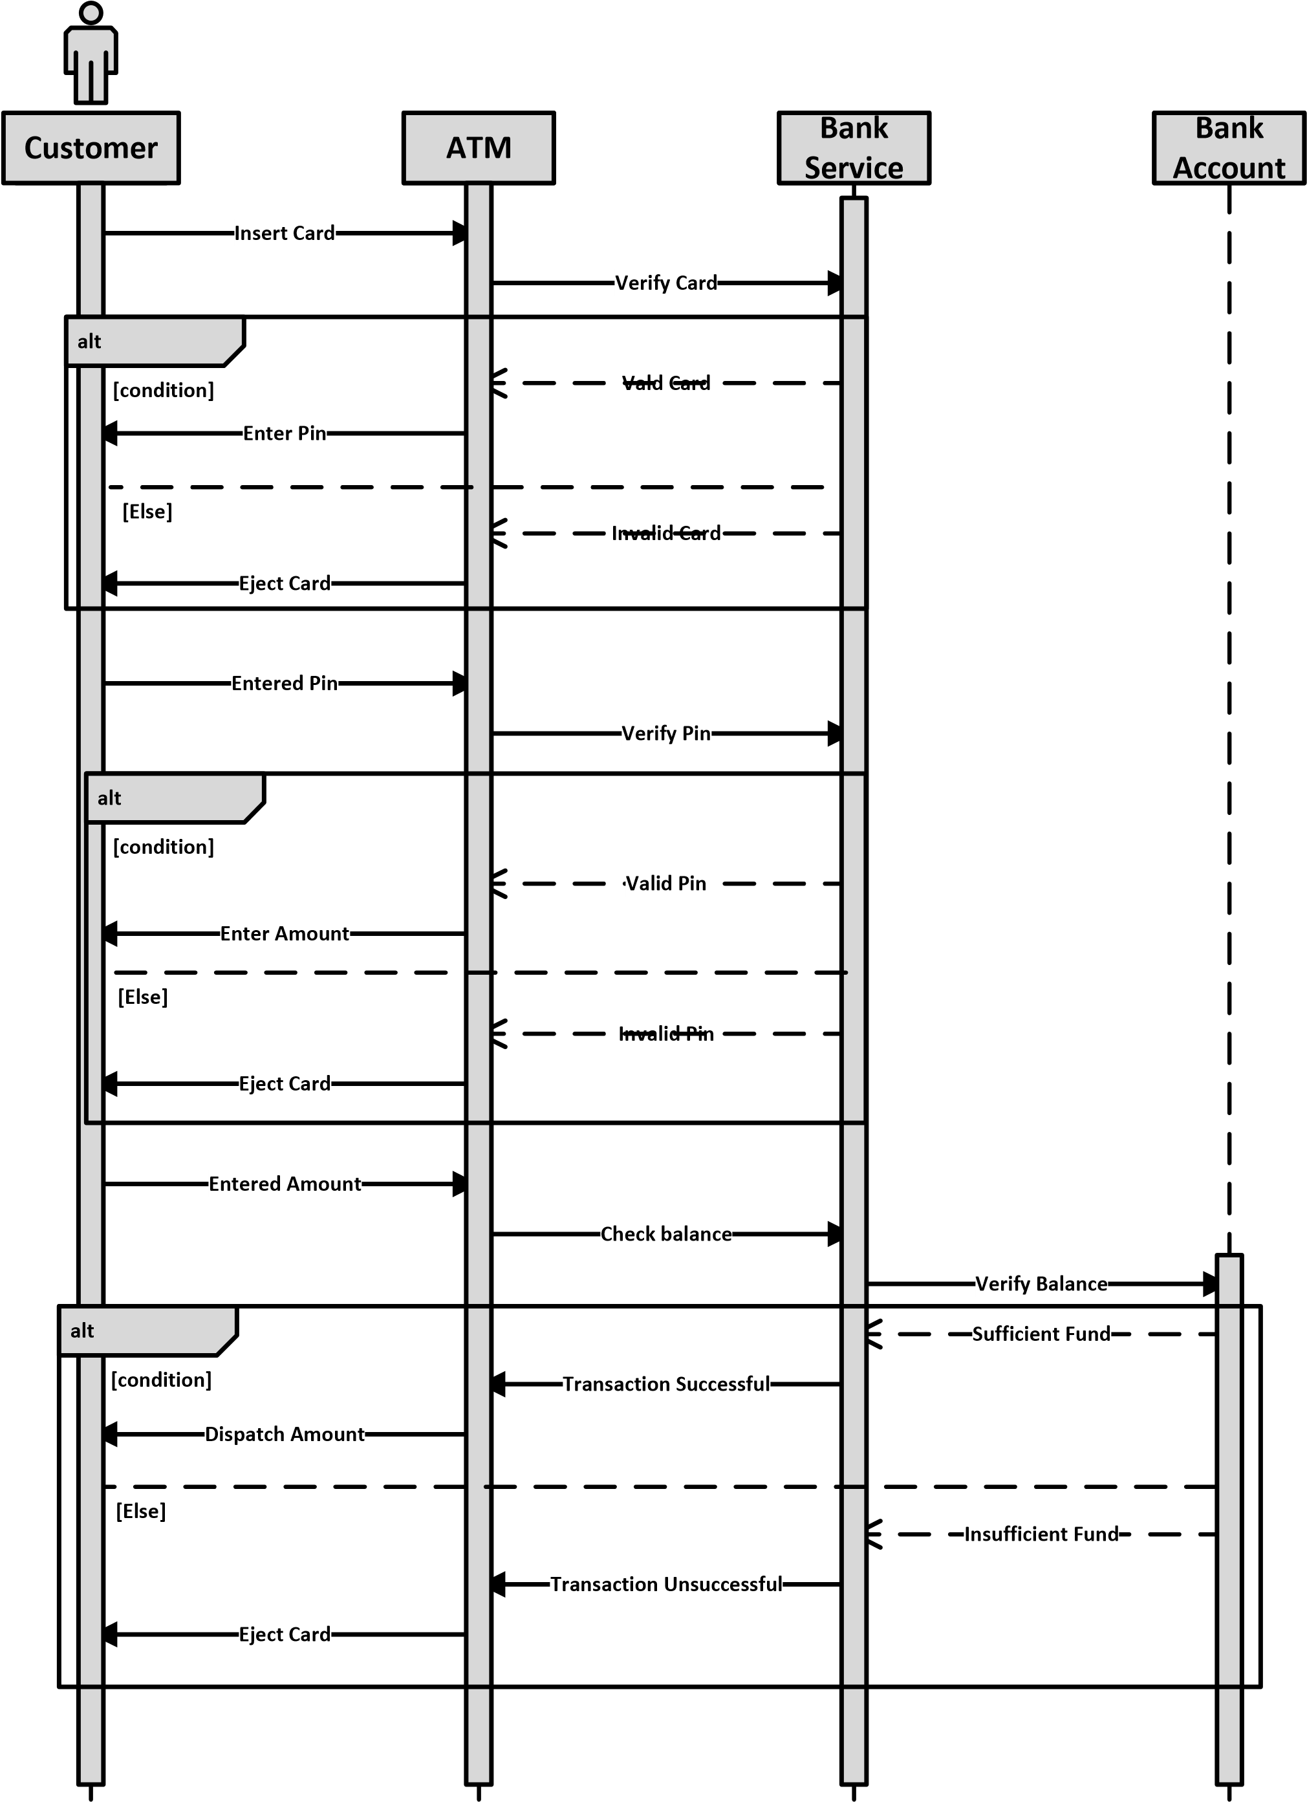

## State Chart Diagram For ATM System

Insert Card

Enter Pin

Withdraw Money

Dispatch Money

Eject Card

Invalid Pin

Transaction Menu

Not Available

Balance

## CRC Card For ATM System

|  |  |  |  |  |  |  |  |  |  |  |  |  |  |  |  |  |  |  |  |  |  |  |
| --- | --- | --- | --- | --- | --- | --- | --- | --- | --- | --- | --- | --- | --- | --- | --- | --- | --- | --- | --- | --- | --- | --- |
| |  |  | | --- | --- | | Customer | | | Responsibility | Colaboration | | Login  InsertCard  WithdrawMoney | ATM Machine | | | | | |  |  |  | | --- | --- | --- | |  | ATM | | | Responsibility |  | Colaboration | | VerifyPin  Withdraw  DispatchCard |  | Customer | | RecordTransaction |  | BankDB | |
| BankDB | |
| Responsibility | Colaboration |
| UpdateAccount SaveTransaction | ATM |

# Object Diagram For ATM System

b : BankDB

a : ATM

c : Customer

atmID= AT2003

location= Mirpur 10

id= 201901

name= Mr Junayed

accountNo= 162536958

balance= 350000.00

()

login

-

-

()

insertCard

-

()

WithdrawMoney

()

verifyPin

-

()

-

Withdraw

DispatchCard

()

-

()

-

RecordTransaction

name= DBBL

-

updateAccount

()

-

saveTransaction

()

Component Diagram for ATM System

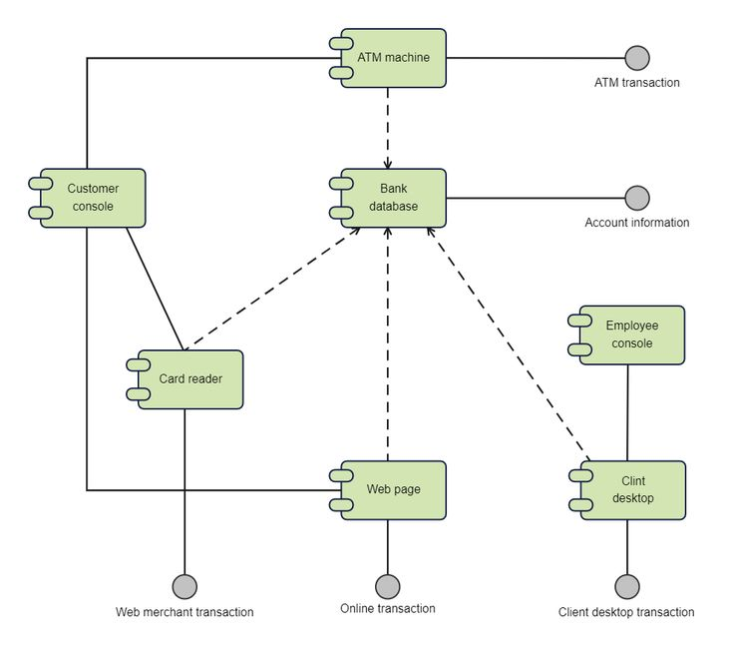

Deployment Diagram For ATM System

