1. Name of employee work in dept_no with the job_id use last_name column
select concat(last_name," works in department ID ",department_id," with job ID as ",job_id) question_1 from employees;
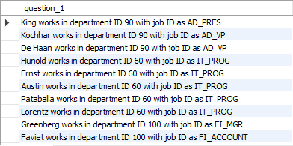

2. Employees who joined in the year 2000.
select first_name, last_name, date_format(hire_date, '%Y') joined_year from employees where date_format(hire_date,'%Y')='2000';
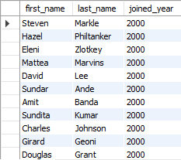

3. Employees who joined in after jan_1996.
select employee_id, last_name, date_format(hire_date,'%Y %M') from employees where date_format(hire_date,'%D-%M-%Y')>'31-01-1996';
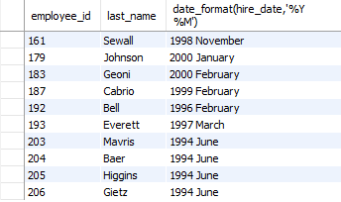

4. Employees whose name starts between 'S' and 'R'.
select * from employees where first_name like 'S%' and last_name like '%r';

5. Employees who works under manager_id (200,201).
select employee_id, first_name, last_name, manager_id from employees where manager_id=200 or manager_id=201;
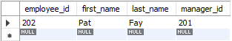

6. Employees who are "REP" or "MAN" and who are paid more than 6000.
select employee_id, first_name, last_name, job_id, salary from employees where (job_id like "%REP" or job_id like "%MAN") and salary>=6000;
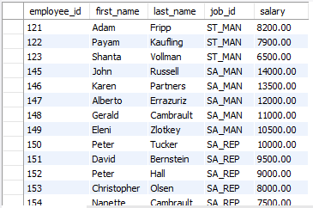

7. Calculate annual salary of each employee and print them in descending order.
select employee_id, first_name, last_name, (salary*12) annual_sal from employees order by annual_sal desc;
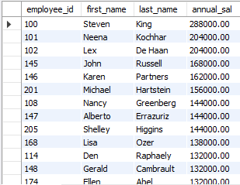

8. Replace the last_name of "Landry" to "Joe" in the employee table.
select employee_id,first_name, replace(last_name,'Landry', 'Joe') from employees;
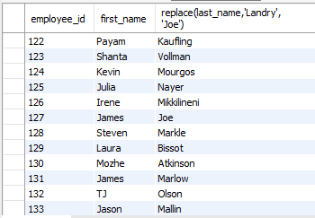

9. Find the 1st occurance of 'o' in last_name.
select employee_id, last_name, instr(last_name,'o') from employees;
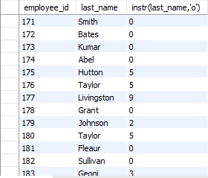

10. Prefix "2020_B84" for employee last_name who works in department 90.
select department_id, concat('2020_BC84 ',last_name) from employees where department_id=90;
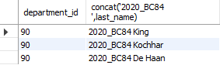

11. Find the current data with local date and time.
select current_timestamp();


12. Find the average commission paid for all the employees (ignoring the null entries).
select avg(commission_pct) from employees where commission_pct not like 'null';
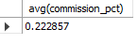

13. Find the average and highest salary paid for department 80, 90, 100.
select department_id, max(salary), avg(salary) from employees where department_id>=80 and department_id<=100 group by department_id;
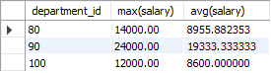

14. Find the department_id where the highest paid employee salary is more than 1000.
select department_id, max(salary) from employees group by department_id having max(salary)>=1000;
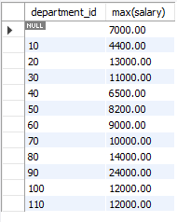

15. Find the department_id who is paid the maximum average salary in the organization: use subqueries.
select max(sal) from (select avg(salary) sal from employees group by department_id) as result;
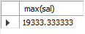

16. Find the department name and location_id in which 'Ernst' works.
select d.department_name, d.location_id, e.first_name, e.last_name from departments d, employees e where e.last_name='ernst';
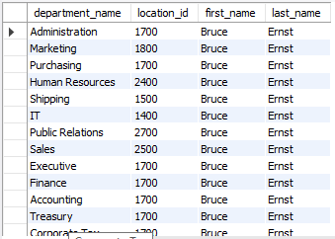
17. Find all the employees names who works in "Tokyo" city (use subqueries, table used: employees, departments, locations)
select first_name, last_name from employees where department_id = (select department_id from departments where location_id = (select location_id from locations where city = "Tokyo"));


18. Find the employees name who are the maximum paid salary in the organization.
select employee_id, first_name, last_name, salary from employees where salary=(select max(salary) from employees);
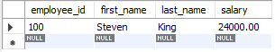

19. Find the employees who are drawing minimum salary in their respective departments (use the job table for getting min salary and use subqueries).
select employee_id, f_name, l_name, min_sal, d_id from (select min(salary) min_sal, employee_id, first_name f_name, last_name l_name, department_id d_id from employees group by department_id)emin;
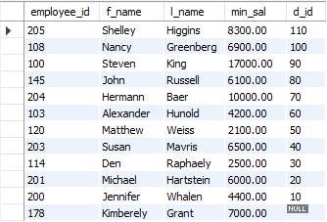

20. Find the employee names and their job_id and job_titles by joining employee and jobs table.
select e.first_name, e.last_name, e.job_id, j.job_title from employees e
inner join jobs j on e.job_id=j.job_id;
