# NgModelChange & Change Event in Angular

# NgModelChange is an Angular specific event, which we can use to listen for changes to the user input. It is the [@Output](https://www.tektutorialshub.com/angular/angular-input-output-eventemitter/) property of the [ngModel](https://www.tektutorialshub.com/angular/ngmodel-two-way-data-binding-in-angular/) directive, Hence we need to use it along with it. ngModle raises the NgModelChange event, whenever the model changes.

# Another way to listen for change is to use the change DOM event.

# If you are using template driven forms or reactive forms, then the better way to listen for changes is using the [ValueChanges](https://www.tektutorialshub.com/angular/valuechanges-in-angular-forms/) observable

## NgModelChange Example

The following is the simple example of ngModelChange.

We assign the method in the component class (handler function) to the ngModelChange using the [event binding](https://www.tektutorialshub.com/angular/event-binding-in-angular/)

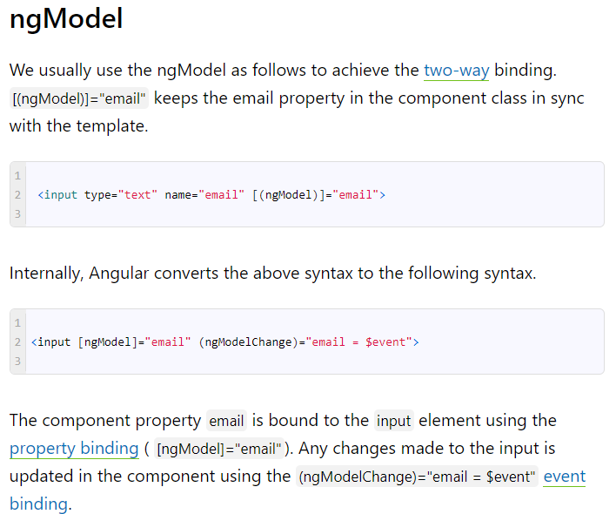

### ngModelChange with ngModel

|  |  |
| --- | --- |
| 3 | <input [(ngModel)]="firstName" (ngModelChange)="firstNameChanged($event)"/> |

|  |
| --- |
|  |

The Angular converts the above to the following syntax. We end up with the two ngModelChange event bindings.

<input [ngModel]="firstName (ngModelChange)="firstName = event"   (ngModelChange)="firstNameChanged($event)"/>

Here the ngModelChange fires in the order it is specified. Hence the (ngModelChange)="firstName = $event" fires first. (ngModelChange)="firstNameChanged($event)" fires later.

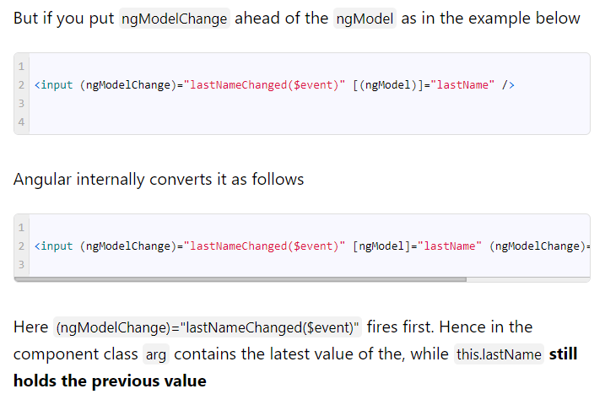

## Change Event

The (change) is a DOM event fires when changes to the form fields like <input>, <select>, and <textarea> is committed by the user.

This event fires when

* user changes the input & moves the focus away from the text box (blur event)
* On <select> it fires when the user selects a new option either by a mouse click or using a keyboard.
* Fires when the state of a check box or radio button change due to users action

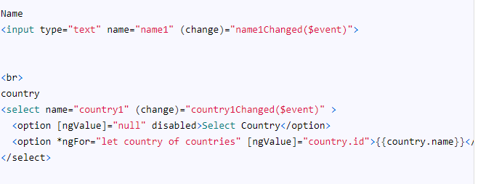

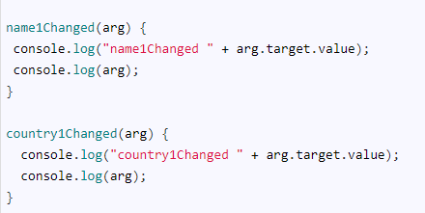

The change event for text element fires when we move the focus away from the element (blurred the input). This is different from the ngModelChange, which fires the event for each input change.

The other import point is the $event parameter. In the ngModelChange, it is always the new value. But in the case of a change event, it is event data. The event data is an object containing data about the event. We need to use the target.value to access the value.

