**What is Angular Environment**

Most apps go through different stages before they go into production.

These stages may be development, testing, staging, and production. We call these stages as Environment. All these Environments require different setups & configuration.

## What is Angular Environment Variable

The Environment Variable are those variables, whose value changes as per the environment we are in. This will help us to change some behavior of the App based on the environment.

For Example, You may want to use different API Endpoints for production, testing, and development. Or you do not want to send those log messages to console in the production environment.

## Where is Angular Environment Variable

The Angular provides built-in support to configure and manage environment variables. It keeps the environment configuration under the folder src/environments folder

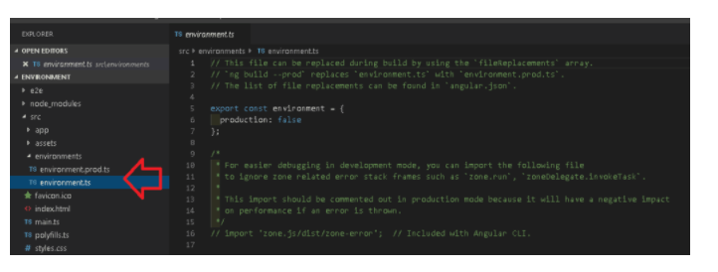

The folder contains two files one in environment.ts & the other one is environment.prod.ts

Out of the box, Angular provides support for the development & production environment

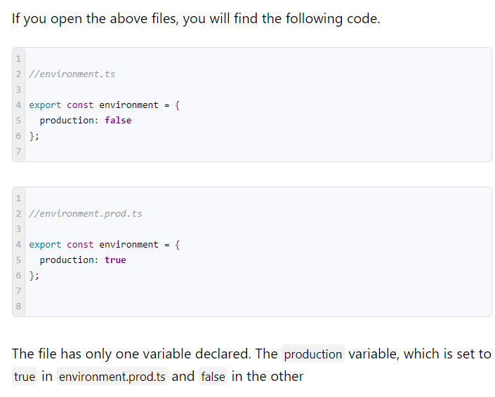

## How to Create Environment Variable

Creating a new environment variable is very simple. Add the new environment variable to all the environment files.

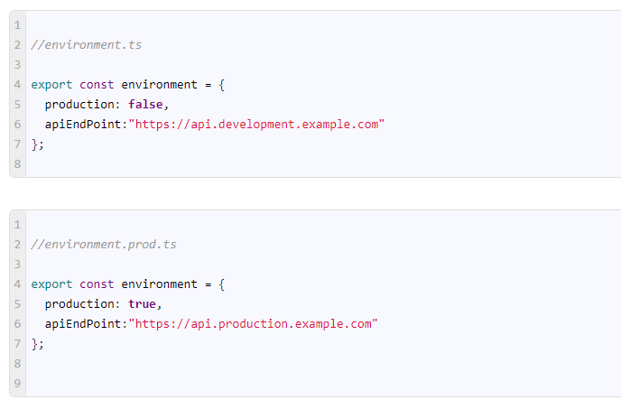

## How To Read the Environment Variable

## First, import the default environment in the component. Note that you should not import any other environment files like environment.prod, but only the default environment file.

## 

## Testing the Environment Variable

### ng serve

The ng serve command builds the app in memory and serves them via the local development server.

Run the app using the ng serve. This will build the app using the default or development environment variable. And you should see the https://api.development.example.com in your console window.

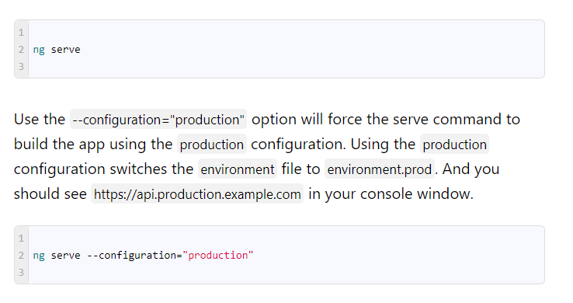

### ng Build

We use ng build to build the app before distributing it. it will only build the app and copies the final output to the dist folder.

ng build uses the default environment i.e. development environment.

The ng build --prod or (ng build --configuration="production") uses the production environment.

## How does Angular know to switch files?

It does not. It is our job to tell angular which files to use for each environment. We do that in Angular.Json file.

All the build related configuration to the app is stored under the node projects -> <name>-> architect -> build.

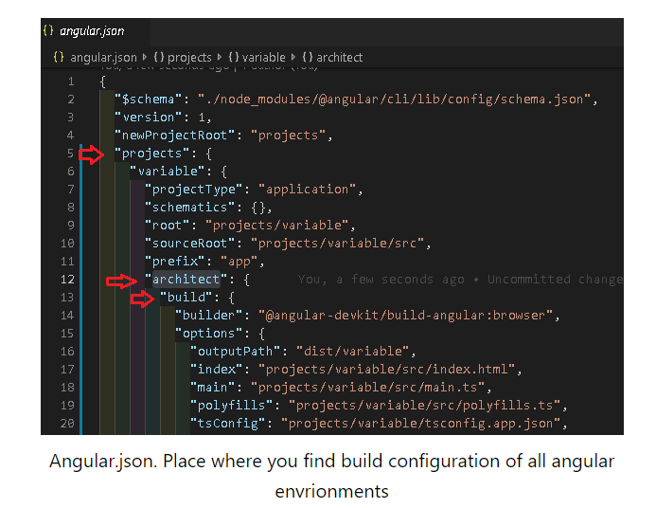

The build -> configuration -> production node is where all our configuration for the production build exits.

The fileReplacements section is where all the magic happens. It tells the angular compiler to replace the environment.ts with the environment.prod.ts, when the production configuration is used.

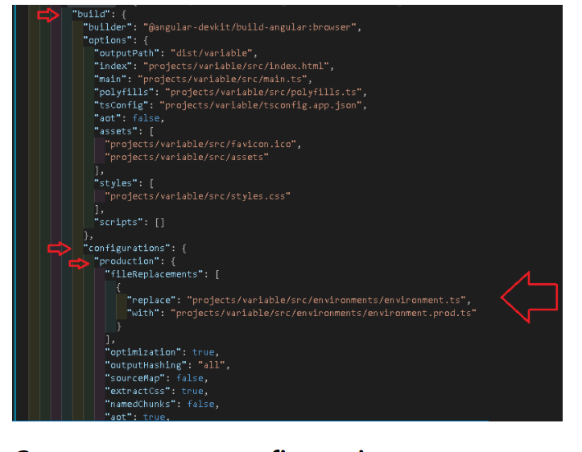

## Create our own configuration

We can create our own environment easily. Let us add the test configuration.

First, go to app->environments folder and create a new environment file. You can actually name the file whatever you want, but let us stick to the convention and name it as environment.test.ts.

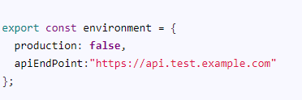

Next, we need to create a test node under the build ->configurations section as shown below. Add the fileReplacements section which instructs the compiler to use the environment.test.ts when in test configuration

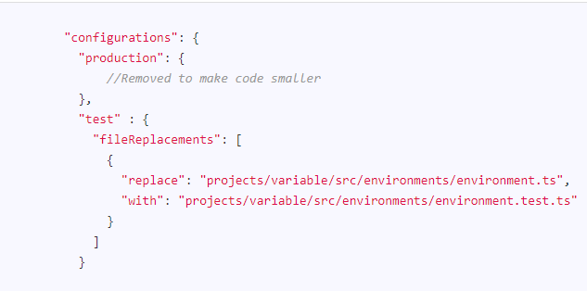

The above is sufficient if we want to use the configuration with the command ng build --configuration="test".

But if you want it to work with the ng serve then. we need to add the test node under architect->serve->configurationsnode with the following "browserTarget": "variable:build:test"

Note that the variable is the name of the app. You need to replace it with the name you have given to your app.

