* db.students.insertMany([

{ name: "Swathi", branch: "CSE", marks: 90 },

{ name: "Arun", branch: "ECE", marks: 82 },

{ name: "Latha", branch: "IT", marks: 88 }

])

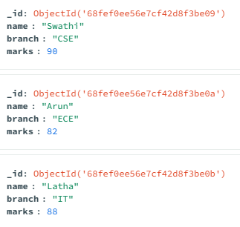

* db.students.find()

{

_id: ObjectId(**'68fef0ee56e7cf42d8f3be09'**),

name: **'Swathi'**,

branch: **'CSE'**,

marks: 90

}

{

_id: ObjectId(**'68fef0ee56e7cf42d8f3be0a'**),

name: **'Arun'**,

branch: **'ECE'**,

marks: 82

}

* db.students.updateOne(

{ name: "Ravi" },

{ $set: { marks: 90 } }

)

{

acknowledged: true,

insertedId: null,

matchedCount: 0,

modifiedCount: 0,

upsertedCount: 0

}

* db.students.deleteOne({ name: "Ravi" })

{

acknowledged: true,

deletedCount: 0

}