A Prototype Framework for Library Book Recommendation and Reservation: Design, Implementation, and Evaluation
CHEBATHINA DEVI LAKSHMI PRASANNA
Scholar, M.Tech, Department of Computer Science and Engineering
Koneru Lakshmaiah Education Foundation, Andhra Pradesh, India
2601050110@kluniversity.in
Raju Anitha
Professor, Department of Computer Science and Engineering
Koneru Lakshmaiah Education Foundation, Andhra Pradesh, India
anitharaju@kluniversity.in

Abstract—
This paper presents a prototype library book recommendation and reservation application implemented in Python. The system maintains five predefined book records and provides a console menu for viewing availability, displaying a fixed recommendation list, reserving an available title, returning a reserved title, and exiting the application. The implementation uses in-memory data structures and validates book selections and state transitions to prevent duplicate reservations and invalid returns. The submitted code was examined against its stated behavior, and functional test cases were derived from the implemented branches. The recommendation component is currently rule-based and fixed rather than personalized; therefore, this paper does not claim recommendation accuracy, user-level personalization, or large-scale performance. The prototype demonstrates a compact baseline for integrating catalog visibility and reservation state management, while identifying database persistence, user profiles, metadata-driven ranking, and empirical evaluation as future work.
Index Terms—Library information systems, book recommendation, reservation management, Python, functional testing, recommender systems.

I. INTRODUCTION
Libraries provide access to collections whose usefulness depends not only on acquisition but also on users’ ability to discover relevant materials and understand their current availability. Recommendation systems have been studied as a way to help users navigate large information spaces by presenting potentially useful items [1]. In library settings, recommendation methods can draw on item descriptions, circulation histories, ratings, or combinations of these signals [2], [3]. However, an operational library application also needs dependable circulation state handling: a recommendation is of limited practical value if a user cannot determine whether the book is available or whether a reservation request is valid.
This work describes a small, console-based prototype built with Python. Its scope is deliberately bounded: it includes five hard-coded book titles and a menu-driven workflow for displaying, recommending, reserving, and returning books. The objective is to document the implementation accurately and assess its basic functional behavior, not to present an unimplemented intelligent recommender as a completed contribution.
The paper makes three modest contributions: (1) a clear description of a simple catalog and reservation workflow; (2) a branch-based functional test specification aligned with the supplied source code; and (3) a gap analysis separating implemented capabilities from research extensions needed for a production or publication-grade recommendation system.

II. RELATED WORK
Recommender systems are designed to reduce information overload by selecting items likely to be useful to a particular user or context [1]. In contrast to a fixed recommendation list, collaborative filtering uses patterns across users and items, while content-based approaches use item attributes and a user’s expressed or inferred interests. Hybrid methods combine signals to address weaknesses that can arise when only one signal is available.
Library-specific studies have examined collaborative filtering and hybrid approaches. A probabilistic-keyword collaborative-filtering approach was proposed to use both circulation information and book keywords, with experiments reporting improvements over traditional user-based and item-based baselines on the study dataset [2]. A college-library personalized recommendation design combined collaborative filtering and content-based techniques and evaluated its method on a university-library dataset [3]. A comparative study of public-library book recommendation algorithms also considered collaborative filtering and association rules, reporting that a hybrid approach could provide more personalized results in its experimental setting [4]. These findings motivate data-driven recommendations, but they do not imply that the present prototype implements those algorithms.
The distinction between recommendation research and basic catalog operations is important. The current application does not collect user-item interactions, compute similarity, rank candidates using metadata, or calculate precision and recall. It is best treated as a functional baseline from which such mechanisms could later be developed.

III. SYSTEM REQUIREMENTS AND SCOPE

A. Functional Requirements
The application supports five menu actions: (1) show all books and their status; (2) print the predefined recommendations; (3) reserve a selected book if it is available; (4) return a selected book if it is reserved; and (5) exit. The initial catalog contains Python Programming, Data Structures, Machine Learning, Artificial Intelligence, and Database Management. All five records are initialized as available.

B. State and Validation Rules
Each record contains a title and an availability value. A successful reservation changes the selected record from available to reserved. A successful return changes it from reserved to available. An attempt to reserve a reserved book or return an available book leaves the state unchanged and displays a message. The code also handles invalid book numbers and non-numeric inputs, although the exact message and input-validation implementation differ slightly between the dictionary-based and nested-list versions.

C. Scope Boundaries
The data is held in process memory and is not persisted to a database or file. The application has no user authentication, individual reservation ownership, multiple-copy inventory, due dates, fine calculation, network interface, or transaction log. The recommendation output consists of three fixed titles—Python Programming, Data Structures, and Machine Learning—and is not generated from a user profile or learned model. These boundaries constrain the claims and evaluation presented in this paper.

IV. DESIGN AND IMPLEMENTATION

A. Architecture
The prototype follows a simple procedural design. A catalog data structure stores each title and availability flag. A menu loop accepts user commands and dispatches to operations for listing, recommending, reserving, and returning books. The display operation enumerates the catalog and maps each Boolean availability value to the human-readable status Available or Reserved. The reservation and return operations first show the catalog, then parse a selected number, check its range, and verify the state transition before updating the record.
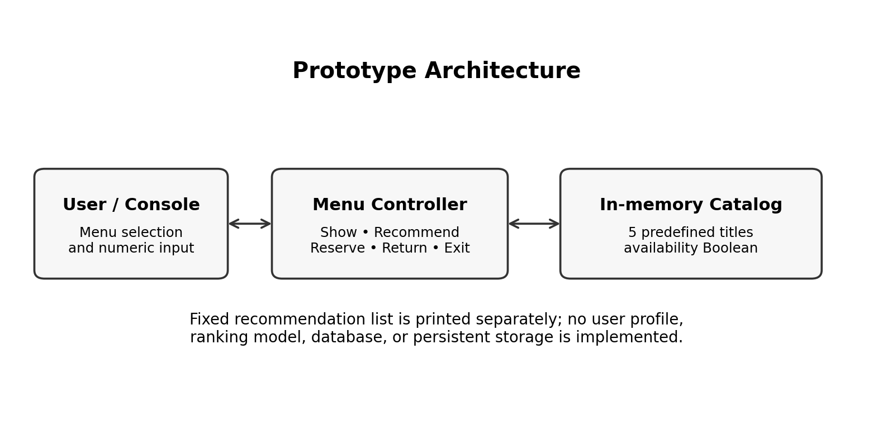
Fig. 1. High-level architecture of the implemented prototype.

B. Data Representation
Two submitted program variants represent the same conceptual data differently. The dictionary-based version stores each book as a mapping with title and available keys and places the menu loop in a main() function. The alternative version uses two-element nested lists and starts its menu at module level. The dictionary version uses exception handling for integer conversion; the nested-list version checks whether the entered selection contains digits before converting it. The differences affect implementation details but not the intended user-facing workflow.

C. Recommendation Strategy
The recommendation function prints three hard-coded entries. This is a deterministic demonstration of how a recommendation menu can be exposed, but it is not an algorithmic recommendation model. A research extension could represent each book with metadata such as subject, keywords, author, and publication year, then compare content-based ranking with collaborative or hybrid baselines. Such an extension would require a documented dataset, train/test protocol where appropriate, and metrics such as Precision@K, Recall@K, or NDCG@K; no such metrics are claimed for the present implementation.
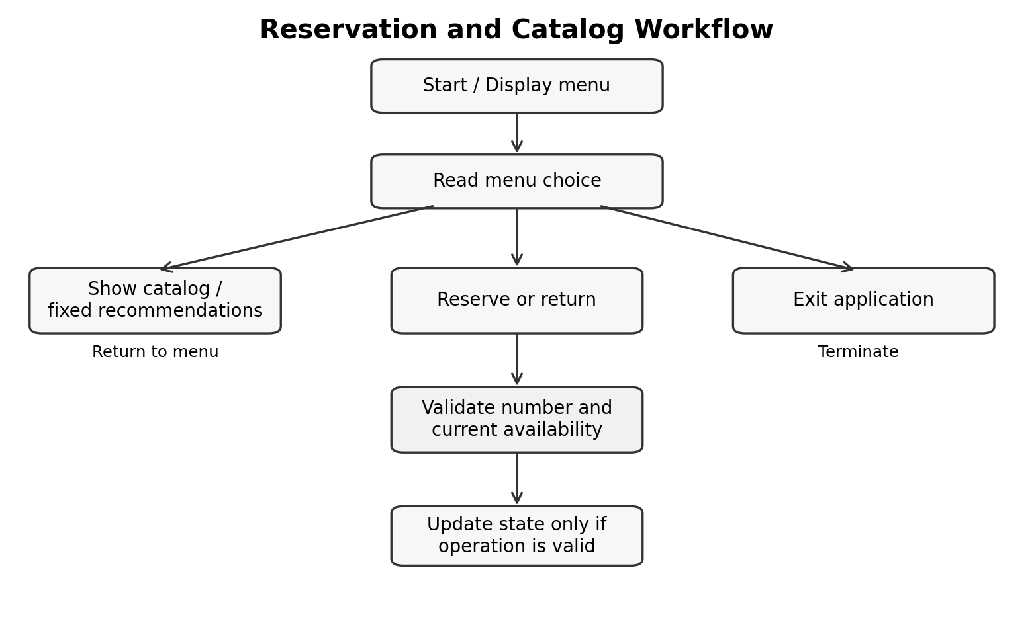
Fig. 2. Menu and reservation workflow; recommendations are fixed.

VIII. FUNCTIONAL EVALUATION
Evaluation was specified from the branches and state changes present in the submitted source. It is a functional verification plan rather than a statistical user study or performance benchmark. The tests below describe expected observable behavior for the implemented workflow.
Test case | Input / precondition | Expected behavior
T1: Catalog display | Choose Show Books | Five titles and current availability are printed.
T2: Recommendations | Choose Recommend Books | Three fixed titles are printed.
T3: Valid reservation | Choose a currently available book number | Availability changes to Reserved; success message appears.
T4: Duplicate reservation | Reserve the same title again | State is unchanged; already-reserved message appears.
T5: Valid return | Return a reserved title | Availability changes to Available; success message appears.
T6: Invalid number | Enter 0 or a number above 5 | Invalid book number is reported.
T7: Non-numeric input | Enter letters at book-selection prompt | Input error is reported without a state change.
T8: Invalid menu option | Enter a menu choice outside 1–5 | Invalid-choice message appears.
The test cases follow directly from the program’s conditional branches. Their expected results should be confirmed by executing each variant with the stated inputs before reporting them as observed test results. Because the application uses in-memory state, the initial availability state is restored when a new process starts. No throughput, latency, recommendation-quality, or multi-user concurrency measurements were performed.
Reproducibility note: Fig. 3 was generated from a local run of the submitted library_system(2).py script using a fixed sequence of menu inputs. Output may vary slightly across the alternate source-code variant.
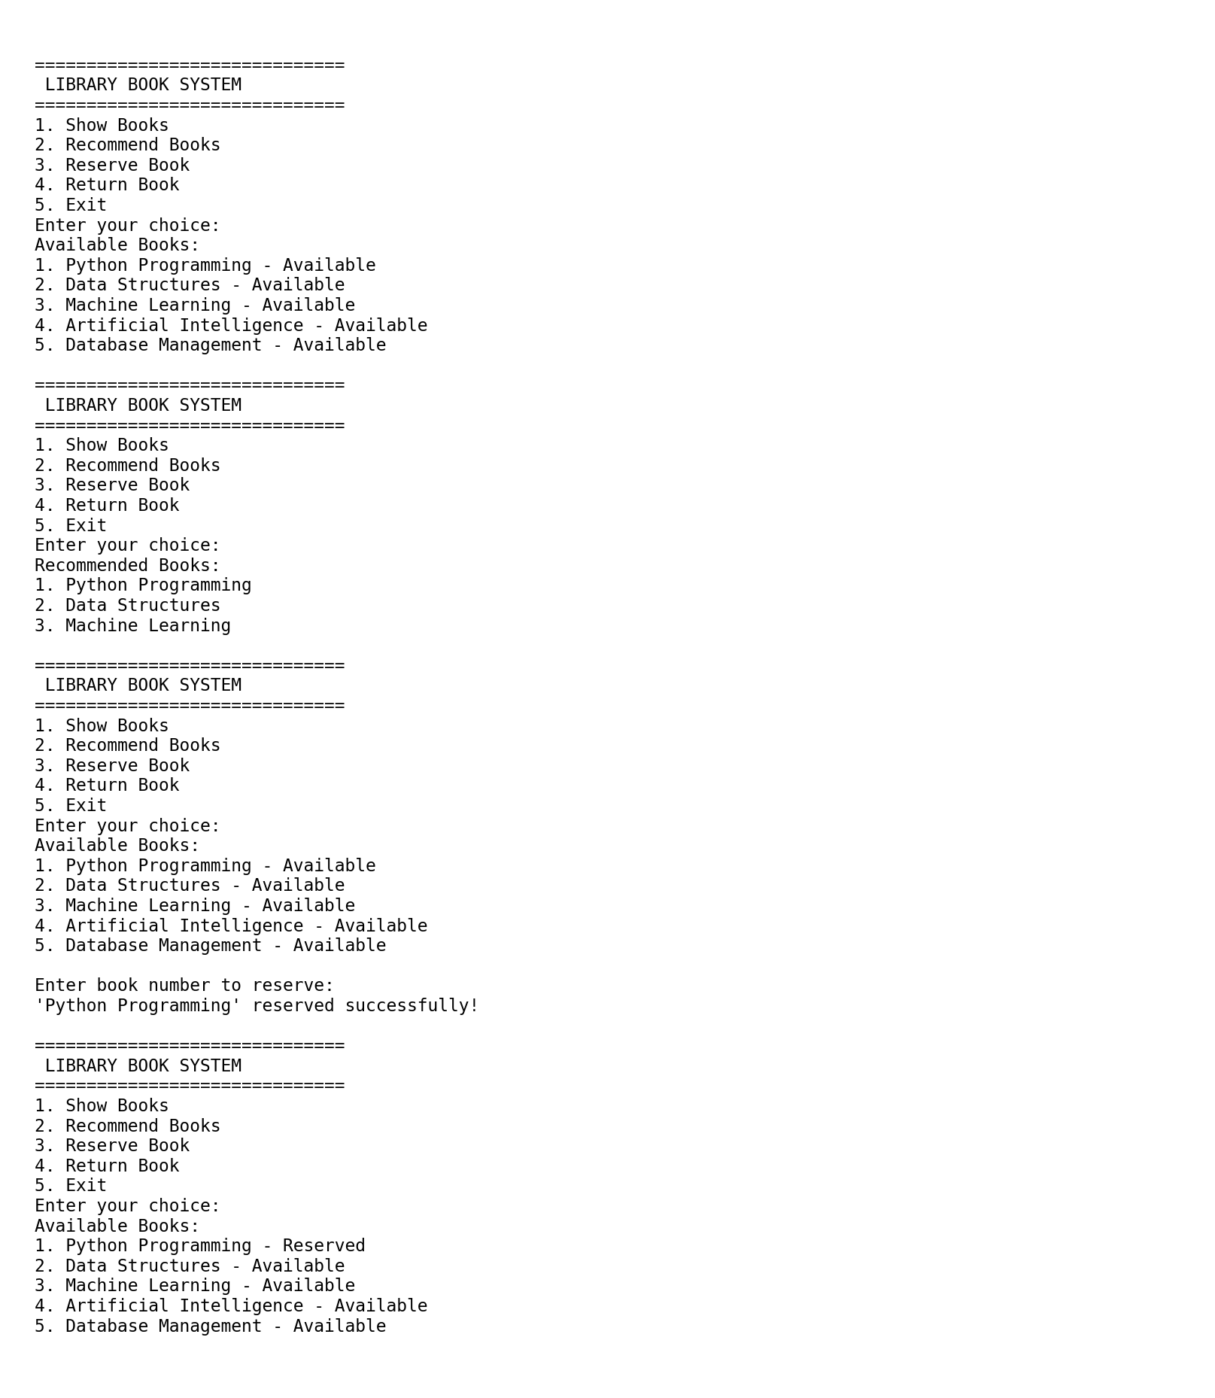
Fig. 3. Sample execution output captured by running the submitted Python program.

IX. DISCUSSION
The prototype demonstrates a compact and understandable reservation state machine. Guarding state changes with availability checks prevents the two most direct logical errors: reserving a title twice and returning a title that is already available. Numbered selection and concise feedback make the workflow easy to follow for a small catalog. The use of standard Python constructs also keeps the implementation portable and accessible for teaching and prototyping.
The principal limitation is that the recommendation label overstates the intelligence of the current fixed list if interpreted as personalized recommendation. Prior library studies use data and algorithms to generate ranked results [2]–[4]; the present implementation does not. Likewise, in-memory storage means that reservation state is not durable across application restarts and cannot coordinate multiple clients. The program should therefore be understood as a prototype of catalog interaction rather than a deployable library management platform.
A stronger evaluation would include a larger and documented catalog, realistic user or circulation data with suitable privacy safeguards, baseline recommendation algorithms, repeated experiments, and quantitative metrics. Reservation testing should additionally cover simultaneous requests, persistent transactions, and recovery from process failure. Until these extensions are implemented and evaluated, conclusions should remain limited to the stated functionality.

X. FUTURE WORK
The next stage should introduce persistent storage using a relational database and explicit entities for books, copies, users, and reservations. A transaction-safe reservation operation would help prevent conflicting updates when multiple clients act concurrently. The catalog could be extended with subject headings and keywords to support content-based ranking, followed by comparison with collaborative-filtering and hybrid baselines. A user interface and authentication layer could be added after privacy, access-control, and data-retention requirements are defined. Finally, an empirical study should specify the dataset, evaluation split, baselines, metrics, hardware, and reproducibility procedure before making claims about accuracy, scalability, or user benefit.

XI. CONCLUSION
This paper documented a Python prototype that combines catalog display, a fixed recommendation list, and book reservation/return operations. The implementation provides basic availability-state validation and informative responses for several invalid operations. Its current recommendation mechanism is deterministic and non-personalized, and its state is held only in memory. The contribution is therefore a transparent functional baseline and an evaluation plan, not a claim of a novel recommendation algorithm or a validated large-scale system. Persistent data management, personalized ranking, concurrency-safe reservations, and quantitative evaluation are the principal steps required to extend the prototype into a stronger research system.

V. OPERATIONAL ALGORITHM AND STATE MODEL

A. Reservation and Return Procedure
Let the catalog be B = {b1, b2, …, bn}, where each book bi has a title ti and a Boolean availability state ai. The current prototype uses n = 5. A menu selection k is valid only when 1 ≤ k ≤ n. For reservation, if ak is true, the operation sets ak ← false and reports success; otherwise it reports that the book is already reserved. For return, if ak is false, the operation sets ak ← true; otherwise it reports that the book is already available. Invalid input does not change the catalog state.
The core state transition can be written as: Available → Reserved after a valid reservation, and Reserved → Available after a valid return. The implementation does not define a separate pending-reservation state, reservation owner, expiration time, or transaction identifier. Consequently, the Boolean flag is sufficient for the prototype but is not sufficient to model the operational needs of a multi-user institutional library.

B. Algorithmic Outline
Algorithm 1: Menu-driven library workflow
1) Initialize the five book records with availability = true. 2) Display the menu and read a command. 3) If command is Show, enumerate records and display status. 4) If command is Recommend, print the fixed three-title list. 5) If command is Reserve or Return, display the catalog, parse the selected index, check range and state, and apply the permitted transition. 6) If command is Exit, print the exit message and terminate; otherwise report an invalid menu option and repeat.
For a catalog of n records, displaying all books takes O(n) time and O(1) auxiliary space apart from output. Reservation and return perform a catalog display before updating a single indexed record, so their total time is also O(n) in the current interaction flow and the state update itself is O(1). Printing the fixed recommendation list is O(r), where r = 3. These are algorithmic bounds for the current in-memory implementation, not measured runtime results.

VI. TEST DESIGN AND OBSERVABLE OUTCOMES

A. Functional Coverage
The test matrix covers normal paths, boundary values, and invalid transitions. A successful reservation should be followed by a catalog display showing the selected title as Reserved. A subsequent duplicate reservation should preserve that state. A successful return should restore Available, while returning the same title again should leave it Available. These paired tests are important because testing only the success message would not verify whether the state was updated correctly.
Boundary tests should include the first valid index (1), the last valid index (5), zero, and an index greater than five. Input parsing tests should include an empty line, alphabetic text, and a numeric-looking value with a sign or decimal point. The two submitted variants differ in parsing strategy: the dictionary implementation attempts integer conversion and catches ValueError, while the nested-list implementation accepts only strings for which isdigit() is true. Therefore, equivalent user inputs can produce slightly different messages, and this behavior should be documented when comparing variants.

B. Reproducibility and Reporting
A reproducible test record should include the source filename and version, Python version, exact input sequence, console output, initial catalog state, and final state. Since state is held in memory, every independent test run should start a new process or explicitly reset the catalog. Thread scheduling output from the separate thread demonstration is nondeterministic and is not evidence that the library reservation operations are thread-safe. No concurrency guarantees should be inferred from that demonstration because the supplied thread example runs independent printing tasks and does not access the book catalog.
The expected outcomes in Table I are specification-derived. To convert this manuscript into a fully empirical paper, the authors should execute and archive each test case and update the results table with observed outcomes, failures, and the environment used. Recommendation evaluation additionally requires a meaningful relevance ground truth or user study; a static list cannot support conventional ranking-quality metrics.

VII. RESEARCH IMPLICATIONS AND VALIDITY THREATS
The prototype provides an educational baseline for joining two tasks that are often discussed separately: resource discovery and availability management. Its immediate value is operational clarity rather than algorithmic novelty. The fixed recommendation list illustrates an interface-level concept, while the state checks demonstrate how a reservation request can be rejected when it violates current availability. This separation creates a useful starting point for future experiments in which ranking methods can be changed without rewriting the basic catalog workflow.
Several validity threats limit interpretation. First, the catalog contains only five hard-coded titles and is not representative of a real academic library. Second, there are no real users, borrowing records, relevance judgments, or user satisfaction measures. Third, the system stores state only in memory, so persistence and multi-client behavior are outside the evaluation. Fourth, functional test expectations do not substitute for a fully logged execution study. Finally, because the recommendations are predetermined, no claim can be made about personalization, recommendation accuracy, or improvement over a baseline.
For a future comparative study, a suitable protocol would define a dataset and privacy procedure; split interaction data into training and test portions using a temporally appropriate strategy; compare popularity, content-based, collaborative-filtering, and hybrid baselines; and report Precision@K, Recall@K, NDCG@K, and coverage. Operational evaluation should separately measure reservation success under concurrent requests, consistency after restart, and response time under a stated workload. Separating ranking quality from transaction correctness would make the resulting claims easier to reproduce and interpret.

REFERENCES
[1] P. Resnick and H. R. Varian, “Recommender systems,” Communications of the ACM, vol. 40, no. 3, pp. 56–58, Mar. 1997, doi: 10.1145/245108.245121.
[2] “Enhancing the performance of library book recommendation system by employing the probabilistic-keyword model on a collaborative filtering approach,” Procedia Computer Science, vol. 157, pp. 345–352, 2019, doi: 10.1016/j.procs.2019.08.176.
[3] “College library personalized recommendation system based on hybrid recommendation algorithm,” Procedia CIRP, vol. 83, pp. 490–494, 2019, doi: 10.1016/j.procir.2019.04.126.
[4] H. Duchen, “A comparative study of various book recommendation algorithms for public libraries,” Technical Services Quarterly, vol. 39, no. 4, pp. 369–380, 2022, doi: 10.1080/07317131.2022.2125676.
[5] IEEE Author Center, “IEEE article templates.” [Online]. Available: https://journals.ieeeauthorcenter.ieee.org/create-your-ieee-journal-article/authoring-tools-and-templates/tools-for-ieee-authors/ieee-article-templates/. Accessed: Oct. 14, 2026.

