A MINI PROJECT REPORT ON
CubeSolve AI
Camera-Based Rubik’s Cube Scanner and Solver

BACHELOR OF TECHNOLOGY IN
[DEPARTMENT / BRANCH NAME]
[UNIVERSITY REGISTRATION NO.]

Submitted By
[STUDENT NAME 1] ([ROLL NO.])
[STUDENT NAME 2] ([ROLL NO.])
[STUDENT NAME 3] ([ROLL NO.])
[STUDENT NAME 4] ([ROLL NO.])

Under the guidance of
[GUIDE NAME, QUALIFICATION, DESIGNATION]
Department of [DEPARTMENT]

[COLLEGE NAME]
[COLLEGE ADDRESS]
[ACADEMIC YEAR, e.g. 2025-2026]

[COLLEGE NAME]
[COLLEGE ADDRESS]
DEPARTMENT OF [DEPARTMENT]

CERTIFICATE

This is to certify that the mini project work entitled “CUBESOLVE AI” is a bonafide work carried out by “[STUDENT NAME 1] ([ROLL NO.]), [STUDENT NAME 2] ([ROLL NO.]), [STUDENT NAME 3] ([ROLL NO.]), [STUDENT NAME 4] ([ROLL NO.])” in partial fulfilment of the requirements for the award of the degree of Bachelor of Technology in [BRANCH] during the academic year [ACADEMIC YEAR].

Project Guide Head of the Department

Abstract
In this project, we present a client-side web application named CubeSolve AI that scans a 3×3 Rubik’s Cube with a device camera, reads the colours of all six faces, checks that the resulting cube is physically valid, computes a solution, and guides the user through every move with an animated 3D cube. The application is built with React, Vite and Tailwind CSS and uses the open-source cubing library for the cube model, the solving algorithm and the 3D viewer. The whole application runs inside the browser. It has no back-end server, no database, no user login, and no image is ever uploaded.
Colour recognition is done without OpenCV or any machine-learning model. Each of the nine stickers of a face is sampled from its cell, converted from sRGB to the CIE Lab colour space and matched to the nearest of the six centre stickers, which act as colour references for that scan. In this way the result adapts to the lighting and to cubes that do not use the standard colour scheme. Stickers that are far from every reference, or almost equally close to two references, are flagged as uncertain so that the user can correct them manually on a review screen.
Before solving, the scanned state is validated against the rules of a real cube: each colour must appear exactly nine times, centres must be correct, every corner and edge must be a valid and unique piece, corner twists, edge flips and permutation parity must be possible. Plain-language error messages explain any problem. Only a valid state is sent to the solver, which runs in a Web Worker, and every generated solution is verified on the cube model before it is shown. The result is a simple, private and free tool that can be used from any modern browser, and it shows how computer vision, colour science and puzzle-solving algorithms can be combined entirely on the client side.

INTRODUCTION

ABOUT THE PROJECT
Have you ever picked up a scrambled Rubik’s Cube and had no idea where to begin? CubeSolve AI is built for exactly that moment. Hold the cube in front of your camera, show each of its six faces, and the application reads the colours, checks them, and tells you the moves needed to solve the cube, one at a time, with a 3D cube that turns along with you. If you do not want to use a camera, you can upload a photo of each face instead. Price: Free.

Application Features
- Camera scanning of all six faces with an on-screen guide square, or photo upload for each face.
- Automatic colour recognition using centre-sticker calibration in CIE Lab colour space.
- Review screen with a cube net, uncertain stickers marked in amber, tap-to-correct colours and 90° face rotation.
- Plain-language validation messages for impossible cube states.
- Verified solution with step-by-step controls: Next, Previous, Reset and Auto-play.
- Animated 3D cube and highlighted layer on the net for every move.
- Fully private: all processing happens in the browser and no image is uploaded.

Currently Supported Platforms
All modern desktop web browsers (Chrome, Edge, Firefox). Camera access needs a secure context, that is localhost, 127.0.0.1 or HTTPS. Testing so far has been done on desktop Chromium; real mobile hardware and iOS Safari have not yet been tested.

Genre
Computer Vision, Puzzle Solving, Educational Tool, Web Application.

PROBLEM STATEMENT
Design a web application that can be opened in a browser without installation or registration, and that lets a user solve a scrambled 3×3 Rubik’s Cube by simply showing the cube to a camera. The application must read the colours reliably under normal lighting, detect and explain scanning mistakes, refuse impossible cube states, and present a correct solution in a form that a beginner can follow. It must not require server infrastructure and must not send the user’s images anywhere.

OBJECTIVES OF STUDY
- To capture the six faces of a Rubik’s Cube using a browser camera or uploaded photos.
- To classify sticker colours accurately using Lab colour distance with the centre stickers as references, without heavy computer-vision libraries.
- To validate the scanned cube state mathematically (counts, pieces, twists, flips and parity) and report problems in plain language.
- To compute and verify a solution using a Kociemba-style two-phase solver running in a Web Worker.
- To guide the user step by step through the solution with an animated 3D view.
- To demonstrate a complete, tested, client-side React application with unit and end-to-end tests.

PROJECT DEFINITION
CubeSolve AI is a single-page client-side web application built with React 19, Vite and Tailwind CSS, with a hash-based router and no server dependency. The user interacts through mouse, keyboard or touch to scan faces, review colours, generate a solution and step through it. The scan state (captures, rotations and manual corrections) is kept in the browser’s sessionStorage so a page refresh does not lose progress, and it is discarded when the tab is closed.

RELATED WORK

EXISTING SYSTEM
Manual colour entry solvers. Many online Rubik’s Cube solvers ask the user to click on each of the 54 stickers and choose its colour. This is slow, tiring and error-prone, and a single wrong click gives an invalid cube with little explanation.
Mobile apps with scanning. Some mobile apps scan the cube with the camera, but they usually need installation, may upload images to a server, and often fail silently when the lighting is poor.
Heavy computer-vision approaches. Research projects often rely on OpenCV or neural networks. These give high accuracy but add large dependencies, training data and hardware requirements that are unnecessary for a simple educational tool.
Solver libraries without a user interface. Algorithm libraries can solve a cube from a given state, but a beginner cannot use them without writing code.

ADVANTAGES OF THE PROPOSED SYSTEM
Reduces Manual Effort. The user shows each face to the camera instead of typing 54 colours. Only the stickers that the app is unsure about need attention.
Adapts to Lighting and Cube Brand. Because each scan uses its own centre stickers as the colour references, the same code works under warm or cool light and on cubes with non-standard colours.
Builds User Confidence. Every problem is explained in plain language, for example that a colour appears eight times instead of nine, or that a corner is twisted. The user always knows what to fix.
Trustworthy Solutions. The generated solution is replayed on the cube model and only shown if it really ends in the solved state.
Privacy. All processing happens in the browser. No image or scan data leaves the device.
Strengthens React and Web API Skills. The project is a practical example of React components and context, Web Workers, the MediaDevices camera API, the Canvas API, hash routing and sessionStorage.
Demonstrates Applied Colour Science. It shows why the CIE Lab colour space and the median of a sampling window give far more stable colour matching than raw RGB values.
Demonstrates Testing Practice. The project includes unit tests for the cube model, solver and vision code, and end-to-end tests that drive the real interface with a fake camera.

REQUIREMENT ANALYSIS
The primary requirement of this application is a modern web browser with camera support. CubeSolve AI is a free, client-side tool. To develop or modify it, Node.js and npm are needed. The project uses plain JavaScript and React, so learners can follow the structure easily and extend it, for example with a better colour classifier or a different solver.

SOFTWARE REQUIREMENTS
Item | Details
Code editor | Visual Studio Code
Runtime | Node.js 22.12 or newer, with npm
Browser | Google Chrome / Microsoft Edge / Firefox with camera support
Operating system | Windows (also works on macOS and Linux)
Frameworks and libraries | React 19.3.0, Vite 8.3.2, Tailwind CSS 4.3.3, cubing 0.63.8
Testing tools | Vitest 5.0.3 (unit tests), Playwright 1.63.0 (end-to-end tests), ESLint 9.39.5 (linting)

SYSTEM REQUIREMENT SPECIFICATION
The system requirement for running the application is any device with a modern browser. All application logic is executed by the browser’s JavaScript engine. To use the live camera, the page must be opened from a secure context: http://localhost, http://127.0.0.1 or an HTTPS address. If it is opened from another device over a plain-HTTP local network address, the browser blocks the camera; in that case the Upload photo option can be used. An internet connection is not required once the page is loaded. On a device where JavaScript is disabled, the application will not work.
Requirement | Specification
Browser | Latest stable Chrome, Edge or Firefox
Camera | Any webcam or phone camera (optional, since photo upload is available)
Secure context | localhost, 127.0.0.1 or HTTPS
Node.js (developers) | 22.12 or newer
Network | Not required after the page has loaded
Storage | sessionStorage support for keeping the scan during the session

PROPOSED SYSTEM
CubeSolve AI delivers its whole workflow inside the browser. As a purely client-side system it has natural limitations, such as approximate colour recognition and no storage of scans across sessions, and these are listed in the Limitations section as the roadmap for future work.

Capabilities
- Access to the device camera through the browser MediaDevices API, with a clear message if permission is blocked.
- Photo upload for each face as an alternative to the camera.
- Median sampling of the central 50% of each sticker cell, so that glare and shadow edges have little effect.
- Colour classification in CIE Lab space with centre stickers as references and flagging of uncertain stickers.
- Manual correction of any sticker and 90° rotation of a whole face on the review screen.
- Full mathematical validation of the cube state with plain-language error messages.
- Solving with the cubing library’s 3×3×3 solver inside a Web Worker so the interface never freezes.
- Verification of the solution on the cube model before display.
- Step-by-step guidance with Next, Previous, Reset and Auto-play, an animated 3D cube (TwistyPlayer) and a highlighted layer on the net.
- Scan state persistence in sessionStorage during the browser tab’s lifetime.

System Workflow
The user moves through three stages: Scan, Review and Solve. The router uses the URL hash (#/scan, #/review, #/solve), so no routing library is needed.
Stage | Main module | What happens
1. Scan | CameraCapture, vision/sampling.js | Each face is captured in the order Up, Right, Front, Down, Left, Back. Nine RGB samples per face are stored.
2. Review | vision/scan.js, ValidationPanel | Stickers are classified, uncertain ones are marked, the user corrects mistakes, and the state is validated.
3. Solve | cube/solver.js, CubeViewer | A verified solution is generated and the user steps through it with the 3D view.

DESIGNER
React lets the developer describe the interface as a tree of components. Each component receives properties and keeps its own state, and the page is updated automatically when that state changes. In CubeSolve AI the components are written in JSX and styled with Tailwind CSS utility classes. The project has two types of building blocks: visible UI components such as buttons, the face chips, the cube net and the 3D viewer, and non-visible logic modules such as the cube model, the validator, the colour classifier and the solver, which are plain JavaScript functions that can be tested without a browser.
The application is divided into four pages, each of which is a React component: Home, Scan, Review and Solve. They share a common Layout component with the header navigation and a footer that states that processing runs in the browser and no images are uploaded.

OUR PROJECT’S DESIGN
First, we planned the three user stages (scan, review, solve) and decided that the application should be a single page with a header containing the links Home, Scan, Review and Solve. The Home page introduces the app and has a Start scanning button. The Scan page has a row of six face chips that show which faces are captured, a Camera / Upload photo tab, a live preview with a square guide divided into a 3×3 grid, and a side panel showing the captured face and the overall progress. The Review button remains disabled until all six faces are captured.
The Review page shows the six faces as a cube net. Each sticker is a button; uncertain stickers have an amber outline. Tapping a sticker opens a colour chooser. Each face has Rotate and Retake controls. A validation panel at the side either says that the cube state is valid or lists the problems found, and the Generate solution button is enabled only when the state is valid.
The Solve page has the 3D cube with a progress bar and the control buttons on the left, and three cards on the right: the current instruction, the cube state net, and the list of all moves. A “Verified solved” badge appears when the final state is solved.

Face and Colour Convention
- A cube state is an array of 54 face letters in the order U R F D L B, nine per face, read row by row as seen from outside the cube. This is the standard Kociemba facelet order.
- The centre sticker of each face is the colour reference of that face. A scanned sticker takes the letter of the nearest centre in Lab space.
- The default labels follow the Western colour scheme: Up white, Right red, Front green, Down yellow, Left orange, Back blue.

COMPONENTS STRUCTURE

Project Folder Structure
RubixCube/
index.html, vite.config.js, eslint.config.js, playwright.config.js
e2e/workflow.spec.js End-to-end tests (Playwright)
src/
main.jsx, App.jsx, index.css
cube/ cubies.js cubeState.js solver.js moves.js (+ unit tests)
vision/ color.js sampling.js scan.js (+ unit tests)
state/ ScanContext.jsx
lib/ router.js capture.js colors.js
components/ CameraCapture CrossNet CubeViewer ValidationPanel
Layout EmptyState
pages/ Home.jsx Scan.jsx Review.jsx Solve.jsx

User Interface Components
Component | Description
Layout | Header with logo and navigation links (Home, Scan, Review, Solve) and a footer with the privacy note
Home page | Introduction to the app and the Start scanning button
Scan page | Face chips, Camera / Upload photo tabs, live preview, capture button and progress panel
CameraCapture | Starts the camera stream, draws the guide square and captures the current frame
Review page | Cube net with correctable stickers, rotate and retake controls, warnings
CrossNet | Draws the six faces in the cross-shaped net and highlights the layer being turned
ValidationPanel | Shows “Cube state is valid” or the list of problems found
Solve page | Generate solution, step controls, progress bar, move list and state net
CubeViewer | Wraps the cubing TwistyPlayer to show the animated 3D cube
EmptyState | Message shown when a page is opened before the required data exists

Logic Modules
Module | Description
cube/cubies.js | Facelet layout, corner and edge tables, default colour scheme
cube/cubeState.js | Converts between the 54-sticker state and the cubing pattern; validates the cube and produces plain-language errors
cube/solver.js | Wrapper around the cubing 3×3×3 solver; verifies each solution before it is returned
cube/moves.js | Move notation, plain-language descriptions and layer highlighting
vision/color.js | sRGB to CIE Lab conversion and colour distance
vision/sampling.js | Finds the guide square and samples the nine stickers of a face using the median
vision/scan.js | Classifies the stickers of all six faces using the centres as references
state/ScanContext.jsx | React context that stores captures, rotations and corrections in sessionStorage
lib/router.js | Small hash router (#/scan, #/review, #/solve)
lib/capture.js | Camera and photo capture helpers

BLOCKS (CODE LOGIC)
Every component in CubeSolve AI has properties whose current values form its state. For example, a sticker’s state is the face letter it represents and whether it is uncertain; the Solve page’s state is the list of moves and the index of the current move. The initial scan state is loaded from sessionStorage when the page opens. Below are the main logic blocks of the application.

1. Sampling a face
The sampleFace() function reads the nine stickers inside the guide square. For each cell it takes the central 50% of the cell and returns the per-channel median of the pixels, so reflections and dark edges between stickers do not change the result.
export function sampleFace(imageData, rect) {
const { data, width } = imageData;
const cell = rect.size / 3;
const out = [];
for (let row = 0; row < 3; row++) {
for (let col = 0; col < 3; col++) {
const x0 = Math.round(rect.x + col * cell + cell * 0.25);
const y0 = Math.round(rect.y + row * cell + cell * 0.25);
const span = Math.max(1, Math.round(cell * 0.5));
// collect r, g, b of every pixel in the window ...
out.push([median(rs), median(gs), median(bs)]);
}
}
return out;
}

2. Classifying the stickers
The classifyScan() function converts the centre sticker of each face into a Lab reference colour. Every sticker is then compared with the six references and receives the letter of the nearest one. A sticker is marked uncertain when it is farther than 45 units from every reference, or when the best and second-best references differ by less than 8 units. The function also warns when two centres are closer than 18 units, because those two colours are likely to be confused.
const refs = {};
for (const f of FACES) refs[f] = rgbToLab(captures[f].samples[4]);

const ranked = FACES.map((face) => ({ face, d: deltaE(lab, refs[face]) }))
.sort((x, y) => x.d - y.d);
const best = ranked[0], second = ranked[1];
const uncertain = best.d > MAX_CONFIDENT_DISTANCE ||
second.d - best.d < MIN_MARGIN;

3. Validating the cube
The decodeCube() function checks the 54-sticker state in stages. It first counts the colours and centres. It then maps every corner and edge to a real piece, makes sure no piece appears twice and finds the orientation of each. Finally it checks that the sum of corner twists is divisible by 3, that the sum of edge flips is even, and that the permutation parity of corners and edges is equal. Any failure produces a readable message such as “The Red (Right) colour appears 8 times; it must appear exactly 9 times.”
if (cornerOrientation.reduce((a, b) => a + b, 0) % 3 !== 0)
errors.push('Corner orientation is impossible: at least one corner is twisted.');
if (edgeOrientation.reduce((a, b) => a + b, 0) % 2 !== 0)
errors.push('Edge orientation is impossible: at least one edge is flipped.');
if (permutationParity(cornerPieces) !== permutationParity(edgePieces))
errors.push('Corner and edge arrangements have different parity ...');

4. Solving and verifying
The solveFacelets() function builds a cubing pattern from the valid state and calls experimentalSolve3x3x3IgnoringCenters(). Before the result is returned, the solution is applied to the pattern and compared with the solved pattern. If it does not end in the solved state, no solution is shown.
solution = await experimentalSolve3x3x3IgnoringCenters(pattern);
const solved = kpuzzle.defaultPattern();
if (!pattern.applyAlg(solution).isIdentical(solved)) {
return { ok: false, errors: ['The generated solution did not verify ...'] };
}
const moves = [...solution.childAlgNodes()].map((n) => n.toString());
return { ok: true, solution, moves, facelets: encodeCube(pattern.patternData) };

5. Hash router
A small custom router reads window.location.hash and re-renders the correct page when it changes, so no routing library is required. A query such as #/scan?face=R opens the Scan page on a chosen face, which is how the Retake button works.
export function navigate(route, query) {
window.location.hash = query
? `/${route}?${new URLSearchParams(query)}` : `/${route}`;
}

TESTING
Testing is automated at two levels. The unit tests (Vitest) check the cube model, the move notation, the solver and the vision code; they verify the facelet mapping against a known reference (an R turn) and against random scrambles, and test colour classification with synthetic images. The end-to-end tests (Playwright, Chromium) drive the real interface with a fake camera feed and with uploaded images that are painted on a canvas using a non-standard colour palette, which proves that centre-based calibration works.
No. | End-to-end test case | Expected result
1 | Open the home page and press Start scanning | Scan page opens at “Scan the Up face”
2 | Enable the fake camera and capture a face | Face is marked captured and the next face is requested
3 | Upload six faces of a scrambled cube, review, generate a solution and press Next for every move | “Cube state is valid”, then “All moves complete. The cube is solved.” and a Verified solved badge
4 | Upload a face with one wrong sticker | Problems are reported, Generate solution is disabled; after correcting the sticker, it is enabled
5 | Press Retake Front face on the review page | Scan page opens on the Front face

RESULTS
After the interface, vision code and solver were complete and verified in the browser, the application is ready to use. In development it is started with npm run dev and opened at http://127.0.0.1:5173; a production build is created with npm run build and served with npm run preview. The screenshots below were captured from the running application using a fake camera feed and synthetic face photos of a scrambled cube.
After opening the application, the home page appears like this:
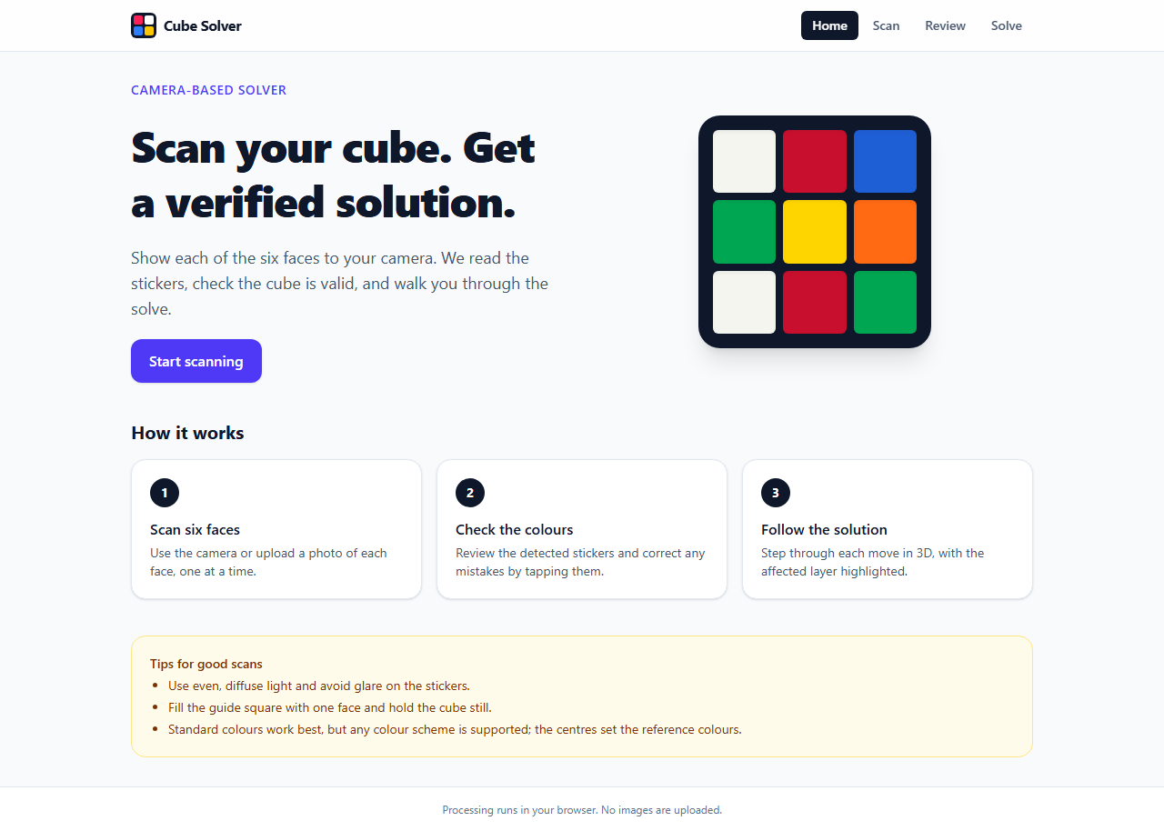
Figure 1: Home page
Scan page with the live camera preview and the 3×3 guide square (a built-in test pattern is shown in place of a real cube):
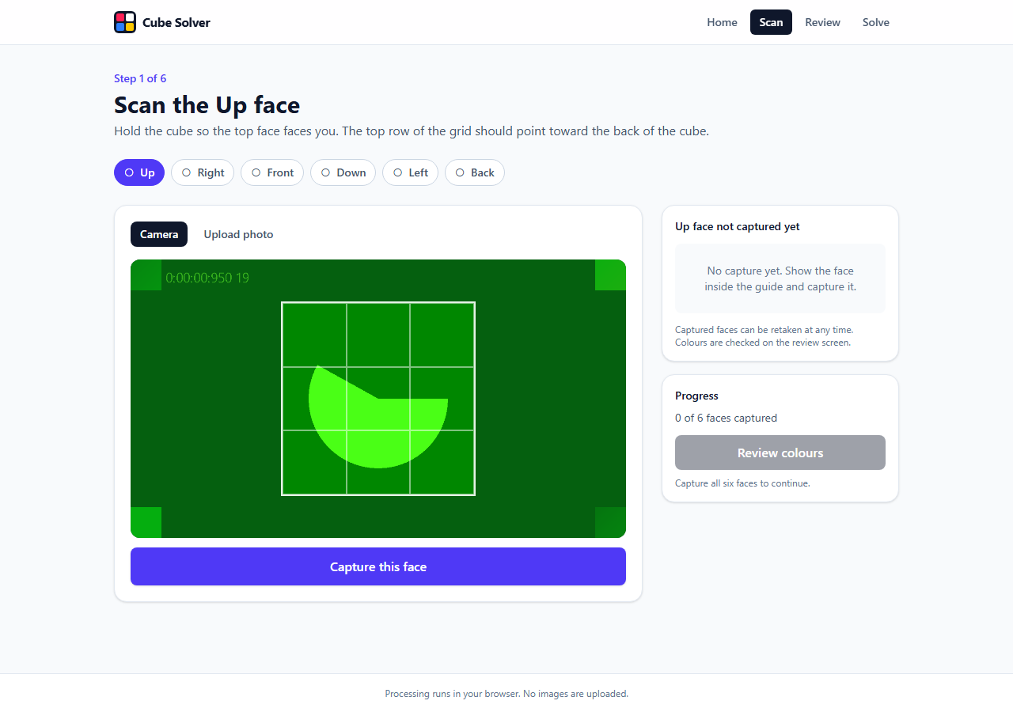
Figure 2: Scan page with live camera preview
Scan page while photos are being uploaded; the captured faces are ticked in the face chips:
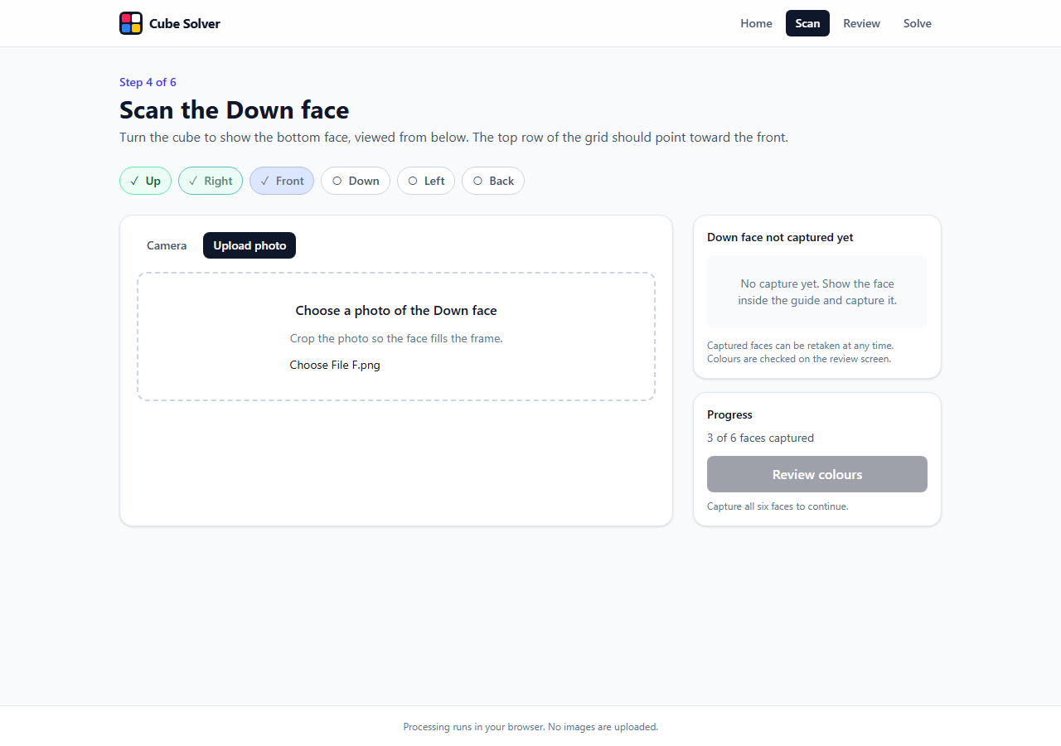
Figure 3: Scanning in progress (three faces captured)
All six faces captured and the Review colours button enabled:
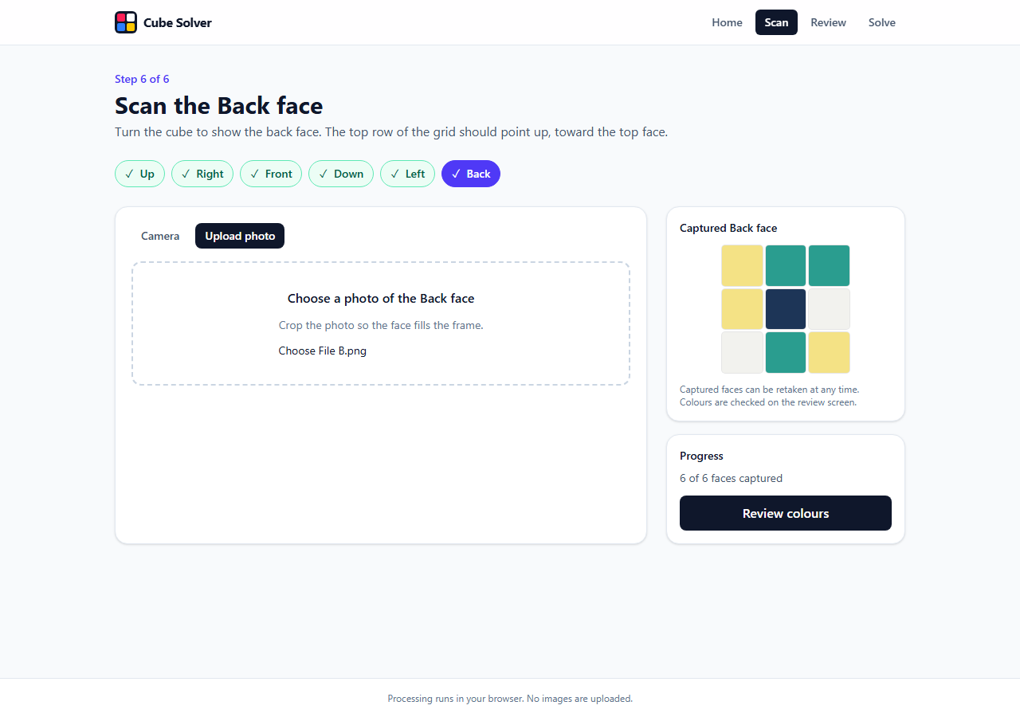
Figure 4: All six faces captured
Review page showing the cube net and a valid cube state:
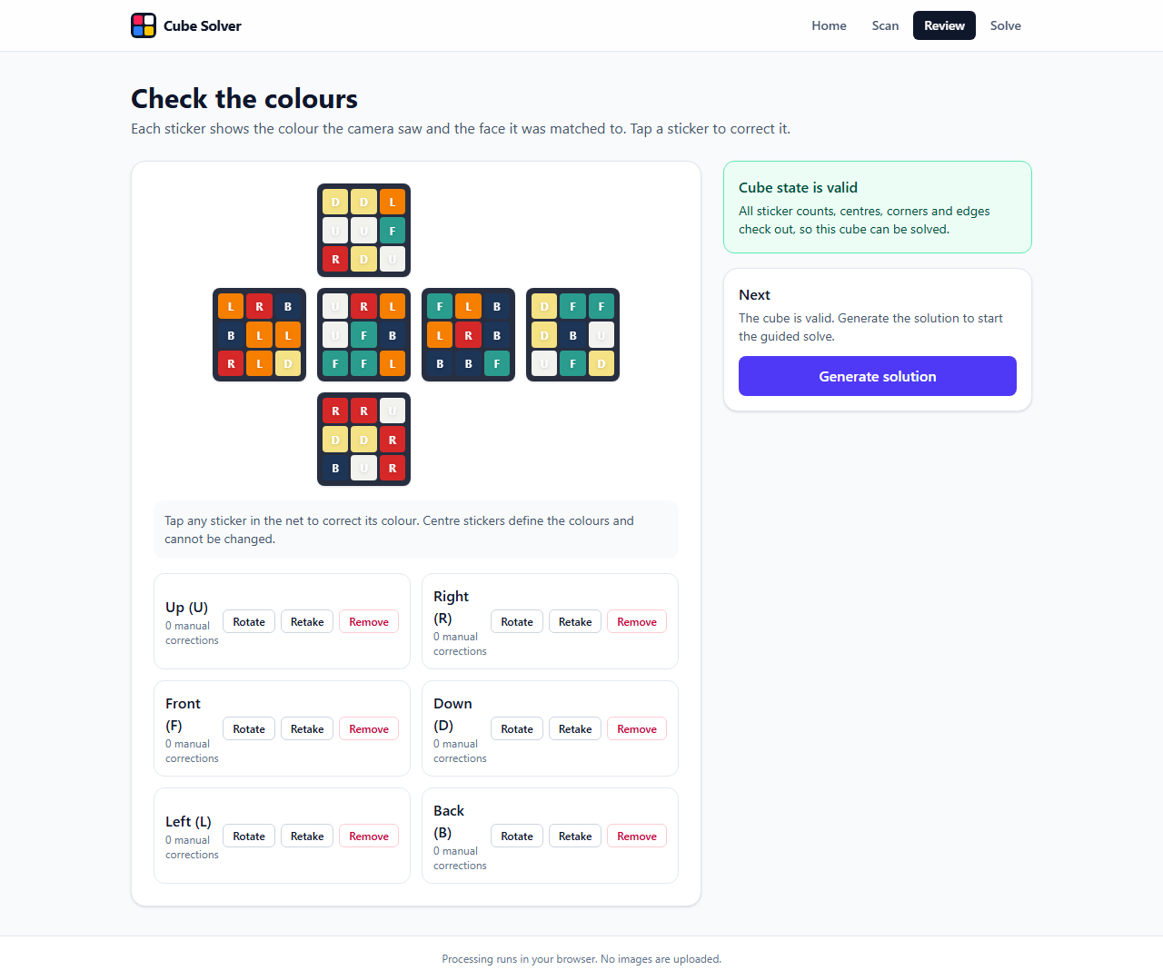
Figure 5: Review page with a valid cube state
Review page when a sticker was read wrongly. The problems are listed and Generate solution is disabled until they are corrected:
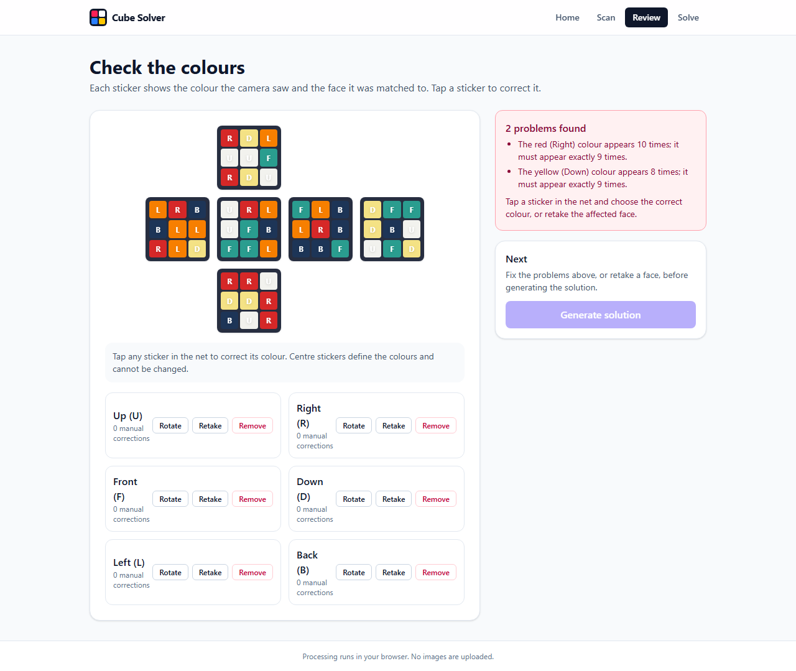
Figure 6: Review page showing validation errors
Solve page at move 0 with the scrambled 3D cube and the generated 18-move solution:
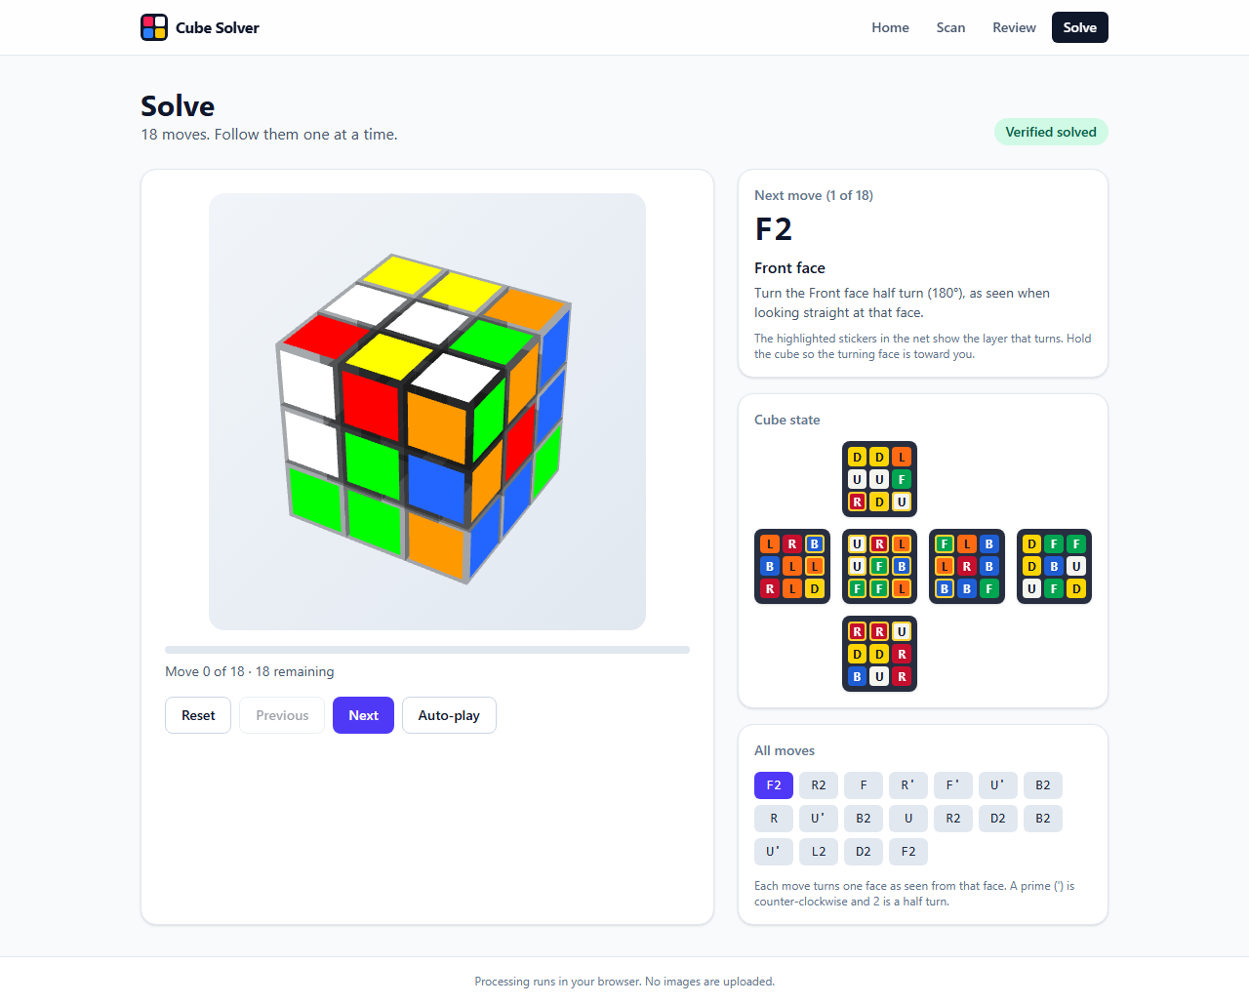
Figure 7: Solve page at the start
Solve page halfway through the solution:
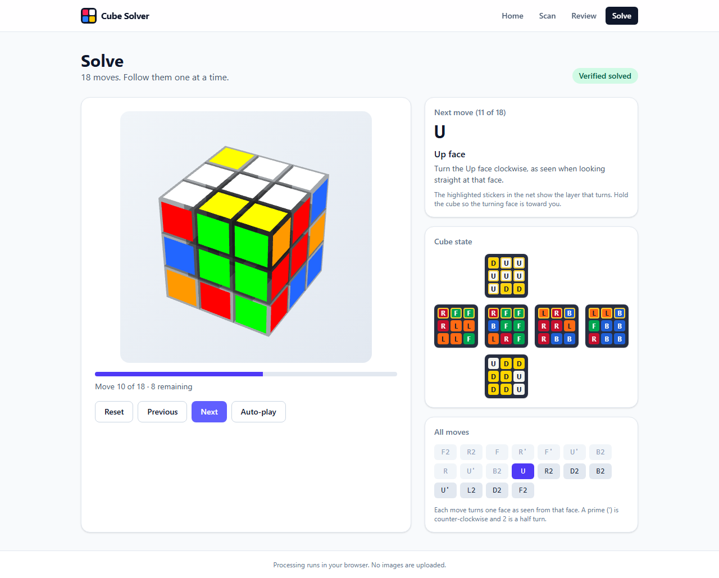
Figure 8: Solve page in the middle of the solution
Solve page after the final move, with the Verified solved badge:
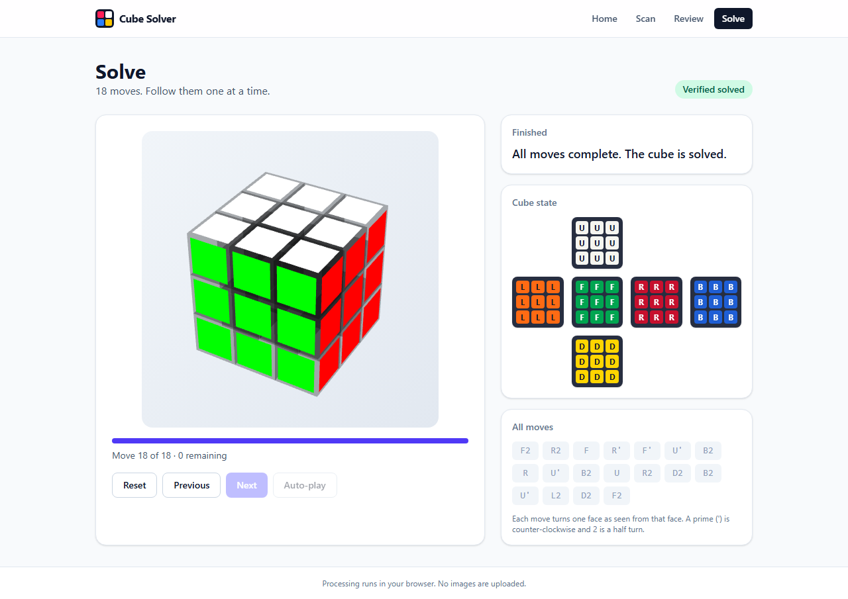
Figure 9: Solve page after the last move (cube solved)

LIMITATIONS
- Colour recognition is approximate. It uses sampled colours and CIE76 colour distance, not OpenCV or machine learning. Accuracy depends on lighting, camera white balance and colour similarity. Uncertain stickers are flagged, but accuracy is not guaranteed.
- Photo upload assumes the photo is cropped to a single face; the central 90% of the image is sampled.
- Orientation depends on holding the cube as the scan step describes. Wrong rotation is usually caught by validation and can be fixed with the Rotate button.
- The solver produces face-turn solutions that may be longer than optimal; computing one typically takes about a second.
- Scan data is kept only for the current browser tab (sessionStorage).
- The 3D view always uses the standard Western colours even when the real cube uses another scheme.
- The application has not yet been tested on real mobile hardware or on iOS Safari.

CONCLUSION
CubeSolve AI shows that a complete scan-to-solution workflow for the Rubik’s Cube can run entirely in the browser using modern web technologies. By using the centre stickers as colour references in Lab space, validating the cube mathematically before solving, and verifying every solution, the application stays simple and reliable while remaining private and free. The project also gave the team practical experience with React, Web Workers, camera and canvas APIs, colour science and automated testing.

FUTURE SCOPE
- Automatic detection of the cube position in the camera frame instead of a fixed guide square.
- A more robust classifier (for example CIEDE2000 distance or a small learned model) and automatic glare handling.
- Shorter solutions through an optimal or near-optimal solver, and support for beginner-method explanations.
- Support for other puzzles, such as 2×2×2 or Pyraminx.
- Progressive Web App packaging so that the tool can be installed and used offline on phones.
- Testing and tuning on real mobile devices, including iOS Safari.

REFERENCES
[1] Cubing.js, “cubing” library for twisty puzzles (KPuzzle, TwistyPlayer and 3×3×3 solver), https://js.cubing.net
[2] H. Kociemba, “The Two-Phase Algorithm,” https://kociemba.org/cube.htm
[3] React documentation, https://react.dev
[4] Vite documentation, https://vite.dev
[5] Tailwind CSS documentation, https://tailwindcss.com
[6] CIE 1976 L*a*b* colour space and colour difference (ΔE*ab), International Commission on Illumination.
[7] MDN Web Docs: MediaDevices.getUserMedia(), Canvas API, Web Workers API and Window.sessionStorage, https://developer.mozilla.org
[8] Vitest, https://vitest.dev, and Playwright, https://playwright.dev

