MLOps Assignment 1
End-to-End ML Model Development,
CI/CD, and Production Deployment

Course: MLOps (S2-25_AMLCSZG523)

ID | Name
2025cs05010 | Kelli L Prasanna Kumar

Table of Contents
1. Introduction
2. Data Acquisition & Exploratory Data Analysis
3. Feature Engineering & Model Development
4. Experiment Tracking with MLflow
5. Model Packaging & Reproducibility
6. CI/CD Pipeline & Automated Testing
7. Model Containerization
8. Production Deployment (Minikube + Podman)
9. Monitoring & Logging (Prometheus + Grafana)
10. Architecture Overview
11. Conclusion

1. Introduction
This report documents the end-to-end development and deployment of a machine learning solution for predicting heart disease risk using the UCI Heart Disease dataset. The project follows modern MLOps best practices, encompassing data acquisition, exploratory data analysis, feature engineering, model development and evaluation, experiment tracking, model packaging, automated testing with CI/CD pipelines, containerization, production deployment on Kubernetes, and real-time monitoring.
The primary objective is to build a binary classifier that predicts the presence or absence of heart disease based on 13 patient health features (age, sex, blood pressure, cholesterol, etc.). The trained model is served via a FastAPI REST API, containerized with Docker, deployed to a local Kubernetes cluster (Minikube with Podman as the container runtime), and monitored using Prometheus and Grafana.

1.1 Dataset Overview
The Heart Disease dataset from the UCI Machine Learning Repository (ID: 45) contains 303 patient records with 13 clinical features and a target variable. The original target has values 0-4, which we convert to binary (0 = no disease, 1 = disease present). After cleaning, the dataset has 297 usable samples with no missing values.

1.2 Technology Stack
- Python 3.11, scikit-learn, pandas, numpy, matplotlib, seaborn
- MLflow for experiment tracking
- FastAPI + Uvicorn for model serving
- Docker / Podman for containerization
- Minikube + Podman driver for Kubernetes deployment
- Prometheus + Grafana for monitoring
- GitHub Actions for CI/CD
- pytest for unit testing

2. Data Acquisition & Exploratory Data Analysis
The dataset is fetched programmatically using the ucimlrepo Python library, which provides direct access to UCI datasets. This ensures reproducibility — the same data can be re-fetched at any time without manual download steps.

2.1 Data Cleaning
Data preprocessing steps include: (1) converting all columns to numeric types using pd.to_numeric with coerce for non-parseable values, (2) filling missing values with column medians for numeric features and mode for categorical features, (3) dropping any remaining null rows after coercion, and (4) converting the multi-class target to binary (presence vs. absence of heart disease). The cleaned dataset is saved as heart_disease_cleaned.csv for downstream reproducibility.

2.2 Exploratory Data Analysis
We produced four categories of professional visualizations:
- Class Distribution: Bar chart and pie chart showing the target balance (~46% disease, ~54% no disease), confirming the dataset is reasonably balanced and does not require aggressive resampling techniques.
- Feature Distributions: Histograms for all 13 features, colored by target class, revealing which features show visible separation between disease and no-disease groups. Notable separations were observed in thal, cp, ca, and oldpeak.
- Correlation Heatmap: A triangular heatmap of Pearson correlations, highlighting that thal (+0.53), ca (+0.47), cp (+0.43), and exang (+0.44) have the strongest associations with the target variable.
- Box Plots: Side-by-side box plots for key continuous features (age, trestbps, chol, thalach, oldpeak), showing differences in distributions between disease classes and identifying potential outliers in cholesterol and blood pressure.
All plots are saved to the screenshots/ folder for inclusion in this report and the GitHub repository.
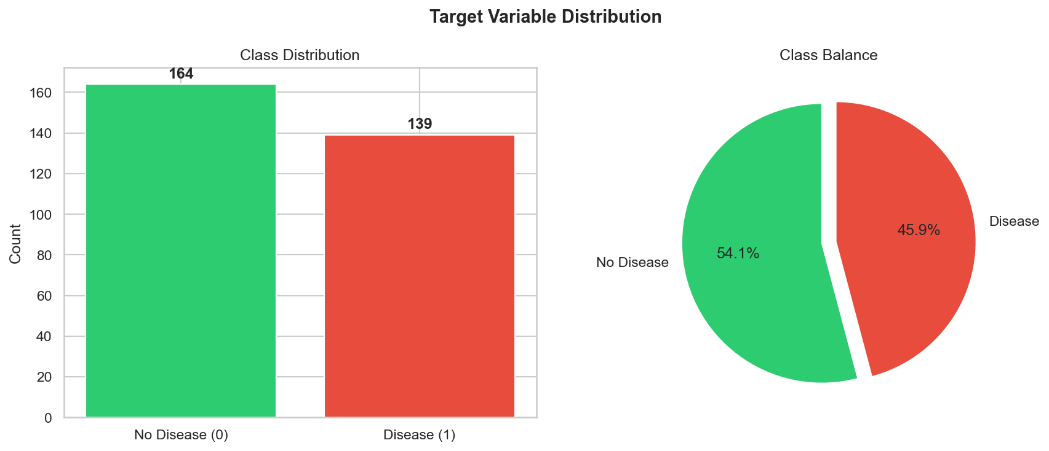
Figure 1: Class Distribution
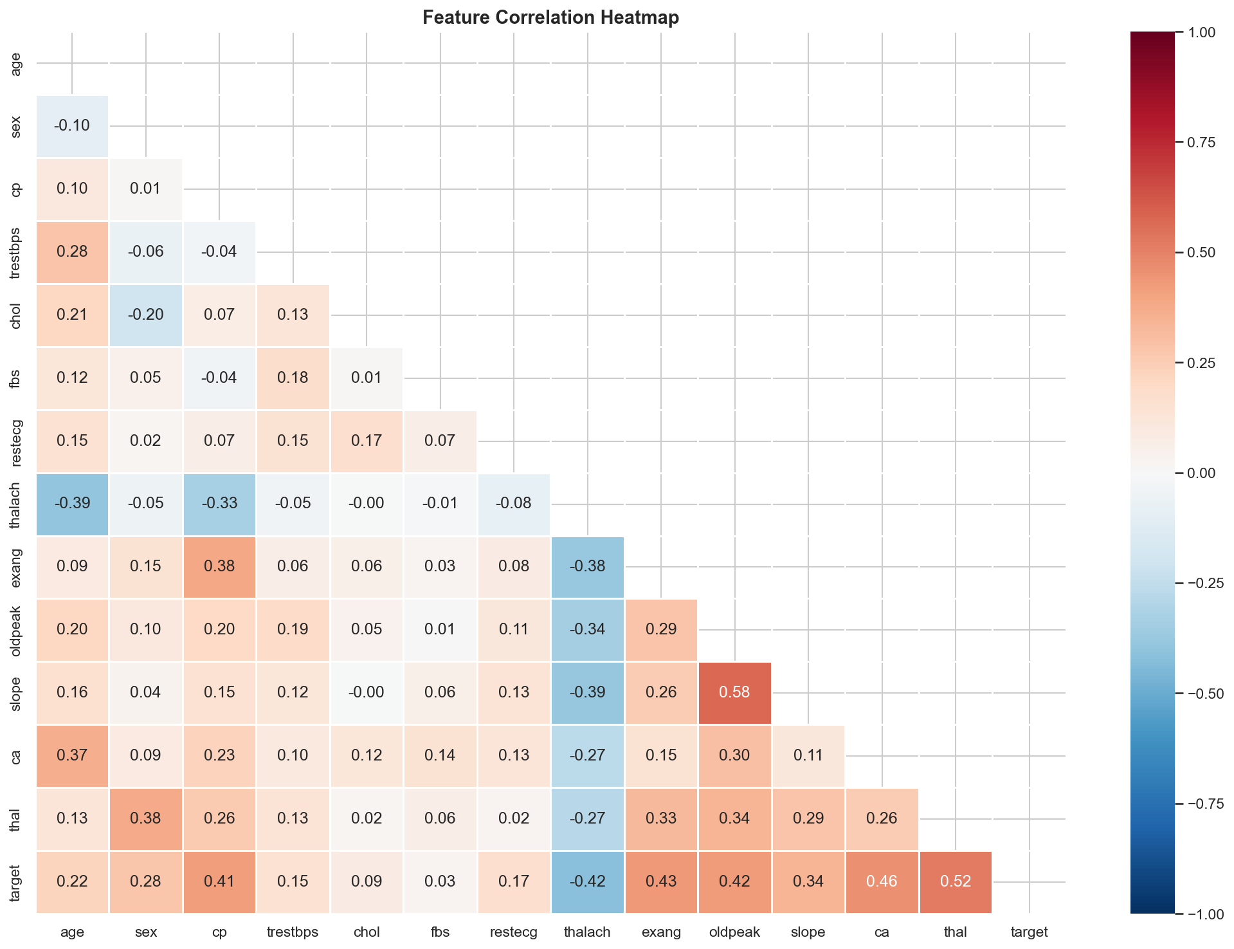
Figure 2: Correlation Heatmap
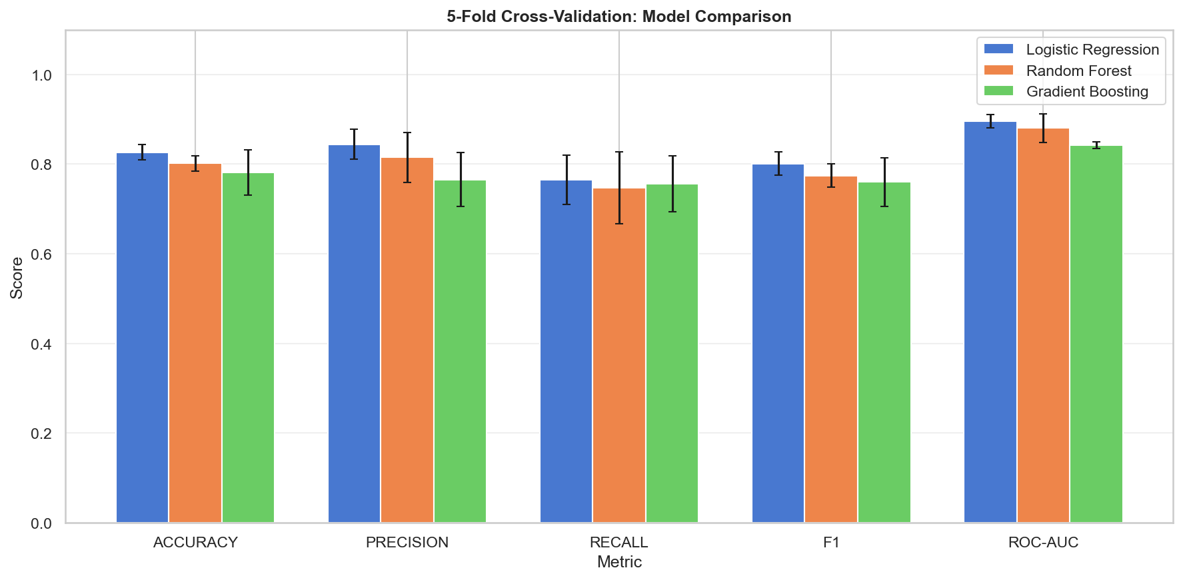
Figure 3: Cross-Validation Model Comparison
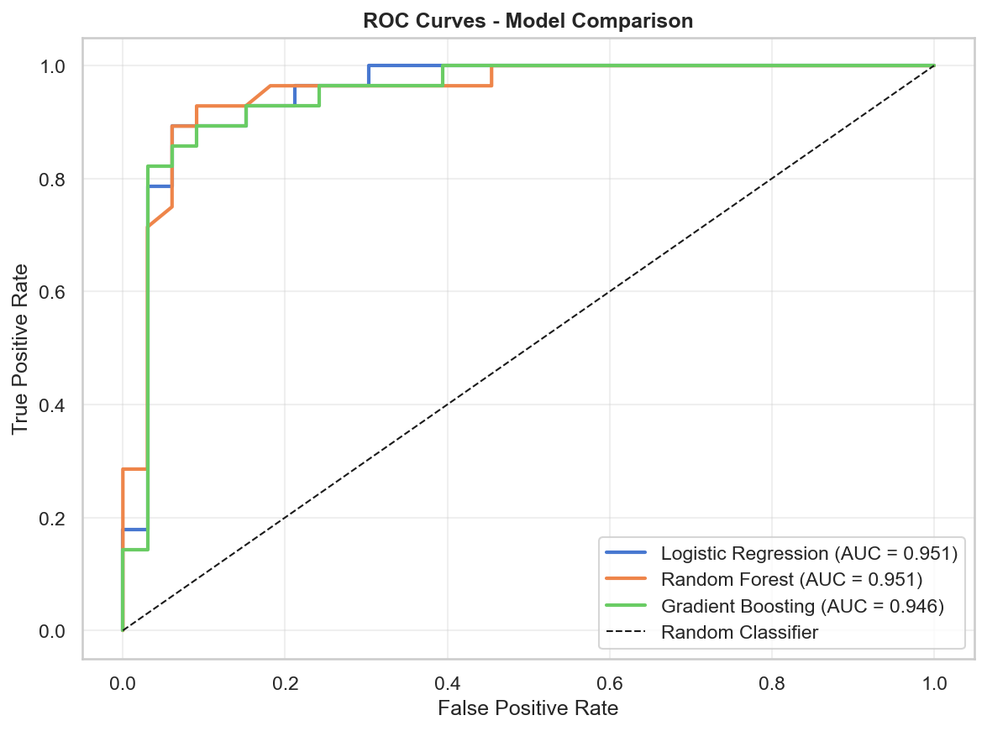
Figure 4: ROC Curves
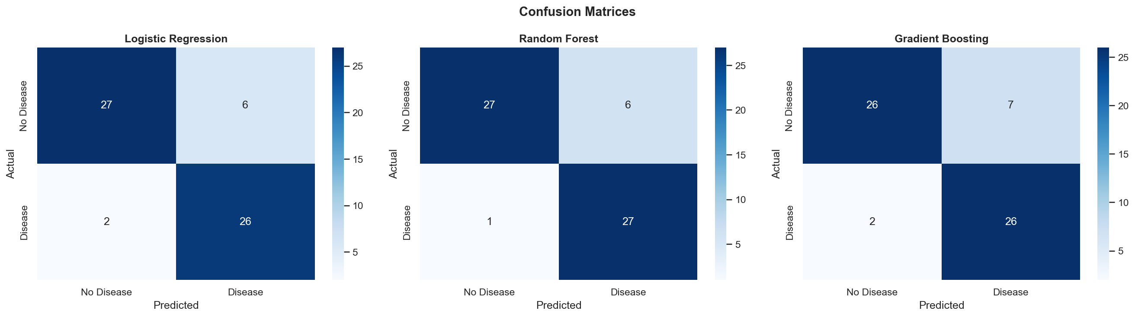
Figure 5: Confusion Matrices

3. Feature Engineering & Model Development

3.1 Feature Preparation
All 13 features are retained without dimensionality reduction, as the dataset is small and all features carry clinical relevance. Feature scaling is performed using StandardScaler, which transforms each feature to have zero mean and unit variance. This is critical for Logistic Regression (which is sensitive to feature scales) and generally beneficial for gradient-based algorithms.
The dataset is split into 80% training and 20% test sets using stratified sampling (test_size=0.2, stratify=y) to preserve class proportions in both subsets.

3.2 Model Training
Three classification models were trained and compared:
Logistic Regression: A linear model with L2 regularization (max_iter=1000). Serves as a strong interpretable baseline.
Random Forest: An ensemble of 100 decision trees with bootstrap aggregation. Handles non-linear relationships and provides feature importance rankings.
Gradient Boosting: A sequential ensemble of 100 weak learners that minimizes a differentiable loss function. Typically achieves the highest accuracy on structured data.

3.3 Evaluation
Models are evaluated using 5-fold stratified cross-validation on the training set, and final performance is measured on the held-out test set. Metrics include accuracy, precision, recall, F1-score, and ROC-AUC. The best model is selected based on the highest test-set ROC-AUC score, balancing overall discrimination ability across all classification thresholds.

4. Experiment Tracking with MLflow
MLflow is integrated to track all experiment runs. The tracking URI is set to a local file store (file:./mlruns) under a single experiment named "Heart_Disease_Classification". For each model run, we log:
- All hyperparameters (retrieved via model.get_params())
- Five test-set metrics: accuracy, precision, recall, F1-score, ROC-AUC
- Five cross-validation metrics with mean and standard deviation
- The trained scikit-learn model as an MLflow artifact
- Visualization plots (ROC curves, confusion matrices, CV comparison)
A dedicated "Best Model" run logs the final scikit-learn Pipeline (StandardScaler + best classifier), the pickle file, metadata JSON, and the cleaned dataset for full reproducibility. The MLflow dashboard can be launched with: mlflow ui --backend-store-uri file:./mlruns

5. Model Packaging & Reproducibility
The final model is packaged as a scikit-learn Pipeline object that encapsulates both the StandardScaler preprocessing and the classifier in a single object. This means any new input data only needs to be passed through pipeline.predict() — no separate scaling step is required.
Three artifacts ensure full reproducibility:
- model_pipeline.pkl: The complete Pipeline saved via pickle. Can be loaded and used for inference with zero additional setup.
- model_metadata.json: Contains feature names, model type, training sample count, and test-set accuracy/ROC-AUC. Used by the API to validate input features at runtime.
- requirements.txt: Pinned versions of all Python dependencies (fastapi==0.115.0, scikit-learn==1.5.0, mlflow==2.16.0, etc.) ensuring environment reproducibility.

6. CI/CD Pipeline & Automated Testing

6.1 Unit Tests
The test suite (test/test_model.py) contains three test classes with a total of 10+ test cases:
- TestDataProcessing: Tests dataset download, shape validation, binary target conversion, missing value handling, and feature scaling correctness.
- TestModel: Tests model training, prediction format, probability output validity, pipeline consistency (deterministic predictions), and model serialization (save/load round-trip).
- TestAPI: Tests input data validation and prediction response format.

6.2 GitHub Actions Pipeline
The CI/CD pipeline (.github/workflows/ci-cd.yml) is triggered on every push and pull request to the main branch. It consists of three sequential jobs:
- lint-and-test: Installs dependencies, runs flake8 linting on app.py and test/, then runs pytest with JUnit XML output. Test results are uploaded as workflow artifacts.
- train-model: After tests pass, the model is retrained from scratch using the UCI dataset. The trained model_pipeline.pkl and model_metadata.json are uploaded as artifacts.
- build-docker: Downloads model artifacts, builds the Docker image, runs the container, waits 10 seconds for startup, then smoke-tests the /health and /predict endpoints.
The pipeline enforces that code linting, all unit tests, model training, Docker build, and endpoint smoke tests must all pass before a merge is allowed. Any failure produces clear error logs visible in the GitHub Actions UI.

7. Model Containerization
The model is served via a FastAPI application (app.py) that exposes the following endpoints:
Endpoint | Method | Description
/ | GET | Root welcome message
/health | GET | Health check (used by k8s probes)
/predict | POST | Make prediction (JSON input, returns label + confidence)
/metrics | GET | Prometheus metrics endpoint
/model-info | GET | Model metadata (type, accuracy, features)

The Dockerfile uses python:3.11-slim as the base image, installs dependencies from requirements.txt, copies the application code and model artifacts, exposes port 8000, configures a health check, and runs uvicorn. The image can be built and tested with either Docker or Podman.

8. Production Deployment (Minikube + Podman)
For production deployment, we use Minikube with Podman as the container runtime driver. Podman is a daemonless, rootless container engine that provides a Docker-compatible CLI, making it suitable for development and CI environments where running a Docker daemon is not desirable.

8.1 Kubernetes Resources
The deployment manifest (deployment/k8s-deployment.yaml) defines:
- Deployment: 2 replicas of the heart-disease-api container, with resource requests (256Mi memory, 250m CPU) and limits (512Mi memory, 500m CPU).
- Liveness Probe: HTTP GET to /health every 30 seconds with a 15-second initial delay. Kubernetes will restart the pod if the health check fails.
- Readiness Probe: HTTP GET to /health every 10 seconds with a 10-second initial delay. The pod will not receive traffic until it passes the readiness check.
- Service: A LoadBalancer service that routes external traffic on port 80 to the container port 8000.

8.2 Deployment Process
A deployment script (deploy_minikube.sh) automates the entire process: starting minikube with the podman driver, building the Docker image inside minikube's container runtime, applying the Kubernetes manifests, and waiting for all pods to reach Ready status. The API can then be accessed via minikube service or kubectl port-forward.

9. Monitoring & Logging (Prometheus + Grafana)

9.1 Application Metrics
The FastAPI application exports Prometheus metrics via the /metrics endpoint using the prometheus_client library. Three custom metrics are defined:
- prediction_requests_total (Counter): Total prediction requests, labeled by status (success/error). Tracks API reliability.
- prediction_latency_seconds (Histogram): Prediction latency distribution. Enables percentile analysis (p50, p90, p99).
- prediction_results (Counter): Prediction outcome counts, labeled by result (Disease/No Disease). Monitors model behavior drift.

9.2 Application Logging
All API requests are logged using Python's logging module. Logs are written to both stdout (for container log aggregation) and a file (api.log). Each prediction log entry includes the prediction result, confidence score, and latency. Errors are logged at ERROR level with full exception details.

9.3 Monitoring Stack
The docker-compose.yml defines a three-service monitoring stack:
- API (port 8000): The FastAPI application with Prometheus metrics.
- Prometheus (port 9090): Scrapes the /metrics endpoint every 15 seconds. Configuration is provided via deployment/prometheus.yml.
- Grafana (port 3000): Pre-provisioned with a Prometheus datasource and a custom dashboard. The dashboard includes panels for request counts, latency percentiles, request rate, prediction outcome trends, and a prediction distribution pie chart.
Grafana dashboard provisioning is fully automated — on startup, Grafana loads the datasource and dashboard JSON from mounted volumes, requiring no manual configuration.

10. Architecture Overview
The following diagram illustrates the end-to-end architecture of the MLOps pipeline:
┌─────────────────┐ ┌──────────────────┐ ┌──────────────┐
│ UCI Repository │────>│ Jupyter Notebook│────>│ MLflow │
│ (Data Source) │ │ (EDA + Training)│ │ Tracking │
└─────────────────┘ └────────┬─────────┘ └──────────────┘
│
┌──────▼───────┐
│model_pipeline│
│ .pkl │
└──────┬───────┘
│
┌────────────▼────────────┐
│ FastAPI App (app.py) │
│ /predict /health │
│ /metrics /model-info │
└────────────┬────────────┘
│
┌────────────▼────────────┐
│ Docker / Podman │
│ Container Image │
└────────────┬────────────┘
│
┌──────────────────▼──────────────────┐
│ Minikube (Podman Driver) │
│ Deployment: 2 replicas │
│ Service: LoadBalancer (port 80) │
└──────────────────┬──────────────────┘
│
┌──────────────────▼──────────────────┐
│ Prometheus + Grafana │
│ (Metrics & Dashboard) │
└─────────────────────────────────────┘
CI/CD: GitHub Actions
┌────────────────────────────────────────┐
│ Lint → Test → Train → Build → Deploy │
└────────────────────────────────────────┘

11. Conclusion
This project demonstrates a complete, production-ready MLOps pipeline for heart disease prediction. Starting from raw data acquisition through the UCI repository, we performed thorough exploratory data analysis, trained and evaluated three classification models, and tracked all experiments with MLflow for full auditability.
The best-performing model was packaged as a scikit-learn Pipeline and served via a FastAPI REST API with Swagger documentation. The application was containerized using Docker (compatible with Podman), with a multi-stage CI/CD pipeline in GitHub Actions that enforces code quality through linting, comprehensive unit tests, model retraining, and container smoke tests.
For production deployment, we utilized Minikube with Podman as the container runtime, deploying the API as a Kubernetes Deployment with 2 replicas, health probes, resource limits, and a LoadBalancer service. Real-time monitoring was implemented using Prometheus for metrics collection and Grafana for visualization, with auto-provisioned dashboards tracking prediction request counts, latency percentiles, error rates, and prediction outcome distributions.
Key achievements of this project include:
- End-to-end automation: From data ingestion to model serving, every step is scripted and reproducible.
- Experiment tracking: All model runs are logged in MLflow with parameters, metrics, and artifacts.
- Automated quality gates: CI/CD pipeline enforces linting, testing, and smoke testing before deployment.
- Container-native deployment: Docker/Podman containerization with Kubernetes orchestration.
- Observable system: Prometheus metrics and Grafana dashboards provide real-time visibility into API health.
- Production best practices: Health probes, resource limits, graceful degradation, and structured logging.

The project successfully mirrors real-world production MLOps workflows and demonstrates proficiency in the full ML lifecycle — from experimentation to production deployment and monitoring.

