**Question 1 : Adding a product to cart and checkout :**

package com.example.test.CC;

import org.openqa.selenium.By;

import org.openqa.selenium.WebDriver;

import org.openqa.selenium.WebElement;

import org.openqa.selenium.chrome.ChromeDriver;

import org.openqa.selenium.chrome.ChromeOptions;

import io.github.bonigarcia.wdm.WebDriverManager;

public class App {

public static void main(String[] args) throws Exception {

WebDriverManager.chromedriver().setup();

ChromeOptions co=new ChromeOptions();

co.addArguments("--remote-allow-origins=*");

WebDriver driver=new ChromeDriver(co);

driver.manage().window().maximize();

driver.get("https://www.saucedemo.com/");

// Login with valid credentials

WebElement usernameInput = driver.findElement(By.id("user-name"));

usernameInput.sendKeys("standard_user");

WebElement passwordInput = driver.findElement(By.id("password"));

passwordInput.sendKeys("secret_sauce");

WebElement loginButton = driver.findElement(By.id("login-button"));

loginButton.click();

Thread.sleep(5000);

// Add a product to the cart

WebElement addToCartButton = driver.findElement(By.xpath("/html/body/div/div/div/div[2]/div/div/div/div[1]/div[2]/div[2]/button"));

addToCartButton.click();

System.out.println("Item is added in the cart");

// Close the browser

// driver.quit();

}

}

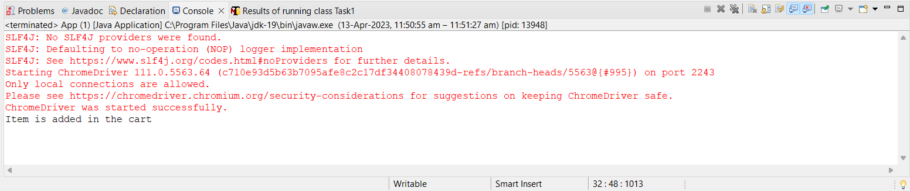

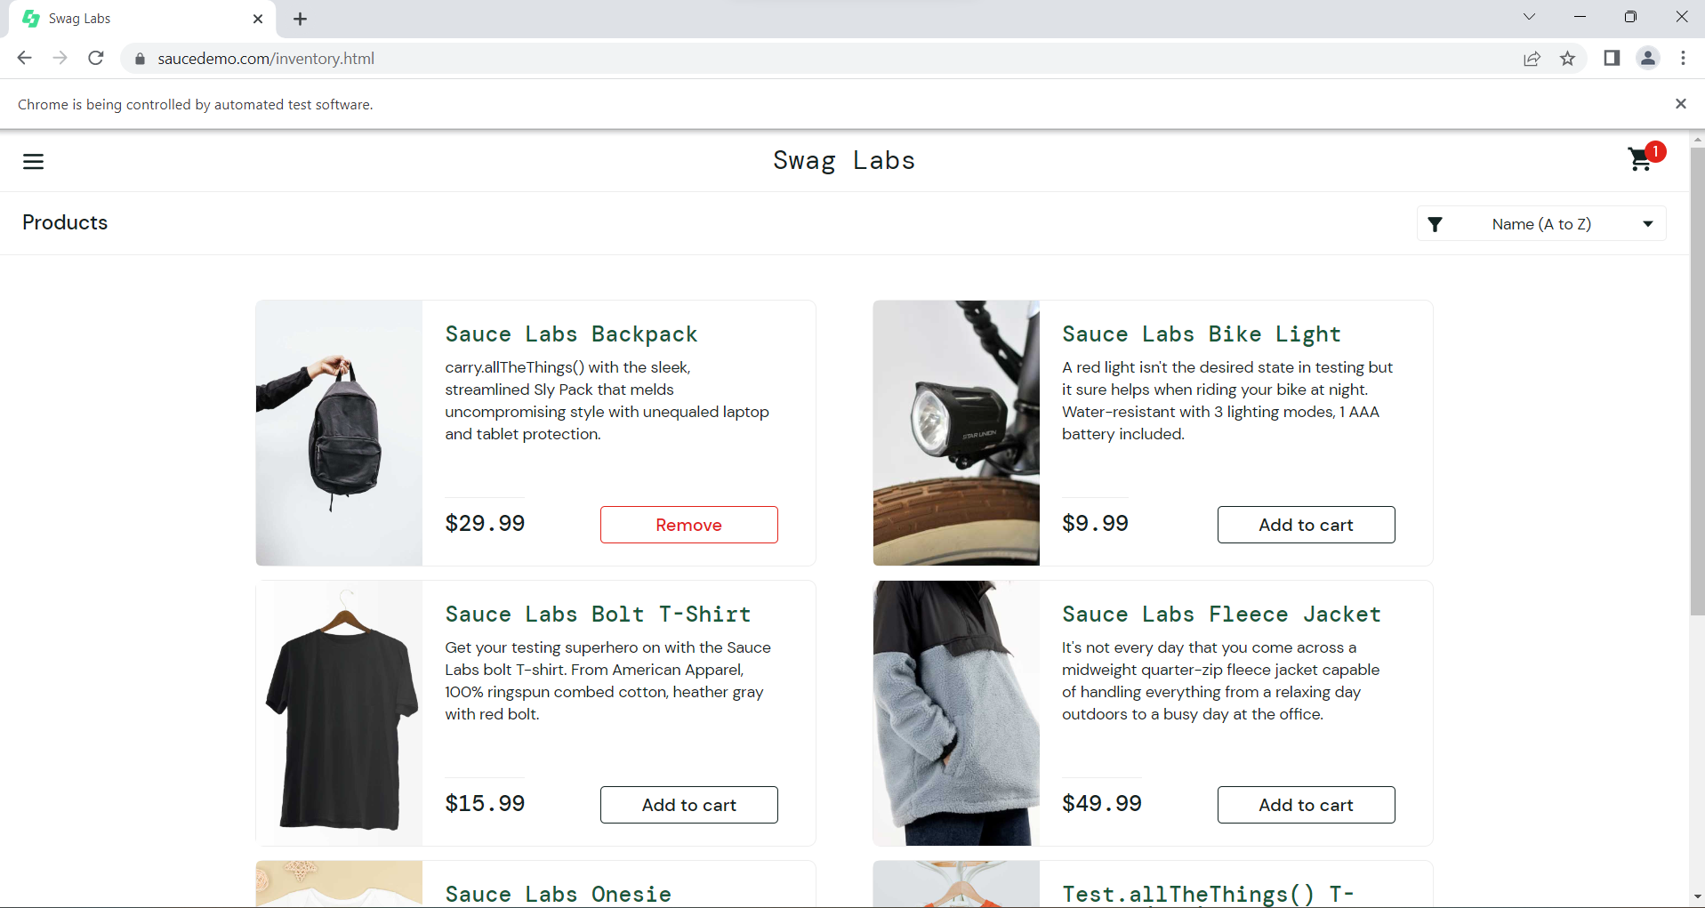

package com.example.test.CC;

import org.openqa.selenium.By;

import org.openqa.selenium.WebDriver;

import org.openqa.selenium.WebElement;

import org.openqa.selenium.chrome.ChromeDriver;

import org.openqa.selenium.chrome.ChromeOptions;

import io.github.bonigarcia.wdm.WebDriverManager;

public class CheckCart {

public static void main(String[] args) throws Exception {

WebDriverManager.chromedriver().setup();

ChromeOptions co=new ChromeOptions();

co.addArguments("--remote-allow-origins=*");

WebDriver driver=new ChromeDriver(co);

driver.manage().window().maximize();

driver.get("https://www.saucedemo.com/");

// Login with valid credentials

WebElement usernameInput = driver.findElement(By.id("user-name"));

usernameInput.sendKeys("standard_user");

WebElement passwordInput = driver.findElement(By.id("password"));

passwordInput.sendKeys("secret_sauce");

WebElement loginButton = driver.findElement(By.id("login-button"));

loginButton.click();

Thread.sleep(5000);

// Add a product to the cart

WebElement addToCartButton = driver.findElement(By.xpath("/html/body/div/div/div/div[2]/div/div/div/div[1]/div[2]/div[2]/button"));

addToCartButton.click();

// Click on the cart icon

WebElement cartIcon = driver.findElement(By.xpath("//a[@class='shopping_cart_link']"));

cartIcon.click();

// Verify Item is in Cart

System.out.println("Item is Present in the cart");

// Close the browser

//driver.quit();

}

}

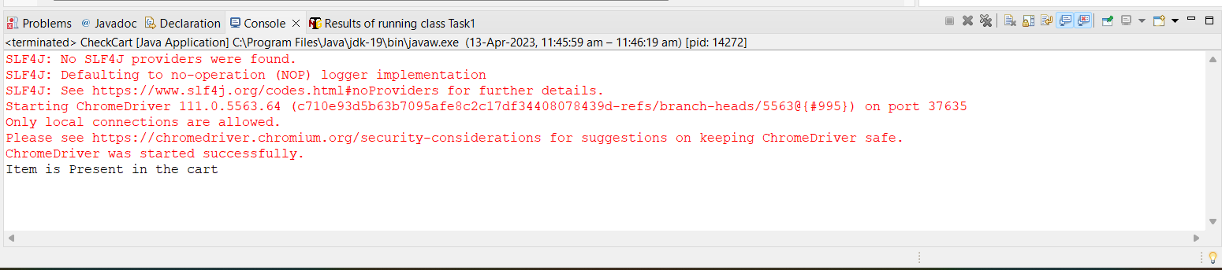

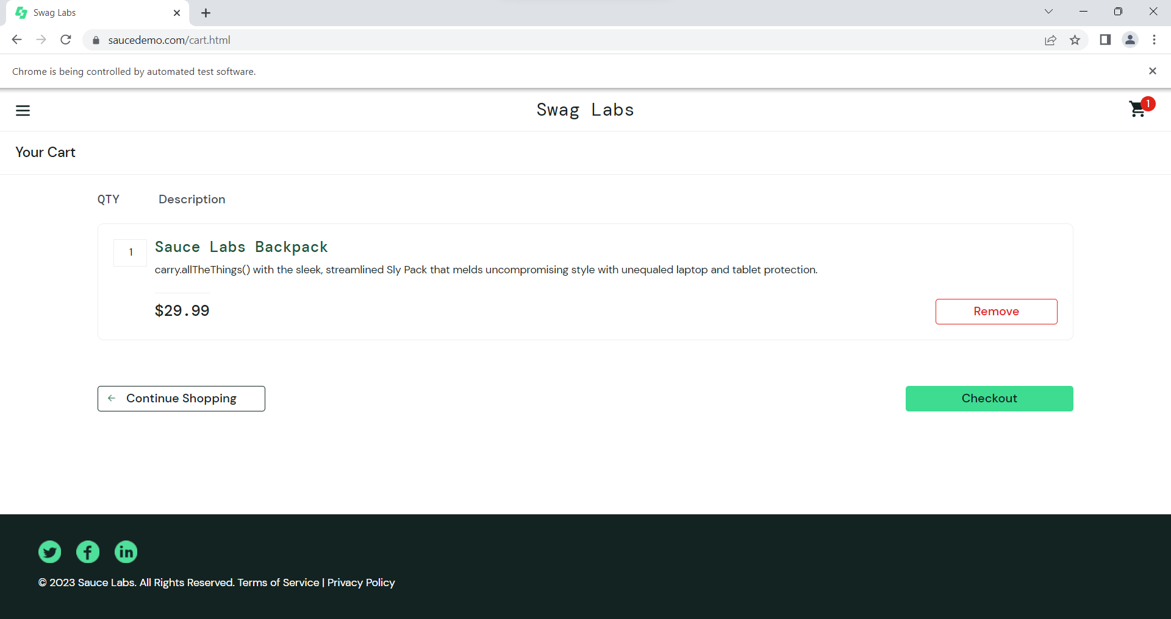

package com.example.test.CC;

import org.openqa.selenium.By;

import org.openqa.selenium.WebDriver;

import org.openqa.selenium.WebElement;

import org.openqa.selenium.chrome.ChromeDriver;

import org.openqa.selenium.chrome.ChromeOptions;

import io.github.bonigarcia.wdm.WebDriverManager;

public class User {

public static void main(String[] args) throws Exception {

WebDriverManager.chromedriver().setup();

ChromeOptions co=new ChromeOptions();

co.addArguments("--remote-allow-origins=*");

WebDriver driver=new ChromeDriver(co);

driver.manage().window().maximize();

driver.get("https://www.saucedemo.com/");

// Login with valid credentials

WebElement usernameInput = driver.findElement(By.id("user-name"));

usernameInput.sendKeys("standard_user");

WebElement passwordInput = driver.findElement(By.id("password"));

passwordInput.sendKeys("secret_sauce");

WebElement loginButton = driver.findElement(By.id("login-button"));

loginButton.click();

Thread.sleep(5000);

// Add a product to the cart

WebElement addToCartButton = driver.findElement(By.xpath("/html/body/div/div/div/div[2]/div/div/div/div[1]/div[2]/div[2]/button"));

addToCartButton.click();

// Click on the cart icon

WebElement cartIcon = driver.findElement(By.xpath("//a[@class='shopping_cart_link']"));

cartIcon.click();

// Click on the checkout button

WebElement checkoutButton = driver.findElement(By.id("checkout"));

checkoutButton.click();

// Verify that "Your Information" form is displayed

driver.findElement(By.xpath("//*[@id=\"first-name\"]")).sendKeys("ANBARASU");

driver.findElement(By.xpath("//*[@id=\"last-name\"]")).sendKeys("AN");

driver.findElement(By.xpath("//*[@id=\"postal-code\"]")).sendKeys("638506");

WebElement continueButton = driver.findElement(By.id("continue"));

continueButton.click();

System.out.println("Verified the Your Information");

// Close the browser

//driver.quit();

}

}

