GAYATRI VIDYA PARISHAD COLLEGE OF
ENGINEERING FOR WOMEN (A)

Madhurawada, Visakhapatnam Dist.,
Andhra Pradesh, PIN-530048

(Approved by AICTE, New Delhi, and Affiliated to Andhra University: Visakhapatnam (AP))

Academic Year: 2026-2027
III B.Tech. - I Semester CSE

FACULTY LABORATORY MANUAL

For

COMPUTER NETWORK Lab (24CT11RC24)

Prepared by

Dr. Patruni Muralidhara Rao

Department of Computer Science & Engineering

GAYATRI VIDYA PARISHAD COLLEGE OF
ENGINEERING FOR WOMEN (A)

Visakhapatnam-530048

CERTIFICATE
Name of the Laboratory : Computer Network Lab (24CT11RC24)
Name of the Faculty : Dr. Patruni Muralidhara Rao

Department : Computer Science & Engineering

Program : B.Tech.

Year : III B.Tech.

Semester : I Semester

Signature(s):

Dr. P Muralidhara Rao
Dr. G Shankara Rao
Dr. D Indu

HOD

C O M P U T E R N E T W O R K S L A B
III Year B. Tech. I semester
[Common to CSE & IT]

L | T | P | C
0 | 0 | 3 | 1.5
Course Code: 24CT11RC24

Course Outcomes: At the end of the Course, the student shall be able to
CO1: Understand the Network Establishment and communication with the uses of NS2
Simulator, Linux and Network Commands. [L2]
CO2: Experiment Data link layer framing methods, Error detection and correction codes like
Checksum, CRC, and Hamming code. [L3]
CO3: Apply Network layer routing methods for Distance Vector Routing Algorithm and shortest
path routing algorithm. [L3]
CO4: Make use of socket programming and Transport layer protocols TCP, UDP for data
communication in a Computer Network. [L3]
CO5: Make use of Application layer protocols HTTP and FTP for data communication in a
Computer Network. [L3]

Module-1:
1. Write different types of Network cables and practically implement the cross-wired cable and straight through cable using clamping tool.
2. Connect the computers in Local Area Networks.
3. Write and Execute Basic Network commands and Network configuration commands like ping, ipconfig, traceroute, nslookup, netstat, whois, arp, rarp, etc
4. Write and Execute Basic Linux commands.
Module-2:
1. Configure a Network topology using packet tracer software.
2. Simulate to find the Number of Packets Dropped using NS2 Simulator
3. Configure subnet on Linux using ip commands. Verify connectivity with ping and trace route.

Module-3:
1. Write a program to implement the data link layer framing methods such as character stuffing and bit stuffing.
2. Write a program to implement on a data set of characters the three CRC polynomials CRC-12, CRC-16 and CRC-CCIP.

Module-4:
1. Write a program to implement Error Detection Technique using Checksum.
2. Write a program to implement Error Correction Technique using Hamming code.

Module-5:
1. Write a program to implement Stop and Wait Protocol.
2. Write a program to implement Go back-N protocol.
3. Write a program to implement Sliding window protocol.
Module-6:
1. Write a program to implement High-Level Data Link Control protocol.
2. Write a program to implement Point-to-Point protocol.

Module-7:
1. Write a program to implement Dijkstra‗s algorithm to compute the Shortest path in a graph.
2. Write a program to implement Flooding routing algorithm.

Module-8:
1. Take an example subnet graph with weights indicating delay between nodes. Now obtain Routing table at each node using distance vector routing algorithm.
2. Write a program to implement Link state routing algorithm.
3. Write a program for congestion control using leaky bucket algorithm
Module-9:
- Understand and Usage of elementary socket system calls
(socket (), bind(), listen(), accept(),connect(),send(),recv(),sendto(),recvfrom())
2. Write a program to implement Connection oriented service protocol (TCP).
3. Write a program to implement Connection less service protocol (UDP).
Module-10:
1. Write a program to implement HTTP protocol.
2. Write a program to implement FTP protocol.
3. Write a program to implement SMTP protocol.

Case Study: Select any one practical application mentioned below
Note: A report has to be submitted by every student at the end of the semester that includes design,
coding, output, etc.
- Configuring routers and switches, experimenting with routing algorithms and analysing network performance under different topologies.
- Students analyse network protocols (e.g., TCP, UDP, HTTP, FTP) using tools like Wireshark to understand packet structures, communication flows, and protocol behaviour.
- Setting up IoT-based networks with sensors and actuators, evaluating wireless communication protocols (e.g., Zigbee, LoRa, MQTT), and assessing security vulnerabilities.

Reference Books:
1. Computer Networks — Andrew S Tanenbaum, Fifth Edition. Pearson Education/PHI
2. Data Communications and Networks – Behrouz A. Forouzan, Fifth Edition TMH.
3. Data Communications and Networks- Achut S Godbole, Atul Kahate
4. Computer Networks, Mayank Dave, CENGAGE

Web References (e-Resources):
1. https://inl.info.ucl.ac.be/CNP3
2. https://wps.pearsoned.com/ecs_kurose_compnetw_8/
3. https://www.netacad.com

Module-1
Experiment:1
Aim: Write different types of Network cables and practically implement the cross-wired cable and straight through cable using clamping tool.
Description: To study different types of network cables and practically prepare Straight-Through and Cross-Over (Cross-Wired) Ethernet cables using an RJ-45 connector and crimping/clamping tool.
1. Types of Network Cables
A. Twisted Pair Cable:
- UTP (Unshielded Twisted Pair)
  - No additional shielding.
  - Low cost and widely used.
  - Example: Cat5e, Cat6.
- STP (Shielded Twisted Pair)
  - Has additional shielding to reduce electromagnetic interference.
  - Used in high-interference environments.
B. Coaxial Cable:
- Contains a central conductor, insulation, metallic shield, and outer covering.
- Used in cable TV and older networking systems.
C. Fiber Optic Cable:
- Transmits data using light signals.
- Provides very high speed and long-distance communication.
- Types: Single-mode fiber
    - Multi-mode fiber
2. Required Components and Tools
- UTP Ethernet cable (Cat5e/Cat6)
- RJ-45 connectors – 4
- RJ-45 crimping/clamping tool
- Cable stripper or cutter
- LAN cable tester
- Network devices/computers for testing
3.RJ-45 Color Coding Standards: The two commonly used standards are T568A and T568B.
1. T568A Standard
Pin | Wire Color
1 | White-Green
2 | Green
3 | White-Orange
4 | Blue
5 | White-Blue
6 | Orange
7 | White-Brown
8 | Brown

2. T568B Standard
Pin | Wire Color
1 | White-Orange
2 | Orange
3 | White-Green
4 | Blue
5 | White-Blue
6 | Green
7 | White-Brown
8 | Brown
4. Straight-Through Cable
Definition: A straight-through cable has the same wiring standard at both ends.
Wiring
End A → T568B
End B → T568B
T568B T568B
1. White-Orange ─────── 1. White-Orange
2. Orange ─────── 2. Orange
3. White-Green ─────── 3. White-Green
4. Blue ─────── 4. Blue
5. White-Blue ─────── 5. White-Blue
6. Green ─────── 6. Green
7. White-Brown ─────── 7. White-Brown
8. Brown ─────── 8. Brown
5. Cross-Over (Cross-Wired) Cable
Definition: A cross-over cable uses T568A at one end and T568B at the other end.
Wiring
End A → T568A
End B → T568B
The important connections are:
Pin 1 ↔ Pin 3
Pin 2 ↔ Pin 6
Pin 3 ↔ Pin 1
Pin 6 ↔ Pin 2
6. Procedure for Making the Cable
Step 1: Cut the Cable
Cut the required length of UTP cable using the cutter.
Step 2: Remove the Outer Jacket
Use the cable stripper or cutter to carefully remove approximately 2–3 cm of the outer insulation.
Step 3: Untwist the Wires
Separate the four twisted pairs and arrange the individual wires according to the required standard
Step 4: Arrange the Wires
1.Straight-Through Cable: T568B → T568B
2. Cross-Over Cable: T568A → T568B
Step 5: Straighten and Cut the Wires
Arrange the wires in the correct order and make their ends equal in length.
Step 6: Insert into the RJ-45 Connector
Hold the RJ-45 connector with the gold contacts facing upward and insert all eight wires completely.
Ensure that:
- All wires reach the end of the connector.
- The order is correct.
- The outer cable jacket enters the connector.

Step 7: Crimp the Connector
Insert the RJ-45 connector into the crimping/clamping tool and press firmly.
This locks the wires into the connector.
Step 8: Repeat for the Other End
Prepare the other end according to the required wiring standard.
7. Testing the Cable: Connect both ends of the cable to a LAN cable tester.
For a Straight-Through Cable : The tester should show:
- 1 → 1
- 2 → 2
- 3 → 3
- 4 → 4
- 5 → 5
- 6 → 6
- 7 → 7
- 8 → 8
For a Cross-Over Cable : The tester should show:
- 1 → 3
- 2 → 6
- 3 → 1
- 4 → 4
- 5 → 5
- 6 → 2
- 7 → 7
- 8 → 8
Experiment:2
Aim: Write and Execute Basic Network commands and Network configuration commands like ping, ipconfig, traceroute, nslookup, netstat, whois, arp, rarp, etc
Description: Network commands are command-line tools used to configure, monitor, troubleshoot, and analyze computer networks. These commands help network administrators identify connectivity problems, examine IP addresses, trace network paths, find DNS information, and view active network connections.
1. PING Command
Purpose : The ping command is used to test whether a computer or network device is reachable.
Syntax : ping <IP Address or Domain Name>
Command: ping google.com
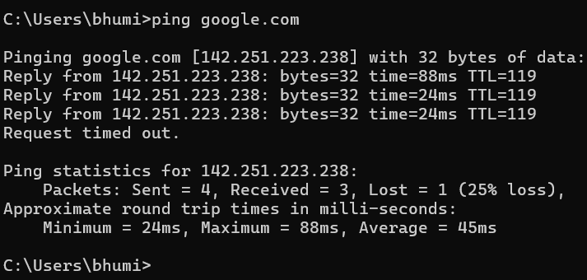
Explanation:
- Reply from – The destination is reachable.
- bytes – Size of the data packet.
- time – Time taken for the response.
- TTL – Time To Live value.
2. IPCONFIG Command
Purpose : The ipconfig command displays the IP configuration of the computer.
Command : ipconfig
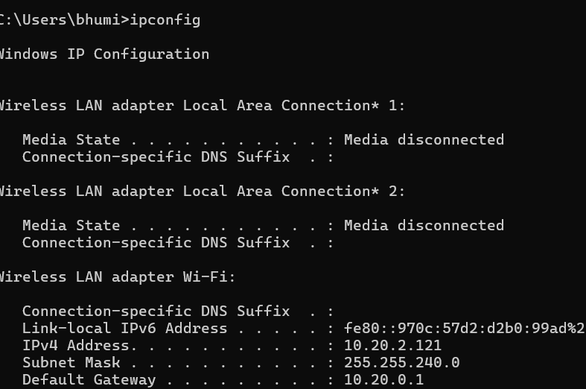
Command : ipconfig /all
Purpose : Displays detailed network configuration.
Command : ipconfig /release
Purpose : Releases the current IP address
Command : ipconfig /renew
Purpose: Obtains a new IP address from the DHCP server.
Command : ipconfig /flushdns
Purpose: Clears the DNS cache
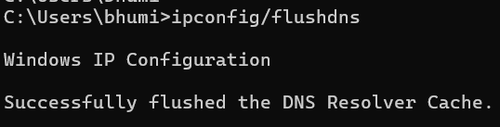
3. TRACERT Command
Purpose: It displays the path taken by packets from the source computer to the destination.
Command: tracert google.com
4. NSLOOKUP Command
Purpose : nslookup is used to obtain DNS information about a domain name.
Command : nslookup google.com
Output : Name: google.com Address: 142.250.xxx.xxx
5. NETSTAT Command :
Purpose: The netstat command displays active network connections, listening ports, and network statistics.
Command: netstat -a
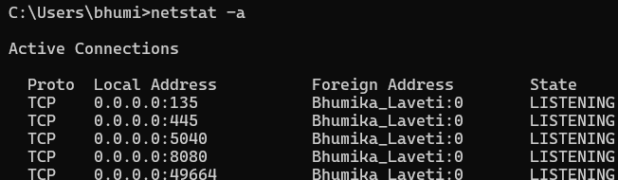
Explanation :
- Proto – Protocol used, such as TCP or UDP.
- Local Address – Local computer's IP and port.
- Foreign Address – Remote computer's IP and port.
- State – Connection state.
6. ARP Command :
Purpose: ARP stands for Address Resolution Protocol. It maps an IPv4 address to a MAC address on a local network.
Command : arp -a
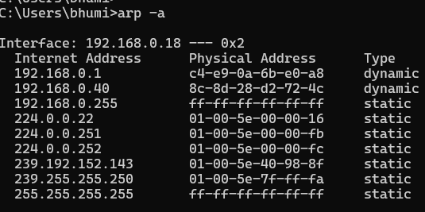
7.GETMAC : Displays the MAC address of the computer.
Command : getmac
8. RARP
Purpose: RARP stands for Reverse Address Resolution Protocol. It was originally used to determine an IP address from a device's MAC address
Command: RARP
9. WHOIS
Purpose :The whois command is used to obtain registration information about a domain name or IP address.
Command :whois example.com

Experiment:3
Aim: Write and Execute Basic Linux Commands
Description: Linux is an open-source operating system that provides a Command Line Interface (CLI) for interacting with the computer. Linux commands are used to perform various operations such as creating and managing files and directories, viewing file contents, checking system information, and managing processes.
1. pwd – Print Working Directory : Displays the current directory location.
Command : $ pwd
2. ls – List Files and Directories :
Command : ls
ls -a :Displays detailed information.
3. cd – Change Directory : Used to move from one directory to another. cd ~
4. mkdir – Make Directory : Creates a new directory. mkdir lab
5. rmdir – Remove Directory : Removes an empty directore rmdir lab
6. touch – Create a File : Creates a new empty file. touch file1.txt
7. cat – Display File Contents : Displays the contents of a file. cat file1.txt
8. cp – Copy Files : Copies a file or directory. cp file1.txt file2.txt
9. mv – Move or Rename Files : mv file1.txt newfile.txt
10. rm – Remove Files : Deletes a file. rm file1.txt

Module-2
What is Network Topology: Network topology refers to the physical or logical arrangement of computers, network devices, and communication links in a network. It describes how devices such as computers, switches, routers, and servers are connected and how data flows between them.
Types of Network Topologies: the main types of network topology are:
- Bus Topology
- Star Topology
- Ring Topology
- Mesh Topology
- Tree Topology
- Hybrid Topology
Experiment:1
Aim: Configure a Network topology using packet tracer software
Description: Cisco Packet Tracer is a network simulation software used to design, configure, and troubleshoot computer networks without using physical networking equipment.In this experiment, a basic star topology is created by connecting multiple PCs to a network switch. IP addresses are assigned to each computer, and the connectivity between the computers is verified using the ping command
1.point to point topology: Point-to-Point topology is a network topology in which two devices are directly connected to each other through a dedicated communication link. The connection can be made using cables, fiber optics, microwave links, or wireless communication.
Advantages :
- Provides a dedicated communication path.
- High data transmission speed.
- Better security because the link is private
Disadvantages:
- Connects only two devices.
- Not suitable for large networks
.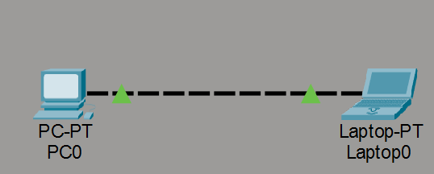
2.Ring topology : In a ring topology, each device is connected to two other devices, forming a circular structure.Data generally travels around the ring from one device to another.
Advantages
- Data transmission is organized.
- Equal access to network resources.
Disadvantages:
- Difficult to troubleshoot.
- Adding or removing devices can interrupt the network.
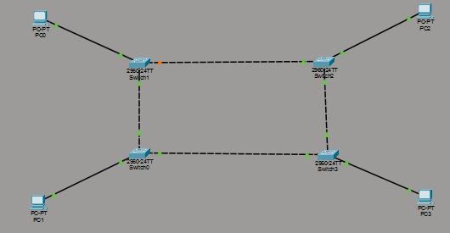

3.Bus Topology: In a bus topology, all devices are connected to a single main cable called the backbone cable.
Advantages :
- Requires less cable.
- Easy to understand for small networks.
Disadvantages :
- Performance decreases as more devices are added.
- Difficult to troubleshoot.
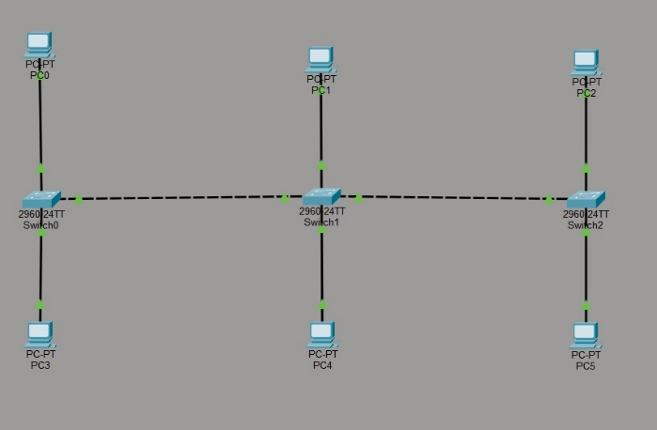
4. Tree Topology: Tree topology is a hierarchical combination of star and bus topologies.
Advantages :
- Easy to expand.
- Supports hierarchical network management.
Disadvantages :
- Failure of a higher-level device can affect multiple sections.
- Requires more cabling
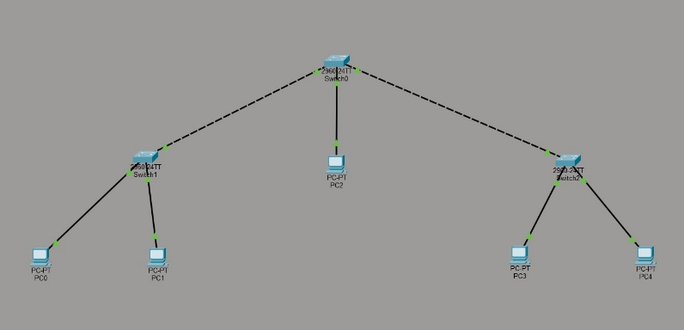
5. Star Topology : In a star topology, all devices are connected to a central device, usually a switch or hub.
Advantage :
- Easy to detect and troubleshoot faults.
- Failure of one cable affects only one device.
Disadvantages :
- Failure of the central switch can affect the entire network.
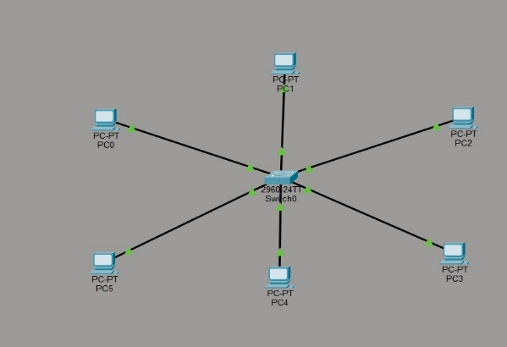
6. Mesh Topology : In a mesh topology, devices are connected to multiple or all other devices.
Advantages :
- Very high reliability.
- Multiple paths are available for data transmission.
Disadvantages :
- Requires a large amount of cabling.
- Difficult to manage as the number of devices increases.
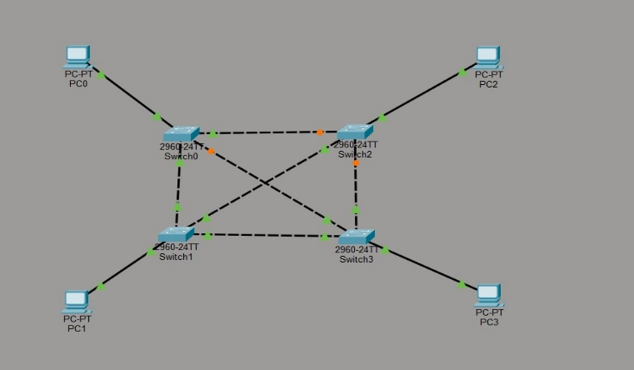
6. Hybrid Topology : A hybrid topology is a combination of two or more different topologies.
Advantages :
- Flexible design.
- Failure in one section may not affect the entire network.
Disadvantages :
- Requires specialized network equipment.
- Troubleshooting can be difficult.
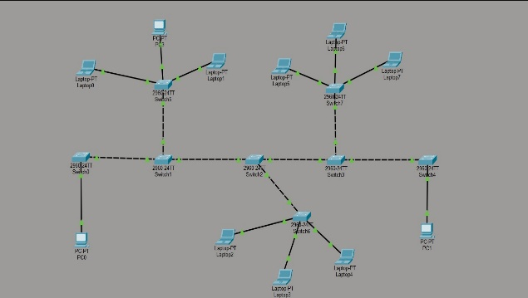
Module-3
AIM: Write a program to implement the data link layer framing methods such as character stuffing and bit stuffing.
1.Character Stuffing : Character Stuffing is a framing method used in character-oriented protocols. Special characters called flag characters are used to mark the start and end of a frame.If the same flag character appears inside the actual data, an escape character is inserted before it. This process is called character stuffing.
SOURCE CODE :
#include <stdio.h>
#include <string.h>
Int main()
{
char data[100], stuffed[200];
int i, j = 0;
printf("\nEnter data for Character Stuffing: ");
scanf("%s", data);
stuffed[j++] = 'F'; // Start Flag
for (i = 0; data[i] != '\0'; i++) {
if (data[i] == 'F' || data[i] == 'E') {
stuffed[j++] = 'E'; // Escape Character
}
stuffed[j++] = data[i];
}
stuffed[j++] = 'F'; // End Flag
stuffed[j] = '\0';
printf("Character Stuffed Frame: %s\n", stuffed);
}
void bitStuffing() {
char bits[200], stuffed[300];
int i, j = 0, count = 0;
printf("\nEnter bit stream: ");
scanf("%s", bits)
for (i = 0; bits[i] != '\0'; i++) {
stuffed[j++] = bits[i];
if (bits[i] == '1') {
count++;
if (count == 5) {
stuffed[j++] = '0'; // Stuff a 0
count = 0;
}
} else {
count = 0;
}
}
stuffed[j] = '\0';
printf("Bit Stuffed Stream: %s\n", stuffed);
}
Output :
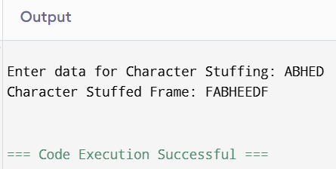
2. Bit Stuffing :
Bit Stuffing : is a framing technique used in bit-oriented protocols. A 0 bit is automatically inserted after every sequence of five consecutive 1s in the transmitted data.
SOURCE CODE :
#include <stdio.h>
#include <string.h>
int main() {
int choice;
do {
printf("\n===== Data Link Layer Framing =====");
printf("\n1. Character Stuffing");
printf("\n2. Bit Stuffing");
printf("\n3. Exit");
printf("\nEnter your choice: ");
scanf("%d", &choice);
switch (choice) {
case 1:
void characterStuffing();
break;
case 2:
void bitStuffing();
break;
case 3:
printf("Exiting...\n");
break;
default:
printf("Invalid Choice!\n");
}
} while (choice != 3);
return 0;
}
Output :
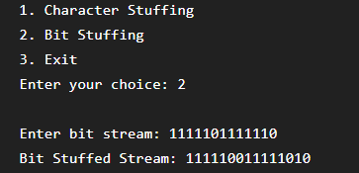
Experment : 2
Aim: Write a program to implement on a data set of characters the three CRC polynomials CRC-12, CRC-16 and CRC-CCIP
Description: The program accepts a binary data string from the user. The user selects one of the CRC generator polynomials. The program appends n−1 zeros to the data (n is the polynomial length). It performs modulo-2 division (XOR operation) between the data and the selected polynomial. The resulting remainder is the CRC checksum. Finally, the checksum is appended to the original data to form the transmitted frame.
CRC Polynomials Used :
CRC Type | Generator Polynomial (Binary) | Degree
CRC-12 | 1100000001111 | 12
CRC-16 | 11000000000000101 | 16
CRC-CCITT | 10001000000100001 | 16
Source code :
#include <stdio.h>
#include <string.h>
char data[100], temp[100], rem[100];
char divisor[20];
int dataLen, divLen;
void xorOperation()
{
for (int i = 1; i < divLen; i++)
{
rem[i] = (rem[i] == divisor[i]) ? '0' : '1';
}
}
void crc()
{
int i, j;
strcpy(temp, data);
dataLen = strlen(data);
divLen = strlen(divisor);
for (i = 0; i < divLen - 1; i++)
temp[dataLen + i] = '0';
temp[dataLen + divLen - 1] = '\0';
for (i = 0; i < divLen; i++)
rem[i] = temp[i];
for (i = divLen; i <= dataLen + divLen - 1; i++)
{
if (rem[0] == '1')
xorOperation();
for (j = 0; j < divLen - 1; j++)
rem[j] = rem[j + 1];
rem[divLen - 1] = temp[i];
}
printf("CRC Remainder : ");
for (i = 0; i < divLen - 1; i++)
printf("%c", rem[i]);

printf("\nTransmitted Frame : %s", data);
for (i = 0; i < divLen - 1; i++)
printf("%c", rem[i]);
printf("\n");
}
int main()
{
int choice;
printf("Enter Binary Data: ");
scanf("%s", data);
printf("\nSelect CRC Polynomial");
printf("\n1. CRC-12");
printf("\n2. CRC-16");
printf("\n3. CRC-CCITT");
printf("\nEnter choice: ");
scanf("%d", &choice);
switch (choice)
{
case 1:
strcpy(divisor, "1100000001111");
printf("\nUsing CRC-12 Polynomial\n");
break;
case 2:
strcpy(divisor, "11000000000000101");
printf("\nUsing CRC-16 Polynomial\n");
break;
case 3:
strcpy(divisor, "10001000000100001");
printf("\nUsing CRC-CCITT Polynomial\n");
break;
default:
printf("Invalid Choice");
return 0;
}
crc();
return 0;
Output:
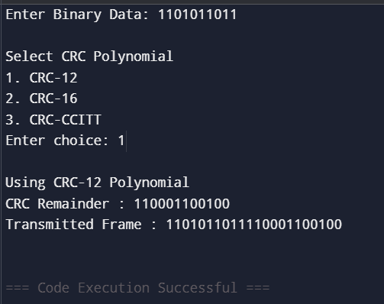

Module-4:
Experiment: 1
Aim :Write a program to implement Error Detection Technique using Checksum
Description : The Checksum is a simple error detection technique used in the Data Link Layer and Transport Layer of the OSI model. It verifies whether the transmitted data has been altered due to transmission errors.
Source code :
#include <stdio.h>
int main() {
int n, i;
unsigned int sum = 0, checksum;
printf("Enter the number of data words: ");
scanf("%d", &n);
unsigned int data[n];
printf("Enter the data words:\n");
for (i = 0; i < n; i++) {
scanf("%u", &data[i]);
sum += data[i];
}
checksum = ~sum;
printf("\nSum = %u", sum);
printf("\nChecksum = %u", checksum);
unsigned int receivedSum = sum + checksum;
if (receivedSum == 0)
printf("\nNo Error Detected.");
else
printf("\nError Detected.");
return 0;
}
Output :
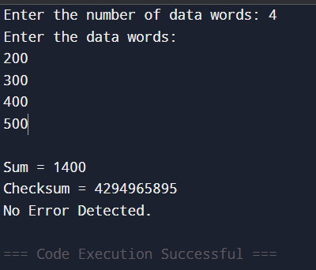
Experiment: 2
Aim : Write a program to implement Error Correction Technique using Hamming code.
Source code:
#include <stdio.h>
#include <math.h>
int main() {
int i, j, n, errorPos = 0;
printf("Enter the number of bits in Hamming code: ");
scanf("%d", &n);
int hamming[n + 1];
printf("Enter the Hamming code bits (from position 1 to %d):\n", n);
for(i = 1; i <= n; i++) {
scanf("%d", &hamming[i]);
}
int r = 0;
while(pow(2, r) < n + 1)
r++;
for(i = 0; i < r; i++) {
int parity = 0;
int p = pow(2, i);
for(j = 1; j <= n; j++) {
if(j & p)
parity ^= hamming[j] }
if(parity)
errorPos += p;
}
if(errorPos == 0) {
printf("\nNo error detected in the received Hamming code.\n");
}
else {
printf("\nError detected at bit position: %d\n", errorPos);
hamming[errorPos] ^= 1;
printf("Corrected Hamming code: ");
for(i = 1; i <= n; i++) {
printf("%d ", hamming[i]);
}
printf("\n");
} return 0;
}
Output :
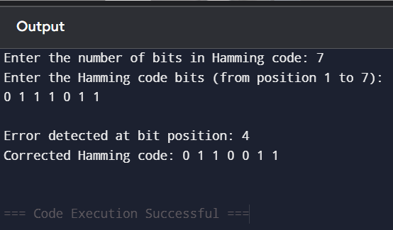

Module-5:
Experiment:1
Aim : Write a program to implement Stop and Wait Protocol
Description : The Stop and Wait Protocol allows the sender to transmit one data frame at a time. After sending a frame, the sender waits until it receives an Acknowledgement (ACK) from the receiver before sending the next frame.
- If the ACK is received, the sender transmits the next frame.
- If the ACK is not received within a specified timeout period, the sender retransmits the same frame.
- This protocol ensures reliable communication but is less efficient for long-distance or high-speed networks because only one frame can be in transit at any time.
Source code :
#include <stdio.h>
int main() {
int i, n;
printf("Enter the number of frames to send: ");
scanf("%d", &n);
for (i = 1; i <= n; i++) {
printf("\nSender: Sending Frame %d\n", i);
printf("Receiver: Frame %d received successfully\n", i);
printf("Receiver: Sending Acknowledgement (ACK %d)\n", i);
printf("Sender: ACK %d received\n", i); }
printf("\nAll frames have been transmitted successfully.\n");
return 0; }
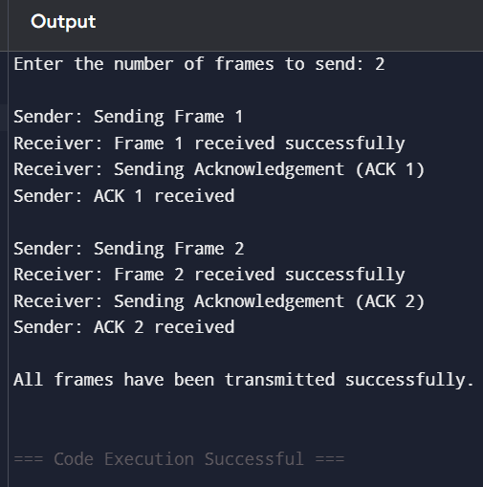
Experiment:2
Aim : Write a program to implement Go back-N protocol
Description : Go-Back-N is a flow control and error control protocol used in the Data Link Layer. The sender can transmit multiple frames without waiting for individual acknowledgments. These frames are sent within a predefined window size.If an error occurs or a frame is lost, the receiver discards that frame and all subsequent frames. The sender then retransmits the lost frame and all frames that follow it in the window.
Source code:
#include <iostream>
using namespace std;
int main()
{
int totalFrames, windowSize, i = 1;
cout << "Enter the total number of frames: ";
cin >> totalFrames;
cout << "Enter the window size: ";
cin >> windowSize;
while (i <= totalFrames)
{
cout << "\nSending frames: ";
for (int j = 0; j < windowSize && (i + j) <= totalFrames; j++)
{
cout << (i + j) << " ";
}
int ack;
cout << "\nEnter the last acknowledged frame (0 if error): ";
cin >> ack;
if (ack == 0) {
cout << "Error occurred! Retransmitting from Frame " << i << endl;
}
else {
cout << "Acknowledgment received up to Frame " << ack << endl;
i = ack + 1;
} }
cout << "\nAll frames transmitted successfully." << endl;
return 0;
}
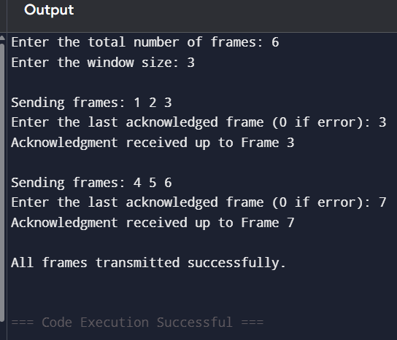

Experement-3
Aim: : Write a program to implement sliding window protocol
Description: The Sliding Window Protocol is a flow control mechanism used in the Data Link Layer to improve communication efficiency. Instead of sending one frame at a time, the sender can transmit multiple frames before receiving acknowledgments. The number of frames that can be sent without waiting is called the window size.As acknowledgments are received, the transmission window moves (slides) forward, allowing new frames to be sent. This protocol increases throughput and makes better use of the communication channel.
Source code:
#include <iostream>
using namespace std;
int main()
{
int totalFrames, windowSize;
cout << "Enter the total number of frames: ";
cin >> totalFrames;
cout << "Enter the window size: ";
cin >> windowSize;
int start = 1;
while (start <= totalFrames)
{
cout << "\nFrames sent: ";
for (int i = start; i < start + windowSize && i <= totalFrames; i++)
{
cout << i << " ";
}
cout << "\nEnter the last acknowledged frame: ";
int ack;
cin >> ack;
if (ack < start)
{
cout << "Invalid acknowledgment! Resending current window.\n";
}
else
{
cout << "Acknowledgment received up to Frame " << ack << endl;
start = ack + 1;
}
}
cout << "\nAll frames transmitted successfully." << endl;
return 0;
}
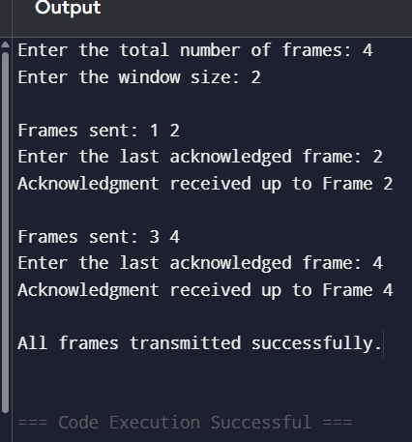

Module-6:
Experiment-1: Write a program to implement High-Level Data Link Control protocol.
Description: High-Level Data Link Control (HDLC) is a bit-oriented Data Link Layer protocol developed by ISO. It provides reliable communication by using bit stuffing, frame synchronization, flow control, and error detection.
HDLC frames begin and end with a special flag sequence: 01111110
- If the sender encounters five consecutive 1s in the data, it automatically inserts a 0 bit. This process is called bit stuffing. At the receiver side, the extra 0 is removed (bit destuffing) to recover the original data.
Algorithm
- Read the binary data from the user.
- Initialize the HDLC flag as 01111110.
- Traverse each bit of the data.
- Count consecutive 1s.
- Whenever five consecutive 1s occur, insert a 0 (bit stuffing).
- Append the starting and ending HDLC flags.
- Display the stuffed data and the final HDLC frame.
Source code:
#include <iostream>
#include <string>
using namespace std;
int main()
{
string data, flag = "01111110";
string stuffedData = "";
cout << "Enter the binary data: ";
cin >> data;
int count = 0;
for (int i = 0; i < data.length(); i++)
{
stuffedData += data[i];
if (data[i] == '1')
{
count++;
if (count == 5)
{
stuffedData += '0';
count = 0;
}
}
else
{
count = 0;
}
}
cout << "\nFlag: " << flag << endl;
cout << "Stuffed Data: " << stuffedData << endl;
cout << "HDLC Frame: " << flag << stuffedData << flag << endl;
return 0;
}
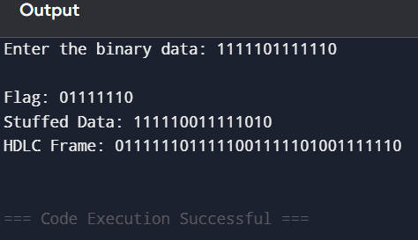

Experement:2
Aim: Write a program to implement Point-to-Point protocol.
Description: Point-to-Point Protocol (PPP) is a Data Link Layer (Layer 2) protocol used to establish a direct communication link between two network devices. It provides encapsulation of network-layer packets, authentication, error detection, and link configurationPPP is commonly used over serial links, telephone lines, DSL connections, leased lines, and VPN connections. It encapsulates data into PPP frames before transmission. In this program, the communication between a sender and receiver is simulated.
Source code:
#include <iostream>
#include <string>
using namespace std;
int main()
{ string data;
cout << "Enter the data to be transmitted: ";
cin >> data;
cout << "\n------ Point-to-Point Protocol (PPP) ------" << endl;
cout << "Sender Side:" << endl;
cout << "Data Sent: " << data << endl;
cout << "\nTransmitting data through point-to-point link..." << endl;
cout << "\nReceiver Side:" << endl;
cout << "Data Received: " << data << endl;
cout << "\nData transmitted successfully using Point-to-Point Protocol (PPP)." << endl;
return 0;
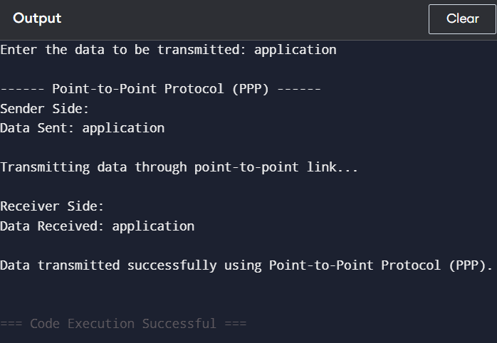

Module:7
Experiment: 1
Aim: Write a program to implement Dijkstra‗s algorithm to compute the Shortest path in a graph.
Description: Dijkstra's Algorithm is a greedy algorithm used to find the shortest path from a source vertex to all other vertices in a graph with non-negative edge weights.The algorithm repeatedly selects the unvisited vertex with the minimum distance from the source and updates the distances of its adjacent vertices. This process continues until all vertices are visited.
Algorithm
- Read the number of vertices.
- Read the weighted adjacency matrix of the graph.
- Enter the source vertex.
- Initialize all distances as infinity except the source vertex (distance = 0).
- Mark all vertices as unvisited.
- Select the unvisited vertex with the smallest distance.
- Mark it as visited.
- Update the distances of all adjacent unvisited vertices if a shorter path is found.
- Repeat Steps 6–8 until all vertices are visited.
- Display the shortest distance from the source to every vertex.
Source code:
#include <iostream>
using namespace std;
#define MAX 10
#define INF 9999
int main()
{
int graph[MAX][MAX], n, source;
cout << "Enter the number of vertices: ";
cin >> n;
cout << "Enter the adjacency matrix (Enter 9999 for no edge):\n";
for (int i = 0; i < n; i++)
{
for (int j = 0; j < n; j++)
{
cin >> graph[i][j];
}
}
cout << "Enter the source vertex (0 to " << n - 1 << "): ";
cin >> source;
int dist[MAX], visited[MAX];
for (int i = 0; i < n; i++)
{
dist[i] = INF;
visited[i] = 0;
}
dist[source] = 0;
for (int count = 0; count < n - 1; count++)
{
int min = INF, u;
for (int i = 0; i < n; i++)
{
if (!visited[i] && dist[i] < min)
{
min = dist[i];
u = i;
}
}
visited[u] = 1;
for (int v = 0; v < n; v++)
{
if (!visited[v] &&
graph[u][v] != INF &&
dist[u] + graph[u][v] < dist[v])
{
dist[v] = dist[u] + graph[u][v];
}
}
}
cout << "\nShortest distances from source vertex " << source << ":\n";
for (int i = 0; i < n; i++)
{
cout << "Vertex " << i << " -> Distance = " << dist[i] << endl;
}
return 0;
}
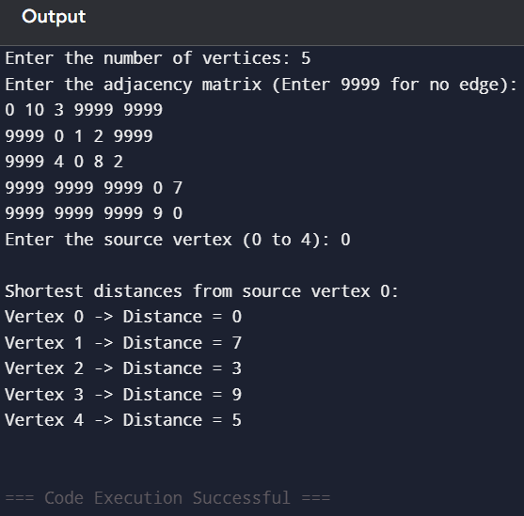
Experiment: 2
Aim: Write a program to implement Flooding routing algorithm.
Description: Flooding is a routing technique in which every incoming packet is forwarded through all outgoing links except the link from which it arrived. This ensures that the packet reaches the destination if a path exists, but it may generate duplicate packets.
source code:
#include <stdio.h>
#define MAX 10
int graph[MAX][MAX];
int visited[MAX];
int n;
void flooding(int current, int destination)
{
int i;
printf("%d -> ", current);
if (current == destination)
{
printf("Destination Reached\n");
return;
}
visited[current] = 1;

for (i = 0; i < n; i++)
{
if (graph[current][i] == 1 && visited[i] == 0)
{
flooding(i, destination);
}
}
}
int main()
{
int i, j;
int source, destination;
printf("Enter number of nodes: ");
scanf("%d", &n);
printf("Enter the adjacency matrix:\n");
for (i = 0; i < n; i++)
{
for (j = 0; j < n; j++)
{
scanf("%d", &graph[i][j]);
}
}
printf("Enter source node: ");
scanf("%d", &source);
printf("Enter destination node: ");
scanf("%d", &destination);
for (i = 0; i < n; i++)
visited[i] = 0;
printf("\nFlooding Path:\n");
flooding(source, destination);

return 0;
}
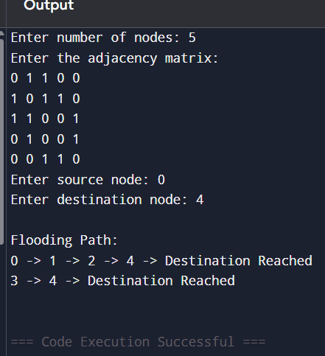
Module:8
Experement 1:
Aim: Take an example subnet graph with weights indicating delay between nodes. Now obtain Routing table at each node using distance vector routing algorithm.
Description :
Source code:
#include <iostream>
using namespace std;
#define MAX 10
#define INF 9999
int main()
{
int n;
int cost[MAX][MAX];
int dist[MAX][MAX];
cout << "Enter the number of nodes: ";
cin >> n;
cout << "Enter the cost matrix (9999 for no direct connection):\n";
for (int i = 0; i < n; i++)
{
for (int j = 0; j < n; j++)
{
cin >> cost[i][j];
dist[i][j] = cost[i][j];
}
}
for (int k = 0; k < n; k++)
{
for (int i = 0; i < n; i++)
{
for (int j = 0; j < n; j++)
{
if (dist[i][k] + dist[k][j] < dist[i][j])
{
dist[i][j] = dist[i][k] + dist[k][j];
}
}
}
}
cout << "\nRouting Tables (Shortest Distance)\n";
for (int i = 0; i < n; i++)
{
cout << "\nRouting Table for Node " << i << endl;
cout << "Destination\tCost\n";

for (int j = 0; j < n; j++)
{
cout << j << "\t\t" << dist[i][j] << endl;
}
}
return 0; }
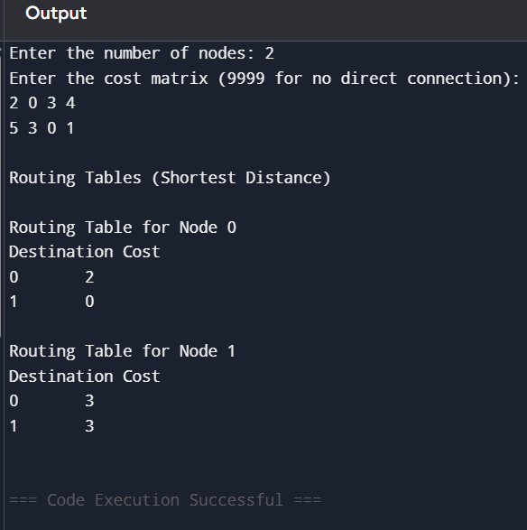

Experiment-2
Aim :Write a program to implement Link state routing algorithm.
Description: The Link State Routing Algorithm is a dynamic routing algorithm in which every router maintains complete information about the network topology. Each router exchanges Link State Advertisements (LSAs) with all other routers. Using the collected information, every router builds the same network map and applies Dijkstra's Algorithm to calculate the shortest path to every destination.
Unlike the Distance Vector Routing Algorithm, Link State Routing has a complete view of the network, resulting in faster convergence and more accurate routing decisions.
Algorithm
- Read the number of nodes in the network.
- Read the weighted adjacency (cost) matrix.
- Select the source node.
- Initialize the distance of the source node as 0 and all other distances with their direct link costs.
- Mark all nodes as unvisited.
- Select the unvisited node with the minimum distance.
- Mark it as visited.
- Update the distances of all adjacent unvisited nodes if a shorter path is found.
- Repeat until all nodes are visited.
- Display the shortest distance from the source to every destination.
Source code:
#include <iostream>
using namespace std;
#define MAX 10
#define INF 9999
int main()
{
int n, graph[MAX][MAX];
int dist[MAX], visited[MAX], source;
cout << "Enter the number of nodes: ";
cin >> n;
cout << "Enter the cost adjacency matrix (9999 for no edge):\n";
for (int i = 0; i < n; i++)
{
for (int j = 0; j < n; j++)
{
cin >> graph[i][j];
}
}
cout << "Enter the source node: ";
cin >> source;
// Initialization
for (int i = 0; i < n; i++)
{
dist[i] = graph[source][i];
visited[i] = 0;
}
dist[source] = 0;
visited[source] = 1;
// Link State Routing using Dijkstra's Algorithm
for (int count = 1; count < n; count++)
{
int min = INF, u = -1;
for (int i = 0; i < n; i++)
{
if (!visited[i] && dist[i] < min)
{
min = dist[i];
u = i;
}
}
if (u == -1)
break;
visited[u] = 1;
for (int v = 0; v < n; v++)
{
if (!visited[v] &&
graph[u][v] != INF &&
dist[u] + graph[u][v] < dist[v])
{
dist[v] = dist[u] + graph[u][v];
}
}
}
cout << "\nShortest Distance from Source Node " << source << ":\n";
cout << "Destination\tCost\n";
for (int i = 0; i < n; i++)
{
cout << i << "\t\t" << dist[i] << endl;
}
return 0;
}
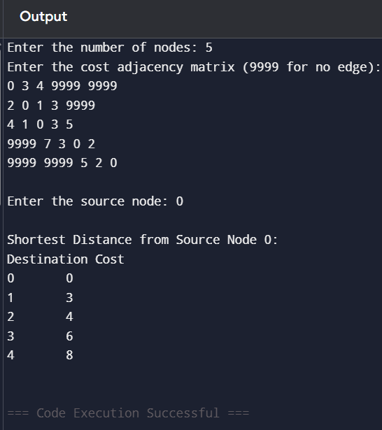
Experiment: 3
Aim: Write a program for congestion control using leaky bucket algorithm
Description: The Leaky Bucket Algorithm is a congestion control and traffic shaping technique used in computer networks. It controls the rate at which packets are transmitted by storing incoming packets in a fixed-size bucket.
- Packets arrive at variable rates.
- The bucket has a limited capacity.
- Packets leave the bucket at a constant output rate.
- If the bucket becomes full, any newly arriving packets are dropped, preventing network congestion.
This algorithm smooths bursty traffic into a steady output stream, improving network performance.
Algorithm
- Read the bucket size.
- Read the output (transmission) rate.
- Read the number and sizes of incoming packets.
- Add each packet to the bucket.
- If the bucket exceeds its capacity, discard the incoming packet.
- Otherwise, transmit packets at the fixed output rate.
- Continue transmitting until the bucket becomes empty.
- Display the packet transmission and bucket status
Source code:
#include <iostream>
using namespace std;
int main()
{
int bucketSize, outputRate, n;
cout << "Enter the bucket size: ";
cin >> bucketSize;
cout << "Enter the output rate: ";
cin >> outputRate;
cout << "Enter the number of packets: ";
cin >> n;
int packets[100];
cout << "Enter the packet sizes:\n";
for (int i = 0; i < n; i++)
cin >> packets[i];
int bucket = 0;
cout << "\nPacket\tReceived\tSent\tBucket Status\n";
for (int i = 0; i < n; i++)
{
bucket += packets[i];

if (bucket > bucketSize)
{
cout << i + 1 << "\t" << packets[i]
<< "\t\tDropped\tBucket Overflow\n";
bucket -= packets[i];
}
else
{
int sent = (bucket >= outputRate) ? outputRate : bucket;
bucket -= sent;
cout << i + 1 << "\t" << packets[i]
<< "\t\t" << sent
<< "\t" << bucket << endl;
}
}
while (bucket > 0)
{
int sent = (bucket >= outputRate) ? outputRate : bucket;
bucket -= sent;
cout << "-\t0\t\t" << sent
<< "\t" << bucket << endl;
}
return 0;
}
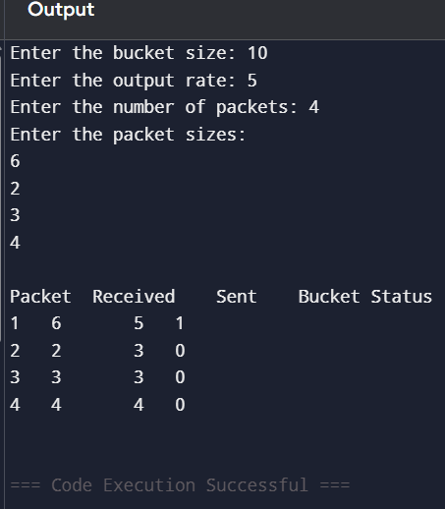

Module: 9
Experiment: 2
Aim: Write a program to implement Connection oriented service protocol (TCP)
Source code:
#include <stdio.h>
#include <stdlib.h>
#include <string.h>
#include <unistd.h>
#include <arpa/inet.h>
int main()
{
int sockfd;
struct sockaddr_in server;
char buffer[1024];
sockfd = socket(AF_INET, SOCK_STREAM, 0);
server.sin_family = AF_INET;
server.sin_port = htons(8080);
server.sin_addr.s_addr = inet_addr("127.0.0.1")
connect(sockfd, (struct sockaddr *)&server, sizeof(server))
strcpy(buffer, "Hello Server");
send(sockfd, buffer, strlen(buffer) + 1, 0)
recv(sockfd, buffer, sizeof(buffer), 0);
printf("Message from Server: %s\n", buffer);
close(sockfd);
return 0;
}
Output: Message from Server: Hello Client
Experiment:3
Aim: Write a program to implement Connection less service protocol (UDP).
source code:
#include <stdio.h>
#include <string.h>
#include <unistd.h>
#include <arpa/inet.h>
int main()
{
int sockfd;
char buffer[1024];
struct sockaddr_in server;
socklen_t len = sizeof(server);
sockfd = socket(AF_INET, SOCK_DGRAM, 0);
server.sin_family = AF_INET;
server.sin_port = htons(8080);
server.sin_addr.s_addr = inet_addr("127.0.0.1");
strcpy(buffer, "Hello Server");
sendto(sockfd, buffer, strlen(buffer) + 1, 0,
(struct sockaddr *)&server, len);
recvfrom(sockfd, buffer, sizeof(buffer), 0,
(struct sockaddr *)&server, &len);
printf("Message from Server: %s\n", buffer);
close(sockfd);
return 0;
}
output: Message from Server: Hello Client

Module-10
Aim: Write a program to implement HTTP protocol.
source code:
#include <stdio.h>
#include <string.h>
#include <unistd.h>
#include <arpa/inet.h>
int main()
{
int server_fd, client_fd;
struct sockaddr_in server, client;
char buffer[1024];
socklen_t len = sizeof(client);
server_fd = socket(AF_INET, SOCK_STREAM, 0);
server.sin_family = AF_INET;
server.sin_addr.s_addr = INADDR_ANY;
server.sin_port = htons(8080);
bind(server_fd, (struct sockaddr *)&server, sizeof(server));
listen(server_fd, 5);
printf("HTTP Server running on port 8080...\n");
client_fd = accept(server_fd, (struct sockaddr *)&client, &len);
recv(client_fd, buffer, sizeof(buffer), 0);
printf("\nHTTP Request Received:\n%s\n", buffer);
char response[] =
"HTTP/1.1 200 OK\r\n"
"Content-Type: text/html\r\n"
"Connection: close\r\n\r\n"
"<html>"
"<head><title>HTTP Server</title></head>"
"<body>"
"<h1>Welcome to Simple HTTP Server</h1>"
"<p>HTTP Protocol Implemented Successfully!</p>"
"</body>"
"</html>";
send(client_fd, response, strlen(response), 0);
close(client_fd);
close(server_fd);
return 0; }
Output:
HTTP Server running on port 8080...
HTTP Request Received:
GET / HTTP/1.1
Host: localhost:8080
Connection: keep-alive
User-Agent: Mozilla/5.0
Accept: text/html
Experiment:2
Aim: Write a program to implement FTP protocol.
source code:
#include <stdio.h>
#include <string.h>
#include <unistd.h>
#include <arpa/inet.h>.
int main()
{
int sockfd;
struct sockaddr_in server;
char filename[100], buffer[1024];
sockfd = socket(AF_INET, SOCK_STREAM, 0);
server.sin_family = AF_INET;
server.sin_port = htons(8080);
server.sin_addr.s_addr = inet_addr("127.0.0.1");
connect(sockfd, (struct sockaddr *)&server, sizeof(server));
printf("Enter file name: ");
scanf("%s", filename);
send(sockfd, filename, strlen(filename) + 1, 0);
printf("\nFile Content:\n");
while (1)
{
recv(sockfd, buffer, sizeof(buffer), 0);
if (strcmp(buffer, "EOF") == 0)
break;
printf("%s", buffer);
}
close(sockfd);
return 0;
}
Output:
Enter file name: sample.txt
File Content:
This is FTP file transfer.
Welcome to Computer Networks Lab.

Experiment:3
Aim: Write a program to implement SMTP protocol.
source code:
#include <stdio.h>
#include <string.h>
#include <unistd.h>
#include <arpa/inet.h>
int main()
{
int sockfd;
struct sockaddr_in server;
char buffer[1024];
sockfd = socket(AF_INET, SOCK_STREAM, 0);
server.sin_family = AF_INET;
server.sin_port = htons(2525);
server.sin_addr.s_addr = inet_addr("127.0.0.1");
connect(sockfd, (struct sockaddr *)&server, sizeof(server));
recv(sockfd, buffer, sizeof(buffer), 0);
printf("Server: %s\n", buffer);
strcpy(buffer, "HELO localhost");
send(sockfd, buffer, strlen(buffer) + 1, 0);
recv(sockfd, buffer, sizeof(buffer), 0);
printf("Server: %s\n", buffer);
strcpy(buffer, "MAIL FROM:<sender@example.com>");
send(sockfd, buffer, strlen(buffer) + 1, 0);
recv(sockfd, buffer, sizeof(buffer), 0);
printf("Server: %s\n", buffer);
strcpy(buffer, "RCPT TO:<receiver@example.com>");
send(sockfd, buffer, strlen(buffer) + 1, 0);
recv(sockfd, buffer, sizeof(buffer), 0);
printf("Server: %s\n", buffer);
strcpy(buffer, "DATA\nSubject: Test Mail\nHello, this is a sample SMTP message.");
send(sockfd, buffer, strlen(buffer) + 1, 0);
recv(sockfd, buffer, sizeof(buffer), 0);
printf("Server: %s\n", buffer);
close(sockfd);
return 0;
}
OUTPUT:
Server: 220 SMTP Server Ready
Server: 250 Hello Client
Server: 250 OK
Server: 250 OK
Server: 250 Message Accepted

Case Study: Select any one practical application mentioned below
Note: A report has to be submitted by every student at the end of the semester that includes design,
coding, output, etc.
- Configuring routers and switches, experimenting with routing algorithms and analysing network performance under different topologies.
- Students analyse network protocols (e.g., TCP, UDP, HTTP, FTP) using tools like Wireshark to understand packet structures, communication flows, and protocol behaviour.
- Setting up IoT-based networks with sensors and actuators, evaluating wireless communication protocols (e.g., Zigbee, LoRa, MQTT), and assessing security vulnerabilities.

Reference Books:
1. Computer Networks — Andrew S Tanenbaum, Fifth Edition. Pearson Education/PHI
2. Data Communications and Networks – Behrouz A. Forouzan, Fifth Edition TMH.
3. Data Communications and Networks- Achut S Godbole, Atul Kahate
4. Computer Networks, Mayank Dave, CENGAGE

Web References (e-Resources):
1. https://inl.info.ucl.ac.be/CNP3
2. https://wps.pearsoned.com/ecs_kurose_compnetw_8/
3. https://www.netacad.com

