MODULE-5
AIM: Create a pipeline project to demonstrate PostBuild actions using pipeline script.
A) Creating postbuildPipeline2 (Success):
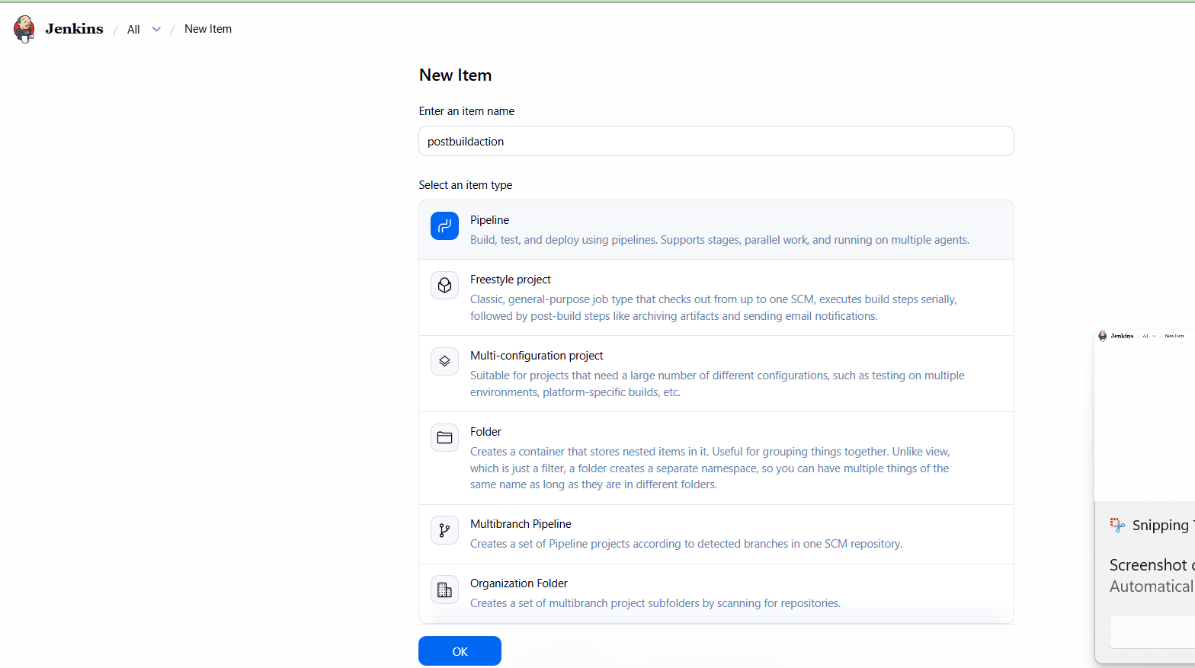
- Click on new item and create a new pipeline project named as “postbuildaction” and select ok.

- Go to configure and write some description.
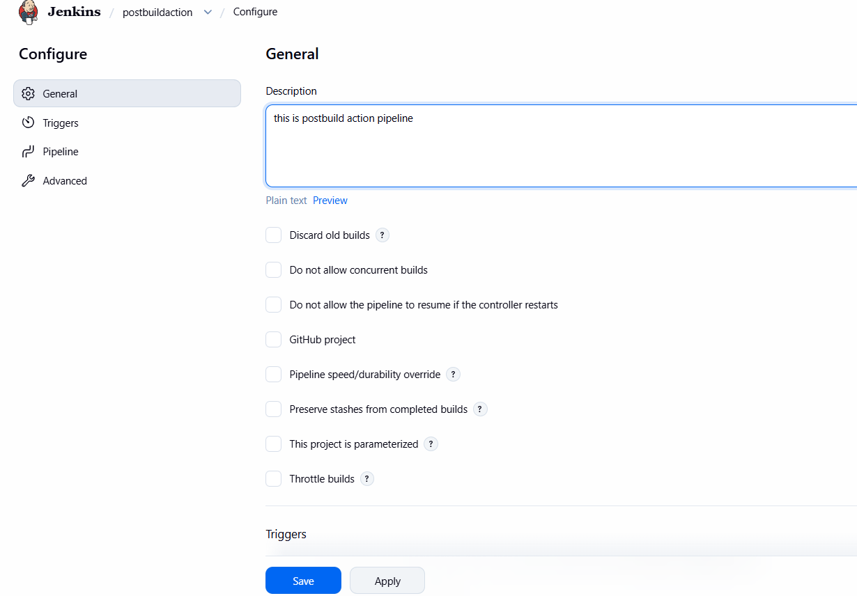

- Now go to pipeline script and and click “Hello World” and go to pipeline syntax and copy the url link from github repository.
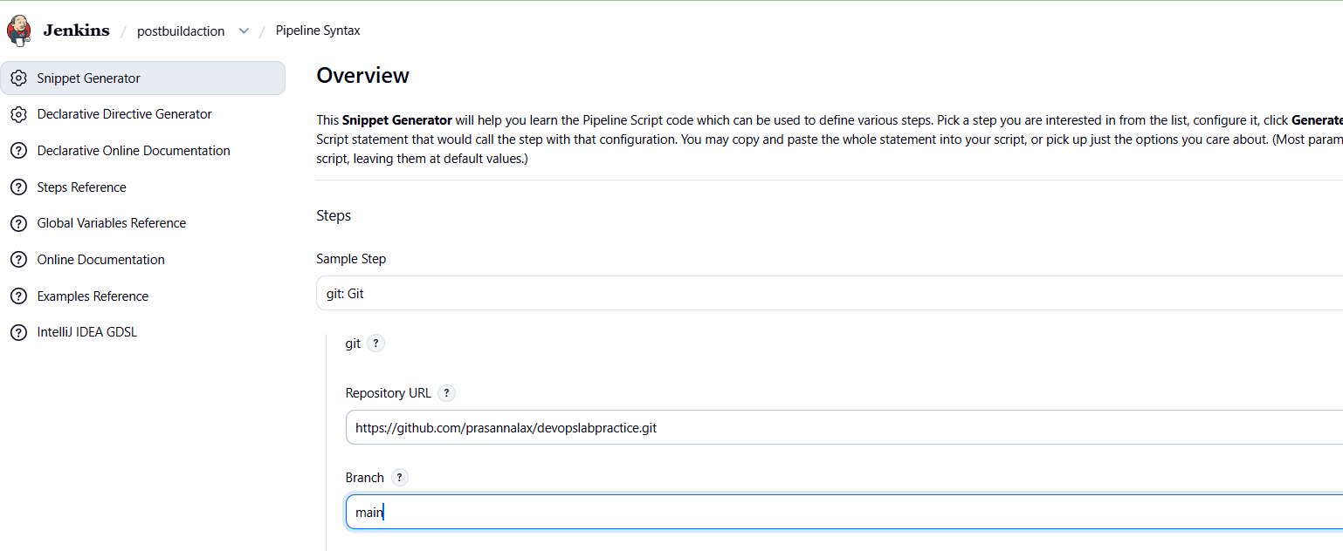
- Now click on generate pipeline script and copy the line.
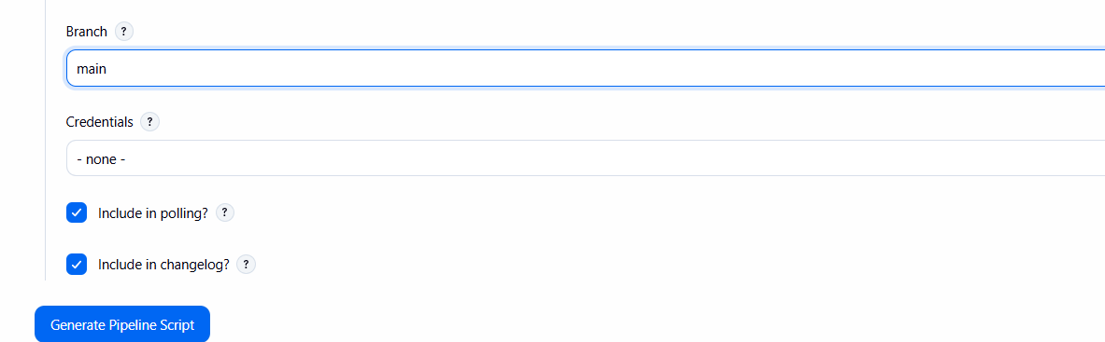
- Paste the line as shown in below and then click on apply and save.
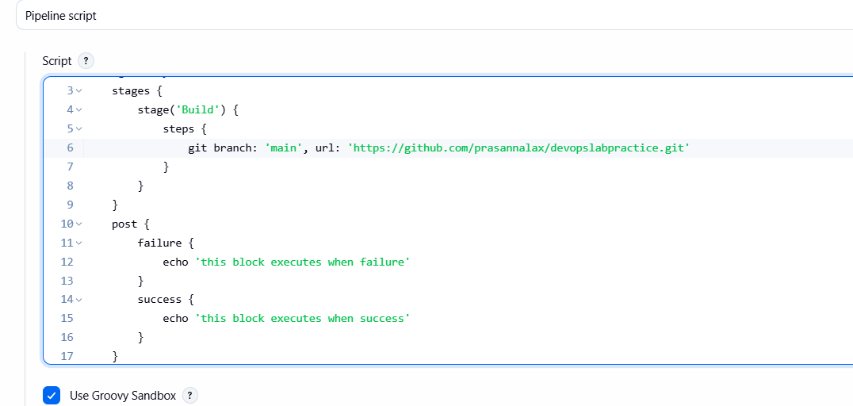

- After saving the configuration click on build now to see the output.
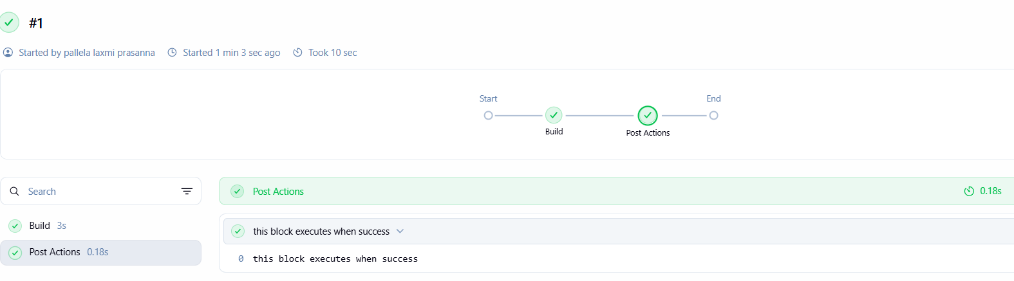
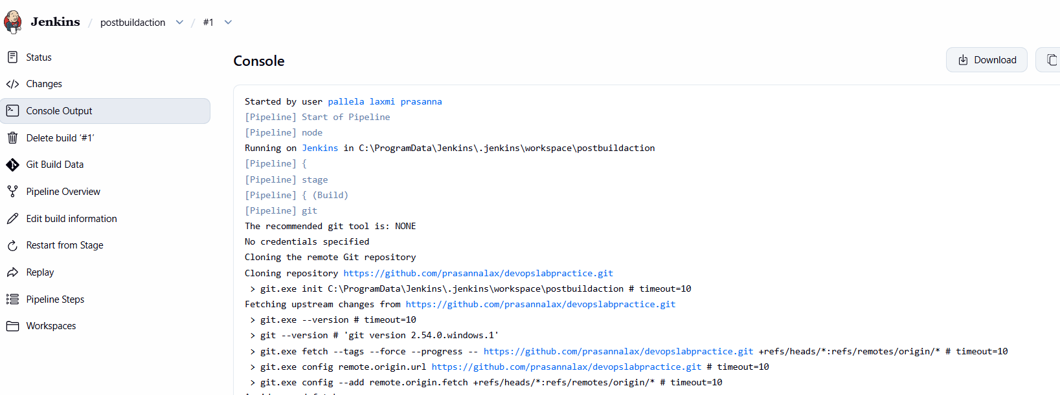
- To view console output click on green mark under build history.

B) To create a Post Build Action Pipeline Failure using Pipeline script \
Creating postbuildPipeline2 (Failure):
Step 1: Click on new item and create a new pipeline project named as “postbuildpieline2” and select ok.
Step 2: Go to configure and write some description.
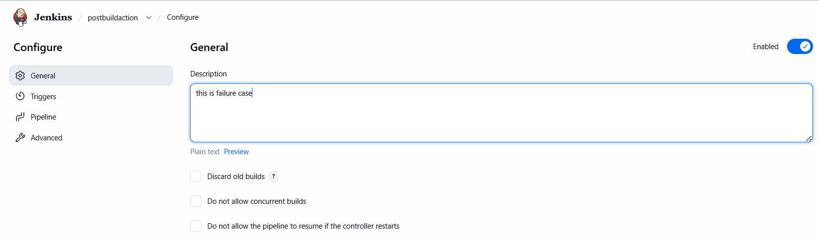

Step 3: Now go to pipeline script and click “Hello World” and modified the code as below and after that click on apply and save
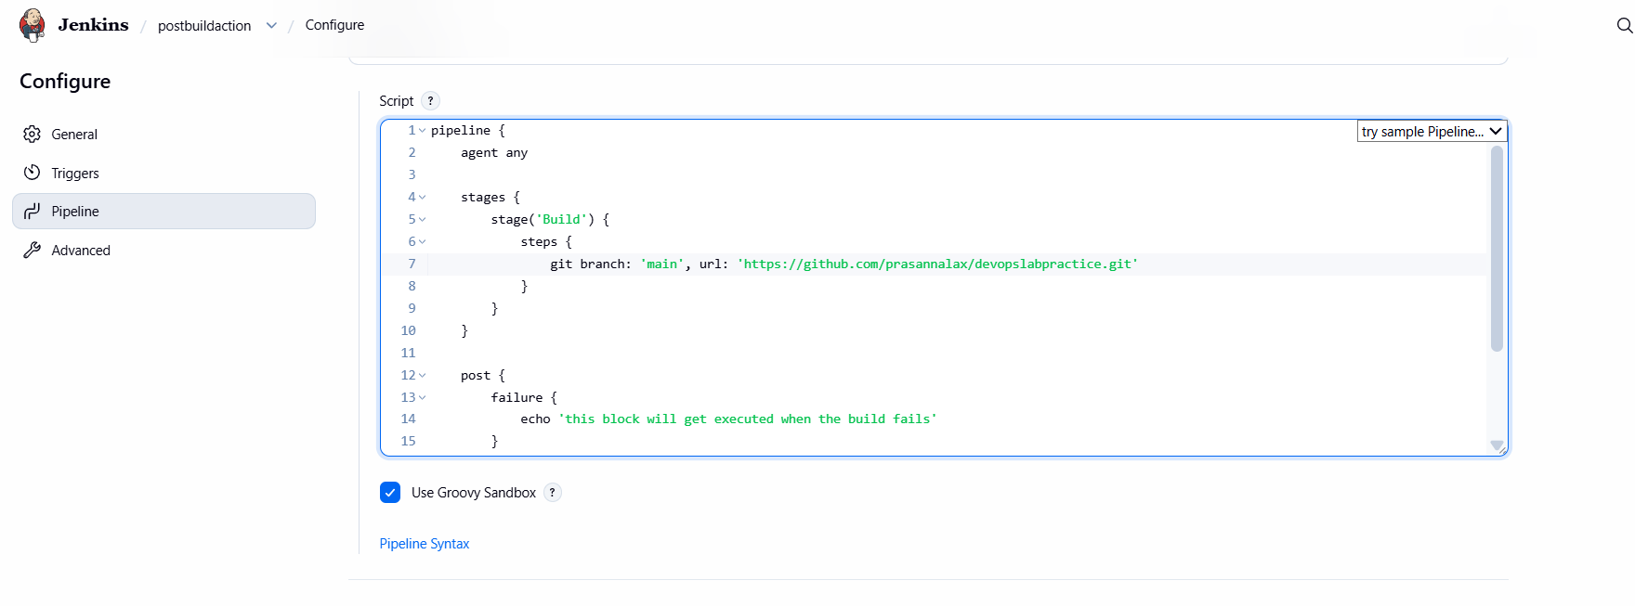
Step 4: After saving the configuration click on buildnow to see the output.
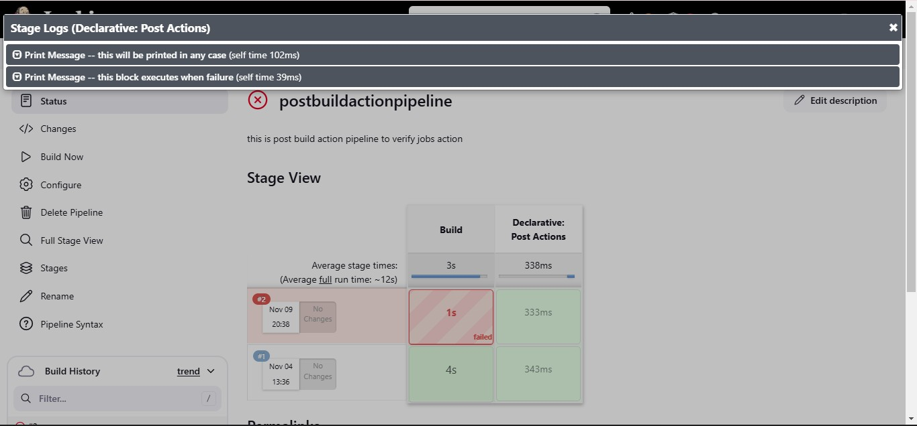 -;p

Step 5: To view console output click on green mark under build history.


