In worm attack project I added existing Back Propagation Neural Network and added Deep Learning Neural Network as extension. Below are the output screens

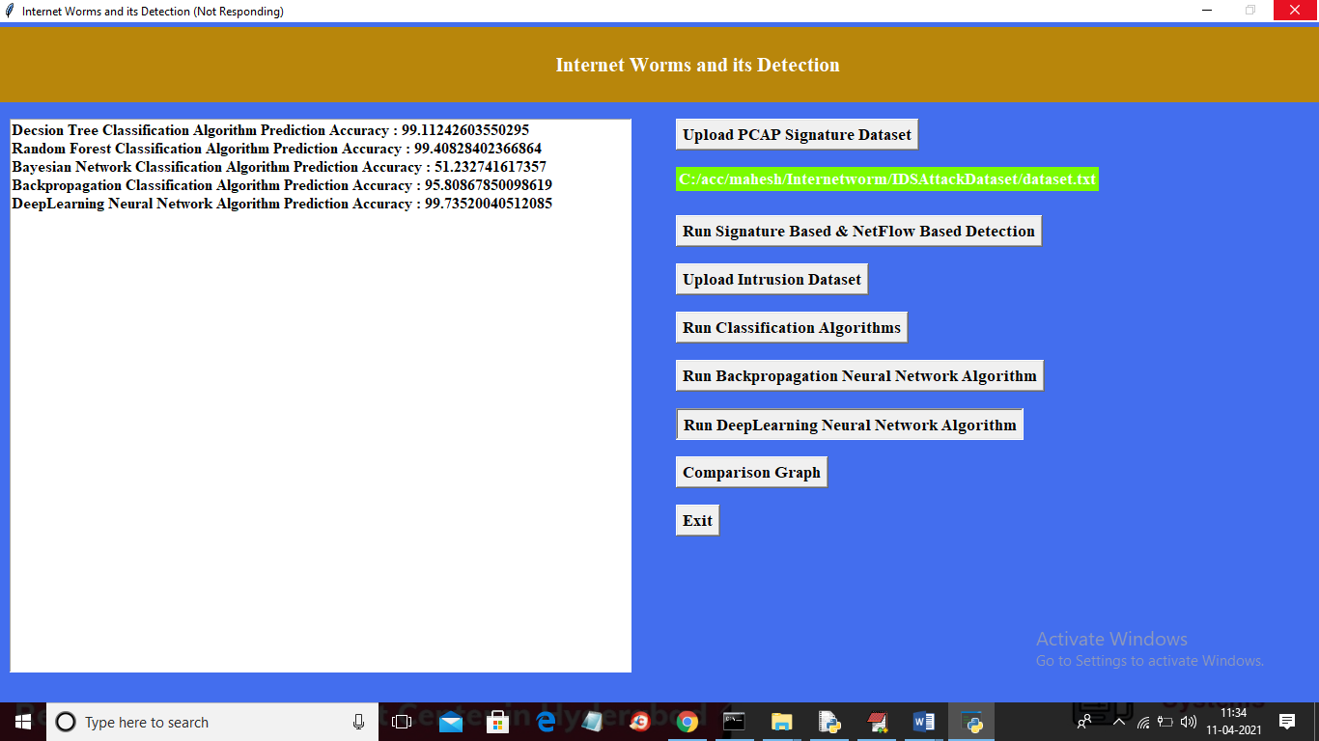

In above screen we got accuracy for each existing algorithm and extension deep learning algorithm and now click on comparison graph button to get below graph

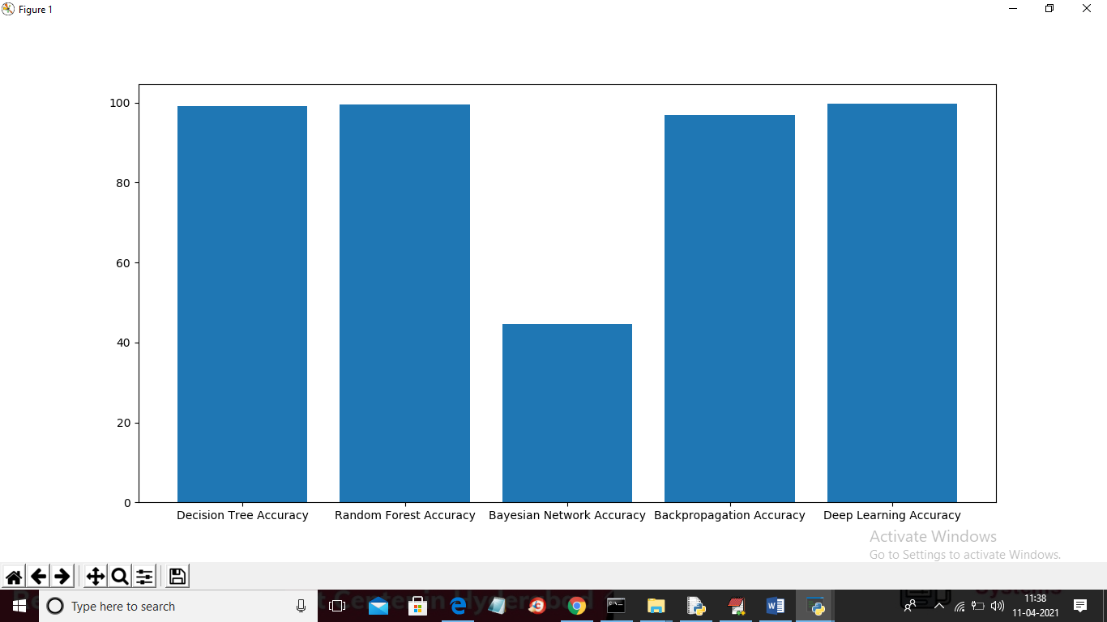

In above graph x-axis represents algorithm names and y-axis represents accuracy of all those algorithms and in all algorithms extension deep learning got high accuracy and now click on ‘Comparison Table’ button to get all algorithms performance result

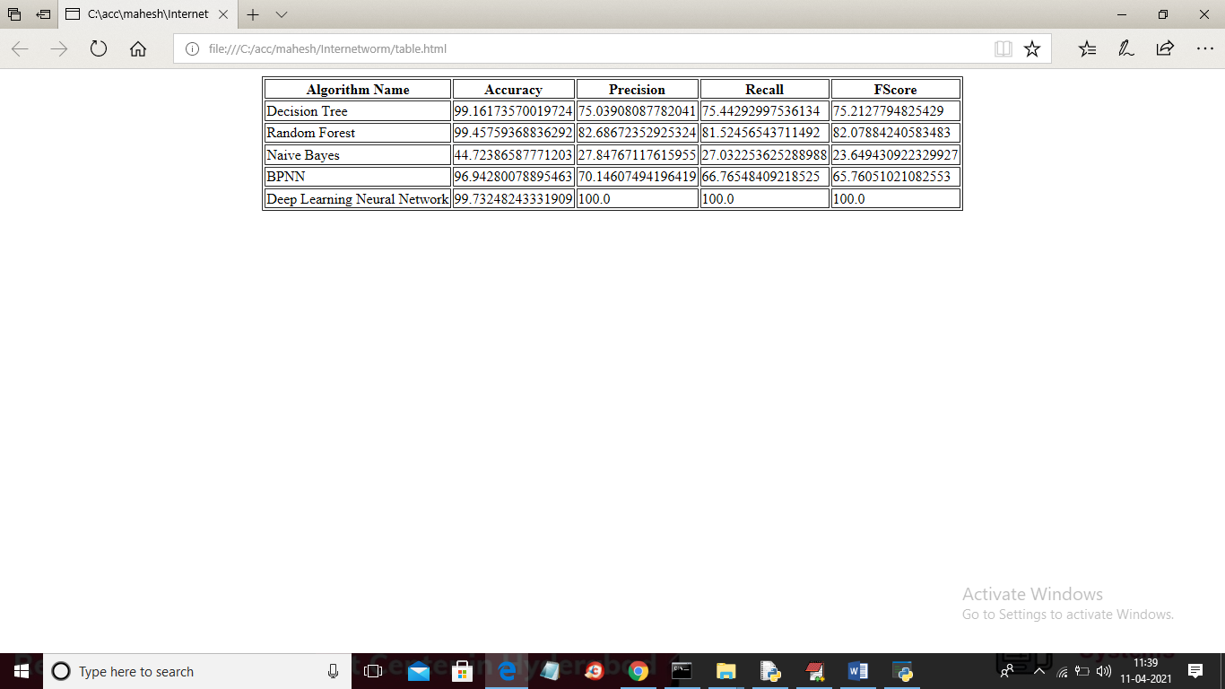

In above table we can see extension deep learning got high accuracy, precision, recall and FSCORE