**ASSIGNMENT-01 (29/04/2020)**

**1)**Write a program to calculate the division/class obtained by the student when the marks obtained by a student in 5 different subjects are given as inputs.

The student gets a division/class as per the following rules:

Percentage above or equal to 60 - “First Class”.

Percentage between 50 and 59 - “Second Class”.

Percentage between 40 and 49 - “Third Class”.

Percentage less than 40 - “Failed”.

PROGRAM :

**package** hcl.com;

**import** java.util.Scanner;

**public** **class** Division {

**public** **static** **void** main(String[] args) {

// **TODO** Auto-generated method stub

Scanner sc =**new** Scanner(System.***in***);

**double** percentage;

//enter marks of each subject

System.***out***.println("Input :");

**int** sub1=sc.nextInt();

**int** sub2=sc.nextInt();

**int** sub3=sc.nextInt();

**int** sub4=sc.nextInt();

**int** sub5=sc.nextInt();

//calculate the percentage of above marks

percentage = (((sub1+sub2+sub3+sub4+sub5)/5));

//write a logic for student gets a division

**if**(percentage >=60) {

System.***out***.println("output :");

System.***out***.println("First class");

}

**else** {

**if**(percentage>=50 && percentage <=59) {

System.***out***.println("output :");

System.***out***.println("Second class");

}

**else** {

**if**(percentage>=40 && percentage <=49) {

System.***out***.println("output :");

System.***out***.println("Third Class");

}

**else** {

**if**(percentage <40) {

System.***out***.println("output :");

System.***out***.println(" Failed");

}

}

}

}

}

}

OUTPUT :

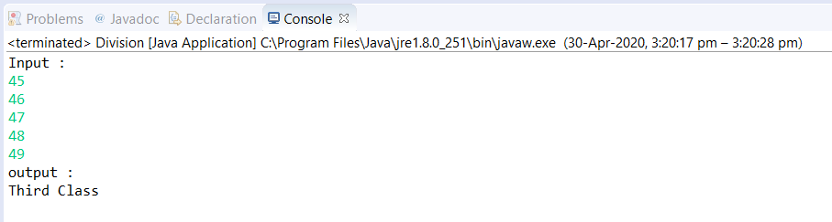

2)Write a program to get all the elements that are greater than 5 from a given input integer list.

Display it in the order as present in the array.

Print the elements.

Program :

**package** hcl.com;

**import** java.util.Scanner;

**public** **class** PrintElements {

**public** **static** **void** main(String[] args) {

// **TODO** Auto-generated method stub

Scanner sc=**new** Scanner(System.***in***);

//scan the input from user

System.***out***.println("Input :");

**int** n = sc.nextInt();

//initialize array with size of n

**int**[] arr = **new** **int**[n];

//read values into the array

**for**(**int** i=0;i<n;i++) {

arr[i]=sc.nextInt();

}

//logic for display numbers which are greater than 5

System.***out***.println("Output :");

**for**(**int** i=0;i<n;i++) {

**if**(arr[i]>5) {

System.***out***.print(arr[i]+",");

}

}

}

}

Output :

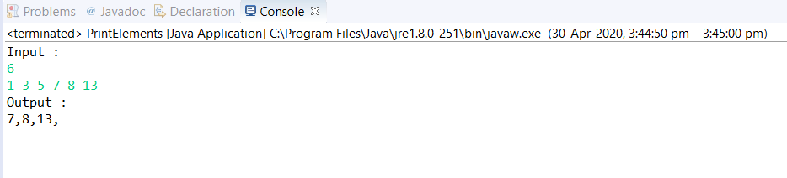

3. Write a program to perform the user specified arithmethic operation. The program will consist of 3 parameters. First one for specifying the type of operation (+,-,*,/) and the other two are the operands upon which the operation has to be performed. Print the final output.

1 --------------- Add the second and third parameter. (second+third)

2 --------------- Subtract the second and third parameter.(second-third)

3 ---------------- Multiply second and third parameter. .(second*third)

4 ---------------- Divide second by third parameter.(second/third)

PROGRAM :

**package** hcl.com;

**import** java.util.Scanner;

**public** **class** ArithmeticOperations {

**public** **static** **void** main(String[] args) {

// **TODO** Auto-generated method stub

Scanner sc= **new** Scanner(System.***in***);

**int**[] arr = **new** **int**[3];

**int** value1;

**double** value2;

//storing parameters in array

System.***out***.println("Input :");

**for**(**int** i=0;i<3;i++) {

arr[i]=sc.nextInt();

}

//logic for to perform the user specified arithmethic operation(+, -, *, /)

**switch**(arr[0]) {

//ADDITION ("1 --------------- Add the second and third parameter. (second+third) \r\n" )

**case** 1:

value1 = arr[1]+arr[2];

System.***out***.println("Output :");

System.***out***.println(value1);

**break**;

//SUBTRACTION ("2 --------------- Subtract the second and third parameter.(second-third) \r\n" )

**case** 2:

value1 = arr[1]-arr[2];

System.***out***.println("Output :");

System.***out***.println(value1);

**break**;

//MULTIPLICATION ("3 ---------------- Multiply second and third parameter. .(second*third) \r\n" )

**case** 3:

value1 = arr[1]*arr[2];

System.***out***.println("Output :");

System.***out***.println(value1);

**break**;

//DIVISION ("4 ---------------- Divide second by third parameter.(second/third)\r\n" )

**case** 4:

value2 = arr[1]/arr[2];

System.***out***.println("Output :");

System.***out***.println(value2);

**break**;

}

}

}

Output 1: ADDITION

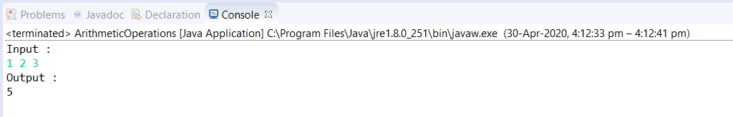

OUTPUT 2 : SUBTRACTION

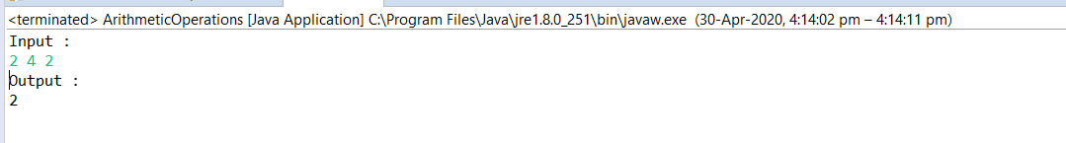

OUTPUT 3 :MULTIPLICATION

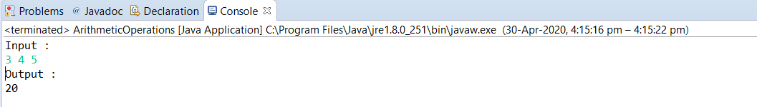

OUTPUT 4: DIVISION

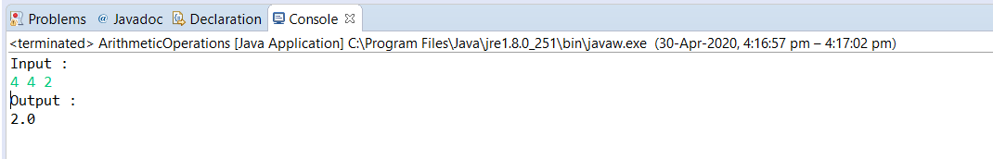

**4)**Write program to read a positive int as input and to calculate the sum of the odd digits in the given number. If the sum is odd print “Odd” else print “Even”.

Program :

**package** hcl.com;

**import** java.util.Scanner;

**public** **class** SumOfElements {

**public** **static** **void** main(String[] args) {

// **TODO** Auto-generated method stub

Scanner sc = **new** Scanner(System.***in***);

**int** sum=0;

//read input number

System.***out***.print("Input = ");

**int** num = sc.nextInt();

//logic for to calculate the sum of the odd digits in the given number.

**while**(num!=0) {

**int** temp = num%10;

**if**(temp%2!=0) {

sum=sum+temp;

}

num=num/10;

}

//if the sum is odd print “Odd” else print “Even”

**if**(sum%2!=0) {

System.***out***.println("Output = Odd");

}

**else** {

System.***out***.println("Output =Even");

}

}

}

Output 1:

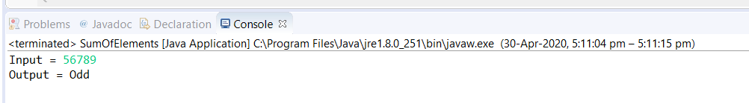

Output 2:

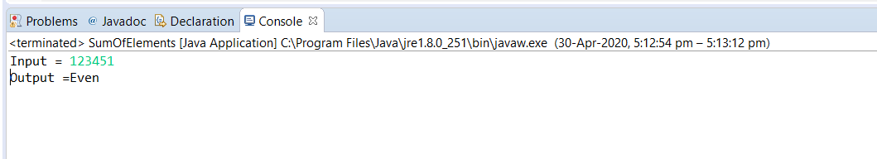

5)Write a program to calculate the commission on given sales as per the following policy.

If sales is less than Rs. 10000/- no commission.

If sales is between Rs. 10000/- to Rs. 25000/- commission is 10% of sales.

If sales is more than Rs. 25000/- then commission is Rs. 500/- plus 8% of sales amount.

Program :

**package** hcl.com;

**import** java.util.Scanner;

**public** **class** SalesCommision {

**public** **static** **void** main(String[] args) {

// **TODO** Auto-generated method stub

Scanner sc= **new** Scanner(System.***in***);

//read input from user

System.***out***.println("Input :");

**int** sales=sc.nextInt();

//write code to calculate the commission on given sales

**if**(sales>0) {

**if**(sales <10000) {

System.***out***.println("Output :");

System.***out***.println("no comission");

}

**else** {

**if**(sales >=10000 && sales <=25000 ) {

**int** comission = (**int**) (0.1*sales);

System.***out***.println("Output :");

System.***out***.println(comission) ;

}

**else** {

**if**(sales>25000) {

**int** comission = (**int**) (500+(0.08*sales));

System.***out***.println("Output :");

System.***out***.println(comission);

}

}

}

}

**else** {

System.***out***.println("Output :");

System.***out***.println("Invalid Input");

}

}

}

Output 1:

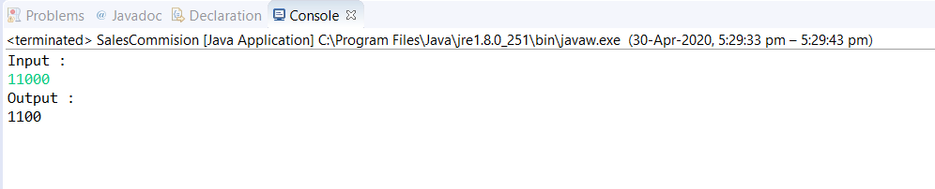

Output 2:

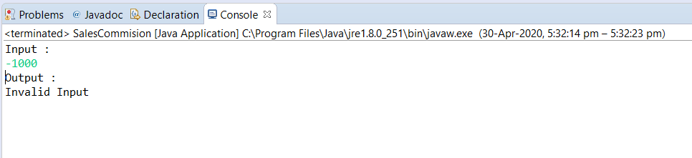

6)Sort elements in an array.

Program:

**package** hcl.com;

**import** java.util.Scanner;

**public** **class** SortElements {

**public** **static** **void** main(String[] args) {

// **TODO** Auto-generated method stub

Scanner sc= **new** Scanner(System.***in***);

//taking input

System.***out***.println("Input :");

**int** n = sc.nextInt();

**int**[] arr = **new** **int**[n];

//read values in array

**for**(**int** i=0;i<n;i++) {

arr[i]=sc.nextInt();

}

//logic for sort elements

**for**(**int** i=0;i<n;i++) {

**for**(**int** j=i+1;j<n;j++) {

**if**(arr[i]>arr[j]) {

**int** temp = arr[i];

arr[i]=arr[j];

arr[j]=temp;

}

}

}

//sorted elements

System.***out***.println("Sorted output :");

**for**(**int** i=0;i<n;i++) {

System.***out***.print(arr[i]+" ");

}

}

}

Output :

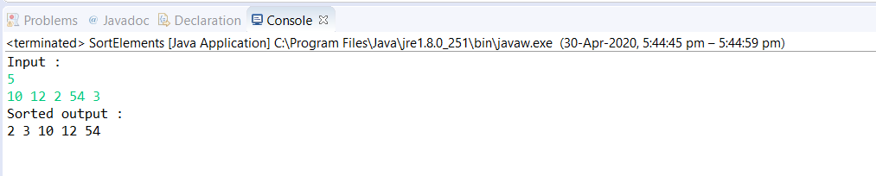

7)Remove particular element from an array.

Program :

**package** hcl.com;

**import** java.util.Scanner;

**public** **class** RemoveElement {

**public** **static** **void** main(String[] args) {

// **TODO** Auto-generated method stub

Scanner sc= **new** Scanner(System.***in***);

//taking input

System.***out***.println("Input :");

**int** n = sc.nextInt();

**int**[] arr = **new** **int**[n];

//read values in array

**for**(**int** i=0;i<n;i++) {

arr[i]=sc.nextInt();

}

//logic for remove particular element from an array

System.***out***.println("enter particular element from an array to remove");

**int** element = sc.nextInt();

**for**(**int** i=0;i<n;i++) {

**if**(arr[i]==element) {

**for**(**int** j=i;j<(n-1);j++) {

arr[j]=arr[j+1];

}

**break**;

}

}

//outut of resultant array

System.***out***.println("Output :");

**for**(**int** i=0;i<(n-1);i++) {

System.***out***.print(arr[i]+" ");

}

}

}

Output :

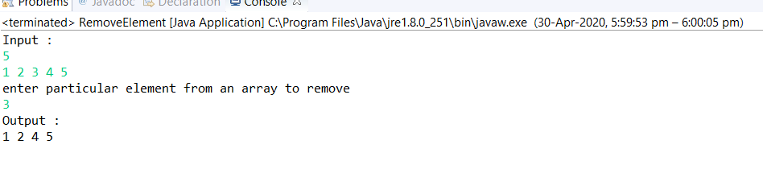

8)Search element in an array.

Program :

**package** hcl.com;

**import** java.util.Scanner;

**public** **class** SearchElement {

**public** **static** **void** main(String[] args) {

// **TODO** Auto-generated method stub

Scanner sc= **new** Scanner(System.***in***);

**int** k=0;

//taking input

System.***out***.println("Input :");

**int** n = sc.nextInt();

**int**[] arr = **new** **int**[n];

//read values in array

**for**(**int** i=0;i<n;i++) {

arr[i]=sc.nextInt();

}

//logic for search an element in array

System.***out***.println("enter element to be searched :");

**int** element = sc.nextInt();

**for**(**int** i=0;i<n;i++) {

**if**(arr[i]==element) {

k++;

**break**;

}

}

//code for display whether element found or not

**if**(k==0) {

System.***out***.println("Element Not Found!!");

}

**else** {

System.***out***.println("Element Found!!");

}

}

}

Output 1:

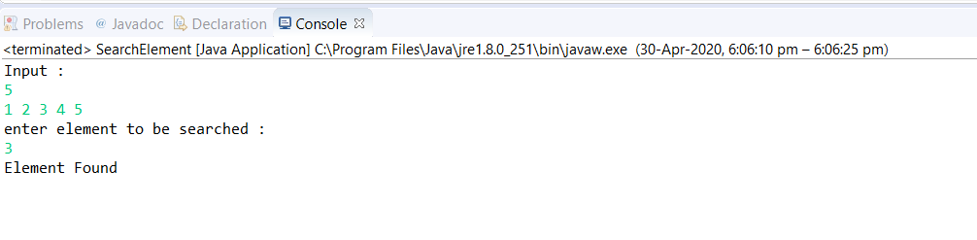

Output 2:

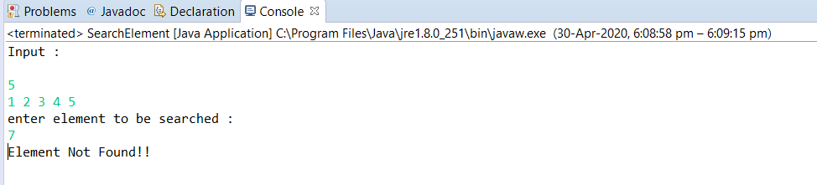

9)Find out Max and Min element in array.

Program :

**package** hcl.com;

**import** java.util.Scanner;

**public** **class** MaxAndMinElement {

**public** **static** **void** main(String[] args) {

// **TODO** Auto-generated method stub

Scanner sc= **new** Scanner(System.***in***);

**int** max=0;

**int** min=9999;

//taking input

System.***out***.println("Input :");

**int** n = sc.nextInt();

**int**[] arr = **new** **int**[n];

//read values in array

**for**(**int** i=0;i<n;i++) {

arr[i]=sc.nextInt();

}

//logic for find maximum element

**for**(**int** i=0;i<n;i++) {

**if**(arr[i]>max) {

max=arr[i];

}

}

//logic for find minimum element

**for**(**int** i=0;i<n;i++)

{

**if**(arr[i]<min) {

min=arr[i];

}

}

//print maximum and minimum elements

System.***out***.println("maximum element in array : "+max);

System.***out***.println("minimum element in array : "+min);

}

}

Output :

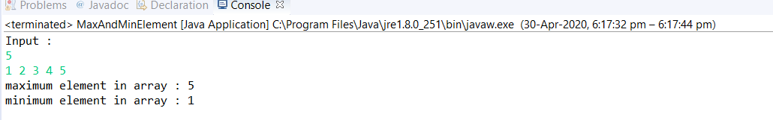

10)Find out second largest element.

Program :

**package** hcl.com;

**import** java.util.Scanner;

**public** **class** SecondLargest {

**public** **static** **void** main(String[] args) {

// **TODO** Auto-generated method stub

Scanner sc= **new** Scanner(System.***in***);

//taking input

System.***out***.println("Input :");

**int** n = sc.nextInt();

**int**[] arr = **new** **int**[n];

//read values in array

**for**(**int** i=0;i<n;i++) {

arr[i]=sc.nextInt();

}

//logic for sort elements

**for**(**int** i=0;i<n;i++) {

**for**(**int** j=i+1;j<n;j++) {

**if**(arr[i]<arr[j]) {

**int** temp = arr[i];

arr[i]=arr[j];

arr[j]=temp;

}

}

}

//print the second largest element

System.***out***.println("Second largest element is : "+arr[1]);

}

}

Output :

